# Data Base connection

Connect to express and run the **bootstrap.sql** found on the documents folder

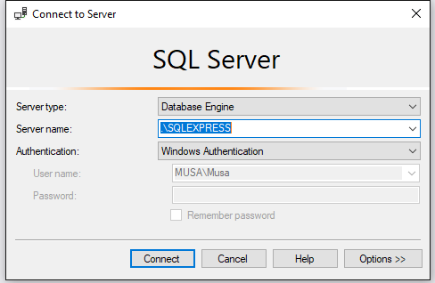

Get SQLEXPRESS FROM HERE: <https://www.microsoft.com/en-us/download/details.aspx?id=55994>

After installation you should see this screen.

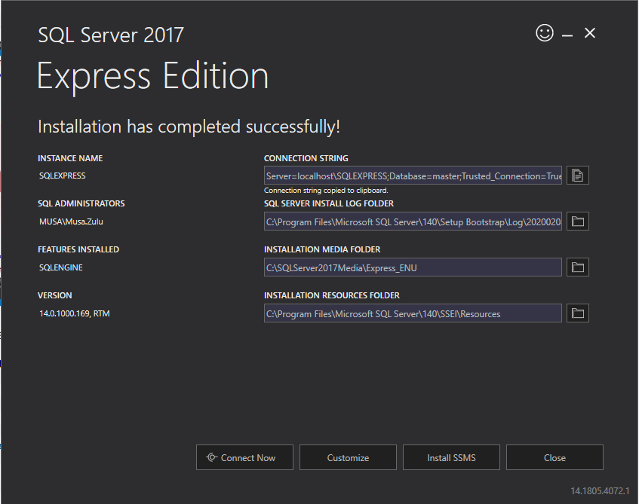

If you don’t have sqlexpress installed (which I recommend that you do install)

Please connect to your local instance e.g my computer name is MUSA and my local instance is MUSA

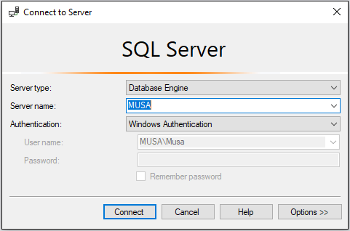

Run the **bootstrap.sql** script found under Documents folder in the project

You have to modifify **appsettings.json found under the DontWaste.Server project**

**Change the underlined line**

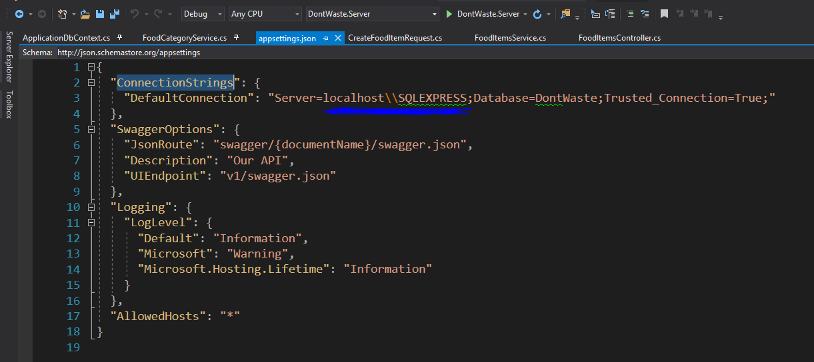

# API

Set the DontWaste.Server as a startup project and run the project. You should see the following screen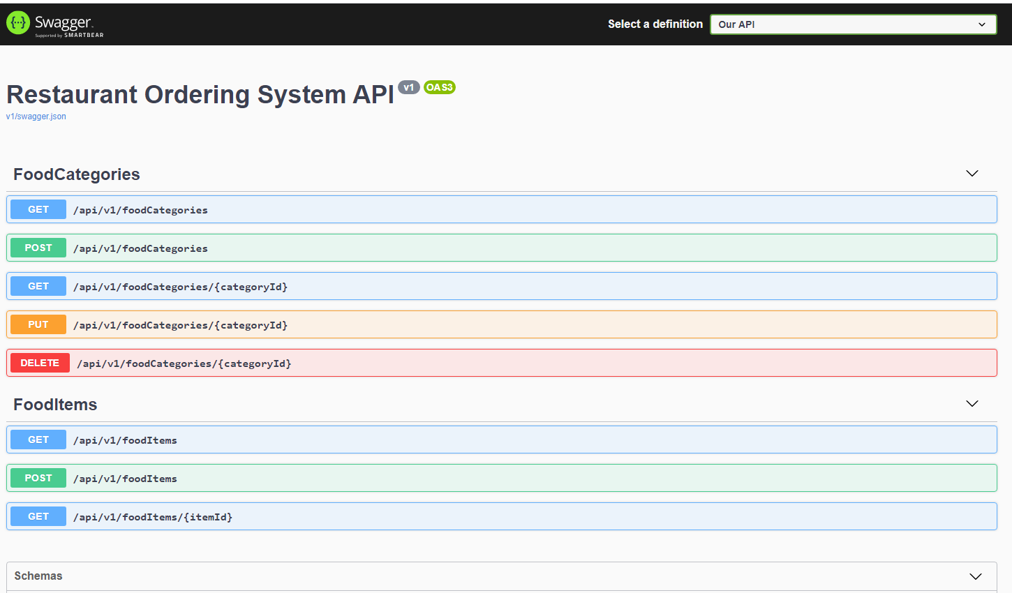

If for any reason you don’t get the swagger screen please right-click on your **DontWaste.Server** project and make sure your Debug settings looks like the following.

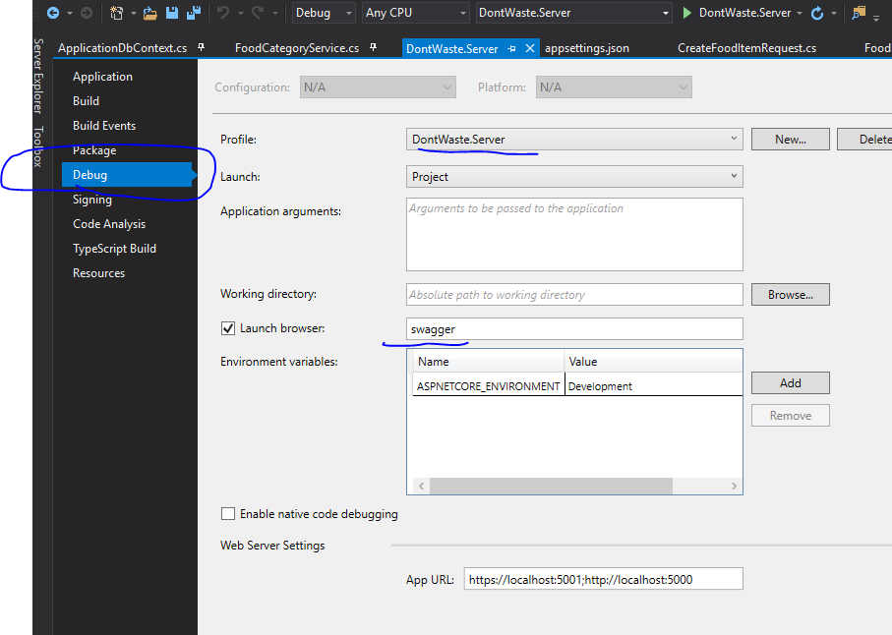

# Run the project

## If you get this error.

Open Sql Server Configuration manager (you can search for this on the start menu on windows)

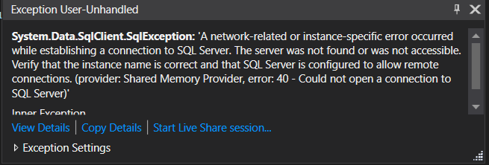

Make sure the SQL Server(SQLEXPRESS) is running and restart your application.

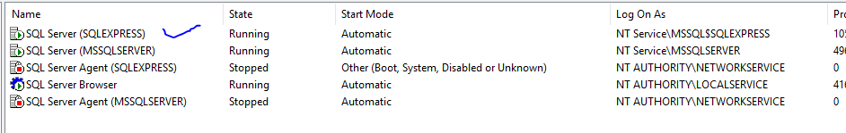

# Navigating around the project

## Home page

This is the landing page it has 4 links on the navigation

* Home which redirects the user to the landing page
* Events which redirects the user to the events landing page
* About which redirects the user to the about me landing page
* Contact which redirects the user to contact page

## 

## Events page

This page has a list of events that have been add to the system. Events are limited to 5 pagination is added to allow for ease of navigation.

It allows the user to perform the following functions

* Create or add a new event
* Edit an existing event
* View details of an event
* Delete an event
* View list of Markets of the event

Steps

* Add event
* Click View Markets button
* Add a new Market
* Edit Probabilities by clicking on the edit pencil
* Click on the Place Bet button to add a new bet
* Calculate Results by clicking on the Calculator button
* Click on binoculars button to view the results

View Details

Edit

Delete event

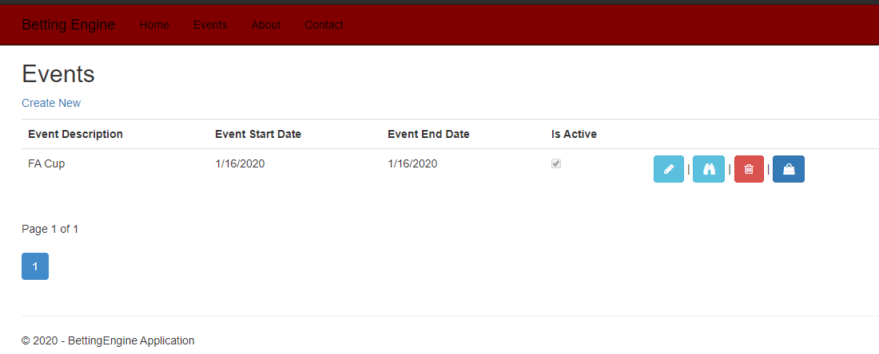

Create new event Page number 1 View markets

## Create Event

This screen allows the user to capture an event

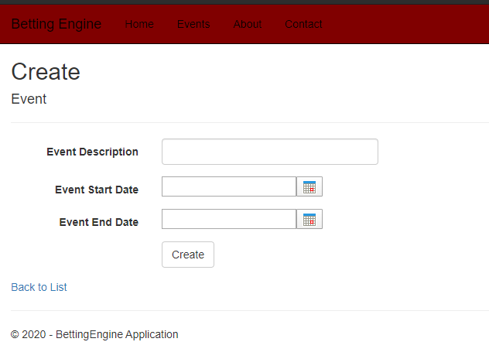

Validations

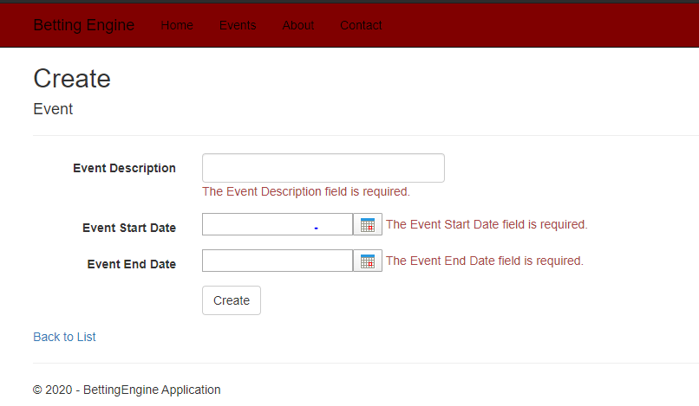

## Edit Event

This page allows a user to edit an event on save the page will redirect to the events landing page

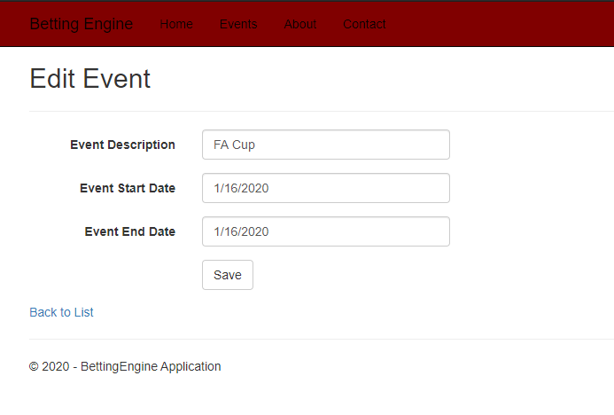

## Events Details

This page allows a user to edit an event or navigate back by clicking “Back to List”

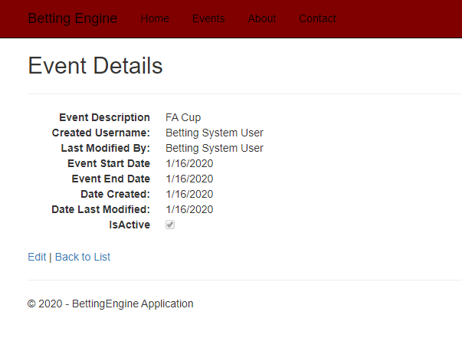

# Delete Event

The button allows a user to delete an event

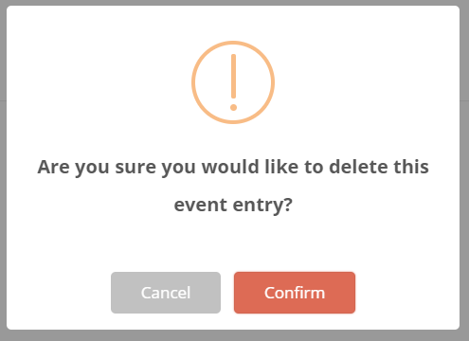

On Confirmation if the event is deleted successfully a user will get the following screen

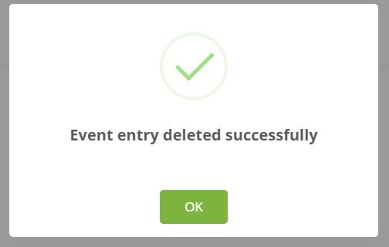

## View Markets

This page is a landing page for markets. It shows a list of all markets for the given event.

On this page the following can be done.

* Create a new Market for the event
* Edit Market and Outcome Probabilities
* Calculate Profit and loss of a particular Market
* Place a new Bet
* Delete the market

Create a new Market Edit Market View Market Details Place a Bet

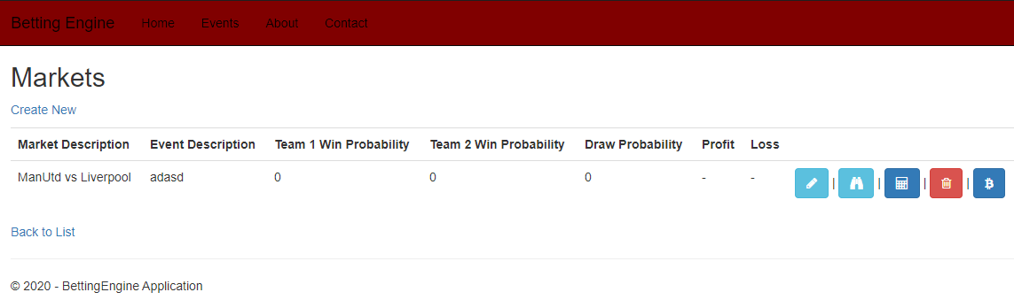

Navigate back to Events landing page Calculate Profit and loss Delete

## Create Market

This page allows a user to create a new market.

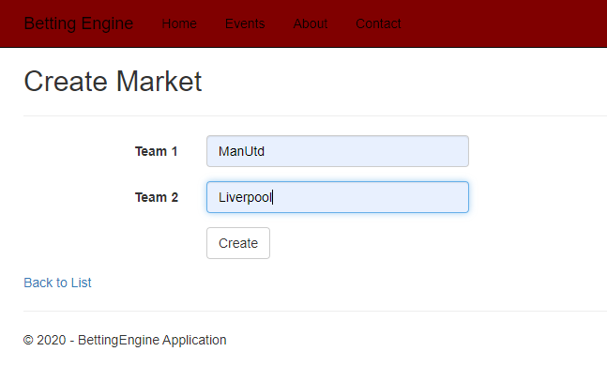

## Edit Market and outcome Probabilities

This page allows a user to edit market and outcome probabilities

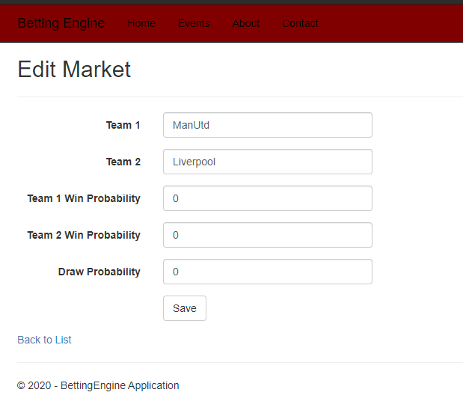

## Market Details

Before bets are placed

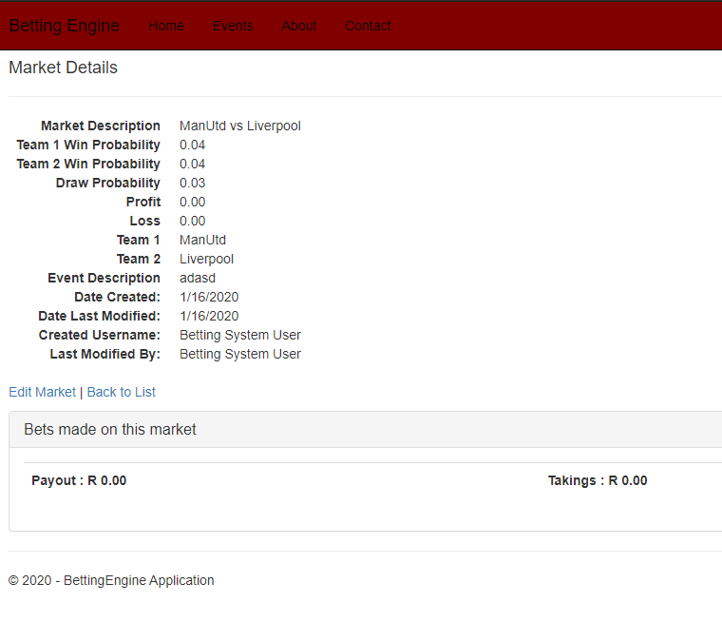

After bets have been placed and calculations have been done

A user can see the Pay-out, Takings and bets that were made as well as Profit and loss

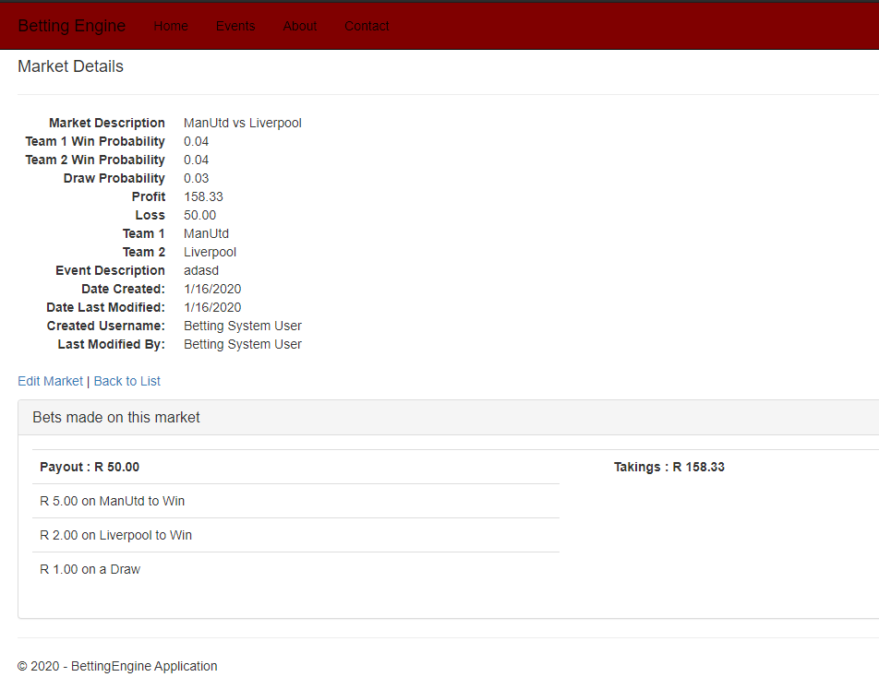

## Place a new bet

This page allows a user to place a new Bet

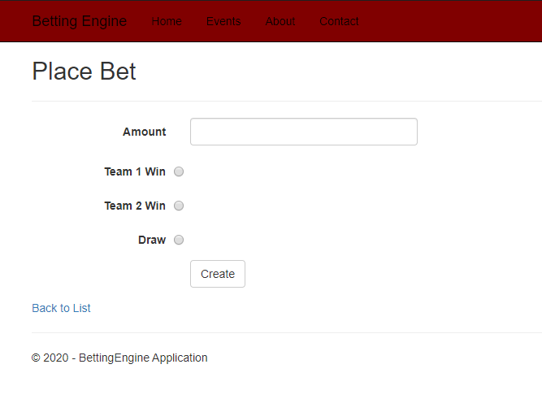

## Calculate Results

