Task 4 — DW/BI Architecture & Categorization
Complete Solutions, Architectural Diagram, Metaphor Analysis & Source Evaluation
1. Item Placement and Justifications
- Item C — Branch POS billing system: Source Systems — It is an operational database captured directly at the point of transaction before entering the data warehouse.
- Item E — HR team's staff Excel sheet: Source Systems — It is an external operational file maintained by a business unit that contains raw employee data.
- Item A — Removing duplicate orders: ETL / Staging — Data cleansing and deduplication occur within the ETL pipeline before loading into the warehouse.
- Item F — Converting CL-150 to Cola 1.5L: ETL / Staging — Mapping cryptic product codes into standardized, human-readable descriptions is a core ETL transformation step.
- Item D — Sales star schema by date, branch, product: Presentation Area — Star schemas with dimensional models are structured specifically for analytical querying in the presentation layer.
- Item H — Finance data mart: Presentation Area — A data mart is a subject-focused subset of the presentation layer organized for business domain analysis.
- Item B — CEO dashboard on a phone: BI Applications — It is an end-user visualization tool that consumes dimensional data to display high-level metrics.
- Item G — Weekly PDF report emailed to managers: BI Applications — It is an automated reporting deliverable distributed to decision-makers from the BI layer.
2. DW/BI Architecture Diagram

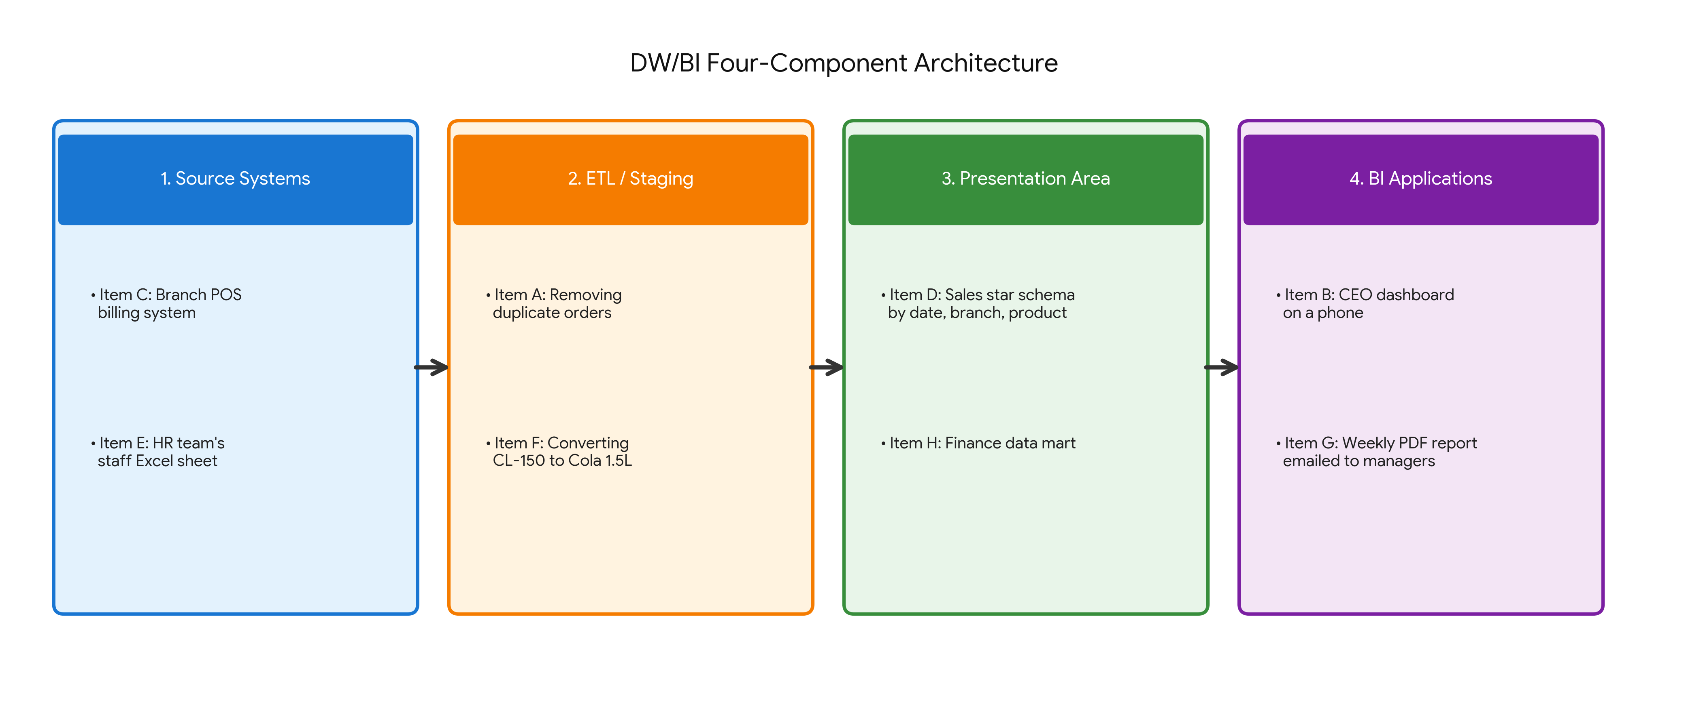
3. Restaurant Metaphor Analysis
Metaphor Mapping:
- Farms:Source Systems (where raw operational data is produced).
- Kitchen:ETL / Staging Area (where raw data is cleaned, prepped, and transformed).
- Serving Counter:Presentation Area (where prepped, dimensional data sits ready for consumption).
- Tables:BI Applications (where end-users consume dashboards and reports).
DW Scenarios:
- Scenario A: A diner wandering into the kitchen to grab food off the stove
- What goes wrong: This represents users directly querying live transactional production databases instead of the warehouse. It slows down operational systems (causing site/POS lag), locks tables, and exposes users to raw, uncleaned, unformatted data.
- Scenario B: The kitchen serving a dish without tasting it
- What goes wrong: This represents ETL pipelines loading data into the presentation area without data quality checks or validation. Bad or corrupted source data enters business reports directly, causing executives to make decisions based on inaccurate metrics.
- Scenario C: Two kitchens cooking the same dish to different recipes
- What goes wrong: This represents isolated data silos where different departments build their own separate ETL processes and logic. It creates conflicting numbers across the company for the exact same metric, destroying the Single Source of Truth.
4. Kimball's Goals & Superstore Case Violations
- Goal 1: Make data easy to access and understand
- Superstore Violation: Storing product codes as cryptic strings like 'CL-150' rather than plain-English descriptions ('Cola 1.5L') forces business users to write complex mapping logic, violating ease of access.
- Goal 2: Present consistent, high-quality information
- Superstore Violation: Having multiple departments report different 'sales last month' figures due to inconsistent metric logic ruins data consistency and trust in reporting.
- Goal 3: Adapt to change smoothly
- Superstore Violation: Silently overwriting Ali’s branch column in the employee database when he moved to Karachi destroyed historical tracking, failing to handle business environment changes properly.
5. Evaluation of HR Team's Staff Excel Sheet (Item E)
- Case FOR treating it as a legitimate source system:
- The Excel sheet contains critical domain-specific metadata (such as staff shift schedules or emergency contacts) that does not exist in any formal ERP or transactional system. Excluding it would leave a gap in HR reporting.
- Case AGAINST treating it as a legitimate source system:
- Spreadsheets lack schema enforcement, audit logs, and access controls. Users can accidentally delete formulas, overwrite history, enter invalid text in date fields, or alter data without oversight, introducing severe data quality risks into the warehouse.
- Final Verdict & Governance Requirements:
- Verdict: I would accept it as a temporary source system only if no central HR system exists, provided strict governance controls are enforced before ingesting it.
- Requirements before trusting it:
1. Form Template & Cell Locking: Standardize the layout and lock cell structure so users cannot change column headers or types.
2. Automated Automated Data Validation in ETL: Reject rows during staging that fail strict type checks (e.g., non-numeric IDs or invalid emails).
3. Designated Ownership & Stored History: Assign a single HR owner responsible for updates and store timestamped snapshots in staging during every load to maintain historical auditability.

