Task 2 — Inmon, Kimball, and the Lifecycle
1. Side-by-Side Comparison
Dimension | Inmon (Top-Down / Corporate Information Factory) | Kimball (Bottom-Up / Dimensional Data Warehouse Bus)
Starting Point | Enterprise-wide data model. You start by modeling all business data across the entire organization into a central repository. | Business process / Data mart. You start by picking one high-value business process (e.g., Sales or Shipments).
Modelling Style | Normalized (3rd Normal Form - 3NF). Data is stored in traditional relational tables to reduce redundancy. | Dimensional (Star / Snowflake Schema). Data is organized into Fact tables surrounded by Dimension tables.
Time to First Value | Slow (Months to Years). Highly complex upfront modeling and ETL setup before users can run queries. | Fast (Weeks to Months). Quick wins by delivering individual data marts iteratively.
Risk | High upfront risk. Expensive and time-consuming; risks failure before delivering business value if scopes drift. | Low upfront risk. Delivers immediate value; risk comes later if shared standards (conformed dimensions) are ignored.
How Consistency is Enforced | Single Central Warehouse. Enforced centrally because all departmental data marts load directly from one normalized EDW. | Conformed Dimensions. Enforced through standardized, shared dimensions (e.g., Date, Customer) across separate data marts.

2. Data Warehouse Architectures & Flow
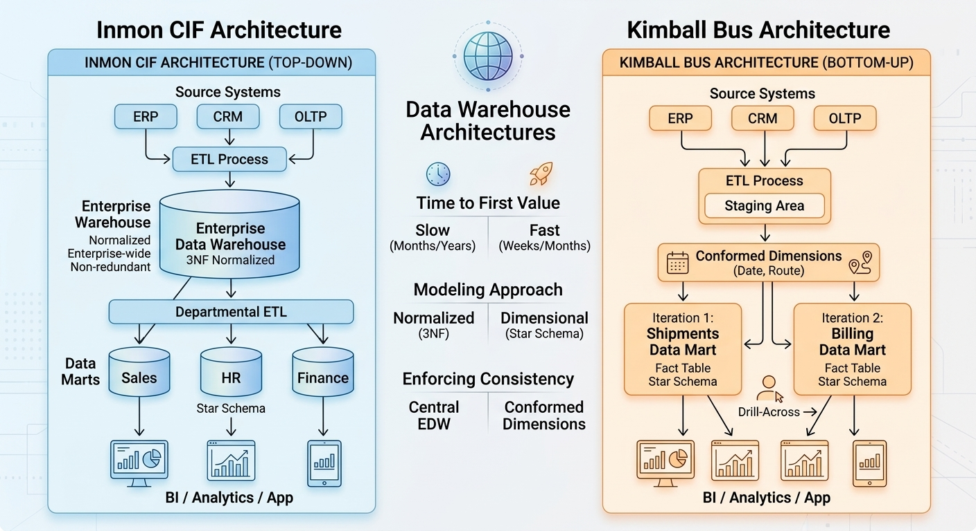

3. Classification of Ten Scenarios
# | Scenario | Classification | Reason
1 | A bank must have one enterprise definition of "customer" before any reporting | Inmon | Requires an enterprise-wide data model and unified single definitions before any reporting can begin.
2 | A startup needs a sales dashboard live within six weeks | Kimball | Prioritizes rapid delivery of a single business process (Sales) to deliver business value quickly.
3 | A hospital group with five systems and a three-year regulatory programme | Inmon | A long-term, multi-system regulatory program requires a centralized, normalized (3NF) core schema for compliance.
4 | PakFreight builds the Shipments mart first, with conformed Date and Route | Kimball | Building an individual process mart (Shipments) using conformed dimensions is the core definition of Kimball's Bus architecture.
5 | A retailer with a normalised core warehouse feeding departmental marts | Inmon | Features a central normalized (3NF) core enterprise warehouse that feeds dependent departmental data marts.
6 | A telecom moving to a lakehouse with bronze, silver and gold layers | Hybrid | Bronze (raw) and Silver (cleansed/normalized) act like Inmon, while Gold (dimensional data marts) acts like Kimball.
7 | A government census programme where the model must be agreed before loading | Inmon | Enterprise-wide governance requires total agreement on the enterprise data model prior to loading any data.
8 | An e-commerce team adding a Returns mart that reuses the existing Product dimension | Kimball | Extends an existing dimensional environment by adding a new data mart (Returns) that reuses a conformed dimension (Product).
9 | A manufacturer who has built six marts and now cannot reconcile them | Failed Kimball / Inmon Solution | Represents uncoordinated stovepipe marts; resolving reconciliation failures requires Inmon-style central governance or proper conformed dimensions.
10 | A bank integrating a newly acquired competitor's systems | Inmon | Merging two distinct corporate systems requires creating a centralized normalized enterprise model to reconcile schema differences.

4. Kimball Lifecycle Applied to PakFreight (Iteration 1: Shipments)
• Business Requirements: Interview logistics managers and operational teams to define key performance metrics for freight delivery (e.g., transit times, on-time delivery rate, delayed shipment counts) and identify essential drill-down attributes.
• Dimensional Modelling: Design a star schema centered around a Fact_Shipments table (containing metrics like weight, cost, delivery duration) and establish conformed dimensions: Dim_Date, Dim_Route, Dim_Customer, and Dim_Driver.
• Physical Design: Set up indexing, partitioning (e.g., partitioning Fact_Shipments by Month or Year based on DateKey), and performance optimization strategies in the target database system.
• ETL Design and Development: Build automated data pipelines to extract raw shipment records, clean missing or invalid values, assign surrogate keys, and populate fact and dimension tables.
• Deployment: Push the Shipments data mart into production, set up automated refresh schedules, train logistics end-users, and establish operational monitoring.
5. Iteration 2 (Billing) & Conformed Dimensions
Two Dimensions to Reuse:
- 1. Dim_Date (Shared Calendar / Timeline Dimension)
- 2. Dim_Customer or Dim_Route (Shared Master Business Entities)
Definition of 'Conformed': A conformed dimension means the dimension table has the exact same structure, domain values, and surrogate keys across different data marts. It ensures that Customer_ID or DateKey in the Shipments Mart means the exact same thing in the Billing Mart, allowing business analysts to write single cross-mart queries (drilling across) without conflicting data definitions or double counting.
6. SDLC vs. CLDS & Data Discovery
Difference between SDLC and CLDS:
• SDLC (Software Development Life Cycle): Requirements-Driven (Requirements → Design → Code → Data). You know what software you are building before you create the database.
• CLDS (Data Warehouse Life Cycle): Data-Driven (Data → Analysis → Requirements → Application). You must first inspect existing source system data to understand what data is actually available, clean, and reliable before defining final business metrics.
Why Requirements are Discovered After Looking at the Data:
Source systems contain hidden bugs, missing fields, unexpected NULLs, and inconsistent formats. A business user might ask for 'Average Delivery Delay,' but until you analyze the actual source data, you won't know if source logs consistently capture actual arrival timestamps versus estimated arrival timestamps.
Example from Freight Files:
When inspecting freight flat files, you might discover that a Delivery_Date field contains text strings like 'N/A' or 'In-Transit' instead of valid dates, or that Weight_KG contains negative numbers. The engineering team must inspect this data first to realize they need a requirement for an exception-handling pipeline or a designated 'Unknown' key in the Date dimension.
7. Final Question Analysis
Question: "We built the Shipments mart first, with conformed Date and Route dimensions." Top-down or bottom-up — and what would have had to be true for the other answer to be right?
Primary Answer: Bottom-Up (Kimball).
Reasoning: Building an individual business process mart (Shipments) first and linking it using shared, standardized dimensions (Date and Route) is the exact definition of Kimball's Data Warehouse Bus Architecture.
What would have to be true for Top-Down (Inmon) to be right?
For Inmon to be the correct answer, the engineering team would have needed to design and populate a centralized 3NF Enterprise Data Warehouse (EDW) containing all enterprise-wide entities first. Only after the central normalized EDW was built would the Shipments mart be created as a downstream, dependent view/extract derived from that normalized core warehouse.

