Research Proposal
Using Controlled In-Plane Lattice Strain to Tune Charge Transfer Between Monolayer MoS₂ and Adsorbed Dyes
A Raman-compatible bending stage for reproducible strain on CVD-grown MoS₂
Musa Ibne Mannan, PhD student
Leem Lab, Department of Mechanical Engineering, The University of Texas at Dallas
Prepared for Prof. Juyoung Leem | 29 October 2026 | Draft for discussion
Related files: 01_Papers (28 PDFs), 03_Literature_Matrix.xlsx, 04_Research_Gap_and_Experiment_Plan.docx in the same project folder.

1. Summary
Charge-transfer (CT) Raman enhancement on 2D semiconductors depends on how the energy levels of an adsorbed molecule line up with the band edges of the 2D layer. Researchers have tuned that alignment with pressure, gate voltage, chemical doping, alloy composition and layer thickness. Each of these either changes the sample, compresses the molecule along with the substrate, or needs electrodes. Controlled in-plane lattice strain, which moves the MoS₂ band edges while the dye layer stays untouched, has not been tested as a CT control in any experiment we found.
We propose to build a four-point bending stage that fits under the lab Raman microscope, apply set, repeatable strain to monolayer MoS₂ carrying a dye layer, and record the dye Raman signal, the MoS₂ Raman modes and the MoS₂ photoluminescence at the same spot at every step. The central question is whether dye CT enhancement on MoS₂ follows the lattice strain in a reversible, dye-specific way once doping is accounted for. The outputs are a calibrated strain device, strain-response curves for two dyes at two lasers, a protocol that separates strain from doping, and a first manuscript.

2. Background

2.1 Charge-transfer enhancement on a flat 2D surface
A flat 2D crystal has no plasmonic hot spots, so most of the Raman gain for a molecule sitting on it comes from the chemical mechanism. An electron moves between a molecular orbital and a band edge of the 2D layer when the laser energy matches that gap (Fig. 1). The closer the system is to that resonance, the larger the gain. Several papers show this directly:
- Plain MoS₂ is the weakest of graphene, h-BN and MoS₂ for CuPc enhancement (Ling et al., 2014), which leaves room for a knob that improves it.
- R6G enhancement on graphene, MoS₂ and WSe₂ tracks the photocurrent measured between R6G and the 2D layer (Lee et al., 2016).
- In WS₂(1−x)Se₂x alloys the R6G 612 cm⁻¹ band rises to a maximum at x = 0.46 and then falls, with an enhancement factor near 1.27 × 10⁶ at the peak (Tang et al., 2023, Fig. 2b). Moving the band edges moved the CT resonance.
- In a diamond anvil cell, R6G on MoS₂/Au showed a maximum degree of CT (ρCT) at 2.39 GPa (Sun et al., 2019, Fig. 5g), and pressure switched monolayer MoS₂ from resonance-dominated to CT-dominated enhancement (Sun et al., 2021).
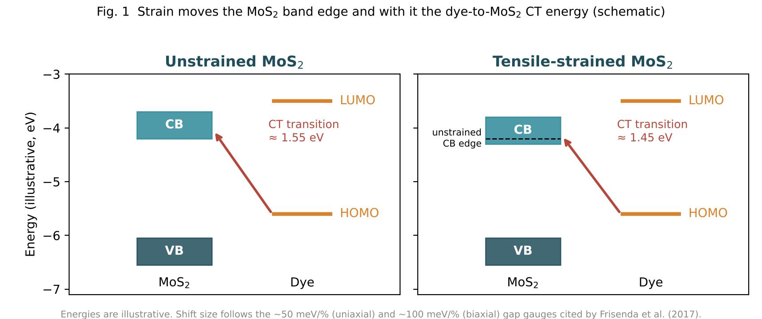
Fig. 1. Concept. Tensile strain lowers the MoS₂ conduction band edge, which changes the energy of the dye-to-MoS₂ CT transition relative to the laser. Energies are illustrative; shift size follows the gap gauges cited by Frisenda et al. (2017).

2.2 What strain does to MoS₂
Tensile strain narrows the optical gap of monolayer MoS₂. Frisenda et al. (2017) cite about 50 meV per % for uniaxial strain and about 100 meV per % for biaxial strain, and their Table 1 gives a measured A-exciton gauge of −51.1 meV per % for MoS₂ on polypropylene and −12.5 meV per % on PDMS. That difference shows how much the substrate controls strain transfer. Under uniaxial strain the MoS₂ E¹₂g mode splits and red-shifts, by about 4.9 and 1.1 cm⁻¹ per % for the two branches in free-standing MoS₂ (Hwang and Suh, 2017). This gives an in-situ strain readout on the flake itself.

2.3 Strain that our CVD films already carry
MoS₂ grown on SiO₂/Si carries about 0.4% biaxial tensile strain and the highest electron density of four substrates tested (Chae et al., 2017, Fig. 3a). Growth temperature changes it (Kataria et al., 2017). Within one flake the E¹₂g position changes from perimeter to centre while A₁g stays uniform, which points to a strain gradient without a matching doping gradient (Luo et al., 2020, Fig. 2c–d). Transfer polymers add strain and doping of their own: PMMA residue gave 0.07% tensile strain with p-doping and polystyrene gave 0.17% compressive strain with n-doping (Bhuyan et al., 2026).

3. Research gap
Fig. 2 summarizes how dye/2D charge transfer has been tuned so far, scored against what a clean test of the substrate's band position needs: the same flake measured repeatedly, the dye left uncompressed, and an effect that acts on CT itself.
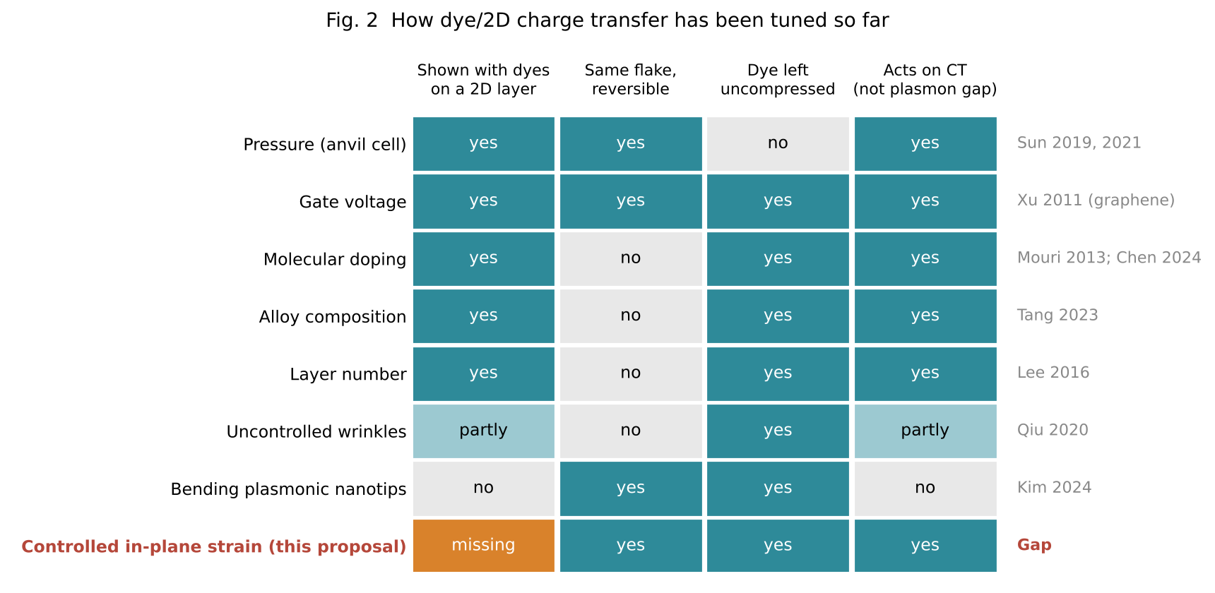
Fig. 2. Each tuning method used in the literature, checked against the conditions for isolating the substrate's band position. Controlled in-plane strain is the only one that meets all of them, and no experiment with dyes has been reported.
- Pressure compresses the dye and the substrate together, so the shift in the dye's own orbitals cannot be separated from the substrate's (Sun et al., 2019; 2021). The same holds for 2D/2D charge transfer under pressure (Kim et al., 2022).
- Alloys, doping and layer number change the sample between data points, which also changes defects and adsorbate coverage (Tang et al., 2023; Chen et al., 2024; Lee et al., 2016).
- Gate voltage tunes CT in place but needs a device with electrodes and showed hysteresis in air (Xu et al., 2011).
- Strain-tuned SERS on MoS₂ exists only through plasmonic gaps: bending a flexible nanotip array changed the enhancement factor of the MoS₂ 2LA mode from 1.23 to 8.72 by changing gap width (Kim et al., 2024). A dye was not involved.
- Wrinkled MoS₂ improved rhodamine B detection, but strain was never measured and the gain was credited to pre-concentration, CT and scattering together (Qiu et al., 2020).
- Theory predicts that strain changes binding and charge transfer between MoS₂ and small molecules such as NO and NH₃ (Kou et al., 2014, Fig. 2), using strains up to 10%, far beyond what experiments apply.
Two recent SERS reviews confirm the opening. Jin et al. (2023) write that the effect of pressure or strain on 2D SERS needs to be understood and then cover pressure studies only. The engineering sections of Tang et al. (2024) cover defects, alloys, thickness, heterojunctions and pressure. The gap we aim to close: there is no experimental measurement of how controlled in-plane lattice strain of a 2D semiconductor changes charge transfer to an adsorbed dye, on the same flake, with the dye uncompressed and plasmonic effects excluded.

4. Objectives and hypotheses
Objectives:
- Build and calibrate a Raman-compatible bending stage that sets strain on monolayer MoS₂ reproducibly between 0 and about 0.8%.
- Measure how dye Raman enhancement, a CT indicator and MoS₂ doping change with measured strain for two dyes and two laser lines.
- Establish a protocol that separates strain, doping and electromagnetic contributions at each measurement point.
- Compare results with DFT of dye/MoS₂ level alignment under strain.
Hypotheses:
- H1. Dye enhancement on MoS₂ changes monotonically and reversibly with in-plane strain at fixed coverage and doping.
- H2. The sign of the change depends on which side of the CT resonance the dye and laser sit, so two dyes or two lasers can respond in opposite directions.
- H3. Built-in growth strain in as-grown flakes accounts for part of the spot-to-spot variation in enhancement.

5. Methodology

5.1 Strain as the controlled variable
The same force produces different strain on substrates of different thickness and stiffness, and the flake may slip on the substrate. Reproducibility therefore comes from setting the deflection with a closed-loop actuator and measuring the strain twice at every step: on the substrate with a foil strain gauge, and on the flake with MoS₂ Raman and PL. Force from a load cell is logged as a secondary record.

5.2 Device design
The stage is a four-point bending fixture (Fig. 3). The actuator pushes two inner rollers up from below while two outer rollers hold the ends from above. The strip bows upward, the top surface (with MoS₂ and dye) is in tension, and the region between the inner rollers has uniform strain and an unobstructed view for the objective. Four-point loading is preferred over three-point because small errors in where the laser lands do not change the strain.
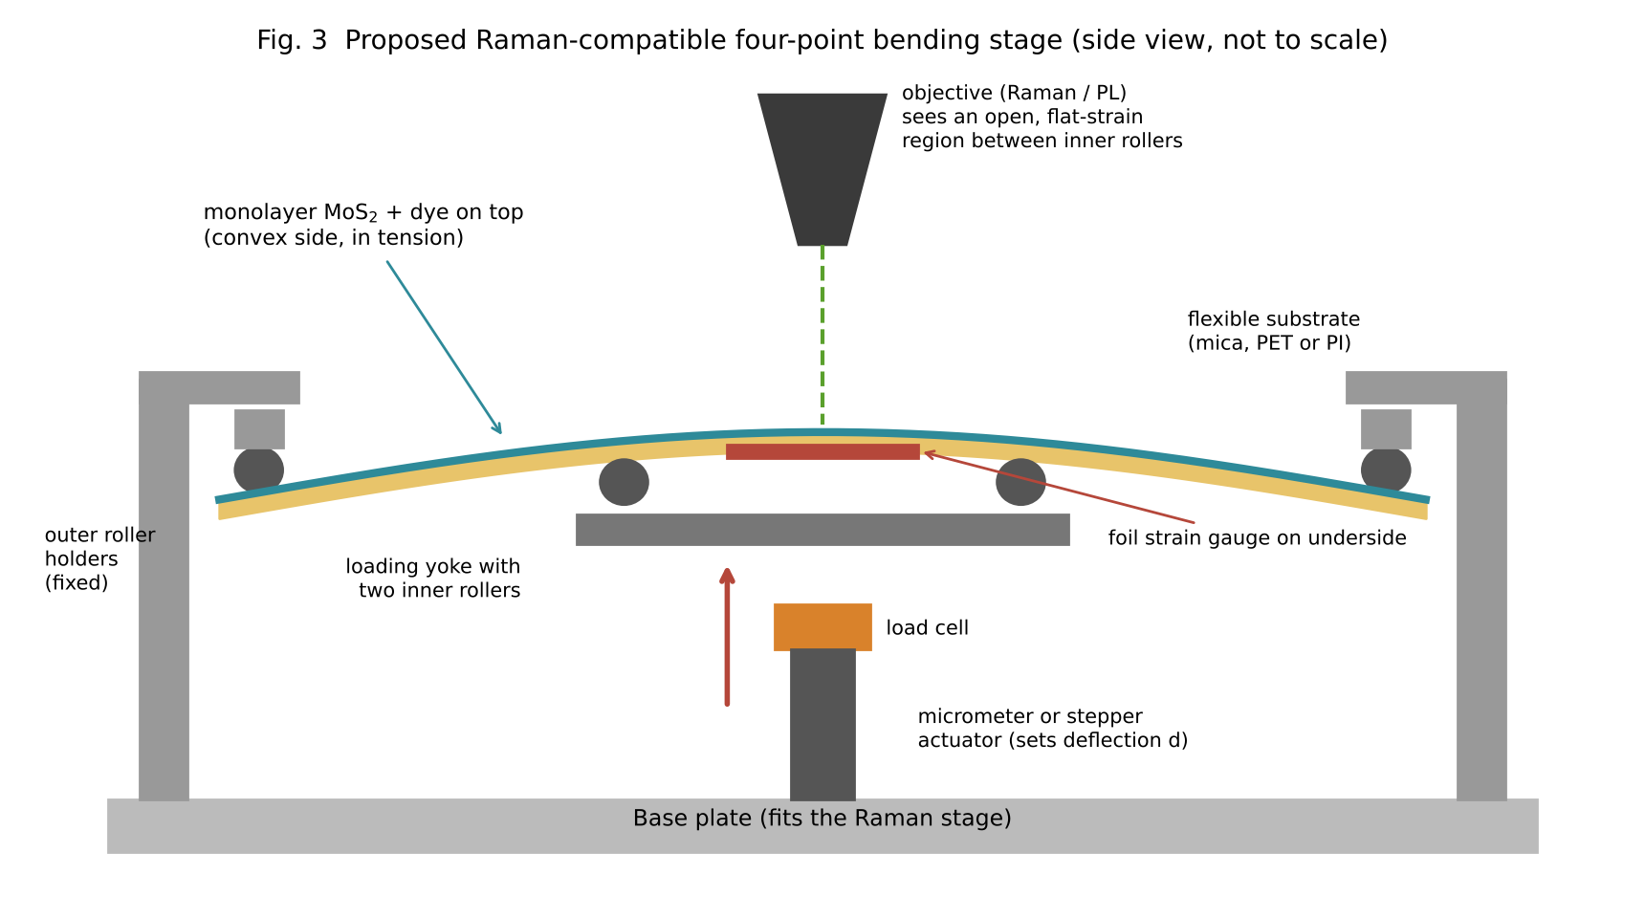
Fig. 3. Proposed Raman-compatible four-point bending stage. Loading from below keeps the strained area facing the objective. A foil strain gauge under the strained region and a load cell under the yoke give independent readings.
Strain on the top surface follows standard beam relations (Fig. 4). For three-point bending the midspan surface strain is ε = 6Dd/L² (ASTM D790), and for four-point bending with the load span at one third of the support span ε = 4.36Dd/L² (ASTM D6272), where D is substrate thickness, d is deflection and L is support span. With L = 20 mm, a 250 µm PET or polyimide strip reaches the 0.2–0.8% range of built-in CVD strain within a few millimetres of deflection. These small-deflection estimates are checked against the gauge and Raman at every step.
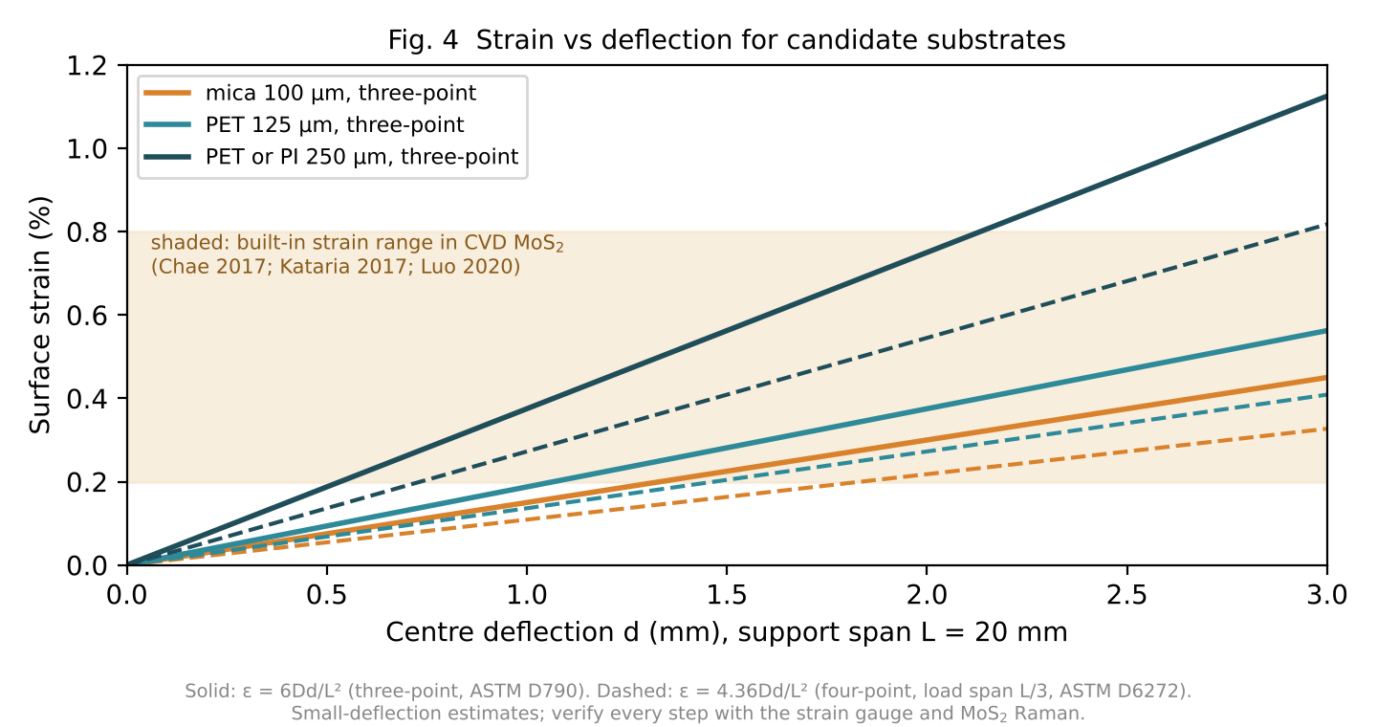
Fig. 4. Design curves for choosing substrate thickness and deflection. The shaded band is the built-in strain range reported for CVD MoS₂, which the stage should be able to match and exceed.
Component | Proposed choice | Purpose
Base and frame | Machined aluminium plate sized for the Raman stage; check objective working distance | Mechanical reference
Rollers | Stainless pins, about 3 mm diameter | Line contacts, low friction
Actuator | Manual micrometer first; stepper with lead screw (Arduino control) or motorized linear actuator next | Sets deflection repeatably
Load cell | Small range (about 10 N) with bridge amplifier | Secondary force log, detects slipping
Strain gauge | Foil gauge bonded under the strained region, bridge amplifier | Independent substrate strain reading
Substrates | Mica (direct growth), PET or polyimide 125–250 µm (transfer) | Flexible carrier for MoS₂
Long-working-distance objective | 50x LWD if available | Clearance above the bent strip

5.3 Samples
- Route A, direct growth on mica. Our APCVD/LPCVD recipe is run on thin muscovite mica, which survives growth temperatures and can be bent. This avoids transfer. Chae et al. (2017) found that MoS₂ couples weakly to mica, so the strain that reaches the flake will be measured on every sample.
- Route B, transfer to PET or polyimide. MoS₂ grown on SiO₂/Si is moved with a polystyrene-based transfer, which Bhuyan et al. (2026) found gave fewer defects than PMMA. Starting strain and doping are recorded before any loading.
- Static reference. As-grown flakes on SiO₂/Si are mapped without the stage, so that perimeter-to-centre strain gradients (Luo et al., 2020) give a first strain series at no cost.

5.4 Dyes and lasers
Probe | Deposition | Reason
R6G | Dip coating from dilute solution (start near 1 µM), rinse, dry; tune for uniform sub-monolayer | Standard MoS₂ SERS probe; 613 and 775 cm⁻¹ bands give a CT indicator (Sun et al., 2019)
CuPc | Thermal evaporation to a fixed thickness, if an evaporator is available | Flat, face-on, non-fluorescent; fixed coverage (Ling et al., 2014)
Methylene blue (optional) | Dip coating | Used in the MoS₂ CT selectivity study (Sun et al., 2021)

Two excitation lines on the same spot (for example 532 and 633 nm, depending on what the lab Raman provides) help separate molecular resonance from CT, and place the dye on different sides of the CT resonance for testing H2.

5.5 Measurement loop
At each strain step the sample rests for a fixed time to let polymer creep settle, then the same marked spot is measured (Fig. 5). Strain is stepped up in about five increments to the maximum and back down, and each flake is cycled at least twice after a few preconditioning cycles.
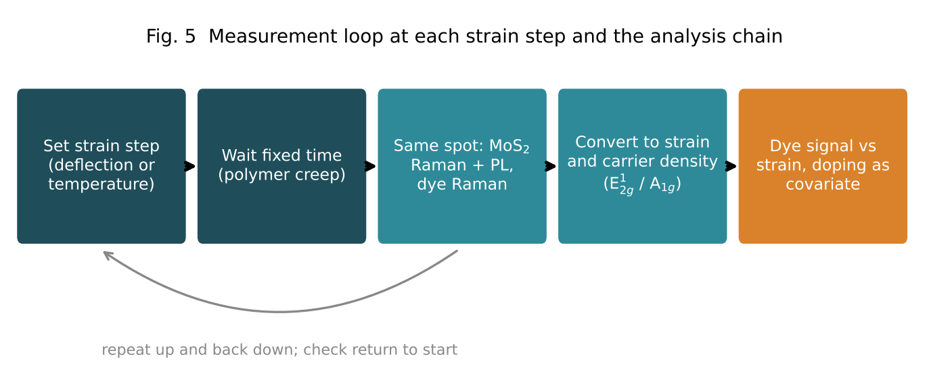
Fig. 5. Measurement loop at each strain step and the analysis chain.
Quantity | How measured | What it tells us
Substrate strain | Foil gauge reading | Applied strain, independent of optics
Flake strain | MoS₂ E¹₂g splitting and shift | Strain actually transferred to MoS₂
Band shift | MoS₂ PL A-exciton energy | Calibrates meV per % on our samples
Carrier density | MoS₂ A₁g position; PL exciton/trion ratio | Doping, including doping from the dye (Mouri, Miyauchi and Matsuda, 2013)
Dye enhancement | Dye peak areas normalized to a substrate reference peak | Main response variable
CT indicator | Ratio of R6G 775 to 613 cm⁻¹ bands | Change in CT contribution, after Sun et al. (2019)
Force | Load cell | Detects slipping or clamping changes

5.6 Controls
- Dye-free MoS₂ on the same stage: separates changes in the substrate background from changes in the dye signal.
- Dye on bare substrate (no MoS₂) under the same bending: rules out the substrate itself changing the dye signal.
- Metal-free samples throughout: keeps electromagnetic enhancement out. Metal particles also strain MoS₂ locally (Sun et al., 2014; 2019b).
- Return-to-zero check after every cycle: the dye and MoS₂ peaks must come back within noise, otherwise coverage changed or the flake slipped.
- Repeated spectra at each step to set the noise floor; low laser power to limit heating and photobleaching.

5.7 Data analysis
- Convert MoS₂ Raman positions to strain and carrier density with the E¹₂g/A₁g correlation approach used by Chae et al. (2017), using our own PL gauge as a check.
- Fit normalized dye intensity against measured strain with carrier density as a covariate, using a mixed model with flake as a random effect so that results from several flakes combine properly.
- Report the slope (change per % strain) with 95% confidence intervals for each dye and laser line, plus loading against unloading residuals as a hysteresis measure.

5.8 Optional biaxial extension
A Peltier stage with PID temperature control and MoS₂ on polypropylene applies biaxial strain through substrate expansion, set and released in seconds (Frisenda et al., 2017). Biaxial strain gives roughly twice the band shift per % of uniaxial strain, which helps if the bending response turns out small. A rigid SiO₂/Si sample heated through the same cycle provides the temperature control.

6. Expected outputs and how we will judge them
Fig. 6 shows the shapes we are looking for in the strain-response data. They illustrate possible outcomes; no data has been taken yet.
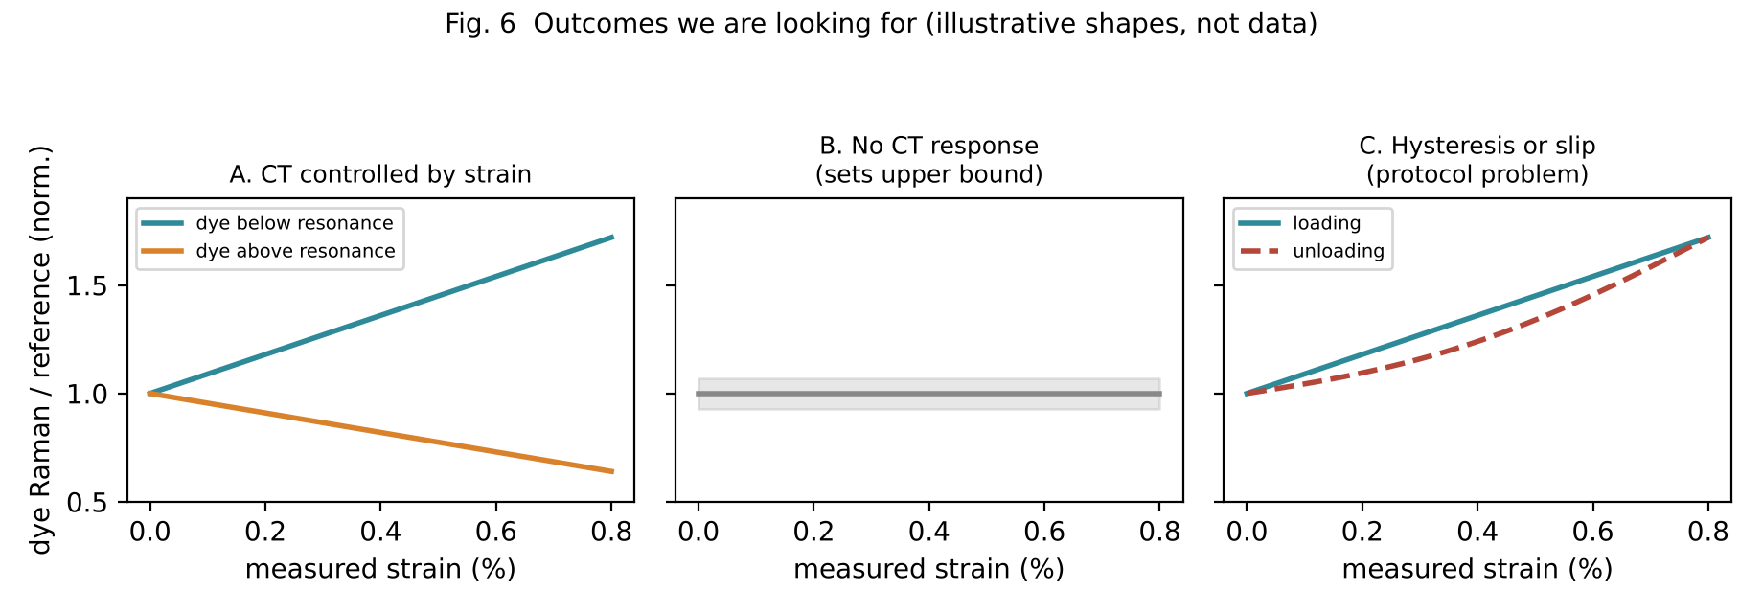
Fig. 6. (A) CT controlled by strain: monotonic, reversible response whose sign depends on dye or laser. (B) No CT response within noise, which still sets an upper bound. (C) Loading and unloading disagree, which points to slipping or creep and a protocol fix.
Output | Measure of success | Decision
Calibrated bending stage | Gauge strain and Raman-derived flake strain agree; repeated cycles at one setpoint return the same strain within noise | Release design files to the lab; proceed to dye work
Strain-response curves (R6G, CuPc; two lasers) | Slope significantly different from zero after doping correction, reversible on unloading, on at least several flakes | Outcome A: confirms H1; write the paper
Opposite-sign responses | Different sign for two dyes or two lasers, as predicted by alignment | Confirms H2; strongest evidence for a CT mechanism
Null result | Slope within noise; report an upper bound per % strain | Outcome B: move to biaxial stage or a dye closer to resonance
Hysteresis | Loading and unloading curves differ beyond noise | Outcome C: improve clamping, add preconditioning, re-run
Strain-doping protocol | Strain and carrier density tracked separately at every point | Method section usable by other groups (Gap C)
Growth-strain correlation | Enhancement varies with perimeter-to-centre strain in as-grown flakes | Supports H3; links furnace parameters to SERS and to the lab's ML synthesis work

Size check: with a uniaxial gap gauge near 45–50 meV per % (Conley et al., as cited by Kataria et al., 2017; Frisenda et al., 2017), 0.5% bending strain moves the band by roughly 25 meV, which is small compared with the few hundred meV spanned by alloying. For that reason the dye and laser should be chosen to sit on the steep side of the CT resonance, and the biaxial option is kept in reserve. Measuring this gauge on our own samples is the first checkpoint of the project.

7. Deliverables and timeline
- A documented, Raman-compatible strain stage (drawings, parts list, control code, calibration data).
- A dataset of strain, doping and dye response for two dyes and two lasers, with analysis scripts.
- A first manuscript; working title: Controlled lattice strain tunes dye charge transfer on monolayer MoS₂.
- Inputs for a DFT collaboration on strained dye/MoS₂ alignment, building on Kou et al. (2014) and Jing et al. (2014).
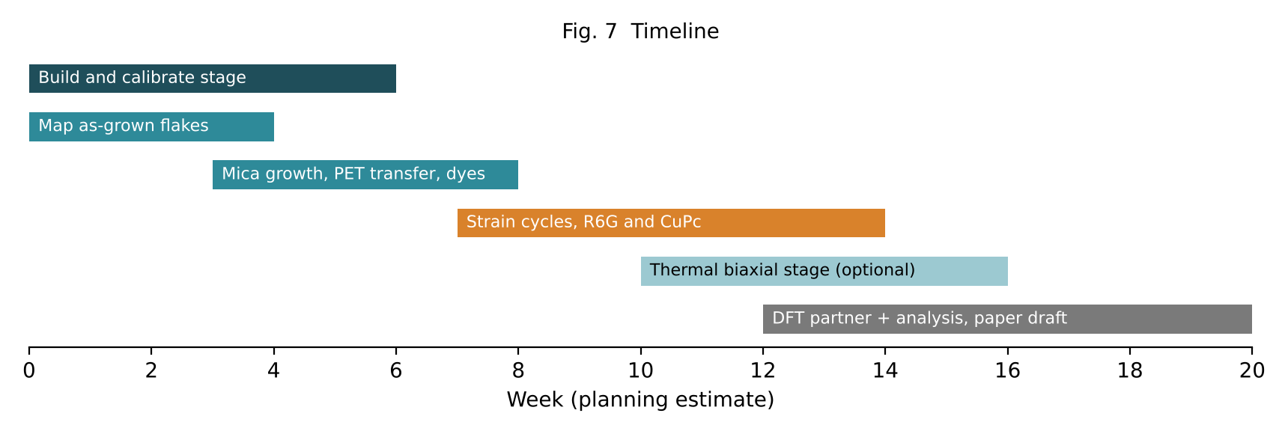
Fig. 7. Timeline in weeks. Durations are planning estimates.

8. Risks and mitigation
Risk | Mitigation
Band shift too small to see | Measure PL gauge first; choose dye and laser on the steep side of resonance; biaxial thermal stage as a backup
Strain and doping change together | Track both at every point; mixed-model analysis with carrier density as covariate
Flake slips on substrate | Load cell and Raman checked at every step; preconditioning cycles; mica route avoids transfer
Dye coverage drifts | Evaporated CuPc for fixed thickness; return-to-zero check; constant ratios between dye peaks
Mica couples weakly to MoS₂ | Compare with transferred PET samples; report transfer efficiency
Objective clearance | Loading from below and an LWD objective; check working distance before machining

References
ASTM International (2017) ASTM D790-17: Standard test methods for flexural properties of unreinforced and reinforced plastics and electrical insulating materials. West Conshohocken, PA: ASTM International.
ASTM International (2017) ASTM D6272-17: Standard test method for flexural properties of unreinforced and reinforced plastics and electrical insulating materials by four-point bending. West Conshohocken, PA: ASTM International.
Bhuyan, C.A. et al. (2026) ‘Evaluation of strain and charge-transfer doping in wet-polymeric transferred monolayer MoS2: implications for field effect transistors’, Advanced Materials Technologies. doi:10.1002/admt.202501920.
Chae, W.H., Cain, J.D., Hanson, E.D., Murthy, A.A. and Dravid, V.P. (2017) ‘Substrate-induced strain and charge doping in CVD-grown monolayer MoS2’, Applied Physics Letters, 111, 143106. doi:10.1063/1.4998284.
Chen, L., Merino, J.P., Torrent-Sucarrat, M., Hou, H.-L. and Prato, M. (2024) ‘Charge transfer-induced SERS enhancement of MoS2/dopants dependent on their interaction difference’, Advanced Materials Interfaces, 11, 2400272. doi:10.1002/admi.202400272.
Frisenda, R. et al. (2017) ‘Biaxial strain tuning of the optical properties of single-layer transition metal dichalcogenides’, npj 2D Materials and Applications, 1, 10. doi:10.1038/s41699-017-0013-7.
Hwang, D.Y. and Suh, D.H. (2017) ‘Evolution of a high local strain in rolling up MoS2 sheets decorated with Ag and Au nanoparticles for surface-enhanced Raman scattering’, Nanotechnology, 28, 025603. doi:10.1088/1361-6528/28/2/025603.
Jin, J. et al. (2023) ‘Spotting the driving forces for SERS of two-dimensional nanomaterials’, Materials Horizons, 10, pp. 1087–1104. doi:10.1039/d2mh01241c.
Jing, Y., Tan, X., Zhou, Z. and Shen, P. (2014) ‘Tuning electronic and optical properties of MoS2 monolayer via molecular charge transfer’, Journal of Materials Chemistry A, 2, pp. 16892–16897. doi:10.1039/c4ta03660c.
Kataria, S. et al. (2017) ‘Growth-induced strain in chemical vapor deposited monolayer MoS2: experimental and theoretical investigation’, Advanced Materials Interfaces, 4, 1700031. doi:10.1002/admi.201700031.
Kim, J.-S. et al. (2022) ‘Strain-modulated interlayer charge and energy transfers in MoS2/WS2 heterobilayer’, ACS Applied Materials & Interfaces, 14, pp. 46841–46849. doi:10.1021/acsami.2c10982.
Kim, Y.B. et al. (2024) ‘Active surface-enhanced Raman scattering platform based on a 2D material–flexible nanotip array’, Biosensors, 14, 619. doi:10.3390/bios14120619.
Kou, L., Du, A., Chen, C. and Frauenheim, T. (2014) ‘Strain engineering of selective chemical adsorption on monolayer MoS2’, Nanoscale, 6, pp. 5156–5161. doi:10.1039/c3nr06670c.
Lee, Y. et al. (2016) ‘Enhanced Raman scattering of rhodamine 6G films on two-dimensional transition metal dichalcogenides correlated to photoinduced charge transfer’, Chemistry of Materials, 28, pp. 180–187. doi:10.1021/acs.chemmater.5b03714.
Ling, X. et al. (2014) ‘Raman enhancement effect on two-dimensional layered materials: graphene, h-BN and MoS2’, Nano Letters, 14, pp. 3033–3040. doi:10.1021/nl404610c.
Luo, S. et al. (2020) ‘Investigation of growth-induced strain in monolayer MoS2 grown by chemical vapor deposition’, Applied Surface Science, 508, 145126. doi:10.1016/j.apsusc.2019.145126.
Mouri, S., Miyauchi, Y. and Matsuda, K. (2013) ‘Tunable photoluminescence of monolayer MoS2 via chemical doping’, Nano Letters, 13, pp. 5944–5948. doi:10.1021/nl403036h.
Qiu, H. et al. (2020) ‘Wrinkled 2H-phase MoS2 sheet decorated with graphene-microflowers for ultrasensitive molecular sensing by plasmon-free SERS enhancement’, Sensors and Actuators B: Chemical, 320, 128445. doi:10.1016/j.snb.2020.128445.
Sun, H. et al. (2019) ‘Pressure-induced SERS enhancement in a MoS2/Au/R6G system by a two-step charge transfer process’, Nanoscale, 11, pp. 21493–21501. doi:10.1039/c9nr07098b.
Sun, H. et al. (2021) ‘SERS selective enhancement on monolayer MoS2 enabled by a pressure-induced shift from resonance to charge transfer’, ACS Applied Materials & Interfaces, 13, pp. 26551–26560. doi:10.1021/acsami.1c02845.
Sun, Y. et al. (2014) ‘Probing local strain at MX2–metal boundaries with surface plasmon-enhanced Raman scattering’, Nano Letters, 14, pp. 5329–5334. doi:10.1021/nl5023767.
Sun, Y. et al. (2019b) ‘Evolution of local strain in Ag-deposited monolayer MoS2 modulated by interface interactions’, Nanoscale, 11, 22432. doi:10.1039/c9nr07599b.
Tang, X. et al. (2023) ‘Alloy engineering allows on-demand design of ultrasensitive monolayer semiconductor SERS substrates’, Nano Letters, 23, pp. 7037–7045. doi:10.1021/acs.nanolett.3c01810.
Tang, X. et al. (2024) ‘Exploring and engineering 2D transition metal dichalcogenides toward ultimate SERS performance’, Advanced Materials, 36, 2312348. doi:10.1002/adma.202312348.
Xu, H. et al. (2011) ‘Modulating the charge-transfer enhancement in GERS using an electrical field under vacuum and an n/p-doping atmosphere’, Small, 7, pp. 2945–2952. doi:10.1002/smll.201100546.
All figures are original schematics or calculations made for this proposal. Figure numbers cited inside the papers (for example Sun et al., 2019, Fig. 5g) point to where the supporting data can be seen in the PDFs in 01_Papers.

