

**LEADING UNIVERSITY**  
**Department of Computer Science and Engineering**

A Final Year Project Submitted in Partial Fulfillment of the Requirement for the Award of the Degree of Bachelor of Computer Science and Engineering.

**PROJECT TITLE:**  
**Blood Donation**

**SUPERVISED BY**  
**Arafat Habib Quraishi**  
**Senior Lecturer, Dept. of CSE**

**AUTHORS:**  
**i. Musa Ibn Ashraf ID. 1512020259**  
**ii. Md. Ashraf Ali ID. 1512020276**  
**iii. Foyazur Rahman ID. 1512020262**

**Approval**

The project is “**Blood Donation**” submitted by Musa Ibn Ashraf, Md.Ashraf Ali, Foyazur Rahman, respectively to the Department of Computer Science and Engineering, Leading University, has been accepted as satisfactory in partial fulfillment for the requirement of the degree of bachelor of Computer Science and Engineering as to its style and content.

**Approved By:**

**---------------------------------------**  
**SUPERVISOR**  
**Arafat Habib Quraishi**  
**Senior Lecturer, Dept. of CSE**

**DECLARATION**

The work herein is original and to the best of our knowledge, it has never been presented anywhere else for academic or any other purpose.

**----------------------------------**  
**Musa Ibn Ashraf**  
**ID: 1512020259**

**----------------------------------**  
**Md. Ashraf Ali**  
**ID**: **1512020276**

**----------------------------------**  
**Foyazur Rahman**  
**ID: 1512020262**

**DEDICATION**

We dedicate this work to all the teachers, students and support staff of the Department of Computer Science and Engineering, at the Leading University, for their tireless and selfless efforts they have spared in making us who we are today. We also dedicate our work to our beloved parents.

To

Head of the Department,

Department of Computer Science & Engineering,

Leading University, Sylhet.

Subject: Application for permission to approve the project proposal

Sir,

With due respect we would like to inform you that we are the students of CSE department, 38th batch. We are interested to develop an Android application of "Blood Donation" for our final year project under your guidance.

So, we therefore pray and hope that you would be kind enough to grant our proposal for the project work.

Your most obediently

Musa Ibn Ashraf (1512020259)

Foyazur Rahman (1512020262)

Md. Ashraf Ali (1512020276)

38th Batch, Department of CSE,

Leading University, Sylhet.

**Project Proposal**

Proposal for the project in partial fulfillment of the requirements for the degree of Bachelor of Science in Computer Science and Engineering.

**Project Title**  
**Blood Donation**

**Project For**

Bachelor Degree in Computer Science and Engineering

**Date of Submission**

21th January 2019

**Expected Date of Completion**

21th January 2018

**SUPERVISOR**

Arafat Habib Quraishi  
Lecturer, Dept. of CSE

**Supervision Agreement**

The program outlined in this project is adequate for the degree of Bachelor of Science in Computer Science and Engineering. The supplies and facilitates required are available and we are willing to supervise and evaluate the project work.

**Supervisor Signature**

**---------------------------------------**  
**SUPERVISOR**  
**Arafat Habib Quraishi**  
**Senior Lecturer, Dept. of CSE**

**Students Signature**

**----------------------------------**  
**(Musa Ibn Ashraf)**

**----------------------------------**  
**(Md. Ashraf Ali)**

**----------------------------------**  
**(Foyazur Rahman)**

**Project Management and Collaboration**

**‘Blood Donation’**

**ACKNOWLEDGEMENT**

Our first and foremost gratitude is to our Almighty Allah who has been with us all along and giving us the strength to complete this project.

We would also like to acknowledge our deepest gratitude to our supervisor Md. Arafat Habib Quraishi, for his guidance, constant attention, valuable suggestion, enthusiastic support and personal concern during the project.

Special thanks go to the Department of Computer Science and Engineering for their permission to use the facilities and equipment available at the Department which aided us to complete this project successfully. We would also like to extend our sincere appreciation to the CSE Department, at the Leading University, for their support carried out for the project.

Special appreciation goes to our loving parents especially our moms who brought us here, and are always on our side, riding along with us on our ups and downs as well as giving us the encouragement to pursue our dreams.

We say a big thank you.

**Abstract:**

The goal of the project is to develop a Android based application named "Blood Donation" which can be accessed via Android(Smartphone). The platform will provide Blood Donors. Blood Donor App puts the power to save lives in the palm of your hand. Donating blood and platelets is easier than ever. This app main aim is to have a society wherein there is no shortage of blood in the most critical situations.

Blood Donation searches, notifies and connect People of blood donors in simple steps Blood donation app ensures hassle free blood donation and privacy of a Connecting blood donors and needy reduces time which increases the possibility of saving lives and also eliminates the shortage of blood.

**Work Plan**

We have followed a proper work plan to complete the project work in due time, we have to maintain a time schedule in months.

**Task Distribution:**

* We distributed our tasks as follows:

**Time Scheduling:**

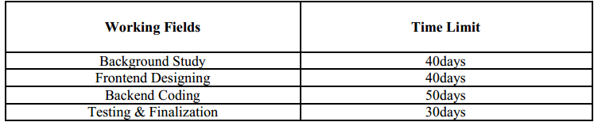

**Work Steps**

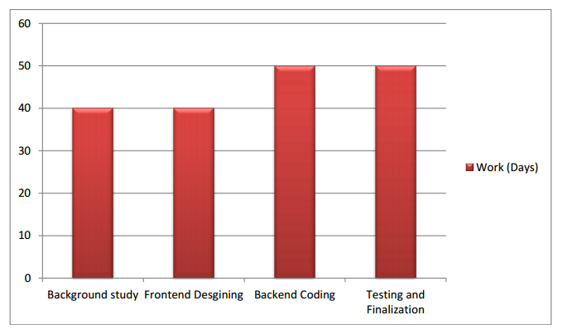

**Details of Work Plan (step):**

**1.Background study**

**2. Frontend Designing**

**3. Backend Coding**

**4. Testing and Finalization**

# **Chapter 1**

# **Introduction**

* 1. **Overview and Motivation:**

Blood Donors is online based project. Today you can easily connect with anything through internet services. So online platform is the best choice for our project. Blood Donors is aims serving for human welfare. We have all the information, you will ever need. Many people are here for you, to help you, willing to donate blood for you anytime. We have done all the job, rest is yours. search the blood group you need. You can help us by registering on Blood Donors if you are willing to donate your blood when needed. As a proud member of Blood Donors and a responsible human being, you can help someone in need. So, donate blood in online.

Person who need to donate blood may register on our App with the help of username and password. The persons who need blood donor, they can search and find blood donors by using our Apps. After searching, a list of donors will be displayed and user can get brief details about their contact details, email including their location, so they can communicate.

* 1. **Objectives**

The Main Objective of this System is to design an Android Application to maintain considerable information of the Patients, Donors, report details for any blood-related organization.

This project is mainly towards persons who are willing to donate blood to the patients. Through this system it will be easier to find a donor for exact blood type and easy to build the connection between donor & the blood bank authorities. The main intend of building this software is to formal the procedure of blood donation & motivate donors in order to donation blood. We have tried to maintain all those information of donor which is easily understandable to the doctors which makes them easy to find the donor.

* 1. **Description**

To develop an Android Mobile Application where blood donors can install the application and register with their name, E-Mail, valid ID, phone number, providing them Navigation for hospitals. And web-application where hospitals request blood bank for blood and blood banks with admin. Admin will send notifications to the users with Hospital details for the user to locate the hospital in their nearby area. The application also keeps a record of the donor’s health record for future reference. Blood seekers can request for blood to the administrator.

This project is mainly towards persons who are willing to donate blood to the patients. Through this system it will be easier to find a donor for exact blood type and easy to build the connection between donor & the blood bank authorities. The main intend of building this software is to formal the procedure of blood donation & motivate donors in order to donation blood. We have tried to maintain all those information of donor which is easily understandable to the doctors which makes them easy to find the donor.

Project has 03( Three) Modules:

1. Admin

2. Donor

3. Acceptor

***Chapter 2***

***Module and Purpose***

**2.1 Modules:**

**Blood Donation Project has 3 Modules-**

**ADMIN :-**  
•Manage Registration for user  
•Manage Blood bank information like (update, delete)  
•Manage Donor Request for Donor  
•Manage patient Request for needy people

**DONOR :-**

From this module user can create their account, when user create his account the user get a user id and password, which identifies him uniquely.  
•Manage Donor information (profile)  
•Add new Donation for Blood

**ACCEPTOR :-**

This module helps user to find blood group. When user click on find a blood group system ask him to enter blood group he want to search. After entering the blood group, system search for the availability of the blood group and give him the list of the donors who has the same blood group.  
•Manage acceptor information(profile)  
•Give the Request for acceptor for blood

**2.3 Purpose:**

This project consists of two parts:

* Users (mobile application)
* Administrator and blood banks (web application)

**2.4 Users (mobile application)**:

* User should register for using this app. With their name, contact no, emailed, blood group etc., after successfully register user can get notification of blood request.
* The user can make a decision on the request whether he accepting the request or ignore the request.
* The user can share that request through facebook, twitter.
* The user can get directions from his current location to blood requesting location (hospital).
* The user can get information if the requesting person got a donor.
* The user can update details.
* The user can get the feedback about blood if they caught any problem in the blood. The user can get information of symptoms, telemedicine link, and doctor details.

**2.5 Administrator and blood banks**:

A web application that can be used by the Admin to add blood requests of the patient after successful login. Admin will fill the details of blood request like patient name, blood group, contact number and choose the patient (hospital) location on the Google map address and latitude and longitude are filled automatically when admin click on a particular location in the map, admin can edit the address.

Immediately after the location selected by admin displaying a list of a donor who is near to that particular location. Admin can increase the radius to get donor list more. If admin submits the form for blood request notifications will send to the donors. If there is any problem find in the blood admin will notify that to the user. Admin can select the donor by mobile number or name or serial number.

***Chapter- 03***

***Software Requirements Analysis***

**3.1 Functional Requirements:**

* Users who have contacts with blood banks,
* Donors will download the application and REGISTER with Email ID, Blood group, phone no., blood group etc.
* Users will send NOTIFICATION to the application users.
* Users can sort-out people who can come in emergency and send a notification to everyone if he gets a donor**.**
* Provide NAVIGATION to the hospital who require blood to reach as soon as possible.
* RECORD of donors information along with their details

**3.2 Software Requirements:**

* Mobile Operating System: Android 2.2 or Later
* Tools (IDE): Eclipse, Neatbeans and Android Studio
* User Interface: XML
* Code Behind: JAVA and XML
* Internet: Yes

**3.3 Hardware Requirements:**

* Android mobile with a minimum version 2.2.
* The processor is not less than 500MHZ.
* RAM is not less than 2048MB.
* SD card with a minimum of 512MB.
* Resolution is not less than 480*800pixs.

***Chapter -4***

***System Design and Diagram***

**4.1 Overview**

An entity-relationship diagram is a Data Modeling technique that creates a graphical representation and the relationships between entities within an information system. An entity-relationship diagram (ERD) is a data modeling technique that graphically illustrates the information system and the relationships between those entities. An ERD is a conceptual and representational model of data used to represent the entity framework infrastructure. An entity is a real-world item or concept that exists on its own. Entities are equivalent to database tables in a relational database, with each row of the table representing an instance of that entity. An attribute of an entity is a particular property that describes the entity. A relationship is the association that describes the interaction between entities. Cardinality, in the context of ERD, is the number of instances of an entity that can or must be associated with each instance of another entity. In general, there may be one-to-one, One-to-many or many-to-many relationships.

* 1. **Relational Modeling Concepts**

When modeling in IBM Congas Framework Manager, it is important to understand that there is no requirement to design your data source to be a perfect star schema. Snowflake and other forms of normalized schemas are equally acceptable as long as your data source is optimized to deliver the performance you require for your application. In general, we recommend that you create a logical model that conforms to star schema concepts. This is a requirement for IBM Congas Analysis Studio and has also proved to be an effective way to organize data for your users. When beginning to develop your application with a complex data source, it is recommended that you create a simplified view that represents how your users view the business and that is designed using the guidelines in this document to deliver predictable queries and results.

**4.3 Implementation**

There have been several attempts to produce a true implementation of the relational database model as originally defined by Coded and explained by Date, Darwin and others, but none have been popular successes so far. Relation is one of the more recent attempts to do this. A recent development is the Object-Relation type-Object model, which is based on the assumption that any fact can be expressed in the form of one or more binary relationships.

The relational model was the first database model to be described in formal mathematical terms. Hierarchical and network databases existed before relational databases, but their Specifications were relatively informal.

**4.4 Symbol**

Rectangles, which represent entity sets

**Figure: Entity Set**

Ellipses, which represent attributes

**Figure: Attributes**

Lines which line attribute entity sets and relationship sets.

**Figure : Many to many relationships**

Double ellipse, which represent multi valued attributes.

**Figure : Multi-valued attributes**

**4.5 Use Case Diagram**

* A use case diagram is a graphic depiction of the interactions among the elements of a system.
* A use case is a methodology used in system analysis to identify, clarify, and organize system requirements.

**Importance of Use Case Diagrams:**

* To identify functions and how roles interact with them – The primary purpose of use case diagrams.
* For a high level view of the system – Especially useful when presenting to managers or stakeholders. You can highlight the roles that interact with the system and the

functionality provided by the system without going deep into inner workings of the

system.

* To identify internal and external factors – This might sound simple but in large complex projects a system can be identified as an external role in another use case.

Use case diagrams consist of 4 objects.

* Actor

  

* Use case
* System
* Package

**Use case Diagram for Blood Donation app:**

**4.6 E-R diagram:**

An entity relationship model, also called an entity-relationship (ER) diagram, is a graphical representation of entities and their relationships to each other, typically used in computing in regard to the organization of data within databases or information systems.

Three main components of an ERD are the entities, which are objects or concepts that can have data stored about them, the relationship between those entities, and the cardinality, which defines that relationship in terms of numbers.

Three main components of an ERD are the entities, which are objects or concepts that can have data stored about them, the relationship between those entities, and the cardinality, which defines that relationship in terms of numbers.

**4.7 E-R diagram Representation**

## Entity

Entities are represented by means of rectangles. Rectangles are named with the entity set they represent.

Donor

Admin

## Attributes

Attributes are the properties of entities. Attributes are represented by means of ellipses. Every ellipse represents one attribute and is directly connected to its entity (rectangle).

**User**

**Email**

**Name**

**Blood Group**

## Relationship

Relationships are represented by diamond-shaped box. Name of the relationship is written inside the diamond-box. All the entities (rectangles) participating in a relationship, are connected to it by a line.

### Binary Relationship and Cardinality

A relationship where two entities are participating is called a **binary relationship**. Cardinality is the number of instance of an entity from a relation that can be associated with the relation.

* **One-to-one** − When only one instance of an entity is associated with the relationship, it is marked as '1:1'. The following image reflects that only one instance of each entity should be associated with the relationship. It depicts one-to-one relationship.

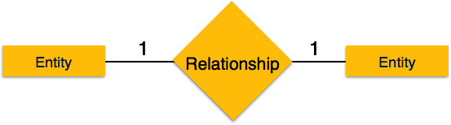

* **One-to-many** − When more than one instance of an entity is associated with a relationship, it is marked as '1:N'. The following image reflects that only one instance of entity on the left and more than one instance of an entity on the right can be associated with the relationship. It depicts one-to-many relationship.

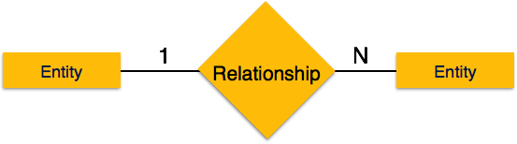

* **Many-to-one** − When more than one instance of entity is associated with the relationship, it is marked as 'N:1'. The following image reflects that more than one instance of an entity on the left and only one instance of an entity on the right can be associated with the relationship. It depicts many-to-one relationship.

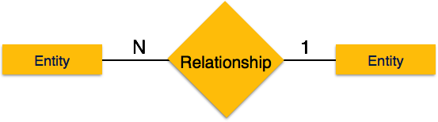

* **Many-to-many** − The following image reflects that more than one instance of an entity on the left and more than one instance of an entity on the right can be associated with the relationship. It depicts many-to-many relationship.

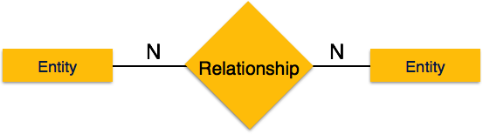

**E-R Diagram of Blood Donation App**

**4.8 Data Flow Diagram**

A data flow diagram (DFD) is a graphical representation of the "flow "of data through an information system, modeling its process aspects. Often they are a preliminary steps used to create an overview of the system which can later be elaborate. DFDs can also be used for the visualization of data processing (structured design). A DFD shows what kinds of data will be input to and output from the system, where the data will come from and go to, and where the data will be stored. Data Flow Diagrams (DFD) helps us in identifying existing business processes. It is a technique we benefit from particularly before we go through engineering. At its simplest, a data flow diagram looks at how data flows through a system. It concerns things like where the data will come from and go to as well as where it will be stored. But you won't find information about the processing timing (e.g. whether the processes happen in sequence or in parallel).

**4.7 Components**

Data flow diagrams are one of the three essential perspectives of the structured-systems analysis and design method SSADM. The sponsor of a project and the end users will need to be briefed and consulted throughout all stages of a system's evolution. With a data flow diagram, users are able to visualize how the system will operate, what the system will accomplish, and how the system will be implemented.

There are four components of a data flow diagram which are the following:

**External entities/ terminators:**

These refer or points to the outside parts ofthe system being developed or modeled. Terminators, depending on whether data flows into or from the system, are often called sinks or sources. They represent the information as wherever it comes from or where it goes.

**Processes:** The processes component modifies the inputs and corresponding Outputs.

**Data stores:**

Refers to any place or area or storage where data will be placedwhether temporarily or permanently.

**Data flows:**

Refers to the way data will be transferred from one terminatorto another, or through processes and data stores.

**4.7 Data flow diagram show**

* + The processes within the system.
  + The data stores supporting the systems operation.
  + The information flows within the system.
  + The system boundary.
  + Interactions with external entities.

**4.8 Rules**

* Each data store must have at least one data flow going into it and one data flow leaving it.
* Each process must have a minimum of one data flow going into it and one data flow leaving it.
* Data A flow out of a process should have some relevance to one or more of the data flows into a process.
* Data stored in a system must go through a process.
* Filing systems within an organization cannot logically communicate with one another unless there is a process involved.
* All processes in DFD must be linked to either another process or a data store.

**Data Flow Diagram:**