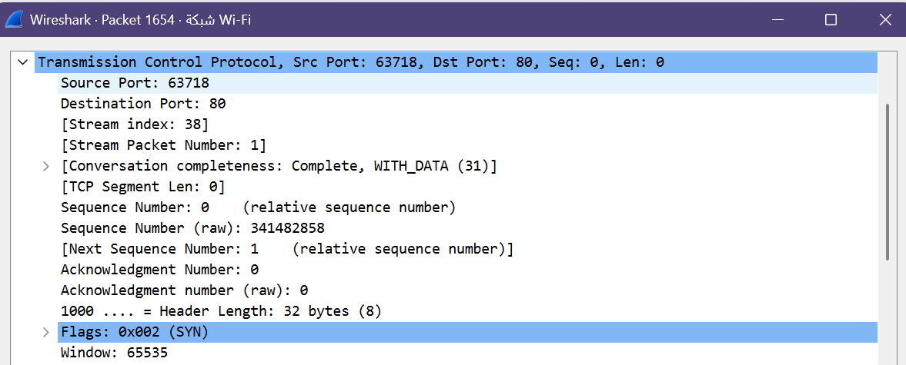

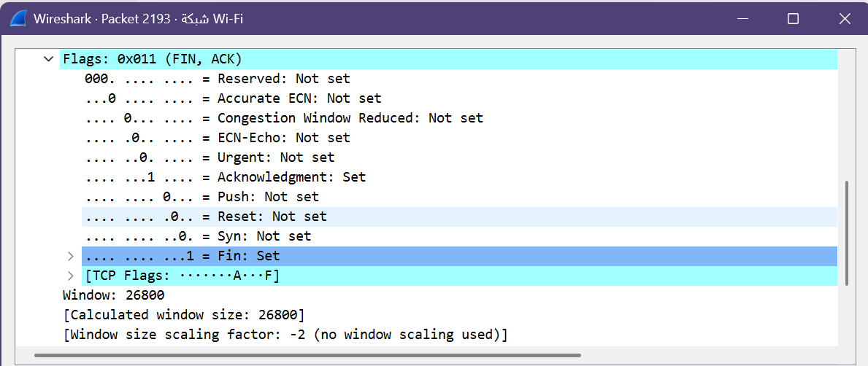

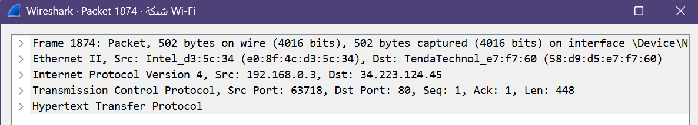

Reasons | TCP or UDP | Aspect
TCP is connection-oriented and requires a 3-way handshake (SYN, SYN-ACK, ACK) to establish a connection before data transfer. It guarantees reliable delivery through acknowledgments (ACKs) and retransmissions. | TCP | Reliability and Connection Establishment
TCP uses Sequence Numbers to reassemble packets in the correct order at the destination and performs error-checking with retransmission of lost packets to ensure data integrity. | TCP | Data Integrity and Ordering

UDP | TCP | Feature
Real-time applications like Video Streaming, Online Gaming, Voice over IP (VoIP), and DNS queries where speed is prioritized over loss tolerance. | Web browsing (HTTP/HTTPS), File transfers (FTP), Email (SMTP/IMAP), and SSH/Telnet where accurate and complete data transfer is critical. | Use Cases
Faster with lower overhead because it is connectionless, does not perform handshakes, and has a smaller header size with no retransmission delays. | Slower with higher overhead due to connection setup (handshake), flow control, error checking, and retransmission mechanisms. | Performance

