Prevalence of Central Obesity in Nigeria; A Systematic Review and Meta-Analysis
M. A. Bashir^{a,*} , A. I. Yahaya^{b}, Mukhtar Muhammad^{c}, A.H. Yusuf^{d}, I.G. Mukhtar^{e}
2021-12-28
^{a,\d}Department of Anatomy, Bayero University Kano, PMB 3011 Kano State, Nigeria
^{e}Department of Physiology, Bayero University Kano, PMB 3011 Kano State, Nigeria
Corresponding author:M.A Bashir^*^ Email: musabashir34@gmail.com
Tel: +2347036878467
Postal Adress: PMB 3011 Kano State, Nigeria.
Declarations of interest: none
ABSTRACT Background Elevated waist circumference results from an excessive accumulation of visceral fat causing an impairment of health. Waist Circumference is highly correlated with diabetes, cardiovascular disease and all-cause mortality. Objectives This study aims to estimate the overall, sex-specific and region-specific prevalence rates of central obesity in Nigeria. Methods Online searches of Google Scholar, PubMed and Scopus were conducted and studies selected based on predefined criteria. Random Effects Model was fitted using inverse variance method with correction using Sidik-Jonkman’s estimator
Results
18 studies consisting of 21859 individuals conducted between 1996 and 2021 were included in the meta-analysis. 39% (95% CI: 25%-54%, I² = 99.3%) of adult Nigerians are centrally obese (by IDF criteria). This translates to estimated 46.8 million centrally obese adult Nigerians. More than half [54% (95% CI:39%-68% )] of adult females are centrally obese. This is four times the prevalence in males [13% (95% CI:5%-24% )]. Although southern regions have higher prevalence of central obesity than northern regions in general (28% vs 21%), the northern regions’ centrally obese are particularly at a substantially more increased risk for cardiovascular disease (48% vs 18%). The overall mean waist circumference in Nigeria is 83.8cm (95% CI: 80.8cm-86.8cm,I² = 99.8%, P value is <0.001 ). Differences in central obesity prevalence rates reflect differences in mean waist circumferences.
Conclusions
Females, Urban residents and individuals living in the northern part of Nigeria have a high burden of central obesity. Public health measures for halting the epidemic of obesity should be targeted at these high risk groups.
Keywords: Obesity, Nigeria, Waist Circumference, Systematic Review, Meta-analysis

1 INTRODUCTION
Obesity is an excessive accumulation of fat in adipose tissue causing an impairment of health^{1,2}. Waist Circumference is a good correlate of abdominal fat and thus used to measure central or abdominal obesity³. The Third Report of the National Cholesterol Education Program (NCEP) Expert Panel on Detection, Evaluation, and Treatment of High Blood Cholesterol in Adults (ATP III) defines central obesity as waist circumference of above 102 cm for males and above 88 cm for females⁴. Definitions of central obesity by the The International Diabetes Federation (IDF) are not only gender-specific but ethnicity-specific as well with Europoids cut off values of above 94 cm for males and above 80 cm for females; these values are recommended for African populations until more data are available⁵. A recent meta-analysis of 288 studies showed that the prevalence of central obesity is rising from 31.3% in the years 1985–1999 to 48.3% in the years 2010–2014 with the prevalence in Africa found to be high (49.7%) even though the region is dominated by low and middle income countries⁶. Waist circumference is correlated to diabetes, cardiovascular disease and all-cause mortality with a 10 cm increase in waist circumference found to be associated with 11% higher risk of all-cause mortality⁷ and development of diabetes⁸. Despite the importance of central obesity, there are no systematic reviews and meta-analyses of the prevalence of abdominal obesity in Nigeria. Females (for biological reasons), urban residents and more economically advanced southern regions may have higher rates of obesity and represent high risk groups⁹. This study aims to estimate: 1. The overall prevalence of central obesity in Nigeria and 2. sex-specific and region-specific prevalence rates of central obesity in the country.

2 METHODOLOGY
The systematic review and meta-analysis was reported according to the Meta-analysis of Observational Studies in Epidemiology (MOOSE) guidelines¹⁰.

2.1 Study Area
Nigeria is a lower middle income¹¹ western African nation with an area of 923,769 sq km, home to more than 250 ethnic groups.¹² It has 36 states and a capital divided into 6 geo-political zones or regions; 3 regions each in the northern and southern parts of the country. The estimated population in 2021 is 211.4 million. 43.4% of the population are under the age of 14 years. 53.9% of the population are between the ages of 15 and 64 years. Only 2.8% of the population are above the age of 65 years.¹³. Supplementary material S1 shows the map of the geopolitical zones of the country.

2.2 Inclusion and Exclusion Criteria
Included in this systematic review are population-based studies in Nigeria conducted in individuals aged 15-65 years. Included studies must use either the IDF or NCEP ATP III criteria for diagnosing central obesity. Only articles in English language were included. Excluded from this review are studies conducted in pregnant women, studies failing to report prevalence of or the criteria used in defining central obesity and all hospital-based studies. Unpublished studies and those with only abstracts available are also excluded.

2.3 Studies Search Strategies
Online databases used were Google Scholar, PubMed and Scopus. Search words and phrases used were: ‘waist circumference,’ ‘central obesity,’ ‘central adiposity’ and ‘abdominal obesity.’ Search was repeated for each word or phrase with the name ‘Nigeria.’ Search was conducted from May 2021 to August 2021. Screening of the abstracts and titles of the articles was done independently by two reviewers (AHY and IGM) and studies selection and exclusion done based on the predefined criteria. Efforts were made to include all available studies including search of references in the included studies. Thereafter, screening of the full-text articles was done independently by the same researchers to select the studies to be included in qualitative and quantitative analyses.

2.4 Quality Appraisal of the Included Studies
The methodological quality of the included studies was assessed using a modification of the Joanna Briggs Institute (JBI) Critical Appraisal Checklist for Studies Reporting Prevalence Data¹⁴. The item’s original 9 questions were reduced to six (6) with questions one (1) and two (2) were given a score of two (2) and the remaining four (4) question each given a score of one (1) for a ‘yes’ and zero (0) for a ‘no.’ The total maximum score is eight(8). A study was judged as good quality if it scored minimum of seven (7), moderate quality if it scored six (6) and of poor quality if it scores less than six (6). Assessment was done independently by two reviewers (AHY and MM) with disagreements sorted by AIH. Supplemental Material S2 shows the modified tool used in critical appraisal of the included studies. Only studies judged as having good or moderate methodological quality were included in the quantitative analysis.

2.5 Data Extraction and Quantitative Analysis
Data extraction was independently done by two reviewers (MAB and IGM). Extracted information from the studies included prevalence of central obesity, mean and standard deviation of the waist circumference, sample size, settlement (urban/rural), state and region of the study, study year, mean age and sex composition of the study participants. Data was entered into Excel and then imported into R statistical environment for statistical computing, version 4.1.0.1¹⁵. Metafor Package¹⁶ was used to fit Random Effects Model for pooling prevalences and Mixed Effects Model for meta-regression using inverse variance method with correction of pooled estimate and its variance using Sidik-Jonkman’s estimator for between study heterogeneity¹⁷.
Heterogeneity between studies will be investigated using meta-regression. Pseudo-R², defined as percentage of explained heterogeneity after fitting the meta-regression model, would be used to estimate the amount of heterogeneity due to study level characteristics.
Prediction Intervals were reported to overcome the difficulties in interpreting both tau² and I² as measures of between study heterogeneity¹⁸

2.6 Publication Bias Assessment
Funnel plot was used to visually inspect for possible publication bias where studies reporting small prevalence were not published and thus not included in the meta-analysis. Formal regression test develooped by Egger and colleagues¹⁹ was employed for testing funnel plot asymmetry.

3 RESULTS

3.1 Search Results
Figure 3.1 shows the results of the search strategy.
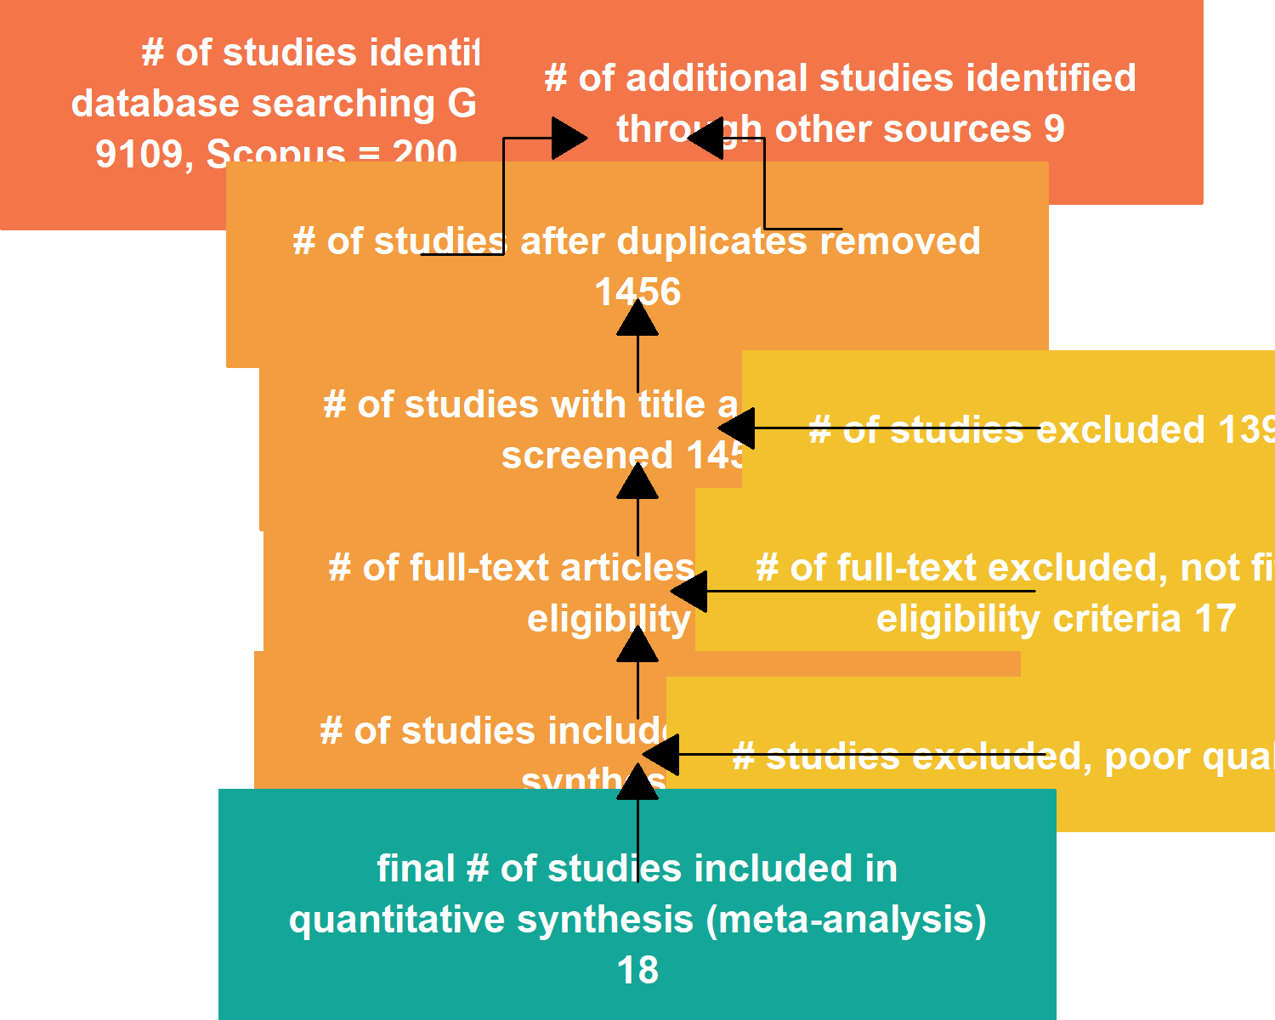
Figure 3.1: Results of the Search
## (gTree[aPhase], gTree[aPhase], gTree[aPhase], gTree[aPhase], gTree[aPhase], gTree[aPhase], gTree[aPhase], gTree[aPhase], gTree[aPhase], gTree[aPhase], curve[GRID.curve.21], curve[GRID.curve.22], move.to[GRID.move.to.23], line.to[GRID.line.to.24], move.to[GRID.move.to.25], line.to[GRID.line.to.26], move.to[GRID.move.to.27], line.to[GRID.line.to.28], move.to[GRID.move.to.29], line.to[GRID.line.to.30], move.to[GRID.move.to.31], line.to[GRID.line.to.32], move.to[GRID.move.to.33], line.to[GRID.line.to.34], move.to[GRID.move.to.35], line.to[GRID.line.to.36])

3.2 Methodological features and the Critical Appraisal of the Included Studies
40 studies were selected and included in the qualitative analysis of methodological features. The quality appraisal of the included studies is shown in the supplemental material S3.

3.3 Characteristics of the Studies Included in the Quantitative Analysis
18 studies consisting of 21859 individuals met the inclusion criteria and are of good or moderate quality and thus included in the meta-analysis. Figure 3.2 showed the mean age, mean sample size, criteria and area of residence of the included studies.
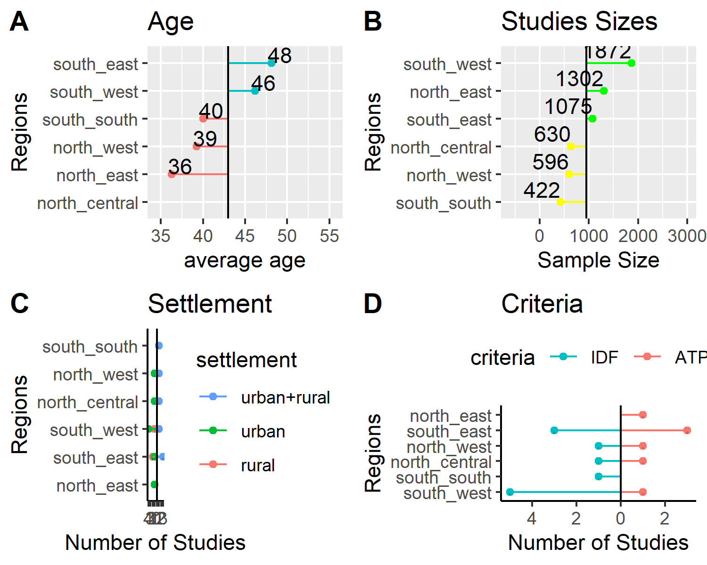
Figure 3.2: Characteristics of the Included Studies

3.4 Fitting the Meta Analytic Models
Random Effects Model was fitted using inverse variance method with correction of pooled estimate and its variance using Sidik-Jonkman’s estimator for between study heterogeneity. Prevalence rates were tranformed using arcsine transformation and means were log transformed. Figure 3.3 shows the forest plot of the models. The pooled prevalence of central obesity under the IDF criteria,39% (95% CI: 25%-54%), is higher than the value of 24% (95% CI: 12%-38%) under the ATP III criteria. The P values for the random meta analytic model is 0.141, the estimated total between studies heterogeneity not explained by sampling error (I²) is 99%. Test for Heterogeneity is significant with p-value<0.001 indicating substantial heterogeneity between the included studies. The prediction interval of the pooled prevalence is 2.2%-73.9%.
The overall mean waist circumference in Nigeria is 83.8cm (95% CI: 80.8cm-86.8cm). The P values for the pooled mean model is <0.001, the estimated total between studies heterogeneity not explained by sampling error (I²) is 99.8%. Test for Heterogeneity is significant with p-value<0.001 indicating substantial heterogeneity between the included studies. The prediction interval of the pooled mean waist circumference is 72.9cm-96.2cm.
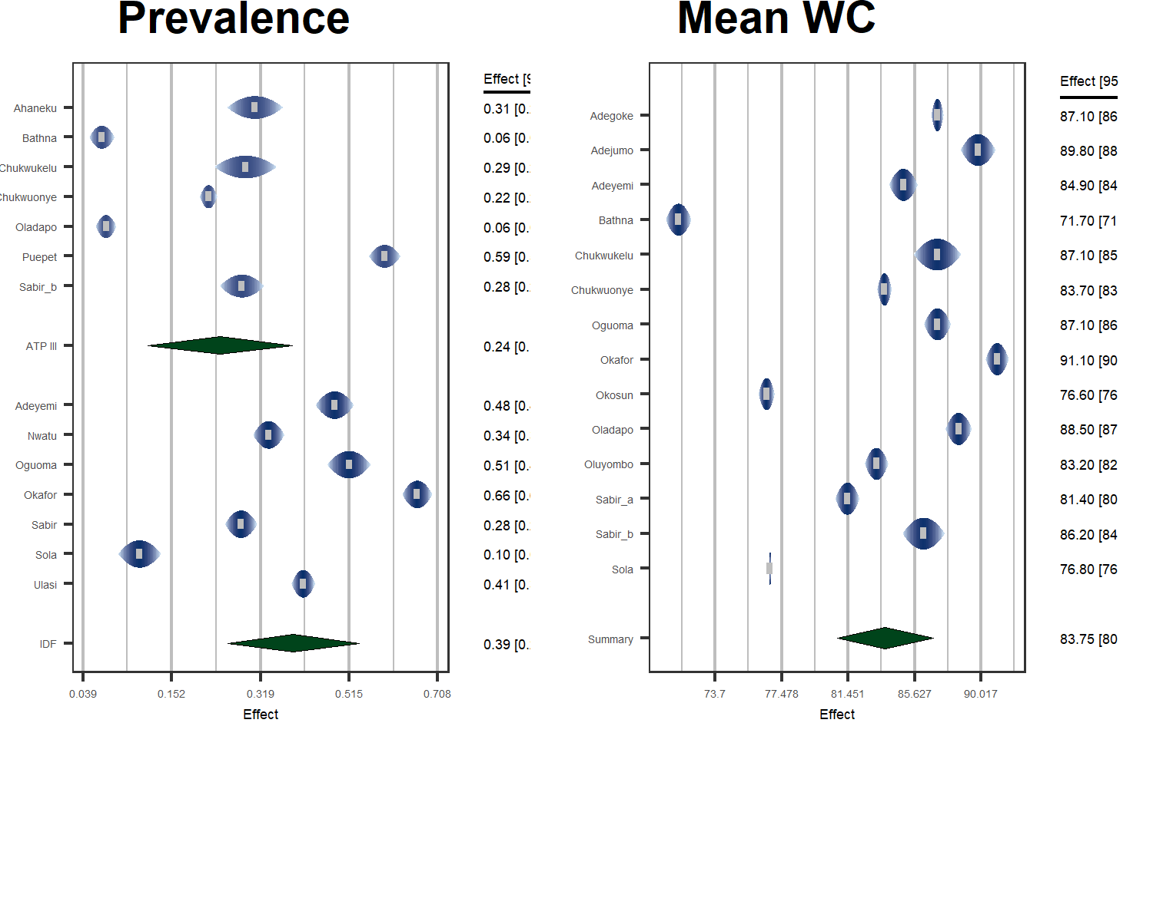
Figure 3.3: forest plots of Pooled Central Obesity and Mean Waist Circumference

3.5 Analysis of Between-Study Heterogeneity
A meta-regression model was fitted using geo-political region, settlement, criteria and participants’ mean age of the included studies. For the prevalence of central obesity prevalence model, value of pseudo-R² after fitting the meta-regression model was 87.3%. The corresponding pseudo-R² for the mean waist circumference was 82%. This means most of the heterogeneity between the studies results from the differences in study characteristics. The relative changes in the two heterogeneity measures (I² and tau²) after fitting the meta-regression models for both pooled prevalence of central obesity and pooled mean waist circumference are shown in Supplemental Material S6. Supplemental Material S7 shows the model coefficients of the meta-regression models.

3.6 Analysis of Publication Bias
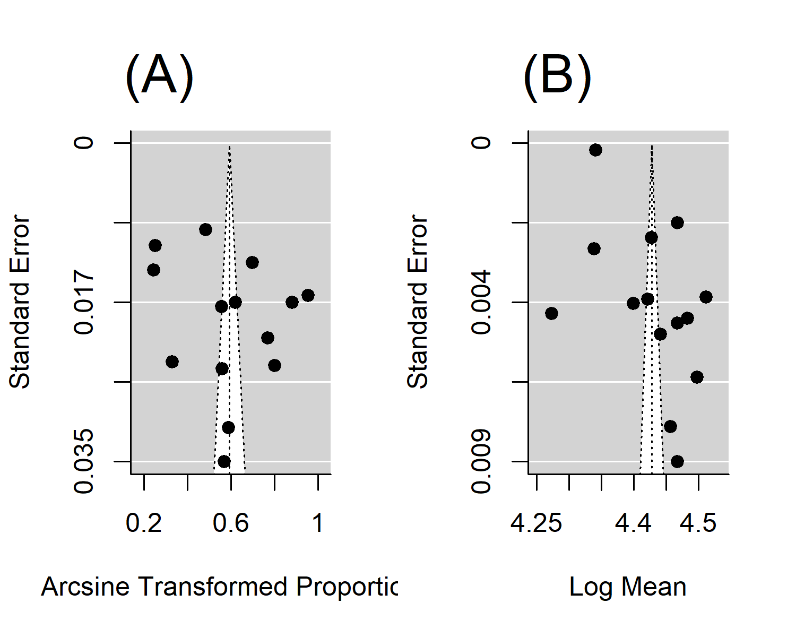
The funnel plots of the pooled prevalence and mean waist circumference models are shown in Figure ??. There was no obvious asymmetry in the plots. Formal test for plot asymmetry (regression test) was conducted and it was not statistically significant (P value is 0.597 and 0.114 for the pooled prevalence rate and mean waist circumference respectively), confirming the visual assessment of the funnel plot.

3.7 Sex-specific and Region-specific Prevalence of Central Obesity
As shown in Table 3.1, Estimates of prevalence under the IDF criteria are consistently higher than estimates under the ATP III criteria. Additionally, females, Urban residents and individuals from the southern regions have consistently higher prevalence rates of central obesity under both ATP III and IDF criteria than their Males, Rural and Northern region residents counterparts.
Table 3.1:
Groups | X | Prevalence..95..CI. | X.1 | I.squared | Pseudo.R.squared | P.value
 | ATP III |  | IDF
Gender
Females | 0.359(0.210-0.523) |  | 0.536(0.392-0.677) | 98.6 | 48.5 | <0.001
Males | 0.085(0.017-0.200) |  | 0.125(0.046-0.235)
Residence
Rural | 0.148(0.021-0.361) |  | 0.279(0.126-0.464) | 99.1 | 1.3 | 0.327
Urban | 0.253(0.094-0.457) |  | 0.449(0.280-0.265)
Regions
Northern | 0.282(0.114-0.490) |  | 0.183(0.031-0.422) | 99.4 | 0.1 | 0.314
Southern | 0.206(0.078-0.374) |  | 0.482(0.318-0.647)

4 DISCUSSION
The overall prevalence of central obesity in Nigeria is high with almost 2 (two) out of every 5 (five) adult Nigerians being centrally obese (by IDF criteria). This translates to estimated 46.8 million centrally obese adult Nigerians. Females are disproportionately afflicted with more than half [54% (95% CI:39%-68% )] being centrally obese. This is four times the prevalence in males [13% (95% CI:5%-24% )]. Southern regions more than twice the prevalence of central obesity than northern regions (48% vs 18%). Metaregression carried out to explain heterogeneity between the studies reduced the tau² by almost 87% but I² barely changed (Supplementary Material S6). This is because the latter is less specific as it is sensitive to sample size²⁰. The prediction intervals for the pooled prevalence of central obesity (2%-74%) is a measure of the precision of any future prevalence study of central obesity in Nigeria.

4.1 Overall Burden of Central Obesity
The higher pooled crude prevalence of central obesity under the IDF criteria (39%) compared to pooled prevalence under the ATP III criteria (24%) is due to the fact that the former criteria uses a lower waist circumference threshold than the latter resulting in higher number of individuals diagnosed with obesity^{4,21}. According to the latest data by the United Nations¹³, this translates to estimated 46.8 million and 28.5 centrally obese individuals in Nigeria under the IDF and ATP III criteria respectively. The two thresholds have been recognized by WHO to represent different levels of cardiovascular risk with the former denoting increased risk and the latter substantially increased risk, at least in Europoid populations². It has also been suggested that the two criteria correspond respectively to BMI levels of overweight (>/= 25kg/m²) and obesity (>/= 30kg/m²)²². The pooled prevalence under the IDF criteria is thus a reflection of prevalence of overweight and obesity. A recent meta-analysis conducted in Nigeria found the combined prevalence of overweight and obesity to be 39.3%²³, which is very close to the prevalence of central obesity under IDF criteria we found in this meta-analysis (39%). The prevalence of central obesity in Nigeria is lower than the global average (41.5%) and the average in the African continent (45.7%) but similar to the average in middle income countries, based on a recent large meta-analysis.⁶
Given the established known risks of central obesity⁷, these numbers represent a potential for increasing burden of diabetes and cardiovascular diseases in the country. Supplementary Material S6 showed the public health impract (as measured by the population attributable fraction, PAF ) due to central obesity based on the prevalence estimates of this meta-analyses and reported relative risk measures for stroke²⁴, myocardial infarction (MI)²⁵ and diabetes²⁶ as reported by other studies. The proportion of stroke, MI and diabetes that could potentially be eliminated from Nigeria through the control of central obesity are 24%, 15% and 21% respectively. Given the Nigeria’s massive infrastructure deficit in healthcare²⁷, the realistic option of controlling the burden of cardiovascular diseases is to invest in public health programs for the prevention of cardiovascular risks. The PAF numbers due to central obesity make the latter a promising targent for public health preventive measures. Nigeria’s government took a necessary step in 2019 by rolling out the National Multi-sectoral Action Plan (NMSAP) for the Prevention and Control of Non-communicable diseases (2019-2025)²⁸. Although this plan is ambitious and has recently secured committment of the Federal Legislatures to enact tax on carbonated beverages²⁹, it is hampered by lack of baseline data necessary for planning, implementation evaluation of its programs. For example, the policy document of the plan did not report a measure of public health impact of any of the established risk factors for non-communicable diseases. For central obesity, not even an estimate of its prevalence was reported in the policy document²⁸. It is difficult to mobilize non-health sectors and non-state actors as envisioned by the plan if the potential impact of reaching the plan’s targets are not clearly stated.

4.2 Sex-specific Prevalence of Central Obesity
The higher prevalence of central obesity among females compared to males (54% versus 13%) is similar to was found in measure of generalized obesity (BMI) in the country²³. This is also a trend observed globally.⁶ In Nigeria, this may be due to the fact that women are less active than men as found in a recent meta-analysis.³⁰ This may explain the higher prevalence in females despite the well-known sexual dimorphism in central obesity where the male hormone, testosterone, favor greater central fat deposition⁹. The contribution of this high prevalence of female central obesity to the burden of stroke, MI and diabetes in Nigeria are 33%, 21% and 29% respectively (Supplemental Material S6). Controlling central obesity in this gender will potentially result in the corresponding decreases in the burden of these diseases. The public health impact of central obesity for males in Nigeria is less pronounced with PAF of less than 5% for MI and PAF of 8% and 7% for stroke and diabetes respectively (Supplemental Material S6)

4.3 Prevalence of Central Obesity by Region and Settlement
The higher prevalence of central obesity in the urban settlements compared to rural areas (45% versus 28%) might be due to the fact that urban residents are less physically active due to access to motorized transport, clerical and mechanized work activity and access to work-saving devices even for home related activities like cooking and laundry. Access to energy dense foods like refined sugar and saturated fats is also higher in urban settlements.² The PAF numbers of central obesity among urban residents mean that almost a quarter (1/4) of stroke and diabetes cases can be eliminated in the urban settlements by eliminating central obesity. For MI, the corresponding proportion is less than one-fifth (1/5). Even among rural dwellers, eliminating central obesity will potentially lead to the reduction of stroke, MI and diabetes by more than 10% (Supplementary Material S6)
The differences between northern and southern regions are more complex. Estimates of IDF criteria, reflecting combination of individuals with increased and those with substantially increased risk for cardiovascular disease, reveal higher prevalence in the southern compared to northern regions (48% versus 8%). This is due to the fact that southern regions have higher levels of socio-economic development and rates of urbanization.^{31,32} The public health impact meaning for these figures in the northern regions is that central obesity accounts for 30% of stroke cases, 18% of myocardial infarction cases and 26% of dibetes cases. The corresponding numbers for the northern regions are 11%, 7% and 10%. However, if ATP III criteria is used, measuring proportion of those at substantially increased risk for cardiovascular disease only, the northern regions have a higher prevalence (28% versus 21%). This means although southern regions have higher prevalence of central obesity in general, the northern regions’ centrally obese are particularly at a substantially more increased risk for cardiovascular disease. This might explain the puzzling finding from a recent multi-center acute coronary sydnrome (ACS) registry study in Nigeria³³. The authors of the study noted with interest the incidence of ACS in the less urbanized northern regions to be almost three times the rates in the socio-economically more advanced southern regions (59 versus 22.2 people per 100 000 hospitalized adult patients per year). This meta-analysis might partly explain the puzzling finding; the proportion of centrally obese at substantially higher risk (as defined by ATP III criteria) is higher in the northern than the southern regions.

4.4 Limitations of the Study
Majority of the included studies are of low methodological quality with subjects not representative of the general population or employing convenient sampling methods. This will have negative effect on the validity of our estimates. However, the quality appraisal of the included studies (Supplemental Material S3) might help in improving the validity as out of the 40 included studies only 18 were judged to be of good methodological quality and included in the quantitative analysis. The study also relied on reported adjusted relative risk measures for stroke, MI and diabetes from case-control studies. Since these are just approximations of true relative risk, our estimates of population attributable fractions will only be approximations.

5 CONCLUSION AND RECOMMENDATIONS
The burden of central obesity in Nigeria is high with 39% of adult Nigerians being centrally obese (by IDF criteria). This means central obesity might be responsible for as much as 24% of stroke cases, 15% of myocardial infarction cases and 21% of diabetes cases in the country. For females these numbers are alarming (33% of stroke cases, 21% of myocardial infarction cases and 29% of diabetes cases); so are numbers for urban residents (27% of stroke cases, 17% of myocardial infarction cases and 24% of diabetes cases). These percentages reflect the burden of diabetes and cardiovascular disease that can be eliminated by eliminating central obesity through effective public health interventions.
The NMSAP for the Prevention and Control of Non-communicable diseases (2019-2025) needs to reflect the burden of central obesity as well its public health impact. Public health impact assessment of risk factors is necessary for both planning (such as targeting high risk groups such as females and urban residents) as well as advocacy in mobilizing non-health sectors and non-state actors for action.
Future population based cohort studies are needed to establish if the differences in the central obesity prevalence rates are related to differences in the prevalence and incidence of diabetes, cardiovascular diseases and all-cause mortality.
1. Lemieux S, Prud’homme D, Bouchard C, Tremblay A, Després JP. Sex differences in the relation of visceral adipose tissue accumulation to total body fatness. The American Journal of Clinical Nutrition. 1993 Oct;58(4):463–7.
2. WHO Consultation on Obesity (1999: Geneva S, Organization WH. Obesity : preventing and managing the global epidemic : report of a WHO consultation [Internet]. World Health Organization; 2000 [cited 2021 Sep 3]. Available from: https://apps.who.int/iris/handle/10665/42330
3. Pouliot MC, Després JP, Lemieux S, Moorjani S, Bouchard C, Tremblay A, et al. Waist circumference and abdominal sagittal diameter: Best simple anthropometric indexes of abdominal visceral adipose tissue accumulation and related cardiovascular risk in men and women. The American Journal of Cardiology. 1994 Mar;73(7):460–8.
4. Expert Panel on Detection, Evaluation, and Treatment of High Blood Cholesterol in Adults. Executive Summary of the Third Report of the National Cholesterol Education Program (NCEP) Expert Panel on Detection, Evaluation, and Treatment of High Blood Cholesterol in Adults (Adult Treatment Panel III). JAMA: The Journal of the American Medical Association. 2001 May;285(19):2486–97.
5. Alberti KGMM, Zimmet P, Shaw J. Metabolic syndromea new world-wide definition. A Consensus Statement from the International Diabetes Federation. Diabetic Medicine. 2006;23(5):469–80.
6. Wong MCS, Huang J, Wang J, Chan PSF, Lok V, Chen X, et al. Global, regional and time-trend prevalence of central obesity: A systematic review and meta-analysis of 13.2 million subjects. European Journal of Epidemiology. 2020;35(7):673–83.
7. Jayedi A, Soltani S, Zargar MS, Khan TA, Shab-Bidar S. Central fatness and risk of all cause mortality: Systematic review and dose-response meta-analysis of 72 prospective cohort studies. BMJ (Clinical research ed). 2020 Sep;370:m3324.
8. Seo D-C, Choe S, Torabi MR. Is waist circumference $≥$102/88cm better than body mass index $≥$30 to predict hypertension and diabetes development regardless of gender, age group, and race/ethnicity? Meta-analysis. Preventive Medicine. 2017 Apr;97:100–8.
9. World Health Organization. Waist circumference and waist-hip ratio : Report of a WHO expert consultation, Geneva, 8-11 December 2008. 2011 [cited 2021 Sep 3]; Available from: https://apps.who.int/iris/handle/10665/44583
10. Stroup DF, Berlin JA, Morton SC, Olkin I, Williamson GD, Rennie D, et al. Meta-analysis of observational studies in epidemiology: A proposal for reporting. Meta-analysis Of Observational Studies in Epidemiology (MOOSE) group. JAMA. 2000 Apr;283(15):2008–12.
11. WDI - The World by Income and Region [Internet]. [cited 2021 Dec 23]. Available from: https://datatopics.worldbank.org/world-development-indicators/the-world-by-income-and-region.html
12. Udo KR, Ajayi JFA, Kirk-Greene AHM, Falola TO. Nigeria. Encyclopedia Britannica [Internet]. 2020 [cited 2021 Jul 5]; Available from: https://www.britannica.com/place/Nigeria
13. UNFPA - United Nations Population Fund. UNFPA - United Nations Population Fund [Internet]. 2021 [cited 2021 Jul 5]. Available from: https://www.unfpa.org/
14. Joanna Briggs Institute. Joanna Briggs Institute Critical Appraisal Checklist for Prevalence Studies [Internet]. Joanna Briggs Institute; 2017. Available from: https://jbi.global/sites/default/files/2019-05/JBI_Critical_Appraisal-Checklist_for_Prevalence_Studies2017_0.pdf
15. R Core Team. R: A language and environment for statistical computing [Internet]. Vienna, Austria: R Foundation for Statistical Computing; 2021 [cited 2021 Jun 16]. Available from: https://www.r-project.org/
16. Viechtbauer W. Conducting meta-analyses in with the metafor package. Journal of Statistical Software [Internet]. 2010;36(3):1–48. Available from: https://doi.org/10.18637/jss.v036.i03
17. Sidik K, Jonkman JN. On Constructing Confidence Intervals for a Standardized Mean Difference in Meta-analysis. Communications in Statistics - Simulation and Computation. 2003 Jan;32(4):1191–203.
18. Borenstein M, Higgins JPT, Hedges LV, Rothstein HR. Basics of meta-analysis: I ² is not an absolute measure of heterogeneity: I ² is not an absolute measure of heterogeneity. Research Synthesis Methods. 2017 Mar;8(1):5–18.
19. Egger M, Davey Smith G, Schneider M, Minder C. Bias in meta-analysis detected by a simple, graphical test. BMJ (Clinical research ed). 1997 Sep;315(7109):629–34.
20. Harrer M, Cuijpers P, Furukawa TA, Ebert DD. Doing Meta-Analysis with R: A Hands-On Guide [Internet]. First. 2021 [cited 2021 Jul 25]. Available from: https://www.routledge.com/Doing-Meta-Analysis-with-R-A-Hands-On-Guide/Harrer-Cuijpers-Furukawa-Ebert/p/book/9780367610074
21. Alberti Kgmm, Eckel RH, Grundy SM, Zimmet PZ, Cleeman JI, Donato KA, et al. Harmonizing the Metabolic Syndrome. Circulation. 2009 Oct;120(16):1640–5.
22. Lean MEJ, Han TS, Morrison CE. Waist circumference as a measure for indicating need for weight management. BMJ. 1995 Jul;311(6998):158–61.
23. Adeloye D, Ige-Elegbede JO, Ezejimofor M, Owolabi EO, Ezeigwe N, Omoyele C, et al. Estimating the prevalence of overweight and obesity in Nigeria in 2020: A systematic review and meta-analysis. Annals of Medicine. 2021;53(1):495–507.
24. Owolabi MO, Sarfo F, Akinyemi R, Gebregziabher M, Akpa O, Akpalu A, et al. Dominant modifiable risk factors for stroke in Ghana and Nigeria (SIREN): A case-control study. The Lancet Global health. 2018 Apr;6(4):e436–46.
25. Yusuf S, Hawken S, Ôunpuu S, Dans T, Avezum A, Lanas F, et al. Effect of potentially modifiable risk factors associated with myocardial infarction in 52 countries (the INTERHEART study): Case-control study. The Lancet. 2004 Sep;364(9438):937–52.
26. Freemantle N, Holmes J, Hockey A, Kumar S. How strong is the association between abdominal obesity and the incidence of type 2 diabetes? International Journal of Clinical Practice. 2008 Sep;62(9):1391–6.
27. Alkali NH, Bello MR. Tertiary hospital standards in Nigeria: A review of current status. Annals of African Medical Research. 2020 Sep;3(1).
28. Nigeria Federal Ministry of Health. National Multi-Sectoral Action Plan for the Prevention and Control of Non-Communicable Diseases (2019 2025) | ICCP Portal [Internet]. 2019 [cited 2021 Dec 28]. Available from: https://www.iccp-portal.org/national-multi-sectoral-action-plan-prevention-and-control-non-communicable-diseases-2019-%E2%80%93-2025
29. ‘NASS supports tax for carbonated drinks’ [Internet]. The Nation Newspaper. 2021 [cited 2021 Dec 28]. Available from: https://thenationonlineng.net/nass-supports-tax-for-carbonated-drinks/
30. Adeloye D, Ige-Elegbede JO, Auta A, Ale BM, Ezeigwe N, Omoyele C, et al. Epidemiology of physical inactivity in Nigeria: A systematic review and meta-analysis. Journal of Public Health. 2021 May;(fdab147).
31. Aliyu AA, Amadu L. Urbanization, Cities, and Health: The Challenges to Nigeria A Review. Annals of African Medicine. 2017;16(4):149–58.
32. Mayah E, Mariotti C, Mere E, Odo CO. Inequality in Nigeria: Exploring the Drivers [Internet]. Oxfam International; 2017 [cited 2021 Sep 12] p. 56. Available from: https://www-cdn.oxfam.org/s3fs-public/file_attachments/cr-inequality-in-nigeria-170517-en.pdf
33. Isezuo S, Sani MU, Talle A, Johnson A, Adeoye A-M, Ulgen MS, et al. Registry for Acute Coronary Events in Nigeria (RACE-Nigeria): Clinical Characterization, Management, and Outcome. Journal of the American Heart Association. 0(0):e020244.
34. Adamu H, Makusidi M, Liman H, Isah B, Jega M, Chijioke A. Prevalence of Obesity, Diabetes Type 2 and Hypertension among a Sampled Population from Sokoto Metropolis-Nigeria. British Journal of Medicine and Medical Research. 2014 Jan;4:2065–80.
35. Adediran O, Akintunde AA, Edo AE, Opadijo OG, Araoye AM. Impact of urbanization and gender on frequency of metabolic syndrome among native Abuja settlers in Nigeria. Journal of Cardiovascular Disease Research. 2012;3(3):191–6.
36. Adegoke OA, Adedoyin RA, Balogun MO, Adebayo RA, Bisiriyu LA, Salawu AA. Prevalence of Metabolic Syndrome in a Rural Community in Nigeria. Metabolic Syndrome and Related Disorders. 2010 Feb;8(1):59–62.
37. Adegoke O, Ozoh OB, Odeniyi IA, Bello BT, Akinkugbe AO, Ojo OO, et al. Prevalence of obesity and an interrogation of the correlation between anthropometric indices and blood pressures in urban Lagos, Nigeria. Scientific Reports. 2021 Dec;11(1):3522.
38. Adejumo EN, Adejumo AO, Azenabor A, Ekun AO, Enitan SS, Adebola OK, et al. Anthropometric parameter that best predict metabolic syndrome in South west Nigeria. Diabetes & Metabolic Syndrome: Clinical Research & Reviews. 2019 Jan;13(1):48–54.
39. Adejumo EN, Adefoluke JD, Adejumo OA, Enitan SS, Ladipo OA. Cardiovascular risk factors among staff of a private university in South-west Nigeria. The Nigerian Postgraduate Medical Journal. 2020 Apr-Jun;27(2):127–31.
40. Adeoye AM, Adebiyi A, Owolabi MO, Lackland DT, Ogedegbe G, Tayo BO. GENDER DISPARITY IN BLOOD PRESSURE LEVELS AMONG NIGERIAN HEALTH WORKERS. Journal of clinical hypertension (Greenwich, Conn). 2016 Jul;18(7):685–9.
41. Adeyemi YA, Onabanjo OO, Sanni SA, Ugbaja RN, Afolabi DO, Oladoyinbo CA. Prevalence of metabolic syndrome among apparently healthy adults in Ogun state, Nigeria. Nutrition & Food Science. 2017 Nov;47(6):780–94.
42. Ahaneku G, Ahaneku J, Osuji C, Oguejiofor C, Anisiuba B, Opara P. Lipid and Some Other Cardiovascular Risk Factors Assessment in a Rural Community in Eastern Nigeria. Annals of Medical and Health Sciences Research. 2015;5(4):284–91.
43. Ayogu RNB, Nwajuaku C, Udenta EA. Components and Risk Factors of Metabolic Syndrome among Rural Nigerian Workers. Nigerian Medical Journal : Journal of the Nigeria Medical Association. 2019;60(2):53–61.
44. Babatunde OA, Olarewaju SO, Adeomi AA, Akande JO, Bashorun A, Umeokonkwo CD, et al. 10-year risk for cardiovascular diseases using WHO prediction chart: Findings from the civil servants in South-western Nigeria. BMC Cardiovascular Disorders. 2020 Mar;20:154.
45. Bathna SJ. Waist-hip ratio, body mass index, physical activity and the risk of diabetes mellitus in Gombe State, Northeast Nigeria. International Research Journal of Medicine and Medical Sciences. 2017;08(04).
46. Bello-Ovosi BO, Asuke S, Abdulrahman SO, Ibrahim MS, Ovosi JO, Ogunsina MA, et al. Prevalence and correlates of hypertension and diabetes mellitus in an urban community in North-Western Nigeria. The Pan African Medical Journal. 2018 Jan;29:97.
47. Bolaji OF, Oluwafemi AJ, Wahab OA, Cecilia AAi, Tope AE, Oluwatoyin JF, et al. Second to Fourth Digit Ratio (2D: 4D) as a Predictor of Adult Circulating Sex Hormones and Overweight/Obesity in Ado-Ekiti Nigeria. Biomedical and Environmental Sciences. 2018 Jul;31(7):539–44.
48. Casmir EA, Amam CM, Obianuju BO, Tim PG, David AW, Oyewole AK, et al. Prevalence of cardiometabolic risk factors among professional male longdistance bus drivers in Lagos, southwest Nigeria: A crosssectional study. Cardiovascular Journal of Africa. 2018;29(2):106–14.
49. Chukwukelu EE, Ogbu ISI, Onyeanusi CJ. Prevalence Of Metabolic Syndrome In Some Urban And Rural Communities In Enugu State, Nigeria. The Internet Journal of Laboratory Medicine [Internet]. 2013 Sep [cited 2021 Jul 21];5(1). Available from: http://ispub.com/IJLM/5/1/14546
50. Chukwuonye IC, Chuku A, Onyeonoro UU, Okpechi IG, Madukwe OO, Umeizudike TI, et al. Prevalence of abdominal obesity in Abia State, Nigeria: Results of a population-based house-to-house survey. Diabetes, Metabolic Syndrome and Obesity: Targets and Therapy. 2013 Aug;6:285–91.
51. Egbi OG, Rotifa S, Jumbo J. Prevalence of hypertension and its correlates among employees of a tertiary hospital in Yenagoa, Nigeria. Annals of African Medicine. 2015 Jan;14(1):8.
52. Ejike CE, Ijeh II. Obesity in young-adult Nigerians: Variations in prevalence determined by anthropometry and bioelectrical impedance analysis, and the development of % body fat prediction equations. International Archives of Medicine. 2012 Jul;5:22.
53. EPITOOLS. Epitools - Sample size to estimate a proportion or appar ... [Internet]. [cited 2021 Jul 28]. Available from: https://epitools.ausvet.com.au/oneproportion
54. Ezekwesili CN, Ononamadu CJ, Onyeukwu OF, Mefoh NC. Epidemiological survey of hypertension in Anambra state, Nigeria. Nigerian Journal of Clinical Practice. 2016 Jan;19(5):659.
55. Gezawa I, Puepet F, Mubi B, Talle M, Haliru I, Uloko A, et al. Socio-demographic and Anthropometric risk factors for Type 2 diabetes in Maiduguri, North-Eastern Nigeria. Sahel Medical Journal. 2015;18(5):1.
56. Gwarzo I Mukhtar, Wali N, Ahmed Ibrahim S. Correlation of Anthropometric Indices with Fasting Blood Glucose and Blood Pressure Among University Students in Kano, Nigeria. 2020 Oct;17:128–34.
57. Joseph-Shehu EM, Ncama BP. Evaluation of health status and its predictor among university staff in Nigeria. BMC Cardiovascular Disorders. 2018 Sep;18(1):183.
58. Nwatu CB, Ofoegbu EN, Unachukwu CN, Young EE, Okafor CI, Okoli CE. Prevalence of prediabetes and associated risk factors in a rural Nigerian community. International Journal of Diabetes in Developing Countries. 2016 Jun;36(2):197–203.
59. Ogunmola OJ, Olaifa AO, Oladapo OO, Babatunde OA. Prevalence of cardiovascular risk factors among adults without obvious cardiovascular disease in a rural community in Ekiti State, Southwest Nigeria. BMC Cardiovascular Disorders. 2013 Oct;13(1):89.
60. Oguoma VM, Nwose EU, Skinner TC, Digban KA, Onyia IC, Richards RS. Prevalence of cardiovascular disease risk factors among a Nigerian adult population: Relationship with income level and accessibility to CVD risks screening. BMC Public Health. 2015 Apr;15:397.
61. Ogwumike OO, Adeniyi AF, Orogbemi OO. Musculoskeletal pain among postmenopausal women in Nigeria: Association with overall and central obesity. Hong Kong Physiotherapy Journal. 2015 Jul;34:41–6.
62. Okafor CI, Raimi TH, Gezawa ID, Sabir AA, Enang O, Puepet F, et al. Performance of waist circumference and proposed cutoff levels for defining overweight and obesity in Nigerians. Annals of African Medicine. 2016;15(4):185–93.
63. Okosun IS, Cooper RS, Rotimi CN, Osotimehin B, Forrester T. Association of waist circumference with risk of hypertension and type 2 diabetes in Nigerians, Jamaicans, and African-Americans. Diabetes Care. 1998 Nov;21(11):1836–42.
64. Oladapo O, Falase A, Salako L, Sodiq O, Shoyinka K, Adedapo K. A prevalence of cardiometabolic risk factors among a rural Yoruba south-western Nigerian population: A population-based survey. Cardiovascular Journal of Africa [Internet]. 2010 Feb [cited 2021 Jul 21];21(1):26–31. Available from: https://www.ncbi.nlm.nih.gov/pmc/articles/PMC3721297/
65. Olatona FA, Onabanjo OO, Ugbaja RN, Nnoaham KE, Adelekan DA. Dietary habits and metabolic risk factors for non-communicable diseases in a university undergraduate population. Journal of Health, Population and Nutrition. 2018 Aug;37(1):21.
66. Olatunbosun ST, Kaufman JS, Bella AF. Central Obesity in Africans: Anthropometric Assessment of Abdominal Adiposity and its Predictors in Urban Nigerians. Journal of the National Medical Association. 2018 Oct;110(5):519–27.
67. Oluyombo R, Akinwusi P, Olamoyegun M, Ayodele O, Fawale M, Okunola O, et al. Clustering of cardiovascular risk factors in semi-urban communities in south-western Nigeria. Cardiovascular Journal of Africa. 2016;27(5):322–7.
68. Puepet FH, Ohwovoriole AE. Prevalence of risk factors for diabetes mellitus in a non-diabetic population in Jos, Nigeria. Nigerian Journal of Medicine: Journal of the National Association of Resident Doctors of Nigeria. 2008 Jan-Mar;17(1):71–4.
69. Rockhill B, Newman B, Weinberg C. Use and misuse of population attributable fractions. American Journal of Public Health [Internet]. 1998 Jan [cited 2021 Dec 28];88(1):15–9. Available from: https://www.ncbi.nlm.nih.gov/pmc/articles/PMC1508384/
70. Rufa’i AA, Sajoh KI, Oyeyemi AL, Gwani AS. Waist Circumference, Waist Hip Ratio and Body Mass Index in Female Undergraduates of a Tertiary Institution in Nigeria: A Cross-sectional Study. 2019;8.
71. Sabir AA. GLUCOSE TOLERANCE AMONG RURAL AND URBAN FULANI OF NORTHERN NIGERIA. Faculty of INTERNAL MEDICINE [Internet]. 2008 [cited 2021 Jul 5]; Available from: http://www.dissertation.npmcn.edu.ng/index.php/FMCP/article/view/520
72. Sabir AA, Jimoh A, Iwuala SO, Isezuo SA, Bilbis LS, Aminu KU, et al. Metabolic syndrome in urban city of North-Western Nigeria: Prevalence and determinants. Pan African Medical Journal. 2016;23.
73. Sani MU, Wahab KW, Yusuf BO, Gbadamosi M, Johnson OV, Gbadamosi A. Modifiable cardiovascular risk factors among apparently healthy adult Nigerian population - a cross sectional study. BMC Research Notes. 2010;3(1):11.
74. Sola AO, Steven AO, Kayode JA, Olayinka AO. Underweight, overweight and obesity in adults Nigerians living in rural and urban communities of Benue State. Annals of African Medicine. 2011 Jan;10(2):139.
75. Ulasi II, Ijoma CK, Onodugo OD. A community-based study of hypertension and cardio-metabolic syndrome in semi-urban and rural communities in Nigeria. BMC Health Services Research. 2010 Mar;10(1):71.

