Pre-diabetes Burden in Nigeria; A Systemic Review and Meta-analysis

M. A. Bashir1,* , A. I. Yahaya1, Mukhtar Muhammad1, A.H. Yusuf1

2021-07-06

1Department of Anatomy Bayero University Kano  
*Author of Correspondence, Email: [musabashir34@gmail.com](mailto:musabashir34@gmail.com), GSM: +2347036878467

ABSTRACT  
*Prediabetes is a borderline glycemic status associated with both higher incident cardiovascular disease as well as higher risk of progression to diabetes. There is a rising burden of diabetes and prediabetes globally. This study aims to estimate the burden of prediabetes in Nigeria. Online searches of Google Scholar, PubMed and African Index Medicus were conducted and studies selected based on predefined criteria. 28 studies consisting of 17671 individuals conducted between 2004 and 2020 were included in the meta-analysis. The pooled prevalence of prediabetes in Nigeria was found to be 37% (CI between 32% and 43% ) translating to 44.3 million adult Nigerians. The region with the lowest prediabetes prevalence is North-Central at 31%. The region with the highest prevalence of prediabetes is South-South at 47%. The pooled prevalence in rural settings is 49% whereas the pooled prevalence for urban settings is 36%. Differences between regions and between rural and urban settings were not statistically significant. In conclusion, the burden of prediabetes Nigeria is high and represents a future burden of diabetes and cardiovascular disease*

**Keywords**: Prediabets, Nigeria, Prevalence, Impaired Glucose Tolerance

# 1 INTRODUCTION

Prediabetes is a borderline glycemic state representing both an increased risk of progression to diabetes mellitus and higher risk of developing cardiovascular disease. It is a heterogenous entity including Impaired Fasting Glucose (IFG), defined as Fasting Glucose in the range 5.6 to 6.9mmol/L, Impaired Glucose Tolerance (IGT), defined as 2-hour blood sugar between 7.8 to 11.0mmol/L during glucose tolerance test and raised glycosylated hemoglobin (HbA1c)levels in the range 5.7 to 6.4%(American Diabetes Association, 2011).  
A recent meta-analysis of 59 prospective studies, the pre-diabetic individuals have more than five times risk of developing diabetes than normoglycemic individuals (Xu et al., 2020). Prediabetes not only predisposes to higher risk of progression to diabetes but is by itself an independent risk factor for cardiovascular disease. Cai et al. (2020), in a meta-analysis of 129 studies comprising of 10 069 955 individuals, found prediabetes to predispose to higher risk of all cause mortality, composite cardiovascular disease, coronary heart disease and stroke. The International Diabetes Federation(IDF) estimated the prevalence of prediabetes in Nigeria to be at 7.3% and projected that, by 2025, the number of individuals with prediabetes in the country will almost double but the prevalence will remain at 7.3% because of increasing population.(Gan et al., 2003). A more recent regional estimate sets the prevalence of prediabetes(defined as IGT) of the African region at 10.1% (CI = 5.6% to 22.7%) translating to 45.3 million individuals. It is of note that neither the 2003 nor the 2019 IDF reports included data from Nigeria in the estimation of prediabetes prevalence (Gan et al., 2003; Karuranga et al., 2019)To the best of our knowledge, this is the first systemic review and meta-analysis of prediabetes prevalence in Nigeria since the 2003 publication by IDF

# 2 METHODOLOGY

## 2.1 Study Area

Nigeria is a western African nation with an area of 923,769 sq km, home to more than 250 ethnic groups (Udo et al., 2020). It has 36 states and a capital divided into 6 geo-political zones or regions. The estimated population in 2021 is 211.4 million. 43.4% of the population are under the age of 14 years. 53.9% of the population are between the ages of 15 and 64 years. Only 2.8% of the population are above the age of 65 years.(UNFPA - United Nations Population Fund, 2021). Figure 2.1 shows the map of the geopolitical zones of the country.

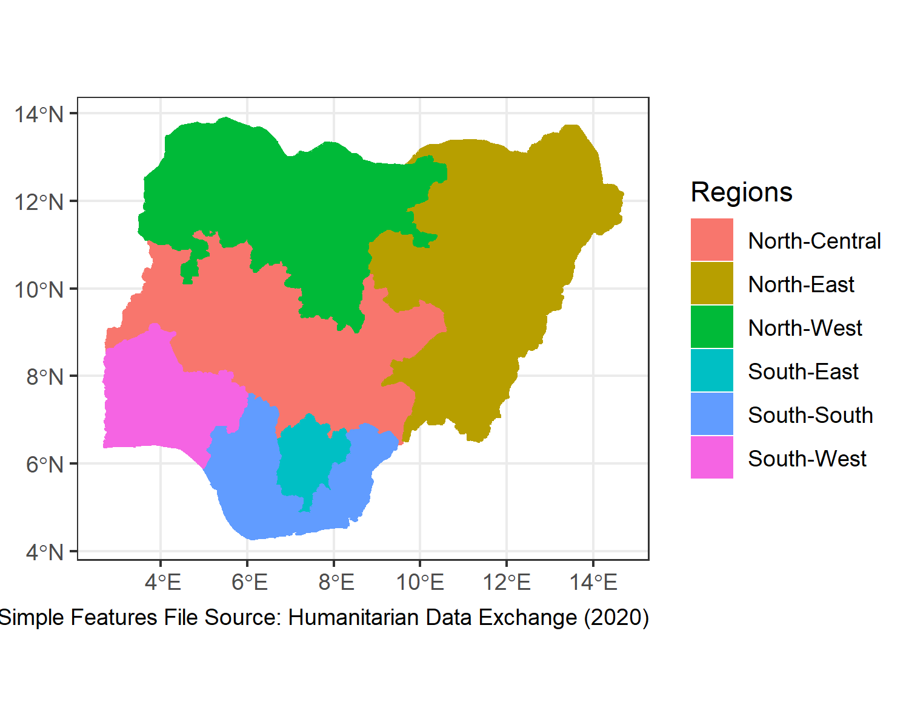

Figure 2.1: Geo-Political Zones in Nigeria

## 2.2 Inclusion and Exclusion Criteria

Included in this review are studies carried out in Nigeria which:

1. have study subjects > 18 years of age
2. are community-based observational and interventional
3. are conducted between the years 2000 to 2020.
4. defined pre-diabetes either using Impaired Glucose tolerance (IGT) of 7.8mmol/L to 11.0mmol/L or use any of the American Diabetic Association criterion for defining pre-diabetes i.e. Fasting blood glucose (FBG) between 5.6mmol/L to 6.9mmol/L or glycosylated hemoglobin (HbA1C) between 5.7% to 6.4%.

Excluded from this review are studies

1. conducted in individuals < 18 years of age
2. conducted in pregnanat women
3. carried out outside the year range 2000-2020
4. that used World Health Organization FBG criterion for diagnosing pre-diabetes
5. that did not report prevalence of pre-diabetes
6. that are hospital-based studies.

## 2.3 Studies Search Strategies

Online databases used were Google Scholar, PubMed and African Index Medicus. Search words and phrases used were: ‘impaired fasting glucose,’ impaired fasting sugar’, ‘impaired glucose tolerance’ and ‘prediabetes.’Search was repeated for each word or phrase with the name ‘Nigeria.’ Advanced search option in Google Scholar was used to limit the search results within the year range 2000-2020.

## 2.4 Data Collection and Analysis

Extracted information from the studies included prevalence of prediabetes, state and region of the study, study year, mean age, body mass index(BMI), waist circumference and sex composition of the study participants. Random Effects Model for pooling prevalences and Mixed Random Effects Model for meta-regression were fitted using inverse variance method with correction of pooled estimate and its variance using Sidik-Jonkman’s estimator for between study heterogeneity. Analyses were done in R statistical environment for statistical computing, version 4.1.0 (R Core Team, 2021)

# 3 RESULTS

## 3.1 Characteristics of the Included Studies

28 studies consisting of 17671 individuals met the inclusion criteria and are included in the meta-analysis. The studies were conducted between 2004 and 2020. There were 8 studies from the north-west region, 1 study from the north-east, 2 studies from north-central, 6 studies from the south-east, 3 studies from the south-south and 7 studies from the south-west region. -1 study was conducted in four regions. 4 were conducted in the rural areas, 24 in urban areas. 2 studies were conducted in both rural and urban areas.  
The reported mean age of the studies’ subjects ranged from 36.1in an urban north-east study to 56 in an urban south-east study. The reported mean body mass index (BMI) of the studies’ subjected ranged from 24 in rural south-east studies to 27 in urban south-east studies. The respective minimum and are maximum mean waist circumference are 76 in urban south-west studies and 90 in urban south-south studies. The reported prevalence of abdominal obesity ranged from 28% in rural south-east studies to 52% in a south-south study conducted in both rural and urban areas (Figure 3.1)

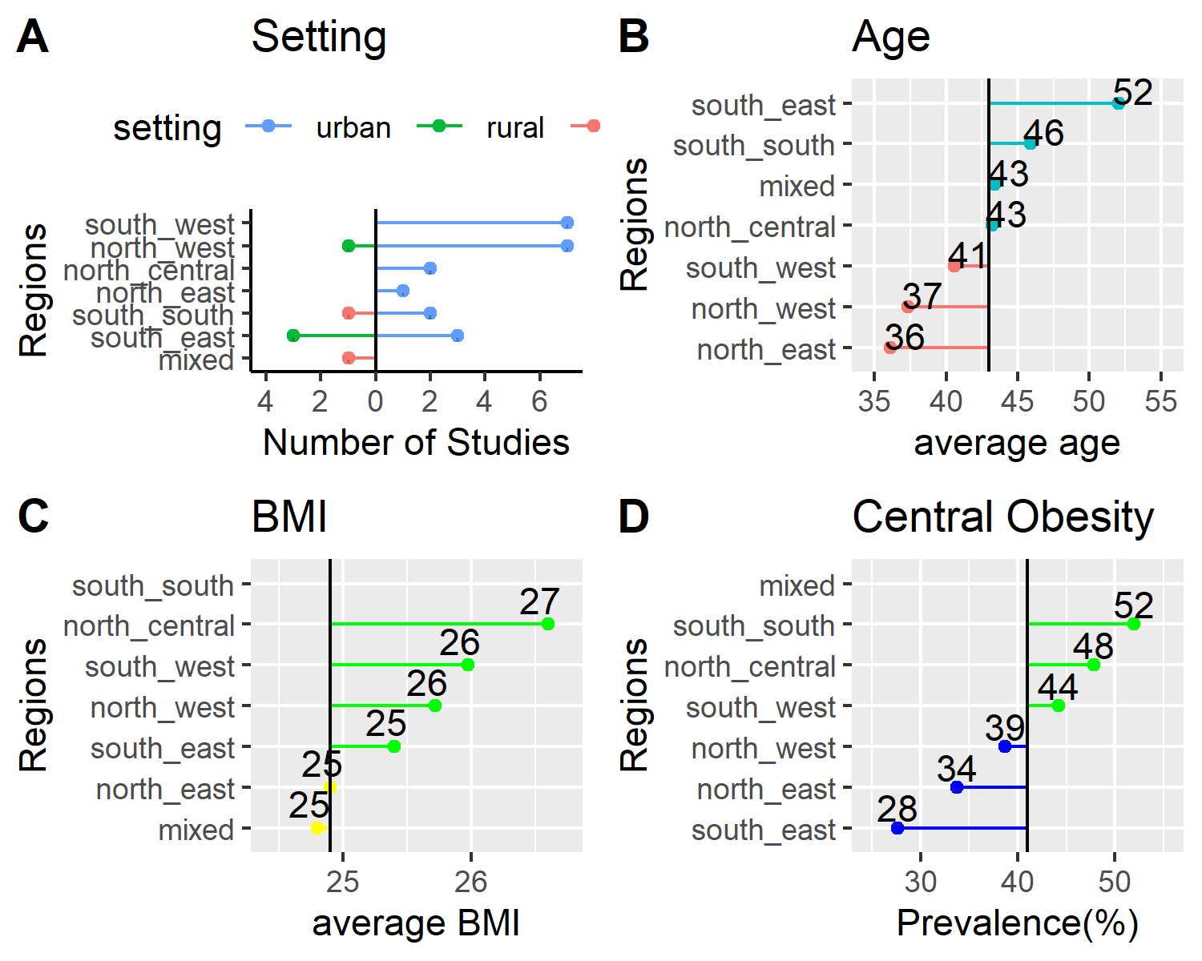

Figure 3.1: Characteristics of the Included Studies

## 3.2 Fitting the Meta Analytic Model

Random Effects Model was fitted using inverse variance method with correction of pooled estimate and its variance using Sidik-Jonkman’s estimator for between study heterogeneity. Prevalences are tranformed using arcsine transformation. Figure 3.2 shows the forest plot of the model.

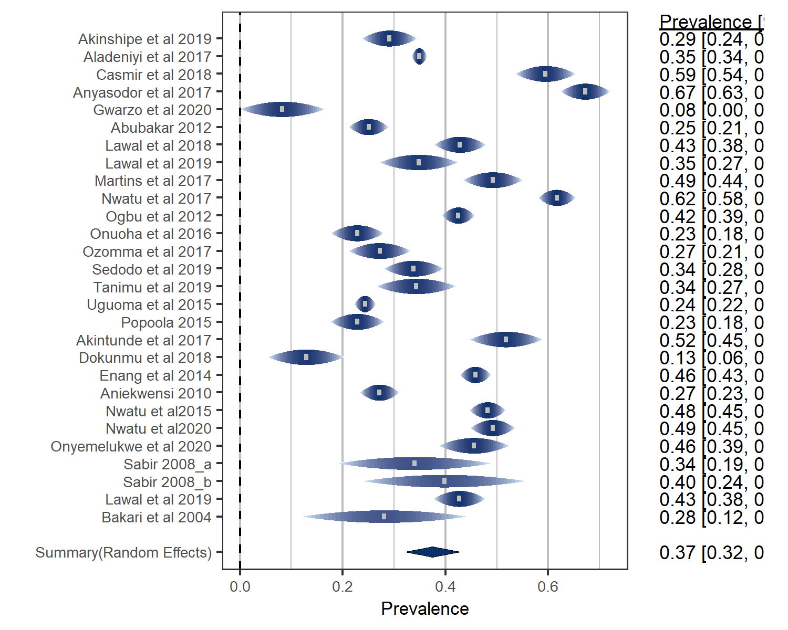

Figure 3.2: forest plot

The overall pooled prevalence of prediabetes in Nigeria is 37% with confidence interval between 32% and 43%. According to the latest data by UNFPA - United Nations Population Fund (2021), this translates to estimated 44.3 million prediabetic individuals in Nigeria. The *P* value for the random meta analytic model is <0.001. The estimated total between studies heterogeneity(tau2) = 0.02(S.E = 0.005). I2 = 97.8%. Test for Heterogenity showed Q(df= 27) = 987, p-value<0.001.

## 3.3 Diagnostics of the Meta Analytic Model

Figure 3.3 shows radial plot of the model with no obvious outlier. This is confirmed by the influence analysis in figure 3.4.

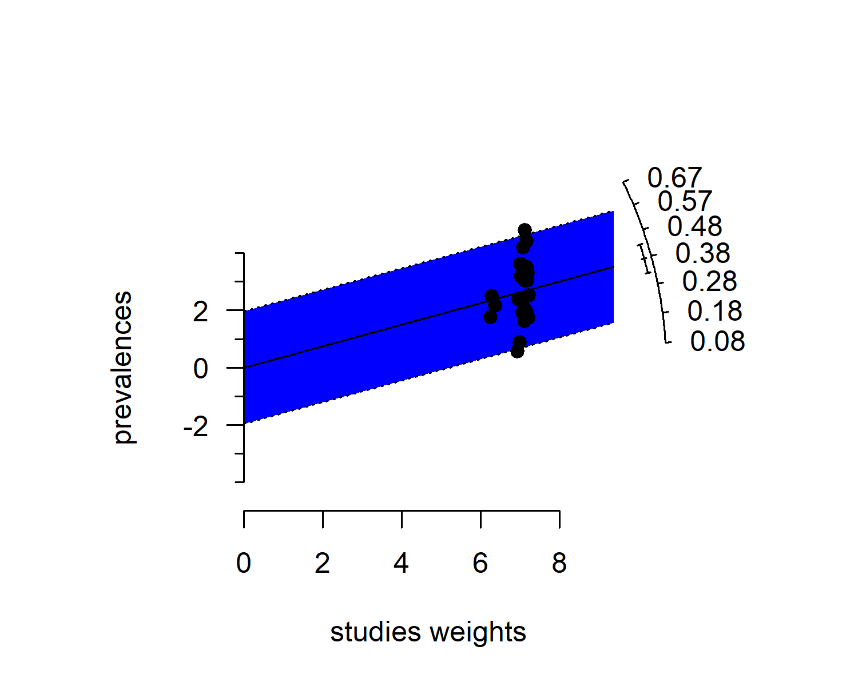

Figure 3.3: radial plot of the model

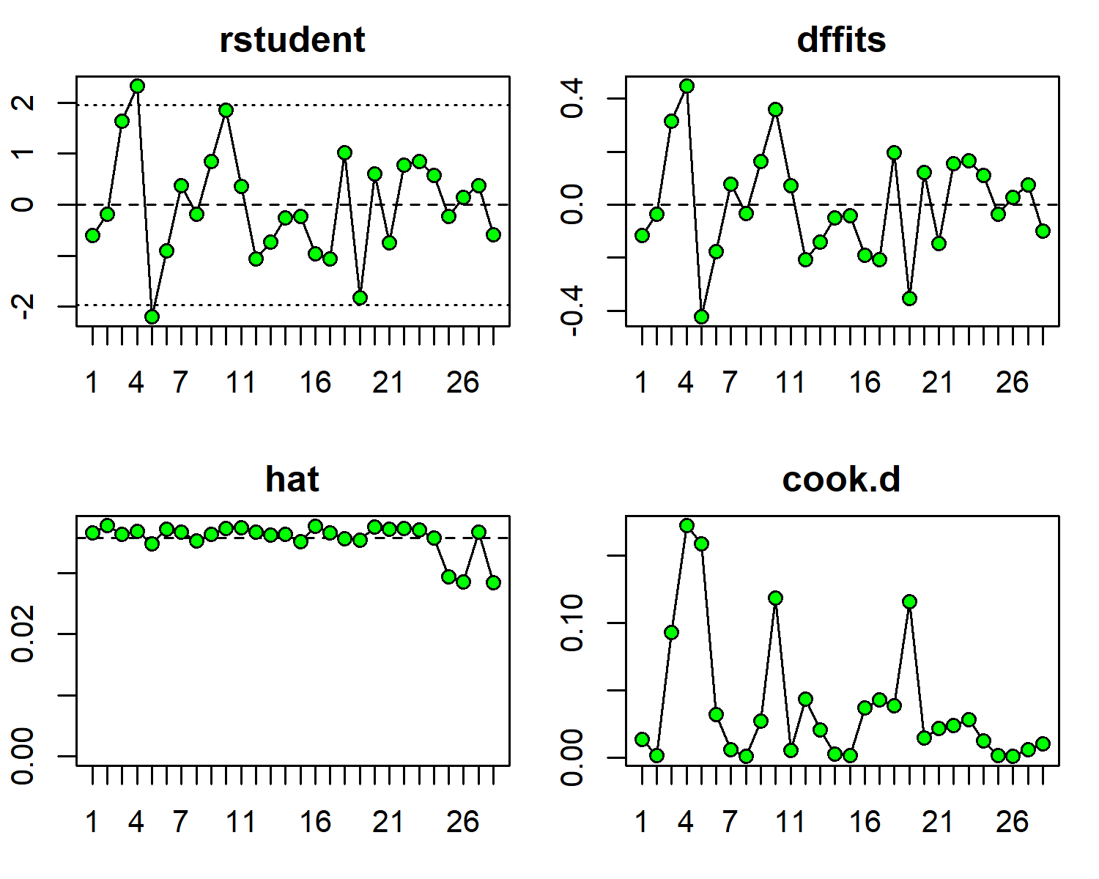

Figure 3.4: Influence analysis of the model

## 3.4 Prevalence of Prediabetes in Nigeria by Geo-political Region

Figure 3.5 shows pooled prediabetes prevalences by geo-political zones in Nigeria. The region with the lowest prediabetes prevalence is North-Central at31%. The region with the highest prevalence of prediabetes is South-South at 47%. The *P* value of the model is 0.699 indicating lack of statistically significant difference in prevalence of prediabetes across the 6 geo-political regions in the country.

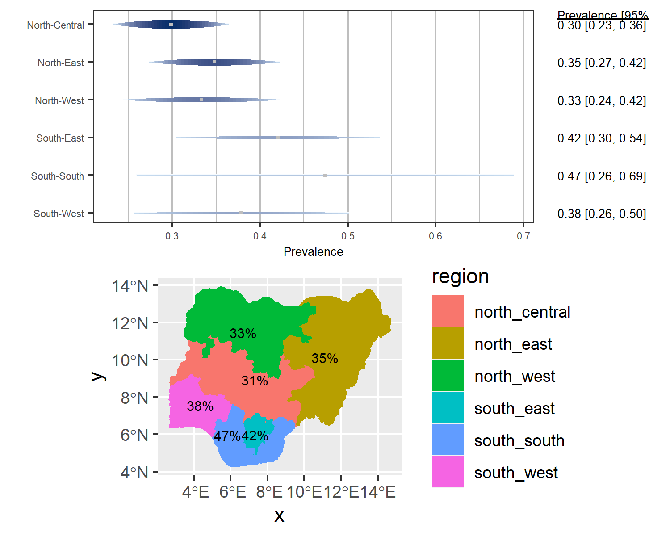

Figure 3.5: Forest Plot and Map of prevalence by region

## 3.5 Difference in Prevalence of Prediabetes between Urban and Rural Settings in Nigeria

Figure 3.6 shows pooled prevalence of prediabetes in rural and urban settings. The pooled prevalence in rural settings is 49% whereas the pooled prevalence for urban settings si 36%. The difference is not statistically significant (p value = 0.098)

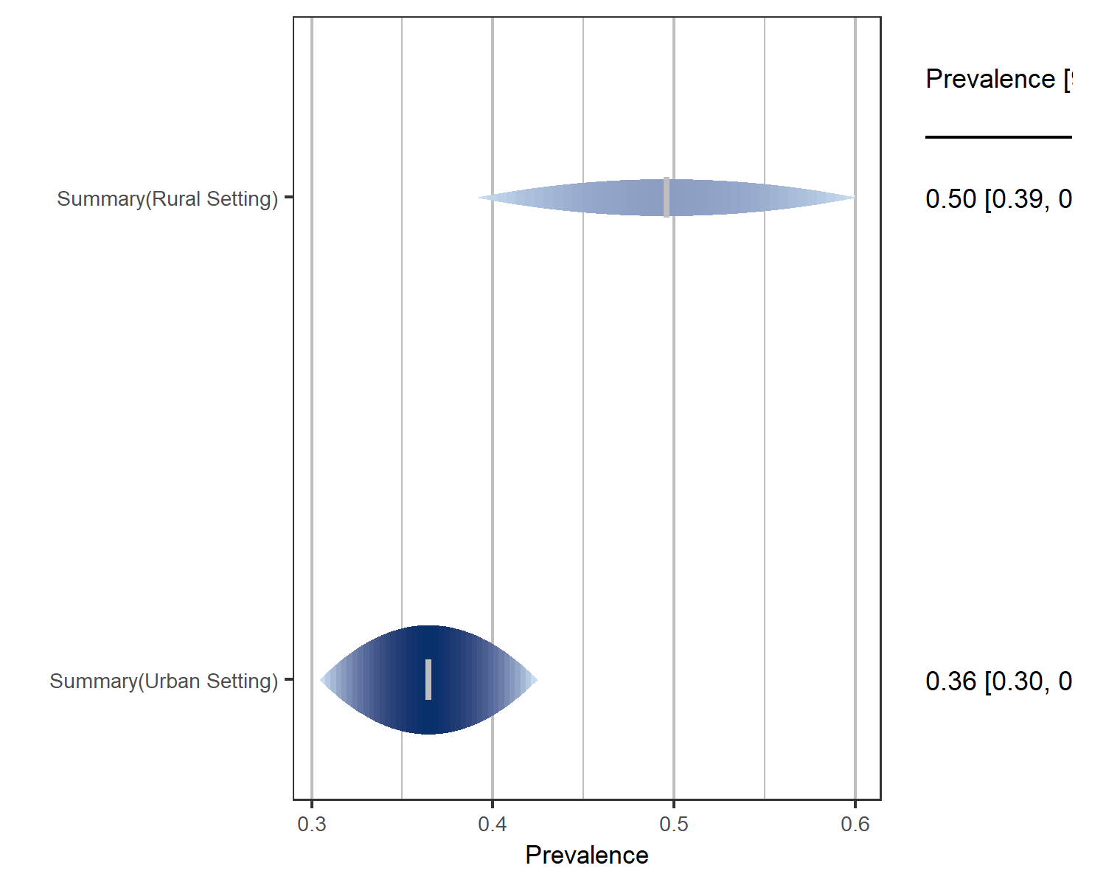

Figure 3.6: forest plot of prevalence by rural and urban settings

# 4 DISCUSSION

The 37% crude prevalence of prediabetes in Nigeria was pooled from studies conducted between 2004 and 2020. In contrast the IDF estimate of 7.3% in 2003 was pooled from two studies conducted in neighboring Cameroon in 1997 and neighboring Ghana in 2002. (Gan et al., 2003). The prevalence of prediabetes in Nigeria has thus increased by more than 5 times since the 2003 publication of the IDF report. This change is not totally as a result of rising prevalence but from the difference in criteria for defining pre-diabetes. Studies in the 2003 IDF report mostly used World Health Organization (WHO) criteria for defining prediabetes whereas the studies included in this meta-analysis used the ADA criteria, which used lower FBG threshold for diagnosing prediabetes. The ADA criteria, compared to the WHO criteria, will naturally classify more individuals as prediabetic.

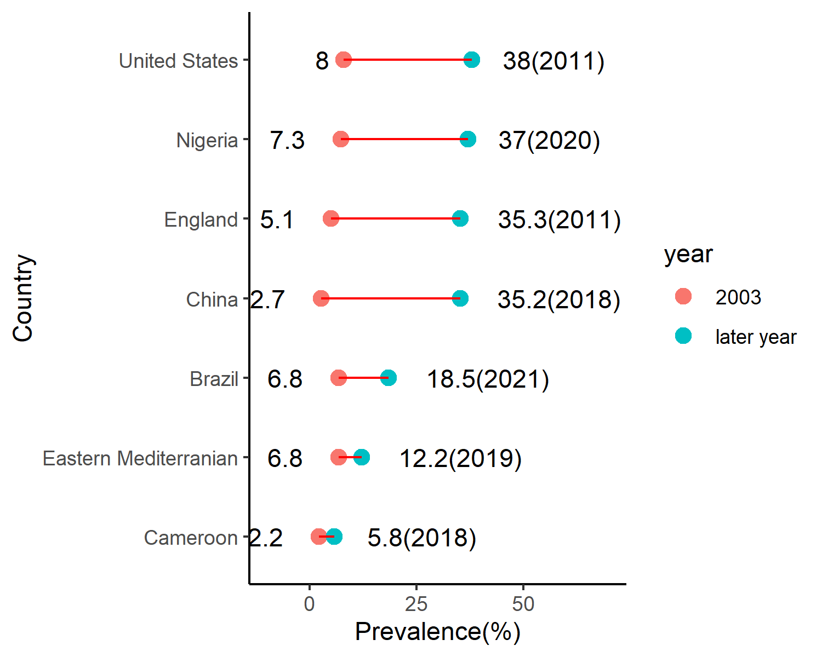

Figure 4.1: Trends in Prediabetic Prevalence in Selected Countries

This rising trend of prediabetes burden is a global phenomenon. It is observed in neighboring Cameroon where the 2003 IDF reported estimate of 2.2% increased by almost 3 times to 5.8% in 2018 (Bigna et al., 2018), in Eastern Mediterranian region where 2003 IDF reported prevalence of 6.8% almost doubled to 12.2% in 2019(Mirahmadizadeh et al., 2020), in Brazil where 2003 IDF reported prevalence of 6.8% almost tripled to 18.5% in 2021(Iser et al., 2021), in Mainland China where 2003 IDF reported prevalence of 2.7% increased almost 13 times to 35.2% in 2018 (Li et al., 2020), in England where 2003 IDF reported prevalence of 5.1% increased almost 7 times to 35.3% in 2011 (Mainous et al., 2014) and in United States where 2003 IDF reported prevalence of 8% increased almost 5 times to 38% in 2011 (Menke et al., 2015).(Figure 4.1)

Putting the burden of prediabetes in Nigeria in the African perspective, the number individuals living with prediabetes in the country (44.3 million) is just a million less than the whole number of adult Africans with IGT (45.3 million) as estimated in 2019(Karuranga et al., 2019). These individuals at high risk of developing overt diabetes and other cardiovascular complications. This will add to the cardiovascular disease burden in the country further pressurizing the overstreched health care system.

# 5 SUMMARY AND CONCLUSION

37% (CI between 32% and 43% ) of adult Nigerians are prediabetic. This translates to 44.3 million adult Nigerians. The region with the lowest prediabetes prevalence is North-Central at 31%. The region with the highest prevalence of prediabetes is South-South at 47%. The pooled prevalence in rural settings is 49% whereas the pooled prevalence for urban settings is 36%. Differences between regions and between rural and urban settings were not statistically significant.  
The prevalence of prediabetes in Nigeria is one of the highest in the world. This means a future burden of diabetes and cardiovascular disease in the country. This will further strech the already fragile health system in the country. This necessitates the development of early detection, prevention and treatment programs for prediabetes

# REFERENCES

Abubakar, L. Y. (2012). PREVALENCE AND CORRELATES OF DIABETES MELLITUS AND GLUCOSE INTOLERANCE AMONG ADULTS IN KANO METROPOLIS. *Faculty of INTERNAL MEDICINE*. <https://dissertation.npmcn.edu.ng/index.php/FMCP/article/view/700>

Akinshipe, B. O., Yusuf, E. O., Akinshipe, F. O., Moronkeji, M. A., & Nwaobi, A. C. (2019). Prevalence and Determinants of Pre-diabetes and Latent Tuberculosis Infection Among Apparently Healthy Adults in Three Communities in Southern Nigeria. *International Journal of Immunology*, *7*(2), 23. <https://doi.org/10.11648/j.iji.20190702.11>

Akintunde, A. A., Saka, W. A., Adeniyi, D. B., Salawu, A. A., & Opadijo, O. G. (2017). Cardio-metabolic risk factors and metabolic syndrome: A study of the prevalence and level of awareness of related risk factors among school teachers in Ogbomoso, South West Nigeria. *Annals of Health Research*, *3*(1), 50–59. <https://mail.annalsofhealthresearch.com/index.php/ahr/article/view/60>

Aladeniyi, I., Adeniyi, O. V., Fawole, O., Adeolu, M., Ter Goon, D., Ajayi, A. I., & Iruedo, J. (2017). The Prevalence and Correlates of Pre-Diabetes and Diabetes Mellitus Among Public Category Workers in Akure, Nigeria. *The Open Public Health Journal*, *10*(1). <https://doi.org/10.2174/1874944501710010167>

American Diabetes Association. (2011). Diagnosis and Classification of Diabetes Mellitus. *Diabetes Care*, *34*(Supplement_1), S62–S69. <https://doi.org/10.2337/dc11-S062>

Aniekwensi, E. (2010). A COMPARATIVE EVALUATION OF BODY MASS INDEX, WAIST CIRCUMFERENCE AND WAIST-TO-HIP RATIO AS CORRELATES OF GLUCOSE INTOLERANCE AMONG URBAN ADULTS IN JOS METROPOLIS, NIGERIA. *Faculty of INTERNAL MEDICINE*. <https://dissertation.npmcn.edu.ng/index.php/FMCP/article/view/554>

Anyasodor, A. E., Nwose, E. U., Bwititi, P. T., Aganbi, E., Richards, R. S., Mudiaga, L. I., Oguoma, V. M., & Enemchukwu, S. C. (2017 Sep-Oct). Prevalence of hyperglycemia and risk factors for orodental disease in Nigeria: Implications of opportunistic screening. *Indian Journal of Dental Research: Official Publication of Indian Society for Dental Research*, *28*(5), 507–513. <https://doi.org/10.4103/ijdr.IJDR_304_17>

Bakari, A. G., & Onyemelukwe, G. C. (2004). Glucose intolerance among apparently healthy Hausa-Fulani Northern Nigerians. *Annals of African Medicine*, *3*(1). <https://www.ajol.info/index.php/aam/article/view/8298>

Bigna, J. J., Nansseu, J. R., Katte, J.-C., & Noubiap, J. J. (2018). Prevalence of prediabetes and diabetes mellitus among adults residing in Cameroon: A systematic review and meta-analysis. *Diabetes Research and Clinical Practice*, *137*, 109–118. <https://doi.org/10.1016/j.diabres.2017.12.005>

Cai, X., Zhang, Y., Li, M., Wu, J. H., Mai, L., Li, J., Yang, Y., Hu, Y., & Huang, Y. (2020). Association between prediabetes and risk of all cause mortality and cardiovascular disease: Updated meta-analysis. *BMJ*, m2297. <https://doi.org/10.1136/bmj.m2297>

Casmir, E. A., Amam, C. M., Obianuju, B. O., Tim, P. G., David, A. W., Oyewole, A. K., & Michael, A. (2018). Prevalence of cardiometabolic risk factors among professional male longdistance bus drivers in Lagos, southwest Nigeria: A crosssectional study. *Cardiovascular Journal of Africa*, *29*(2), 106–114. <https://doi.org/10.5830/CVJA-2018-006>

Dokunmu, T. M., Yakubu, O. F., Adebayo, A. H., Olasehinde, G. I., & Chinedu, S. N. (2018). Cardiovascular Risk Factors in a Suburban Community in Nigeria. *International Journal of Hypertension*, *2018*, e6898527. <https://doi.org/10.1155/2018/6898527>

Enang, O. E., Otu, A. A., Essien, O. E., Okpara, H., Fasanmade, O. A., Ohwovoriole, A. E., & Searle, J. (2014). Prevalence of dysglycemia in Calabar: A cross-sectional observational study among residents of Calabar, Nigeria. *BMJ Open Diabetes Research and Care*, *2*(1), e000032. <https://doi.org/10.1136/bmjdrc-2014-000032>

Gan, D., International Diabetes Federation, & World Diabetes Foundation. (2003). *Diabetes atlas*. International Diabetes Federation.

Gwarzo, I., Mukhtar, Wali, N., & Ahmed Ibrahim, S. (2020). Correlation of Anthropometric Indices with Fasting Blood Glucose and Blood Pressure Among University Students in Kano, Nigeria. 17, 128–134.

Humanitarian Data Exchange. (2020). Nigeria - Subnational Administrative Boundaries. In *The Humanitarian Data Exchange*. <https://data.humdata.org/dataset/nga-administrative-boundaries>

Iser, B. P. M., Pinheiro, P. C., Malta, D. C., Duncan, B. B., & Schmidt, M. I. (2021). Prediabetes and intermediate hyperglycemia prevalence in adults and associated factors, Health National Survey. *Ciência & Saúde Coletiva*, *26*, 531–540. <https://doi.org/10.1590/1413-81232021262.34852020>

Karuranga, S., Federation, I. D., & International Diabetes Federation. (2019). *IDF Atlas 9th edition* (Ninth). International Diabetes Federation. <https://www.diabetesatlas.org/en/resources/>

Lawal, Y., Anumah, F. E., & Bakari, A. G. (2018). Is Glycated Haemoglobin an Alternative to Diagnose Diabetes Mellitus in a Northern Nigerian Population? *Annals of Medical and Health Sciences Research*. <https://www.amhsr.org/abstract/is-glycated-haemoglobin-an-alternative-to-diagnose-diabetes-mellitus-in-a-northern-nigerian-population-4485.html>

Lawal, Y., Bello, F., Anumah, F. E., & Bakari, A. G. (2019). Prevalence and determinants of glucose intolerance in a Northern Nigerian population: Role of insulin resistance. *Nigerian Journal of Basic and Clinical Sciences*, *16*(2), 83. <https://doi.org/10.4103/njbcs.njbcs_36_18>

Lawal, Y., Muhammad, S., Dahuwa, U. F., Bichi, I., & Ahmed, H. (2019). Screening for obesity and undiscovered glucose intolerance among employees of a tertiary health center in northeast Nigeria. *Journal of Health Research and Reviews,India*. <https://www.jhrr.org/article.asp?issn=2394-2010;year=2019;volume=6;issue=3;spage=107;epage=113;aulast=Lawal>

Li, Y., Teng, D., Shi, X., Qin, G., Qin, Y., Quan, H., Shi, B., Sun, H., Ba, J., Chen, B., Du, J., He, L., Lai, X., Li, Y., Chi, H., Liao, E., Liu, C., Liu, L., Tang, X., … Shan, Z. (2020). Prevalence of diabetes recorded in mainland China using 2018 diagnostic criteria from the American Diabetes Association: National cross sectional study. *BMJ (Clinical Research Ed.)*, *369*, m997. <https://doi.org/10.1136/bmj.m997>

Mainous, A. G., Tanner, R. J., Baker, R., Zayas, C. E., & Harle, C. A. (2014). Prevalence of prediabetes in England from 2003 to 2011: Population-based, cross-sectional study. *BMJ Open*, *4*(6), e005002. <https://doi.org/10.1136/bmjopen-2014-005002>

Mainous, A. G., Tanner, R. J., Jo, A., & Anton, S. D. (2016). Prevalence of Prediabetes and Abdominal Obesity Among Healthy-Weight Adults: 18-Year Trend. *The Annals of Family Medicine*, *14*(4), 304–310. <https://doi.org/10.1370/afm.1946>

Martins, S. O., Folasire, O. F., & Irabor, A. E. (2017). PREVALENCE AND PREDICTORS OF PREDIABETES AMONG ADMINISTRATIVE STAFF OF A TERTIARY HEALTH CENTRE, SOUTHWESTERN NIGERIA. *Annals of Ibadan Postgraduate Medicine*, *15*(2), 114–123. <https://www.ncbi.nlm.nih.gov/pmc/articles/PMC5846173/>

Menke, A., Casagrande, S., Geiss, L., & Cowie, C. C. (2015). Prevalence of and Trends in Diabetes Among Adults in the United States, 1988-2012. *JAMA*, *314*(10), 1021–1029. <https://doi.org/10.1001/jama.2015.10029>

Mirahmadizadeh, A., Fathalipour, M., Mokhtari, A. M., Zeighami, S., Hassanipour, S., & Heiran, A. (2020). The prevalence of undiagnosed type 2 diabetes and prediabetes in Eastern Mediterranean region (EMRO): A systematic review and meta-analysis. *Diabetes Research and Clinical Practice*, *160*, 107931. <https://doi.org/10.1016/j.diabres.2019.107931>

Nwatu, C. B., Ofoegbu, E. N., Unachukwu, C. N., Young, E. E., Okafor, C. I., & Okoli, C. E. (2016). Prevalence of prediabetes and associated risk factors in a rural Nigerian community. *International Journal of Diabetes in Developing Countries*, *36*(2), 197–203. <https://doi.org/10.1007/s13410-015-0401-5>

Nwatu, C. B., Young, E. E., Okwara, C. C., Okoli, C. E., Obi, P. C., Anyim, O. B., Ubani, B. C., Okafor, C. I., & Oli, J. M. (2017). Concurrent Prediabetes and Prehypertension in a Rural Community in South East Nigeria. *Journal of Advances in Medicine and Medical Research*, 1–10. <https://doi.org/10.9734/JAMMR/2017/34226>

Nwatu, C. B., Young, E. E., Onyenekwe, B. M., Ezike, C. H., Ugwu, E. T., & Obi, P. C. (2020). Association of short sleep duration with cardiometabolic risk factors in a population of rural Nigerian women: A cross-sectional study. *International Journal of Medicine and Health Development*, *25*(2), 120. <https://doi.org/10.4103/ijmh.IJMH_17_20>

Ogbu, I. S. I., Azodo, E. C., & Chinwuba, A. U. (2012). Prevalence of pre-diabetes and unreported diabetes mellitus in population aged 45 years and above in Owerri Municipality, Imo State Nigeria. *International Journal of Medicine and Health Development*, *17*(2), 31–38. <https://doi.org/10.4314/jcm.v17i2.4>

Oguoma, V. M., Nwose, E. U., Skinner, T. C., Digban, K. A., Onyia, I. C., & Richards, R. S. (2015). Prevalence of cardiovascular disease risk factors among a Nigerian adult population: Relationship with income level and accessibility to CVD risks screening. *BMC Public Health*, *15*(1), 397. <https://doi.org/10.1186/s12889-015-1709-2>

Oguoma, V. M., Nwose, E. U., Ulasi, I. I., Akintunde, A. A., Chukwukelu, E. E., Bwititi, P. T., Richards, R. S., & Skinner, T. C. (2017). Cardiovascular disease risk factors in a Nigerian population with impaired fasting blood glucose level and diabetes mellitus. *BMC Public Health*, *17*(1), 36. <https://doi.org/10.1186/s12889-016-3910-3>

Onuoha, N., Am, O., Pe, E., & Ud, O. (2016). Anthropometric status, fasting blood sugar, nutrient intake and energy balance of traders in a market population in Nsukka, Nigeria. *Integrative Food, Nutrition and Metabolism*, *4*(1). <https://doi.org/10.15761/IFNM.1000168>

Onyemelukwe, O. U., Mamza, A. A., Suleiman, Y. K., Iyanda, M. A., Bello-Ovosi, B., Bansi, K. I., Adeleye, A. O., Balarabe, H., Ahmed, M. S., Okpe, I. O., Bello, F., & Bakari, A. G. (2020 Apr-Jun). Prevalence of Pre-Diabetes, Diabetes and Associated Cardiovascular Risk Amongst Healthcare Workers in Ahmadu Bello University Teaching Hospital (ABUTH), Zaria using Glycated Haemoglobin. *West African Journal of Medicine*, *37*(2), 91–99.

Ozomma, O. P., J. u, E., S. c, M., E. c, O., R. a, A., I. p, E., C. e, O., U. k, A., M. c, U., M. o, O., & P. c, O. (2017). Prevalence of Prediabetes and the Associated Risk of Kidney Disease in Apparently Healthy Subjects in Nnewi, Anambra State, Nigeria. *Journal of Diseases*, *4*(2), 27–33. <https://econpapers.repec.org/article/pkpjoudis/2017_3ap_3a27-33.htm>

Popoola, O. O. (2015). Prevalence of Obesity, Hyperglycemia and Dyslipidemia and Associated Factors among Senior Staff of the Univeristy College Hospital Ibadan. AFRICAN DIGITAL HEALTH REPOSITORY PROJECT. <http://adhlui.com.ui.edu.ng/jspui/bitstream/123456789/1139/1/UI_Dissertation_Popoola_OO_Prevalence_2015.pdf>

R Core Team. (2021). *R: A language and environment for statistical computing*. R Foundation for Statistical Computing. <https://www.r-project.org/>

Sabir, A. A. (2008). GLUCOSE TOLERANCE AMONG RURAL AND URBAN FULANI OF NORTHERN NIGERIA. *Faculty of INTERNAL MEDICINE*. <http://www.dissertation.npmcn.edu.ng/index.php/FMCP/article/view/520>

Sedodo, N. S., Abosede, O. P., Ilori, O. A., Adenekan, M. K., Idowu, O. M., Nupo, A. O., & Akinlotan, J. V. (2020). Assessment of Fasting Blood Glucose Level of Undergraduates in Abeokuta Ogun State Nigeria. *Archives of Current Research International*, 42–49. <https://doi.org/10.9734/acri/2020/v20i530196>

Tanimu, H., & Paul, A. D. (2019). Investigation of the Occurrence of Abnormal Oral Glucose Tolerance (OGT) Level among People of Nasarawa State Polytechnic, Lafia. *Agricultural Research & Technology: Open Access Journal*, *10*(4), 001–005. <https://doi.org/10.19080/CRDOJ.2019.10.555791>

The International Expert Committee. (2009). International Expert Committee Report on the Role of the A1C Assay in the Diagnosis of Diabetes. *Diabetes Care*, *32*(7), 1327–1334. <https://doi.org/10.2337/dc09-9033>

Udo, K. R., Ajayi, J. F. A., Kirk-Greene, A. H. M., & Falola, T. O. (2020). Nigeria. *Encyclopedia Britannica*. <https://www.britannica.com/place/Nigeria>

UNFPA - United Nations Population Fund. (2021). *UNFPA - United Nations Population Fund*. <https://www.unfpa.org/>

Wasserstein, R. L., Schirm, A. L., & Lazar, N. A. (2019). Moving to a World Beyond “p $<$ 0.05.” *The American Statistician*. <https://www.tandfonline.com/doi/abs/10.1080/00031305.2019.1583913>

Xu, X. Y., Leung, A. Y. M., Smith, R., Wong, J. Y. H., Chau, P. H., & Fong, D. Y. T. (2020). The relative risk of developing type 2 diabetes among individuals with prediabetes compared with individuals with normoglycaemia: Meta-analysis and meta-regression. *Journal of Advanced Nursing*, *76*(12), 3329–3345. <https://doi.org/10.1111/jan.14557>