Prevalence of Prehypertension in Nigeria: a Systematic Review and Meta-analysis

M. A. Bashir1,* , A. I. Yahaya1, Mukhtar Muhammad1, A.H. Yusuf1

2021-07-30

1Department of Anatomy  
Bayero University Kano  
*Author of Correspondence, Email: [musabashir34@gmail.com](mailto:musabashir34@gmail.com), GSM: +2347036878467

ABSTRACT  
*Prehypertension is a borderline blood pressure status associated with both higher incidence of cardiovascular disease as well as higher risk of progression to hypertension. The rising burden of hypertension and prehyperension globally is a serious concern to all and sundry. This study aims to estimate the burden of prehypertension in Nigeria. Online searches of Google Scholar, PubMed and African Index Medicus were conducted and studies selected based on predefined criteria. 21 studies consisting of 25839 individuals conducted between 2011 and 2021 were included in the meta-analysis. The pooled prevalence of prehypertension in Nigeria was found to be 34%*  
*(95% CI: 30%-40%) translating to 41.4 million adult Nigerians. Males have higher prehypertension prevalence of 39.1% (95% CI: 30.9%-47.6%) than females with prevalence of 28.5% (95% CI: 21.2%-36.4%). Differences between sexes are not statistically significant. The region with the lowest prehypertension prevalence is North-East at 18%. The region with the highest prevalence of prehypertension is North-West at 43%. Differences between the regions are statistically significant. The pooled prevalence in rural settlements is 32% whereas the pooled prevalence for urban settlements is 37%. Differences rural and urban settlements were not statistically significant. In conclusion, the burden of prehypertension in Nigeria is high and represents a future burden of hypertension and other cardiovascular diseases*

**Keywords**: Prehypertension, Prevalence, Nigeria

# 1 INTRODUCTION

Hypertension is an abnormally raised blood pressure. The risk of cardiovascular diseases increases in a log-linear fashion from systolic blood pressure 115mmHg and diastolic blood pressure of 75mmHg with a doubling in risk of cardiovascular-related death doubling for each 20mmHg and 10mmHg increase in systolic and diastolic blood pressures respectively.1 Despite this continuous risk of rising blood pressure, defining a cut-off value is important to set a threshold of action in for both clinical and public health interventions.2 defined this threshold as systolic blood pressure of 140mmHg and/or diastolic blood pressure of 90mmHg.

Since the association between blood pressure and cardiovascular risk is continous, it is only logical to define other low-level blood pressure thresholds to alert both clinicians and public health officials to institute low-level interventions to mitigate the cardiovacular risk. Prehypertension (PHTN) is such a category. It is a borderline high-risk blood pressure status defined as systolic Blood Pressurev(BP) of 120-139mmHg and/or diastolic BP of 80-89mmHg2. Prehypertension is associated with about fourfold increased risk of developing hypertension compared to normotensive individuals with 10% annualized progression rate to hypertension3. In addition to this high risk of conversion to hypertension, prehypertension is associated with 200% increase in cardiovascular disease incidence compared to blood pressure less than 120/80mmHg2.

There is worldwide increase in the burden of high blood pressure. In a pooled analysis of 1479 studies from 174 countries including 19.1 million participants, there were 594 million people with high blood pressure in 1975. This number increased to 1.13 billion people in 2015 with the increase largely in developing countries. Eighty eight percent (88%) of mortality attributable to high BP is now in developing countries.4  
In a meta-analysis of 242 322 individuals from 11 countries including Nigeria, prevalence of prehypertension was 38%.5 In a recent meta-analysis of 9 studies conducted in Nigeria between 1995 to 2020 and consisting of 16, 241 individuals, the prevalence of prehypertension was found to be 30.9% (95% CI: 22.0-39.7). However, the analysis involved studies conducted in only 4 of the 6 geo-political zones of the country. In addition, no sex-specific prevalence of prehypertension was reported..6 This study aims to determine the sex-specific prevalence of prehypertension across the 6 geo-political zones as well as in urban and rural settlements of Nigeria.

# 2 METHODOLOGY

## 2.1 Study Area

Nigeria is a western African nation with an area of 923,769 sq km, home to more than 250 ethnic groups7. It has 36 states and a capital divided into 6 geo-political zones or regions. The estimated population in 2021 is 211.4 million. About 43.4% of the population are under the age of 14 years. Also 53.9% of the population are between the ages of 15 and 64 years. Only 2.8% of the population are above the age of 65 years.8 Figure 2.1 shows the map of the geopolitical zones of the country.

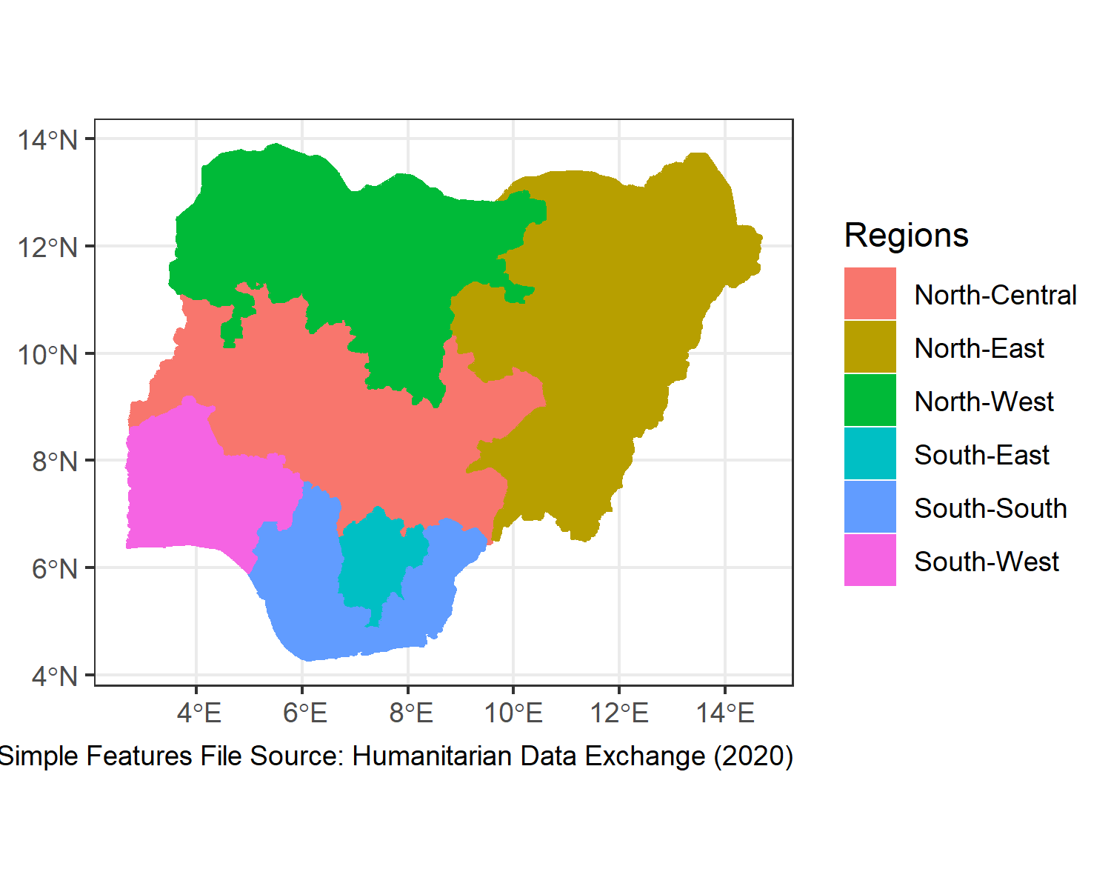

Figure 2.1: Geo-Political Zones in Nigeria

## 2.2 Inclusion and Exclusion Criteria

We included community-based studies conducted in adult population (greater than 18 years of age) of Nigeria. Studies selected defined prehypertension as systolic Blood Pressure(BP) of 120-139mmHg and/or diastolic BP of 80-89mmHg. We excluded studies conducted in individuals less than 18 years of age, studies on pregnant women and all hospital-based studies.

## 2.3 Studies Search Strategies

Online databases used were Google Scholar, PubMed, Global and African Index Medicus. Search words and phrases used were: ‘prehypertension,’ ‘pre-hypertension’ and ‘hypertension.’Searches were repeated for each word with the name ‘Nigeria.’ Searches were conducted between 4rth March 2021 to 15th March 2021. Screening of the abstracts and titles of the articles was done independently by two reviwers (MAB and MM) and studies selection and exclusion done based on the predefined criteria. Thereafter, screening of the full-text articles was done independently by the same researches to select the studies to be included in qualitative and quantitative analyses.

## 2.4 Qualitative Analysis of the Included Studies

The methodological quality of the included studies was assessed using a modification of the Joanna Briggs Institute (JBI) Critical Appraisal Checklist for Studies Reporting Prevalence Data9. The item’s original 9 questions were reduced to six (6) with each question given a score of one (1) for a ‘yes’ and zero (0) for a ‘no.’ The total maximum score is six. A study was judged as good quality if it scored minimum of five (5) and of poor quality if it scores less than five (5). Assessment was done independently by two reviewers (AIH and MM) with disagreements sorted by AHY. Table ?? shows the modified tool used in critical appraisal of the included studies. The minimum sample size for scoring a study as a ‘yes’ was three hundered and twenty three (323) calculated using Epitools online calculator10 assuming an estimated prevalence of 30% based on a recent meta-analysis of studies conducted in Nigeria6. Only studies judged as having high methodological quality were included in the quantitative analysis.

## 2.5 Data Extraction and Quantitative Analysis

Data Extraction was independently done by two reviewers (MAB and AHY). Extracted information from the studies included prevalence of prehypertension, sample size, settlement (urban/rural), state and region of the study, study year, mean age and sex composition of the study participants. Data was entered into Excel and then imported into R statistical environment for statistical computing, version 4.1.0.11

Metafor Package12 was used to fit Random Effects Model for pooling prevalences and Mixed Effects Model for meta-regression using inverse variance method with correction of pooled estimate and its variance using Sidik-Jonkman’s estimator for between study heterogeneity.13

### 2.5.1 Influence and Heterogeneity Analyses

The investigation of heterogeneity was done in three levels. At first level, individuals studies were investigated for influencers defined as follows:

1. Based on hat value, which is standardized distance of each study’s reported prevalence from the pooled prevalence,
2. Based on rstudent, which is standardized distance of the predicted prevalence for each study from the pooled prevalence
3. Based on Cook’s distance, which is the distance between the pooled prevalence when the individual study is included and when it is excluded and
4. Based difference in fits(diffits) which is also a distance between pooled prevalence with the study included and when the study is excluded but in standard deviation units. Cut off values implemented in the R metafor package were adopted. Influential studies according to these cut-off values were marked red in the generated influence plots.14

On a second level, gosh analysis, also implemented in metafor package, was done to explore possible clusters in the included studies.

On a third level, metaregression model, using characteristics of the included studies as predictors, was fitted to investigate the extent to which the calculated heterogeneity is attributed to the study-level characteristics such as the sex composition, geo-political region, settlement, mean age of the subjects and sample size.

Prediction Intervals implemented in meta R package15 were reported to overcome the difficulties in interpreting both tau2 and I2 as measures of between study heterogeneity16.

### 2.5.2 Publication Bias Assessment

Funnel plot was used to visually inspect for possible publication bias where studies reporting small prevalence were not published and thus not included in the meta-analysis. Formal regression test by Eggar and colleagues17 was employed for testing funnel plot asymmetry.

## 2.6 Search Results

Figure ?? shows the results of the search strategy.

# 3 RESULTS

## 3.1 Methodological features and the Critical Appraisal of the Included Studies

Out of the 64 included in the qualitative analysis, only 21 were judged of good quality and included in the quantitative analysis. Table ?? shows the result of the qualitative analysis.

## 3.2 Characteristics of the Studies Included in the Quantitative Analysis

21 studies consisting of 25839 individuals met the inclusion criteria and have good enough methodological quality to be included in the meta-analysis. The studies were conducted between 2011 and 2021. There were 8 studies from the south-west region, 8 studies from the south-south, 6 studies from south-east, 4 studies from the north-central, 3 studies from the north-west and 1 study from the north-east region. 10 were conducted in the rural areas, 13 in urban areas and 6 studies were conducted in both rural and urban areas and the authors did not report separate data for the two settlements.  
The reported mean age of the studies’ subjects ranged from 37.5in a south-south studies conducted in urban areas to 51.5 in a south-east study conducted in both urban and rural settings. South-west has the largest number of participants included in the analysis (9907) and the north-east has the least number of participants(1070). Studies from the southern regions of the country are, in general, larger in size and have older subjects. (Figure 3.1 and Figure 3.2)

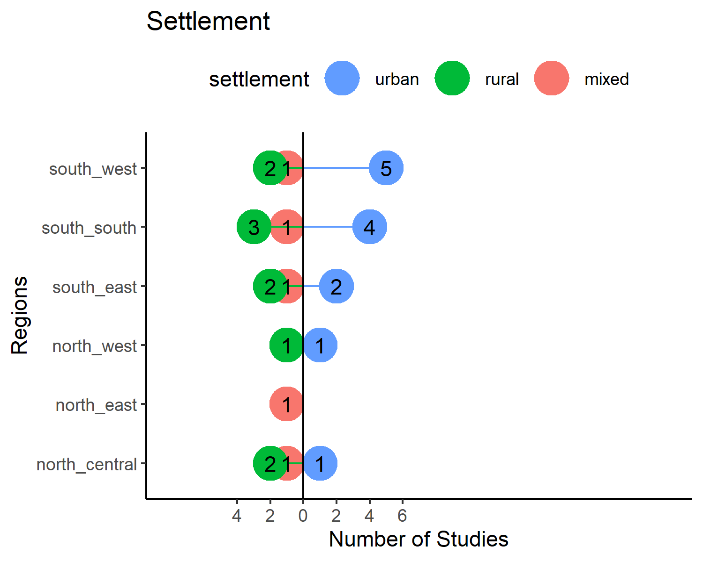

Figure 3.1: Number of Included Studies by Region and Settlement

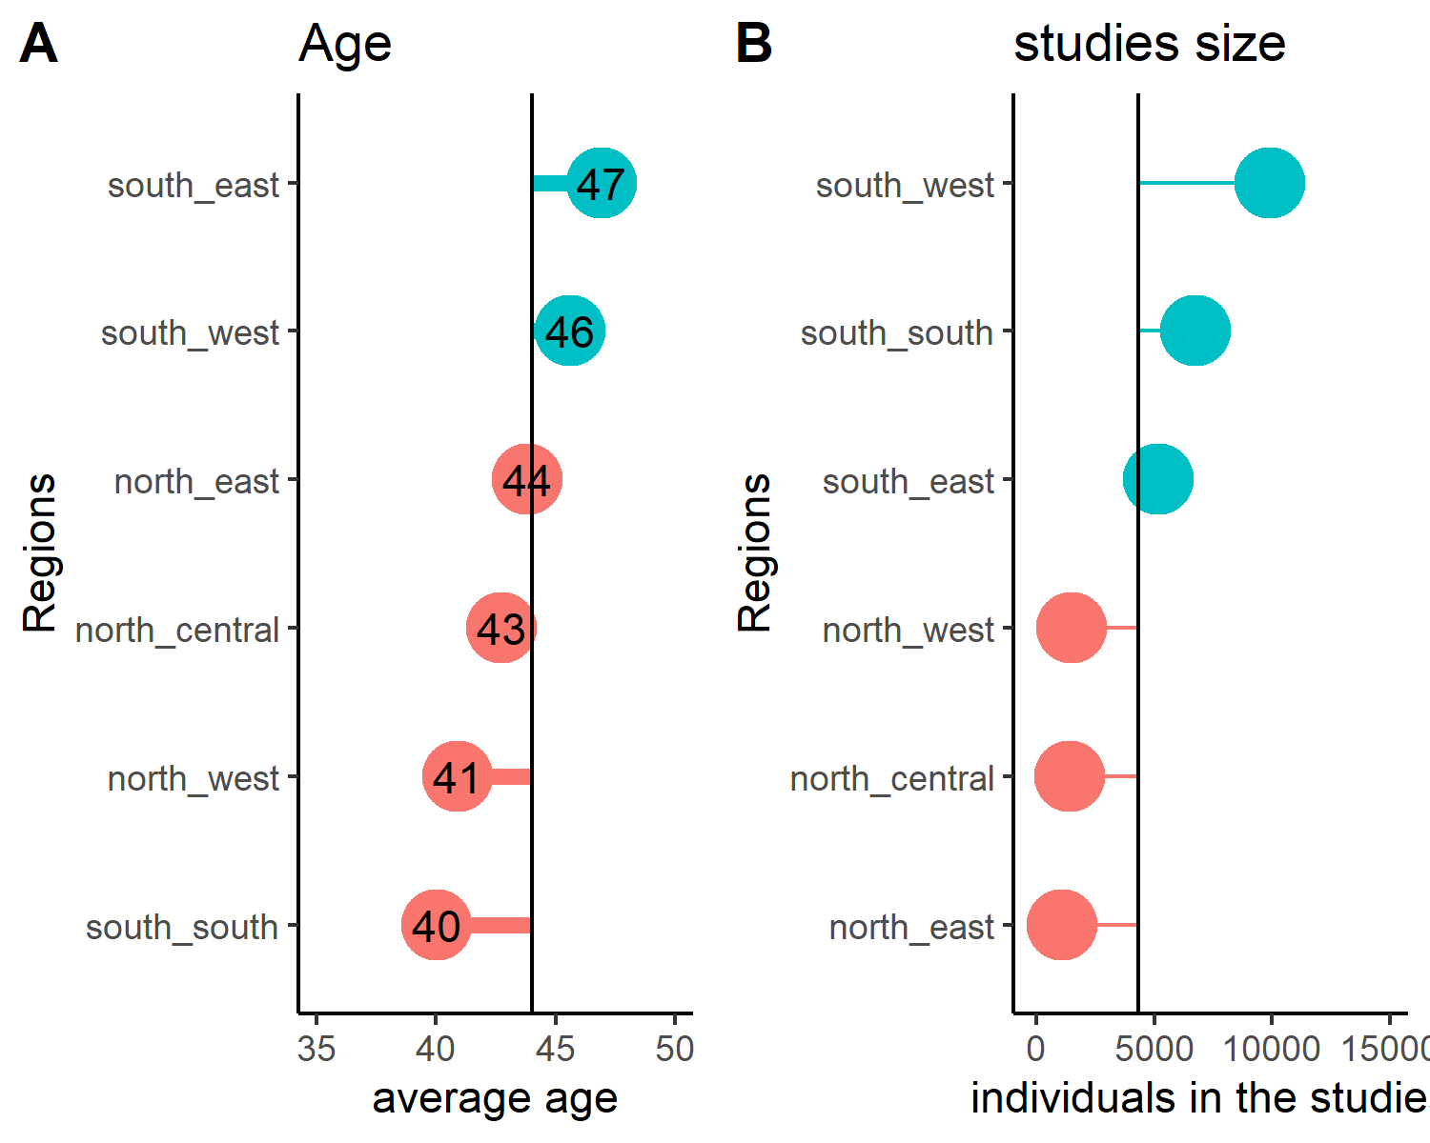

Figure 3.2: Mean Age and Number of Subjects in the Included Studies by Region

## 3.3 Fitting the Meta Analytic Model

Random Effects Model was fitted using inverse variance method with correction of pooled estimate and its variance using Sidik-Jonkman’s estimator for between study heterogeneity. Prevalences were tranformed using arcsine transformation. Figure 3.3 shows the forest plot of the model.

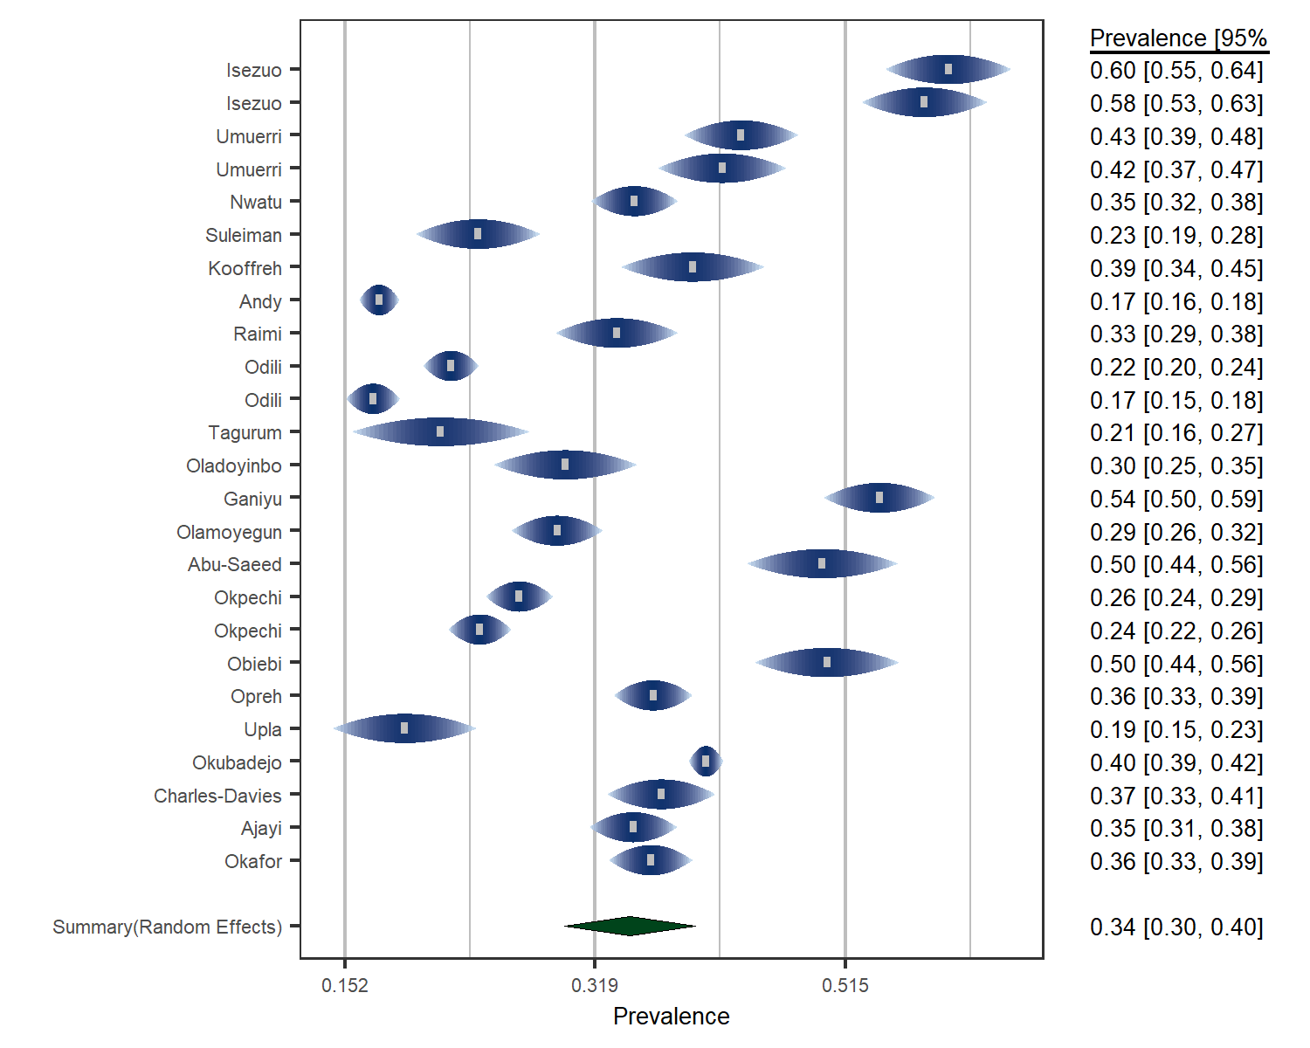

Figure 3.3: forest plot

The overall pooled prevalence of prehypertension in Nigeria is 34% (95% CI: 30%-40%). According to the latest data by United Nations,8 this translates to estimated 41.4 million adult prehypertensive individuals in Nigeria. The *P* value for the random meta analytic model is <0.001. The estimated total between studies heterogeneity(tau2) = 0.02(S.E = 0.005). Percentage of between study heterogeneity not explained by the sampling error (I2) is 98.6%. Test for Heterogenity showed Q(df= 24) = 1600, p-value<0.001 indicating substantial heterogeneity between the included studies. The more intuitive prediction interval generated from R package meta was from 10% to 61%. This range represents the possible values of prehypertension prevalence future studies in Nigeria can find.

## 3.4 Analysis of Between Study Heterogeneity

### 3.4.1 Outliers and Influencers

To explain the substantial heterogeneity, an exploration of possible outliers and influencers was carried out. Figure 3.4 shows radial plot of the model with no obvious outlier. This is confirmed by the influence analysis plots in figure 3.5.

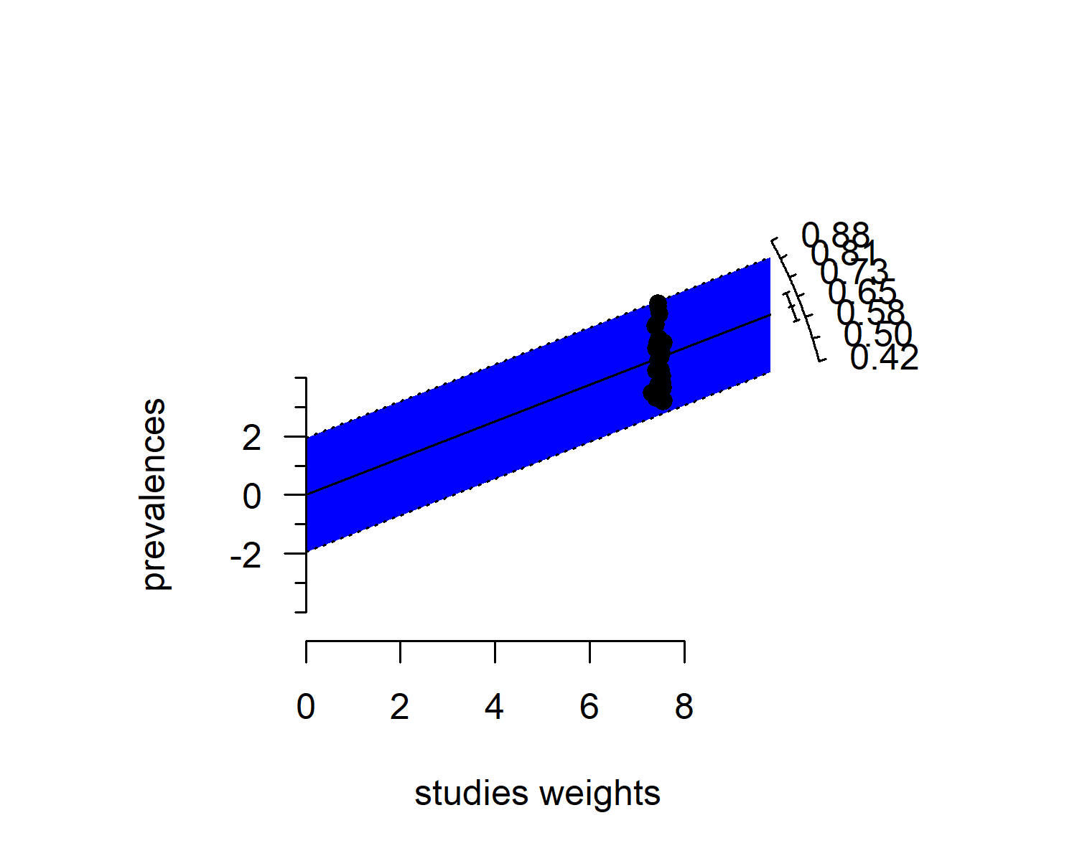

Figure 3.4: radial plot of the model

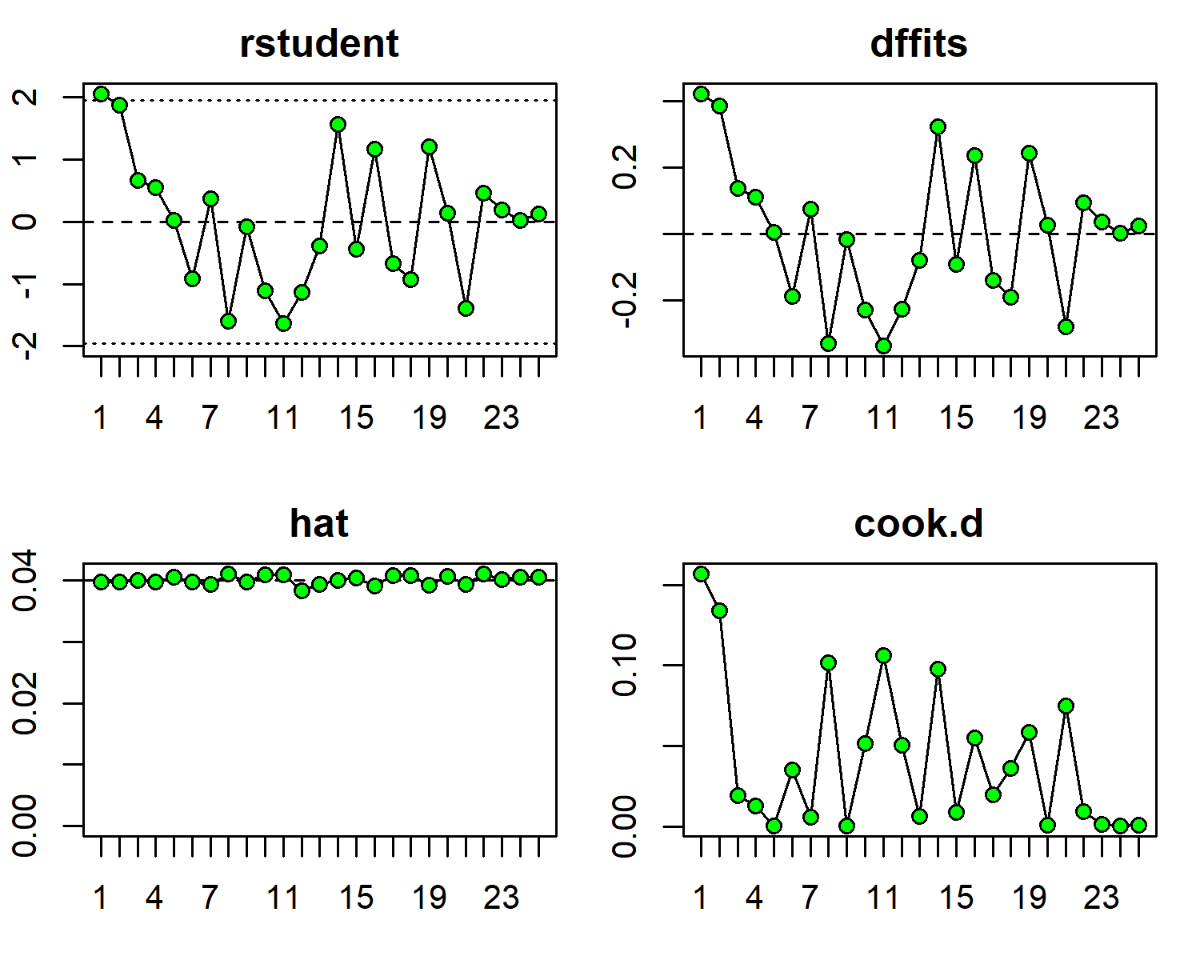

Figure 3.5: Influence analysis of the model

### 3.4.2 Gosh Analysis

The possibility of clusters within the included studies was explored through Gosh analysis implemented in metafor R package. Figure ?? reveals no clusters. The included studies formed indeed a single cluster with substantial heterogeneity.

### 3.4.3 Meta-regression using Studies Characteristics as Predictors

A meta-regression model was fitted using gender, geo-political region, settlement, mean age and sample size of the included studies. The value of tau2 dropped from 0.017 in the model without the predictors to 0.002 ( a 91% drop). The change in I2 is equally dramatic from 98.6%, signifying substantial heterogeneity, to 70.3% indicating moderate heterogeneity. This means most of the heterogeneity between the studies results from the differences in study characteristics. The relative changes in the two heterogeneity measures after fitting the meta-regression models is shown in Figure 3.6

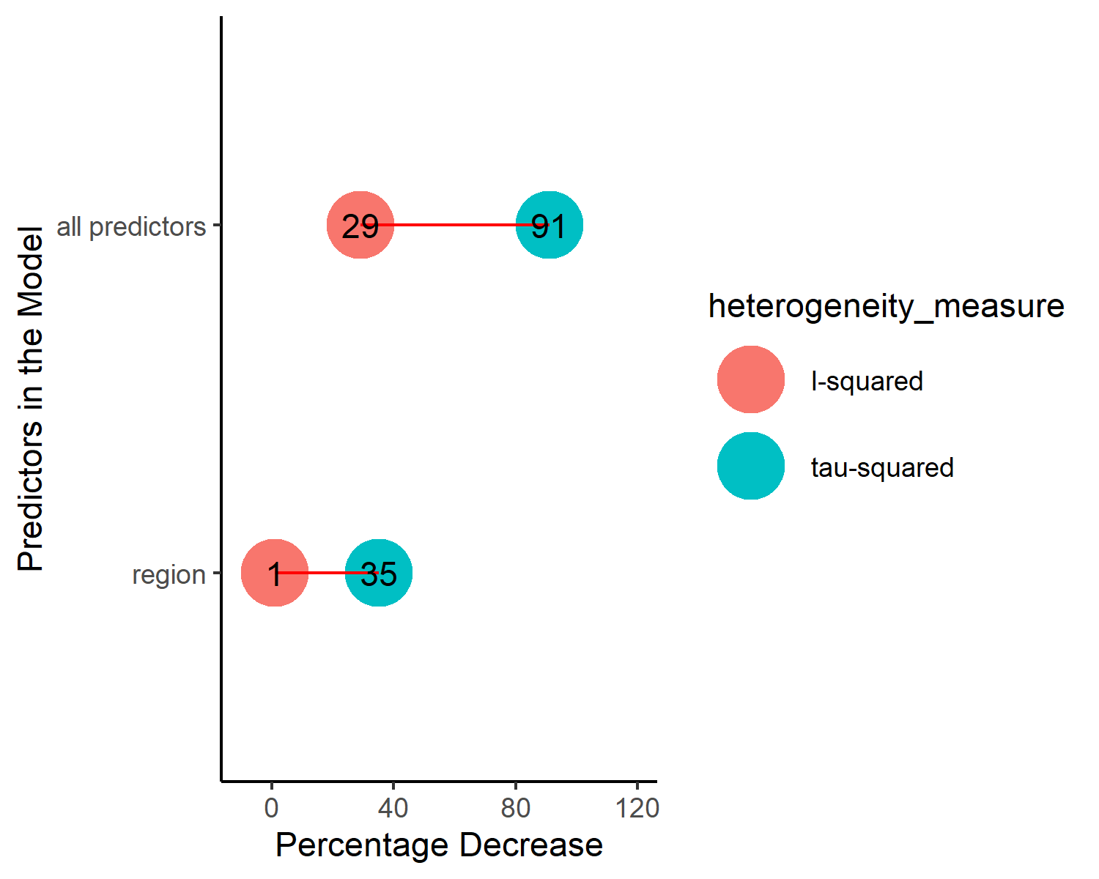

Figure 3.6: Comparison of Change in the Heterogeneity Measures after Fitting Meta-regression Models

## 3.5 Analysis of Publication Bias

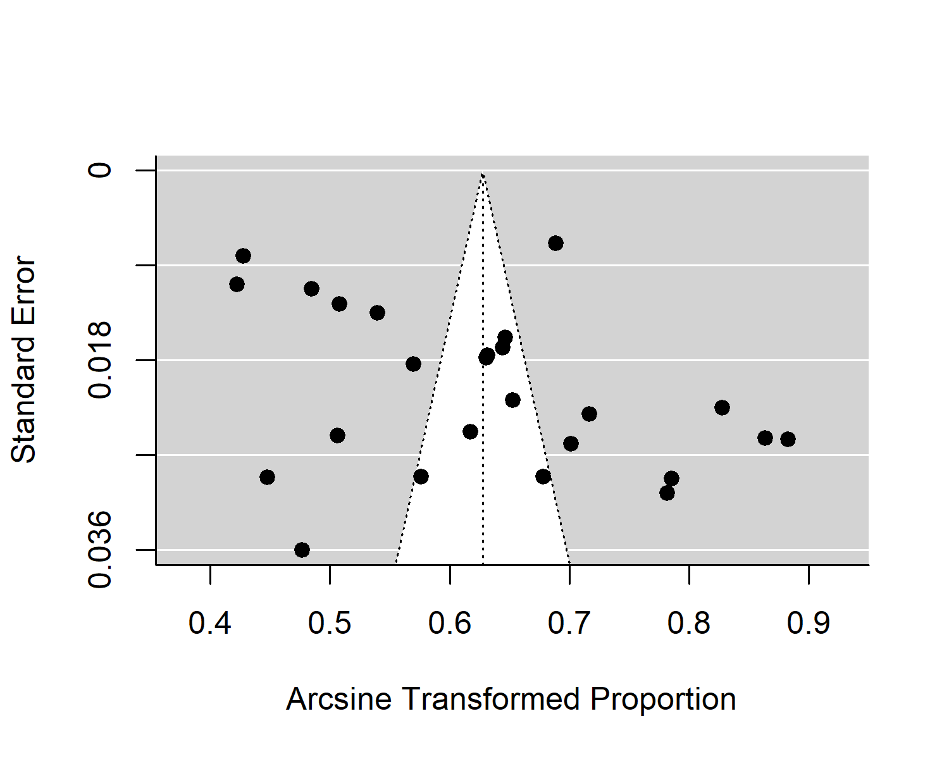

Figure 3.7: Funnel Plot

Figure 3.7 shows the funnel plot of the model. There was no obvious asymmetry in the plot. Formal test for plot asymmetery (regression test) was conducted and it was not statistically significant (*P* value = 0.079), confirming the visual assessment of the funnel plot.

## 3.6 Sex-Specific Prevalences of Prehypertension in Nigeria

As shown in figure 3.8, males have higher prehypertension prevalence of 39.1% (95% CI: 30.9%-47.6%) than females with prevalence of 28.5% (95% CI: 21.2%-36.4%). The difference is not statistically significant (*P* = 0.066)

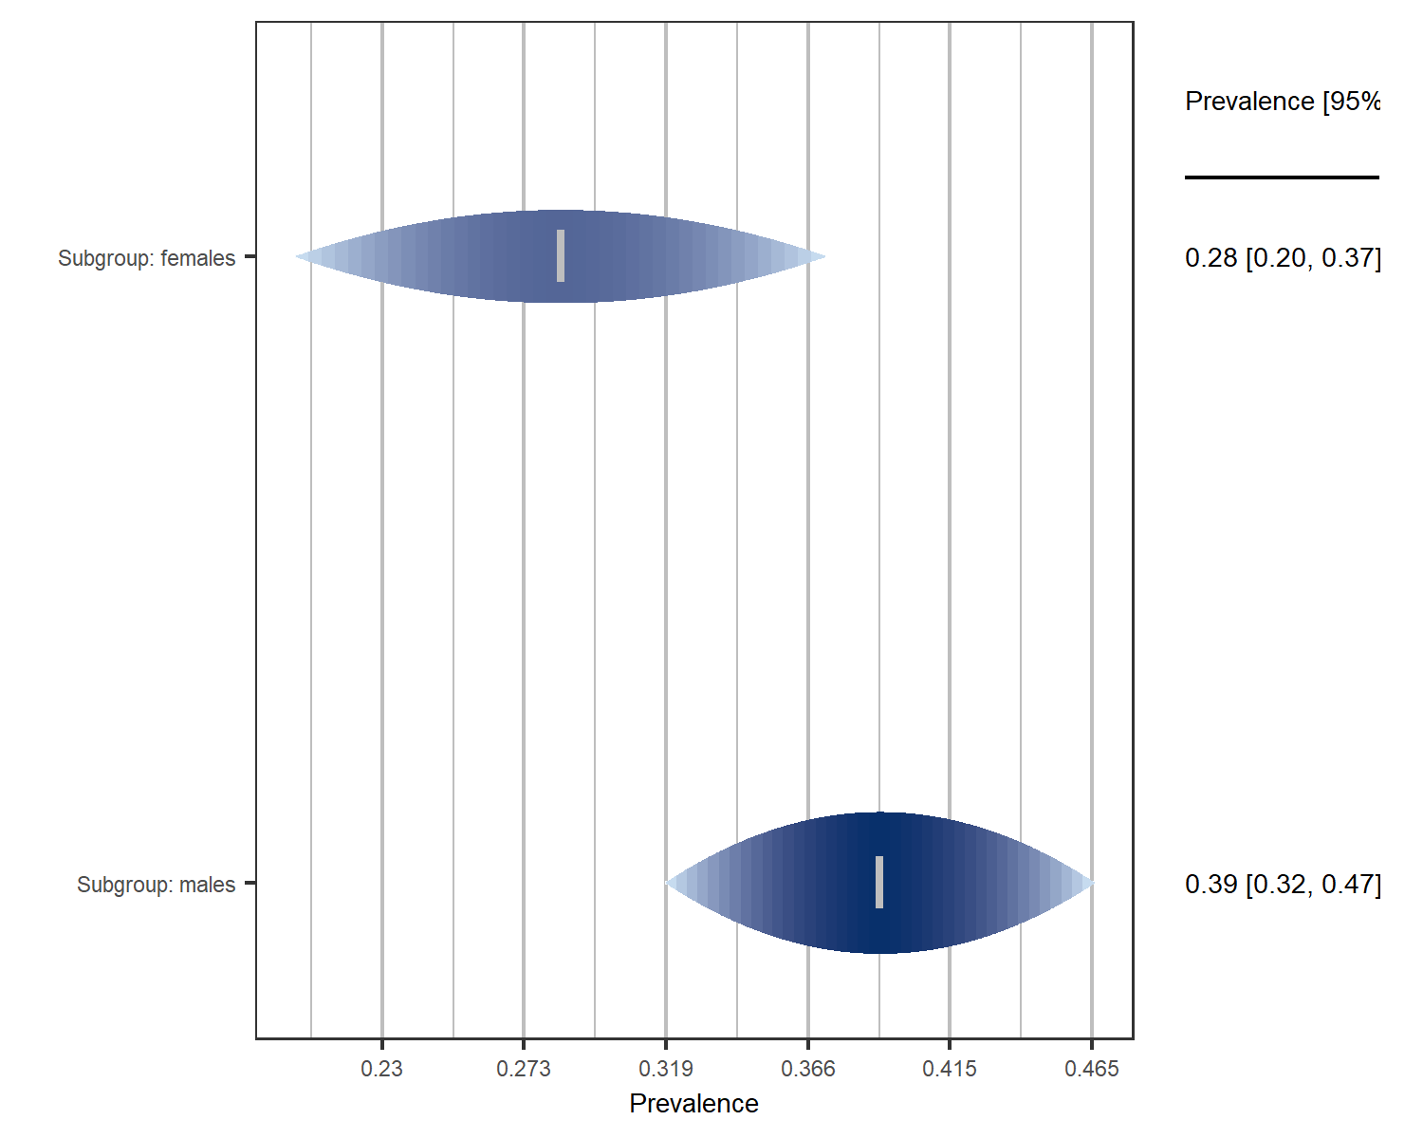

Figure 3.8: Prevalence of Prehypertension in Males and Females

## 3.7 Prevalence of Prehypertension in Nigeria by Geo-political Region

Figure 3.9 shows pooled prehypertension prevalences by geo-political zones in Nigeria. The region with the lowest prehypertension prevalence is North-East at 18%. The region with the highest prevalence of prehypertension is North-West at 43%. The *P* value of the model is 0.003 indicating a statistically significant difference in prevalence of prehypertension across the 6 geo-political regions in the country.

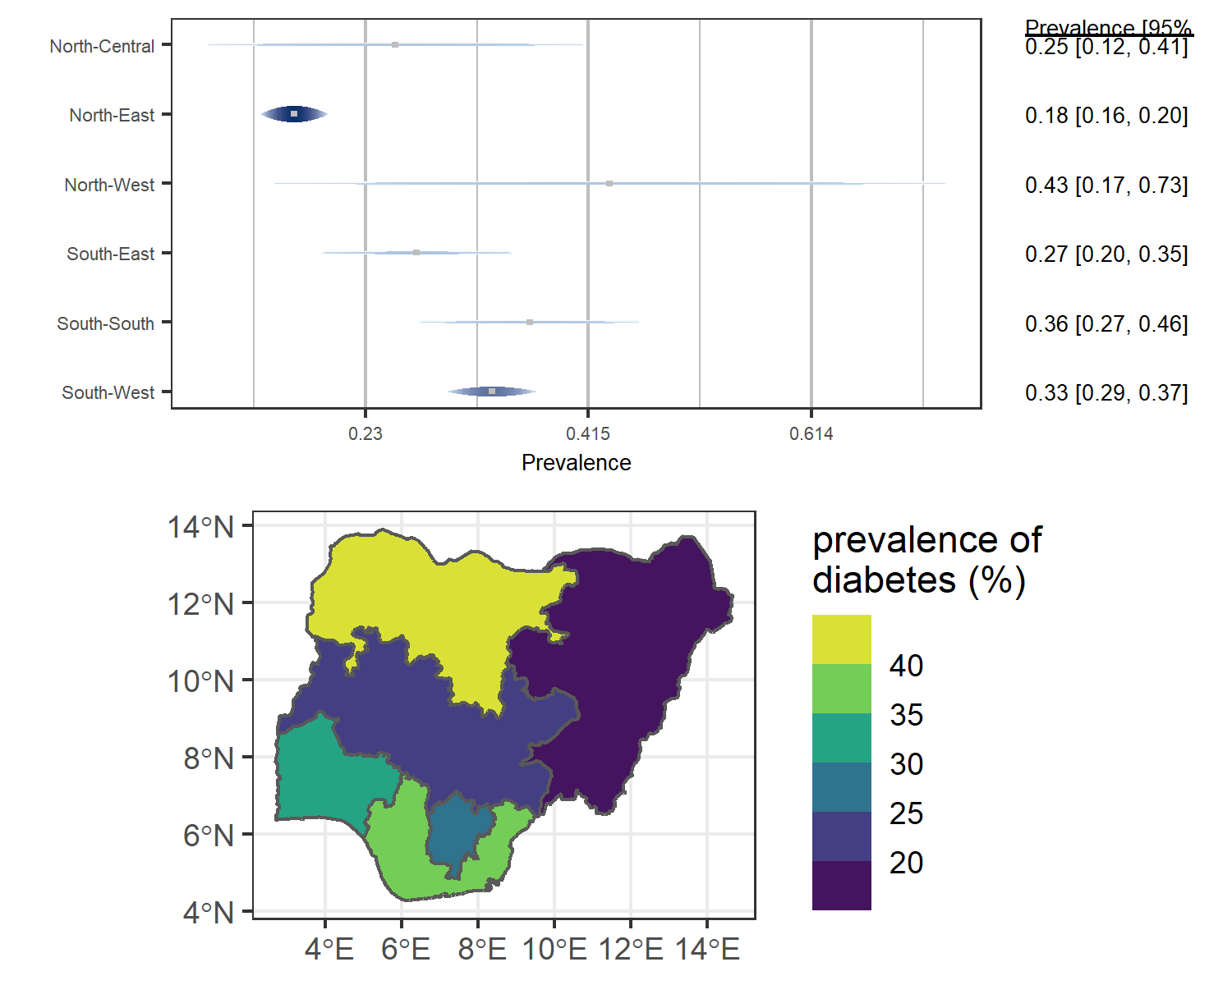

Figure 3.9: Forest Plot and Map of prevalence of Prehypertension by region

## 3.8 Difference in Prevalence of Prehypertension between Urban and Rural Settlements in Nigeria

As figure 3.10 shows The pooled prevalence in rural settings is 32% whereas the pooled prevalence for urban settings is 37% The difference is not statistically significant (*P* = 0.307)

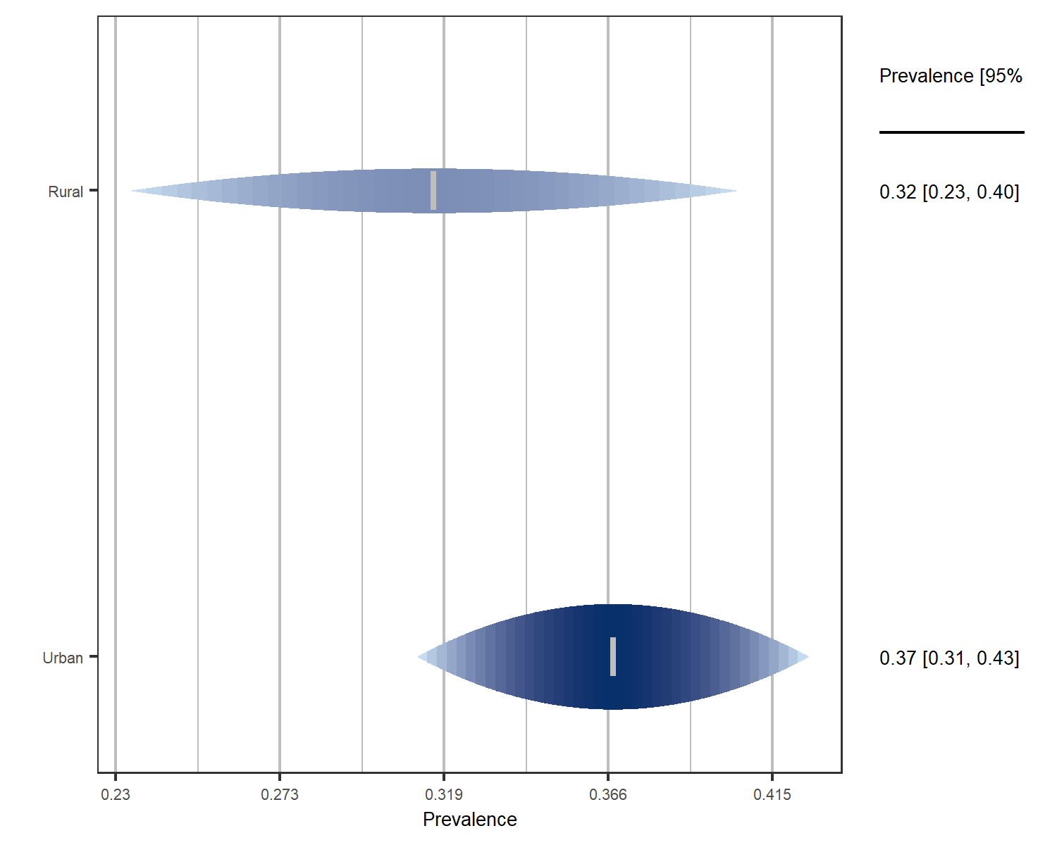

Figure 3.10: forest plot of prevalence by rural and urban settlements

# 4 DISCUSSION

The pooled estimate of prehypertension prevalence in Nigeria found by this study, 34% (95% CI: 30%-40%), is similar to but more precise than the prevalence of 30.9% (95% CI: 22.0%-39.7%) found in a recent meta-analysis in the country.6 The reason for this disparity in precision is explained by the difference in the number of studies and individuals included in the two meta-analyses; our analysis involves larger number of studies and individuals explaining the higher precision of our estimate. It is of note that prehypertension and hypertension have almost the same prevalence.6 This essentially means that two-thirds of adult Nigerians have abnormal blood pressures and are at high risk of developing endpoint cardiovascular events like stroke, coronory heart disease and chronic kidney disease.

Analysis of heterogeneity in this study reveals different behaviours for the two measures of heterogeneity; I2 and tau2. The former is known to be sensitive to the size of studies i.e. if the included studies are fairly large then the sampling error will be close to zero and I2 as a ratio will approach 100%18. To measure, with a precision of 0.05 and 95% confidence interval, a prehypertension prevalence of 34% found in this study, the minimum sample size required is 34510. The studies included in this meta-analysis are, by the selection criteria, relatively large with sample sizes having an interquartile range of 635. Consequently, I2 might be closer to 100% even if the between study heterogeneity is not substantial. This is likely the case as a metaregression with a single predictor (region where the study is carried out) reduced the tau2 by 35% while leaving I2 barely changed (Figure 3.6 ).

The burden of prehypertension in Nigeria is higher than what was found in United States19 and Canada,20 similar to what was found in China,21 Iran22 and Nepal23 and lower than what was found in Ghana,24 India25 and England20 (Figure 4.1).

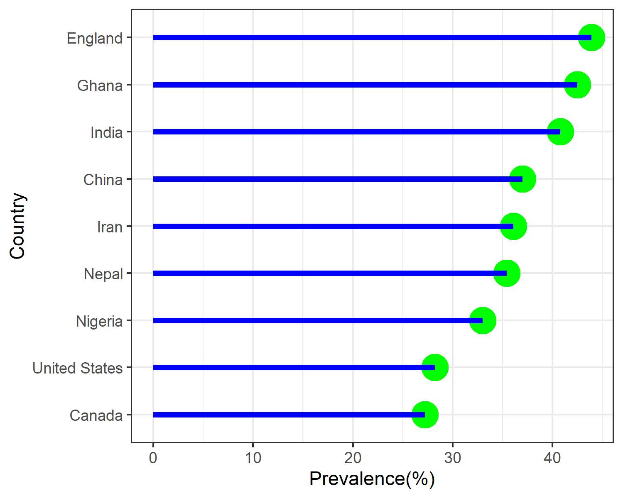

Figure 4.1: Prevalence of Prehypertension in Selected Countries

The higher prevalence of prehypertension in males compared to females found in this study(39.1% vs 28.5%) is consistent with global trend as found in another meta-analysis of published literature world-wide5. The higher prevalence of prehypertesion in males was also found in Nepal (31.6% vs 20.0%)23, India (47.3% vs 35.1%)25, England(53.5% vs 35%), Canada(32.9% vs 21.6%) and United States(42.7% vs 29.3%)20.

The higher prevalence of prehypertension in urban compared to rural settlements in Nigeria (32% vs 37%) is in contrast to what was found in a 2017 Nationwide Survey which found a higher prevalence of prehypertension in rural areas (37.5% vs 24.7%)26. However, consideing the overlapping confidence intervals of the pooled prevalences in rural and urban areas (24%-39% and 30% -44%) respectively), the survey’s finding are plausibe under this meta-analytic model. This high prevalence in rural settings may be part of the trend in urbanization of Nigerian rural areas with adoption of lifestlyes fueling rise in non-communicable disease26. This higher prevalence of prehypertension in rural vs urban areas was also found in Nepal (40.4% vs 29.3%)23 and India (41.3% vs 40.2%)25.

Out of the six geo-political regions in the country, the three regions with highest prevalence of prehypertension, in descending order are north-west(43%), south-south (36%) and south-west(33%) with the north-east having the lowest prevalence among the six regions(18%). However, only the south-west and north-east prevalence estimates have relatively narrow confidence interval with the estimates of the remaining regions having wide confidence intervals (Figure 3.9). The high ranking of south-western and south-southern regions is similar to Nationwide survery earlier mentioned26.

# 5 SUMMARY AND CONCLUSION

34% (95% CI: 30%-40%) of adult Nigerians or 41.4 million adult Nigerians have prehypertension. Males have higher prehypertension prevalence of 39.1% (95% CI: 30.9%-47.6%) than females with prevalence of 28.5% (95% CI: 21.2%-36.4%). The region with the lowest prehypertension prevalence is North-East at 18%. The region with the highest prevalence of prehypertension is North-West at 43%. The pooled prevalence in rural settlements is 32% whereas the pooled prevalence for urban settlements is 37%. Differences between sexes and between rural and urban settlements were not statistically significant. However, differences bewteen the geo-political regions are statistically significant. In conclusion, the burden of prehypertension Nigeria is high and represents a future burden of hypertension and other cardiovascular events

# REFERENCES

1. Whelton PK, Carey RM, Aronow WS, Casey DE, Collins KJ, Dennison HC, et al. 2017 ACC/AHA/AAPA/ABC/ACPM/AGS/APhA/ASH/ASPC/NMA/PCNA Guideline for the Prevention, Detection, Evaluation, and Management of High Blood Pressure in Adults. Journal of the American College of Cardiology. 2018 May;71(19):e127–248.

2. National High Blood Pressure Education Program. The Seventh Report of the Joint National Committee on Prevention, Detection, Evaluation, and Treatment of High Blood Pressure [Internet]. Bethesda (MD): National Heart, Lung, and Blood Institute (US); 2004 [cited 2021 Jul 13]. Available from: <http://www.ncbi.nlm.nih.gov/books/NBK9630/>

3. Vasan RS, Larson MG, Leip EP, Kannel WB, Levy D. Assessment of frequency of progression to hypertension in non-hypertensive participants in the Framingham Heart Study: A cohort study. Lancet (London, England). 2001 Nov;358(9294):1682–6.

4. NCD Risk Factor Collaboration (NCD-RisC). Worldwide trends in blood pressure from 1975 to 2015: A pooled analysis of 1479 population-based measurement studies with 19 $⋅$ 1 million participants. Lancet (London, England). 2017 Jan;389(10064):37–55.

5. Guo X, Zhang X, Hu J, Sun Y, Zheng L, Zou L, et al. The prevalence and heterogeneity of prehypertension: A meta-analysis and meta-regression of published literature worldwide. Cardiovascular Journal of Africa. 2012 Feb;23(1):44–50.

6. Adeloye D, Owolabi EO, Ojji DB, Auta A, Dewan MT, Olanrewaju TO, et al. Prevalence, awareness, treatment, and control of hypertension in Nigeria in 1995 and 2020: A systematic analysis of current evidence. Journal of Clinical Hypertension (Greenwich, Conn). 2021 May;23(5):963–77.

7. Udo KR, Ajayi JFA, Kirk-Greene AHM, Falola TO. Nigeria. Encyclopedia Britannica [Internet]. 2020 [cited 2021 Jul 5]; Available from: <https://www.britannica.com/place/Nigeria>

8. UNFPA - United Nations Population Fund. UNFPA - United Nations Population Fund [Internet]. 2021 [cited 2021 Jul 5]. Available from: <https://www.unfpa.org/>

9. Joanna Briggs Institute. Joanna Briggs Institute Critical Appraisal Checklist for Prevalence Studies [Internet]. Joanna Briggs Institute; 2017. Available from: <https://jbi.global/sites/default/files/2019-05/JBI_Critical_Appraisal-Checklist_for_Prevalence_Studies2017_0.pdf>

10. EPITOOLS. Epitools - Sample size to estimate a proportion or appar ... [Internet]. [cited 2021 Jul 28]. Available from: <https://epitools.ausvet.com.au/oneproportion>

11. R Core Team. R: A language and environment for statistical computing [Internet]. Vienna, Austria: R Foundation for Statistical Computing; 2021 [cited 2021 Jun 16]. Available from: <https://www.r-project.org/>

12. Viechtbauer W. Conducting meta-analyses in with the metafor package. Journal of Statistical Software [Internet]. 2010;36(3):1–48. Available from: <https://doi.org/10.18637/jss.v036.i03>

13. Sidik K, Jonkman JN. On Constructing Confidence Intervals for a Standardized Mean Difference in Meta-analysis. Communications in Statistics - Simulation and Computation. 2003 Jan;32(4):1191–203.

14. Viechtbauer W, Cheung MW-L. Outlier and influence diagnostics for meta-analysis. Research Synthesis Methods. 2010 Apr;1(2):112–25.

15. Balduzzi S, Rücker G, Schwarzer G. How to perform a meta-analysis with R: A practical tutorial. Evidence-Based Mental Health. 2019;22:153–60.

16. Borenstein M, Higgins JPT, Hedges LV, Rothstein HR. Basics of meta-analysis: *I* 2 is not an absolute measure of heterogeneity: *I* 2 is not an absolute measure of heterogeneity. Research Synthesis Methods. 2017 Mar;8(1):5–18.

17. Egger M, Davey Smith G, Schneider M, Minder C. Bias in meta-analysis detected by a simple, graphical test. BMJ (Clinical research ed). 1997 Sep;315(7109):629–34.

18. Harrer M, Cuijpers P, Furukawa TA, Ebert DD. Doing Meta-Analysis with R: A Hands-On Guide [Internet]. First. 2021 [cited 2021 Jul 25]. Available from: <https://www.routledge.com/Doing-Meta-Analysis-with-R-A-Hands-On-Guide/Harrer-Cuijpers-Furukawa-Ebert/p/book/9780367610074>

19. Booth JN, Li J, Zhang L, Chen L, Muntner P, Egan B. Trends in Prehypertension and Hypertension Risk Factors in US Adults. Hypertension. 2017 Aug;70(2):275–84.

20. Joffres M, Falaschetti E, Gillespie C, Robitaille C, Loustalot F, Poulter N, et al. Hypertension prevalence, awareness, treatment and control in national surveys from England, the USA and Canada, and correlation with stroke and ischaemic heart disease mortality: A cross-sectional study. BMJ Open. 2013 Aug;3(8):e003423.

21. Jin N, Li G, Li H, Chen L, Leng B. [Incidence and risk factors of prehypertension among adults in mainland China: a meta-analysis]. Nan fang yi ke da xue xue bao = Journal of Southern Medical University. 2013 Dec;33(12):1738–43.

22. Afsargharehbagh R, Rezaie-Keikhaie K, Rafiemanesh H, Balouchi A, Bouya S, Dehghan B. Hypertension and Pre-Hypertension Among Iranian Adults Population: A Meta-Analysis of Prevalence, Awareness, Treatment, and Control. Current Hypertension Reports. 2019 Apr;21(4):27.

23. Huang Y, Guo P, Karmacharya BM, Seeruttun SR, Xu DR, Hao Y. Prevalence of hypertension and prehypertension in Nepal: A systematic review and meta-analysis. Global Health Research and Policy. 2019 Apr;4(1):11.

24. Dosoo DK, Nyame S, Enuameh Y, Ayetey H, Danwonno H, Twumasi M, et al. Prevalence of Hypertension in the Middle Belt of Ghana: A Community-Based Screening Study. International Journal of Hypertension. 2019 Oct;2019:e1089578.

25. Tripathy JP, Thakur JS, Jeet G, Chawla S, Jain S. Alarmingly high prevalence of hypertension and pre-hypertension in North India-results from a large cross-sectional STEPS survey. PLOS ONE. 2017 Dec;12(12):e0188619.

26. Odili AN, Chori BS, Danladi B, Nwakile PC, Okoye IC, Abdullahi U, et al. Prevalence, Awareness, Treatment and Control of Hypertension in Nigeria: Data from a Nationwide Survey 2017. Global Heart. 15(1):47.

27. Abah I. Hypertension prevalence, knowledge, attitude & awareness among pharmacists in Jos, Nigeria. West African Journal of Pharmacy. 2014 Sep;25:98–106.

28. Abu-Saeed K, Odili VU, Muslim JO. High Prevalence of Hypertension among Residents of Ilorin. 2014 Dec [cited 2021 Jul 9];1(1):54–8. Available from: <http://www.jsppharm.org/home/abstract.php?id=11&aTitle=High%20Prevalence%20of%20Hypertension%20among%20Residents%20of%20Ilorin>

29. Adamu H, Makusidi AM, Liman HM, Isah MD, Jega MR, Chijioke A. Prevalence of Obesity, Diabetes Type 2 and Hypertension among a Sampled Population from Sokoto Metropolis-Nigeria. Journal of Advances in Medicine and Medical Research. 2014 Jan;2065–80.

30. Adedoyin RA, Mbada CE, Balogun MO, Martins T, Adebayo RA, Akintomide A, et al. Prevalence and pattern of hypertension in a semiurban community in Nigeria. European journal of cardiovascular prevention and rehabilitation. 2008 Dec;15(6):683–7.

31. Adejumo EN, Ogundahunsi OA, Adejumo OA, Daniel OJ, Okafor PA, Azenabor A. Generalized And Abdominal Obesity; The Association With Hypertension Among Men In Ikeja, Lagos State. Nigerian Journal of Clinical Medicine. 2013 Dec;5(1).

32. Adelowo A, Mercy O. An Assessment of the Prevalence of Diabetes Mellitus and Its Risk Factors among People Living in Abuja, Nigeria. 2019 Jun;5:171–86.

33. Adelowo A, Mercy O. An Assessment of the Prevalence of Diabetes Mellitus and Its Risk Factors among People Living in Abuja, Nigeria. 2019 Jun;5:171–86.

34. Adenrele H, Mercy O, Adelowo A. CARDIO-METABOLIC RISK ASSESSMENT AMONG CORPORATE WORKFORCE IN ABUJA. NIGERIA JOURNAL OF RESEARCH AND CONTEMPORARY ISSUES IN HUMAN KINETICS AND HEALTH EDUCATION [Internet]. 2020 Dec;4(1):27–41. Available from: <https://www.researchgate.net/publication/347389567_JOURNAL_OF_RESEARCH_AND_CONTEMPORARY_ISSUES_IN_HUMAN_KINETICS_AND_HEALTH_EDUCATION_PEER-REVIEWED_JORCIHKHE_2018_4_1_27_-41_CARDIO-METABOLIC_RISK_ASSESSMENT_AMONG_CORPORATE_WORKFORCE_IN_ABUJA_NIGERIA_J>

35. Adeoye AM, Adebiyi A, Owolabi MO, Lackland DT, Ogedegbe G, Tayo BO. GENDER DISPARITY IN BLOOD PRESSURE LEVELS AMONG NIGERIAN HEALTH WORKERS. Journal of clinical hypertension (Greenwich, Conn). 2016 Jul;18(7):685–9.

36. Ajayi DD, Deji SA, Odu OO, Dada SA, Amu EO, Marcus O. Cardiovascular Disease Risk Factors Assessment of Women Attending a Religious Program in Ado Ekiti, Nigeria. American Journal of Biomedical and Life Sciences. 2019 May;7(2):36.

37. Ajayi I, Sowemimo I, Akpa O, Ossai N. Prevalence of hypertension and associated factors among residents of Ibadan-North Local Government Area of Nigeria. Nigerian Journal of Cardiology. 2016;13(1):67.

38. Akinbodewa AA, Adejumo AO, Koledoye OV, Kolawole JO, Akinfaderin D, Lamidi AO, et al. Community screening for pre-hypertension, traditional risk factors and markers of chronic kidney disease in Ondo State, South-Western Nigeria. The Nigerian Postgraduate Medical Journal. 2017 Jan-Mar;24(1):25–30.

39. Akinlua JT, Meakin R, Umar AM, Freemantle N. Current Prevalence Pattern of Hypertension in Nigeria: A Systematic Review. Reboldi G, editor. PLOS ONE. 2015 Oct;10(10):e0140021.

40. Aladeniyi I, Adeniyi O, Owolabi E, Fawole O, Adeolu M, Ter G, et al. Prevalence, Awareness and Correlates of Hypertension Among Urban Public Workers in Ondo State, Nigeria. Online Journal of Health and Allied Sciences. 2017 Oct;16.

41. Ale O, Ajuluchukwu J, Oke D, Mbakwem A. Impact of prehypertension on left ventricular mass and QT dispersion in adult black Nigerians. Cardiovascular Journal of Africa. 2014 Apr;25(2):78–82.

42. Ambakederemo TE, Chikezie EU. Assessment of some traditional cardiovascular risk factors in medical doctors in Southern Nigeria. Vascular Health and Risk Management. 2018 Oct;14:299–309.

43. Andy JJ, Peters EJ, Ekrikpo UE, Akpan NA, Unadike BC, Ekott JU. Prevalence and correlates of hypertension among the Ibibio/Annangs, Efiks and Obolos: A cross sectional community survey in rural South-South Nigeria. Ethnicity & Disease [Internet]. 2012 Jul [cited 2021 Jul 9];22(3):335–9. Available from: <https://www.ethndis.org/edonline/index.php/ethndis/article/view/459>

44. Ayanniyi O, Akinremi A, Odunnaiya N, Adenaike I. Cardiovascular disease risk among professionals: A survey of modifiable risk factors among teachers in an urban community. Highland Medical Research Journal. 2016 Jul;16(1):1–6.

45. Ayodele OE, Akanbi OO, Akinwusi PO, Hassan AO, Ogunro PO. Urinary Abnormalities, Blood Pressure and Anthropometric Profiles Among Students in a Nigerian University. Tropical Journal of Nephrology [Internet]. 2009 [cited 2021 Jul 9];4(1):21–9. Available from: <http://www.tjn-online.com/index.php/tjn/article/view/91>

46. Banigbe BF, Itanyi IU, Ofili EO, Ogidi AG, Patel D, Ezeanolue EE. High prevalence of undiagnosed hypertension among men in North Central Nigeria: Results from the Healthy Beginning Initiative. PLOS ONE. 2020 Nov;15(11):e0242870.

47. Bello-Ovosi BO, Asuke S, Abdulrahman SO, Ibrahim MS, Ovosi JO, Ogunsina MA, et al. Prevalence and correlates of hypertension and diabetes mellitus in an urban community in North-Western Nigeria. Pan African Medical Journal. 2018;29(1):1–7.

48. Bergmann T. Identifying outliers and influential cases [Internet]. Till Bergmann. 2015 [cited 2021 Jul 27]. Available from: <https://tillbe.github.io/./outlier-influence-identification.html>

49. Charles-Davies MA, Fasanmade AA, Olaniyi JA, Oyewole OE, Owolabi MO, Adebusuyi JR, et al. Metabolic Alterations in Different Stages of Hypertension in an Apparently Healthy Nigerian Population. International Journal of Hypertension. 2013;2013:351357.

50. Dada IO, Igbe IA. Feeding habits, Overweight, Obesity and Hypertension and Associated Factors among Polytechnic Students in Ekiti State, Southwest Nigeria. Journal of Multidisciplinary Research in Healthcare. 2020;7(1):33–48.

51. DerSimonian R, Laird N. Meta-analysis in clinical trials. Controlled Clinical Trials. 1986 Sep;7(3):177–88.

52. Dokunmu TM, Yakubu OF, Adebayo AH, Olasehinde GI, Chinedu SN. Cardiovascular Risk Factors in a Suburban Community in Nigeria. International Journal of Hypertension. 2018 Apr;2018:e6898527.

53. Egbi O, Ogoina D, Oyeyemi A. Prevalence of hypertension and associated factors in a rural community in Bayelsa State. International Journal of Research in Medical Sciences. 2018 Mar;6:1106.

54. Egbi OG, Rotifa S, Jumbo J. Prevalence of hypertension and its correlates among employees of a tertiary hospital in Yenagoa, Nigeria. Annals of African Medicine. 2015 Jan;14(1):8.

55. Egbuonu ACC, Egbuonu ONC, Akabogu N, Udensi ZI, Ugwo UO, Ejidike AG. The Prevalence And Demographic Pattern Of Obesity And Its Correlates In Undergraduates Of Michael Okpara University Of Agriculture Umudike South-East, Nigeria. 2015 Nov;

56. Ejike CECC, Ukegbu PO. Not a ‘Straitjacket Affair’: Anthropometrically Derived Obesity Index Correlates of Elevated Blood Pressure among University Undergraduates. Medical Sciences. 2017 Jun;5(2):9.

57. Ganiyu K, Kpokiri E, Omoshue O. Prevalence of Undiagnosed Elevated Blood Pressure in Okparabe Community in Southern Nigeria. 2015 Jan;1.

58. Guwatudde D, Nankya-Mutyoba J, Kalyesubula R, Laurence C, Adebamowo C, Ajayi I, et al. The burden of hypertension in sub-Saharan Africa: A four-country cross sectional study. BMC Public Health. 2015 Dec;15(1):1211.

59. Hartung J. An Alternative Method for Meta-Analysis. Biometrical Journal. 1999;41(8):901–16.

60. Humanitarian Data Exchange. Nigeria - Subnational Administrative Boundaries [Internet]. The Humanitarian Data Exchange. 2020 [cited 2021 Jul 4]. Available from: <https://data.humdata.org/dataset/nga-administrative-boundaries>

61. Ibuaku C, Nwajei A, Queen A. Anthropometric Assessment of Nutritional Status of Adults in a Non-Conflict Environment of the Niger-Delta Region of Nigeria. 2018 Aug;46–9.

62. Isezuo SA, Sabir AA, Ohwovorilole AE, Fasanmade OA. Prevalence, associated factors and relationship between prehypertension and hypertension: A study of two ethnic African populations in Northern Nigeria. Journal of Human Hypertension. 2011;

63. Kooffreh M, M.G A. Differences in Blood Pressure Levels and Its Association with Obesity Indices among Traders in Watt Market Calabar, Cross River State Nigeria. Scholars Academic Journal of Biosciences. 2016 Jul;4:565–70.

64. Makusidi MA, Liman HM, Yakubu A, Isah MDA, Jega RM, Adamu H, et al. Prevalence of Non-communicable Diseases and its Awareness among Inhabitants of Sokoto Metropolis: Outcome of a Screening Program for Hypertension, Obesity, Diabetes Mellitus and Overt proteinuria. Arab Journal of Nephrology and Transplantation. 2013 Oct;6(3):189–91.

65. Mmom FC, Chuemere AN. A Study of Incidence and Prevalence of Hypertension, Diabetes and Obesity with Blood Type in Postmenopausal Females in Port Harcourt. Saudi Journal of Biomedical Research. 2016;1(1):22–9.

66. Munn Z, Moola S, Lisy K, Riitano D, Tufanaru C. Methodological guidance for systematic reviews of observational epidemiological studies reporting prevalence and incidence data. Int J Evid Based Healthc. 2015;13(3):147–53.

67. Nkechi OI. Prevalence and Predictors of Overweight, Obesity and Hypertension among Undergraduates of a Southern Nigerian University. Journal of Medical Science And clinical Research. 2018 Dec;6(12).

68. Nwatu CB, Young EE, Okwara CC, Okoli CE, Obi PC, Anyim OB, et al. Concurrent Prediabetes and Prehypertension in a Rural Community in South East Nigeria. Journal of Advances in Medicine and Medical Research. 2017 Jun;1–0.

69. Nwazor FOO, Oputa SC. Blood Pressure Pattern Among Young People In South-Eastern Nigeria: A Cross-Sectional Survey. Ebonyi Medical Journal. 2012;11(1-2):77–83.

70. Obiebi IP, Aiwuyo HO. 2017 American College of Cardiology/American Heart Association Clinical Guideline-based Prevalence of Hypertension in a semi-urban community in Nigeria: Public Health Perspective. Revista Colombiana de Cardiología. 2019 Nov;26(6):346–53.

71. Obiorah MO, Ogbodo EC, Amah UK, Ezeugwunne IP, Analike RA, Onah CE, et al. PREVALENCE OF PREHYPERTENSION AND ASSESSMENT OF CARDIOVASCULAR FUNCTION AMONG PREHYPERTENSIVE UNDERGRADUATE STUDENTS IN NNEWI, ANAMBRA STATE, NIGERIA. [Internet]. 2017 [cited 2021 Jul 9]. Available from: <https://www.semanticscholar.org/paper/PREVALENCE-OF-PREHYPERTENSION-AND-ASSESSMENT-OF-IN-Ajulu-Meludu/b27a9be3c926f0ad37b641b726895f22e9878bab>

72. Odunaiya N, Okoye E, Adegoke O, Ojoye D, Ooguntibeju O. High Prevalence and Clustering Of Modifiable Cardiovascular Disease Risk Factors among Nurses in Nigeria: Implication for Translating Knowledge into Practice among Health Care Professionals. International Journal of Public Health. 2021 Feb;5:1–7.

73. Ofori SN, Fobil JN, Odia OJ. Household biomass fuel use, blood pressure and carotid intima media thickness; a cross sectional study of rural dwelling women in Southern Nigeria. Environmental Pollution. 2018 Nov;242:390–7.

74. Okafor ChinyereN, Young EkenechukwuE, Nwobi EmmanuelA, Ike SamuelO. CARDIOVASCULAR RISK FACTORS IN A POPULATION OF RURAL WOMEN IN SOUTH-EAST NIGERIA. African journal of medicine and medical sciences [Internet]. 2014 Sep [cited 2021 Jul 9];43(Suppl 1):225–32. Available from: <https://www.ncbi.nlm.nih.gov/pmc/articles/PMC4679289/>

75. Okafor CI, Fasanmade O, Ofoegbu E, Ohwovoriole AE. Comparison of the performance of two measures of central adiposity among apparently healthy Nigerians using the receiver operating characteristic analysis. Indian Journal of Endocrinology and Metabolism. 2011;15(4):320–6.

76. Okpechi IG, Chukwuonye II, Tiffin N, Madukwe OO, Onyeonoro UU, Umeizudike TI, et al. Blood Pressure Gradients and Cardiovascular Risk Factors in Urban and Rural Populations in Abia State South Eastern Nigeria Using the WHO STEPwise Approach. PLoS ONE. 2013 Sep;8(9):e73403.

77. Okubadejo NU, Ozoh OB, Ojo OO, Akinkugbe AO, Odeniyi IA, Adegoke O, et al. Prevalence of hypertension and blood pressure profile amongst urban-dwelling adults in Nigeria: A comparative analysis based on recent guideline recommendations. Clinical Hypertension. 2019 Apr;25:7.

78. Okwuonu CG, Ngoka SC, Chimezie OJ, Eze TH, Uwanurochi K, Mbanaso AU. Towards prevention of hypertension in Nigeria: A study of prehypertension and its associations among apparently healthy adults in Umuahia, South-East Nigeria. International Journal of Preventive Medicine. 2015 Jul;6:61.

79. Oladoyinbo CA, Ekerette NN, Ogunubi TI. Obesity and Hypertension amongst Traders in Ijebu Ode, Nigeria. African Journal of Biomedical Research. 2015;18(1):23–7.

80. Olaitan OO. Central Obesity and Stress- Predisposing Factors to Hypertension among Health Workers in Jos University Teaching Hospital, Plateau State, Nigeria. Current Research in Diabetes & Obesity Journal. 2020 Feb;12(4).

81. Olamoyegun M, Iwuala S, Asaolu S, Oluyombo R. Epidemiology and patterns of hypertension in semi-urban communities, south-western Nigeria. Cardiovascular Journal of Africa. 2016;27(6):356–60.

82. Olatona FA, Onabanjo OO, Ugbaja RN, Nnoaham KE, Adelekan DA. Dietary habits and metabolic risk factors for non-communicable diseases in a university undergraduate population. Journal of Health, Population and Nutrition. 2018 Aug;37(1):21.

83. Olawade D, Afolalu T, Wada O, Barka I. Evaluations of Hypertension among Adult Residents of Tinda Rural Community, Nigeria. 2020 Aug;6:157–62.

84. Ononamadu Chimaobi James, Ezekwesili Chinwe Nonyelum, Onyeukwu Onyemaechi Faith, Umeoguaju Uchenna Francis, Ezeigwe Obiajulu Christian, Ihegboro Godwin Okwudiri. Comparative analysis of anthropometric indices of obesity as correlates and potential predictors of risk for hypertension and prehypertension in a population in Nigeria. Cardiovascular Journal of Africa. 2017 Apr;28(2):92–9.

85. Opreh OP, Olajubu TO, Akarakiri KJ, Ligenza V, Amos JT, Adeyeye AV, et al. Prevalence and factors associated with hypertension among rural community dwellers in a local government area, South West Nigeria. African Health Sciences. 2021 Apr;21(1):75–81.

86. Program NHBPE. The Seventh Report of the Joint National Committee on Prevention, Detection, Evaluation, and Treatment of High Blood Pressure [Internet]. National Heart, Lung, and Blood Institute (US); 2004 [cited 2021 Jul 13]. Available from: <https://www.ncbi.nlm.nih.gov/books/NBK9630/>

87. Rai̇mi̇ T, Odusan O. Association of hypertension with generalized obesity in rural south-western Nigeria. Journal of Surgery and Medicine. 2020 Mar;4(3):177–81.

88. Shittu RO, Odeigah LO, Fakorede KO, Sikiru BA, Sule AG, Musah Y, et al. Prevalence and correlates of hypertension-outcome of a free medical screening in Oke-Ogun area of Oyo state, Nigeria, West Africa. Journal of the American Society of Hypertension: JASH. 2018 Apr;12(4):268–74.

89. Suleiman IA, Amogu EO, Ganiyu KA. Prevalence and control of hypertension in a Niger Delta semi urban community, Nigeria. Pharmacy Practice [Internet]. 2013 [cited 2021 Jul 9];11(1):24–9. Available from: <https://www.ncbi.nlm.nih.gov/pmc/articles/PMC3780508/>

90. Tagurum YO, Okoh OE, Inalegwu E, Ozoilo JU, Banwat ME, Zoakah AI. Non-communicable diseases: Prevalence and Risk Factors among Adults in a Rural Community in Plateau State, Nigeria. 2015 [cited 2021 Jul 9]; Available from: <http://irepos.unijos.edu.ng/jspui/handle/123456789/1083>

91. Umuerri EM, Aiwuyo HO. Prevalence and correlates of prehypertension and hypertension among adults in Delta State, Nigeria: A cross-sectional community-based study. Ghana Medical Journal. 2020 Mar;54(1):48–57.

92. Upla PU, Sani B, Hadi NS, Anbalaga GA, Anura F, Bassey MI, et al. Prevalence Of Hypertension Among Residents Of Alakio Community, Lafia East Development Area, Nasarawa State. International Journal of Innovative Research and Advanced Studies (IJIRAS). 2020;7(4).

93. Uwah A, Idongesit N, Uka E. Prevalence of hypertension among adults attending Faith-based Centres in Abak Township, Akwa Ibom State, Nigeria. 2015 Jul;3:245–8.

94. Wada O, Olawade D, Afolalu T, O O, G A. Prevalence of Hypertension among Rural Adults and Availability of Management Services in Abimbola Community, Ayedaade Local Government Area, Osun State, Nigeria. Journal of Hypertension and Management. 2020 Apr;6.

95. Wokoma FS, Alasia DD. Blood Pressure Pattern in Barako - A Rural Community in Rivers State, Nigeria. Nigerian Health Journal [Internet]. 2011 [cited 2021 Jul 9];11(1):8–13. Available from: <https://www.ajol.info/index.php/nhj/article/view/90500>

96. Wordu G, O.M A. Dietary Pattern and Prevalence of High Blood Pressure among Adult Traders in Port Harcourt, Nigeria. Asian Journal of Medicine and Health. 2018 Mar;11:1–7.

97. Yakubu Muhammad I, Bigelow P. Prevalence and Determinants of Overweight, Obesity, Prehypertension, and Hypertension in the Banking Industry in Nigeria: An Analysis of a Nationwide Dataset. TEXILA INTERNATIONAL JOURNAL OF PUBLIC HEALTH. 2019 Dec;7.