

Faculty of Science

**Course**: CSCI 2020u: Software Systems Development and Integration

**Component:** Practice Final Exam - Lab Exam Portion

**Overview**

In this lab exam, you will download JSON data from the Internet, and display the results in a bar chart. Your application will also save that data to a CSV file.

**Instructions**

You can use any operating system for this lab exam. You can use IntelliJ for this lab exam, but you can also use another IDE (or just a plain text editor and the command line). Use what you know best. This is an assessment, and the instructor will be unable to solve your technical issues for you. It is your responsibility to know an operating system and environment well enough to complete this exam.

**Overview**

*Your program will perform the following basic functions:*

1. Programmatically, download data about housing prices from the following URL:
   * http://csundergrad.science.uoit.ca/csci2020u/data/housing_prices.json
   * The results come back in JSON format (see listing 1 for a sample)
2. Process the JSON data using the SimpleJSON library
   * Hint: Refer back to the ‘More Socket Examples’ demo
   * See listing 3 for a build.gradle file that adds the SimpleJSON dependency
3. Display the data in a JavaFX bar chart (by drawing rectangles using 2D graphics)
   * The bar chart must include a legend, as shown in the output in figure 1
   * Hint: refer back to Lab 06 for reference
4. Save data to a comma-separate values (CSV) file
   * Use filename: data.csv
   * See listing 2 for a sample of the output

**Listing 1 – Sample JSON data**

[

{

"Year": 2002,

"1 bed flats": 166,

"2 bed flats": 213,

"2 bed houses": 265,

"3 bed houses": 332,

"4 bed houses": 416

},

{

"Year": 2003,

"1 bed flats": 156,

"2 bed flats": 216,

"2 bed houses": 285,

"3 bed houses": 328,

"4 bed houses": 380

},

...

{

"Year": 2015,

"1 bed flats": 201,

"2 bed flats": 335,

"2 bed houses": 438,

"3 bed houses": 524,

"4 bed houses": 707

}

]

**Listing 2 – Sample Comma-separated text (CSV) output file (data.csv)**

Year,1 bed flats,1 bed flats,2 bed houses,3 bed houses,4 bed houses

2002,166,213,265,332,416

2003,156,216,285,328,380

2004,166,219,257,351,448

2005,121,224,264,364,458

2006,163,259,303,375,486

2007,170,235,326,402,496

2008,255,327,391,510,638

2009,237,321,408,528,758

2010,225,291,386,517,651

2011,197,328,417,510,698

2012,196,331,385,485,647

2013,224,340,407,477,702

2014,199,340,377,458,691

2015,201,335,438,524,707

**Listing 3 – The gradle file (build.gradle)**

apply plugin: 'java'

repositories {

mavenCentral()

}

dependencies {

compile group: 'org.json',

name: 'json',

version: '20160810'

}

task(run, dependsOn: 'classes', type: JavaExec) {

main = 'dataviz.Main'

classpath = sourceSets.main.runtimeClasspath

}

**Detailed Requirements**

The program will be broken down into 3 classes:

* Main – this is the UI for the application
* HousingPricesLoader – this class provides the method for downloading and processing the JSON data from the web
* FileStorage – this class provides the method for saving the data to .csv format

***Note:*** *All of these classes must be placed into a package called 'dataviz'.*

***The Source JSON Data***

The JSON data to be used as input to this program will be downloaded from the web (by your program) at the following URL: <http://csundergrad.science.uoit.ca/csci2020u/data/housing_prices.json>. The data contains 5 series of data: 1 bed flats, 2 bed flats, 2 bed houses, 3 bed houses, and 4 bed houses. These will be the 5 series in your bar chart. Each series has 14 years of price data, 2002-2015.

***Main***

This class will be the user interface for the entire application. All user interface-related functionality is to be placed in this class. The user interface consists simply of a Canvas, to which we will draw our bar chart and legend. This class will also invoke the code to load the housing prices, using HousingPricesLoader.

The code to be included in this class:

* Create and initialize the user interface
* Invoke HousingPricesLoader::loadPrices() to obtain the data to be plotted
* Invoke FileStorage::saveData() to save the data to a CSV file
* Invoke Main::drawBarChart() to draw each series (1 bed flats, 2 bed flats, 2 bed houses, 3 bed houses, and 4 bed houses) as a single bar chart
  + The bar chart should include the years as labels along the bottom, as well as two black axis lines (see figure 1 for details)
  + The colour scheme for the bar chart is provided in Table 1
* Invoke Main::drawLegend() to draw a legend which maps the colours of the bars to the series names (1 bed flats, 2 bed flats, 2 bed houses, 3 bed houses, and 4 bed houses)

|  |  |
| --- | --- |
| **Series** | **Colour** |
| 1 bed flats | Color.RED |
| 2 bed flats | Color.BLUE |
| 2 bed houses | Color.ORANGE |
| 3 bed houses | Color.GREEN |
| 4 bed houses | Color.YELLOW |

**Table 1 – Colour scheme to use for the bar chart series**

***HousingPricesLoader***

This class will implement one method, loadPrices(), which returns all 5 series of data loaded from the JSON data. The data will be obtained by programmatically downloading it from the URL given above, and processing it using SimpleJSON. The data will be returned as a Map<String,List<Integer>> object.

***FileStorage***

This class will implement one method, saveData(), which will save all 5 series of data into a CSV file, matching the format from listing 2 (including the header line). To generate .csv output, simply print the data in with commas (and newlines) in the appropriate places.

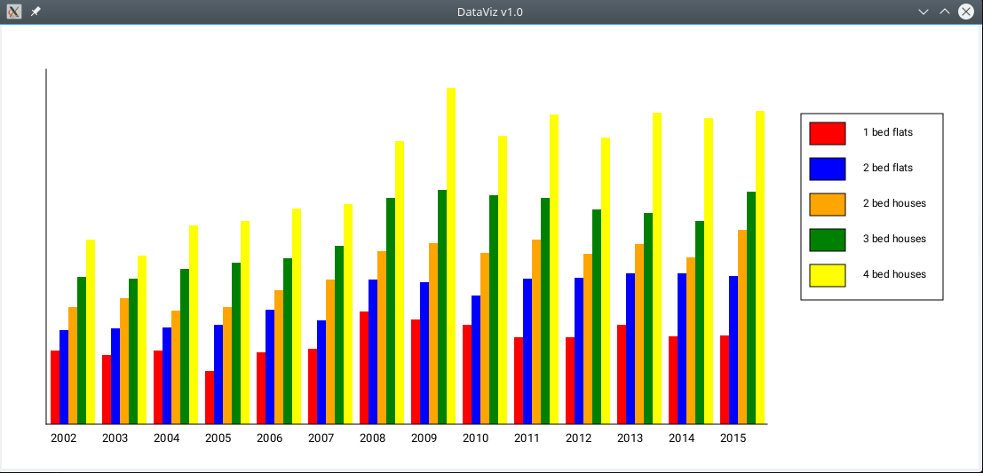

**Figure 1: The application window**