Object Oriented Programming
Focus Guard
Anti-Procrastination Desktop Assistant
Semester Project Report
Project Type | Student educational desktop application
Course | Object Oriented Programming (OOP)
Technology | Java 21, JavaFX 21, Maven, CSV/properties file handling
Storage | Local file-based storage only
Group Members |  | Registration No.
Kashaf Iftikhar |  | FA25-BCS-013
Rehab Nouman |  | FA25-BCS-019
Fatima Sibghat |  | FA25-BCS-024
Section | BCS-2A
Instructor | Dr. Nadir Shah

Table of Contents
1. Abstract 3
2. Introduction 3
3. Problem Statement 3
4. Objectives 3
5. Scope 4
6. Tools and Technologies Used 4
7. System Features 5
7.1 Dashboard 5
7.2 Focus Session Timer 5
7.3 Inactivity Detection 5
7.4 Distraction Detection and Warning 5
7.5 Strict Mode Safe Overlay 5
7.6 Task Planner 5
7.7 Session History 5
7.8 Analytics Charts 5
7.9 Settings 5
7.10 File-Based Persistence 5
8. OOP Concepts Used 6
9. System Architecture 6
10. File Handling and Data Persistence 7
11. UML Class Diagram 8
12. UML Class Diagram Explanation 9
13. Algorithm and Working Flow 9
14. Testing 10
15. Limitations 11
16. Future Enhancements 11
17. Conclusion 12

Abstract
Focus Guard is an anti-procrastination desktop assistant designed as a student educational application for an Object-Oriented Programming semester project. The application helps students plan tasks, run focused study sessions, observe inactivity, record distraction events, view session history, and understand productivity through analytics. It uses JavaFX for the graphical user interface, Java service classes for business logic, model classes for data representation, and local file handling for persistence. The system does not rely on network access, cloud storage, a database server, or forced operating system control. Its purpose is to demonstrate practical OOP design in a useful student productivity context.

Introduction
Procrastination is a common problem for students, especially when study time is interrupted by entertainment applications, social media, browser tabs, or long inactive periods. FocusGuard addresses this problem by providing a simple desktop environment where students can start a focus session, maintain a study goal, manage study tasks, and later review their performance.
The project is relevant for students because it combines a real-life productivity problem with core programming concepts. It is not intended to be a commercial monitoring product. Instead, it is an educational desktop application that demonstrates JavaFX interface design, file handling, layered architecture, and object-oriented class relationships.

Problem Statement
Many students begin study sessions with good intentions but lose focus because of poor time management, distracting applications, and lack of visibility into their actual study behavior. A normal timer can count minutes, but it usually cannot record distractions, inactivity events, task progress, productivity score, or session history. Because of this limitation, students may complete a timer period without knowing how focused the session actually was.
Focus Guard attempts to solve this problem within a safe educational scope by combining a focus timer, task planner, monitoring services, warning overlay, history screen, analytics screen, and file-based persistence.

Objectives

- Provide a focus session timer with start, pause, resume, and end behavior.
- Track distraction events and inactivity events during study sessions.
- Save study sessions, tasks, events, and settings locally using files.
- Display dashboard metrics, session history, and analytics charts.

- Demonstrate object-oriented programming through models, services, views, and utilities.
- Use JavaFX components such as TableView, Charts, ProgressBar, Stage, and BorderPane.

Scope
The scope of the project is intentionally limited to a desktop-only JavaFX application. The system runs locally, stores data in CSV/properties files, and supports productivity tracking for demonstration purposes. It does not include cloud synchronization, database integration, online accounts, mobile support, forced blocking of applications, or remote monitoring.
This safe scope makes the application suitable for a semester project because it focuses on OOP design, JavaFX UI development, and basic local persistence rather than complex operating system control.

Tools and Technologies Used
Tool / Technology | Purpose in Project
Java 21 | Core programming language used to implement models, services, utilities, and application logic.
JavaFX 21 | Graphical user interface framework used for desktop screens,  controls, charts, overlays, and layouts.
Maven | Project build and dependency management tool.
javafx-maven-plugin | Used to run and manage the JavaFX application through Maven.
CSV file handling | Used for storing sessions, tasks, and event records locally.
properties file handling | Used for storing user settings such as idle timeout, strict mode,  default duration, and blacklisted keywords.
JavaFX Timeline | Used for timer-based updates and monitoring behavior.
TableView, Charts,  ProgressBar | Used to display history, analytics, task data, and progress information.

System Features

7.1 Dashboard
Shows important productivity metrics and provides quick navigation to focus sessions, task planning, analytics, history, and settings.

7.2 Focus Session Timer
Allows the student to start, pause, resume, and end a study session. The session stores goal, planned minutes, completion state, score, and timing information.

7.3 Inactivity Detection
Uses mouse-based inactivity monitoring to identify when the user is not actively interacting with the desktop during a focus session.

7.4 Distraction Detection and Warning
Uses keyword/process-based best-effort detection to record distraction events and show warnings when a distraction is identified.

7.5 Strict Mode Safe Overlay
Provides a warning overlay stage in strict mode. It is safe and educational; it does not forcefully control the operating system.

7.6 Task Planner
Allows adding, updating, deleting, and filtering study tasks with title, subject, priority, estimated minutes, and status.

7.7 Session History
Displays previous focus sessions and supports export of a summary report for review.

7.8 Analytics Charts
Uses chart components such as BarChart and PieChart to show productivity statistics and patterns.

7.9 Settings
Stores idle timeout, strict mode, default duration, and blacklisted keywords for monitoring behavior.

7.10 File-Based Persistence
Reads and writes sessions, tasks, events, and settings using local files instead of a database.

OOP Concepts Used

Inheritance | MainApp extends the JavaFX Application class. View classes are designed as JavaFX screens based on components such as  BorderPane, while FocusWarningOverlay is based on Stage.
Encapsulation | Model classes such as StudySession, StudyTask, UserSettings, DistractionEvent, and InactivityEvent keep data in fields and expose controlled access through getters/setters.
Composition | StudySession contains related event information such as distractions and inactivity records. These parts belong to the session context.
Aggregation | ProductivityStats aggregates information from multiple StudySession objects to build analytics without owning the original sessions permanently.
Abstraction /  Separation of  Concerns | UI views display screens, services handle logic and persistence, models store data, and utility classes create reusable UI components.
Enum Usage | Task priority and task status are represented using enum-style fixed values to avoid random strings and improve program safety.

System Architecture
Focus Guard uses a layered architecture. This structure keeps the user interface separate from business logic and data models. The design shown in the UML diagram contains five main areas: app, view, service, model, and util.

Package /  Layer | Main Classes | Responsibility
app | MainApp | Starts the JavaFX application, initializes services, and navigates between screens.
view | DashboardView,  FocusSessionView,  TaskPlannerView,  AnalyticsView, HistoryView,  SettingsView,  FocusWarningOverlay | Builds the JavaFX user interface and handles screen-level user interaction.
service | SessionService, TaskService,  SettingsService,  AnalyticsService,  ScoreCalculator,  FileStorageService,  InactivityMonitor,  DistractionMonitor | Manages focus session logic, tasks, settings, analytics, score calculation, file operations, and monitoring.
model | StudySession, StudyTask,  UserSettings,  ProductivityStats,  DistractionEvent,  InactivityEvent | Stores application data in object form.
util | UiFactory | Creates reusable UI components such as titles, cards, metric cards, primary buttons, and styled tables.

File Handling and Data Persistence
The application uses local files for persistence. This matches the project scope because it avoids database setup while still demonstrating permanent storage. Service classes use FileStorageService for reading, writing, appending, and parsing CSV lines.
- sessions.csv - stores completed and active focus session records.
- tasks.csv - stores study tasks with title, subject, priority, estimated minutes, and status.
- events.csv - stores distraction and inactivity events related to focus sessions.
- settings.properties - stores user settings such as idle timeout, strict mode, default duration, and blacklisted keywords.
- summary report text files - exported session/history summaries for user review.

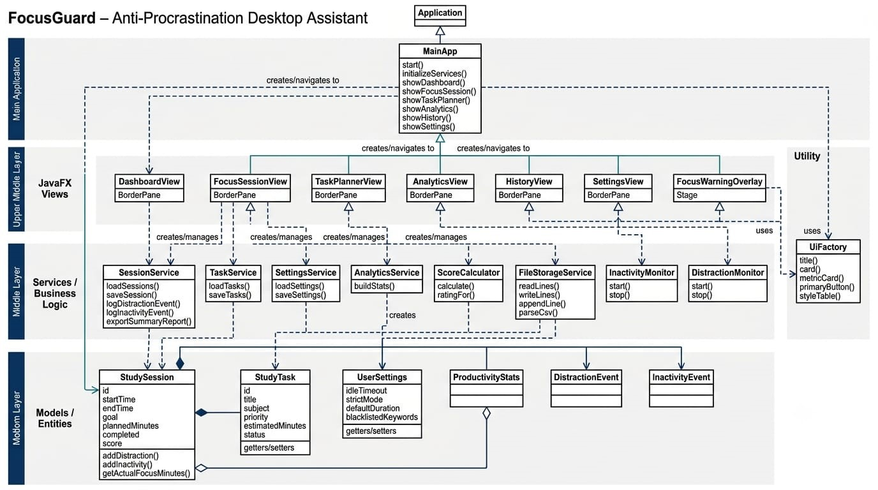
UML Class Diagram
Figure 1: UML Class Diagram

UML Class Diagram Explanation
The UML diagram presents a clear top-down structure. The top layer contains the JavaFX Application and MainApp. MainApp is responsible for starting the system, initializing services, and navigating to the dashboard, focus session, task planner, analytics, history, and settings screens.
The upper middle layer contains JavaFX views. These views represent separate screens such as
DashboardView, FocusSessionView, TaskPlannerView, AnalyticsView, HistoryView, and SettingsView. FocusWarningOverlay is represented separately because it uses a Stage for warning behavior.
The middle layer contains services and business logic. SessionService manages focus sessions and logs events, TaskService manages tasks, SettingsService stores and loads settings, AnalyticsService builds productivity statistics, ScoreCalculator calculates session score/rating, FileStorageService performs file operations, and monitor classes observe inactivity and distractions.
The bottom layer contains models/entities. StudySession stores session details, StudyTask stores task information, UserSettings stores configuration, ProductivityStats stores analytic results, and event classes represent distraction and inactivity records. UiFactory is shown on the side as a utility used by views for reusable JavaFX components.
The main relationships include inheritance from JavaFX classes, service-view associations, model-service dependencies, composition between study sessions and event records, and aggregation between ProductivityStats and study sessions.

Algorithm and Working Flow
- The following algorithm describes the normal user flow of FocusGuard from launching the application to viewing analytics.
- Launch the FocusGuard application through MainApp.
- MainApp initializes required services such as SessionService, TaskService, SettingsService, AnalyticsService, FileStorageService, InactivityMonitor, and DistractionMonitor.
- The dashboard is displayed with productivity metrics and navigation options.
- The user opens the Focus Session screen and enters or selects a study goal and duration.
- The user starts the focus session. The timer begins and monitoring services start running.
- InactivityMonitor checks mouse-based inactivity according to the configured idle timeout.
- DistractionMonitor performs best-effort keyword/process-based checking and logs distraction events when detected.
- If strict mode is enabled and a distraction is found, FocusWarningOverlay displays a safe warning to the user.
- The user may pause, resume, or end the focus session.
- When the session ends, SessionService calculates completion details and uses ScoreCalculator to compute a productivity score/rating.
- FileStorageService saves session, task, event, and settings information in local files.
- HistoryView shows saved session records and supports exporting a summary report.
- AnalyticsView rebuilds statistics from stored records and displays charts such as BarChart and PieChart.

Testing
Testing was planned around the implemented desktop features. The purpose was to confirm that navigation, session flow, task management, monitoring, settings, persistence, and analytics work according to the expected educational scope.

Test Case | Input / Action | Expected Output | Status
Application launch | Run project using  Maven/JavaFX | Main dashboard opens without error | Pass
Start focus session | Enter goal and duration, click Start | Timer starts and session becomes active | Pass
Pause and resume session | Click Pause, then Resume | Timer pauses and continues correctly | Pass
End focus session | Click End Session | Session data is saved and score is calculated | Pass
Inactivity logging | Remain inactive beyond idle timeout | Inactivity event is recorded | Pass
Distraction warning | Open/trigger blacklisted keyword or process | Distraction event is recorded and warning overlay appears in strict  mode | Pass
Add task | Enter task details and save | Task appears in task planner and tasks.csv | Pass
Update/delete task | Modify or remove selected task | Task list updates correctly | Pass
Save settings | Change timeout, strict mode, blacklisted keywords | settings.properties updates correctly | Pass
View analytics | Open Analytics screen after sessions | Charts and statistics are generated | Pass
Export history | Click export summary | Text report is generated | Pass

Limitations
- The system does not use a database or cloud storage; all data is saved locally in files.

- Distraction detection is best-effort and depends on keywords/process information available to the application.

- Inactivity detection is mouse-based and does not represent full user activity detection.

- There are no user accounts or authentication features.

- Break reminder support exists only in limited form; a complete break pop-up system is not implemented.

- The application is educational and does not forcefully block operating system applications.

Future Enhancements

- Add user profiles for multiple students on the same desktop.

- Replace file storage with database storage for larger data sets.

- Improve activity detection using keyboard, mouse, and application focus signals.

- Add notifications and complete break reminder pop-ups.

- Generate weekly and monthly productivity reports.

- Add richer analytics and more export formats such as PDF or spreadsheet reports.

Conclusion
Focus Guard is a practical student-focused productivity application developed for an OOP semester project. It addresses procrastination by combining a focus timer, task planner, inactivity monitoring, distraction logging, warning overlay, history, analytics, settings, and local file persistence. The project demonstrates important programming skills including JavaFX UI development, object-oriented modeling, layered architecture, file handling, and separation of concerns.
Although the system is limited to educational desktop use, it successfully shows how object-oriented design can be applied to a real-life student problem in a safe and manageable way.

