

Ankara University Faculty of Engineering Computer Engineering Department 2021-22 Fall Semester Microprocessors & Embedded Systems Term Project

Course Code: COM3525-B

Course Teacher:

[Doç.Dr. Gazi Erkan BOSTANCI](https://ekampus.ankara.edu.tr/user/view.php?id=3164&course=12310)

Problem:

[Project.docx](https://ekampus.ankara.edu.tr/pluginfile.php/370321/mod_assign/introattachment/0/Project.docx?forcedownload=1)

Student Name:

[Ahmet Musa Çatak](https://github.com/musacatak)

ID:

[18290088](https://www.linkedin.com/in/ahmet-musa-%C3%A7atak-25b387192/)

Problem:



Create a a traffic lights simulation in VHDL to this road structure.

What I learned as a result of this project:

I learned a lot of things about VHDL and some things about ModelSIM. First of all , I familiar with VHDL before lecture that is Digital Logic Design . In addition, I knew common methods like loops (for,while) ,conditions (if,else) , cases, exit,wait,etc. However, I did’nt know how I may use these methods in VHDL. Therefore, with this project now I familiar with VHDL syntaxes and some methods that unique to VHDL.

In Code:

So we have two code files , one of them is contains all contents that we used other code file. This relation similar with HTML & JS or .h .c.

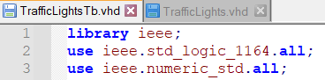Implement extra library that is not in default WHDL.

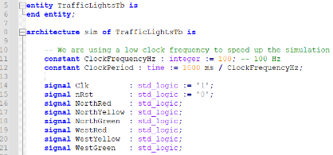Implement entity and architecture that bounded with our main entity. Define signals that we use in codes before begin architecture. We don’t need extra signals like EastRed or SouthGreen in this simulation because of road structure.

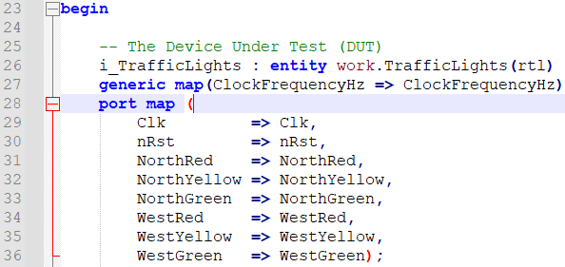Define subEntity and give him resource like super-get function. Generics are a type of data that can be passed into an entity. The component of the module instantiation where you indicate which local signals the module's inputs and outputs will be connected to is called the port map.

define some variables. t_State like 2D char array in C 

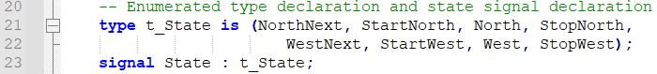that contains situations.

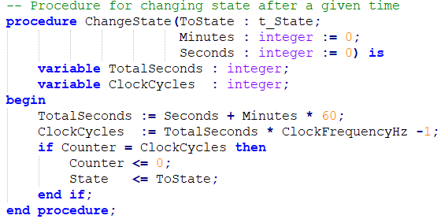Implement a procedure to simplify code. It gets next state and time variables that must be changed. It provides to calculate real time to use for lights time durations.

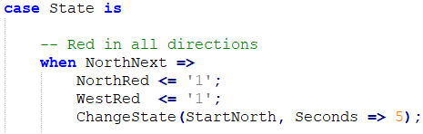Define every single state what happen when its turns one by one. For example in NorthNext case North’s and West’s red lights must be on , other ones must be off.

Improving the solution:

We can add a lot of things to improve the solution. In our country we have some applications. One of them is night time traffic light app. .

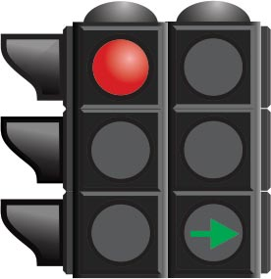 In this app. all traffic lights off until morning in some region. The other one is extra traffic light for turning. In this app , they separate lights two ; one of them for straight direction and the other one is turning direction. If opposite direction’s straight light is green, then our direction’s turning light can be green with suitable road design.

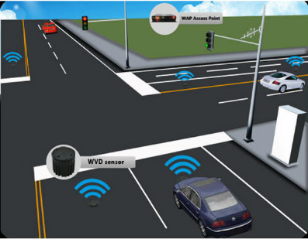Improve to efficient of traffic light to which direction is more crowded. How can we solve this. We can solve this many thinks. We may use some sensors on the road that count cars then choose best solution ,that implement before, to specific situations. However, this will be much expensive to afford for all country and its regions but still it is a solution. Also, we can use AI integrate with imaging device (camera) that can recognize is this object a car and its waiting in tail of traffic light.

Furthermore, we must use thermal sensors to differentiate is car parking or in operation. Then AI take these data and give the best solution (lights time for each directions). This solution also so expensive so we use this just crowded routes. Besides, AI must recognize emergency cars and give them road advantage.

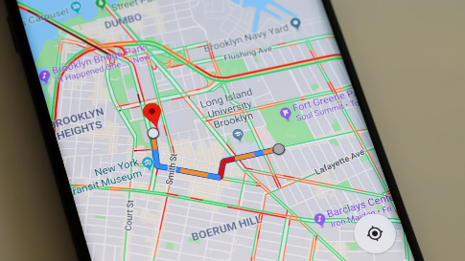 I suggest to watch ‘Person Of Interest’ that series is tell a story about an AI that has all control of a country ,start with a Traffic Light Optimization AI. Actually , if we can trust a map application , we can use its traffic data. That kind of applications use their customer location data and give them the emptiest road to their target.

# References

* *Car counter sensor*. (n.d.). [Image]. Alibaba. https://www.google.com/url?sa=i&url=https%3A%2F%2Fwww.alibaba.com%2Fproduct-detail%2FTraffic-wireless-vehicle-detection-magnetometer-for_1405896924.html&psig=AOvVaw0lvn1mF7cK3FL6LTENGLrj&ust=1640068751211000&source=images&cd=vfe&ved=0CAsQjRxqFwoTCOjguKbl8fQCFQAAAAAdAAAAABAR
* Jensen, J. J. (n.d.). *VHDL Tutorials*. Vhdlwhiz. Retrieved December 20, 2021, from https://vhdlwhiz.com/
* Jensen, J. J. (2018, August 25). *Traffic Lights and Rotations* [Gif]. Vhdlwhiz. https://cdn.vhdlwhiz.com/wp-content/uploads/2016/11/intersection_fsm.gif
* *Map Image*. (n.d.). [Image]. Webtekno. https://www.google.com/url?sa=i&url=https%3A%2F%2Fwww.webtekno.com%2Fgoogle-haritalar-aydinlik-yerler-ozelligi-h81193.html&psig=AOvVaw0bFbDGBGJ08JPnQAupqRX4&ust=1640069074911000&source=images&cd=vfe&ved=0CAsQjRxqFwoTCMCm_43l8fQCFQAAAAAdAAAAABAD
* *Traffic Light*. (n.d.). [Image]. Korkorttr. https://www.google.com/url?sa=i&url=https%3A%2F%2Fwww.korkorttr.com%2F2020%2F01%2Fiskl-ve-figurlu-trafik-lambalar.html&psig=AOvVaw2bQVr4yHXT7GeKnm96BRBf&ust=1640069200840000&source=images&cd=vfe&ved=0CAsQjRxqFwoTCMjEmonk8fQCFQAAAAAdAAAAABAj