Intermediate status report: NYC Taxi Trip Duration
DAM2026 · · Musa Faal, Mariama Secka, Yamai Senghore
Competition: kaggle.com/competitions/nyc-taxi-trip-duration. Predict the duration of a taxi trip in New York City (seconds) from pickup time, coordinates, passenger count and vendor.
Metric: The RMSLE, the measure of error on a logarithmic scale. The RMSLE measure gives equal weight to relative error in both short and long journeys. This is because the training is done on the log(1+duration) using RMSE measure.
Repository: github.com/musafaal1998-star/nyc-taxi-trip-duration

1. What has been done
Data. Number of training samples: 1,458,644; Number of test samples: 625,134, Date range (both): Jan-Jun 2016; Number of features: 11; Missing data: None; Same date ranges (train & test data) – random sample split; Drop-off time column dropped since it contains target variable information.
Key EDA findings
- The target is highly right-skewed (median 11 min, maximum 41 days); the log transformation brings it close to normality.
- Distance is the most impactful (Spearman ρ = 0.79 for duration), yet it is not an inherent feature, which needs to be created.
- Timeseries pattern: the median trip duration is roughly 8 min at 6 AM and 12-13 min in the late morning and afternoon on weekdays; the weekends have a different pattern.
- Data issues: 2,061 trips in 6 hours (meter on, virtually all trips by vendor 2), 8,595 trips less than 1 minute, roughly 1,000 trips with out-of-bounds NYC coordinates, 65 trips with 0 or more than 6 passengers.
Anomalies. Rows like this are omitted during the training phase only; validation and test data sets retain them since each test row must be classified. Data cleaning does not make any difference for the score (±0.0005). However, an abnormal 0.2% of trips in the validation set accounts for 23.6% of the error.
Preprocessing and features. Binary variables are represented in the format of 0/1. As for the linear model, hour, weekday, month, passengers, and zones are one-hot encoded, and numeric variables are standardized, while tree-based models do not require this at all. Novel variables include datetime variables, Haversine and Manhattan distances, bearing, airport binary variables, rotated coordinates, and zones using PCA and KMeans.
Feature effect (LightGBM, validation RMSLE): raw columns 0.460 → + datetime 0.417 → + distances 0.386 → + PCA and zones 0.385.

2. Current scores
model (20% hold-out validation) | RMSLE
Constant (geometric mean): trivial baseline | 0.797
Rule: mean duration by distance bin | 0.514
Ridge regression | 0.466
Random forest (300k sample) | 0.404
LightGBM, untuned | 0.385
LightGBM, tuned (random search + early stopping) | 0.373

Kaggle late submission | validation | public LB | private LB
LightGBM, untuned | 0.3846 | 0.3901 | 0.3876
LightGBM, tuned | 0.3729 | 0.3771 | 0.3751
The leaderboard scores are 0.002–0.005 worse than validation, and tuning improves both by the same amount (−0.012), so the validation scheme ranks models correctly.

3. Plan until the defense (4 and 11 December)
- • Add an external dataset: OSRM fastest path distance and duration per trip (from a Kaggle dataset available to this competition).
- • Aggregate features based on training fold data: mean speed per zone pair and hour, traffic count per hour.
- • Test XGBoost and CatBoost models with simple model blending (based on the best performing models, using the same parameter tuning strategy).
- • Analyze validation and leaderboard score per each submission and state reasons for a possible discrepancy; prepare 15-20 minutes presentation.

member | done so far | until the defense
Musa Faal | data description, EDA, anomalies (notebook 01) | OSRM route features and their EDA; slides on problem, data and EDA
Mariama Secka | preprocessing, validation scheme, baselines (notebook 02) | aggregate speed / traffic features; validation vs leaderboard analysis; slides on validation and baselines
Yamai Senghore | feature engineering, model comparison, tuning (notebook 03) | XGBoost / CatBoost, blending and tuning, final submissions; slides on models and results

4. Key figures
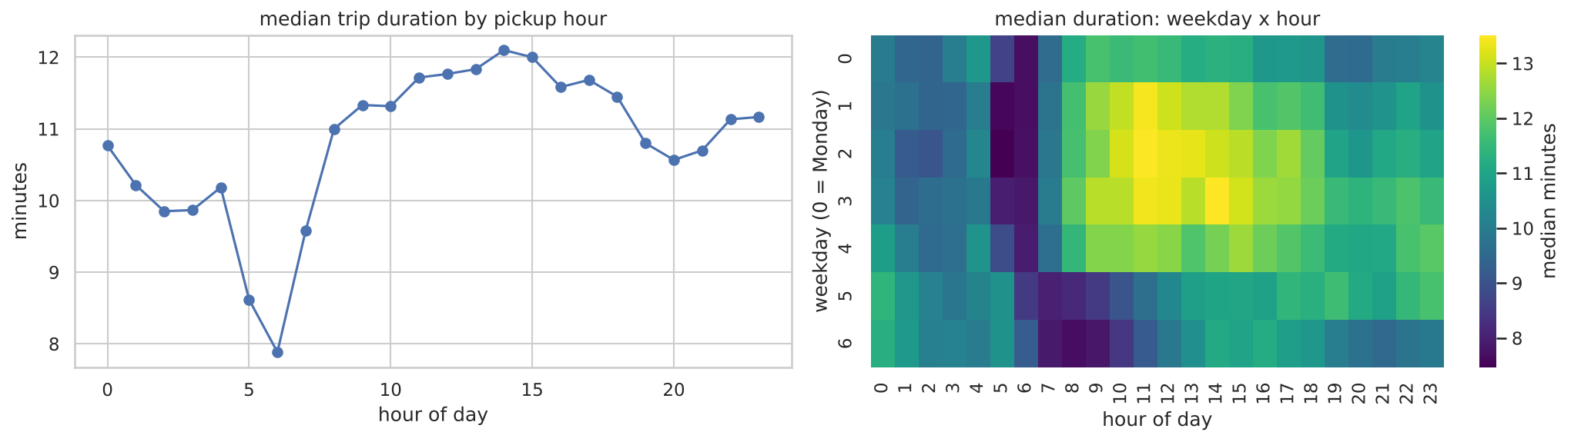
Figure 1. Median trip duration by pickup hour and by weekday × hour: traffic makes daytime weekday trips about 50% longer than early-morning trips.
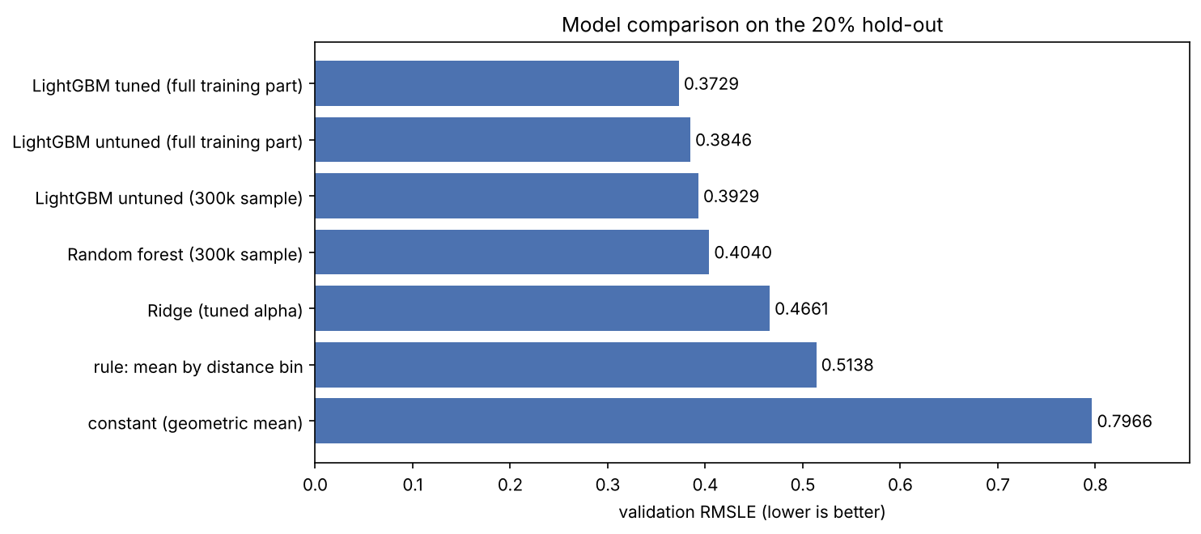
Figure 2. All models on the same 20% hold-out validation set (RMSLE, lower is better).

