Database Design Documentation
Relational Database Schema & Entity-Relationship Diagram
MUSHAF MASHOOD & ESHAAL NAZIR
Submitted: April 26, 2025

1. Entity-Relationship Diagram
The following ERD illustrates the complete database structure including all entities, attributes, relationships, and cardinalities for the inventory and sales management system.

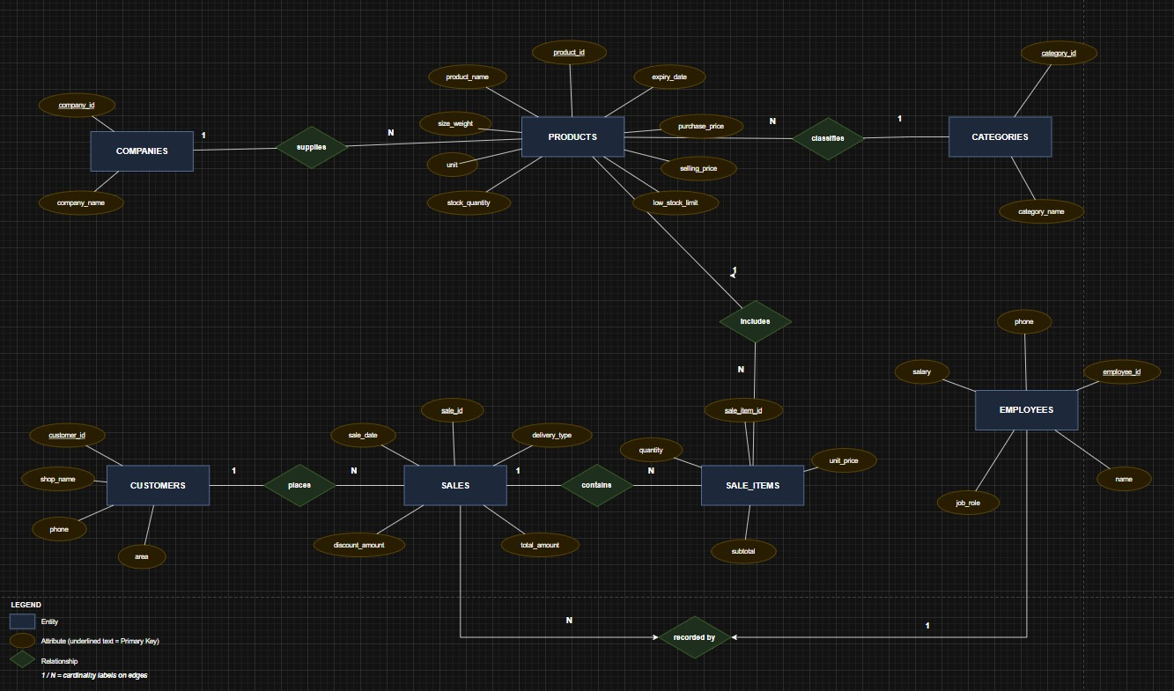
ERD

2. Relational Database Schema
The database consists of 7 tables representing the core entities of the system. Each table is described below with its attributes, primary keys (PK), and foreign keys (FK).

2.1 COMPANIES
Stores information about supplier companies that provide products to the business.

Attribute | Data Type | Constraint | Description
company_id | INT | PRIMARY KEY | Unique identifier for each company
company_name | VARCHAR(100) | NOT NULL | Name of the supplier company

2.2 CATEGORIES
Classifies products into logical groups for easier browsing and reporting.

Attribute | Data Type | Constraint | Description
category_id | INT | PRIMARY KEY | Unique identifier for each category
category_name | VARCHAR(100) | NOT NULL | Name of the product category

2.3 PRODUCTS
Central table holding all product information, linked to companies and categories.

Attribute | Data Type | Constraint | Description
product_id | INT | PRIMARY KEY | Unique identifier for each product
product_name | VARCHAR(150) | NOT NULL | Name of the product
size_weight | VARCHAR(50) | NULL | Size or weight specification
unit | VARCHAR(30) | NULL | Unit of measure (e.g., kg, pcs)
stock_quantity | INT | NOT NULL | Current quantity in stock
purchase_price | DECIMAL(10,2) | NOT NULL | Cost price of the product
selling_price | DECIMAL(10,2) | NOT NULL | Retail selling price
low_stock_limit | INT | NOT NULL | Threshold for low stock alert
expiry_date | DATE | NULL | Product expiry date (if applicable)
company_id | INT | FOREIGN KEY → COMPANIES | Supplier company reference
category_id | INT | FOREIGN KEY → CATEGORIES | Product category reference

2.4 CUSTOMERS
Records customer details for all parties placing sales orders.

Attribute | Data Type | Constraint | Description
customer_id | INT | PRIMARY KEY | Unique identifier for each customer
shop_name | VARCHAR(150) | NOT NULL | Name of the customer's shop/business
phone | VARCHAR(20) | NULL | Contact phone number
area | VARCHAR(100) | NULL | Geographic area or region

2.5 EMPLOYEES
Stores employee records; employees are linked to sales they process.

Attribute | Data Type | Constraint | Description
employee_id | INT | PRIMARY KEY | Unique identifier for each employee
name | VARCHAR(100) | NOT NULL | Full name of the employee
phone | VARCHAR(20) | NULL | Contact phone number
salary | DECIMAL(10,2) | NULL | Monthly salary amount
job_role | VARCHAR(80) | NULL | Role or position title

2.6 SALES
Represents a sales transaction header, linking a customer and employee to a sale event.

Attribute | Data Type | Constraint | Description
sale_id | INT | PRIMARY KEY | Unique identifier for each sale
sale_date | DATE | NOT NULL | Date the sale was made
delivery_type | VARCHAR(50) | NULL | Mode of delivery (pickup/delivery)
discount_amount | DECIMAL(10,2) | NULL | Discount applied to the sale
total_amount | DECIMAL(10,2) | NOT NULL | Total bill after discount
customer_id | INT | FOREIGN KEY → CUSTOMERS | Customer who placed the order
employee_id | INT | FOREIGN KEY → EMPLOYEES | Employee who recorded the sale

2.7 SALE_ITEMS
Line-item table storing individual products within each sale transaction.

Attribute | Data Type | Constraint | Description
sale_item_id | INT | PRIMARY KEY | Unique identifier for each sale line item
quantity | INT | NOT NULL | Number of units sold
unit_price | DECIMAL(10,2) | NOT NULL | Price per unit at time of sale
subtotal | DECIMAL(10,2) | NOT NULL | quantity × unit_price for this line
sale_id | INT | FOREIGN KEY → SALES | Parent sale transaction reference
product_id | INT | FOREIGN KEY → PRODUCTS | Product included in this line item

3. Relationships Summary
The table below summarizes all entity relationships, their type, and the enforcing foreign keys.

Relationship | Type | FK (Child Table) | Description
COMPANIES → PRODUCTS | One-to-Many (1:N) | products.company_id | One company supplies many products
CATEGORIES → PRODUCTS | One-to-Many (1:N) | products.category_id | One category classifies many products
CUSTOMERS → SALES | One-to-Many (1:N) | sales.customer_id | One customer places many sales
EMPLOYEES → SALES | One-to-Many (1:N) | sales.employee_id | One employee records many sales
SALES → SALE_ITEMS | One-to-Many (1:N) | sale_items.sale_id | One sale contains many line items
PRODUCTS → SALE_ITEMS | One-to-Many (1:N) | sale_items.product_id | One product appears in many sale items

4. Design Notes & Constraints
- All primary keys use auto-increment integers for simplicity and performance.
- Foreign key constraints enforce referential integrity across all relationships.
- The SALE_ITEMS table acts as a bridge between SALES and PRODUCTS, normalising the many-to-many relationship into two one-to-many links.
- PRODUCTS stores both purchase_price and selling_price to support margin analysis.
- low_stock_limit enables automated inventory alerts when stock_quantity falls below the threshold.
- The ERD was created using a digital diagramming tool and follows standard Chen notation (rectangles = entities, ellipses = attributes, diamonds = relationships).

