Milestone 2
ERD Design & Normalization

MUSHAF MASHOOD & ESHAAL NAZIR
Submitted: May 2025

1. Introduction
This document presents the normalization process applied to the Inventory & Sales Management database schema designed in Milestone 1. Each table is analyzed for 1NF, 2NF, and 3NF compliance with justifications.

2. Original Schema Summary (from Milestone 1)
Table Name | Attributes
COMPANIES | company_id (PK), company_name
CATEGORIES | category_id (PK), category_name
PRODUCTS | product_id (PK), product_name, size_weight, unit, stock_quantity, purchase_price, selling_price, low_stock_limit, expiry_date, company_id (FK), category_id (FK)
CUSTOMERS | customer_id (PK), shop_name, phone, area
EMPLOYEES | employee_id (PK), name, phone, salary, job_role
SALES | sale_id (PK), sale_date, delivery_type, discount_amount, total_amount, customer_id (FK), employee_id (FK)
SALE_ITEMS | sale_item_id (PK), quantity, unit_price, subtotal, sale_id (FK), product_id (FK)

3. Step 1 - Normalization Analysis

3.1 First Normal Form (1NF)
A table is in 1NF if all columns contain atomic values, each row is uniquely identifiable by a PK, and there are no repeating groups.
Table | Analysis | Change | Status
COMPANIES | company_name is atomic. Unique PK. No repeating groups. | None needed | Already in 1NF
CATEGORIES | category_name is atomic. Unique PK. No repeating groups. | None needed | Already in 1NF
PRODUCTS | All attributes are atomic single values. FKs are single integer references. No multi-valued attributes. | None needed | Already in 1NF
CUSTOMERS | shop_name, phone, area are all single atomic values. | None needed | Already in 1NF
EMPLOYEES | name, phone, salary, job_role are all single atomic values. | None needed | Already in 1NF
SALES | All attributes atomic. Products sold stored separately in SALE_ITEMS (no repeating groups). | None needed | Already in 1NF
SALE_ITEMS | All attributes are atomic. Each row = one product in one sale. | None needed | Already in 1NF

1NF Conclusion: All seven tables satisfy 1NF. The SALE_ITEMS table prevents repeating groups in SALES.

3.2 Second Normal Form (2NF)
A table is in 2NF if it is in 1NF and has no partial dependencies. Partial dependencies only occur with composite primary keys.
All seven tables use single-column auto-increment PKs. Since none have composite keys, partial dependencies are structurally impossible.
Table | Analysis | Change | Status
COMPANIES | Single PK. company_name fully depends on company_id. | None needed | Already in 2NF
CATEGORIES | Single PK. category_name fully depends on category_id. | None needed | Already in 2NF
PRODUCTS | Single PK. All attributes fully depend on product_id. | None needed | Already in 2NF
CUSTOMERS | Single PK. All attributes fully depend on customer_id. | None needed | Already in 2NF
EMPLOYEES | Single PK. All attributes fully depend on employee_id. | None needed | Already in 2NF
SALES | Single PK. All attributes fully depend on sale_id. | None needed | Already in 2NF
SALE_ITEMS | Single PK (sale_item_id). Avoids partial dependency that would occur with composite PK (sale_id, product_id). | None needed | Already in 2NF

2NF Conclusion: All tables satisfy 2NF due to single-column surrogate primary keys.

3.3 Third Normal Form (3NF)
A table is in 3NF if it is in 2NF and has no transitive dependencies. No non-key attribute should depend on another non-key attribute.
Table | Analysis | Change | Status
COMPANIES | Only one non-key attribute. Transitive dependency impossible. | None needed | Already in 3NF
CATEGORIES | Only one non-key attribute. Transitive dependency impossible. | None needed | Already in 3NF
PRODUCTS | All attributes are independent facts. selling_price and purchase_price are independently set. | None needed | Already in 3NF
CUSTOMERS | All attributes depend directly on customer_id. area is a direct fact. | None needed | Already in 3NF
EMPLOYEES | All attributes depend directly on employee_id. salary is per-employee, not determined by job_role. | None needed | Already in 3NF
SALES | VIOLATION: total_amount is derived (computed from SALE_ITEMS data minus discount). Transitive dependency. | REMOVED total_amount | 3NF FIXED
SALE_ITEMS | VIOLATION: subtotal is derived (quantity x unit_price). Depends on non-key attributes. | REMOVED subtotal | 3NF FIXED

3NF Conclusion: Two violations fixed: removed subtotal from SALE_ITEMS and total_amount from SALES.

4. Step 2 - Removing Duplicates & Redundancies
Item Reviewed | Analysis | Action
Derived columns (subtotal, total_amount) | Stored computed values, risk of inconsistency. | Removed in 3NF step
Phone columns (CUSTOMERS vs EMPLOYEES) | Same attribute type for different entities. Not duplication. | No change
Price columns (PRODUCTS vs SALE_ITEMS) | PRODUCTS = current price; SALE_ITEMS.unit_price = historical price at sale time. | No change
Foreign keys | All properly placed, no duplicates across tables. | No change

5. Step 3 - Updated Schema After Normalization

COMPANIES (No Changes)
Attribute | Data Type | Constraint | Description
company_id | INT | PRIMARY KEY | Unique company identifier
company_name | VARCHAR(100) | NOT NULL | Supplier company name

CATEGORIES (No Changes)
Attribute | Data Type | Constraint | Description
category_id | INT | PRIMARY KEY | Unique category identifier
category_name | VARCHAR(100) | NOT NULL | Product category name

PRODUCTS (No Changes)
Attribute | Data Type | Constraint | Description
product_id | INT | PRIMARY KEY | Unique product identifier
product_name | VARCHAR(150) | NOT NULL | Product name
size_weight | VARCHAR(50) | NULL | Size/weight spec
unit | VARCHAR(30) | NULL | Unit of measure
stock_quantity | INT | NOT NULL | Current stock
purchase_price | DECIMAL(10,2) | NOT NULL | Cost price
selling_price | DECIMAL(10,2) | NOT NULL | Retail price
low_stock_limit | INT | NOT NULL | Low stock threshold
expiry_date | DATE | NULL | Expiry date
company_id | INT | FK -> COMPANIES | Supplier ref
category_id | INT | FK -> CATEGORIES | Category ref

CUSTOMERS (No Changes)
Attribute | Data Type | Constraint | Description
customer_id | INT | PRIMARY KEY | Unique customer identifier
shop_name | VARCHAR(150) | NOT NULL | Shop/business name
phone | VARCHAR(20) | NULL | Phone number
area | VARCHAR(100) | NULL | Geographic area

EMPLOYEES (No Changes)
Attribute | Data Type | Constraint | Description
employee_id | INT | PRIMARY KEY | Unique employee identifier
name | VARCHAR(100) | NOT NULL | Full name
phone | VARCHAR(20) | NULL | Phone number
salary | DECIMAL(10,2) | NULL | Monthly salary
job_role | VARCHAR(80) | NULL | Position title

SALES (UPDATED - total_amount REMOVED)
Attribute | Data Type | Constraint | Description
sale_id | INT | PRIMARY KEY | Unique sale identifier
sale_date | DATE | NOT NULL | Sale date
delivery_type | VARCHAR(50) | NULL | Delivery mode
discount_amount | DECIMAL(10,2) | NULL | Discount applied
customer_id | INT | FK -> CUSTOMERS | Customer ref
employee_id | INT | FK -> EMPLOYEES | Employee ref

SALE_ITEMS (UPDATED - subtotal REMOVED)
Attribute | Data Type | Constraint | Description
sale_item_id | INT | PRIMARY KEY | Unique line item identifier
quantity | INT | NOT NULL | Units sold
unit_price | DECIMAL(10,2) | NOT NULL | Price per unit at sale time
sale_id | INT | FK -> SALES | Parent sale ref
product_id | INT | FK -> PRODUCTS | Product ref

6. Step 4 - Updated ERD
The updated ERD below reflects normalization changes: subtotal removed from SALE_ITEMS, total_amount removed from SALES. All relationships and cardinalities remain unchanged.
Changes reflected:
- SALE_ITEMS: subtotal attribute removed
- SALES: total_amount attribute removed
- All relationships and cardinalities unchanged
- All PKs and FKs unchanged

Updated ERD Diagram:
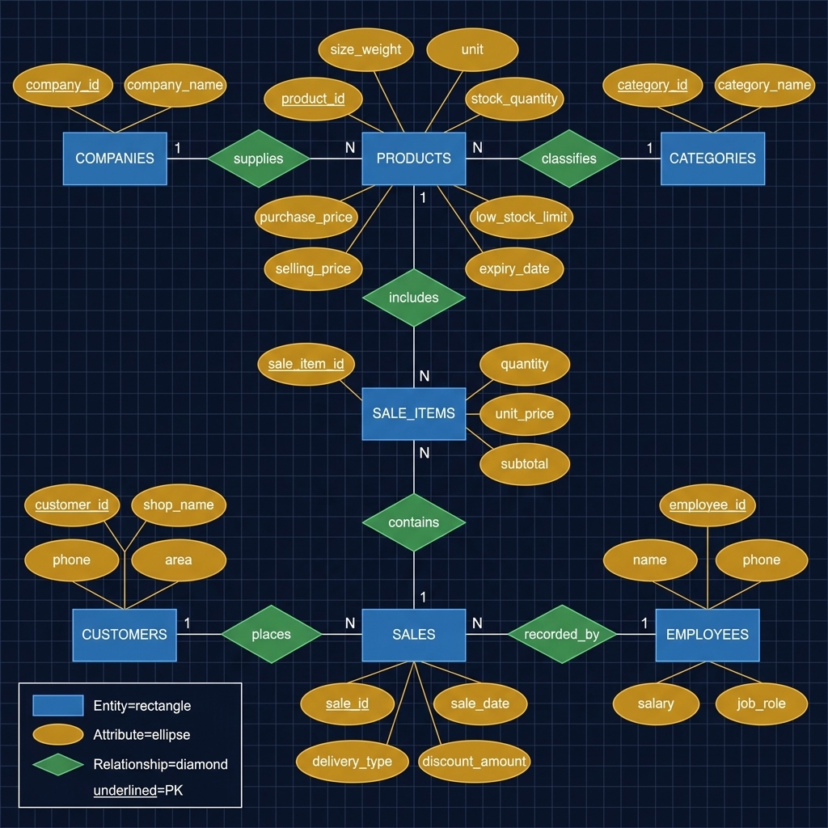

7. Summary of All Changes
# | Normal Form | Table | Change | Justification
1 | 3NF | SALE_ITEMS | Removed subtotal | Derived value (quantity x unit_price). Transitive dependency on non-key attributes.
2 | 3NF | SALES | Removed total_amount | Derived from SALE_ITEMS data minus discount. Computed aggregate, not a stored fact.

Tables With No Changes (Justified)
Table | Reason
COMPANIES | Single non-key attribute. No dependencies possible.
CATEGORIES | Single non-key attribute. No dependencies possible.
PRODUCTS | All attributes are independent facts. No derived columns.
CUSTOMERS | All attributes are independent facts. No computed columns.
EMPLOYEES | All attributes are independent. salary is per-employee, not determined by job_role.

