Glamour Hair & Beauty Studio
Salon Booking System – Screen-by-Screen Walkthrough

Introduction
This document walks through every screen of the Glamour Hair & Beauty Studio booking application in the order a customer would use it. Each screenshot is shown first, followed by an explanation of what is happening on that screen. The skills used to build the application are listed at the end.

Screen 1: Homepage
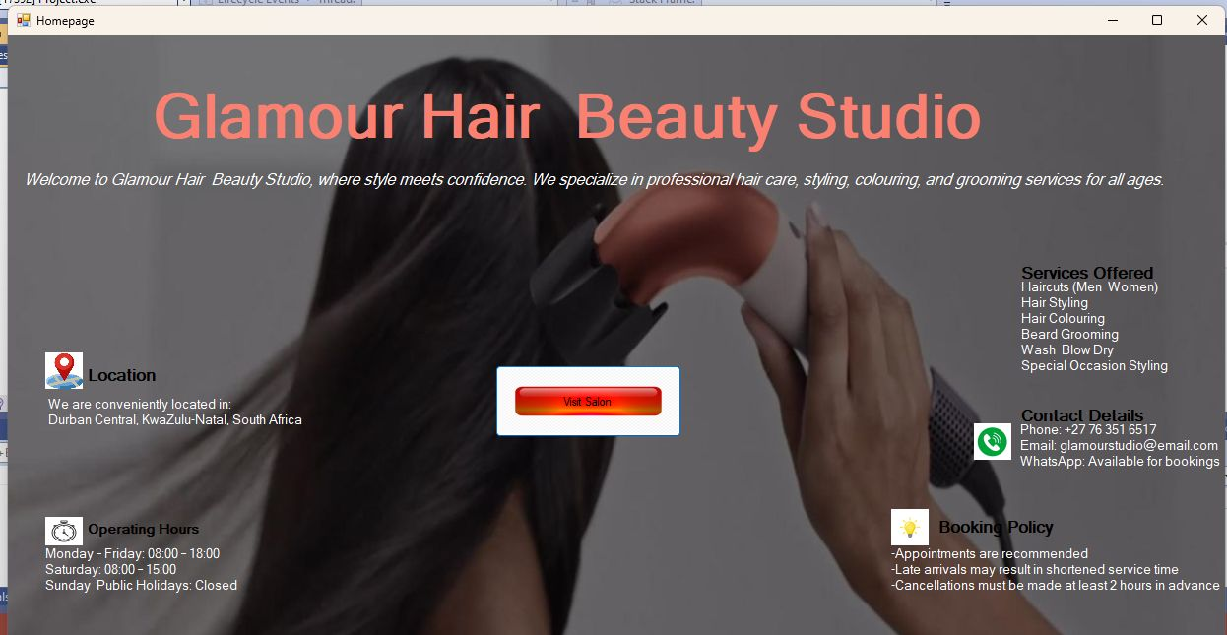
Figure 1: Homepage

What is happening
This is the landing screen of the Glamour Hair & Beauty Studio application. It introduces the salon with a welcome message and presents key business information in clearly separated sections: Location (Durban Central, KwaZulu-Natal), Operating Hours, Services Offered, Contact Details and a short Booking Policy.
The central "Visit Salon" button is the entry point into the system and takes the user to the login screen. The dark overlay on the background photo keeps the text readable.

Screen 2: Member Login
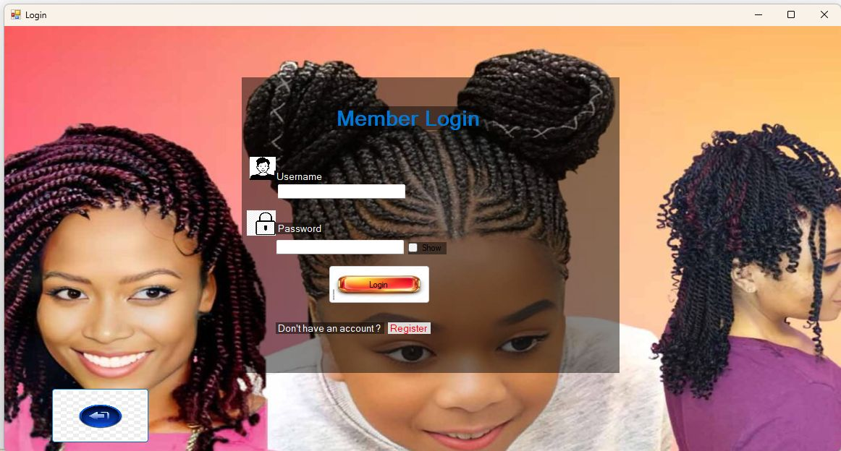
Figure 2: Member Login

What is happening
Existing customers sign in here using a username and a password. The password box has a "Show" checkbox so the user can reveal what they typed.
Below the Login button is a "Don't have an account? Register" link that sends new users to the registration form, and a back-arrow button in the bottom-left corner returns to the previous screen.

Screen 3: Create An Account (Register)
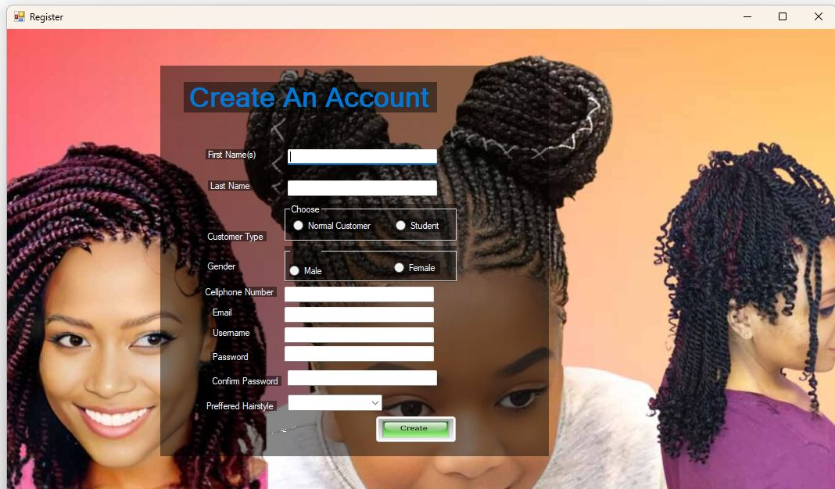
Figure 3: Create An Account (Register)

What is happening
New customers create an account on this form. It collects first name(s), last name, customer type (Normal Customer or Student), gender, cellphone number, email, username, password, confirm password and a preferred hairstyle chosen from a drop-down list.
Radio buttons restrict the customer type and gender to a single choice, and the "Confirm Password" field lets the system check that the password was typed correctly. The Create button saves the account.

Screen 4: Book An Appointment (empty form)
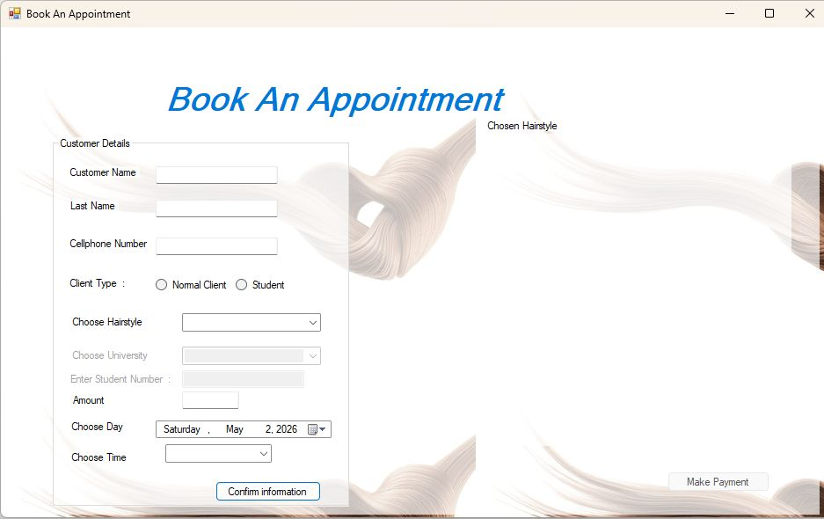
Figure 4: Book An Appointment (empty form)

What is happening
After logging in, the customer reaches the booking screen, shown here before anything has been filled in. The Customer Details group holds the name, last name, cellphone number, client type, hairstyle, university, student number, amount, day and time fields.
The Choose University and Enter Student Number fields are greyed out because they only apply to students, and the "Chosen Hairstyle" picture area on the right and the Make Payment button stay inactive until a booking is confirmed. The date picker defaults to the current date.

Screen 5: Book An Appointment (completed form)
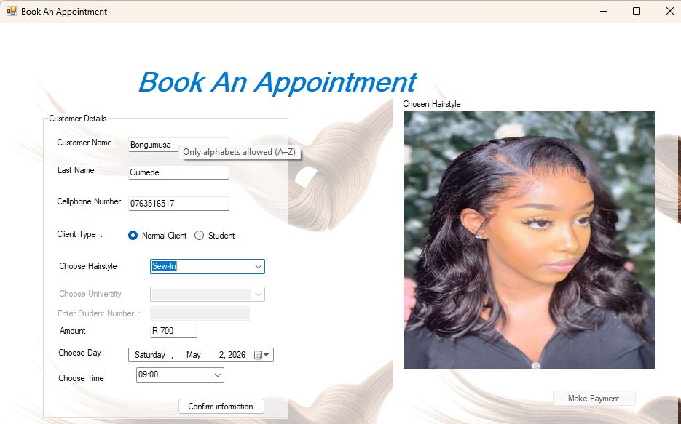
Figure 5: Book An Appointment (completed form)

What is happening
The same screen after the customer, Bongumusa Gumede, has entered her details: Normal Client, hairstyle "Sew-In", Saturday 2 May 2026 at 09:00.
Choosing the hairstyle automatically fills the Amount box with R 700 and displays a preview photo of the style under "Chosen Hairstyle". A tooltip reading "Only alphabets allowed (A–Z)" is visible on the name field, showing input validation that stops numbers or symbols in names. Student fields stay disabled because the client type is Normal Client. Clicking "Confirm information" enables the Make Payment button.

Screen 6: Payment Method (card details)
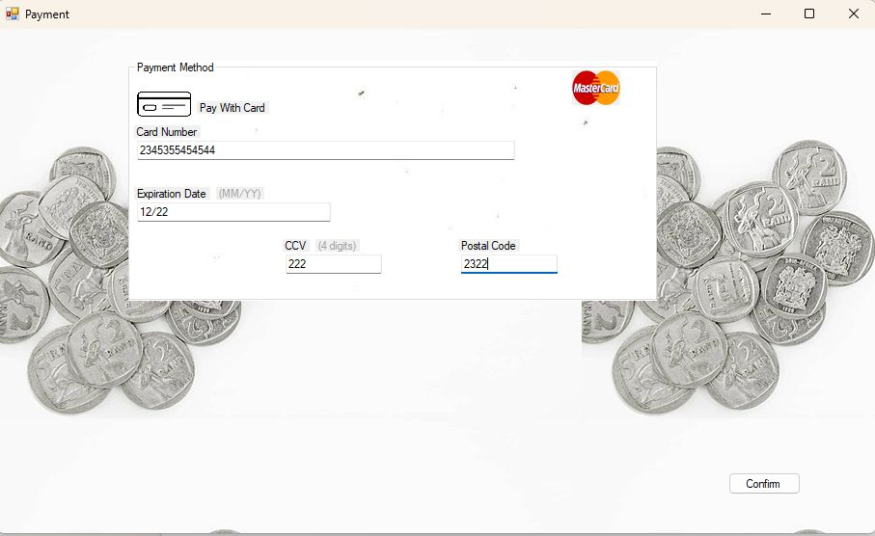
Figure 6: Payment Method (card details)

What is happening
The payment screen lets the customer pay by card (MasterCard logo shown). The Payment Method group asks for the card number, expiration date (MM/YY), CCV (4 digits) and postal code, with format hints beside the labels.
Once the details are entered the customer presses Confirm to proceed. The background of South African rand coins reinforces the payment theme.

Screen 7: Terms and Conditions with agreement warning
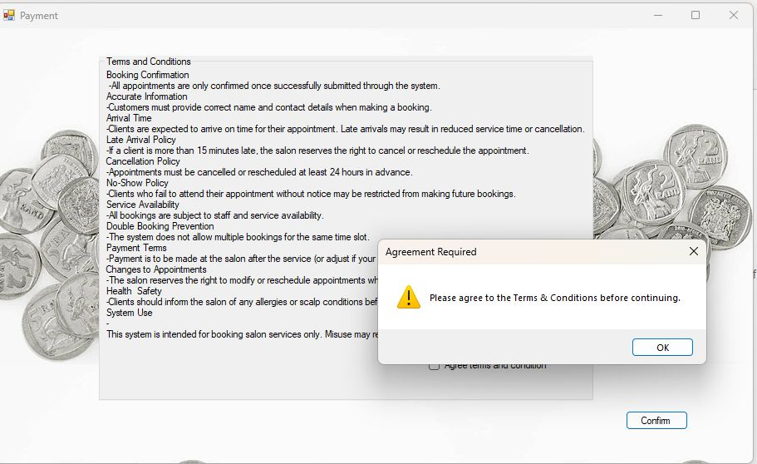
Figure 7: Terms and Conditions with agreement warning

What is happening
Before payment is finalised, the system displays the salon's Terms and Conditions, covering booking confirmation, accurate information, arrival time, late arrival, cancellation, no-show, service availability, double booking prevention, payment terms, changes to appointments, health and safety, and system use.
The customer must tick the "Agree terms and condition" checkbox. In this screenshot Confirm was clicked without ticking it, so an "Agreement Required" message box appears: "Please agree to the Terms & Conditions before continuing." This is a validation check that blocks the booking until consent is given.

Screen 8: Payment Approved
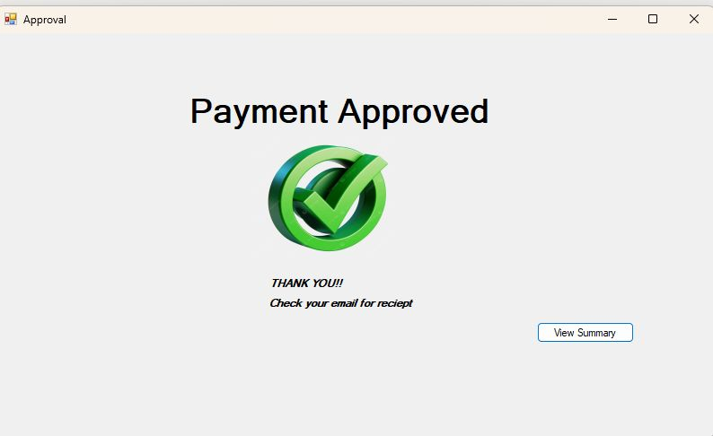
Figure 8: Payment Approved

What is happening
This confirmation screen is shown after the payment passes validation and the terms are accepted. It displays "Payment Approved" with a green tick graphic and a thank-you note telling the customer to check their email for the receipt.
The "View Summary" button opens the final booking summary.

Screen 9: Booking Summary
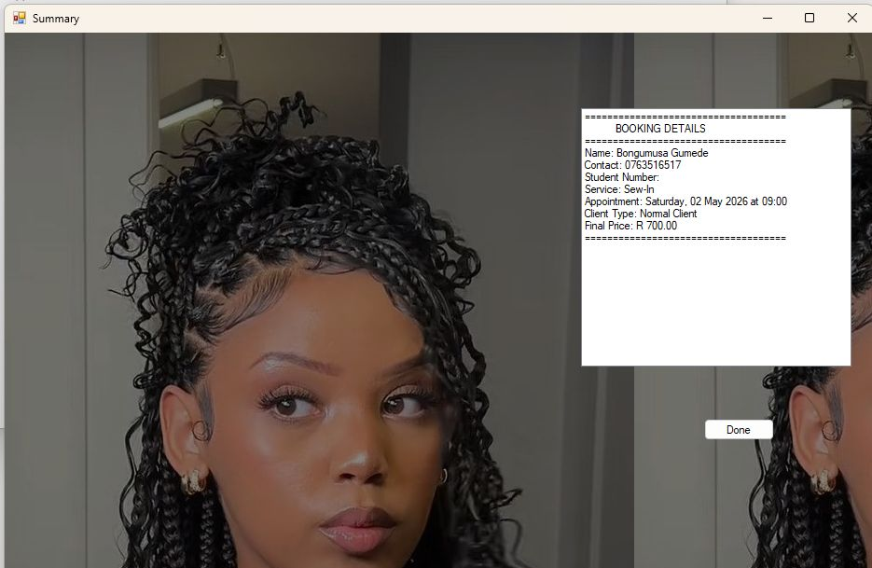
Figure 9: Booking Summary

What is happening
The final screen shows a "Booking Details" receipt-style summary: Name (Bongumusa Gumede), Contact (0763516517), Student Number (blank because she is a Normal Client), Service (Sew-In), Appointment (Saturday, 02 May 2026 at 09:00), Client Type (Normal Client) and Final Price (R 700.00).
The "Done" button closes the booking process. The summary gives the customer a clear record of what was booked and what they paid.

Skills Used
The screens above show the following skills being applied in the development of the system:
- Windows Forms (.NET) application development: Building a multi-screen desktop application with forms, labels, text boxes, radio buttons, check boxes, combo boxes, date/time pickers, buttons, group boxes and picture boxes.
- User interface and user experience design: Consistent salon-themed look, background images, clear headings, logical flow from homepage to summary, and disabled controls to guide the user.
- Navigation between forms: Moving the user through Homepage, Login, Register, Booking, Payment, Approval and Summary screens, including back buttons and links.
- Input validation: Letters-only name fields with tooltip feedback, required fields, password confirmation, card detail formats, and a mandatory Terms and Conditions agreement.
- Conditional logic and event handling: Enabling or disabling student fields based on client type, enabling Make Payment only after confirmation, and responding to button clicks and selection changes.
- Pricing and business rules: Automatically setting the amount from the chosen hairstyle and client type, applying booking rules such as time slots and preventing double bookings.
- Working with dates and times: Using a date picker and time drop-down to schedule appointments and formatting them in the summary (e.g. Saturday, 02 May 2026 at 09:00).
- Image handling: Displaying a preview of the selected hairstyle and using images as backgrounds and icons.
- User feedback and error handling: Message boxes such as "Agreement Required", and clear confirmation screens for payment approval.
- Data capture and display: Collecting customer, booking and payment details and presenting them back in a formatted summary receipt.
- Documentation and testing: Capturing screenshots of each screen and describing the behaviour of every step in the system.

Observation
The homepage Booking Policy says cancellations must be made at least 2 hours in advance, while the Terms and Conditions screen says at least 24 hours. It would be best to make these two consistent.

