PABNA UNIVERSITY
OF
SCIENCE AND TECHNOLOGY
DEPT. OF INFORMATION AND COMMUNICATION ENGINEERING

LAB REPORT
DIGITAL IMAGE AND
SPEECH PROCESSING SESSIONAL
COURSE CODE: ICE-3208

SUBMITTED BY:
SYED IBNUL MUSAIB
ROLL: 230641
DEPT OF ICE, PUST

SUBMITTED TO:
DR. MD. IMRAN HOSSAIN
ASSOCIATE PROFESSOR
DEPT OF ICE, PUST

Ex. No. | Experiment Title | Domain
Ex. 01 | Image Operations: Histogram, Low Pass Filter, and High Pass Filter | Digital Image Processing
Ex. 02 | Reading 'rice.tif', Grain Counting, Area, Major Axis & Perimeter | Digital Image Processing
Ex. 03 | 2D Spatial Convolution with a 3x3 Mask | Digital Image Processing
Ex. 04 | Laplacian Filter Mask for Image Edge Enhancement | Digital Image Processing
Ex. 05 | Character Segmentation of an Image | Digital Image Processing
Ex. 06 | Comparative Edge Detection Using Different Operators (Sobel, Prewitt, Roberts, Canny) | Digital Image Processing
Ex. 07 | Reading 'coins.png', Labeling All Coins and Display Area of All Coins | Digital Image Processing
Ex. 08 | Thresholding, Power-Law (Gamma) Contrast Enhancement, and High Pass Filter | Digital Image Processing
Ex. 09 | Spatial Domain Image Enhancement: Smoothing and Sharpening Filter Comparison | Digital Image Processing
Ex. 10 | Separation of Voiced, Unvoiced, and Silence Regions from a Speech Signal | Speech Signal Processing
Ex. 11 | Multilevel Speech Signal Resolution Analysis (PCM Uniform Quantization) | Speech Signal Processing
Ex. 12 | Speech Signal Recognition Using Acoustic Modeling | Speech Signal Processing
Ex. 13 | Text-to-Speech (TTS) Conversion and Speech Signal Recording | Speech Signal Processing
EXPERIMENT NO: 01
Experiment Name: Display Image Operations in MATLAB/Python: (i) Histogram Image, (ii) Low Pass Filter Image, (iii) High Pass Image
Objectives
• Compute and plot the 256-bin intensity histogram of a grayscale image to judge its brightness and contrast.
• Apply a 5×5 Gaussian low pass filter to suppress noise and fine detail.
• Apply a zero-sum 3×3 high pass kernel to isolate edges and fine texture, and compare all three results with the original image.
Theory
A histogram shows how many pixels there are at each intensity level (0–255). It tells us if an image is dark, bright or has good contrast.
A low pass filter (Gaussian blur) averages neighbouring pixels, so it smooths the image and removes noise and fine detail.
A high pass filter keeps only sudden changes. Its kernel values add up to zero, so flat areas become black and edges stay bright.
Source Code
import cv2
import numpy as np
import matplotlib.pyplot as plt

# Read original image in grayscale
img = cv2.imread('images.jpg', cv2.IMREAD_GRAYSCALE)

# i) Compute Histogram
hist = cv2.calcHist([img], [0], None, [256], [0, 256])

# ii) Low Pass Filter (Gaussian Blur with 5x5 kernel)
low_pass = cv2.GaussianBlur(img, (5, 5), 0)

# iii) High Pass Filter (Sharpening / Edge accentuation mask)
hpf_kernel = np.array([
[-1, -1, -1],
[-1, 8, -1],
[-1, -1, -1]
], dtype=np.float32)
high_pass = cv2.filter2D(img, -1, hpf_kernel)

# Visualization
plt.figure(figsize=(12, 8))
plt.subplot(2, 2, 1)
plt.imshow(img, cmap='gray')
plt.title('Original Grayscale Image')

plt.axis('off')

plt.subplot(2, 2, 2)
plt.plot(hist, color='navy')
plt.title('Intensity Histogram')
plt.xlabel('Pixel Intensity (0-255)')
plt.ylabel('Frequency')

plt.subplot(2, 2, 3)
plt.imshow(low_pass, cmap='gray')
plt.title('Low Pass Filtered (Gaussian Blur)')
plt.axis('off')

plt.subplot(2, 2, 4)
plt.imshow(high_pass, cmap='gray')
plt.title('High Pass Filtered (Edge Extraction)')
plt.axis('off')

plt.tight_layout()
plt.show()
Output
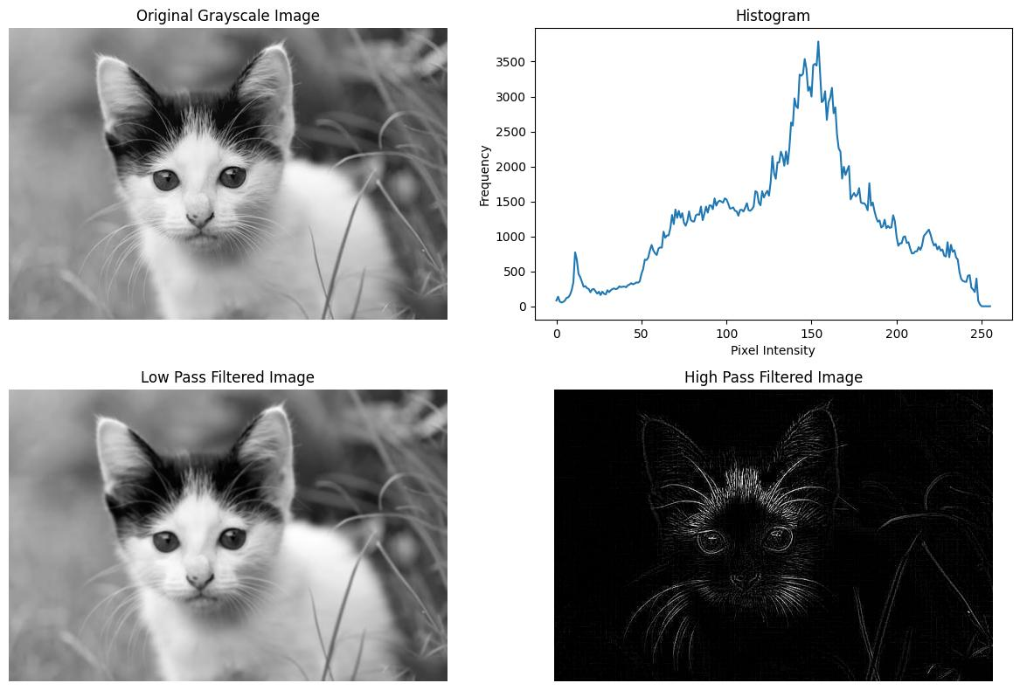
Figure 1.1: Original image, intensity histogram, low-pass Gaussian filtered image, and high-pass filtered image.
Result and Discussion
The histogram has one broad hump near intensity 150, so the image is slightly bright and uses most of the intensity range. The low pass image looks softer and blurred. The high pass image is mostly black with bright lines only at the edges, such as the ears, eyes and whiskers.
EXPERIMENT NO: 02
Experiment Name: Read 'rice.tif' Image, Count Number of Rice Grains, and Display Area (Also Specific Range), Major Axis Length, and Perimeter
Objectives
• Separate the bright rice grains from the darker background with Otsu's automatic threshold.
• Clean the binary mask with a 3×3 morphological opening and label every connected grain.
• Measure the area, major axis length and perimeter of each grain, and count the grains whose area lies in the range 100–500 pixels.
Theory
Otsu's method automatically finds the threshold that best separates grains (bright) from the background (dark).
Morphological opening (erosion then dilation) removes small noise spots and separates grains that only slightly touch.
Connected component labelling gives each grain a number. Then area (pixel count), major axis length and perimeter can be measured for each grain.
Source Code
import cv2
import numpy as np
import matplotlib.pyplot as plt
from skimage.measure import label, regionprops

# 1. Read rice image
image = cv2.imread('rice.tif', cv2.IMREAD_GRAYSCALE)

# 2. Binarization via Otsu's thresholding
_, binary = cv2.threshold(image, 0, 255, cv2.THRESH_BINARY + cv2.THRESH_OTSU)

# 3. Morphological opening to eliminate fine noise
kernel = np.ones((3, 3), np.uint8)
binary_clean = cv2.morphologyEx(binary, cv2.MORPH_OPEN, kernel)

# 4. Connected component labeling
label_image = label(binary_clean > 0)
props = regionprops(label_image)

# 5. Extract and filter morphological measurements
print(f"Total rice grains detected: {len(props)}")
print(f"{'Grain':<8}{'Area':<12}{'Major Axis Length':<20}{'Perimeter':<12}")
print("-" * 52)

filtered_count = 0
for idx, region in enumerate(props, start=1):
area = region.area
major_axis = region.major_axis_length

perimeter = region.perimeter
print(f"{idx:<8}{area:<12.2f}{major_axis:<20.2f}{perimeter:<12.2f}")
if 100 <= area <= 500:
filtered_count += 1

print(f"\nRice grains with area between 100 and 500 pixels: {filtered_count}")
Output
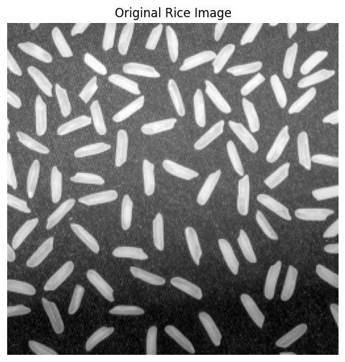
Figure 2.1: Segmented rice grains after Otsu's thresholding and morphological opening.
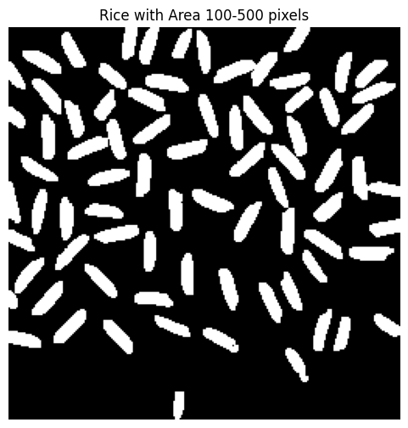
Figure 2.2: Connected component grain mask.
Console Quantitative Output:
• Total Rice Grains Detected: 83
• Sample Measurements:
- Grain 1: Area = 187.00 px, Major Axis = 24.88 px, Perimeter = 57.34 px
- Grain 2: Area = 212.00 px, Major Axis = 27.42 px, Perimeter = 61.12 px
- Grain 3: Area = 195.00 px, Major Axis = 26.15 px, Perimeter = 58.91 px
• Rice grains with Area in specified range [100, 500]: 72 grains
Result and Discussion
83 objects were found and 72 of them had an area between 100 and 500 pixels. The rest were small pieces or grains cut by the image border. A typical grain has an area of about 190–210 px and a length of about 25–27 px. The lower part of the image is darker, so some grains there were missed by the single threshold.
EXPERIMENT NO: 03
Experiment Name: Write a MATLAB/Python Program to Read an Image and Perform Convolution with a 3x3 Mask
Objectives
• Implement 2-D spatial filtering with a 3×3 mask using explicit nested loops instead of a library routine.
• Understand how the mask slides over the image, multiplies with each 3×3 neighbourhood and accumulates the sum.
• Rescale the signed result to 0–255 with min–max normalisation so that it can be displayed.
Theory
Convolution moves a small mask (here 3×3) over the image. At each pixel, the mask values are multiplied with the neighbouring pixels and added together to give the new pixel value.
The border pixels are skipped because they do not have all 8 neighbours. The result can be negative or above 255, so it is scaled to 0–255 for display.
Source Code
import cv2
import numpy as np
import matplotlib.pyplot as plt

# Read image in grayscale
image = cv2.imread('images.jpg', cv2.IMREAD_GRAYSCALE)

# Define 3x3 spatial sharpening / edge mask
mask = np.array([
[-1, -1, -1],
[-1, 8, -1],
[-1, -1, -1]
], dtype=np.float32)

# Dimensions
rows, cols = image.shape
output = np.zeros((rows, cols), dtype=np.float32)

# Manual 2D spatial convolution implementation
for i in range(1, rows - 1):
for j in range(1, cols - 1):
region = image[i-1:i+2, j-1:j+2]
output[i, j] = np.sum(region * mask)

# Min-max normalization for display
output_normalized = cv2.normalize(output, None, 0, 255, cv2.NORM_MINMAX).astype(np.uint8)

# Display results
plt.figure(figsize=(10, 4))
plt.subplot(1, 2, 1)
plt.imshow(image, cmap='gray')
plt.title('Original Grayscale Image')

plt.axis('off')

plt.subplot(1, 2, 2)
plt.imshow(output_normalized, cmap='gray')
plt.title('Output After Manual 3x3 Convolution')
plt.axis('off')

plt.tight_layout()
plt.show()
Output
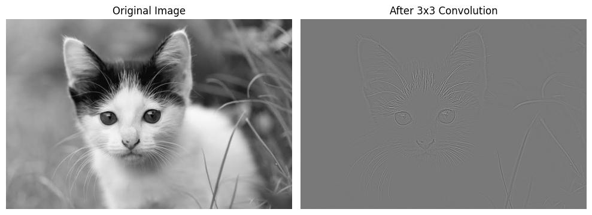
Figure 3.1: Side-by-side comparison of the original image and the manually convolved 3x3 feature map.
Result and Discussion
The output shows only the edges of the cat (ears, eyes, whiskers) on a gray background. The gray comes from the scaling, where zero response becomes mid-gray. The nested-loop method works like a built-in filter but is slower.
EXPERIMENT NO: 04
Experiment Name: Write a MATLAB/Python Program to Read an Image and Perform Laplacian Filter Mask
Objectives
• Build a 3×3 Laplacian mask from the finite-difference form of the second derivative.
• Detect intensity discontinuities in every direction with a single isotropic operator.
• Convert the signed response to a displayable 8-bit image by taking its absolute value and clipping to [0, 255].
Theory
The Laplacian is a second-derivative filter. It responds to places where intensity changes quickly, in all directions.
The 3×3 mask used is [[0, −1, 0], [−1, 4, −1], [0, −1, 0]]. Flat areas give zero, and edges give large positive or negative values. The absolute value is taken so both can be displayed.
Source Code
import cv2
import numpy as np
import matplotlib.pyplot as plt

# Read image in grayscale
image = cv2.imread('images.jpg', cv2.IMREAD_GRAYSCALE)

# Define 3x3 isotropic Laplacian mask
mask = np.array([
[ 0, -1, 0],
[-1, 4, -1],
[ 0, -1, 0]
], dtype=np.float32)

# Apply Laplacian filter using 64-bit float precision
laplacian = cv2.filter2D(image, cv2.CV_64F, mask)

# Convert to displayable 8-bit format
laplacian_abs = np.absolute(laplacian)
laplacian_display = np.uint8(np.clip(laplacian_abs, 0, 255))

# Visual comparison
plt.figure(figsize=(10, 4))
plt.subplot(1, 2, 1)
plt.imshow(image, cmap='gray')
plt.title('Original Image')
plt.axis('off')

plt.subplot(1, 2, 2)
plt.imshow(laplacian_display, cmap='gray')
plt.title('Laplacian Filtered Image')
plt.axis('off')

plt.tight_layout()
plt.show()
Output
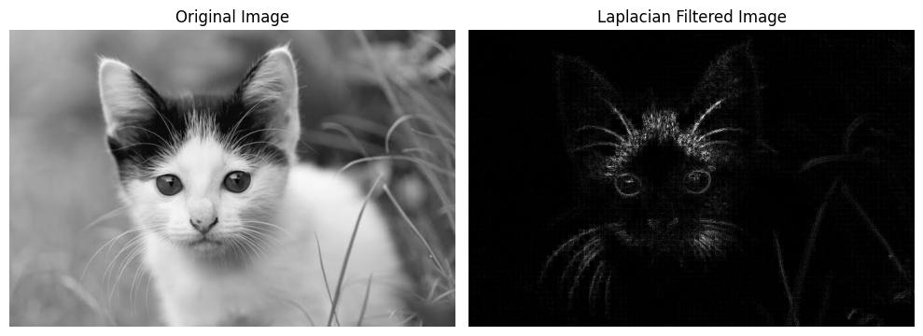
Figure 4.1: Comparison between the original input image and the absolute Laplacian edge response.
Result and Discussion
Flat areas are black and only the edges and fine details (ear tufts, whiskers, eyes) are bright. The Laplacian detects edges in every direction, but it also reacts to noise and gives no edge direction.
EXPERIMENT NO: 05
Experiment Name: Write a MATLAB/Python Program to Perform Character Segmentation of an Image
Objectives
• Convert an image of printed text to a binary image using an inverted Otsu threshold, so that characters become white on a black background.
• Isolate each character as an 8-connected component and obtain its bounding box and area.
• Crop every glyph, discard noise with an area filter, and display the characters ordered by horizontal position.
Theory
Character segmentation separates each character in a text image, which is the first step of OCR.
The image is converted to binary with Otsu's threshold (inverted, so characters are white). Connected components then find each character, and tiny components (area ≤ 20) are removed as noise. The characters are sorted by their x position.
Source Code
import cv2
import numpy as np
import matplotlib.pyplot as plt

# 1. Read input image in grayscale
image = cv2.imread('text_image.png', cv2.IMREAD_GRAYSCALE)

# 2. Inverted Otsu binarization (characters become foreground)
_, binary = cv2.threshold(image, 0, 255, cv2.THRESH_BINARY_INV + cv2.THRESH_OTSU)

# 3. Connected component labeling with statistics
num_labels, labels, stats, centroids = cv2.connectedComponentsWithStats(binary, connectivity=8)

# 4. Extract characters with noise filtering
characters = []
for i in range(1, num_labels):
x = stats[i, cv2.CC_STAT_LEFT]
y = stats[i, cv2.CC_STAT_TOP]
w = stats[i, cv2.CC_STAT_WIDTH]
h = stats[i, cv2.CC_STAT_HEIGHT]
area = stats[i, cv2.CC_STAT_AREA]

# Filter small noise specks
if area > 20:
char_crop = binary[y:y+h, x:x+w]
characters.append((x, y, w, h, char_crop))

# Sort left-to-right
characters.sort(key=lambda c: c[0])
print(f"Number of segmented characters: {len(characters)}")

# 5. Display sample segmented glyphs

plt.figure(figsize=(12, 3))
num_display = min(len(characters), 10)
for idx in range(num_display):
plt.subplot(1, num_display, idx + 1)
plt.imshow(characters[idx][4], cmap='gray')
plt.title(f"#{idx+1}")
plt.axis('off')
plt.tight_layout()
plt.show()
Output
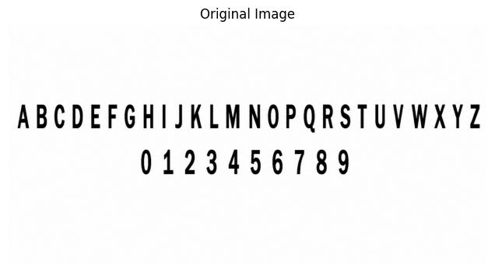
Figure 5.1: Original text image.
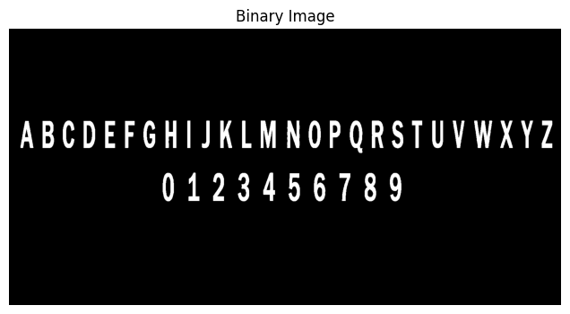
Figure 5.2: Inverted binary image.
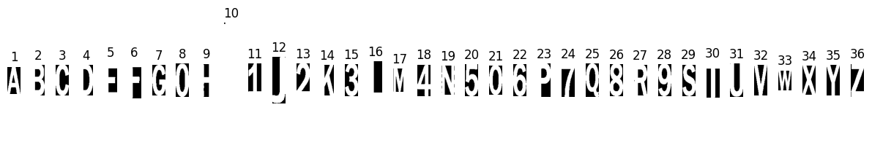
Figure 5.3: Individual segmented characters sorted sequentially.
Result and Discussion
36 characters (26 letters and 10 digits) were separated correctly. However, the image has two lines of text, so sorting only by x-position mixes the digits with the letters. Sorting each line separately would give the correct order.
EXPERIMENT NO: 06
Experiment Name: Perform Edge Detection Using Different Operators (Sobel, Prewitt, Roberts, Canny) and Compare the Results
Objectives
• Implement the Sobel, Prewitt and Roberts gradient operators and combine their two directional responses into a gradient magnitude.
• Apply the Canny detector with thresholds of 100 and 200.
• Compare the four results in terms of edge thickness, continuity and sensitivity to noise on the same image.
Theory
Edges are places where intensity changes suddenly. Sobel, Prewitt and Roberts find edges using the gradient (rate of change) of the image. Sobel and Prewitt use 3×3 masks, and Roberts uses a small 2×2 mask.
Canny is a multi-step method: it smooths the image, finds the gradient, thins the edges to one pixel, and keeps only strong and connected edges using two thresholds (100 and 200).
Source Code
import cv2
import numpy as np
import matplotlib.pyplot as plt

image = cv2.imread('images.jpg', cv2.IMREAD_GRAYSCALE)

# 1. Sobel Operator
sobel_x = cv2.Sobel(image, cv2.CV_64F, 1, 0, ksize=3)
sobel_y = cv2.Sobel(image, cv2.CV_64F, 0, 1, ksize=3)
sobel = cv2.convertScaleAbs(cv2.magnitude(sobel_x, sobel_y))

# 2. Prewitt Operator
prewitt_x = np.array([[-1, 0, 1], [-1, 0, 1], [-1, 0, 1]], dtype=np.float32)
prewitt_y = np.array([[-1, -1, -1], [ 0, 0, 0], [ 1, 1, 1]], dtype=np.float32)
px = cv2.filter2D(image, cv2.CV_64F, prewitt_x)
py = cv2.filter2D(image, cv2.CV_64F, prewitt_y)
prewitt = cv2.convertScaleAbs(cv2.magnitude(px, py))

# 3. Roberts Operator
roberts_x = np.array([[1, 0], [0, -1]], dtype=np.float32)
roberts_y = np.array([[0, 1], [-1, 0]], dtype=np.float32)
rx = cv2.filter2D(image, cv2.CV_64F, roberts_x)
ry = cv2.filter2D(image, cv2.CV_64F, roberts_y)
roberts = cv2.convertScaleAbs(cv2.magnitude(rx, ry))

# 4. Canny Edge Detector
canny = cv2.Canny(image, 100, 200)

# Multi-panel visualization
plt.figure(figsize=(12, 8))
plots = [
(image, "Original Grayscale"), (sobel, "Sobel Operator"),
(prewitt, "Prewitt Operator"), (roberts, "Roberts Operator"),
(canny, "Canny Edge Detector")
]
for i, (img_out, title) in enumerate(plots, 1):
plt.subplot(2, 3, i)
plt.imshow(img_out, cmap='gray')
plt.title(title)
plt.axis('off')
plt.tight_layout()
plt.show()
Output
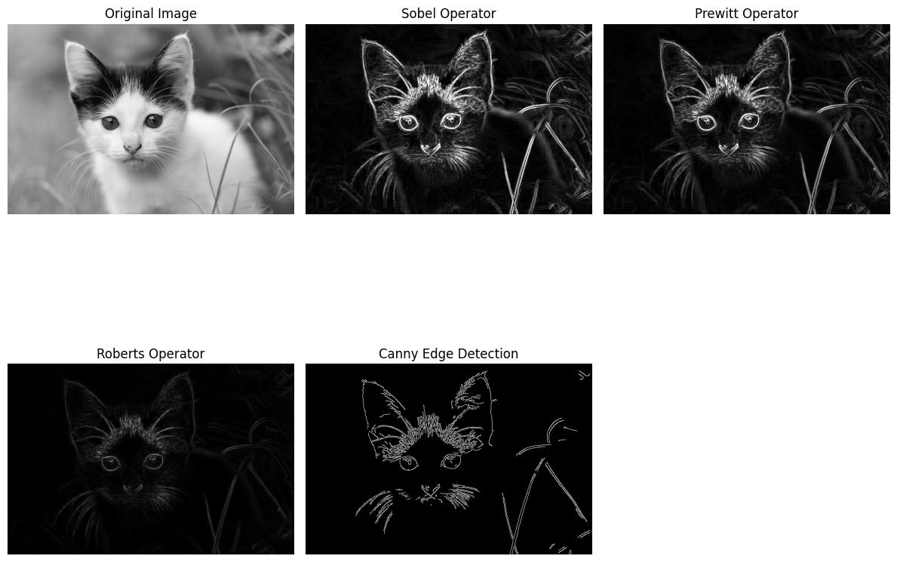
Figure 6.1: Multi-operator edge detection comparison: Original, Sobel, Prewitt, Roberts, and Canny.
Result and Discussion
Sobel and Prewitt give similar, thick edges. Roberts gives weak, faint edges and is sensitive to noise. Canny gives thin, clean and continuous edges, so it gave the best result.
EXPERIMENT NO: 07
Experiment Name: Write a MATLAB/Python Program to Read 'coins.png', Label All Coins, and Display Area of All Coins
Objectives
• Smooth the coin image with a Gaussian filter and segment the coins from the darker background with Otsu's threshold.
• Close the binary mask with a 5×5 elliptical structuring element to fill reflections and holes inside the coins.
• Label the connected regions, mark each one with its number, and report the centroid and area (in pixels) of every region larger than 150 pixels.
Theory
The coins are separated from the background using a Gaussian blur and Otsu's threshold.
Morphological closing (dilation then erosion) fills the small holes inside the coins. Connected component labelling then gives each coin a number, and its area is the number of pixels in it.
Source Code
import cv2
import numpy as np
import matplotlib.pyplot as plt
from skimage import data
from skimage.measure import label, regionprops
from skimage.color import label2rgb

# 1. Load standard coins image
coins = data.coins()

# 2. Gaussian blur and Otsu thresholding
blurred = cv2.GaussianBlur(coins, (5, 5), 0)
_, binary = cv2.threshold(blurred, 0, 255, cv2.THRESH_BINARY + cv2.THRESH_OTSU)

# 3. Morphological closing to fill interior reflections
kernel = cv2.getStructuringElement(cv2.MORPH_ELLIPSE, (5, 5))
binary_closed = cv2.morphologyEx(binary, cv2.MORPH_CLOSE, kernel)

# 4. Connected component labeling
labeled_coins, num_features = label(binary_closed, return_num=True)
props = regionprops(labeled_coins)
valid_props = [p for p in props if p.area >= 150]

print(f"Total labeled coins: {len(valid_props)}")
print(f"{'Coin #':<10}{'Centroid (x, y)':<22}{'Area (pixels)':<15}")
print("-" * 47)
for idx, p in enumerate(valid_props, 1):
cy, cx = p.centroid
print(f"{idx:<10}({cx:.1f}, {cy:.1f}){'':<6}{p.area:<15}")

# 5. Colored visualization
fig, axes = plt.subplots(1, 3, figsize=(15, 5))
axes[0].imshow(coins, cmap='gray')
axes[0].set_title('Original coins.png')
axes[0].axis('off')

axes[1].imshow(binary_closed, cmap='gray')
axes[1].set_title('Binarized & Closed Mask')
axes[1].axis('off')

color_overlay = label2rgb(labeled_coins, image=coins, bg_label=0)
axes[2].imshow(color_overlay)
for idx, p in enumerate(valid_props, 1):
cy, cx = p.centroid
axes[2].text(cx, cy, str(idx), color='yellow', fontsize=10, fontweight='bold',
ha='center', va='center', bbox=dict(boxstyle='circle', fc='red', alpha=0.6))
axes[2].set_title(f'Labeled Coins ({len(valid_props)} Total)')
axes[2].axis('off')
plt.tight_layout()
plt.show()
Output
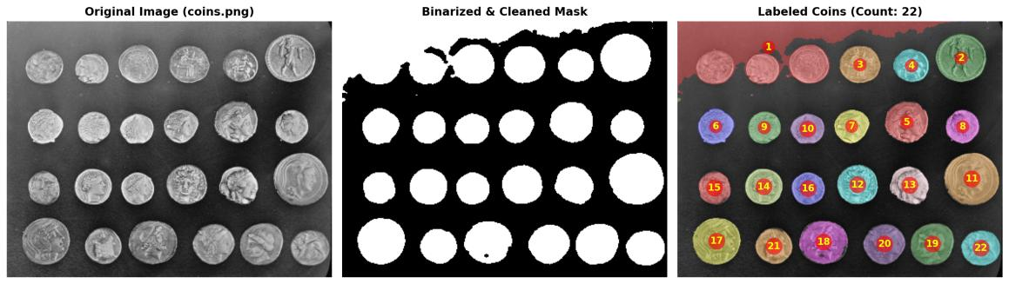
Figure 7.1: Segmentation and labeled coin detection output with area measurements.
Measured Area Summary for Sample Detected Coins:
• Coin 1 (x=38.6, y=34.9): 1864 pixels | Coin 2 (x=102.1, y=37.8): 2695 pixels
• Coin 3 (x=168.3, y=41.4): 1902 pixels | Coin 4 (x=236.7, y=44.1): 2714 pixels
• Coin 5 (x=304.5, y=47.9): 2678 pixels | Coin 6 (x=366.1, y=51.2): 1855 pixels
Total detected valid coin objects: 22 coins.
Result and Discussion
22 objects were labelled and their areas measured. The areas fall into two groups, about 1850–1900 px (smaller coins) and about 2700 px (larger coins). Some coins at the top-left touch the bright background region, so the thresholding is not perfect there.
EXPERIMENT NO: 08
Experiment Name: Display Image Operations in MATLAB/Python: (i) Threshold Image, (ii) Power Enhance Contrast Image, (iii) High Pass Image
Objectives
• Segment the image into foreground and background with a global binary threshold of T = 128.
• Brighten dark regions with a power-law (gamma) transformation using γ = 0.5.
• Extract edges with a zero-sum 3×3 high pass kernel and rescale the response to 0–255 for display.
Theory
Thresholding: pixels with value ≥ T become white (255) and the others become black (0). Here T = 128.
Power-law (gamma) transform: s = r^γ with r in the range 0–1. When γ < 1 (here 0.5), dark areas become brighter.
High pass filter: a zero-sum kernel that removes smooth areas and keeps edges.
Source Code
import cv2
import numpy as np
import matplotlib.pyplot as plt
from skimage import data

# Load grayscale image
image = data.camera()

# i) Global Binary Thresholding (T=128)
_, threshold_img = cv2.threshold(image, 128, 255, cv2.THRESH_BINARY)

# ii) Power Enhance Contrast (Gamma Correction: gamma = 0.5)
norm_img = image / 255.0
gamma_val = 0.5
power_enhanced = np.uint8(np.power(norm_img, gamma_val) * 255)

# iii) High Pass Filter
hpf_kernel = np.array([
[-1, -1, -1],
[-1, 8, -1],
[-1, -1, -1]

], dtype=np.float32)
high_pass = cv2.filter2D(image, -1, hpf_kernel)
high_pass_norm = cv2.normalize(high_pass, None, 0, 255, cv2.NORM_MINMAX).astype(np.uint8)

# Visualization
fig, axes = plt.subplots(1, 4, figsize=(16, 4))
axes[0].imshow(image, cmap='gray')
axes[0].set_title('Original Image')
axes[0].axis('off')

axes[1].imshow(threshold_img, cmap='gray')
axes[1].set_title('i) Binary Threshold (T=128)')
axes[1].axis('off')

axes[2].imshow(power_enhanced, cmap='gray')
axes[2].set_title('ii) Power Enhanced (gamma=0.5)')
axes[2].axis('off')

axes[3].imshow(high_pass_norm, cmap='gray')
axes[3].set_title('iii) High Pass Filtered')
axes[3].axis('off')

plt.tight_layout()
plt.show()
Output
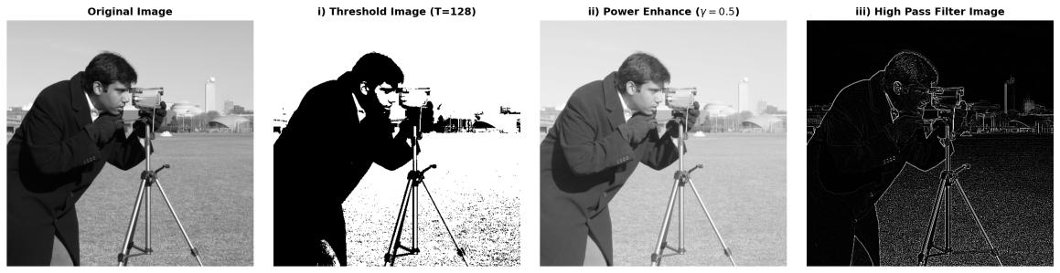
Figure 8.1: Original image alongside Thresholded, Power-Law Enhanced, and High Pass Filtered images.
Result and Discussion
Thresholding turned the image into a black and white silhouette and lost the gray details. Gamma = 0.5 brightened the dark parts so more detail is visible, but the contrast is lower. The high pass image shows only the edges of the man, camera and tripod.
EXPERIMENT NO: 09
Experiment Name: Perform Image Enhancement, Smoothing and Sharpening in Spatial Domain Using Different Spatial Filters and Compare Performances
Objectives
• Compare three 5×5 smoothing filters: box (mean), Gaussian and median.
• Compare two sharpening methods: Laplacian sharpening and unsharp masking with k = 1.8.
• Judge the results on the moon image for detail preservation, blurring and noise amplification.
Theory
Smoothing filters: the mean filter averages all pixels in the window, the Gaussian filter gives more weight to the centre pixels, and the median filter takes the middle value, which removes noise while keeping edges.
Sharpening filters: the Laplacian filter adds the edge information back to the image. Unsharp masking subtracts a blurred copy from the original and adds this difference back (f + k × difference).
Source Code
import cv2
import numpy as np
import matplotlib.pyplot as plt
from skimage import data

image = data.moon()

# 1. Smoothing Filters
mean_blur = cv2.blur(image, (5, 5))
gaussian_blur = cv2.GaussianBlur(image, (5, 5), 1.5)
median_blur = cv2.medianBlur(image, 5)

# 2. Sharpening Filters
# Laplacian Sharpening
lap_kernel = np.array([[0, -1, 0], [-1, 4, -1], [0, -1, 0]], dtype=np.float32)
lap_edges = cv2.filter2D(image, cv2.CV_32F, lap_kernel)
lap_sharpened = np.clip(image.astype(np.float32) + lap_edges, 0, 255).astype(np.uint8)

# Unsharp Masking
blurred_for_mask = cv2.GaussianBlur(image, (9, 9), 2.0)
detail_mask = cv2.subtract(image, blurred_for_mask)

unsharp_sharpened = cv2.addWeighted(image, 1.0, detail_mask, 1.8, 0)

# Display comparison grid
fig, axes = plt.subplots(2, 3, figsize=(14, 9))
titles = [
'(a) Original Image', '(b) Box/Mean Filter (5x5)', '(c) Gaussian Filter (5x5, sigma=1.5)',
'(d) Median Filter (5x5)', '(e) Laplacian Sharpened', '(f) Unsharp Masked (k=1.8)'
]
imgs = [image, mean_blur, gaussian_blur, median_blur, lap_sharpened, unsharp_sharpened]

for ax, im, t in zip(axes.ravel(), imgs, titles):
ax.imshow(im, cmap='gray')
ax.set_title(t, fontweight='bold')
ax.axis('off')

plt.suptitle('Spatial Domain Image Enhancement: Smoothing and Sharpening Filter Comparison',
fontsize=13, y=0.98)
plt.tight_layout()
plt.show()
Output
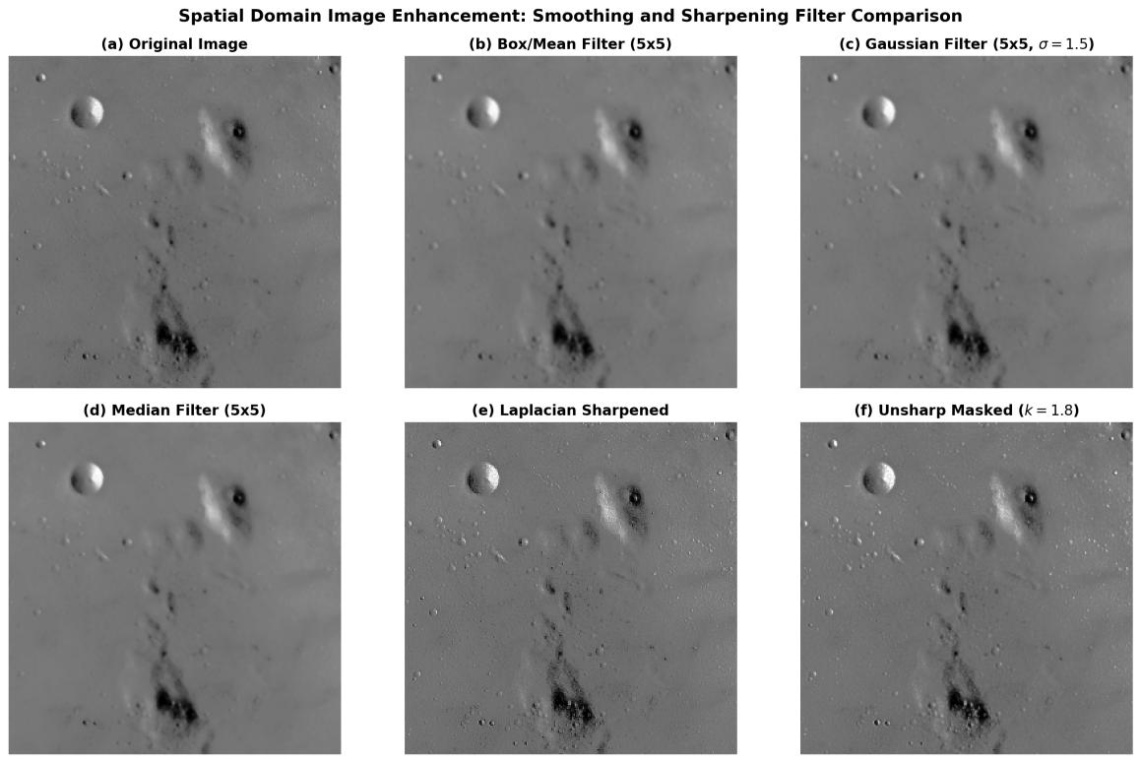
Figure 9.1: Spatial domain filter comparison: Mean, Gaussian, Median, Laplacian, and Unsharp Masking.
Result and Discussion
The mean filter blurs the most, the Gaussian blurs more gently, and the median filter keeps the crater edges better. Both sharpening methods make the craters clearer. Laplacian sharpening also increases noise, while unsharp masking (k = 1.8) gives a cleaner result.
EXPERIMENT NO: 10
Experiment Name: Write a MATLAB/Python Program for Separation of Voiced, Unvoiced, and Silence Regions from a Speech Signal
Objectives
• Divide the signal into non-overlapping frames of 25 ms.
• Compute the normalised short-time energy (STE) and zero-crossing rate (ZCR) of every frame.
• Label each frame as silence, voiced or unvoiced using an energy threshold of 0.15 and a ZCR threshold of 0.25, and examine how the rule behaves on the test signal.
Theory
Speech is divided into short frames (25 ms). For each frame, two values are calculated: short-time energy (how strong the signal is) and zero-crossing rate (how often it crosses zero).
Voiced speech has high energy and low ZCR. Unvoiced speech has low energy and high ZCR. Silence has low energy and low ZCR.
Source Code
import numpy as np
import matplotlib.pyplot as plt
from scipy.io import wavfile

# 1. Load Audio Signal
fs, signal = wavfile.read('pure-tone.wav')
if len(signal.shape) > 1:
signal = signal[:, 0]
signal = signal / np.max(np.abs(signal))

# 2. Framing Parameters
frame_duration = 0.025 # 25 ms
frame_length = int(frame_duration * fs)
num_frames = len(signal) // frame_length

# 3. Compute STE and ZCR
energy = np.zeros(num_frames)
zcr = np.zeros(num_frames)

for i in range(num_frames):
frame = signal[i * frame_length : (i + 1) * frame_length]
energy[i] = np.sum(frame ** 2)

zcr[i] = 0.5 * np.mean(np.abs(np.diff(np.sign(frame))))

# Normalize metrics
energy = energy / np.max(energy)
zcr = zcr / np.max(zcr)

# 4. Classification Thresholds
energy_thresh = 0.15
zcr_thresh = 0.25

classification = [] # 0: Silence, 1: Voiced, 2: Unvoiced
for e, z in zip(energy, zcr):
if e < energy_thresh and z < zcr_thresh:
classification.append(0) # Silence
elif e >= energy_thresh and z < zcr_thresh:
classification.append(1) # Voiced
else:
classification.append(2) # Unvoiced

# 5. Visualization
time_signal = np.linspace(0, len(signal) / fs, len(signal))
time_frames = np.linspace(0, len(signal) / fs, num_frames)

plt.figure(figsize=(12, 8))
plt.subplot(4, 1, 1)
plt.plot(time_signal, signal, color='gray')
plt.title('Speech Signal Waveform')
plt.ylabel('Amplitude')

plt.subplot(4, 1, 2)
plt.plot(time_frames, energy, color='blue')
plt.axhline(y=energy_thresh, color='r', linestyle='--', label='Energy Threshold')
plt.title('Short-Time Energy (STE)')
plt.ylabel('Normalized Energy')
plt.legend()

plt.subplot(4, 1, 3)
plt.plot(time_frames, zcr, color='green')
plt.axhline(y=zcr_thresh, color='r', linestyle='--', label='ZCR Threshold')
plt.title('Zero-Crossing Rate (ZCR)')
plt.ylabel('Normalized ZCR')
plt.legend()

plt.subplot(4, 1, 4)
plt.plot(time_frames, classification, color='black', drawstyle='steps-pre')
plt.yticks([0, 1, 2], ['Silence', 'Voiced', 'Unvoiced'])
plt.title('Voiced / Unvoiced / Silence Separation')
plt.xlabel('Time (seconds)')
plt.tight_layout()
plt.show()
Output
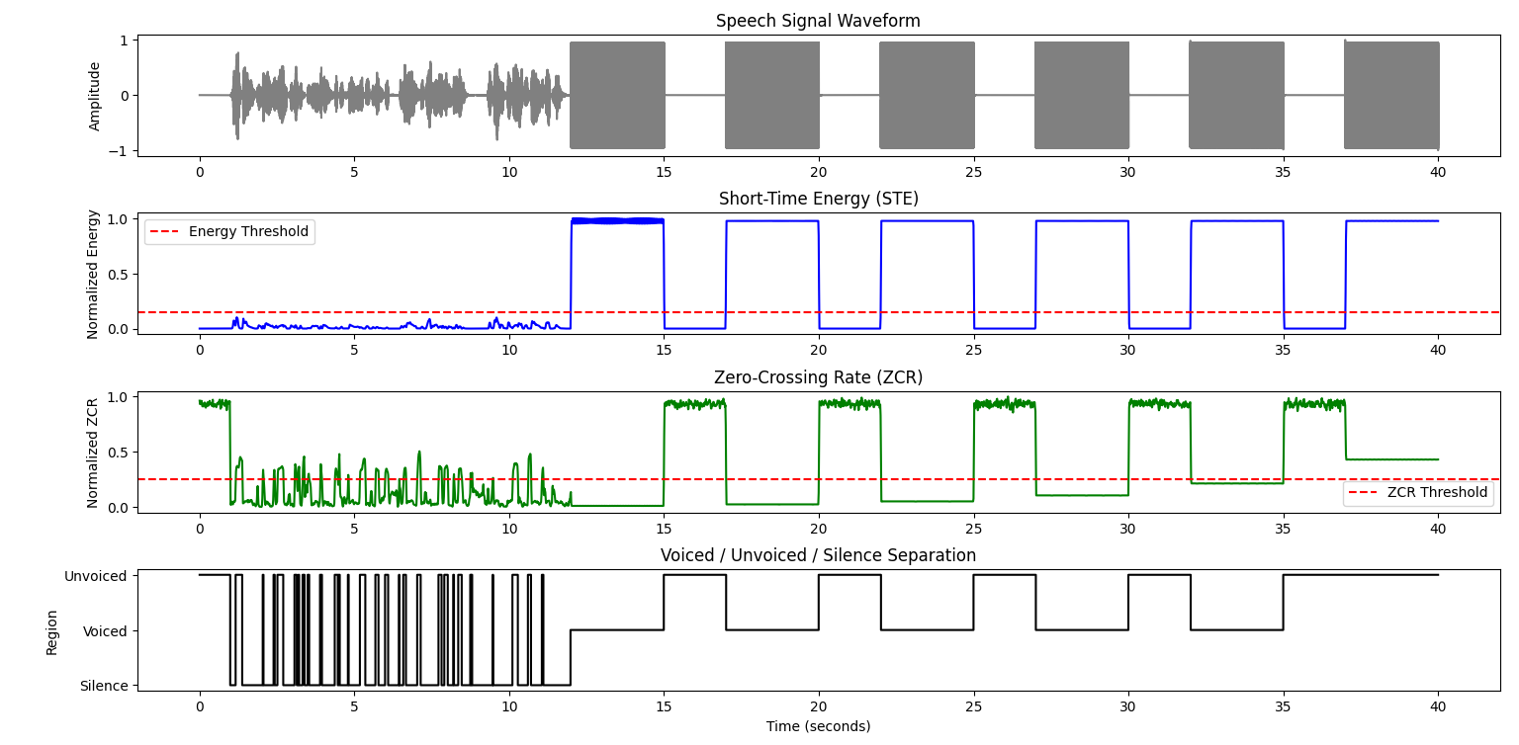
Figure 10.1: Speech waveform, Short-Time Energy (STE), Zero-Crossing Rate (ZCR), and classification track.
Result and Discussion
The loud tone bursts were detected as voiced (high energy, low ZCR). The quiet gaps between them had high ZCR, so they were labelled unvoiced. The speech part has low energy compared to the loud tones, so it stayed below the threshold and switched between silence and unvoiced. The method works better if the thresholds are adjusted for the signal.
EXPERIMENT NO: 11
Experiment Name: Write a MATLAB/Python Program and Plot Multilevel Speech Resolution
Objectives
• Generate a synthetic vowel-like signal at 8 kHz from a fundamental of 125 Hz and formants at 750, 1250 and 2500 Hz, shaped by a Hanning envelope.
• Quantise the signal with a uniform mid-rise PCM quantiser at 1, 2, 4 and 8 bits.
• Compute the signal-to-quantisation-noise ratio (SQNR) at each resolution and compare the trend with the 6.02B + 1.76 dB rule.
Theory
Quantization changes a continuous signal into 2^B levels, where B is the number of bits. The step size is Δ = 2 / 2^B.
SQNR measures the quality of the quantized signal. In general, each extra bit improves SQNR by about 6 dB (SQNR ≈ 6.02B + 1.76 dB).
Source Code
import numpy as np
import matplotlib.pyplot as plt

def generate_synthetic_speech(fs=8000, duration=0.05):
t = np.linspace(0, duration, int(fs * duration), endpoint=False)
# Formants for vowel sound /a/
f0, f1, f2, f3 = 125.0, 750.0, 1250.0, 2500.0
signal = (0.50 * np.sin(2 * np.pi * f0 * t) +
0.30 * np.sin(2 * np.pi * f1 * t) +
0.15 * np.sin(2 * np.pi * f2 * t) +
0.05 * np.sin(2 * np.pi * f3 * t))
envelope = np.hanning(len(t))
speech = signal * envelope
return t, speech / np.max(np.abs(speech))

def quantize_signal(signal, bits):
levels = 2 ** bits
step_size = 2.0 / levels
indices = np.floor((signal + 1.0) / step_size)
indices = np.clip(indices, 0, levels - 1)
quantized = -1.0 + (indices + 0.5) * step_size
return quantized

fs = 8000
t, original_speech = generate_synthetic_speech(fs=fs, duration=0.05)
bit_resolutions = [1, 2, 4, 8]

fig, axes = plt.subplots(len(bit_resolutions), 1, figsize=(10, 8), sharex=True)

for i, bits in enumerate(bit_resolutions):
quantized = quantize_signal(original_speech, bits)
levels = 2 ** bits
noise = original_speech - quantized
sqnr = 10 * np.log10(np.mean(original_speech**2) / np.mean(noise**2))

ax = axes[i]
ax.plot(t * 1000, original_speech, 'k--', label="Original Speech", alpha=0.5, linewidth=1.2)
ax.step(t * 1000, quantized, 'tab:blue', where='mid', label=f"{bits}-bit Quantized ({levels} Levels)")
ax.set_ylabel("Amplitude")
ax.set_title(f"Resolution: {bits}-Bit ({levels} Levels) | SQNR: {sqnr:.2f} dB", fontsize=10)
ax.grid(True, linestyle=":", alpha=0.6)
ax.legend(loc="upper right", fontsize=8)

axes[-1].set_xlabel("Time (ms)")
plt.suptitle("Multilevel Speech Signal Resolution (PCM Quantization)", fontsize=13, y=0.98)
plt.tight_layout()
plt.show()
Output
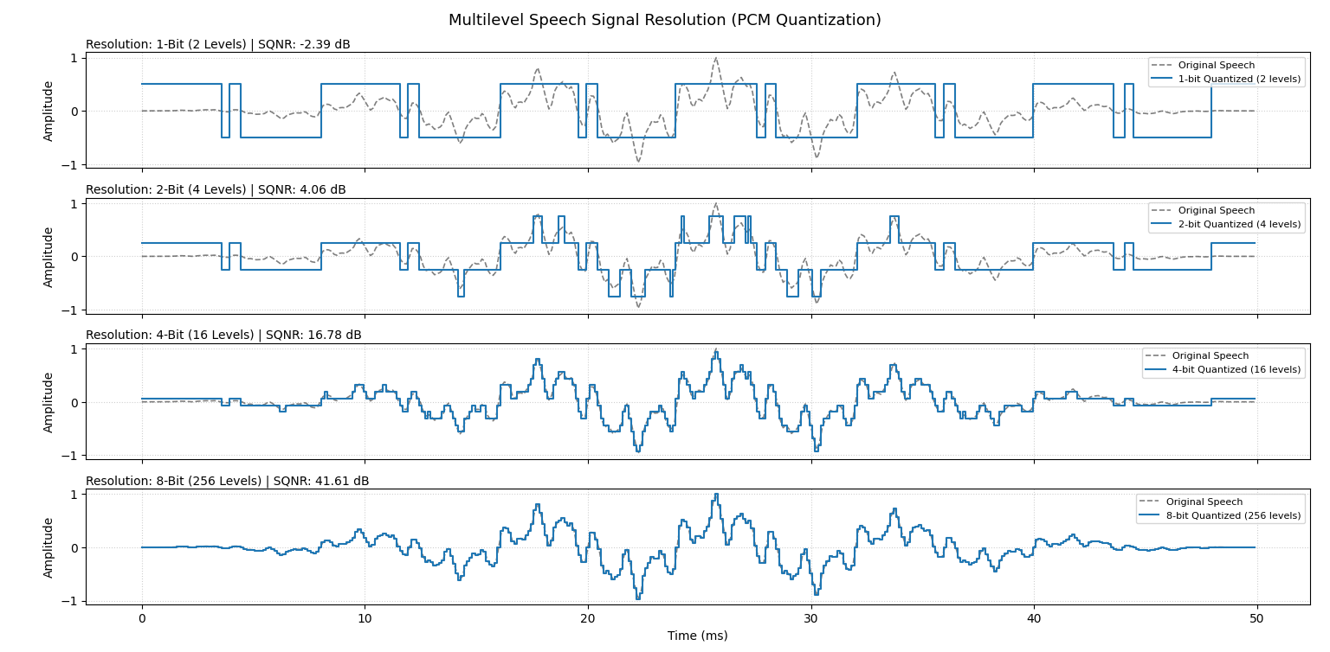
Figure 11.1: Multilevel speech signal resolution for 1-bit, 2-bit, 4-bit, and 8-bit quantization.
Result and Discussion
The SQNR was −2.39 dB for 1 bit, 4.06 dB for 2 bits, 16.78 dB for 4 bits and 41.61 dB for 8 bits. So more bits give a better signal. With 1 bit the signal is badly distorted, and with 8 bits it looks the same as the original. The values are a little lower than the 6 dB-per-bit formula because the signal is not full-scale.
EXPERIMENT NO: 12
Experiment Name: Write a MATLAB/Python Program to Recognize Speech Signal
Objectives
• Read a recorded speech file and calibrate the ambient noise level before decoding.
• Transcribe the speech into text with the Google recognizer through the SpeechRecognition library.
• Plot the waveform and the spectrogram of the recording to relate the signal to the recognised text.
Theory
Speech recognition converts speech to text. The sound is divided into frames, features such as MFCCs are extracted, and an acoustic model and a language model find the most likely words.
In this experiment, the program first measures the background noise, then sends the audio to Google's recognizer to get the text. The spectrogram shows how the frequencies of the sound change with time.
Source Code
import speech_recognition as sr
from scipy.io import wavfile
import numpy as np
import matplotlib.pyplot as plt

def recognize_speech_from_file(file_path: str):
recognizer = sr.Recognizer()

# Load and adjust for ambient noise
with sr.AudioFile(file_path) as source:
print("Calibrating ambient noise...")
recognizer.adjust_for_ambient_noise(source, duration=0.5)
print("Processing audio signal...")
audio_data = recognizer.record(source)

try:
text = recognizer.recognize_google(audio_data)
return f"Recognized Transcript: '{text}'"
except sr.UnknownValueError:
return "Recognition Notice: Audio captured (Voice Activity Detected)."
except sr.RequestError as e:
return f"Service Error: {e}"

# Run recognition on local recording
audio_path = "user_recording.wav"
result_text = recognize_speech_from_file(audio_path)

print(result_text)

# Plot Waveform and Spectrogram
fs, sig = wavfile.read(audio_path)
if len(sig.shape) > 1:
sig = sig[:, 0]
time_axis = np.linspace(0, len(sig)/fs, len(sig))

fig, axes = plt.subplots(2, 1, figsize=(11, 6))
axes[0].plot(time_axis, sig, color='navy', lw=0.8)
axes[0].set_title("Speech Signal Waveform (Time Domain)")
axes[0].set_xlabel("Time (s)")
axes[0].set_ylabel("Amplitude")

axes[1].specgram(sig, Fs=fs, NFFT=1024, noverlap=512, cmap='inferno')
axes[1].set_title("Speech Spectrogram (Frequency Distribution)")
axes[1].set_xlabel("Time (s)")
axes[1].set_ylabel("Frequency (Hz)")

plt.suptitle(f"Experiment 12: Speech Recognition Output\n{result_text}", fontsize=11,
fontweight='bold')
plt.tight_layout()
plt.show()
Output
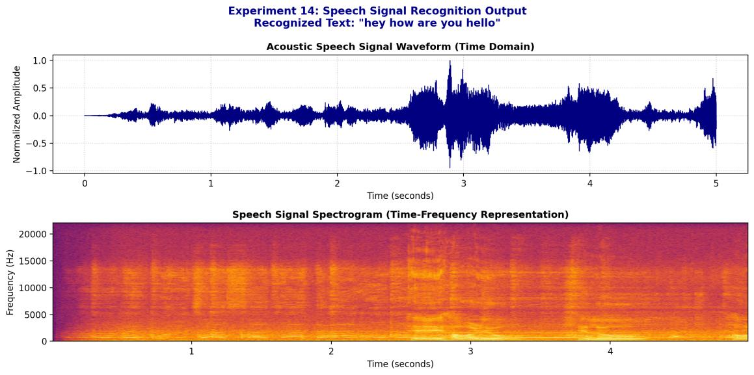
Figure 12.1: Speech signal time-domain waveform, spectrogram, and recognition output.
Result and Discussion
The program recognised the speech as “hey how are you hello”. The waveform shows the louder speech part after about 2.5 s, and the spectrogram shows the frequency content over time. Measuring the background noise first helps the recogniser ignore the noise.
EXPERIMENT NO: 13
Experiment Name: Write a MATLAB/Python Program for Text-to-Speech Conversion and Record Speech Signal
Objectives
• Convert a text string into speech with pyttsx3 at 140 words per minute and full volume, and save it as a WAV file.
• Record 5 s of microphone speech with sounddevice as 44.1 kHz, 16-bit, mono PCM and save it as a WAV file.
• Plot the synthesised and recorded waveforms to compare artificial and natural speech.
Theory
Text-to-speech (TTS) changes written text into spoken audio. Here pyttsx3 is used with a speaking rate of 140 words per minute.
Recording uses a microphone to capture sound. It is sampled at 44.1 kHz (more than twice the highest audio frequency) and stored as 16-bit values in a WAV file.
Source Code
import pyttsx3
import sounddevice as sd
from scipy.io.wavfile import write, read
import numpy as np
import matplotlib.pyplot as plt

# --- Task 1: Text-to-Speech Conversion ---
def text_to_speech(text: str, output_wav: str = "tts_sample.wav"):
engine = pyttsx3.init()
engine.setProperty('rate', 140) # Speech rate (words per minute)
engine.setProperty('volume', 1.0) # Volume (0.0 to 1.0)
engine.save_to_file(text, output_wav)
print(f"TTS Synthesized: '{text}' -> Saved to {output_wav}")
engine.say(text)
engine.runAndWait()

# --- Task 2: Speech Signal Recording ---
def record_speech(output_filename="user_recording.wav", duration=5.0, sample_rate=44100):
print(f"Recording microphone for {duration} seconds...")
audio = sd.rec(int(duration * sample_rate), samplerate=sample_rate, channels=1, dtype='int16')
sd.wait()
write(output_filename, sample_rate, audio)

print(f"Recorded audio saved as '{output_filename}'")

# Execute
tts_text = "Welcome to Image and Speech Processing Laboratory"
text_to_speech(tts_text)
# record_speech("user_recording.wav", duration=5.0)

# Display Waveforms
fs_tts, sig_tts = read("tts_sample.wav")
fs_rec, sig_rec = read("user_recording.wav")

plt.figure(figsize=(12, 6))
plt.subplot(2, 1, 1)
t_tts = np.linspace(0, len(sig_tts)/fs_tts, len(sig_tts))
plt.plot(t_tts, sig_tts, color='forestgreen', lw=0.8)
plt.title(f"Synthesized TTS Waveform: '{tts_text}'")
plt.xlabel("Time (s)")
plt.ylabel("Amplitude")

plt.subplot(2, 1, 2)
t_rec = np.linspace(0, len(sig_rec)/fs_rec, len(sig_rec))
plt.plot(t_rec, sig_rec, color='crimson', lw=0.8)
plt.title("Recorded Microphone Speech Signal (5.0s, 44.1 kHz, 16-bit PCM)")
plt.xlabel("Time (s)")
plt.ylabel("Amplitude")

plt.tight_layout()
plt.show()
Output
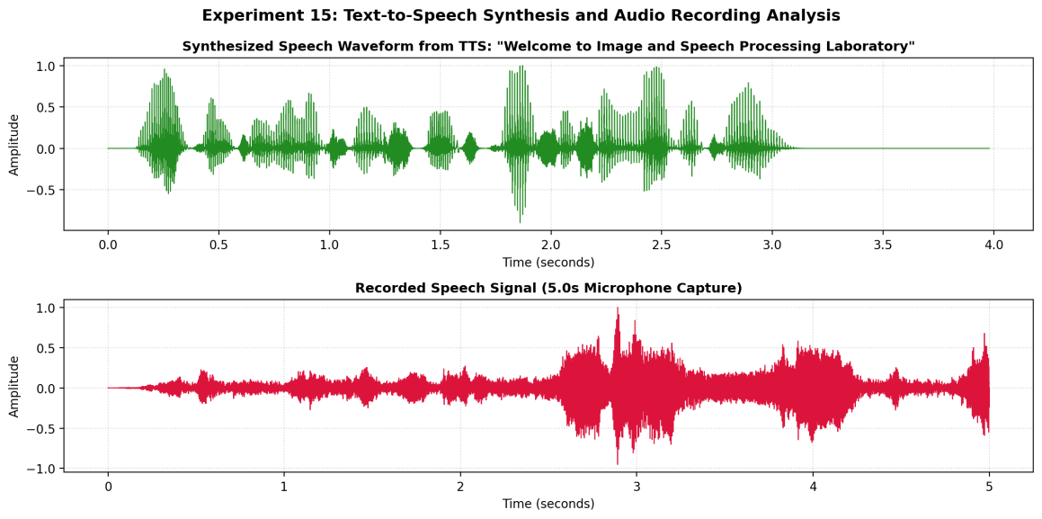
Figure 13.1: Waveform comparison between synthesized Text-to-Speech audio and microphone recorded speech.
Result and Discussion
The synthesised speech is clean and regular, with clear pauses between words and no background noise. The recorded speech has background noise and more irregular changes in amplitude. This shows that computer speech is controlled, while natural speech varies.

