Microsoft | OA 2019 | Numbers With Equal Digit Sum

**10**

[](https://leetcode.com/captaincode8)[captaincode8](https://leetcode.com/captaincode8)26

Last Edit: October 5, 2019 7:39 PM

5.2K VIEWS

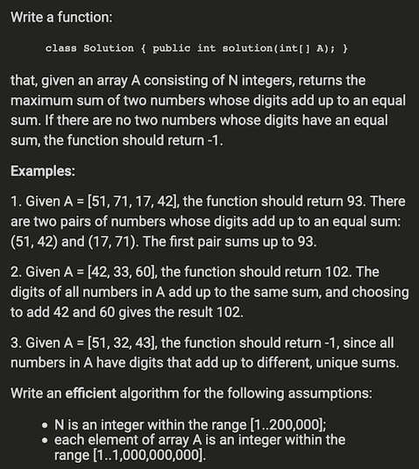

Comments: 23

BestMost VotesNewest to OldestOldest to Newest

Login to Comment

[](https://leetcode.com/siyc)[SiyC](https://leetcode.com/siyc)120

Last Edit: August 28, 2019 1:04 AM

Read More

Java O(NlogK) time complexity & O(N) space complexity solution with playground.  
There contains logK since computing the digit sum of A[i], which complexity is log(A[i]) with base 10.

private int computeDigitSum(int a){

// supposed to be valid for negative numbers and the output must be non-negative integer.

a = Math.abs(a);

int res = 0;

while(a > 0){

res += a % 10;

a /= 10;

}

return res;

}

public int maxSum(int[] A){

int N = A.length;

if(N <= 1) return -1;

Map<Integer, Integer> map = new HashMap<>();

int res = -1;

for(int i = 0; i < N; ++i){

int digitsum = computeDigitSum(A[i]);

if(!map.containsKey(digitsum)){

map.put(digitsum, A[i]);

}

else{

res = Math.max(res, map.get(digitsum) + A[i]);

map.put(digitsum, Math.max(A[i], map.get(digitsum)));

}

}

return res;

}

<https://leetcode.com/discuss/interview-question/365872/>

2.

<https://leetcode.com/discuss/interview-question/398026/>

##### Microsoft | OA 2019 | Min Moves to Obtain String Without 3 Identical Consecutive Letters

**2**

[](https://leetcode.com/sithis)[Sithis](https://leetcode.com/sithis)Moderator5580

Last Edit: October 6, 2019 7:36 PM

2.3K VIEWS

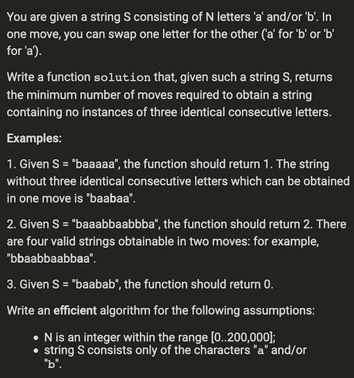

Java solution

Time complexity: O(n).  
Space complexity: O(1).

public int solution(String s) {

int moves = 0;

for (int i = 0 ; i < s.length(); i++) {

int runLength = 1;

for (; i + 1 < s.length() && s.charAt(i) == s.charAt(i + 1); i++) {

runLength++;

}

moves += runLength / 3;

}

return moves;

}

3.

<https://leetcode.com/discuss/interview-question/364760/>

Microsoft | OA 2019 | Max Network Rank

**3**

[](https://leetcode.com/captaincode8)[captaincode8](https://leetcode.com/captaincode8)26

Last Edit: October 5, 2019 7:52 PM

2.3K VIEWS

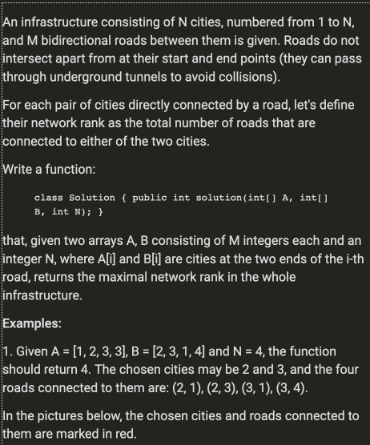

// "static void main" must be defined in a public class.

public class Main {

public static void main(String[] args) {

System.out.println(countEdges(new int[]{1,2,3,3}, new int[]{2,3,1,4}, 4));

System.out.println(countEdges(new int[]{1,2,4,5}, new int[]{2,3,5,6}, 6));

}

public static int countEdges(int[] A, int[] B, int N){

if (A == null || B == null || A.length == 0 || B.length == 0 || A.length != B.length){

return 0;

}

//Form an adjacency list

Map<Integer, List<Integer>> map = new HashMap<>();

for (int i=0; i<A.length; i++){

if(!map.containsKey(A[i])){

map.put(A[i], new ArrayList<Integer>());

}

if(!map.containsKey(B[i])){

map.put(B[i], new ArrayList<Integer>());

}

map.get(A[i]).add(B[i]);

map.get(B[i]).add(A[i]);

}

// Iterate through all nodes and perform DFS on the node not present in seen set

Set<Integer> seen = new HashSet<>();

int res = 0;

for(int j=1; j<=N; j++){

if(!seen.contains(j)){

int edges = dfs(seen, map, j);

res = Math.max(res, edges);

}

}

// Since each edge is counted twice in the dfs method we return res/2

return res/2;

}

public static int dfs(Set<Integer> seen, Map<Integer, List<Integer>> map, int cur){

if (seen.contains(cur) || !map.containsKey(cur)){

return 0;

}

seen.add(cur);

List<Integer> nodes = new ArrayList<>();

nodes = map.get(cur);

int res = nodes.size();

for(Integer node : nodes){

if (!seen.contains(node)){

res += dfs(seen, map, node);

}

}

return res;

}

}

4. <https://leetcode.com/discuss/interview-question/351783/>

Microsoft | OA 2019 | Min Swaps to Make Palindrome

**8**

[](https://leetcode.com/rithiksingh098)[rithiksingh098](https://leetcode.com/rithiksingh098)28

Last Edit: October 5, 2019 7:46 PM

3.6K VIEWS

Given a string, what is the minimum number of **adjacent swaps** required to convert a string into a palindrome. If not possible, return -1.

Practice online: <https://www.codechef.com/problems/ENCD12>

**Example 1:**

Input: "mamad"

Output: 3

**Example 2:**

Input: "asflkj"

Output: -1

**Example 3:**

Input: "aabb"

Output: 2

**Example 4:**

Input: "ntiin"

Output: 1

Explanation: swap 't' with 'i' => "nitin"

Have someone managed to solve this in less than O(n^2)??  
My Java solution, seems to be O(n^2)

public static int minSwapPalindrome(String s) {

if (s == null) throw new IllegalArgumentException();

if (!canFormPalindrome(s)) return -1;

int n = s.length(), swaps = 0;

StringBuilder sb = new StringBuilder(s);

for (int i = 0; i < n / 2; i++) {

boolean found = false;

for (int j = n - i - 1; j > i; j--) {

//System.out.println(i + ":" + j);

if (sb.charAt(j) == sb.charAt(i)) {

found = true;

for (int k = j; k < n - i - 1; k++) {

swap(sb, k, k + 1);

swaps++;

}

break;

}

}

if (!found && n % 2 != 0) {

for (int k = i; k < n/2; k++) {

swap(sb, k, k + 1);

swaps++;

}

}

}

return swaps;

}

private static void swap(StringBuilder sb, int i, int j) {

char c = sb.charAt(i);

sb.setCharAt(i, sb.charAt(j));

sb.setCharAt(j, c);

}

// only for lowercase letter

private static boolean canFormPalindrome(String s) {

int[] counts = new int[26];

for (char c : s.toCharArray())

counts[c - 'a']++;

boolean hasOdd = false;

for (int count : counts) {

if (count % 2 == 0) continue;

else {

if (hasOdd)

return false;

hasOdd = true;

}

}

return true;

}

5. <https://leetcode.com/discuss/interview-question/398031/>

Given a string s containing only a and b, find longest substring of s such that s does not contain more than two contiguous occurrences of a and b.

**Example 1:**

Input: "aabbaaaaabb"

Output: "aabbaa"

**Example 2:**

Input: "aabbaabbaabbaa"

Output: "aabbaabbaabbaa"

Time complexity O(N)  
Space complexity O(1)

public static String validLongestSubstring(String s) {

if (s.length() < 3)

return s;

int cur = 0, end = 1;

char c = s.charAt(0);

int count = 1;

int maxLen = 1;

int start = 0;

while (end < s.length()) {

if (s.charAt(end) == c) {

count ++;

if (count == 2) {

if (end - cur + 1 > maxLen) {

maxLen = end - cur + 1;

start = cur;

}

}

else {

cur = end - 1;

}

}

else {

c = s.charAt(end);

count = 1;

if (end - cur + 1 > maxLen) {

maxLen = end - cur + 1;

start = cur;

}

}

end ++;

}

return s.substring(start, start + maxLen);

}

6. <https://leetcode.com/discuss/interview-question/366869/>

Lexicographically smallest string formed by removing at most one character.

**Example 1:**

Input: "abczd"

Output: "abcd"

public static void main(String[] args) {

String s1 = "abczd";

System.out.println(getSmallString(s1));

String s2 = "abcde";

System.out.println(getSmallString(s2));

}

private static String getSmallString(String s) {

StringBuilder sb = new StringBuilder();

Stack<Character> stack = new Stack<>();

int cnt = 0;

for(int i=0;i<s.length();i++) {

char c = s.charAt(i);

if(!stack.isEmpty() && stack.peek() > c && cnt < 1) {

stack.pop();

cnt++;

}

stack.push(c);

}

if(cnt == 0)

stack.pop();

while(!stack.isEmpty()) {

sb.insert(0, stack.pop());

}

return sb.toString();

}

abcd  
abcd

**1**

Reply

Share

7. <https://leetcode.com/discuss/interview-question/398035/>

Given a string s consisting of n lowercase letters, you have to delete the minimum number of characters from s so that every letter in s appears a unique number of times. We only care about the occurrences of letters that appear at least once in result.

**Example 1:**

Input: "eeeeffff"

Output: 1

Explanation:

We can delete one occurence of e or one occurence of 'f'. Then one letter will occur four times and the other three times.

**Example 2:**

Input: "aabbffddeaee"

Output: 6

Explanation:

For example, we can delete all occurences of 'e' and 'f' and one occurence of 'd' to obtain the word "aabbda".

Note that both 'e' and 'f' will occur zero times in the new word, but that's fine, since we only care about the letter that appear at least once.

**Example 3:**

Input: "llll"

Output: 0

Explanation:

There is no need to delete any character.

**Example 4:**

Input: "example"

Output: 4

Java solution: Thanks for the idea from [@manidh](https://leetcode.com/manidh)

public static void main(String[] args) {

String s1 = "aaaabbbb";

System.out.println(s1 + ":" + minDeletion(s1));

String s2 = "aabbbbcccdddd";

System.out.println(s2 + ":" + minDeletion(s2));

String s3 = "aaaaaabbbbbccccddddeeeeee";

System.out.println(s3 + ":" + minDeletion(s3));

String s4 = "abcdefghijkl";

System.out.println(s4 + ":" + minDeletion(s4));

String s5 = "aaaaaa";

System.out.println(s5 + ":" + minDeletion(s5));

String s6 = "aabbffddeaee";

System.out.println(s6 + ":" + minDeletion(s6));

String s7 = "llll";

System.out.println(s7 + ":" + minDeletion(s7));

String s8 = "example";

System.out.println(s8 + ":" + minDeletion(s8));

}

private static int minDeletion(String s) {

Map<Character, Integer> map = new HashMap<>();

for(char c : s.toCharArray())

map.put(c, map.getOrDefault(c, 0) + 1);

Map<Integer, Integer> cnt = new HashMap<>();

for(char c : map.keySet()) {

cnt.put(map.get(c), cnt.getOrDefault(map.get(c), 0) + 1);

}

Queue<Map.Entry<Integer, Integer>> maxHeap = new PriorityQueue<>((a, b)->b.getKey() - a.getKey());

maxHeap.addAll(cnt.entrySet());

int res = 0;

while(maxHeap.size() > 1) {

Map.Entry<Integer, Integer> e1 = maxHeap.poll();

Map.Entry<Integer, Integer> e2 = maxHeap.poll();

res += e1.getValue() - 1;

e2.setValue(e2.getValue() + e1.getValue() - 1);

maxHeap.offer(e2);

}

Map.Entry<Integer, Integer> lastEntry = maxHeap.poll();

if(lastEntry.getValue() > lastEntry.getKey()){

res += lastEntry.getKey() * (lastEntry.getValue() - lastEntry.getKey());

lastEntry.setValue(lastEntry.getKey());

}

res += getSum(lastEntry.getValue() - 1);

return res;

}

static int getSum(int n) {

if(n <= 1)

return n;

return n + getSum(n-1);

}

---------------------------------------------------------------------------------------------------------'  
aaaabbbb:1  
aabbbbcccdddd:3  
aaaaaabbbbbccccddddeeeeee:5  
abcdefghijkl:11  
aaaaaa:0  
aabbffddeaee:6  
llll:0  
example:4

8. <https://leetcode.com/discuss/interview-question/398039/>

Microsoft | OA 2019 | String Without 3 Identical Consecutive Letters

**2**

[](https://leetcode.com/sithis)[Sithis](https://leetcode.com/sithis)Moderator5581

October 5, 2019 8:12 PM

1.2K VIEWS

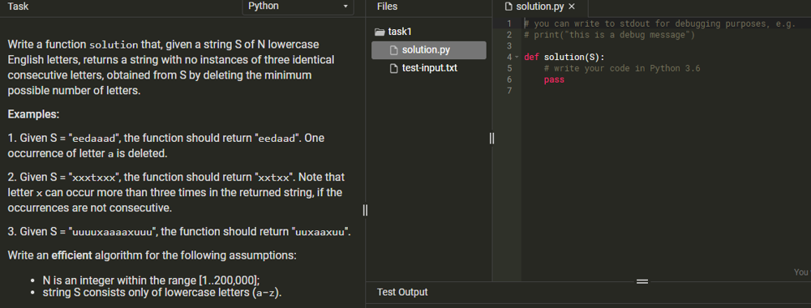

Java Solution:

public static void main(String[] args) {

String s1 = "eedaaad";

String s2 = "xxxtxxx";

String s3 = "uuuuxaaaaxuuu";

System.out.println(getLongestSubstring(s1));

System.out.println(getLongestSubstring(s2));

System.out.println(getLongestSubstring(s3));

}

private static String getLongestSubstring(String s) {

StringBuilder sb = new StringBuilder();

sb.append(s.charAt(0));

int cnt = 1;

for(int r=1;r<s.length();r++) {

char c = s.charAt(r);

if(c == s.charAt(r-1))

cnt++;

else {

cnt = 1;

}

if(cnt < 3)

sb.append(c);

}

return sb.toString();

}

eedaad  
xxtxx  
uuxaaxuu

9. <https://leetcode.com/discuss/interview-question/398037/>

Microsoft | OA 2019 | Longest Semi-Alternating Substring

**2**

[](https://leetcode.com/sithis)[Sithis](https://leetcode.com/sithis)Moderator5581

October 5, 2019 8:10 PM

1.3K VIEWS

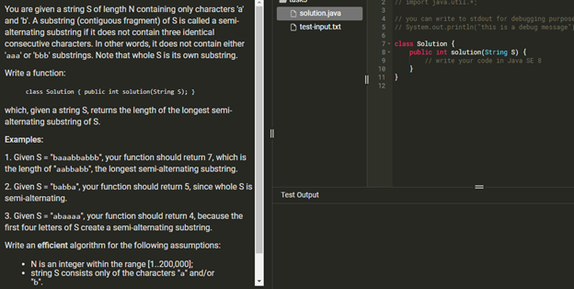

Comments: 7

Java solution:

public static void main(String[] args) {

String s1 = "baaabbabbb";

String s2 = "babba";

String s3 = "abaaaa";

System.out.println(getLongest(s1));

System.out.println(getLongest(s2));

System.out.println(getLongest(s3));

}

private static int getLongest(String s) {

int cnt = 1, l = 0, lastSeen = 0;

int res = 0;

for(int r = 1;r < s.length();r++) {

char c = s.charAt(r);

if(s.charAt(r-1) == c) {

cnt++;

}else {

cnt = 1;

lastSeen = r;

}

if(cnt > 2 && l < lastSeen)

l = lastSeen;

while(cnt > 2) {

l++;

cnt--;

}

res = Math.max(res, r - l + 1);

}

return res;

}

7  
5  
4

10. <https://leetcode.com/discuss/interview-question/364618/>

Microsoft | OA 2019 | Min Steps to Make Piles Equal Height

**6**

Anonymous User

Last Edit: August 22, 2019 3:43 PM

1.7K VIEWS

Alexa is given n piles of equal or unequal heights. In one step, Alexa can remove any number of boxes from the pile which has the maximum height and try to make it equal to the one which is just lower than the maximum height of the stack. Determine the minimum number of steps required to make all of the piles equal in height.

**Example 1:**

Input: piles = [5, 2, 1]

Output: 3

Explanation:

Step 1: reducing 5 -> 2 [2, 2, 1]

Step 2: reducing 2 -> 1 [2, 1, 1]

Step 3: reducing 2 -> 1 [1, 1, 1]

So final number of steps required is 3.

Java O(NlogN) solution with playground.  
For piles = [5, 2, 1], 5 needs 2 steps to come to 1(5 -> 2 -> 1) and 2 needs 1 step to 1(2 -> 1) and 1 for 0 step. We just need to sort the array and record how many different numbers appeared before and sum them up.

public int minSteps(int[] piles){

int len = piles.length;

if(len <= 1) return 0;

Arrays.sort(piles);

int res = 0, distinctNums = 0;

for(int i = 1; i < len; ++i){

if(piles[i] == piles[i - 1]){

res += distinctNums;

}

else{

++distinctNums;

res += distinctNums;

}

}

return res;

}

11. <https://leetcode.com/discuss/interview-question/398047/>

Microsoft | OA 2019 | Day of Week

**4**

[](https://leetcode.com/sithis)[Sithis](https://leetcode.com/sithis)Moderator5581

October 5, 2019 8:24 PM

1.4K VIEWS

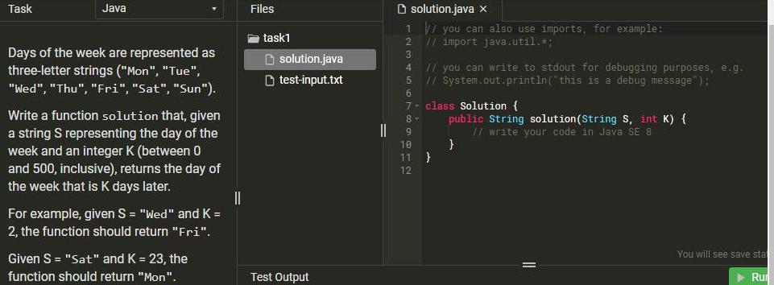

Comments: 5

Java O(1) solution

public static String dayAfter(String day, int k){

String[] days = new String[]{"Mon", "Tue", "Wed", "Thu", "Fri", "Sat", "Sun"};

Map<String, Integer> dayMap = new HashMap<>();

for( int i=0; i<days.length; i++)

dayMap.put(days[i], i);

int numOfDay = (k+dayMap.get(day)) % 7;

return days[numOfDay];

}

12. <https://leetcode.com/discuss/interview-question/398050/>

Microsoft | OA 2019 | Max Possible Value

**1**

[](https://leetcode.com/sithis)[Sithis](https://leetcode.com/sithis)Moderator5581

October 5, 2019 8:26 PM

1.3K VIEWS

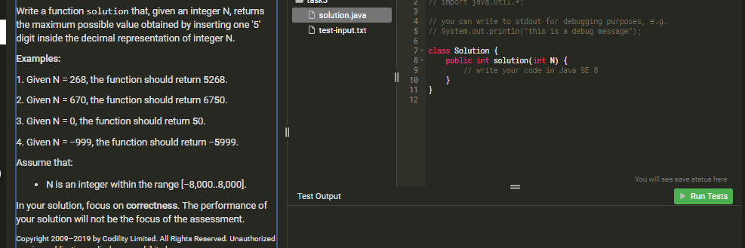

Slightly messy but here was my go at it in Java

public static void main(String[] args)

{

System.out.println(maxDidget(268));

System.out.println(maxDidget(670));

System.out.println(maxDidget(0));

System.out.println(maxDidget(-999));

System.out.println(maxDidget(-462));

System.out.println(maxDidget(000));

}

public static int maxDidget(int N)

{

String strN = N + "";

final int i = helper(strN, isNeg(N));

return i;

}

public static Integer helper(String n, boolean neg)

{

String s = "";

boolean changed = false;

if(neg)

{

// go as far right as possible till next number is greater than 5

for(int i = 0; i < n.length(); i++)

{

if(n.charAt(i) < '5')

{

s+= n.charAt(i);

}

else

{

s += '5' + n.substring(i);

changed = true;

break;

}

}

if(!changed)

s += '5';

}

else

{

// add to front of first number less than 5

for(int i = 0; i < n.length(); i++)

{

if(n.charAt(i) > '5')

{

s+= n.charAt(i);

}

else

{

s += '5' + n.substring(i);

changed = true;

break;

}

}

if(!changed)

s += '5';

}

return Integer.parseInt(s);

}

public static boolean isNeg(int N)

{

if(N < 0)

return true;

return false;

}

13. <https://leetcode.com/discuss/interview-question/398056/>

Microsoft | OA 2019 | Max Inserts to Obtain String Without 3 Consecutive 'a'

**0**

[](https://leetcode.com/sithis)[Sithis](https://leetcode.com/sithis)Moderator5581

October 5, 2019 8:29 PM

1.1K VIEWS

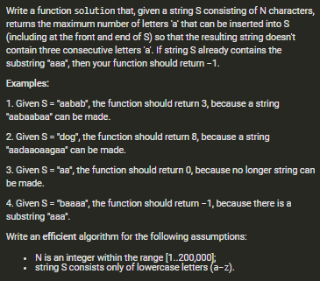

public int solution(String input){

if(input.length() == 0)

return 2;

int result = 0;

char c = input.charAt(0);

int countOfAs = c == 'a'?1:0;

result += c != 'a'?2:0;

for (int i = 1; i <= input.length(); i++) {

if(i == input.length()){

result += 2-countOfAs;

break;

}

c = input.charAt(i);

if(c != 'a'){

result += 2-countOfAs;

countOfAs = 0;

}else{

countOfAs++;

}

if(countOfAs>=3)

return -1;

}

return result;

}

14. <https://leetcode.com/discuss/interview-question/401826/>

**6**

Anonymous User

Last Edit: October 24, 2019 2:52 PM

2.2K VIEWS

Given an Array A consisting of N Strings, calculate the length of the longest string S such that:

* S is a concatenation of some of the Strings from A.
* every letter in S is different.

Example -  
A = ["co","dil","ity"] , function should return 5, resulting string S could be codil , dilco, coity,ityco  
A = ["abc","kkk","def","csv"] , returns 6 , resulting Strings S could be abcdef , defabc, defcsv , csvdef  
A = ["abc","ade","akl"] , return 0 , impossible to concatenate as letters wont be unique.

N is [1..8] ; A consists of lowercase English letters ; sum of length of strings in A does not exceed 100.

Should be NlogN.  
Intuition - Start with a longest string , if it has all letters unique that means its length should definitely be a part of answer !!

static void findConcatenated(String[] input) {

Arrays.sort(input,new Comparator<String>(){

public int compare(String s1, String s2) {

return s2.length()- s1.length();

}

});

HashMap <Character,Integer> characterInputAddress = new HashMap<>();

for (int i = 0; i < input.length; i++) {

String curr = input[i];

if(curr.length() != findUniqueWordLength(curr)) continue;

boolean charaterExists = false;

for(int j = 0 ; j < curr.length() ; j++) {

if(characterInputAddress.containsKey(curr.charAt(j))) {

charaterExists = true;

break;

}

}

if(!charaterExists) {

for(int j = 0 ; j < curr.length() ; j++) {

characterInputAddress.put(curr.charAt(j),i);

}

}

}

System.out.println(characterInputAddress.size());

}

static int findUniqueWordLength(String s) {

HashSet<Character> currWithoutDuplicates = new HashSet<>();

for (int i = 0; i < s.length(); i++) {

currWithoutDuplicates.add(s.charAt(i));

}

return currWithoutDuplicates.size();

}

15. <https://leetcode.com/discuss/interview-question/406031/>

Write a function that, given an array A of N integers, returns the lagest integer K > 0 such that both values K and -K exisit in array A. If there is no such integer, the function should return 0.

**Example 1:**

Input: [3, 2, -2, 5, -3]

Output: 3

**Example 2:**

Input: [1, 2, 3, -4]

Output: 0

ava solution:

public static void main(String[] args) {

int[] nums1 = { 3, 2, -2, 5, -3 };

int[] nums2 = { 1, 2, 3, -4 };

System.out.println(largestNum(nums1));

System.out.println(largestNum(nums2));

System.out.println("-------------------------------------");

System.out.println(largestNum2(nums1));

System.out.println(largestNum2(nums2));

}

private static int largestNum(int[] nums) {

int res = 0;

Set<Integer> set = new HashSet<>();

for(int i=0;i<nums.length;i++) {

set.add(-nums[i]);

if(set.contains(nums[i])) {

res = Math.max(res, Math.abs(nums[i]));

}

}

return res;

}

private static int largestNum2(int[] nums) {

int res = 0;

Arrays.sort(nums);

int l = 0, r = nums.length -1;

while(l < r) {

int sum = nums[l] + nums[r];

if(sum == 0) {

res = Math.max(res, Math.max(nums[l], nums[r]));

l++;

r--;

}

else if(sum < 0) {

l++;

}else {

r--;

}

}

return res;

}

3  
0

3  
0

16. <https://leetcode.com/discuss/interview-question/414660/>

Microsoft | OA 2019 | Min Swaps to Group Red Balls

**1**

Anonymous User

Last Edit: 14 hours ago

597 VIEWS

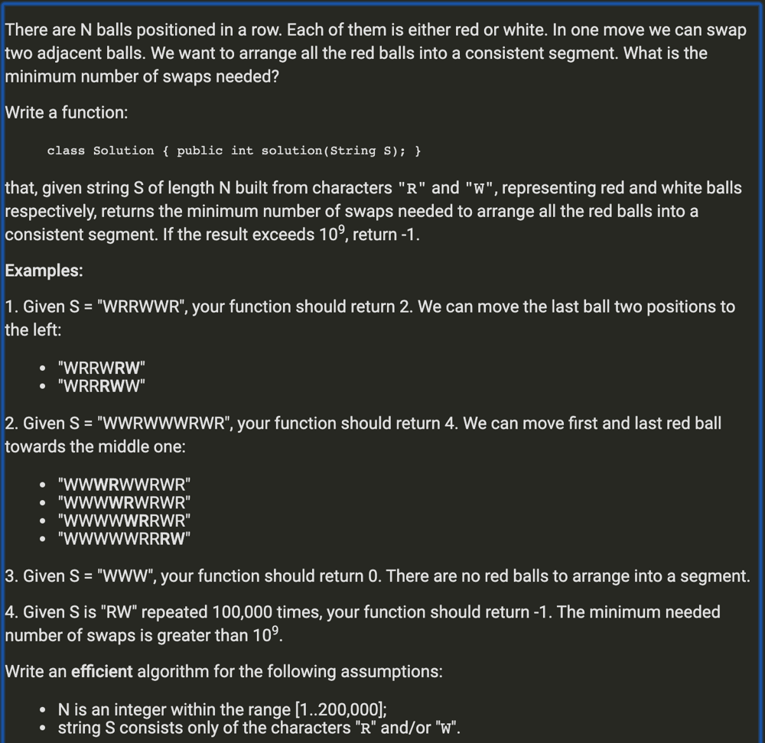

**Example:**

Input: "RRRWRR"

Output: 2

Related problems:

* [Minimum swaps need to make K girls sitting together](https://leetcode.com/discuss/interview-question/125154/)
* public static int solution(String s) {
* List<Integer> redIndices = getRedIndices(s);
* int mid = redIndices.size() / 2;
* int minSwaps = 0;
* for (int i = 0; i < redIndices.size(); i++) {
* // number of swaps for each R is the distance to mid, minus the number of R's between them
* minSwaps += Math.abs(redIndices.get(mid) - redIndices.get(i)) - Math.abs(mid - i);
* }
* return minSwaps;
* }
* private static List<Integer> getRedIndices(String s) {
* List<Integer> indices = new ArrayList<>(s.length());
* for (int i = 0; i < s.length(); i++) {
* if (s.charAt(i) == 'R') {
* indices.add(i);
* }
* }
* return indices;
* }

17. <https://leetcode.com/problems/maximum-length-of-a-concatenated-string-with-unique-characters/>

**1239. Maximum Length of a Concatenated String with Unique Characters**

Medium

7414FavoriteShare

Given an array of strings arr. String s is a concatenation of a sub-sequence of arr which have **unique characters**.

Return *the maximum possible length* of s.

**Example 1:**

**Input:** arr = ["un","iq","ue"]

**Output:** 4

**Explanation:** All possible concatenations are "","un","iq","ue","uniq" and "ique".

Maximum length is 4.

**Example 2:**

**Input:** arr = ["cha","r","act","ers"]

**Output:** 6

**Explanation:** Possible solutions are "chaers" and "acters".

**Example 3:**

**Input:** arr = ["abcdefghijklmnopqrstuvwxyz"]

**Output:** 26

**Constraints:**

* 1 <= arr.length <= 16
* 1 <= arr[i].length <= 26
* arr[i] contains only lower case English letters.
* I think you can optimize a bit by adding memory to it. Time was limited during the contest, I didn't have time to optimized it.
* class Solution {
* private int result = 0;
* public int maxLength(List<String> arr) {
* if (arr == null || arr.size() == 0) {
* return 0;
* }
* dfs(arr, "", 0);
* return result;
* }
* private void dfs(List<String> arr, String path, int idx) {
* boolean isUniqueChar = isUniqueChars(path);
* if (isUniqueChar) {
* result = Math.max(path.length(), result);
* }
* if (idx == arr.size() || !isUniqueChar) {
* return;
* }
* for (int i = idx; i < arr.size(); i++) {
* dfs(arr, path + arr.get(i), i + 1);
* }
* }
* private boolean isUniqueChars(String s) {
* Set<Character> set = new HashSet<>();
* for (char c : s.toCharArray()) {
* if (set.contains(c)) {
* return false;
* }
* set.add(c);
* }
* return true;
* }
* }

18. <https://leetcode.com/discuss/interview-question/414880/>

Microsoft | OA 2019 | Unique Integers That Sum Up To 0

**0**

[](https://leetcode.com/sithis)[Sithis](https://leetcode.com/sithis)Moderator5581

Last Edit: October 27, 2019 7:20 PM

517 VIEWS

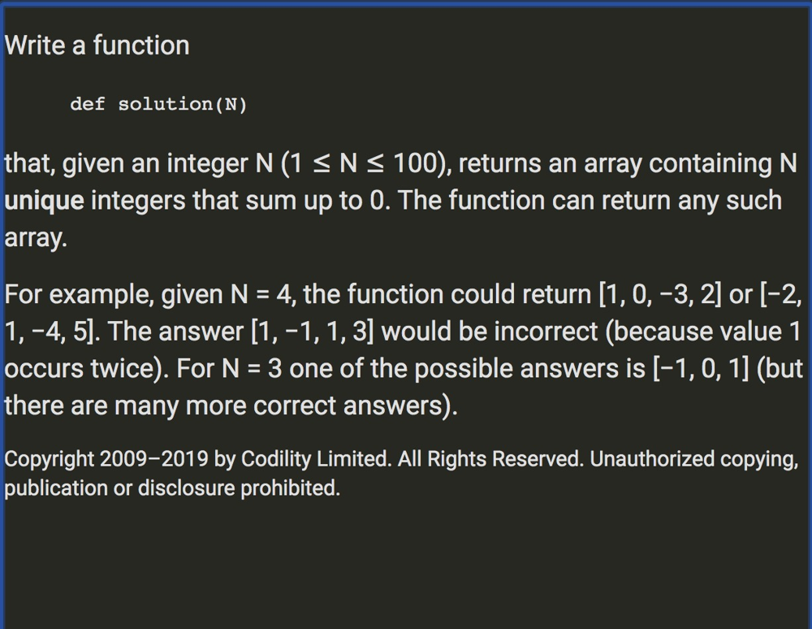

Java O(N)

public static List<Integer> solution(int n)

{

int remaining = n;

int start = 1;

List<Integer> list = new ArrayList<Integer>();

// if odd we need a 0

if(n % 2 != 0)

{

list.add(0);

remaining--;

}

while(remaining > 0)

{

list.add(start);

list.add(-start);

start++;

remaining -= 2;

}

return list;

}

19. <https://leetcode.com/discuss/interview-question/421975/>

Microsoft | OA 2019 | Min Deletions To Obtain String in Right Format

**8**

Anonymous User

Last Edit: 14 hours ago

1.8K VIEWS

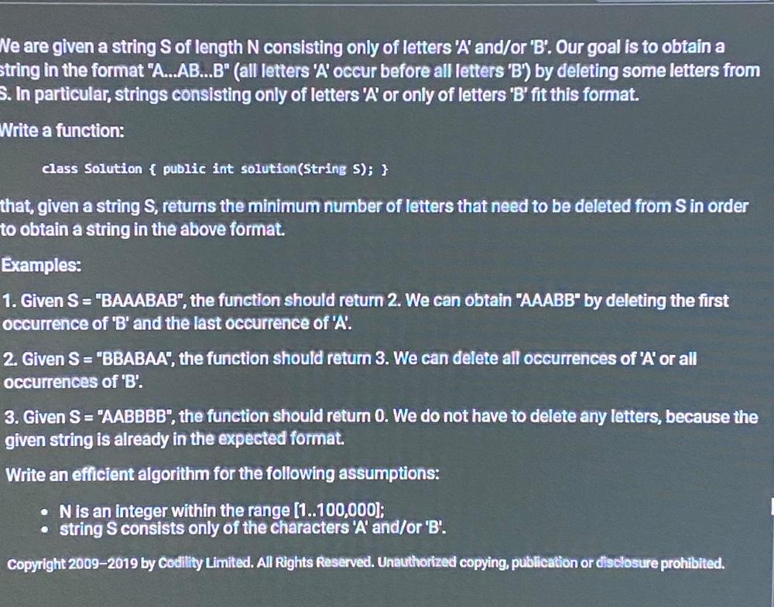

Comments: 7

Notice we can partition the original string in half, deleting all B's in the left-side and all A's on the right side. Therefore, the trick is to find a constant time computation of the number of Bs in the left partition, and number of As in the right partition. Then we can iterate through all n + 1 partitions, sum the B's and A's, and track the minimum deletions.

For example take the string BAABAB, the partitions are as follows:

| BAABAB -> BBB  
B | AABAB -> BB  
BA | ABAB -> ABB  
BAA | BAB -> AABB  
BAAB | AB -> AAB  
BAABA | B -> AAAB  
BAABAB | -> AAA

Define f(i) = number of Bs up-to index i [exclusive]+ number As after index i [inclusive]  
This function is the number of deletion required to transform the string to A...AB...B where index i corresponds to the partition before the first B.

Re-stating the problem: Find f(k) s.t. f(k) <= f(i) for all indices i.

int sol(string s) {

int rhs = 0, lhs = 0;

for (int i = 0; i < s.size(); ++i) if (s[i] == 'A') ++rhs;

// rhs equals number of A's after index i [inclusive]

// lhs equals number of B's before index i [exclusive]

int ans = rhs;

for (int i = 0; i < s.size(); ++i) {

if (s[i] == 'A') --rhs;

else ++lhs;

ans = min(ans, rhs + lhs);

}

return ans;

}