Exercise 1 : Discover Your Network Interfaces

Questions
1. Which interface is your primary network interface?
The primary network interface is eth0 because it is associated with the default route.
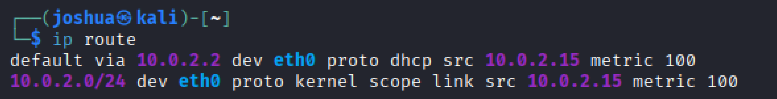

2. Does your primary interface have an IPv4 address? Verify using ip addr show
Yes, the primary interface eth0 has an IPv4 address assigned: 10.0.2.15/24, as shown by the inet field in ip addr show.
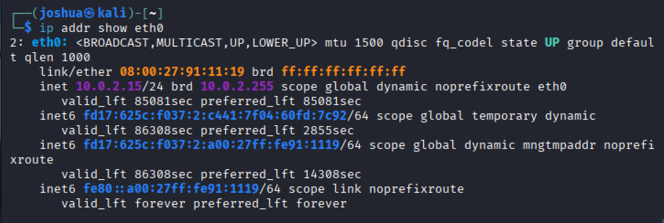

3. Which IPv6 addresses are assigned?
The interface has the following IPv6 addresses assigned:
• fd17:625c:f037:2:c441:7f04:60fd:7c92/64 (global temporary IPv6 address)
• fd17:625c:f037:2:a00:27ff:fe91:1119/64 (global dynamic IPv6 address)
• fe80::a00:27ff:fe91:1119/64 (link-local IPv6 address)

4. What is the status of your device and its active connection ?
The network device eth0 is UP and has an active connection, as indicated by the state UP and LOWER_UP flags in the ip addr show output.

Exercise 2 : Disable and Enable a Network Interface

Questions
1. Disable your network interface and check using ping (e.g. google.com). What happens?
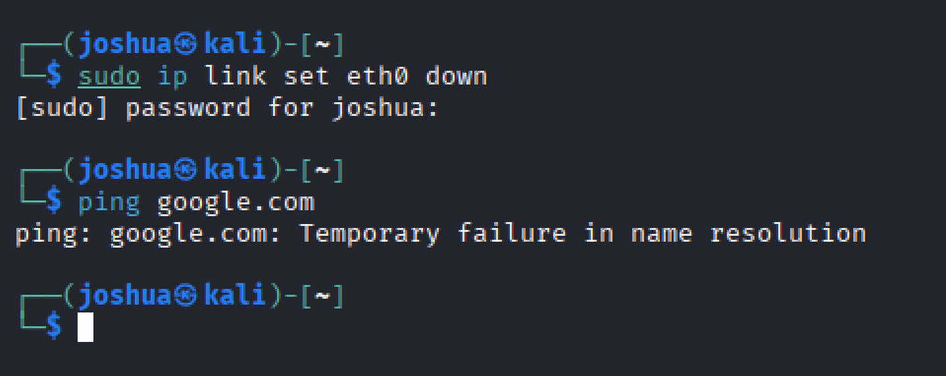

After disabling the primary network interface (eth0), the system loses network connectivity.
When running ping google.com, the request fails with an error such “Temporary failure in name resolution”.
This happens because the network interface is down, preventing packets from being sent to external networks.

2. What happens when the interface is up again?
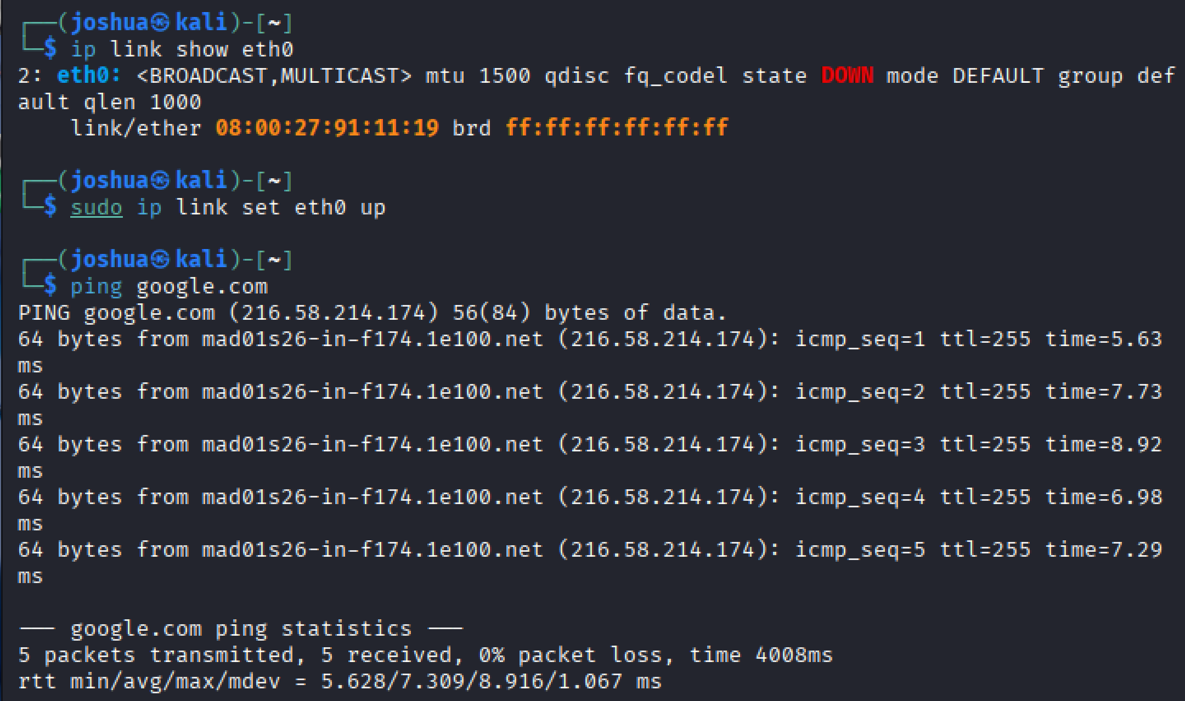

When the network interface is brought back up, network connectivity is restored.
The system can again resolve domain names and communicate with external hosts.
As a result, ping google.com succeeds and returns ICMP reply messages.

Exercise 3 : Assign a Static IPv4 Address
sudo nmcli con add type ethernet ifname enp0s3 con-name lab

