Nuclibook: User Manual
Table of Contents

1. Introduction
2. Login Screen
2.1 Logging In
2.2 Errors
3. Menu
3.1 Navigation Sidebar
3.2 Top Bar
3.3 Account Settings
3.3.1 Changing Your Password
4. Dashboard
4.1 Daily Summary
5. Appointments
5.1 Bookings
5.1.1 Viewing Bookings (Absences)
5.1.2 Viewing Bookings (Events)
5.1.3 Viewing Bookings (Camera Use)
5.1.4 Viewing Booking Details
5.1.5 Edit Booking
5.2 New Booking
5.2.1 Select Patient
5.2.2 Select Therapy
5.2.3 View Available Slots
5.2.4 Make a booking
6. Hospital Entities
6.1 Patients
6.1.1 Adding a Patient
6.1.2 Editing a Patient
6.1.3 Export Patients
6.1.4 Import Patients
6.1.5 Errors
6.2 Cameras
6.2.1 Adding a new Camera
6.2.2 Editing a Camera
6.2.3 Deleting a Camera
6.2.4 Errors
6.3 Camera Types
6.3.1 Adding a Camera Type
6.3.2 Editing a Camera Type
6.3.3 Deleting a Camera Type
6.3.4 Errors
6.4 Therapies
6.4.1 Adding a Therapy
6.4.2 Editing a Therapy
6.4.3 Deleting a Therapy
6.5 Tracers
6.5.1 Adding a Tracer
6.5.2 Editing a Tracer
6.5.3 Deleting a Tracer
6.6 Tracer Orders
6.6.1 Viewing Tracer Order details
6.7 Generic Events
6.7.1 Adding a Generic Event
6.7.2 Editing a Generic Event
6.7.3 Deleting a Generic Event
7. Staff Entities
7.1 Staff Accounts
7.1.1 Adding a Staff Account
7.1.2 Editing a Staff Account
7.1.3 Deleting a Staff Account
7.1.4 Staff Account Errors
7.2 Staff Roles
7.2.1 Adding a Staff Role
7.2.2 Editing a Staff Role
7.2.3 Deleting a Staff Role
7.2.4 Error Section for Staff Roles
7.3 Staff Availabilities
7.3.1 Selecting a Staff Member to view availability
7.3.2 Adding a new Availability
7.3.3 Editing Staff Availability
7.3.4 Delete Staff Availability
7.3.5 Error Section for Staff Availability
7.4 Staff Absences
7.4.1 Selecting a Staff Member to view absences
7.4.2 Adding Staff Absence
7.4.3 Editing Staff Absence
7.4.4 Deleting Staff Absence
7.3.5 Error Section for Staff Absence
7.5 Action Logs

1. Introduction

Nuclibook is a booking system built specifically for the Nuclear Medicine Department at Chelsea and Westminster Hospital, built by students (Team 3-D) for their Software Engineering Group project at King’s College London.

Nuclibook was designed to become an electronic version of the system that the Nuclear Medicine Department at Chelsea & Westminster Hospital uses for booking nuclear medicine studies and therapies, tracking tracer orders and managing camera equipment.

In this user manual, you’ll find step by step instructions on how to use and benefit from each part of the application. The software is designed to be as simple as possible, but at the same models complex relationships and contains intertwined functionalities that aim to accomplish all the tasks that are normally done on paper.

If you have any questions on how to accomplish tasks on the system that are unclear in this manual, or if you face an error that you do not understand, please speak to the department Systems Administrator or Systems Manager immediately.

2. Login Screen

2.1 Logging In

When you first launch the application, you’ll be greeted by the login page (Figure 1).
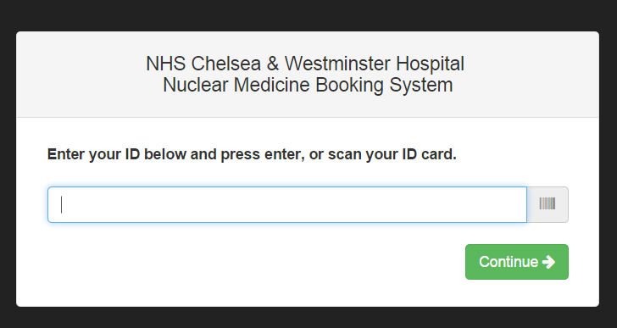

Figure 1: Login Screen

To log in, you can either:

- Use the barcode scanner, if your username is the same as your ID number.
- Type in your username manually, if it is not your ID number. Click Continue.

TIP If you see a barcode sign next to a text field, it means you can use your barcode
scanner as an input method.

NOTE If you’ve received an error, jump down to Errors (Section 2.2) for troubleshooting.

You should now see your name on the screen followed by a field that asks for your password/PIN (Figure 2). Enter your password/PIN and click on Login to access the system.

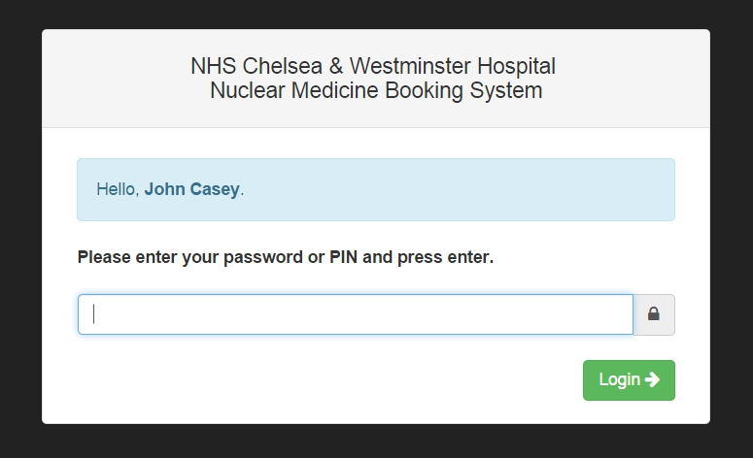
Figure 2: Password/PIN Input Screen

2.2 Errors

Error: that staff ID doesn’t exist

You’ve entered an incorrect username. Try again and make sure you spell your ID
correctly. If you’re using a barcode scanner to read your ID and it’s still not letting you access the system, please speak to your systems administrator.

Error: incorrect password supplied

You’ve entered your password incorrectly.

Error: your account is currently disabled

Please speak to the systems administrator.

You have been logged out!

You (or the person before you) left the application open for more than ten minutes
without any activity, and the system has logged off the account for security reasons.

3. Menu

Once signed in, you’ll reach the dashboard, which will be discussed later in this manual in more detail. Every page on the application consists of a left sidebar and a top menu bar, as well as the content of the page. Let’s look at them individually.

3.1 Navigation Sidebar

The navigation sidebar is located on the left side of the page (Figure 3). The sidebar will be located on every page for your convenience, as long as you are logged in.

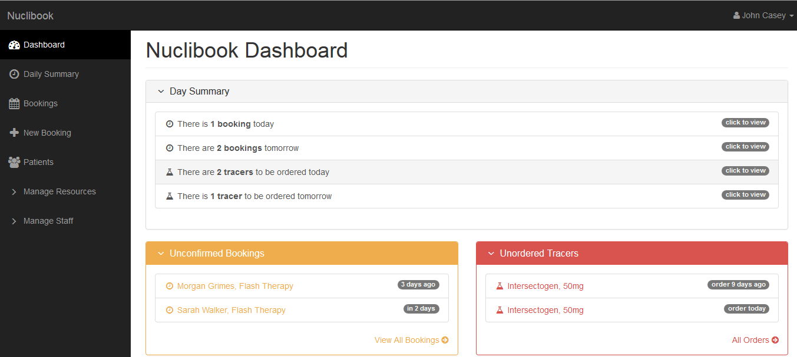
Figure 3: Navigation Sidebar

NOTE The sidebar in Figure 3 may contain more options than you would find when you sign in. This is because your systems administrator has given you access to only those options. If you believe you should have access to some of the pages in this application that you do not at the moment, please speak to your systems administrator.

3.2 Top Bar

The top bar only consists of one button, which should have your full name on it. If you click it, you will see two options (Figure 4).

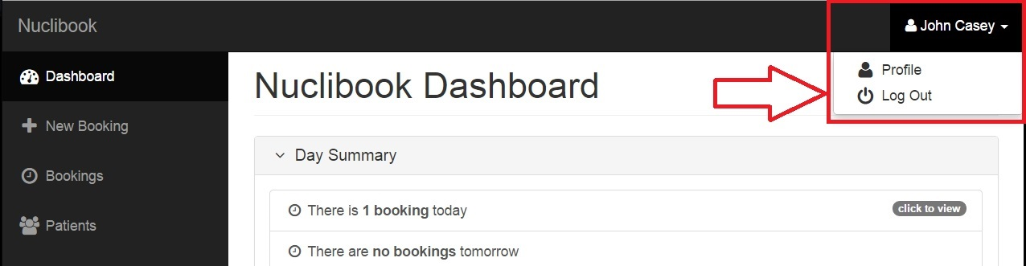
Figure 4: Top Menu Bar

The first button will take you to the Account Settings page (see Section 3.3), and the second will log you out of the system.

3.3 Account Settings

On the accounts settings page, you will see information about your account (Figure 5). This includes your username, your full name, your role, how long you have remaining before you are forced to change your password and finally the option to change your password (see Section 3.3.1).

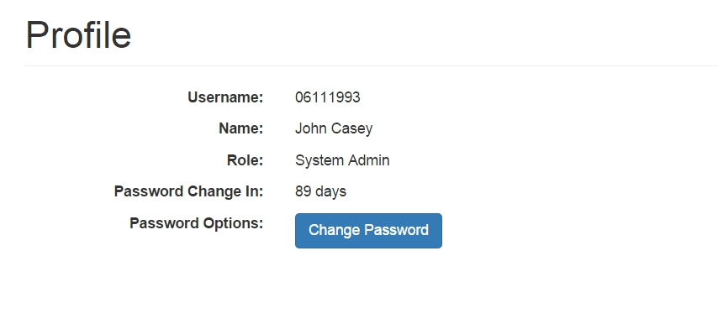
Figure 5: Account Settings

3.3.1 Changing Your Password

On the Account Settings page (Figure 5), there’s a button that says Change Password next to Password Options. If you click on it, a form will drop down (Figure 6). Simply fill in the form with your current password and your new one and click Ok.

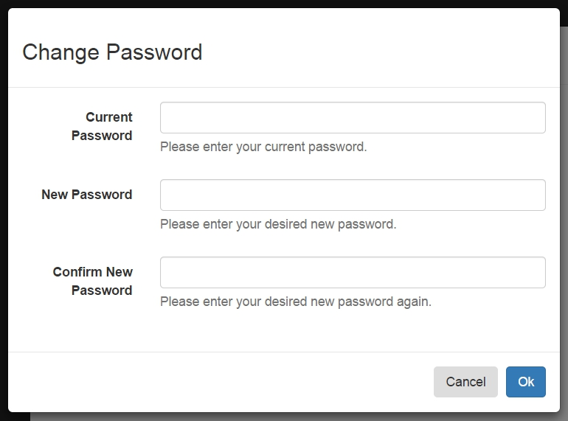
Figure 6: Change Password

NOTE For security purposes, you are forced to change your password every 90 days.

TIP Use capital letters, small letters and numbers to make your password more
secure. Here’s an example of a strong password: NucliBooK123

3.3.2 Errors

Error: Your passwords did not match
Make sure that the second and third field contain the exact same password.

Error: Password must not be the same as the last few passwords.
Ensure that your new password is different than the last 3 you have used before.

4. Dashboard

On the dashboard (Figure 7), you’ll find a lot of useful information that’s useful to know at a first glance. There are three panels on the dashboard.

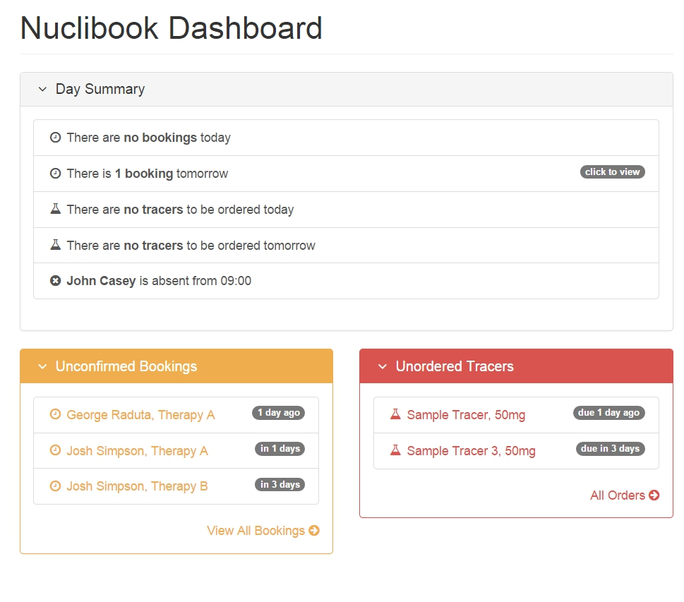
Figure 7: Dashboard
They are:

- A Day Summary, which contains:
  - The number of bookings there are today.
  - The number of bookings there are tomorrow.
  - The number of tracers to be ordered today.
  - The number of tracers to be ordered tomorrow.
  - Staff absences in the near future.

You can click on any of the rows to find out more information. For example, if you click on a staff’s absence, you’ll be taken to the Staff Absences page (see Section 6.4)
- A list of Unconfirmed Bookings. Each unconfirmed booking shows you when the appointment is scheduled for, past or present. You can click on an unconfirmed booking to see more information about the booking (see Section 5.2).

- A list of Unordered Tracers, each one showing you the latest it has to be ordered. You can click on an unordered tracer to see more information about order (see Section 5.7).

TIP If the panels are taking up too much space on the page, you can click on the
panel headers and they’ll close! To expand it, click on the panel header again.
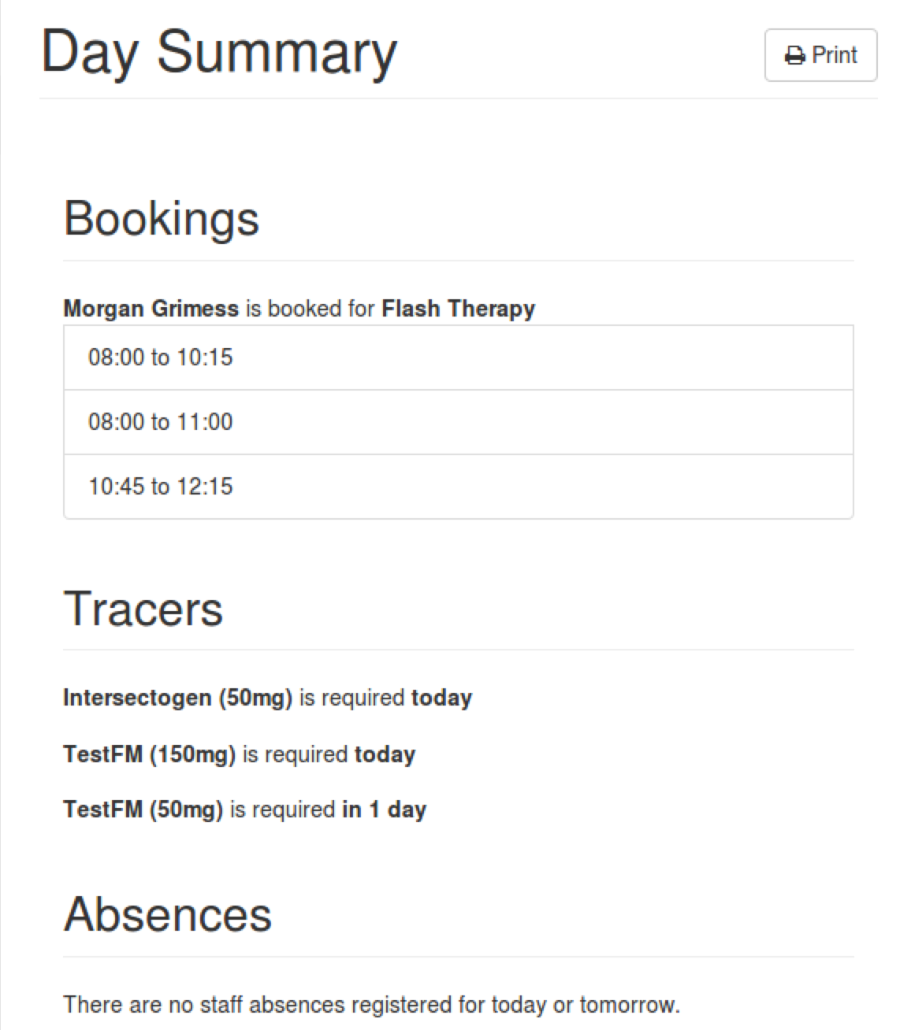

4.1 Daily Summary

There’s also a Daily Summary on the sidebar (under Dashboard), that contains the list of appointments happening that day, tracers that need to be ordered today or tomorrow and absences that are registered today and tomorrow.

This was designed to be printer-friendly, and you can click on Print to obtain a hard copy of the day summary.

Figure 8: Daily Summary

5. Appointments

The Nuclear Medicine Booking system, as the name mentions is made for the purpose of the hospital to be able to make bookings. There are two pages, one called Bookings that allows you to view all booking made and the other named New Booking which allows you to make a new booking and add it to the bookings page.

5.1 Bookings

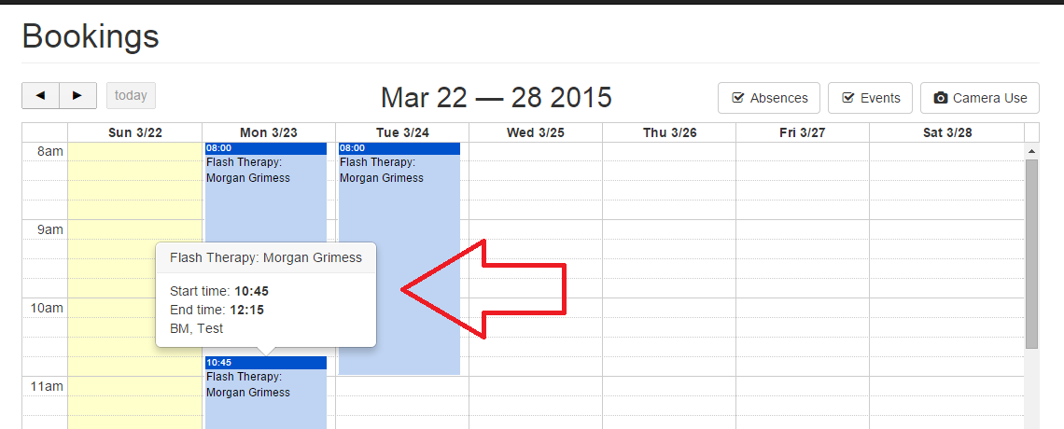
The Bookings page (Figure 9) shows a calendar displaying all the bookings being made by the user. It is there for you to view your daily schedule. You can hover over the bookings to see clear details of the start and end time of the booking and the booking detail.
Figure 9: Bookings Page

5.1.1 Viewing Bookings (Absences)

At the top of the calendar on the bookings page you will see an Absences button (Figure 10). Clicking on this button will show you the details of which staff is absent at a particular time. This information would help when making a booking for a staff so that no appointment is assigned to a member of staff that will not be in hospital on that day.

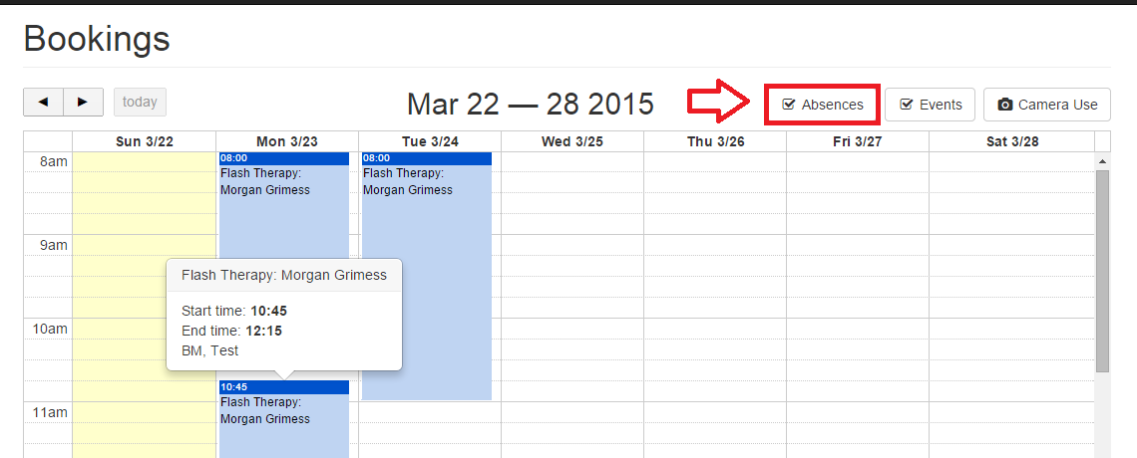Figure 10: Absences

5.1.2 Viewing Bookings (Events)

Next to the Absences button you will find an Events button (Figure 11). Clicking on this button will show you the details of when any generic event has been booked (not an appointment), such as staff meetings or camera maintenances.

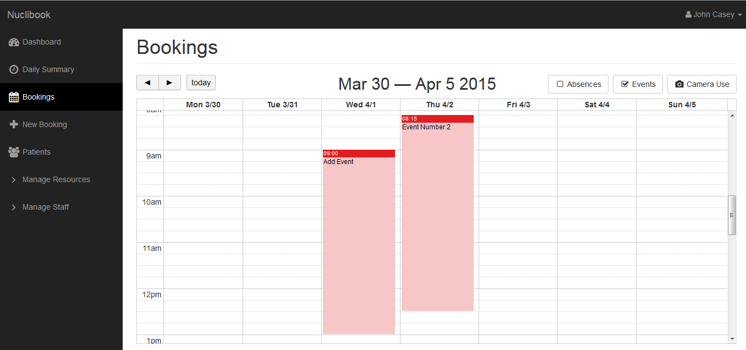Figure 11: Events

5.1.3 Viewing Bookings (Camera Use)

Next to the Events button, you will find the Camera Use button (Figure 12), via this you can view the details of the cameras that are being used for the appointments made. This page shows the bookings that have been made so far.

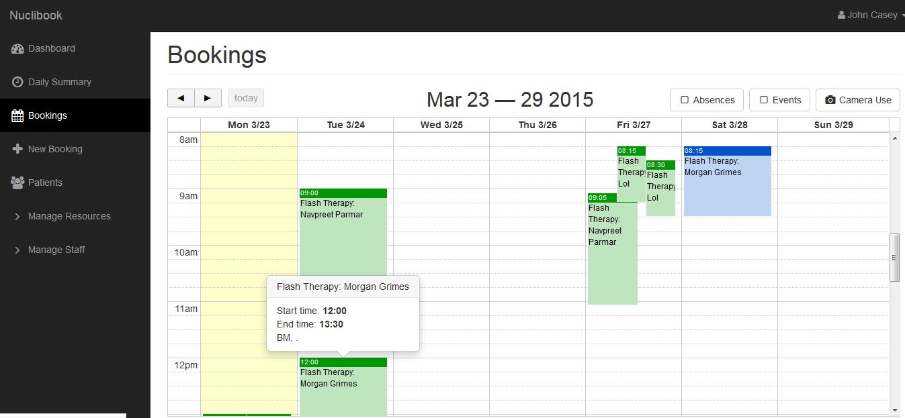Figure 12: Camera Use button

On clicking this button, you will see a form drop down asking you to confirm which camera you would like to view on the calendar (Figure 13). When you select (a) camera(s), you will be able to see all the bookings on the calendar that are using the selected camera(s).

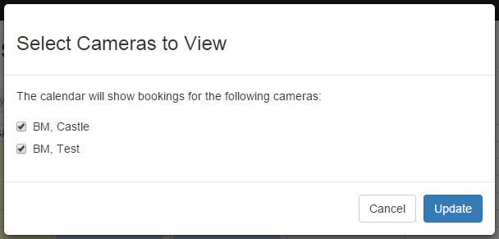
Figure 13 Select Cameras to View

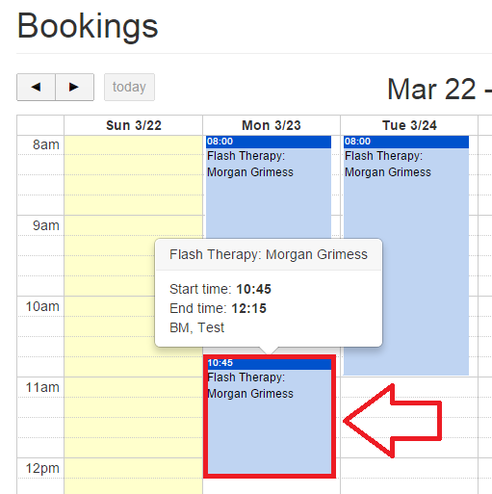
5.1.4 Viewing Booking Details

If you would like to view details of a specific booking, you can easily do so by simply clicking on the bookings whose details you would like to view (Figure 14).

After clicking on a booking (on the calendar) you will be able to view the booking details in a new page (Figure 15).

Figure 14: View Booking Details
On the Booking Details page, you will be able to view all details of the booking such as the patient and staff assigned, cameras and tracers used and a general breakdown of the booking schedule. You can also update the status of the booking (e.g. confirmed, unconfirmed, cancelled etc.) (Figure 16). You may also edit a booking (see Section 5.1.5).

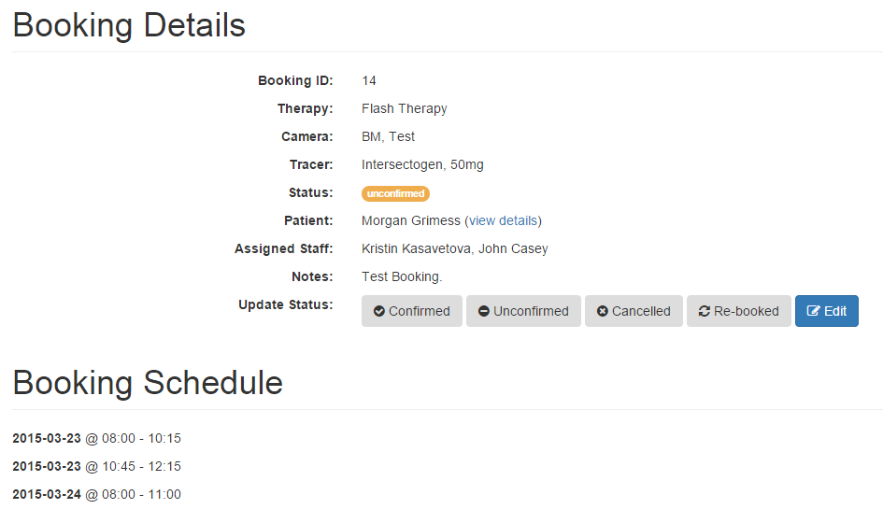
Figure 15: Booking Details Page

5.1.5 Edit Booking

You can edit a previously made booking by simply clicking on the Edit button (Figure 16)
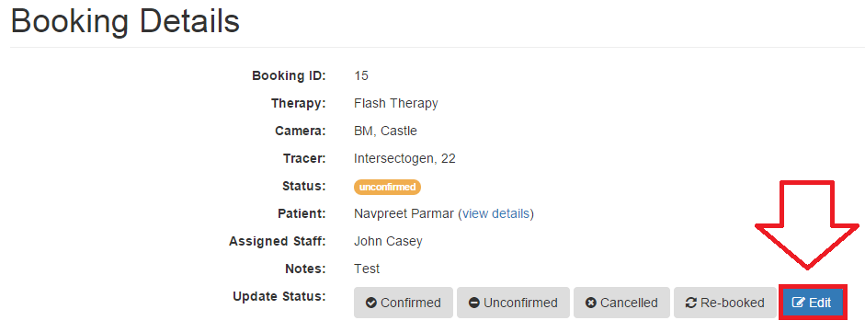Figure 16: Edit Booking

On clicking the Edit button, you will see a form drop down, this form already contains the details of the booking, you can make the changes you wish to. (Figure 17) In the figure below, the staff assigned has been changed
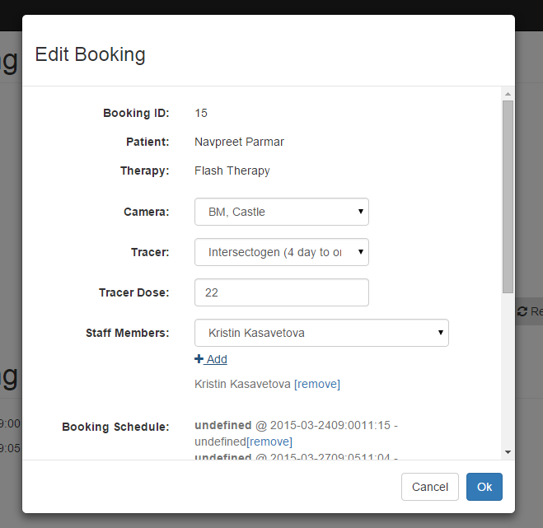
Figure 17: Edit Booking Form

On making the changes, click Ok to save them and you will see the changes updated in the Booking Details page (Figure 18).

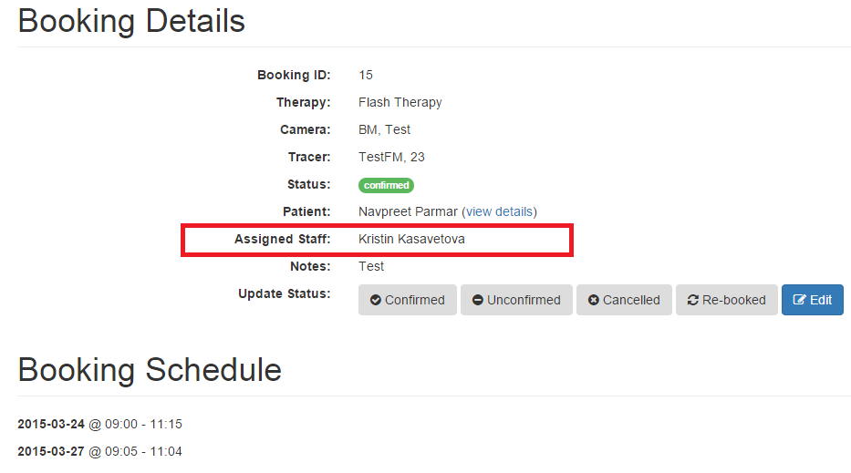Figure 18: Booking Details Page

5.2 New Booking

The New Booking page allows you to make a new booking, you will need to select the patient and therapy before getting access to the calendar in order to make the booking. Initially the page looks like Figure 19.
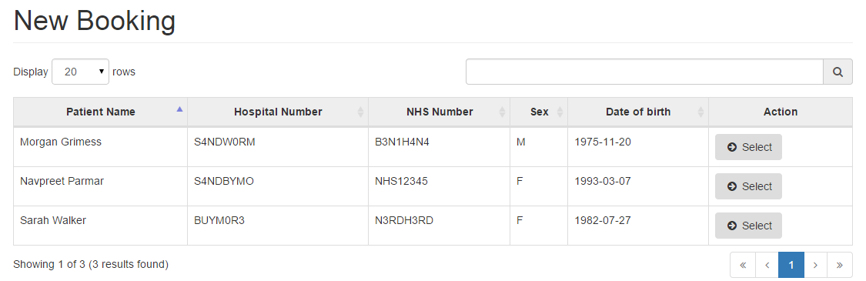
Figure 19: New Booking Page

5.2.1 Select Patient

In order to make a booking, the first thing you will need to do is to select a patient (Figure 20). You will see a table of patients just like in Figure 16 and you can also search for a specific patient by using the search bar at the top right of the table. To select a patient, click on the Select patient button next to the specific patient you want to book an appointment for.

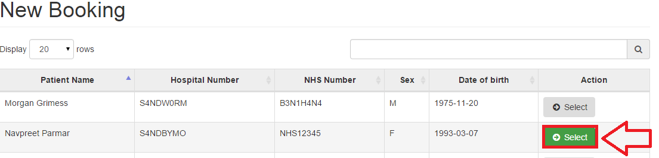Figure 20: Select Patient for Booking an Appointment

5.2.2 Select Therapy

After selecting a patient, the patients table will slide up and the therapy table will appear, the next thing you will need to do is to select a therapy (Figure 21). To select a therapy, click on the Select patient button next to the specific therapy.

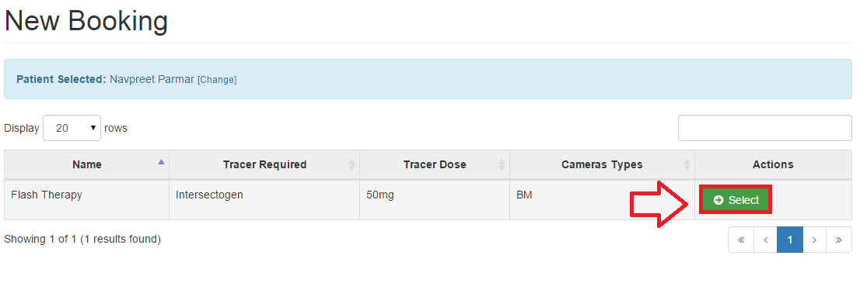Figure 21: Select Therapy for Booking an Appointment

NOTE You will be allowed to change the patient you have selected, by clicking on the
change link above the table, it is next to the name of the patient selected. This is
displayed to confirm that you have selected the right patient, and if it is wrong you
can still make a change.

5.2.3 View Available Slots

After selecting the therapy you will see the therapy table slide up and a new page showing you the patient and the therapy that you have selected. (Figure 22) Just like where you were allowed to change the patient selected, here you can also change the therapy selected. Once you are happy with the patient and the therapy you have selected and are ready to go ahead
and book an appointment, you may click on the View Available Slots button.
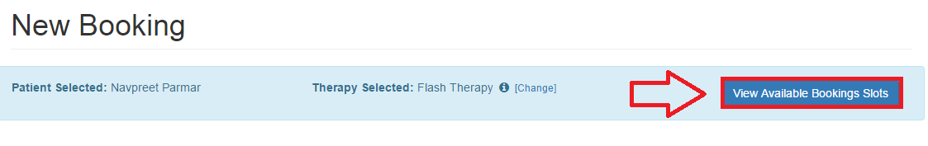
Figure 22: View Available Slots

After clicking on the View Available Slots button you will be able to view the calendar with the existing slots. (Figure 23)

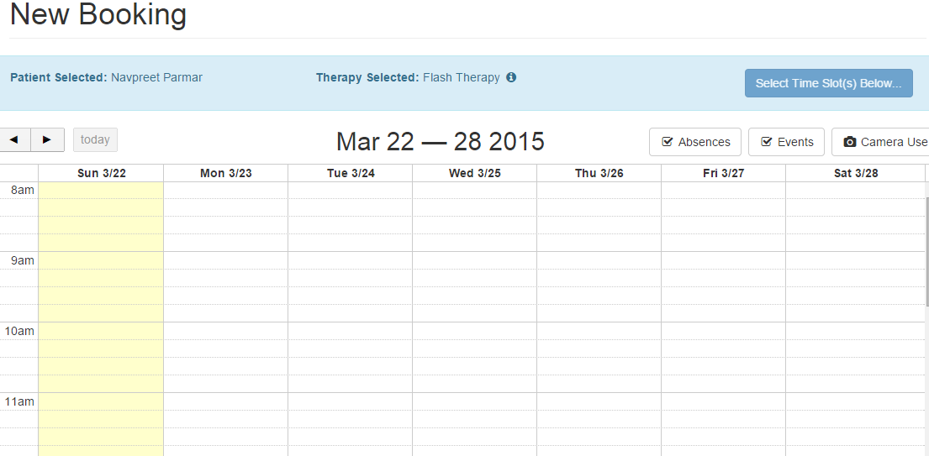Figure 23: Bookings Calendar

5.2.4 Make a booking

Now that you have selected a patient and therapy and viewed the available slots, you can now make an appointment. Click in the calendar on the day and time you wish to make the booking on (Figure 24). You will see a form drop down on your screen asking you to confirm the start and end time of the booking. (Figure 24).

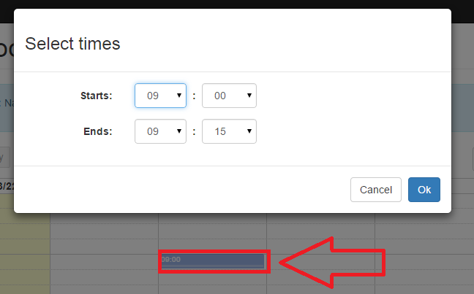
Figure 24: Make a New Booking

Once you have selected the dates and times of the booking, you will be able to see your booking added to the calendar. In order to save this booking, you must click on the Save Booking button at the top of the calendar (Figure 25).
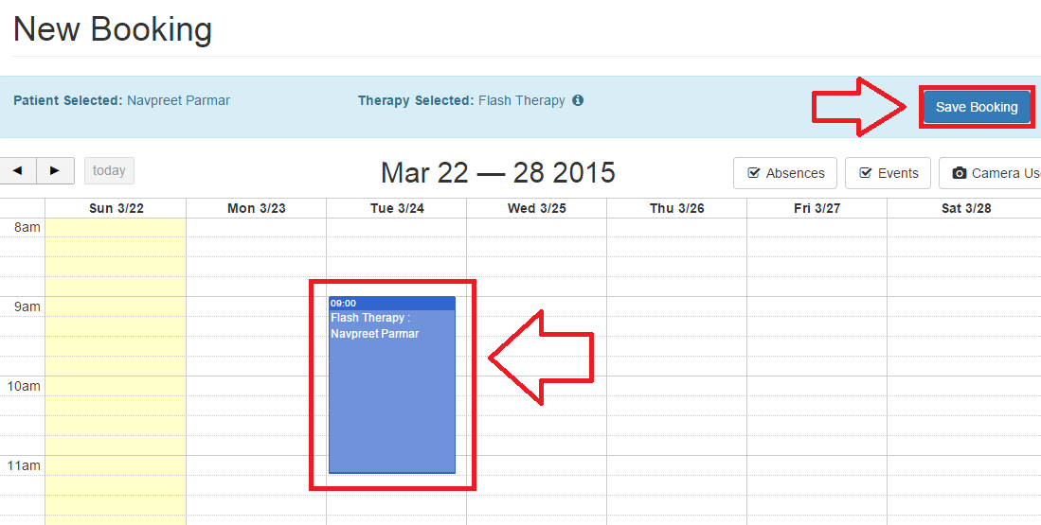Figure 25: Save Booking

NOTE The Save Booking button will only be visible once you have selected the times of
your booking.

After saving a booking, you will be able to view the New Booking Details page which asks you to add the details of the booking such as the camera being used, the staff being assigned to the booking etc.

This page also gives a review of the patient, therapy and the booking schedule you selected whilst making the booking (Figure 26).
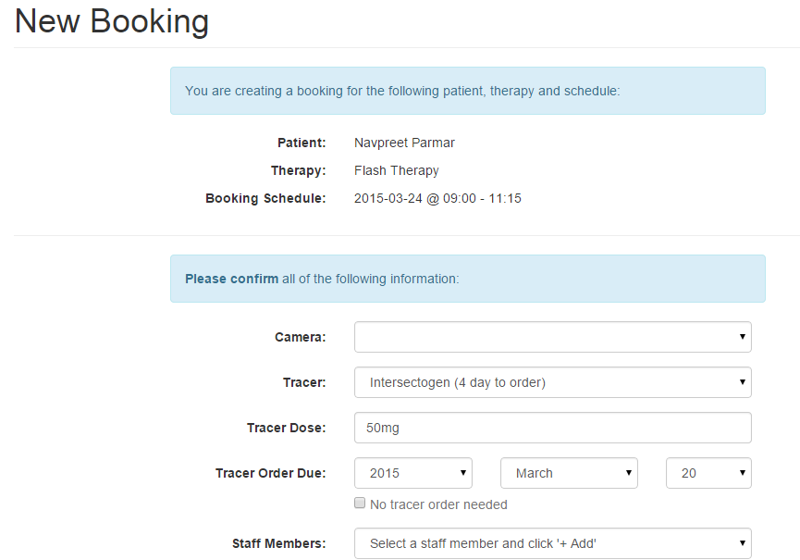
Figure 26: New Booking Page

After filling in the necessary appointment details, you must click on the Confirm Booking button below the form in order to confirm and save the booking to the calendar (Figure 27).

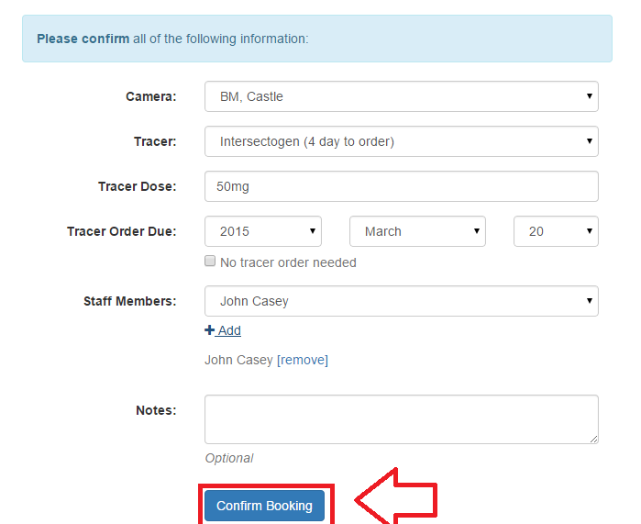
Figure 27: Confirm Bookings

After confirming the booking details, you will be redirected to the Booking Details page showing you all the details for that specific booking (Figure 28)
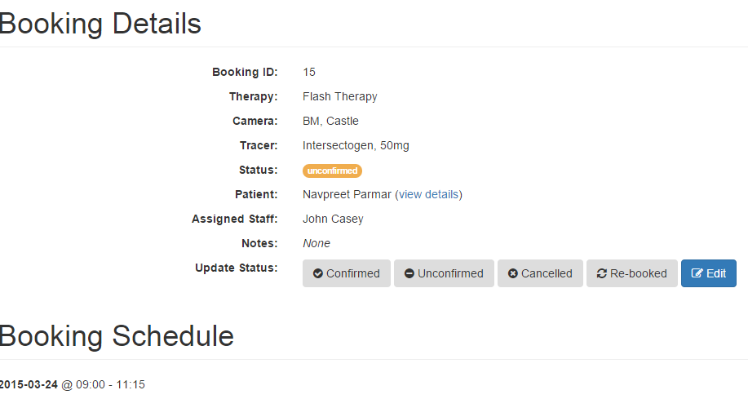
Figure 28: Booking Details

6. Hospital Entities

This section explains the different entities you interact on the system with. Their pages mostly look the same, and we’ll discuss the main common features of hospital entity pages before discussing each one individually. However, keep in mind that all pages may have features that are specific to that entity. Those will be discussed individually also in their own sections.

NOTE For the purpose of explaining the common features of hospital entity pages, we’ll be using the Patients page (Figure 29).

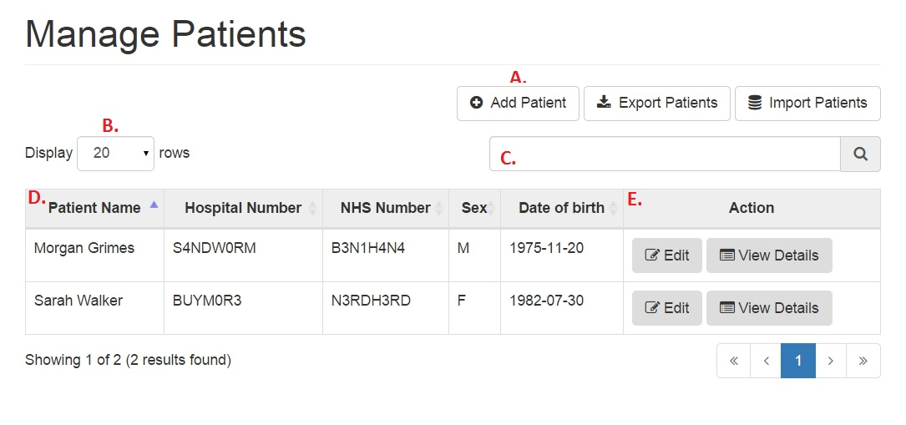
Figure 29: Common Features in Hospital Entities

- If your role permission allows you to, you may add entities using the “Add” button, always located on the top left of the page.

- You can select the number of rows of data you’d like to show on the table. The options are 20, 50 and All. You can move between pages of tables using the navigational buttons at the bottom left of the table.

- You can search for an entity in the table using any data that is in the table already. This means that if I type in “B3N1” or “W0RM”, Morgan Grimes’ data will be displayed.

- You can sort the data in the table in ascending or descending order by clicking on any of the columns.

- If your role permission allows to, you may edit, delete or view more information about entities through the Action column.

6.1 Patients

On the Patients page, you can add and edit patients as well as view detailed information about each patient.

6.1.1 Adding a Patient

Referring back to Figure 8, you can add a patient by clicking on the Add Patient button (See Section 6, part A). On clicking the Add Patient button, a new form will drop down asking you to fill some details of the new patient (Figure 30).

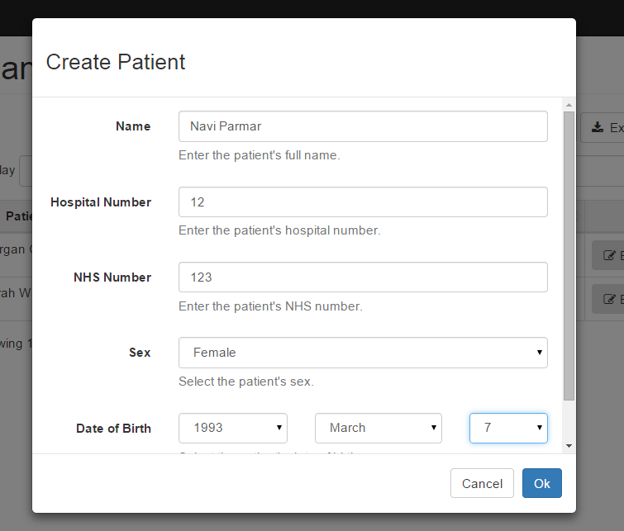
Figure 30: Create Patient Form

NOTE The application will not allow you to leave any fields blank.

NOTE If you’ve received an error, jump down to Errors (Section 6.1.5) for troubleshooting.

After you have filled in the details you can click Ok and the new patient will be permanently added to the database (Figure 31).

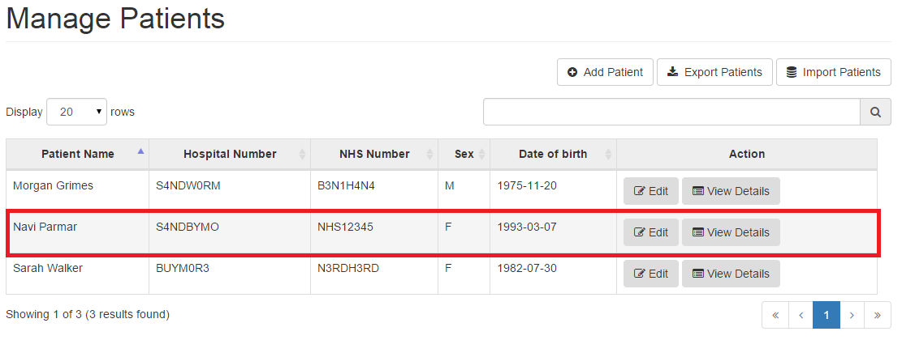
Figure 31: Added New Patient

6.1.2 Editing a Patient

In order to Edit a patient’s details, you need to click on the Edit button in the Actions column of the table (Figure 32).

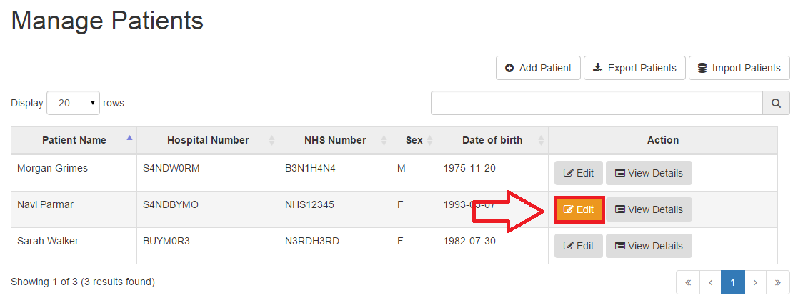
Figure 32: Edit Patient

On clicking this, you will see a new form drop down on your screen which contains the details of the patient and allows you to make changes to it (Figure 33).

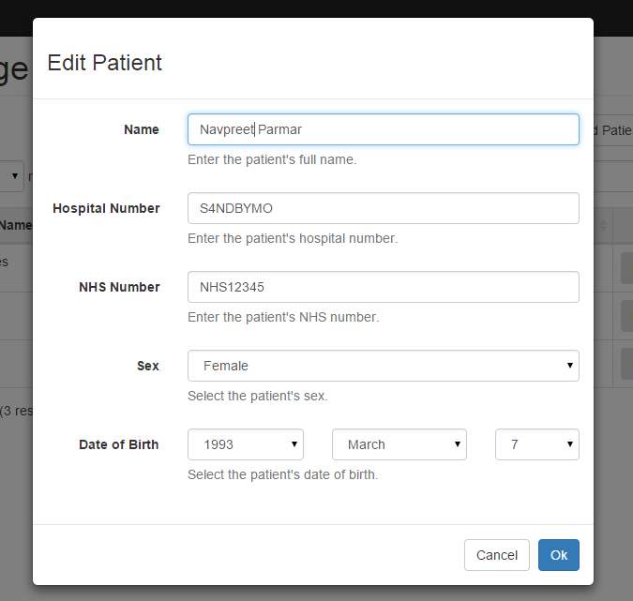
Figure 33: Edit Patient Form

NOTE If you’ve received an error, jump down to Errors (Section 6.1.5) for troubleshooting.

After changing the details, you can click on the Ok button to see the changes being updated in the table (Figure 34)

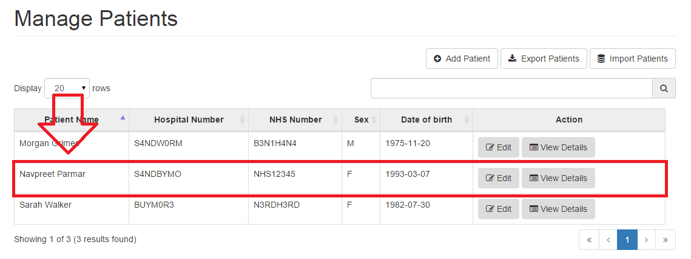
Figure 34: Updating Changes

6.1.3 Export Patients

If you would like to view the list of all patients in the hospital you may wish to export these patients by clicking on the Export Patients button which can be found right next to the Add Patient button (Figure 35).

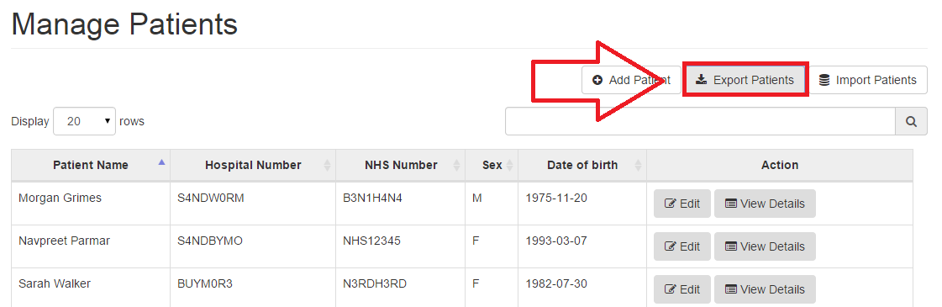Figure 35: Export Patients

After clicking on the Export Patients button, you will see a file called patients.csv being downloaded.

6.1.4 Import Patients
Just like exporting patients you may also import some if need be, all you need to do is click on the Import Patients button next to the Export Patients button (Figure 36).

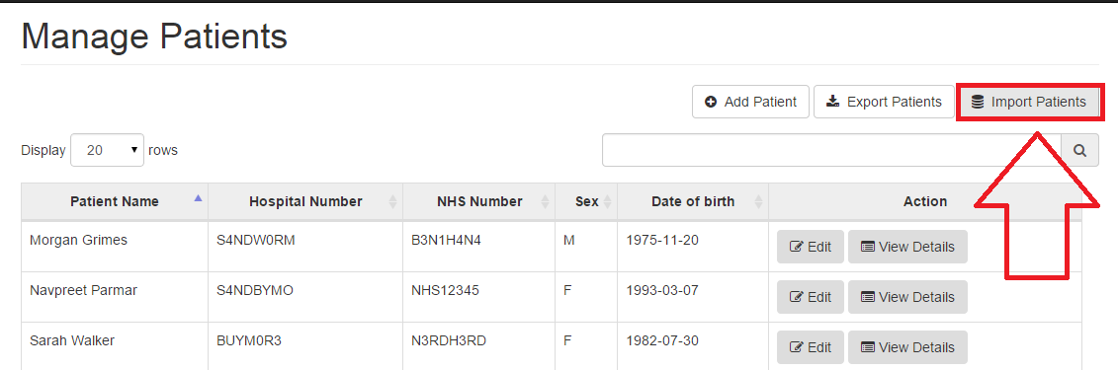Figure 36: Export Patients

After clicking on the Import Patients button, you will see a form drop down asking you to enter a CSV document of the patients you would like to import (Figure 37).
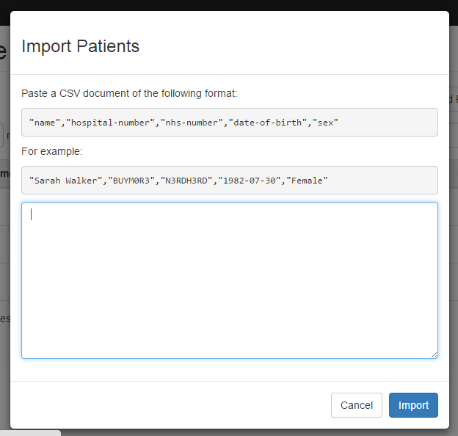
Figure 37: Import Patients Form

NOTE Patients details should be in exactly the same format asked by the form else patient will not be imported.

After clicking on the Import button in the form, the patients entered will be imported.

6.1.5 Errors

Error: Name of the patient should not exceed 64 characters

Error: Hospital number should not exceed 64 characters

Error: NHS number should not exceed 64 characters

You will get any of the above stated errors, if your input is too long.

Error: The data you entered is invalid; please check again

You get this error, if your input for some fields in the form do not follow the certain format. For example, “Name” field cannot contain digits, input for “Hospital Number” and “NHS Number” must not contain the “.” symbol.

Error: You did not enter a valid NHS number

You get this error if you leave the field for NHS number blanked. You have to enter a valid NHS number in order for the form to be processed.

Error: You did not enter a valid hospital number

You get this error if you leave the field for hospital number blanked. You have to enter a valid hospital number in order for the form to be processed.

Error: You did not enter a valid name

You get this error if you leave the field for name blanked. You have to enter a valid name in order for the form to be processed.

Error: Please enter a valid date of birth

You get this error if you did not choose any date. You have to enter a valid date of birth in order for the form to be processed.

Error: You do not have permission to edit or create this item

Every staff have certain permissions. If you get this error, then the system admin didn’t give you permission to do so. Speak to your system admin.

Error: Something went wrong; please try again

In most of the cases you get this error if there is a loss of connection with the server. Please ensure you are connected to the internet before preceding. If that doesn’t fix the problem, restart the application and try again.

6.2 Cameras

This page shows the list of cameras that are used by the hospital. These cameras are used to represent the different camera equipment that the Nuclear Medicine department has or uses (Figure 38) It is possible to add, edit the names and delete certain cameras.

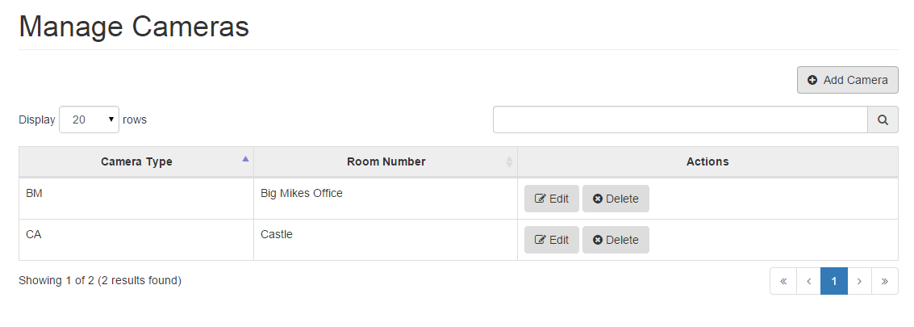Figure 38: Cameras Page

6.2.1 Adding a new Camera

If you need to add a new camera to the existing list of cameras, that is also possible by just simply clicking on the Add Camera button at the top right of the page. (Figure 39)
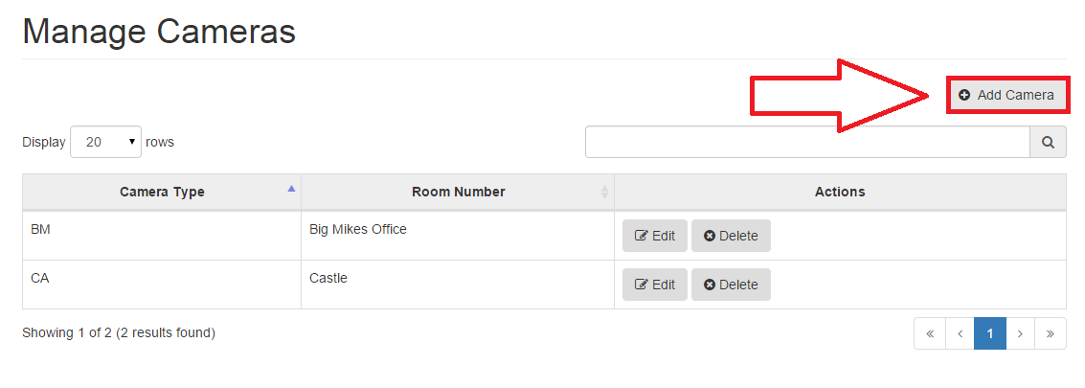
Figure 39: Add Camera

After clicking on the Add Camera button, a new form will drop down which you will need to fill in order to add a new camera to the existing list. (Figure 40). The form will ask you to choose a camera type and a room number for that camera. (Camera types are described in the Section 6.3.)
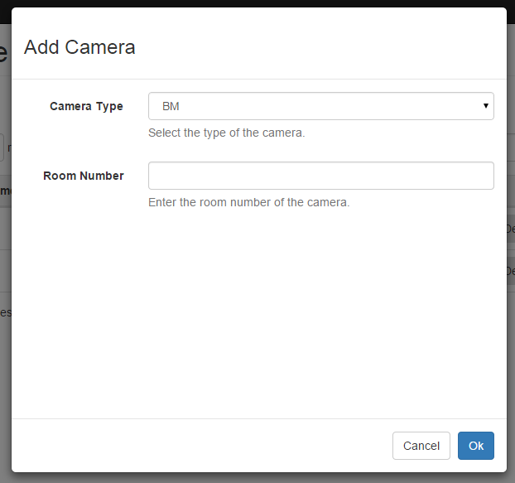
Figure 40: Add Camera Form

NOTE If you’ve received an error, jump down to Errors (Section 6.2.4) for troubleshooting.

After filling in the form and clicking Ok, the camera will be added to the Camera page (Figure 41) else clicking Cancel will cancel the form and take you back to the Camera page.

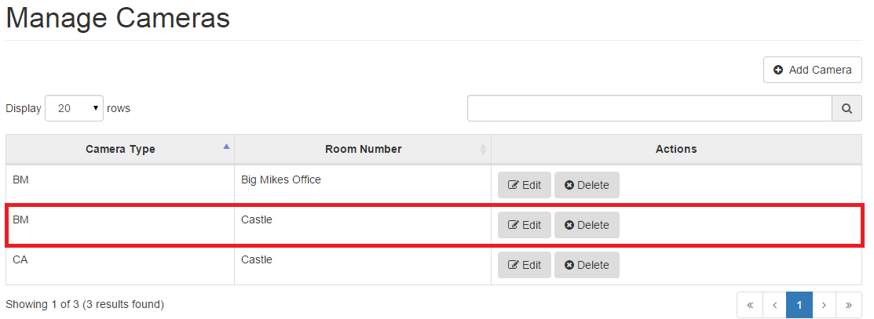
Figure 41: Camera successfully added

6.2.2 Editing a Camera

Just like adding a camera, it is also possible to edit some basic details of a camera like camera type and/or room number. If you need to do this, you can do by just clicking on the Edit button next to the camera you wish to edit (Figure 42)
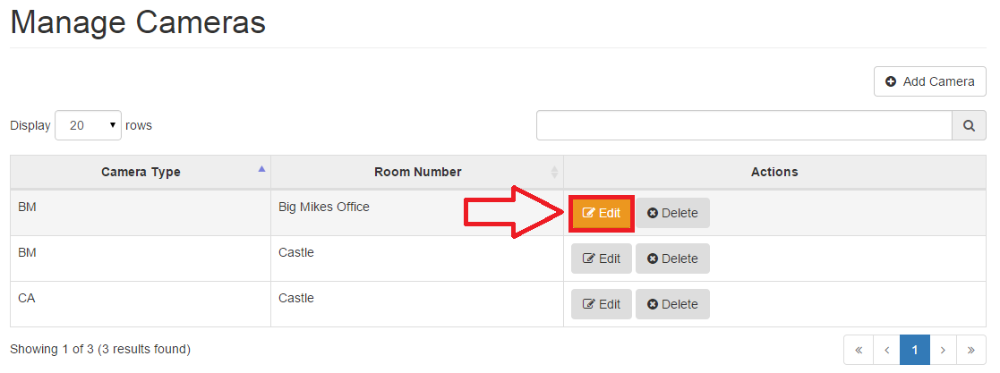Figure 42: Edit Camera

After clicking on the Edit button, you will see a form drop down which is already filled with the initial details, this form allows you to make the changes you wish to. (Figure 43)
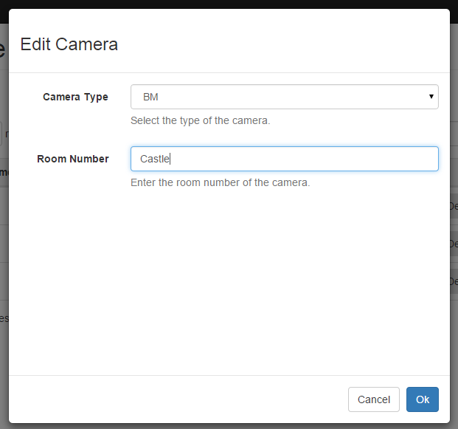
Figure 43: Edit Camera Form

After making the changes and clicking on Ok, the Camera details will be successfully updated.

6.2.3 Deleting a Camera

You may permanently delete a camera from your list by clicking on the Delete button, which can be found right next to the Edit button (Figure 44)
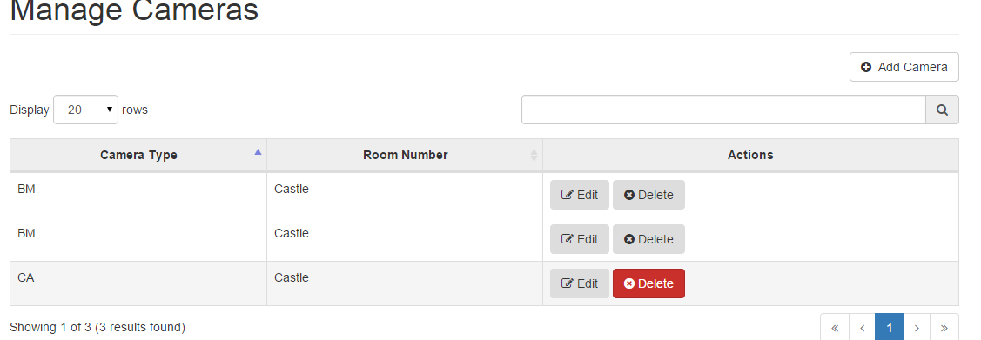Figure 44: Delete Patient

After clicking on the Delete button, you will be asked if you are sure you want to permanently delete this camera (Figure 45).
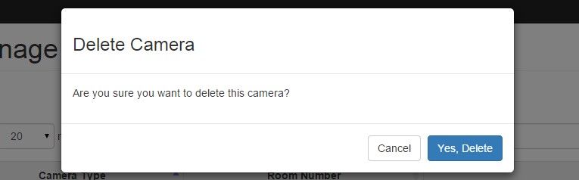
Figure 45: Delete Camera confirmation

If you click on Yes, Delete, the camera will be deleted from the table (Figure 46).
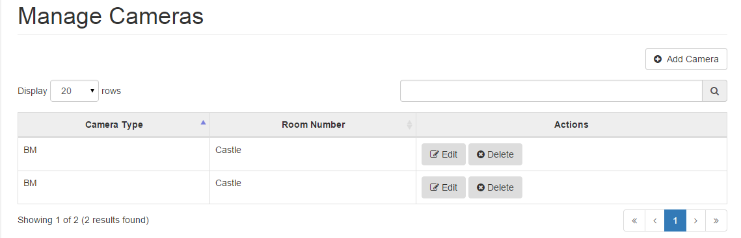Figure 46: Camera Deleted

6.2.4 Errors

Error: You did not enter a room number.

You get this error if you leave the field for a room number blanked. You have to enter a valid name in order for the form to be processed.

Error: Room number should not exceed 32 characters

You will get any of the above stated errors, if your input is too long. Enter a room number that does not exceed 32 characters.

Error: The data you entered is invalid; please check again

You get this error, if your input for some fields in the form do not follow the certain format. For example, “Name” field cannot contain digits, input for “Hospital Number” and “NHS Number” must not contain the “.” symbol.

Error: You do not have permission to edit or create this item

Every staff have certain permissions. If you get this error, then the system admin didn’t give you permission to do so. Speak to your system admin.

Error: Something went wrong; please try again

In most of the cases you get this error if there is a loss of connection with the server. Please ensure you are connected to the internet before preceding. If that doesn’t fix the problem, restart the application and try again.

6.3 Camera Types
The Camera Types page stores the list of the type of cameras the hospital has. (Figure 47)
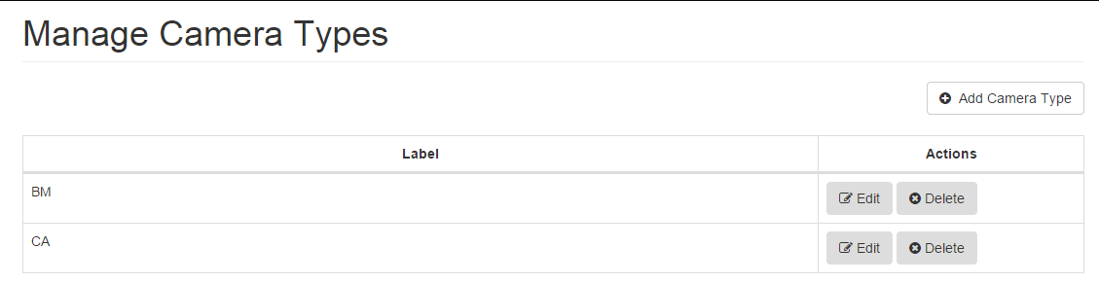Figure 47: Camera Type page

6.3.1 Adding a Camera Type
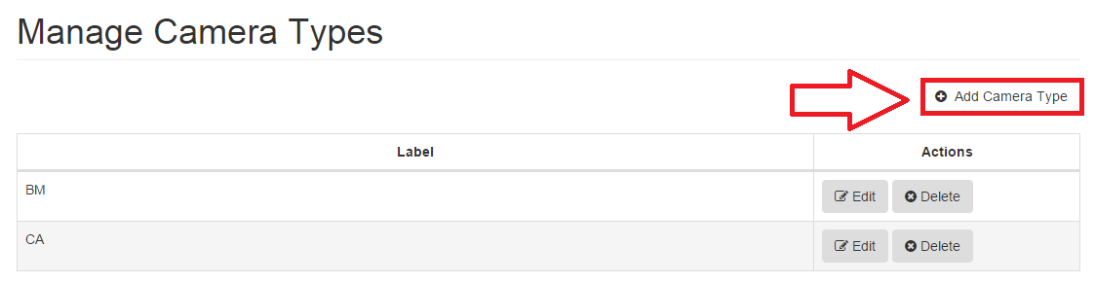
It is possible to add a new camera type to the list by simply clicking on the Add Camera Type button at the top (Figure 48)
Figure 48: Add Camera Type

After clicking on the Add Camera Type button, you will see a form drop down asking you to fill in the new camera type details. (Figure 49)
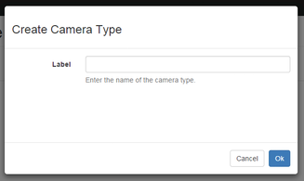
Figure 49: Create Camera Type Form
On clicking Ok, the details entered will be added to the camera type page as a new camera type

6.3.2 Editing a Camera Type
In order to edit an existing camera type, you can do this by clicking on the Edit button as shown in Figure 50
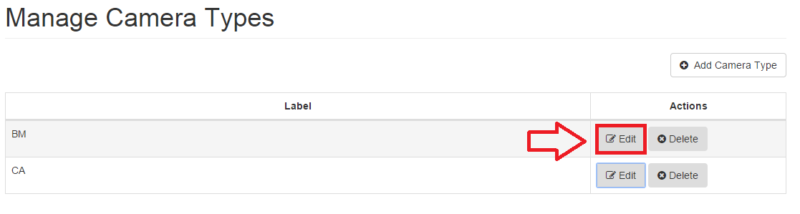
Figure 50: Edit Camera Type

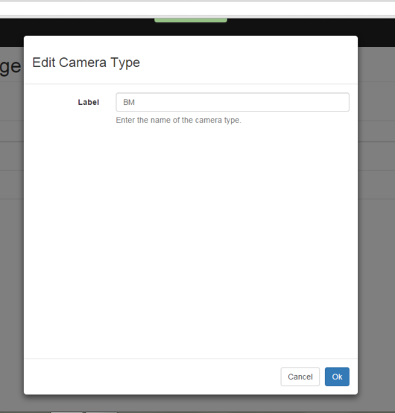
After clicking on the Edit button, you will see a new form drop down that would show the camera type you want to edit. (Figure 51)
Figure 51: Edit Camera Type Form
NOTE If you’ve received an error, jump down to Errors (Section 6.3.4) for troubleshooting.

After making the changes and clicking Ok, you will see the changes automatically updated in the camera type page

6.3.3 Deleting a Camera Type

If you would like to delete an existing camera type, as it is not being used anymore you can also do that by clicking on the Delete button which is found right next to the Edit button (Figure 52).
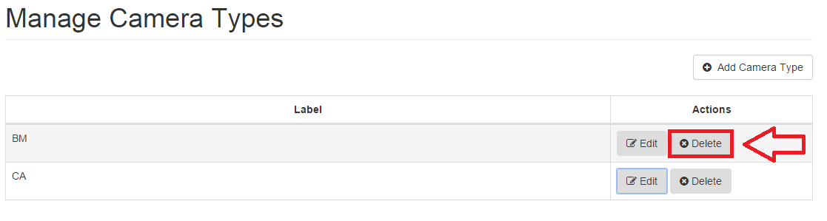Figure 52: Delete Camera Type

After clicking on Delete, you must confirm if you would like to permanently delete this camera type. (Figure 53) On clicking Yes, Delete this camera will be permanently deleted from the camera type page.

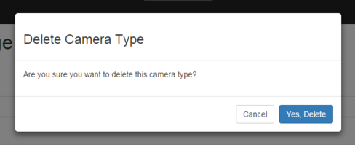
Figure 53: Permanently Delete Camera Type

6.3.4 Errors

Error: You did not enter a label for the camera type.

You get this error if you leave the field for a room number blanked. You have to enter a valid name in order for the form to be processed.

Error: Camera type label should not exceed 32 characters

You will get any of the above stated errors, if your input is too long. Enter a room number that does not exceed 32 characters.

6.4 Therapies

The Therapies page displays all the therapies that the department offers (Figure 54).

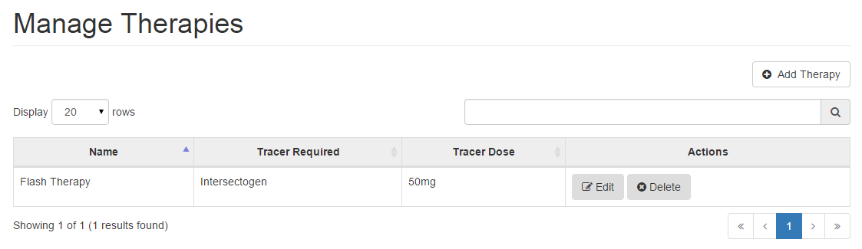Figure 54: Therapies page

6.4.1 Adding a Therapy

You can add a therapy when you need to. This can be done by just clicking on the Add Therapy button which can be found at the top of the therapy table (Figure 55).

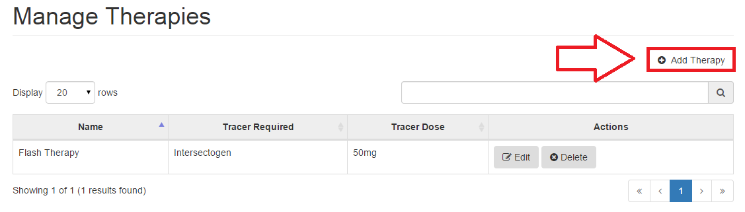Figure 55: Add Therapy

After clicking on the Add Therapy button, you can see a new form drop down which allows you to enter details of the new therapy (Figure 56). You might want to read Errors Section for the Therapy (Section 6.4.4) to see the description of errors you might get when filling the form.
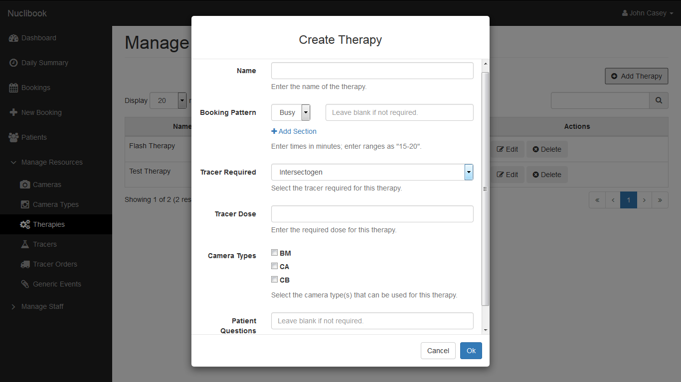
Figure 56: Create Therapy Form

The sections that require filling include:
Booking Pattern, which represents the different slots this therapies contains.
Tracer Dose, which could be “40mg”
Patient Questions, which is a set of questions that the patients need to be asked
or information that they need to know before the appointment is booked.

After filling in the details, you may click on Ok and see the new therapy added to the therapy page automatically (Figure 57).
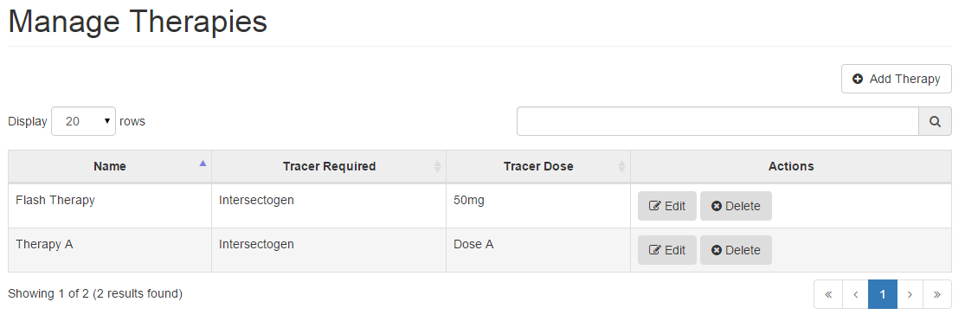Figure 57: New Therapy Added

6.4.2 Editing a Therapy

Just like adding, you may also edit a therapy. If you ever need to edit a therapy, you can do so by clicking on the Edit Therapy button next to the therapy you wish to edit. (Figure 58).

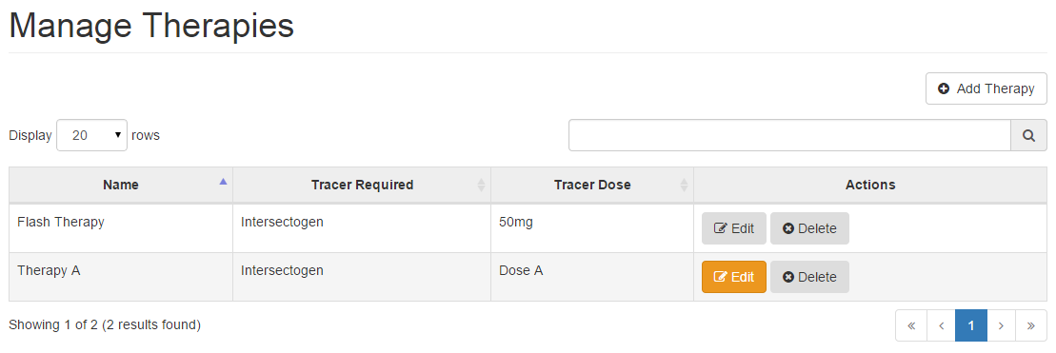Figure 58: Edit Therapy

After clicking on the Edit Therapy button you will see a form drop down which allows you to make changes to any detail of the therapy. (Figure 59)

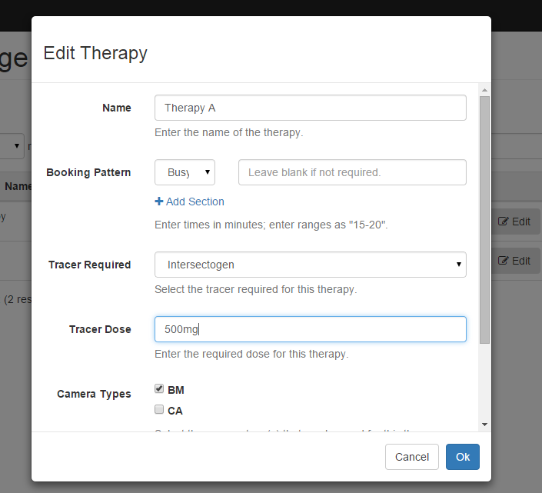
Figure 59: Edit Therapy

After making the changes, you may click on Ok to save them. You will be able to view the changes in the therapies page. (Figure 60). You might want to read Adding a Therapy Section (Section 6.4.1) or/and Errors Section for the Therapy (Section 6.4.4) to see the expected fields inputs on the form and description of error you might get when filling the form.

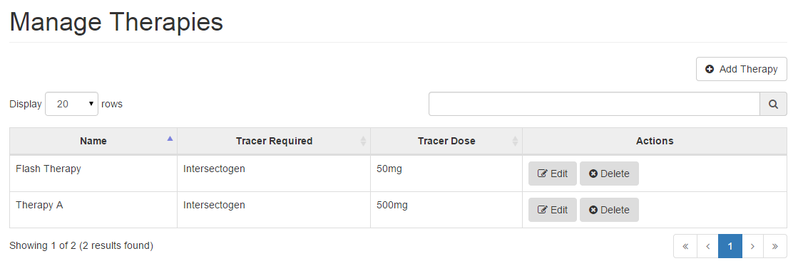
Figure 60: Edited Therapy

6.4.3 Deleting a Therapy

If you would like to delete a therapy, you can do so by clicking on the Delete button which is found right next to the Edit button (Figure 61)
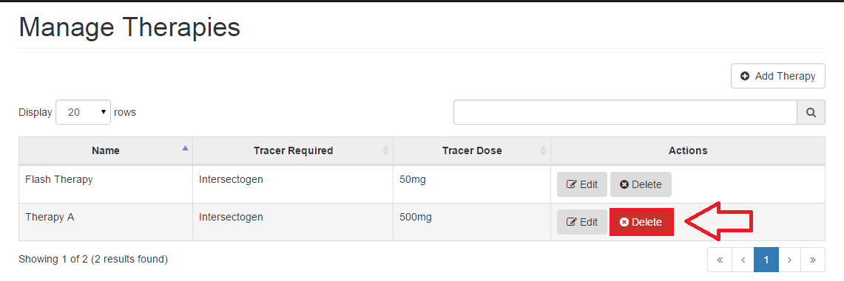
Figure 61: Delete Therapy

After clicking on Delete, you will be asked if you are sure you want to permanently delete this therapy (Figure 62)

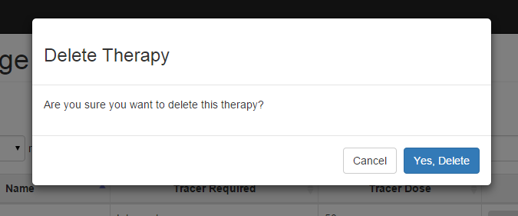
Figure 63: Permanently Delete Therapy

On clicking Yes, Delete the therapy will be permanently deleted and will no longer be visible in the therapy page. (Figure 64)
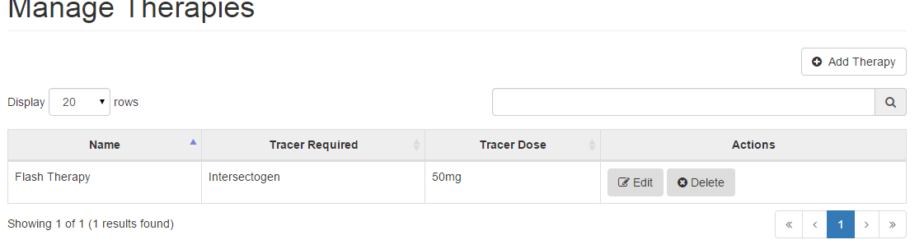
Figure 64: Deleted Therapy

6.5 Tracers
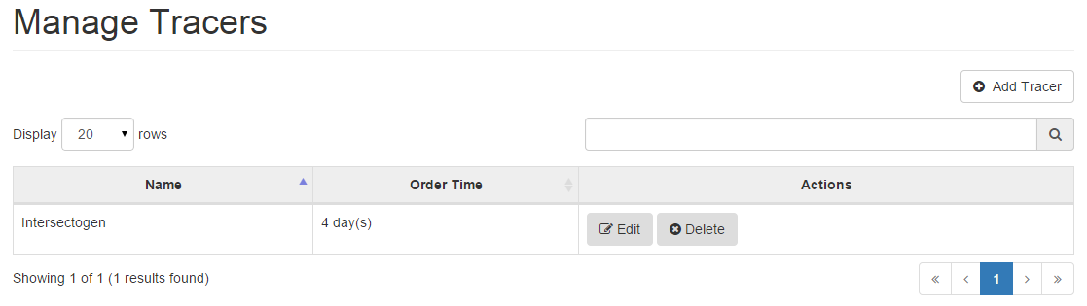
The Tracers page keeps a record of all the traces in the hospital (Figure 65)
Figure 65: Tracer Page

6.5.1 Adding a Tracer
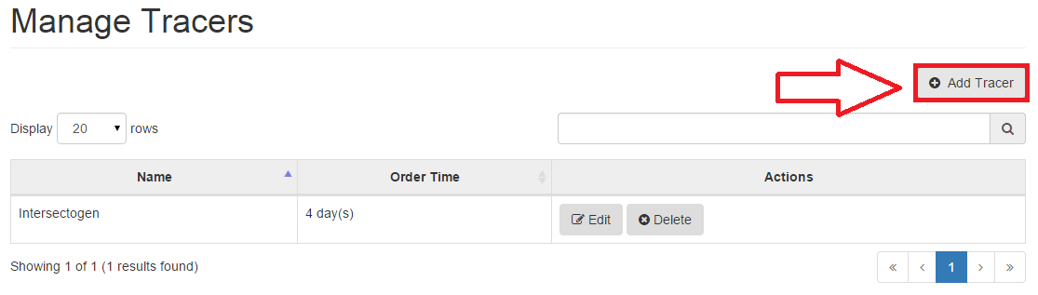
You can add a tracer when you need to. This can be done by just clicking on the Add Tracer button which can be found at the top of the tracer table (Figure 66)
Figure 66: Add Tracer

After clicking on the Add Tracer button, you can see a new form drop down which allows you to enter details of the new tracer (Figure 67)

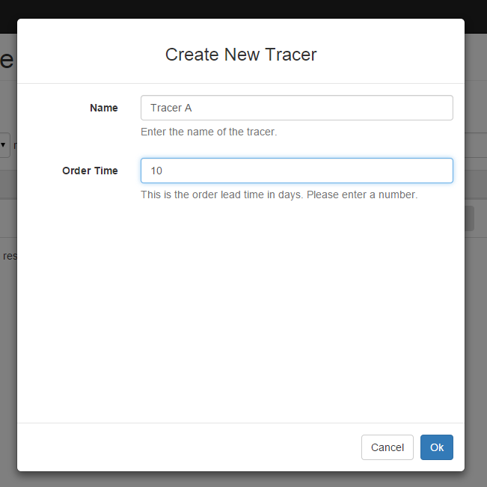
Figure 67: Create New Tracer

Once you’ve inputted the tracer name and the order lead time in days, you may click on Ok and see the new tracer added to the tracer page automatically. (Figure 68)

Figure 68: Added Tracer

6.5.2 Editing a Tracer
Just like adding, you may also edit a tracer. If you ever need to edit a tracer, you can do so by clicking on the Edit Tracer button next to the therapy you wish to edit. (Figure 69)
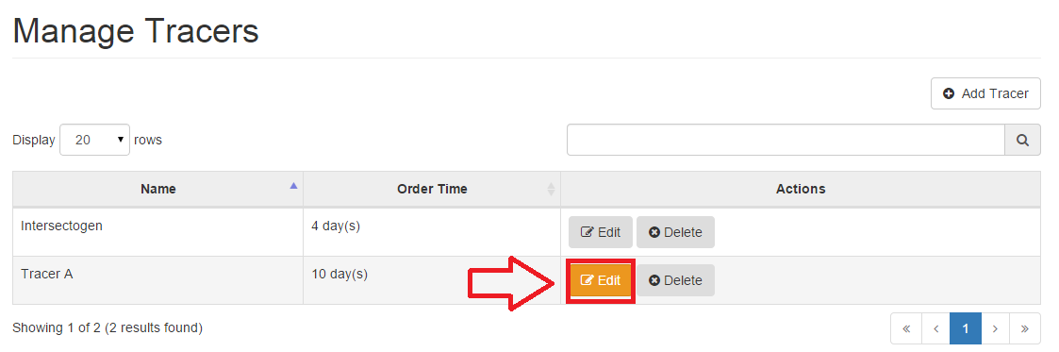
Figure 69: Edit Tracer

After clicking on the Edit Tracer button you will see a form drop down which allows you to make changes to any detail of the tracer. (Figure 70)
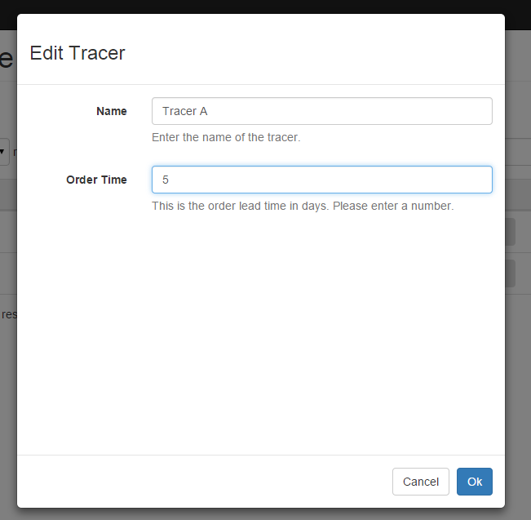
Figure 70: Edit Tracer Form

After making the changes, you may click on Ok to save them. You will be able to view the changes in the tracers page. (Figure 71)
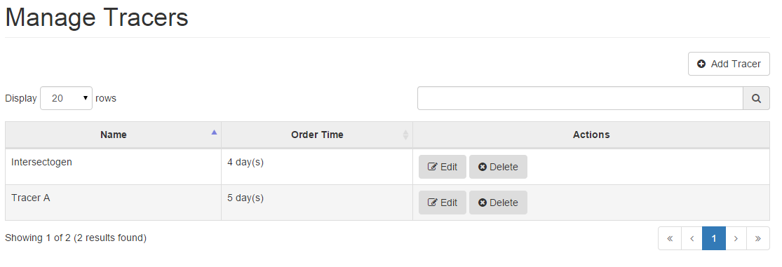
Figure 71: Edited Tracers

6.5.3 Deleting a Tracer

If you would like to delete a tracer, you can do so by clicking on the Delete button which is found right next to the Edit button (Figure 72).

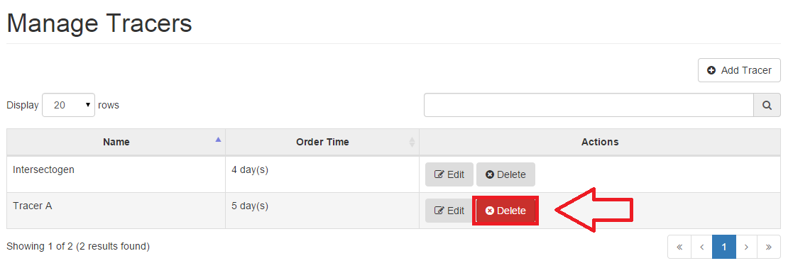
Figure 72: Delete Tracer

After clicking on Delete, you will be asked if you are sure you want to permanently delete this tracer (Figure 73).

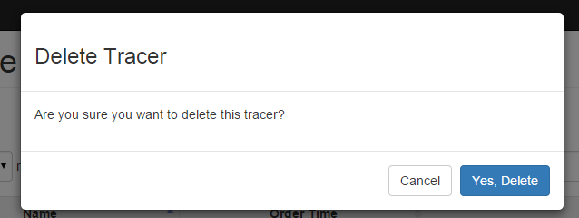
Figure 73: Delete Tracer Confirmation

On clicking Yes, Delete the tracer will be permanently deleted and will no longer be visible in the tracer page (Figure 74).

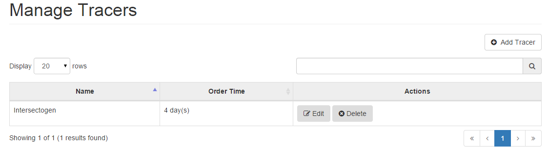Figure 74: Tracer Deleted

6.6 Tracer Orders
The Tracer orders page gives the list of the tracers and allows you to see placed tracer orders, update the status of a pending order or cancel an existing order. Tracer orders are placed automatically when a booking that requires a tracer is created (Figure 75).

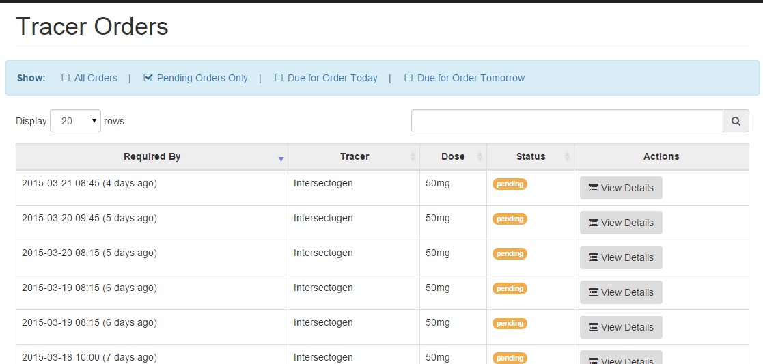Figure 75: Tracer Orders Page

NOTE You can also filter the table by selecting an option above the table. For example you
may wish to only see the orders due for today or all pending orders.

6.6.1 Viewing Tracer Order details

You may view a specific tracer in order to place or cancel the order. For this, you will need to click on the View Details button next to the tracer you want to view (Figure 76)
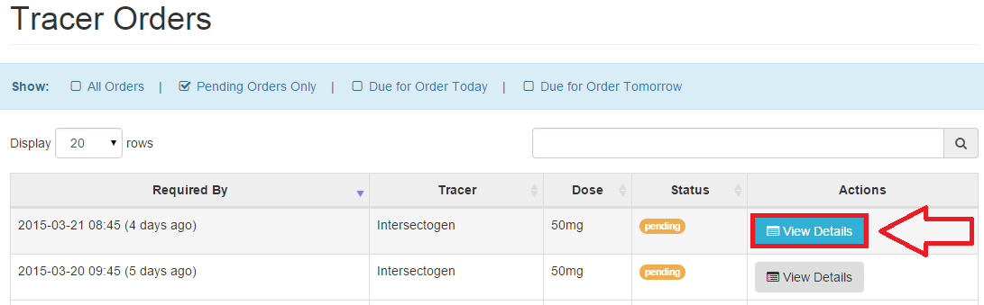
Figure 76: View Tracer Details

On clicking the View Details button, you will see the Tracer Order Details page which is the page where you can update the status of that particular tracer (Figure 77)
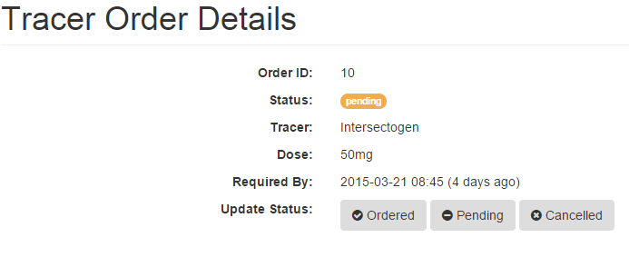
Figure 77: Tracer Order Details

NOTE When you update the status on the Tracer Order Details page (Figure 77) you will see the status automatically updated on the Traer Order page (Figure 76) next to the the relevant tracer

6.7 Generic Events
The Generic Events page keeps a record of all the general events in the hospital such as staff meetings, camera maintenances etc. (Figure 78).

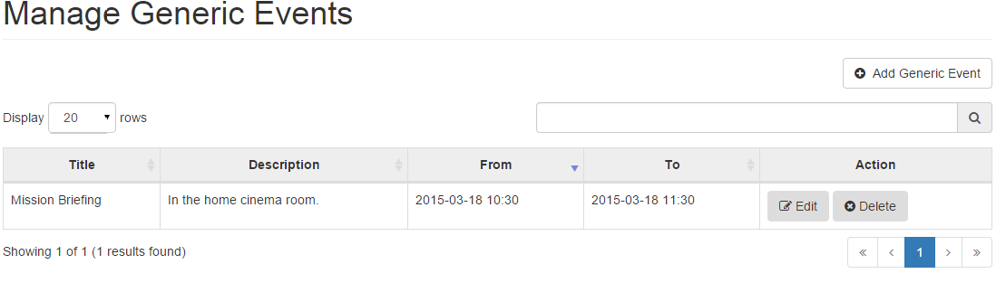Figure 78: Generic Events Page

6.7.1 Adding a Generic Event

You can add a generic event when you need to. This can be done by just clicking on the Add Generic Event button which can be found at the top of the generic event table (Figure 79)

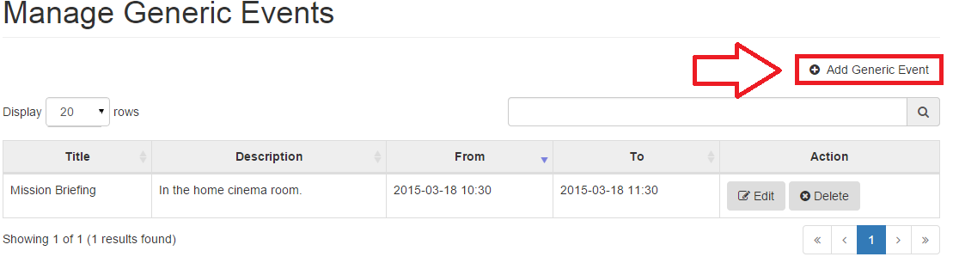Figure 79: Add Generic Event

After clicking on the Add Generic Event button, you can see a new form drop down which allows you to enter details of the new event (Figure 80).
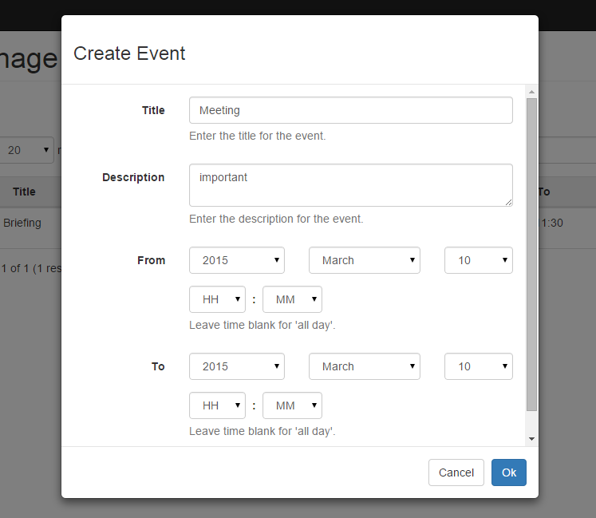
Figure 80: Create Event Form

If the event is a full-day event, you can set that in the calendar by not setting a start and end time. After filling in the details, you may click on Ok and see the new generic event added to the generic event page automatically.

6.7.2 Editing a Generic Event
Just like adding, you may also edit a Generic Event. If you ever need to edit an event, you can do so by clicking on the Edit button next to the event you wish to edit. (Figure 81)

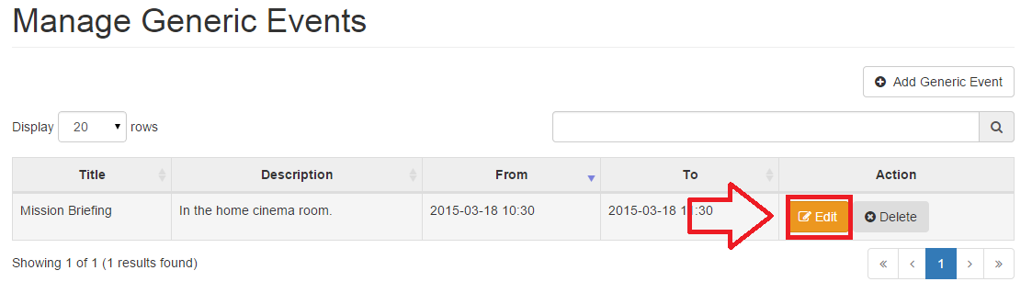
Figure 81: Edit Generic Event

After clicking on the Edit button you will see a form drop down which allows you to make changes to any detail of the event. (Figure 82)
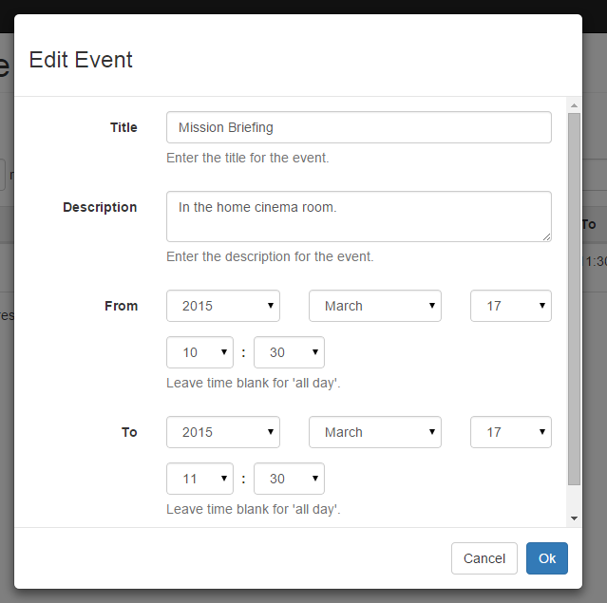
Figure 82: Edit Event Form

After making the changes, you may click on Ok to save them. You will be able to view the changes in the Generic Events page.

6.7.3 Deleting a Generic Event
If you would like to delete an event, you can do so by clicking on the Delete button which is found right next to the Edit button (Figure 83)
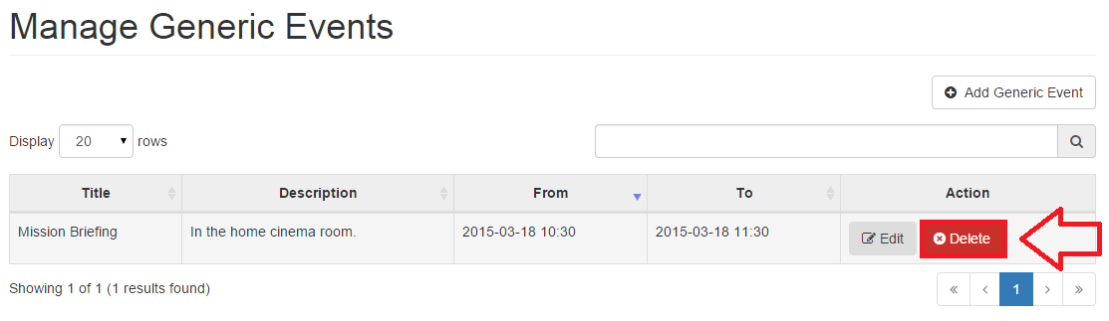
Figure 83: Delete Generic Event

After clicking on Delete, you will be asked if you are sure you want to permanently delete this event (Figure 84).

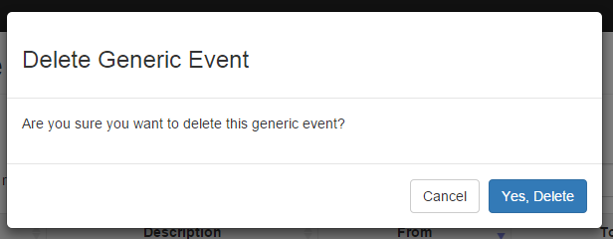Figure 84: Delete Generic Event Confirmation

On clicking Yes, Delete the tracer will be permanently deleted and will no longer be visible in the Generic Events page.

7. Staff Entities
In here you will find a number of features for managing staff accounts, staff roles, staff availabilities and absences, as well as view a log of all the actions that were performed since the beginning.

NOTE You might not be able to see all the Staff Entities options in your sidebar. This is
because your account may not have these permissions. Speak to your systems administrator if you believe this is a mistake.

7.1 Staff Accounts

In this section you will be able to view a list of all the staff accounts in the database. Depending on your permissions, you may be able to create, edit or delete staff accounts, as well as change other users’ passwords - this will most likely be an admin-only option (unless the admin has given these permissions to another staff account).

These actions are explained individually in the next sections.

7.1.1 Adding a Staff Account

On the Staff Accounts page (Figure 85), you will see an Add Staff Member button at the top right of the page which allows you to add a new member of staff. By clicking this, a form will drop down (Figure 86) for you to fill in the new user’s details.

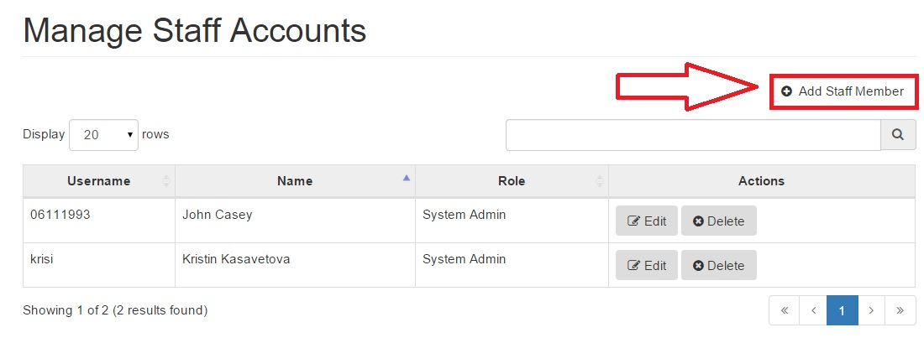
Figure 85: Staff Accounts

Simply, fill out the form with your details and click ok, again while selecting a password for the staff refer back to the tips and notes of the change password section (Section 3.3.1)
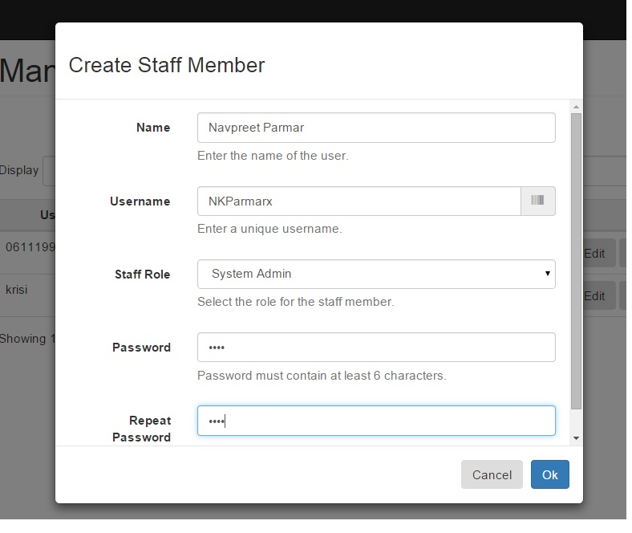
Figure 86: Create Staff Member

NOTE Username must be unique from other staff members, If the username you want is
already taken by another member of staff, you will not be able to keep it. Refer to
section 7.1.4 Staff Account Errors for more details.

After clicking ok, you can now see the new staff member added appears in the Manage Staff Accounts table (Figure 87).
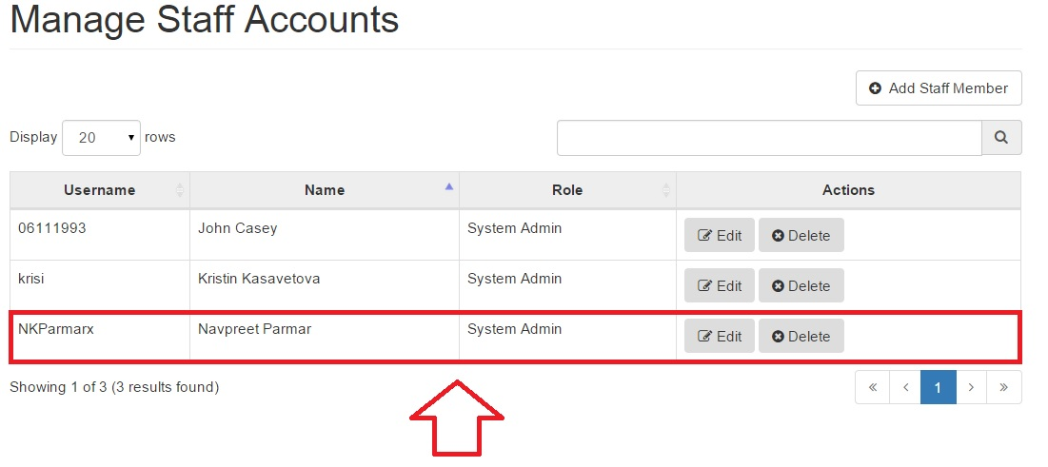
Figure 87: Manage Staff Accounts

7.1.2 Editing a Staff Account

The Staff Accounts table makes it possible to edit staff accounts. For example, if a staff member wants to change their username, surname or password it can be done by clicking on the edit button next to the staff member whose details you want to edit (Figure 88). Additionally, staff accounts may have permissions to edit other users’ information and/or password.

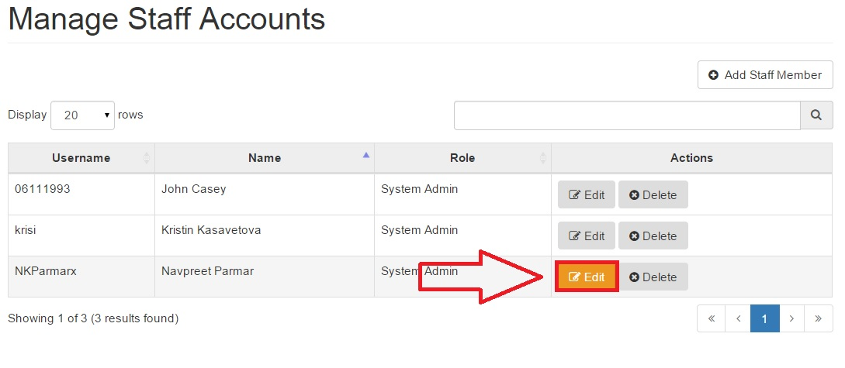
Figure 88: Edit Staff Account

After clicking on the edit button, a form will drop down which contains a form filled out with the staff’s initial details making it easier to identify what to edit. In Figure 89, we would like to change the username from NKParmarx to Navi, so we can simply click on the text we want to edit, change it and click Ok

NOTE You might not see the password fields - this is because your admin has not given
you permission to edit other users passwords. If you would like to change your own
password, you can do so by clicking on your name in the top bar and navigate to
Profile. See section 3.2 for more details on how to do this.

TIP If you do not want to change an account’s password, just leave both password fields
blank.
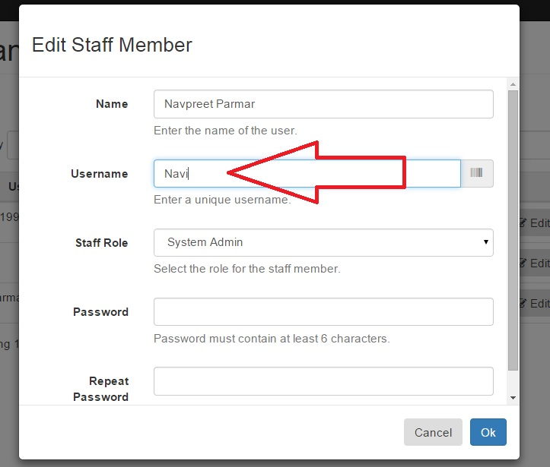
Figure 89: Edit Staff Form

After clicking Ok, the form will disappear and we can now see the changes we have in the staff accounts table (Figure 90), In our case the username has been successfully changed. If you have encountered an error, refer to Section 7.1.4 Staff Account Errors for more details.

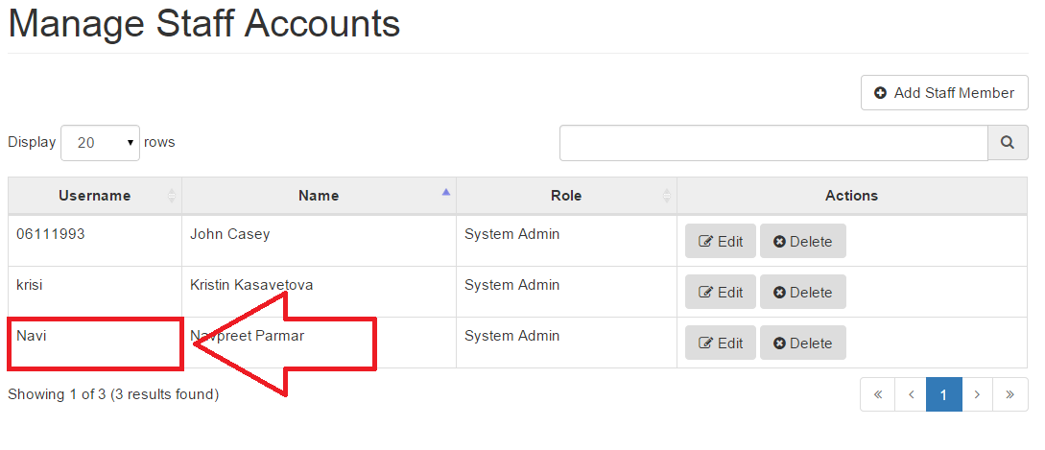Figure 90: Updated Changes to the Staff Accounts Table

7.1.3 Deleting a Staff Account

The admin can delete a staff account, this is a feature that would be useful if a staff member no longer works for the hospital or has changed departments. The delete button can be seen right next to the edit button (Figure 91).
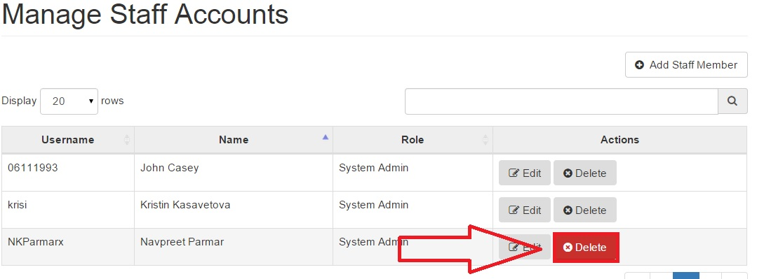
Figure 91: Delete Staff Member

By clicking on the Delete button, a drop down appears confirming whether the user wants to delete this account. (Figure 92) By clicking yes, Delete, the user will be deleted whereas by clicking Cancel, the user will be taken back to the Staff Accounts page.

NOTE Clicking Delete will set the selected user as disabled in the database. Their record
will not be permanently deleted in order to have them preserved in the bookings and
action log history.

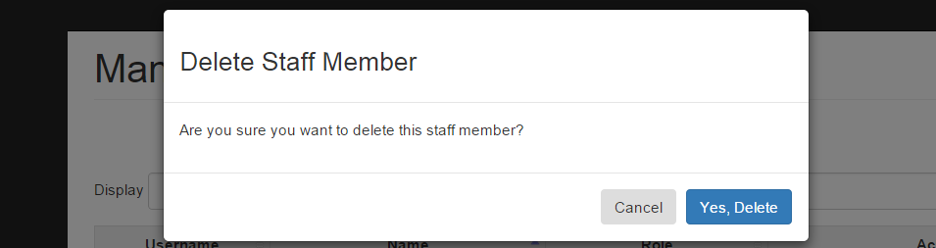
Figure 92: Deleting Staff Account form

Figure 93 shows the updated table on deleting a staff member. In this case we have deleted the third member of staff in the table

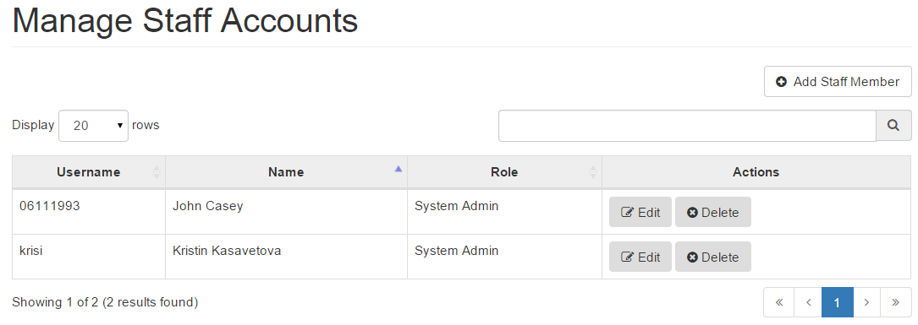
Figure 93: Removed Staff Account

NOTE If you’ve received an error, jump down to Errors (Section 7.1.4) for troubleshooting.

7.1.4 Staff Account Errors

Error: You did not enter a valid name
Ensure that you have entered a name that’s between 1 and 64 characters.

Error: Name of the staff should not exceed 64 characters
Ensure that you have entered a name that’s between 1 and 64 characters.

Error: You did not enter a valid username
Ensure that you have entered a username that’s between 1 and 64 characters.

Error: Username should not exceed 64 characters
Ensure that you have entered a username that’s between 1 and 64 characters.

Error: Your password must be at least 6 characters long

Ensure that the password you have entered is at least 6 (or more) characters long.

Error: Your passwords did not match

Ensure that you have entered the same password in both ‘Password’ and ‘Repeat Password’ fields.

Error: Password must not be the same as the last few passwords.

Ensure that your new password is different than the last 3 you have used before.
If you do not want to change the password of the account, just leave the password fields blank.

Error: The data you entered was invalid; please check again

Ensure that you have followed the above instructions for all fields. It is likely you are getting this error due to having entered symbols or other disallowed characters in the fields, such as ‘\’ for example.

Error: Something went wrong; please try again
It is likely you are getting this error due to a failed connection to the server. Please ensure you are connected to the Internet before proceeding. If that doesn’t fix the problem, restart the application and try again.

7.2 Staff Roles

In this section you would be able to see and edit the list of permissions for the current roles on the system. You might not be able to see this, if your admin has not given allowances for your account to view and edit staff role permissions. (Figure 94)
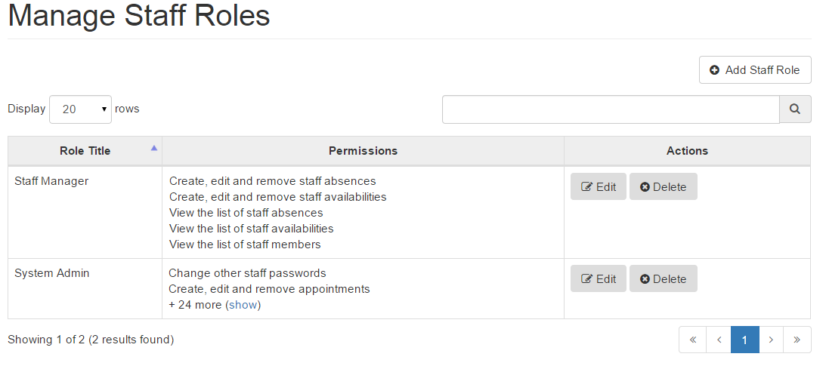
Figure 94: Staff Roles Page

Apart from editing an existing staff’s permissions, you could also create a new role or delete one. These actions are explained individually in the next sections.

Below is a list of all the available permissions in the system:

- Change other staff passwords - a permission allowing to change other users’ passwords
- Create, edit and remove bookings - a permission allowing to create new, update and delete existing bookings
- Create, edit and remove cameras and camera types - a permission allowing to create new, update and delete existing cameras and camera types
- Create, edit and remove generic events - a permission allowing to create new, update and delete existing generic events
- Create, edit and remove patients - a permission allowing to create new and update existing patients
- Create, edit and remove radio tracers - a permission allowing to create new, update and delete existing radio tracers and update tracer orders
- Create, edit and remove staff absences - a permission allowing to create new, update and delete existing staff absences
- Create, edit and remove staff availabilities - a permission allowing to create new, update and delete existing staff availabilities
- Create, edit and remove staff members and assign roles - a permission allowing to create new, update and delete existing staff accounts and assign roles to them
- Create, edit and remove therapies - a permission allowing to create new, update and delete existing therapies
- Edit the permissions assigned to each staff role - a permission allowing to create new, update and delete existing staff roles
- Export the database of patients - a permission allowing to export the patients database
- Import patients to the database - a permission allowing to import patients to database
- View a booking's details - a permission allowing to view a certain booking’s details
- View the calendar of existing appointments - a permission allowing to view the calendar bookings
- View the details and history of a single patient - a permission allowing to view the full details of a patient and their booking history.
- View the list of cameras and camera types - a permission allowing to view the existing cameras and camera types
- View the list of generic events - a permission allowing to view a list of all generic events
- View the list of staff absences - a permission allowing to view all staff member’s absences
- View the list of staff availabilities - a permission allowing to view all staff member’s availabilities
- View the list of staff members - a permission allowing to view a list of all staff accounts
- View the list of staff roles and assigned permissions - a permission allowing to view a list of all staff roles and their assigned permissions
- View the list of therapies - a permission allowing to view a list of all therapies
- View the list of tracers - a permission allowing to view a list of all tracers and tracer orders
- View the patient list - a permission allowing to view a list of all patients
- View the staff action log - a permission allowing to view a list of all the action log events

7.2.1 Adding a Staff Role

You can add a new staff role by click on the Add Staff Role button (Figure 95).

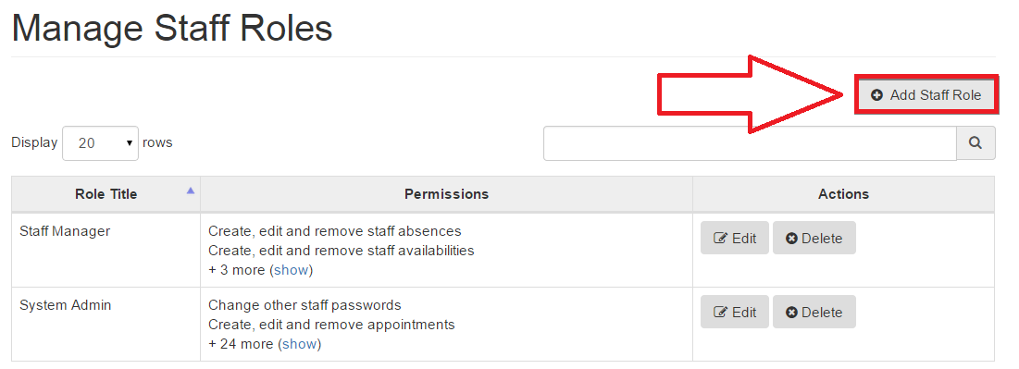Figure 95: Add Staff Role

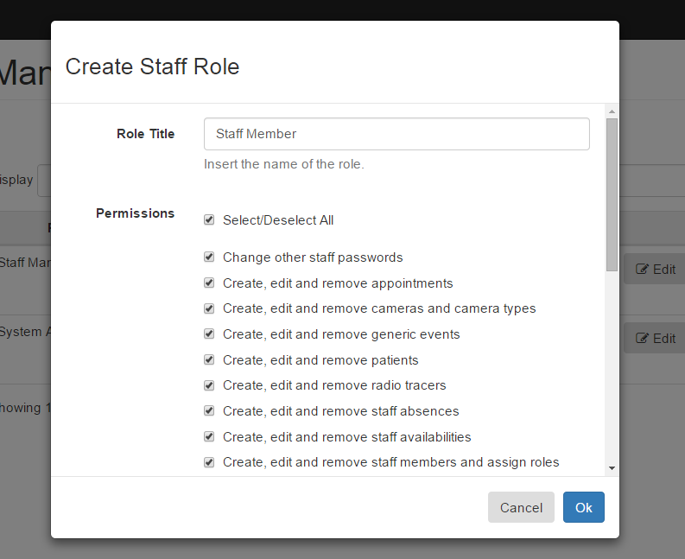
Figure 96: Create Staff Role Form

By clicking on the Add Staff Role button, a form will drop down (Figure 96) which needs to be filled with the role title, and the permissions need to be selected for that role. By clicking ok, the new staff role will be added to the table (just like adding a new staff member) and by clicking cancel you will be taken back to the Staff Roles page.

TIP In order to select or deselect all permissions, you can check the Select/Deselect All option

7.2.2 Editing a Staff Role

In order to edit a Staff Role, the user can click on the edit button next to the role they want to edit (Figure 97)
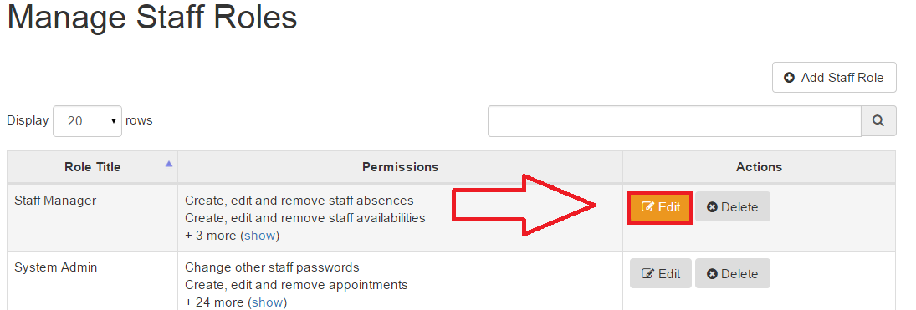Figure 97: Edit Staff Role

By clicking on the edit button, a form will drop down (Figure 98) with the initial details already filled it, you can change the permissions or the role title and click ok to save the changes or cancel to go back to the Staff Roles page
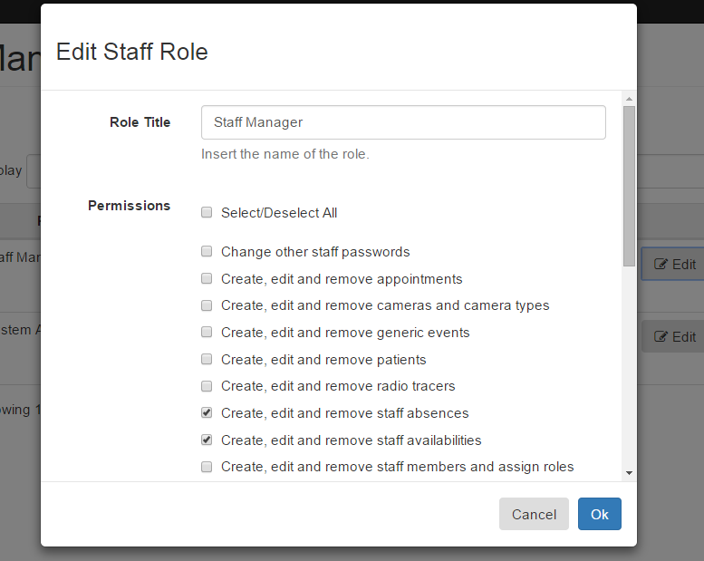
Figure 98 Edit Staff Role Form

TIP In order to select or deselect all permissions, you can check the Select/Deselect All option

7.2.3 Deleting a Staff Role

In order to delete a Staff Role, you can click on the delete button which is found right next to the edit button (Figure 99)

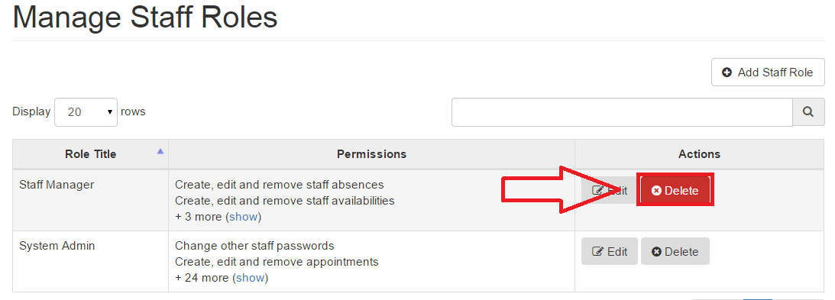
Figure 99: Delete Staff Roles

By clicking the Delete button, a drop down will appear (Figure 100) confirming whether you would like to delete this particular staff role, clicking Yes, Delete will permanently delete the Staff Role whereas Cancel will take you back to the Staff Roles page
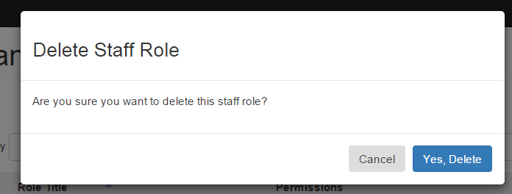
Figure 100: Permanently delete Staff Role

7.2.4 Error Section for Staff Roles

Error: Role title should not exceed 32 characters.
Ensure that you have entered a role title that is between 1 and 32 characters.

Error: You did not enter a valid role title.
Ensure that you have entered a role title and not left it blank.

Error: Role title should only contain numbers, letters and spaces.
Ensure that you have entered a role title with only letters, numbers, -, . and spaces.

Error: Please select at least one permission.
Ensure that you have selected at least one permission, staff role cannot be made unless given certain permissions, therefore you must select at least one permission.

7.3 Staff Availabilities

The Staff Availabilities page shows the times that the staff members are available in the hospital in the form of a table (Figure 101).

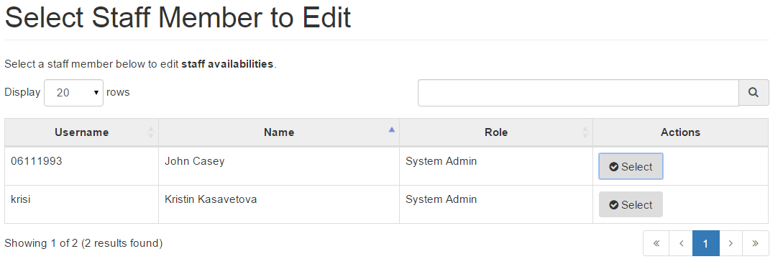Figure 101: Staff Availabilities Page

7.3.1 Selecting a Staff Member to view availability

The Staff Availabilities page (Figure 101) only shows the list of staff members available in the hospital. In order to check the exact details and time of the staff availability click the select button (Figure 102) in the row whose availability you want to view
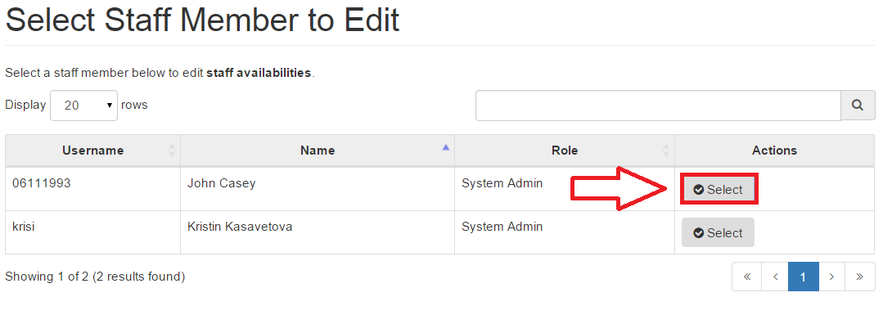Figure 102: Select a Staff Member

After clicking on the select button, you will be taken to a new page which shows the availability of the staff member you have selected in the table (Figure 103). However in Figure 26, you can see there is no availability for this staff selected in which case we can add a new availability (Section 7.3.2).

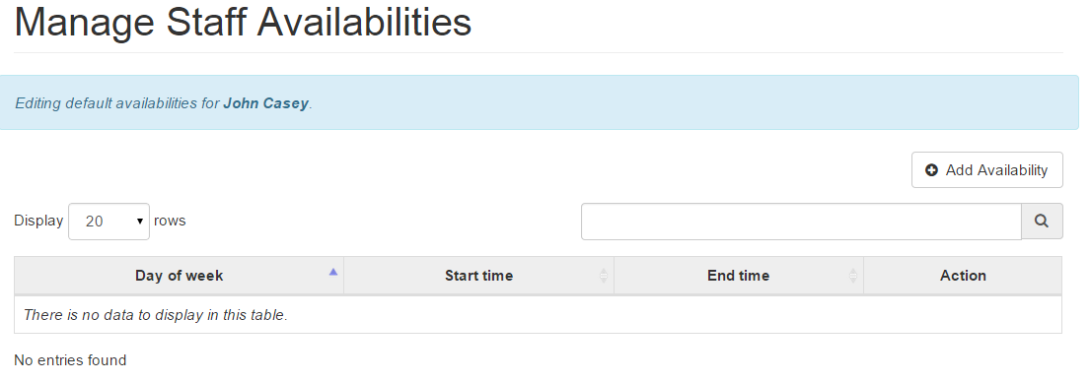Figure 103: Showing Availabilities Page

NOTE If there are no staff availabilities for that staff then the table would be empty showing “There is no data to display in this table” just like in Figure 103

7.3.2 Adding a new Availability
In order to add a new staff availability, you can click on the Add Availability button above the Staff Availabilities table. (Figure 104)
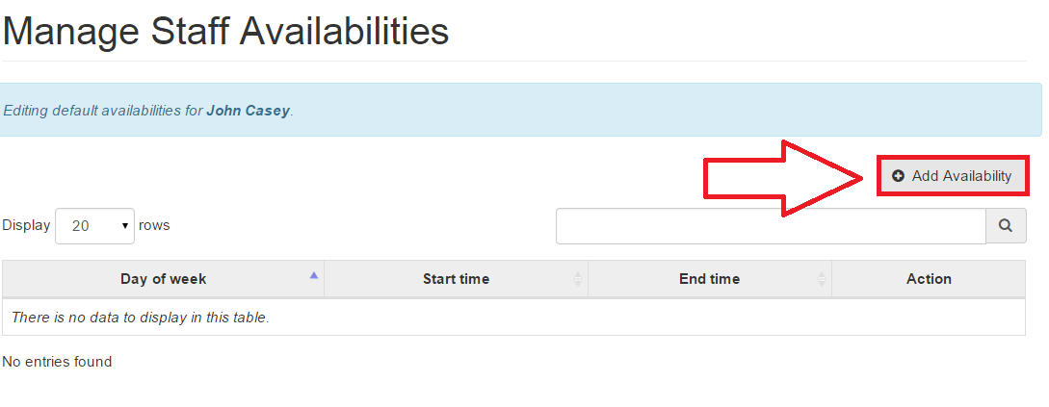Figure 104: Add Availability

After clicking on the Add Availability button, you see a form drop down asking you to add the availability of the staff (Figure 105). After filling in the availability, you can click Ok to save the availability or click Cancel to go back to the previous page
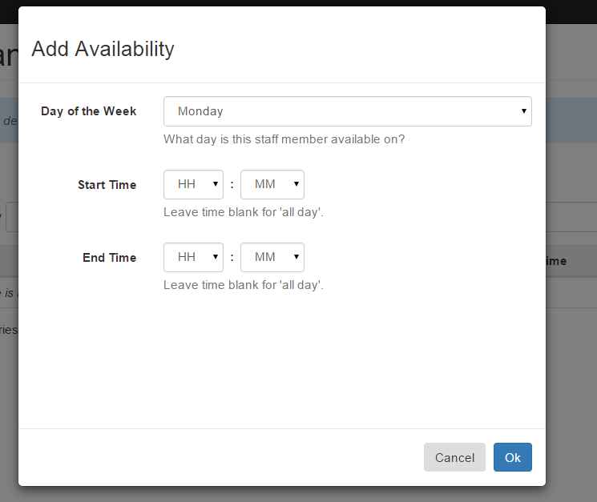
Figure 105: Add Availability Form

NOTE If a Staff Member is available for the entire day you can leave the Start Time and End Time unselected and just select the Day of the Week that they are available on

On clicking the Ok button, you will be able to see the added availability in the table as you can see in Figure 106, the table contains the availability we added in Figure 105.

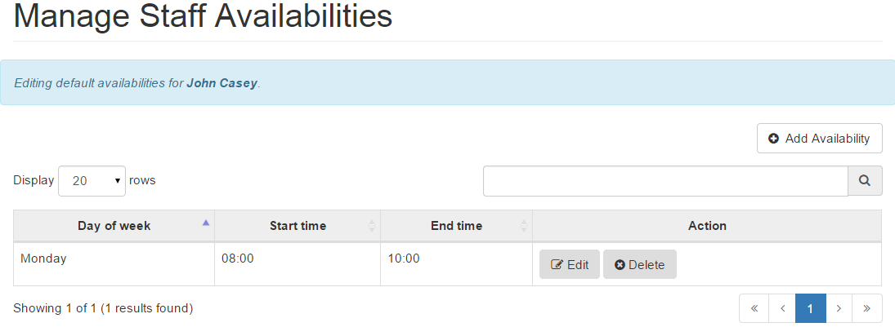Figure 106: Added Availability

7.3.3 Editing Staff Availability

Just like adding a new availability, you can also edit an existing availability by simply clicking on the Edit button next to the availability you want to edit. (Figure 107)
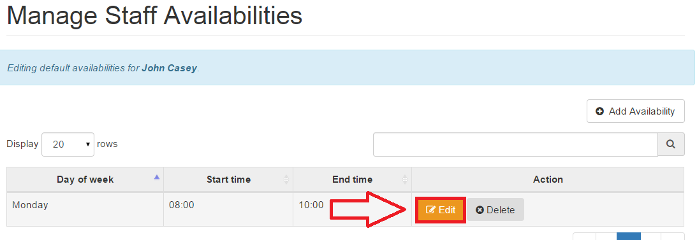Figure 107: Edit Staff Availability

After clicking on the Edit Availability button, you will see a form drop down containing the existing details of the availability allowing you to make changes to it. (Figure 108) In Figure 108, the End Time has been changed to 11:00

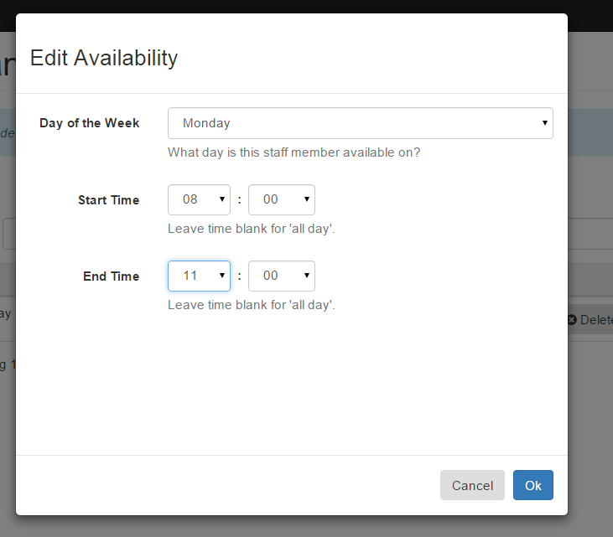
Figure 108: Edit Availability Form
After making the changes and clicking on Ok, you will see the changes automatically updated in the Staff Availabilities table (Figure 109)
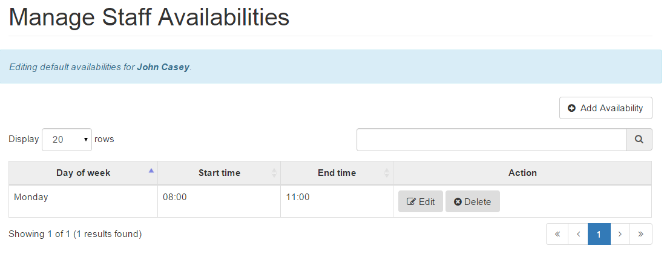
Figure 109: Changes updated to the table

7.3.4 Delete Staff Availability

You can also delete an existing availability by simply clicking on the Delete button which is right next to the edit button (Figure 110)
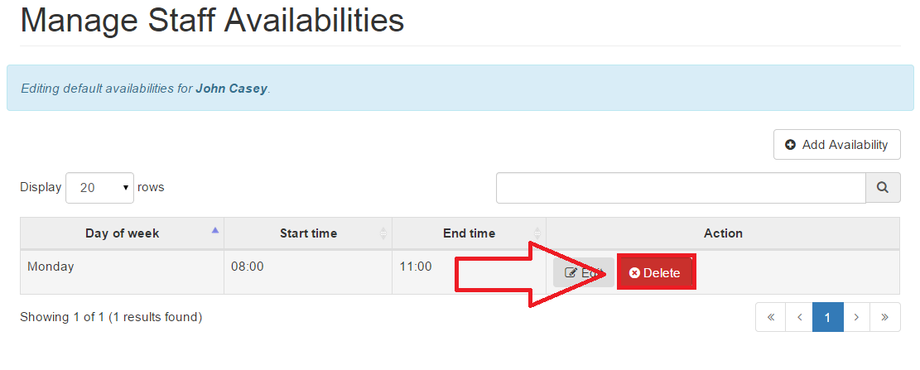
Figure 110: Delete Staff Availability

On clicking the Delete button, a new form drops down confirming whether you want to permanently delete this availability. (Figure 111)
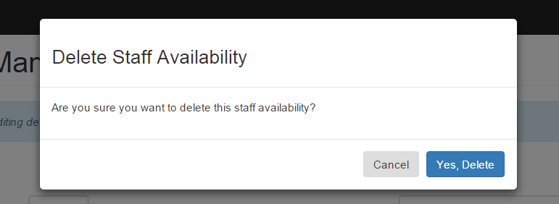Figure 111: Delete Staff Availability Form

If you decide to click on the Yes, Delete button then the availability will be permanently deleted as shown in Figure 112
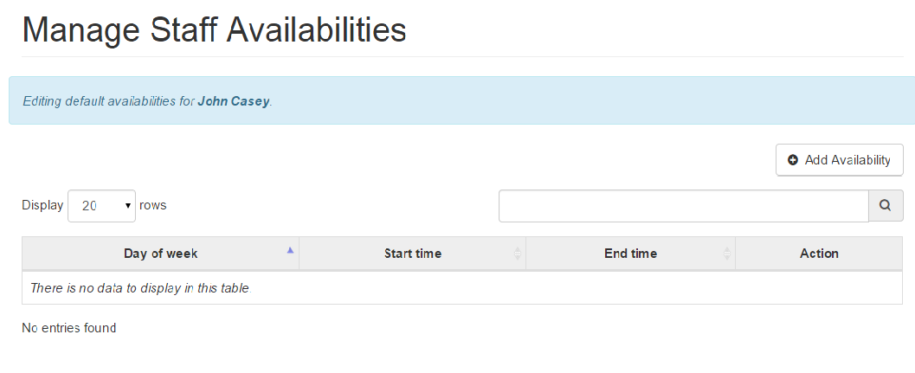
Figure 112: Staff Availability

7.3.5 Error Section for Staff Availability

Error: Please enter a valid start time
Ensure that you have entered a start time in the HH:MM format

Error: Please enter a valid end time.
Ensure that you have entered an end time in the HH:MM format

Error: The start time cannot be after the end time
Ensure that the end time you have entered is after the start time unless it is an earlier time on a day after the start day.

7.4 Staff Absences

The Staff Absences page keeps a record of the times when staff are absent. This data is displayed in a table (Figure 113) If you are the System Admin, you will be able to edit, delete and add an absence.
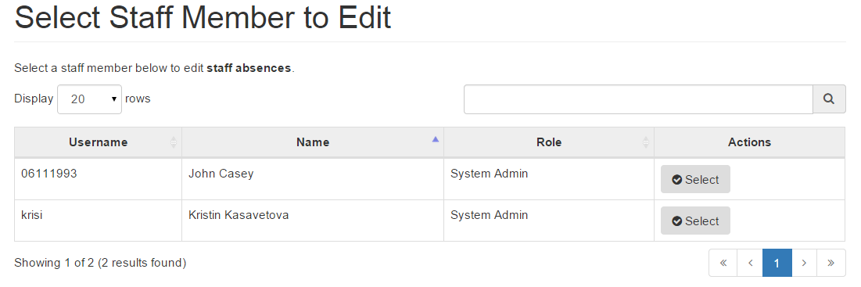
Figure 113: Staff Absences Page

7.4.1 Selecting a Staff Member to view absences

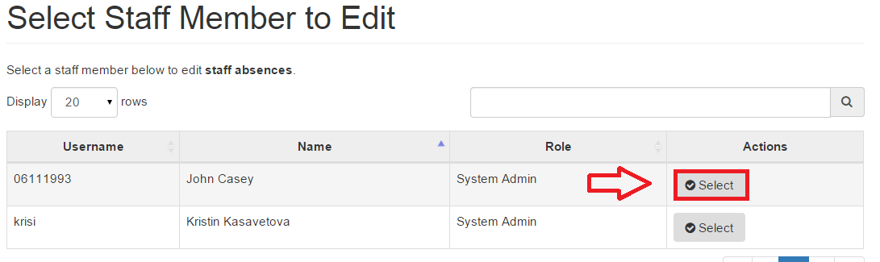
Where the Staff Absences page shows the list of all staff’s absences (Figure 113). In order to view a particular staff’s absence, you may wish to click on the Select button next to the staff you want to view (Figure 114)
Figure 114: Selecting Staff Absence

After clicking on the Select button, you will be taken to a new page which shows the absences of that staff (Figure 115).

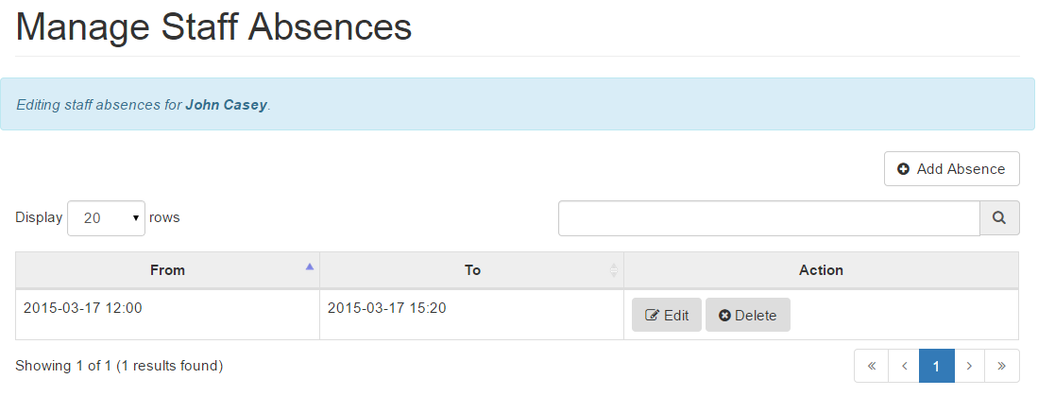Figure 115: Staff Absence Details

7.4.2 Adding Staff Absence

Adding a Staff Absence is possible, all you need to do is click on the Add Absence button at the top right above the table (Figure 116)

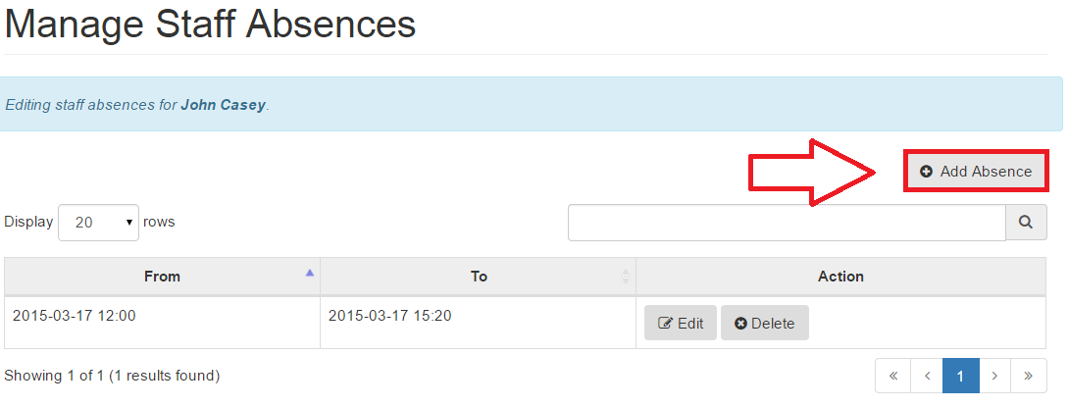
Figure 116: Adding Staff Absence

After clicking on the Add Absence button, a new form will drop down which will allow you to add the date and time from and to when the staff will be absent. (Figure 117)

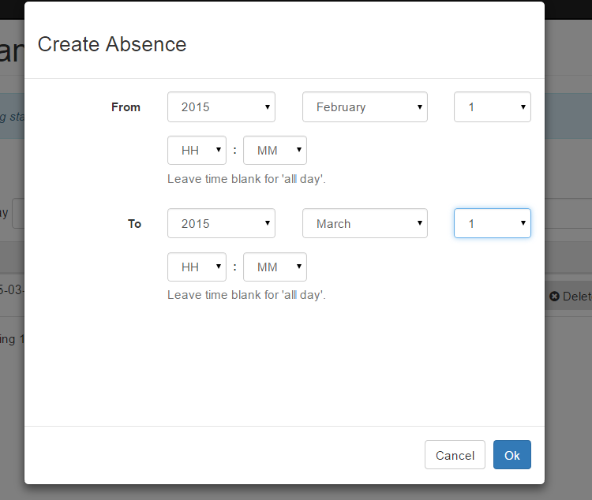
Figure 117: Create Absence Form

NOTE If a Staff Member is absent for the entire day you can leave the Start Time and End Time blank and just select the dates that they are absent between

On clicking the Ok button in the Create Absence form, the absence will be successfully added to the Staff Absences page (Figure 118).

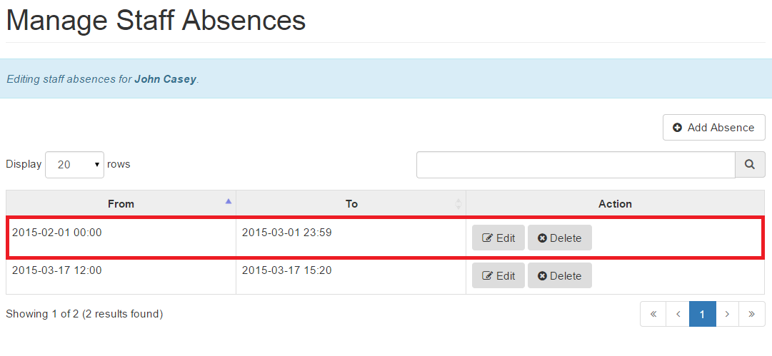
Figure 118: Added new Staff Absence

NOTE At the top of the table, you will be able to see the name of the staff the absences are being edited for (in blue)

7.4.3 Editing Staff Absence

You can also edit a Staff Absence in order to reflect changes in someones leave. This can be done by simply clicking on the Edit button next to the Absence dates that you wish to edit (Figure 119).

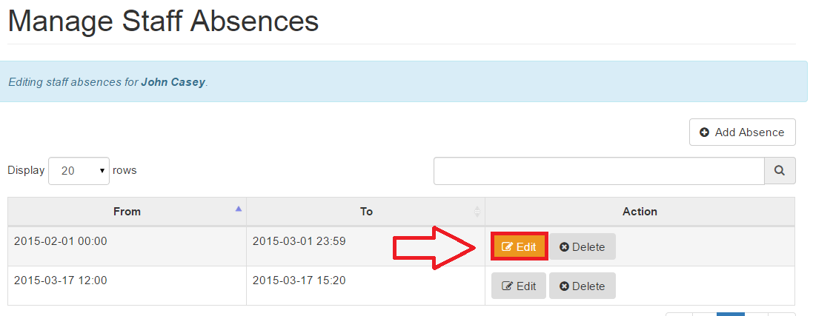Figure 119: Edit Staff Absences

On clicking the Edit button, you can see a new form drop down which allows you to change the dates of the staff’s absences. (Figure 120).
In the figure below, the absence has been extended from March to April.

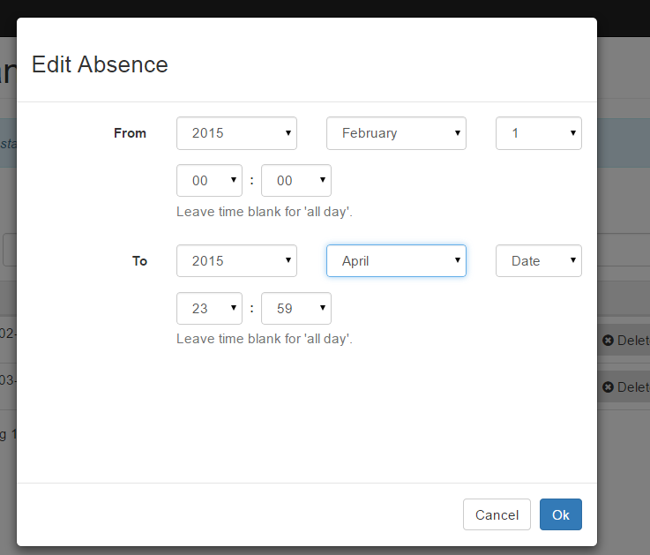
Figure 120: Edit Absence Form

You can see that there’s a blue box with the name of the staff member we’re editing the absence for. After making the changes, you can click on the Ok button and the changes made would be immediately updated in the Staff Absences page (Figure 121). Clicking Cancel would take you a step back to the list of staff members on the Staff Absences page.

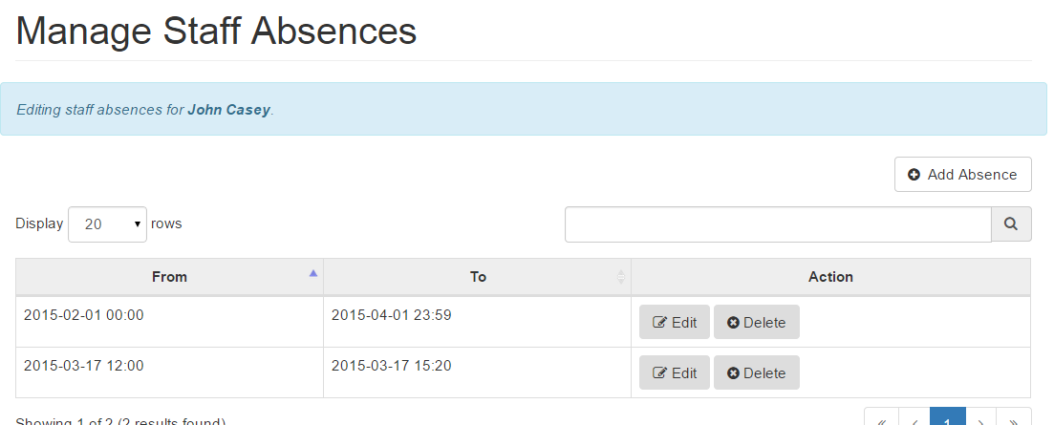Figure 121: Changes shown in the table

7.4.4 Deleting Staff Absence

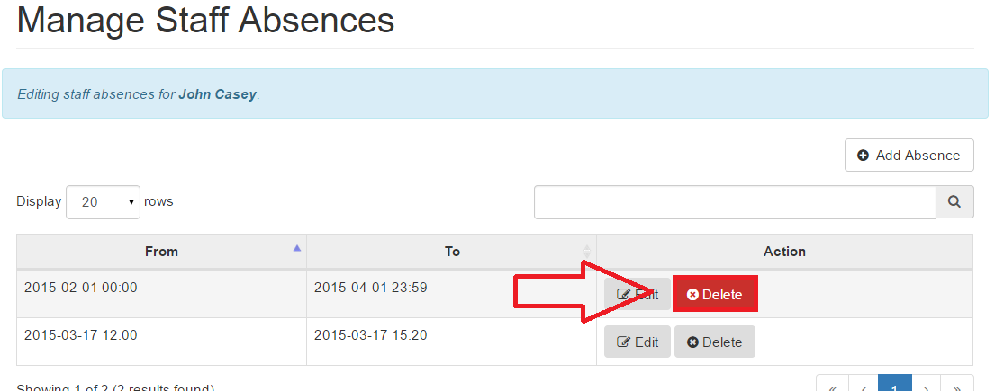
It is possible to delete a staff absence just by simply clicking on the Delete button which is placed right next to the Edit button (Figure 122)
Figure 122: Delete Staff Absences

By clicking on the Delete button, you will be asked again if you would definitely like to delete the absence (Figure 123)

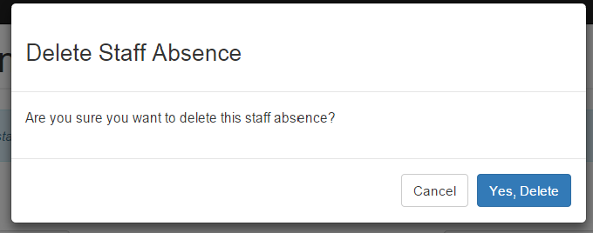
Figure 123: Delete Staff Absence Modal

If you click on the Yes, Delete button, the absence would be permanently deleted from the table as shown in Figure 124. Clicking Cancel would take you a step back to the Staff Absences page.

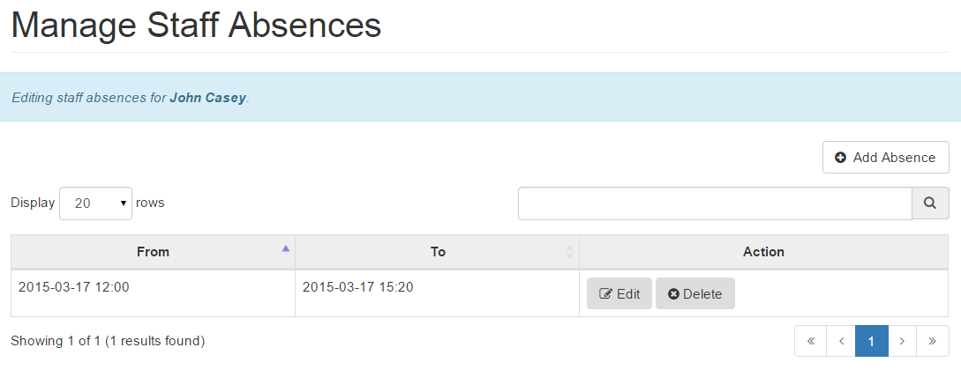Figure 124: Staff Absence Deleted

7.3.5 Error Section for Staff Absence

Error: You did not enter the ‘from’ date in YYYY-MM-DD format
Ensure that you have entered the ‘from’ date in the YYYY-MM-DD format. An example of that format would be 1993-03-07 (1993 - Year; 03 - Month; 07 - Date)

Error: You did not enter the ‘from’ date in YYYY-MM-DD format
Ensure that you have entered the ‘to’ date in the YYYY-MM-DD format. An example of that format would be 1993-03-07 (1993 - Year; 03 - Month; 07 - Date)

Error: The ‘from’ date cannot be after the ‘end’ date.
Ensure that the ‘from’ date you have entered is NOT after the ‘end’ date.

7.5 Action Logs

The Action Log page contains a log of all user activity including their navigation history, any errors they face, any instances of unauthorised access and any entries they make in the system (i.e. making a booking, adding a patient etc) (Figure 125).

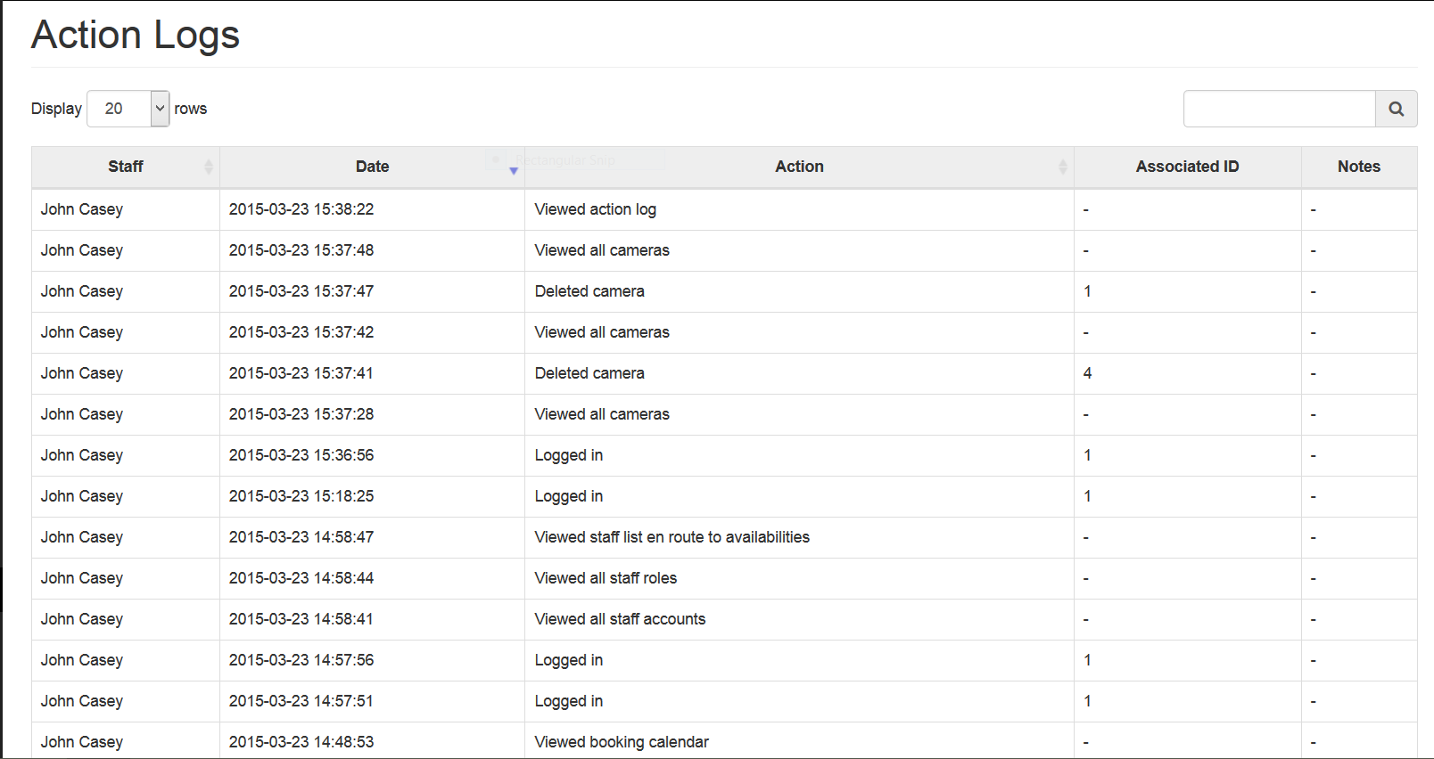
Figure 125: Viewing the action log

- The Staff column in the table represents the user who executed the action. In some cases this may be empty (“-”) in cases when the user who tried to perform the action wasn’t logged in. For example, when a staff member attempted to log in to the application with the wrong username, the Staff column for this particular action will show a “-”.
- The Date column shows the date and time at which the action was performed.
- The Action column represents a description of the action that was performed.
- The Associated ID column shows the ID of the object, on which an action is performed. For example, if we delete a Camera that has an ID of 4, then the associated ID for this action will be 4. There will be a “-” shown in the column in case the action is not performed on any particular ID, e.g. when viewing the booking calendar.
- The Notes column will show the notes for a particular action. For example, when a user tries to log in with a username that doesn’t exist - this will be recorded as a note in the Notes column. The action notes are usually used when an action failed to complete.

TIP Logs that represent an error because they failed to complete will be highlighted in
red. This will occur in instances such as unauthorised access attempts.

