

**SCHOOL OF COMPUTER SCIENCE AND INFORMATION TECHNOLOGY**

**DEPARTMENT OF INFORMATION TECHNOLOGY**

**PROJECT TITLE:** ELECTRONIC EDUCATIONAL BURSARY FUND MANAGEMENT SYSTEM

**NAME: CHACHA MOSES SASI**

**REGISTRATION NUMBER: C027-01-0186/2016**

**Submitted in partial fulfillment of the requirements of the Bachelor of Business Information Technology (BSc. BIT)**

**MONTH OF SUBMISSION: SEPTEMBER 2019**

# Declaration

I declare that this work has not been previously submitted and approved for the award of a  
degree by this or any other University. To the best of my knowledge and belief, this proposal  
contains no material previously published or written by another person except where due  
reference is made in the proposal itself.

**Student**

CHACHA MOSES SASI  
  
Signature: ……………………………………………………………………………

Date: …………………………………………………………………………………

**Supervisor**

James Iraya

Signature: ……………………………………………………………………………

Date: …………………………………………………………………………………

# ABSTRACT

Bursary fund is one of the most popular sources of financial help to most of the needy students in Kenya today. Because most of the families are unable of providing all basic needs to their family. Various bursary officials are working to enhance transparency and inclusiveness for good governance of bursary funds. This has risen the need to put these services online for timely delivering of information to many people because of the big number of people on social media.

Following keenly the current bursary application process, there are a series of processes that are involved that requires traveling from place to place in search of documents and delivering of the application forms to required bursary provider. Sometime the information never reaches the intended people when the commencement of application window and disconnect between bursary officials and the applicants. In order to solve this problem, there is need to create an online platform containing all bursary providers to ease delivery of information.

In order to deliver a good platform, I will use Incremental Development Methodology used to develop the mobile and web-based application using Android studio and visual studio code and Php. The application will contain features that will capture applicant’s data, Email updates for applicants at the inception of the application window, after application, and during disbursements process. The application also enabled the applicants to obtain application forms easily during the application window.

Contents

Declaration 2

ABSTRACT 3

CHAPTER ONE 6

1.1 BACKGROUND INFORMATION 6

1.2 PROBLEM STATEMENT 7

1.3 OBJECTIVES 7

1.3.1 General Objectives 7

1.3.2 Specific Objectives 7

1.4 PROBLEM SCOPE 8

1.5 PROJECT LIMITATION 8

CHAPTER TWO: LITERATURE REVIEW 9

2.0 INTRODUCTION 9

2.1.1 E-GOVERNMENT SERVICES 9

2.1.2 E-Citizen Services 10

2.1.3 E-Business services 10

2.1.4 E-Learning 10

2.2 SUMMARY 11

CHAPTER THREE 12

3.0 INTRODUCTION 12

3.1 System Development and Methodology 12

3.2 Data Collection Methods 13

3.2.1 Primary data collection methods 13

3.2.2 Secondary data collection methods 13

3.3 Implementation 13

CHAPTER FOUR: SYSTEM ANALYSIS AND DESIGN 14

4.0 Introduction 14

4.1 Requirement Analysis 14

4.1.1 Functional Requirements 14

4.1.2 Non-Functional Requirements 14

4.2 Hardware and Software Requirements 14

4.2.1 Software Requirements 14

4.2.2 Hardware Requirements 15

4.3 Economic Requirements 15

4.4 Security Requirements 15

4.5 System Analysis 15

4.5.1 Use Case Diagram 15

4.5.2 Activity Diagram 17

4.5.3 Context Diagram 18

4.5.4 Data Flow Diagram 18

4.5.5 ERD Diagram 20

System requirement analysis 21

CONCLUSIONS 23

CHAPTER FIVE: IMPLEMENTATION, DEPLOYMENT AND CHALLENGES 24

5.1 Introduction 24

5.2 Test Cases 24

5.2.1 Test Case 1: 25

5.2.2 Test Case 2: 25

5.2.3 Test case 3: 25

5.4 Appendices 25

5.4.1 Budget 25

5.4.2 Time Schedule 26

5.5 References 26

LIST OF FIGURES

Figure 1 Incremental system model methodology 12

Figure 2: Use case 16

Figure 3:Activity diagram 17

Figure 4: Context diagram 18

Figure 5: Level 0 DFD 19

Figure 6: Level 1 DFD 20

Figure 7: ERD diagram 20

Figure 8: System requirement analysis table 21

Figure 9: Pie chart 22

Figure 10: Bar chart 22

Figure 11: Line chart 23

Figure 12: Test step 24

Figure 13: Budget 25

Figure 14: Gantt charts 26

# CHAPTER ONE

## 1.1 BACKGROUND INFORMATION

There are various educational bursary funds available in our country Kenya today, they include the following; CDF bursary, Governor bursary, county representative bursary, Helb bursary and banks who grant educational bursary fund to enable financially challenged students to continue with their education. These funds are created by the various institutions with the main objective of addressing poverty at grassroots level and the reduction of poverty.

Following keenly on how bursaries are issued, I found it to be complicated with a number of processes and activities which are also costly and at times also there is communication burrier between bursary provider and applicants. With this problem in mind, I saw the need to develop a platform to harmonize the current situation which will also have a timely information delivery to applicants.

Likewise, the Government has been working hard to cultivate an image of transparency and inclusiveness for good governance in Kenya by implementing E-Governance services and hence creating better relations between citizens and those in power. ICT has been exploited in this relationship to help transform the accessibility, quality and cost-effectiveness of public services.

Introduction of web-based Internet applications and other information technologies combined with processes that implement these technologies to enhance access to and delivery of Government information and other bursary providers services to the public, other agencies and other Government entities have been put in place in the recent past. For example; electronic filing systems, documents exchange systems, procurement (IFMIS), declaration and application systems, and other tools have now been introduced in various Government departments towards EGovernance. E.g. Ministry of Information, Finance, Tourism, Devolution among others have put up websites that contain information about the economy, culture, rules of business, tenders, draft bills. The current Government has put up e-service portals such as E-Citizen where citizens can easily apply for legal documents.

Nevertheless, there are increasing concerns about the utilization of CDF fund, governor, county representative, Helb and banks which suggest that the funds are not being optimized.

There is an exponential need for faster, accurate and timely information dissemination mechanisms in delivering Government and bursary fund to the people. This has escalated the need for real time information with people turning attention to social media such as Twitter, Facebook and personal blogs as a means of obtaining faster feedback.

However, for other kinds of information, it is difficult to keep track of the huge data generated from social media as this information’s validity expires so fast. For instance, most people with the need to apply for CDF Funds may not necessarily be on social media. This means that issues such as timely information dissemination on the applications, application deadline alerts and application status alerts may arise.

The web has been an exemplary tool in information dissemination given the large masses of people who browse through to find information each minute. Of this, a very large number of people; approximately 25.5 million users use their mobile phones to access the Internet hence making mobile web applications an integral part of mobile sage.

## 1.2 PROBLEM STATEMENT

Access to information about Bursary Fund application is not easy. Additionally, the actual application process is long, tedious and sometimes complicated. For example, when applying for bursary funds, one has to acquire the forms at the, i.e. CDF office in their constituency of registration, fill it in and then return it to the office for official evaluation. Filling in the forms follows a long procedure of traveling outside residential counties to obtain the forms in the registered counties and institutions for signing and to have them stamped.

If the participants or signatories required live far apart, one has to make trips which might incur a considerable cost in both time and money resources. Often, the traveling meets challenges such as delay at the CDF offices, deadline for receiving the applications has already passed or the forms have all been issued out. For constituencies within Nairobi County, the process of bursary applications is fuzzy. All one needs is voter’s registration, identification card and legal stamps from the county administration. For this case there is no way to prove the legitimacy and relationship between the bearer of the voter’s card and the applicant. People end up making applications in more than one constituency. What this means, another person is deprived of the opportunity to benefit from the program.

After disbursement of the funds, one has to keep calling the CDF officials or physically walk to the CDF premises to be updated on the progress of the application and when disbursements shall be made. In some cases, officials may be rude and unwilling to tackle such kinds of queries a situation that users have to put up with every time they make an application. In addition, the CDF officials do not maintain historical data for the student beneficiaries to gauge the impact of the fund.

## 1.3 OBJECTIVES

### 1.3.1 General Objectives

This work is aimed to develop an application that will provide a platform with bursary providers to ease applications done by applicants and provide a timely update to successive applications and Keep the history of bursary beneficiaries.

### 1.3.2 Specific Objectives

1) Allow applicant to fill in the required information.

2) Termination of form submission when the amount of funds needed is complete.

3) Processing the application forms.

4) To integrate all the education aid fund providers in one platform.

5) Notification on successful applicants.

## 1.4 PROBLEM SCOPE

The research and application of this problem will be carried out in consideration of the five educational bursary fund providers.

## 1.5 PROJECT LIMITATION

This implementation of the project will be only limited to CDF, governor, county representative, Helb and bank, having in mind that there are several bursary fund providers.

# CHAPTER TWO: LITERATURE REVIEW

## 2.0 INTRODUCTION

2.1 Overview and Analysis of Related Systems

### 2.1.1 E-GOVERNMENT SERVICES

The adoption of e-government has brought about changes in many aspects of individuals' day to day lives around the world. This transformation has to a great extent altered the way governments around the world communicate with their citizens, organizations, agencies, workers and other various stakeholders. Changes from manual handling of information to electronic storage and access advancement have stimulated the adoption of electronic government or e-government. The insurgency in e-government has raised the attention among nations with emphasis on comprehension of the key advantages to the clients.

E-government strategy is an emerging application area in the IT domain. One essential advantage of utilizing E-government services is to get data about new business opportunities online. In the event that business organizations and governments are mindful of the present status of e-government adoption, organization performance and appropriate strategies can be utilized to decrease a percentage of the inherent barriers. Further, an understanding of the kind of technology that supports the use of e-government technique can provide input to enable more business firms access government services online.

As of now, most governments exchange information and services with citizens, business organizations, and across different arms of government to form a favorable environment inside their nations. The move from traditional government services to E-government services gives better public services and quality of life. It permits the users of government services to perform their business transactions with government agencies electronically, at any time and location of their choice. This has numerous favorable circumstances for the citizens of any nation, for example, giving simple access to data, convenient services, quick response to requests, and quick conveyance of services, enhanced information security and data privacy. E-government as a procedure is used to help individuals take advantage from data innovation. E-government has enhanced the way services are introduced to the citizens.

Change has been observed in governments and other autonomous public policy organs who have understood the significance of e-government strategy as a vital tool for responsive administration. Generally, many governments have been utilizing study-and-file approaches in dealing with their business organizations which has proved to be disadvantageous in the extent to which accountability is considered. Due to the changing landscape where the larger part of governments' interface with the public users, organizations and private bodies occur at the local level, it is critical that necessary attention be given towards putting up procedures that permit consultative and participatory administration. The ideal model transformation in the transformation of government has been achieved partly by the fast execution of e-government procedures that can possibly change the way services are delivered to the public by public institutions.

### 2.1.2 E-Citizen Services

The e-Citizen is a portal for citizens to access information and services provided by the Kenyan government (https://www.ecitizen.go.ke/). The services offered include business name search and registration, notice of marriage, registration of marriage, driving licenses, land searches and clearances, passport and visa applications. The system allows citizens to sign up, apply for government services and conveniently pay using mobile money, credit/debit cards and online banking from local banks. Users receive email and SMS notification every time their application has progressed.

### 2.1.3 E-Business services

This is the buying and selling of goods and services on the Internet. Other than buying and selling, many people use Internet as a source of information to compare prices or look at the latest products on offer before making a purchase online or at a traditional store. EBusiness is sometimes used as another term for the same process. More often, though, it is used to define a broader process of how the Internet is changing the way companies do business, of the way they relate to their customers and suppliers, and of the way they think about such functions as marketing and logistics. For this purpose, e-commerce is taken to mean doing business electronically.

### 2.1.4 E-Learning

E–learning is defined as acquisition of knowledge and skill using electronic technologies such as computer and Internet-based courseware at local and wide area networks. Technology-based e-learning encompasses the use of the internet and other important technologies to produce materials for learning and teaching in organization. As a result, Internet and Information technology in tutoring and studying has created a different necessity to modify how university students learn by using more modern, effective, and alternative such as e-learning system.

With the developing of computer and Internet technologies, this technology has a high interaction and collaboration level between instructors or lectures and peers than traditional environment for learning. Hence, e-learning system might be able to deliver a broad array of solutions to enable learning and improve students’ performance.

There are three ways of classifying the models of e-learning. The first one is called synchronous, the second one is asynchronous and the third one is blended learning.

**Synchronous training (at the same time):** Intrinsically synchronous training involves the collaboration of participants with E-mentor via the virtual platform in real time. In other words, synchronous training provides facilities to the participations to discuss with the mentor and also among themselves via the e-classroom with the use/help of tools such as the videoconference and/or chat rooms.

**Asynchronous (not at the same time):** The asynchronous mode gives the opportunity to the participations to discuss with the instructors or teachers/mentor as well as among themselves over the internet on his/her own pace without live interaction with the instructor. In this way students are able to learn at a time that suits them the most. However, immediate feedback from instructors, their colleague learners is not receivable.

**Blended learning (the mix of synchronous and asynchronous learning):** This kind of training combine aspects of online and face-to-face instruction, so the course materials and explanations is shared between traditional learning method and e-learning method in the classroom setting. Blended learning allows for personalized education as a result student can work at their own pace, making sure they have mastered the curriculum before moving on.

Using e-learning at university classrooms give to instructors the multiplicity of their lectures, displaying more information, and enhancing student learning. Also, e-learning system can helps lecturers to save time and allow for more attention to be paid to the content of course.

With e-learning system students don’t have to come to class in person and feel uncomfortable answering their teacher’s questions in class. Therefore, students can study at home, work or even on the street by using multi-electronic devices as computers, laptops, or smart phones. As follows, students can easily read or download the materials or reference books online when and wherever they want.

There are numbers of advantages for using this technology and learning materials in the university classroom:

1. More active learning class

2. Diversified teaching method

3. Better student attention and realization

4. Effective time management for lecturers

5. Visual stimulation

The major advantage of e-learning lies in its flexibility and ability to cover distances. The curriculum can be repeated until it is understood by the trainee. Hence full time and part time undergraduates can take part in their degree courses selected from any place or location so students can gain multiple learning ways depending on their needs.

## 2.2 SUMMARY

From the case studied above, they majorly focus on the online platforms which bridge the gap between various service providers and the public and ensures timely delivery of information. They also reduce the expenses of travelling to get documents i.e. government offices. It also ensures timely update to the public.

# CHAPTER THREE

## 3.0 INTRODUCTION

This section outlines the different methodologies that will be used in developing the system. It will give detail description of the software design methodologies used, data collection methods used, the plan and implementation and the programming languages to be used in development of the proposed system.

It also gives rationale behind the choice of the development process and the technologies.

## 3.1 System Development and Methodology

The proposed system will be developed using incremental development methodology. The idea is to develop the fundamental functionalities of the system first, present the system to the users, then add the other less crucial functionalities incrementally until the system is fully functional as per the specific objectives. This model combines some approaches of waterfall merged with prototyping methodology to come up with a superior hybrid.

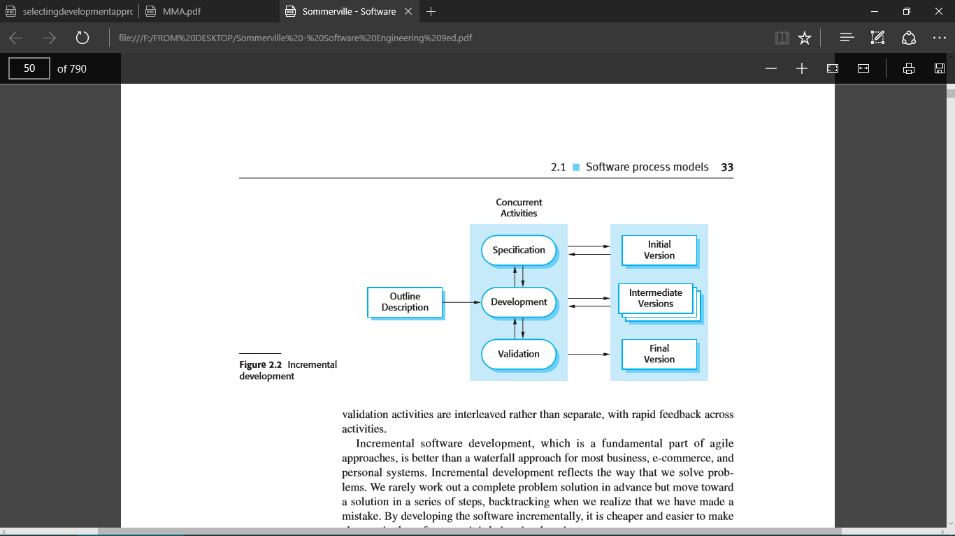

Figure 1 Incremental system model methodology

This approach would be appropriate because, there is a need to build the most important modules of the system first, and then add the rest later as the system stabilizes. The decision to use incremental rather than waterfall or solely prototyping was arrived at, first and foremost, after considering the following advantages among others: -

1. There would be need to exploit knowledge gained in development of early in increments as later increments are being developed.
2. Users will be allowed to test the system at various stages of increments to make sure that it meets the requirements up to that far.
3. It will allow delivery of a series of implementations that are gradually more complete and can go into production more quickly as incremental releases.
4. Gradual implementation would provide the ability to monitor the effect of incremental changes, isolate issues and make adjustments before users change over to the proposed system.

This would make sure that testing is done after every iteration (incremental release). This would mean that identifying bugs and developing of test cases and scenarios would be easier for this system, given its complexity.

## 3.2 Data Collection Methods

Data will be collected from both secondary and primary sources of data

### 3.2.1 Primary data collection methods

Questionnaires

A questionnaire is a set of questions for gathering information from individuals. Open questionnaires were administered electronically by email to the bursary providers.

Structured Interviews

This is a quantitative research method which aims at ensuring that each interview is presented with exactly same questions and in the same order.

Structured interviews were conducted to various bursary applicants on the challenges they face during bursary application.

Observation

This method involves gathering of primary data by investigator’s own direct observation of relevant people, actions and situations without asking from the respondent. It has been observed that many counties and bursary providers don’t have online platform for bursary application.

### 3.2.2 Secondary data collection methods

Some data was collected from articles, documents, journals and online articles

## 3.3 Implementation

The Mobile application will be developed using Android studio platform.

The database technology to be used is FIREBASE database and JSON application server. Database transactions will be implemented using Structured Query Language.

# CHAPTER FOUR: SYSTEM ANALYSIS AND DESIGN

## 4.0 Introduction

This chapter gives details on the analysis and design of the E-bursary system. System requirements and design are discussed. The system requirements provide the functional and Non-functional requirements of the System. Design of the system is carried out according to the features and operations of the system which includes the user interface, database schemas, code and other documentation. Designing of the system mainly focuses on the user and ensures the System will be user friendly and interactive.

## 4.1 Requirement Analysis

### 4.1.1 Functional Requirements

The application should be able to perform the following functions:

1. User account registration.
2. User can be able to apply bursaries that are on offer.
3. User can check the successful bursary applications.
4. User can update his/her documents on the applications window.
5. User can search all bursaries applied.
6. Admin can update the opening of application window.

### 4.1.2 Non-Functional Requirements

1. Ease to use: The application is easy to use by all type of users.
2. Understandable: The System is easy to understand by new users as it contains very user-friendly interfaces.
3. Availability: The System works 24 hours a day making it convenient for users to access it at any time.
4. Security: The System enhances data authentication by use of passwords to protect it from unauthorized users.
5. Confidentiality: The System ensures confidentiality of users’ information.
6. Reliability: Minimum meantime to failure, low probability of unavailability and rate of failure occurrence, it should be available at all times.

## 4.2 Hardware and Software Requirements

The proposed application will we be mobile application.

### 4.2.1 Software Requirements

This mobile application requires:

1. Android Studio
2. Firebase
3. Git repository.
4. Microsoft office 2016 and above used in documentation and slide presentation for purpose of presentation.
5. Windows OS- important as it was the platform for the software to run on.
6. Antivirus-to help protect files against external attacks and malware.
7. Web browser- for access web contents important for research in application development.

### 4.2.2 Hardware Requirements

1. Minimum of 80 GB external hard disk.
2. Power supply.
3. Modem/internet connection.
4. Laptop.

## 4.3 Economic Requirements

If the proposed System will be implemented, one will need an internet-enabled device to enable online storage of data and bursary applications.

## 4.4 Security Requirements

Security and control over the data is necessary in creating an application. This is to minimize the threat of unauthorized access.

## 4.5 System Analysis

In this phase, one does the analysis of the data that was collected in the previous phase and put it in a way that it’s easier to automate, best done by a diagrammatical representation of the information. For this project we will use the UML modelling language because it’s a visual language that assists one to analyze and design Systems.

### 4.5.1 Use Case Diagram

The diagram shows the actors and the use cases and the relationship between the two. It is a diagrammatical representation of how the Admin and Students will interact with the System in order to make the application efficient, reliable, and affordable.

**Actors**Below is a list of actors who will interact with the system:

**Admin** – this is a person who is in charge of managing all web portal content  
including updating disbursement data.

**User** – a user is a person who has the access to make applications and query for their  
status updates.

Use case diagram

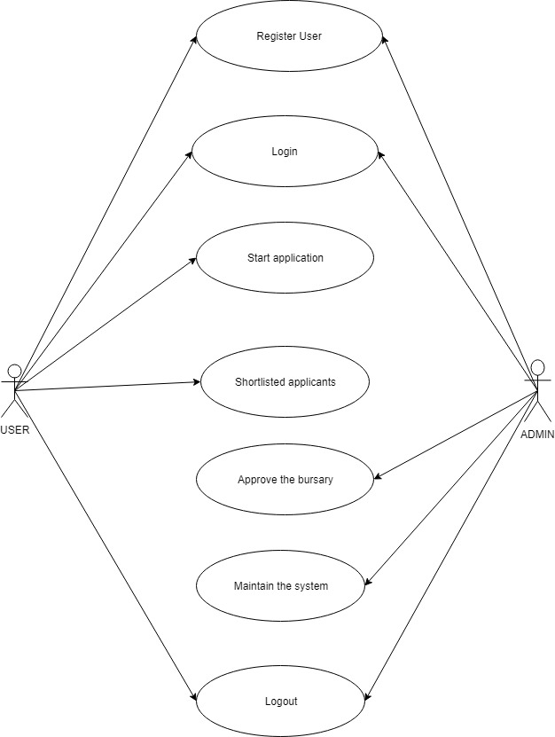

Figure 2: Use case

### 4.5.2 Activity Diagram

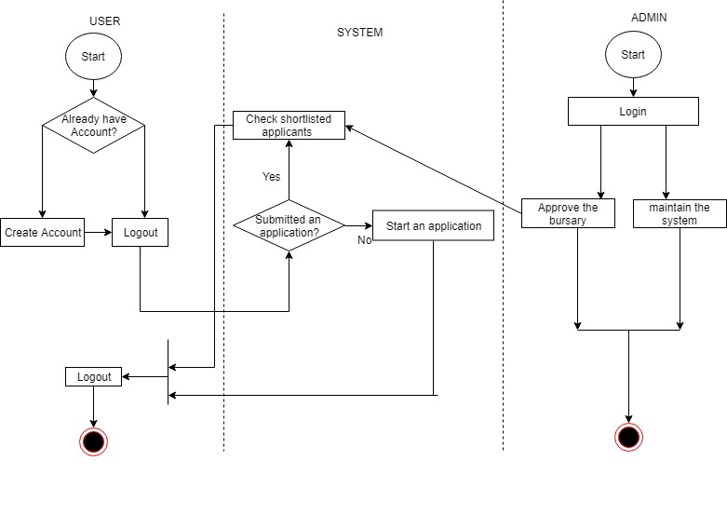

Figure 3:Activity diagram

From the figure above, a user can create an account or login. Once they have access to the system, they can submit an application if they haven’t submitted one or check the status of their application. On the other hand, the bursary official will login into the system and update  
content and the disbursements allocated to a user.

### 4.5.3 Context Diagram

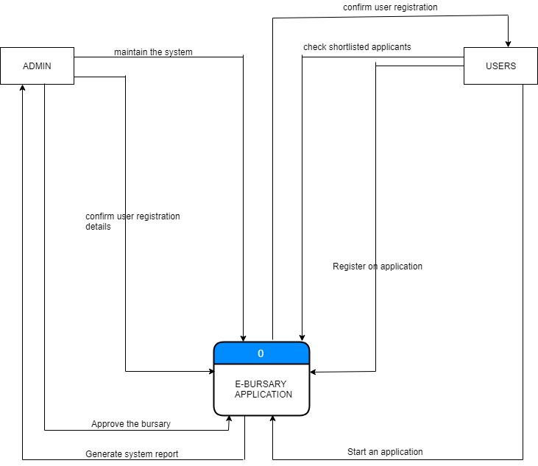

Figure 4: Context diagram

### 4.5.4 Data Flow Diagram

This is a graphical representation of the flow of data through an information System. I will use a data flow diagram to visualize on data processing in my proposed project. Further, I will use it to develop a conceptual picture of the interaction between the System and outside entities.

Level 0 DFD

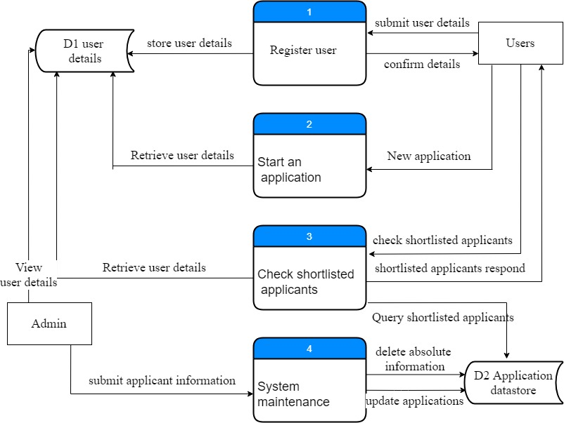

Figure 5: Level 0 DFD

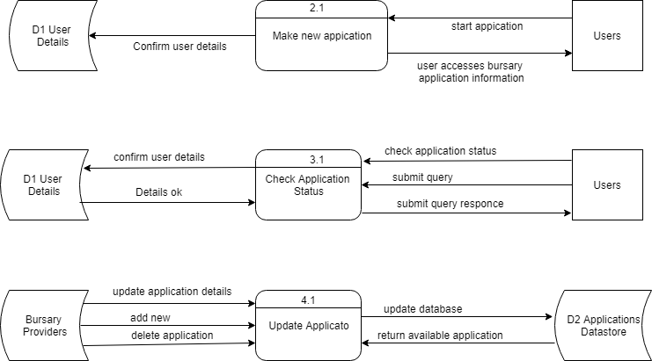

Figure 6: Level 1 DFD

### 4.5.5 ERD Diagram

An ERD diagram showed the relationships of entity sets stored in the database.

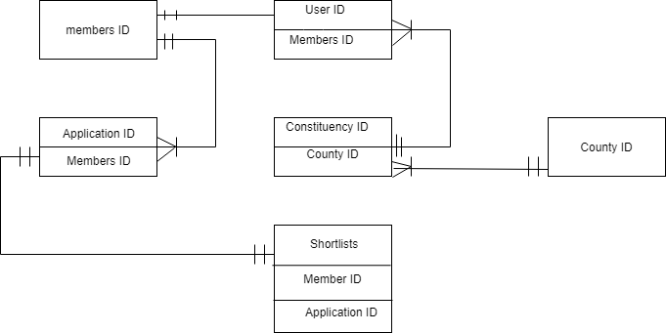

Figure 7: ERD diagram

From the figure shown above, a student can only make one application or check status for one application at a time. However, bursary officials may update several applications on the portal. Also, in a county, we can have several constituencies which can have the same application material.

## System requirement analysis

The techniques used in seeking respondents’ answers is a printed questionnaire and, in some cases, direct talks with the beneficiaries of the bursary fund.

|  |  |  |  |
| --- | --- | --- | --- |
| Number of respondents | Satisfied respondents | Not satisfied | Not aware |
| 20 | 17 | 1 | 2 |

Figure 8: System requirement analysis table

Percentage of the bursary beneficiaries who were satisfied with the E-Bursary application = 17/10*100=85%

Percentage of the bursary beneficiaries who were not satisfied with the E-Bursary application =/20*100=5%

Percentage of the bursary beneficiaries who were not aware about the bursary application process=2/20*100=10%

Below are the graphical interfaces to clearly indicate the results received from the questionnaires: -

Figure 9: Pie chart

We can clearly conclude that majority of the respondents liked the application.

Figure 10: Bar chart

Figure 11: Line chart

We can clearly conclude that majority of the respondents liked the application. From the bar, pie and line chart analysis above, it was clear that most people were satisfied with the E-Bursary application being introduced.

## CONCLUSIONS

The responses received were positive in determining if building the application was a viable idea. It also helped understand the challenges facing the current system where forms are issued on the basis of nepotism.

# CHAPTER FIVE: IMPLEMENTATION, DEPLOYMENT AND CHALLENGES

## 5.1 Introduction

As a dual function, software testing is used to ascertain the defects in program and it is used to assist in judging whether a program is usable in practice or not. With this regard, software testing is used for validation and the verification which in turn ensure that the software conforms to its specification and meets the user needs.

There are various types of testing that have been used in testing the developed system.

test step

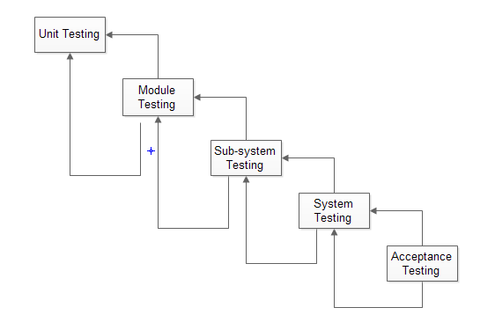

Figure 12: Test step

**Unit testing**: the unit testing warrants that each component works independently of one another, that is, as a single unit. This includes ensuring a successful user log in for authorized uses, entering the property details as well as modifying them

**Integration Testing**: This testing is paramount in meeting the systems functionality objectives. In this testing, once a person applies a bursary or any other user is registered into the system, his or her details are reflected in the database instantaneously.

**System Testing**: This was done after integrating developed modules and running part of the developed system to verify if it meets the functional and non-functional requirements.

**Acceptance Testing**: This is done prior to deploying the system to a live environment. It is done using specified inputs into the system and verifies that the resulting outputs are correct, without knowing the internal workings of the system.

5.2 Test Cases During the system development, tests were carried out to determine the workability of the system. Some of these tests include:

5.2.1 Test Case 1: User Registration and Login For the registration, the inputs include: the username which is to be viewed in the profile details of the registered user, email and also the password, which later are used to authenticate the user during any login attempts made.

Expected results: after a successful registration or login attempt, the home page of the application is loaded, which then showcases various bursary being issued by various bursary officials. Otherwise, if the registration or login attempt fails, an alert is displayed alerting the user if the account exist or to do correct application, and thus will not proceed to the homepage.

Status: Test passed.

5.2.2 Test Case 2: Applying new bursary

Procedure: the user clicks the menu tabs at the upper left-hand side of the home page window, this will display various activities hence he will select apply new bursary of which it will display a field where the user will input personal information and submit which will directly reflect to the database.

Status: Test passed.

5.2.3 Test case 3: Checking applications made

Procedure: after submitting the application for upon completion of filling in the required information, the user will click the back button which will take him to the home page and then click the tabs on the upper left corner which will display various activities and he will select my application for him to check the submitted application.

## 5.4 Appendices

### 5.4.1 Budget

Table 1 budget

|  |  |
| --- | --- |
| **Resources** | **Cost Estimation in KSH** |
| Personal Computer | 40,000.00 |
| Visual studio code | 0.00 |
| Ionic framework | 0.00 |
| Stationery | 500.00 |
| Internet Connection | 3,000.00 |
| Power | 500.00 |
| **Total in KSH** | 44,000.00 |

Figure 13: Budget

### 5.4.2 Time Schedule

|  |  |  |  |  |  |  |  |  |
| --- | --- | --- | --- | --- | --- | --- | --- | --- |
| DURATION | May | June | July | August | September | October | November | December |
| TASK |
| FEASIBILITY STUDY |  |  |  |  |  |  |  |  |
| REQUIREMENTS  IDENTIFICATION |  |  |  |  |  |  |  |  |
| RESEARCH |  |  |  |  |  |  |  |  |
| REQUIREMENTS  ANALYSIS |  |  |  |  |  |  |  |  |
| DESIGN |  |  |  |  |  |  |  |  |
| DEVELOPMENT AND CODING |  |  |  |  |  |  |  |  |

Table 2 Gantt chart

Figure 14: Gantt chartS

## 5.5 References

1.http://www.icta.go.ke The Kenya ICT Authority. Retrieved July, 2, 2015.

2.http://www.businesslicense.or.ke/index.php/news/article/id/9 The Republic of Kenya

3.Business Licensing Portal. Retrieved July, 12, 2015.

4.Clayton, T. et al (2002). Electronic Commerce and Business Change.

5. Óbuda University, Keleti Faculty of Business and Management [duongvan.tinh@kgk.uni-obuda.hu](mailto:duongvan.tinh@kgk.uni-obuda.hu).

6. Aggarwal, D.: Role of e-Learning in A Developing Country Like India. Bharati Vidyapeeth‘s Institute of Computer Applications and Management, New Delhi, India, 2009.