ReliefLink Surge Optimizer
Joint volunteer assignment during flood surges, solved with QAOA in Qiskit
Qiskit Fall Fest 2026 Hackathon | Domain: Disaster Response
Team: [add team member names]
Code: [GitHub link] | Video: [video link]

Summary
ReliefLink is a disaster-response platform we designed for Pakistan. It matches people who need help with nearby volunteers, much like ride-hailing. Right now it matches greedily: one request at a time, highest priority first, each taking its best free volunteer. That is fine when requests trickle in. In a flood surge, when several arrive together and skilled volunteers are scarce, it wastes them. In our test town, greedy sends Bilal, who is both a first-aider and a swimmer, to a medical call because he happens to be closest. A rescue request that sat queued offline for 40 minutes is then left with nobody who can swim.
We replace this step with a joint assignment of all volunteers to all waiting requests. Travel times follow a street network in which the flood has closed roads and a bridge. We write the problem as a QUBO, solve it with QAOA on Qiskit's statevector simulator, and check every answer against greedy, the Hungarian algorithm and brute force. On our 15-qubit instance (32,768 possible assignments), greedy reaches 75.3% of the best possible relief value and Hungarian reaches 87.3%. With CVaR training at depth 4, the single most frequent measurement from the quantum circuit is the exact optimum. QAOA does not beat brute force and we do not claim a speedup. What we show is a correct quantum formulation that does real work in the pipeline, measured honestly.

The problem and who it serves
Pakistan's floods cut roads, power and mobile networks at the same moment that requests for help spike. Our ReliefLink design (Technical Context v2) handles this with offline queues, SMS fallback and hazard-aware routing. Its matching engine, though, still looks at one request at a time. Section 8 of the spec ranks candidate volunteers for a single request and dispatches the top few. Our roadmap even lists multi-request optimisation as a feature deferred to later. This project builds that feature.
The people it serves are the coordinators at a district emergency cell or rescue service, who must decide in minutes which volunteer goes where, and through them the families who are waiting. When a surge arrives, the order in which requests happen to be processed should not decide who gets the only swimmer. Every request in the surge competes for the same small pool of volunteers, and inside a single trip there is a second trade-off: serving a second request on the way against keeping the first one fast.

Formulation

Inputs
A surge batch contains requests (type, urgency, vulnerable flag, number of people, minutes waited, location), on-duty volunteers (skills, transport mode, trust score, minutes since last seen, location), a road network, and confirmed flood polygons. Every scoring formula below is copied unchanged from ReliefLink Technical Context v2. The spec calls its weights starting values that have not been validated, and we carry that caveat.
Priority of request j (spec §7):
priority_{j} = type weight × urgency × vulnerability × (1 + log₂ people) × (1 + min(wait/30, 1))
Score of volunteer i for request j (spec §8, Stage 3):
score_{ij} = 0.40/(1 + ETA_{ij}) + 0.25·skill + 0.15·equipment + 0.15·trust − 0.05·workload − staleness
Travel time follows the roads, as in the spec's normal routing mode (§8, Stage 2). Every road segment that touches a confirmed flood polygon is closed. The ETA is the shortest open route divided by the spec's assumed flood speed for that transport mode (car 25 km/h, truck 20 km/h, bicycle 10 km/h, pedestrian 4 km/h). A closed bridge therefore means a longer detour (spec test T5), and a volunteer with no open route at all is excluded (T6).

Decision variables
One binary variable per usable volunteer–request pair: x_{ij} = 1 if volunteer i is sent to request j. Before the quantum step we remove pairs that cannot or should not be used, and every removed pair is a qubit saved:
- No open road. The flood leaves no route (T6).
- Missing skill. Medical calls need first aid and rescues need a swimmer. The spec leaves open whether this is a hard filter or only a score term (§19); we chose a hard filter.
- Too far. Road ETA above 45 minutes, our stand-in for the spec's search radius.
- Not in the top three. The spec only ever notifies a request's top 3 to 5 candidates (§8, Stage 4), so we keep each request's three best-scoring volunteers.

Objective and constraints
The reward for a pair is w_{ij} = priority_{j} × score_{ij}. We minimise the QUBO cost below. The relief value we report is its negative.
f(x) = − Σ_{a} w_{a} x_{a} + Σ_{a<b} Q_{ab} x_{a} x_{b}
The pairwise terms Q encode the rules:
- One lead per request. Two volunteers on the same request cost a penalty P (spec §6.2: exactly one assigned lead).
- Feasible trips only. One volunteer given two requests costs P, unless the two requests are at most 2 km apart along open roads.
- Chaining (our extension). If the trip is feasible, the volunteer serves the higher-priority request first. The second request's ETA becomes the first ETA plus the road leg between them, and workload rises to 1. The pair term is the value lost compared with two separate fresh volunteers. Road distances obey the triangle inequality, so this cost is never negative and chaining only wins when nobody better is free.
c_{i,jk} = w_{i,first} + w_{i,second} − [ p_{first}·score(ETA_{i,first}, 0) + p_{second}·score(ETA_{i,first} + ETA_{first→second}, 1) ]
We set P = 1.5 × the largest reward. This guarantees the lowest-cost bitstring never breaks a rule. Take any solution that breaks one and switch off one of the offending variables. That removes at most one reward, at most max w, and removes at least one penalty P. Since P is larger than max w, the cost drops, so a rule-breaking solution can never be the minimum.
Why not simply use the Hungarian algorithm? Without chaining, every pair term is a penalty and the problem is a linear assignment problem, which the Hungarian method (Kuhn, 1955) solves exactly in polynomial time. We include it as a baseline for exactly that reason. With chaining the objective has genuine quadratic terms that depend on which two requests share a volunteer. Hungarian cannot express those, while a QUBO represents them directly.

Test instance
Six requests and five volunteers sit at street corners of a 10 × 7 km town split by a nullah with three bridges. Requests R1–R4 are exactly requests A–D from the spec's worked priority table, and R5 is its late-delivery example F (priority 80.0), so five of the six priorities can be checked by hand. The flood polygon closes 18 road segments, including the GT Road bridge. Of the 30 possible pairs, 9 are removed for missing skills, 2 for distance and 4 for not being in a request's top three. That leaves 15 qubits. Usman, the stale truck driver, ends up with no pairs at all.
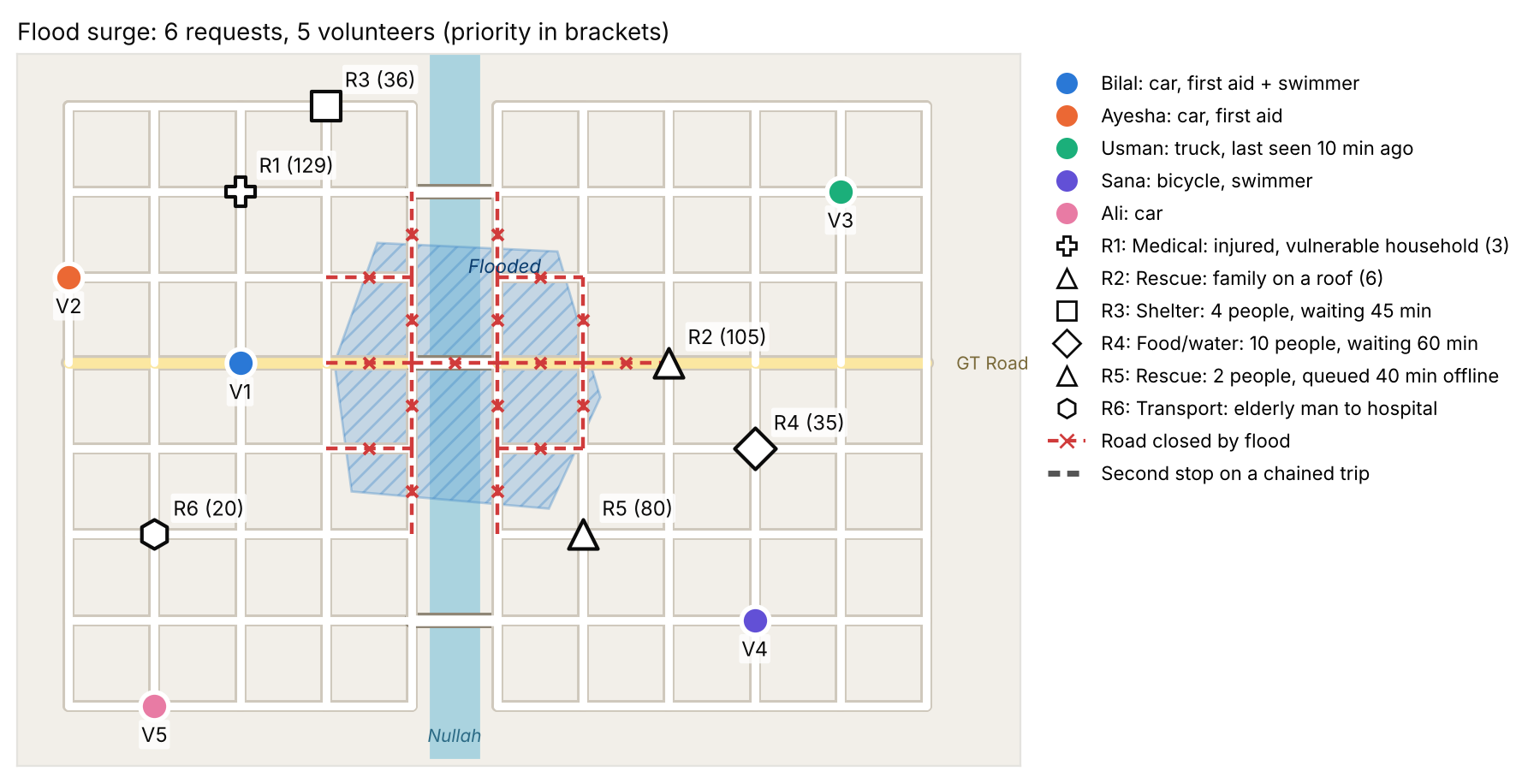
Figure 1. The flood-hit town. Red dashed segments are roads closed by the flood; numbers in brackets are request priorities.
ID | Request or volunteer | Priority
R1 | Medical: injured, vulnerable household (3) | 129.25
R2 | Rescue: family on a roof (6) | 104.56
R3 | Shelter: 4 people, waiting 45 min | 36.00
R4 | Food/water: 10 people, waiting 60 min | 34.58
R5 | Rescue: 2 people, queued 40 min offline | 80.00
R6 | Transport: elderly man to hospital | 20.25
V1 | Bilal: car, first aid + swimmer | –
V2 | Ayesha: car, first aid | –
V3 | Usman: truck, last seen 10 min ago | –
V4 | Sana: bicycle, swimmer | –
V5 | Ali: car | –

Variable | Road ETA (min) | Reward w
V1→R1 | 4.8 | 76.12
V1→R2 | 21.6 | 56.22
V1→R3 | 9.6 | 20.08
V1→R4 | 26.4 | 18.48
V1→R5 | 19.2 | 43.18
V1→R6 | 7.2 | 11.52
V2→R1 | 7.2 | 71.58
V2→R3 | 12.0 | 19.29
V2→R4 | 28.8 | 17.92
V2→R6 | 9.6 | 10.99
V4→R2 | 24.0 | 57.61
V4→R4 | 12.0 | 19.56
V4→R5 | 18.0 | 44.48
V5→R3 | 21.6 | 18.28
V5→R6 | 4.8 | 11.32

Why QAOA, and how the problem maps onto qubits
Our problem is already in QUBO form, and QAOA (Farhi, Goldstone and Gutmann, 2014) is the standard gate-model algorithm for exactly that form. Its circuit is built directly from the cost function, so the problem's structure lives in the gates rather than in a generic ansatz, and it runs in plain Qiskit. We considered the alternatives. A hardware-efficient VQE ansatz ignores the problem structure. Grover adaptive search needs deep oracle circuits. Quantum annealing is not gate-based, so it is outside a Qiskit gate-model build.

From QUBO to Ising
Substituting x_{a} = (1 − z_{a})/2 with z_{a} ∈ {+1, −1} turns the QUBO into an Ising Hamiltonian, which we build as a Qiskit SparsePauliOp:
H_{C} = Σ_{a} h_{a} Z_{a} + Σ_{a<b} J_{ab} Z_{a} Z_{b} + constant
Qubit a is variable a, and measuring |1⟩ means that volunteer is sent. Our tests check the mapping exactly: the Ising energy equals the QUBO cost on all 32,768 bitstrings, and the diagonal of Qiskit's operator matrix equals our cost table.

The circuit
The circuit starts from an equal superposition of all 32,768 assignments (a Hadamard on every qubit) and then applies p layers. Each layer is a cost step, RZ(2γh_{a}) on each qubit and RZZ(2γJ_{ab}) on each of the 37 coupled pairs, followed by a mixer step, RX(2β) on every qubit. At depth 4 the circuit has 148 RZZ gates and depth 136.
|γ, β⟩ = Π_{k} exp(−iβ_{k} Σ X) exp(−iγ_{k} H_{C}) |+⟩^{⊗n}
COBYLA tunes the 2p angles. Random starting angles worked at small sizes but not at fifteen qubits, so we grow the circuit one layer at a time. Depth 1 starts from the best point of a coarse 12 × 10 grid of angles, and each deeper circuit starts from the previous optimum stretched with the INTERP rule of Zhou et al. (2020).

Two training objectives
Standard QAOA minimises the expected energy ⟨H_{C}⟩, evaluated with Qiskit's StatevectorEstimator. CVaR-QAOA (Barkoutsos et al., 2020) minimises the average energy of only the best 10% of outcomes. Since we only ever act on the good samples, the circuit is rewarded for making good answers likely rather than for a good average. In both cases the final answer comes from 4,096 measured shots (StatevectorSampler), which we decode, check against the rules and rank by frequency.

Architecture
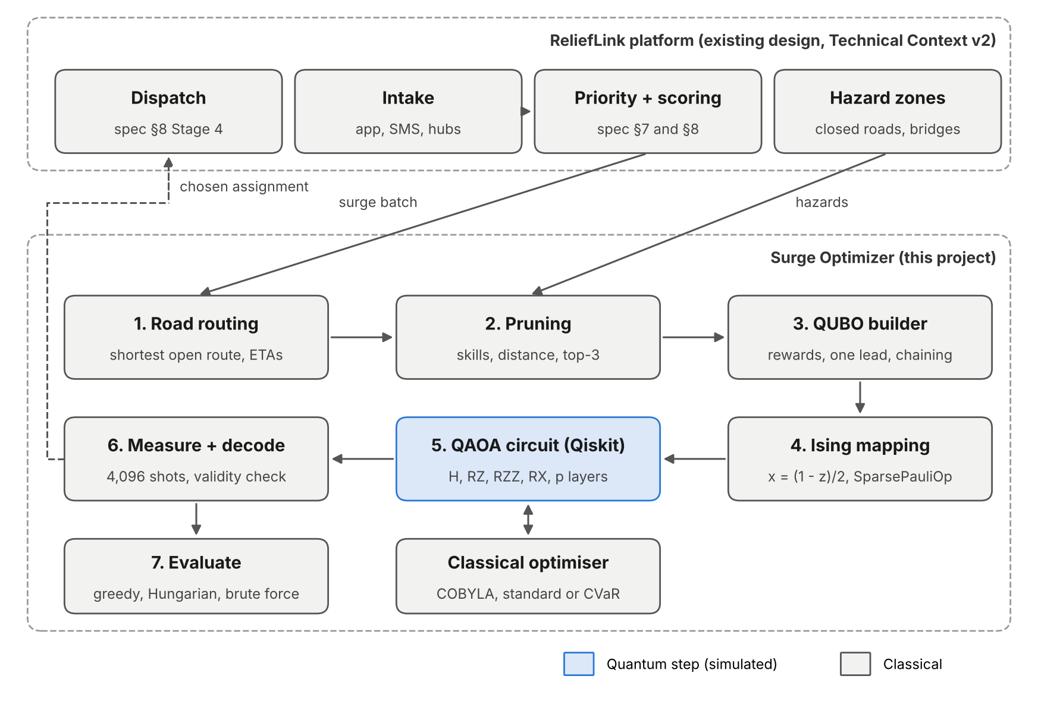
Figure 2. Where the Surge Optimizer sits inside ReliefLink. Only step 5 runs on the (simulated) quantum computer.
The optimiser plugs in between ReliefLink's scoring stage and its dispatch stage. When several requests are waiting at once, the batch, the volunteer pool, the road network and the current flood zones go to the optimiser, and its chosen assignment goes on to the existing dispatch pipeline. That pipeline still handles push and SMS notification and first-accept locking, so nothing else in the platform has to change.

Implementation
The code is a small Python package on Qiskit 2.x. spec.py holds the ReliefLink formulas, roads.py the street network and flood closures, model.py builds the QUBO and Ising forms, qaoa.py builds and trains the circuit, and baselines.py holds the classical methods. run_all.py reproduces every number and chart in this report in about six minutes on a laptop, with all randomness seeded. Eleven tests cover the spec's own worked examples (T1, T8 and T20 reproduce exactly), the flood detour (T5), the skill filter, and the correctness of the quantum mapping. A Streamlit page (app.py) draws the town map, runs each method and shows what the circuit measured. It also lets you switch the flood off to watch routes and travel times change. We wrote the circuit, QUBO, Ising conversion and road model ourselves from the published formulas; no tutorial code is reused.

Results

Comparison with classical and exact methods
Method | Assignment | Relief value | % of optimum
Greedy (ReliefLink today) | V1→R1, V2→R3, V4→R2, V5→R6 | 164.34 | 75.3%
Hungarian (one task each) | V1→R5, V2→R1, V4→R2, V5→R3 | 190.65 | 87.3%
QAOA, CVaR, p = 4 (most frequent valid) | V1→R5, V2→R1, V2→R3, V4→R2, V4→R4, V5→R6 | 218.32 | 100.0%
Exact (brute force over 32,768) | V1→R5, V2→R1, V2→R3, V4→R2, V4→R4, V5→R6 | 218.32 | 100.0%

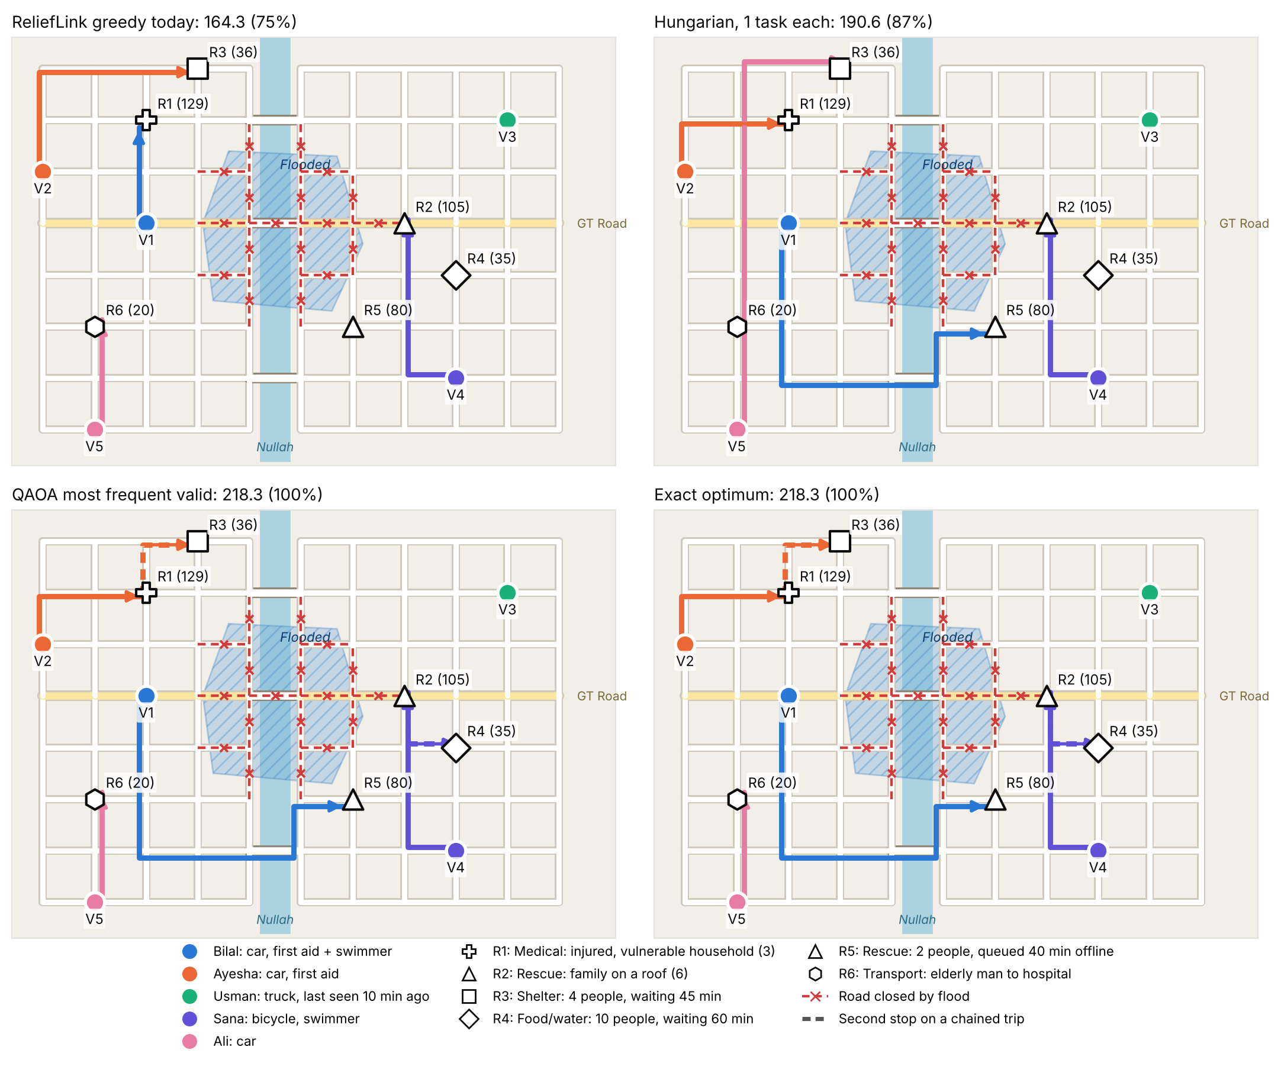
Figure 3. Who goes where under each method, routed along open roads. Dashed coloured segments are the second stop of a chained trip.
Greedy handles the medical call first and gives it Bilal, who is closest. Sana takes the rooftop rescue, and the second rescue (R5, queued offline for 40 minutes) has no swimmer left, so it goes unserved, and so does the food request. Hungarian fixes the swimmer problem by sending Ayesha to the medical call and Bilal across the southern bridge to R5, but with one task per volunteer it still leaves the food and transport requests without anyone. The exact optimum serves all six: Ayesha does the medical call and then the shelter around the corner, Sana does the rooftop rescue and then the food drop, Bilal takes R5 and Ali takes the transport request.

What the quantum circuit actually measured
QAOA run | P(valid) | P(exact optimum) | P(≥ 90% of optimum) | Most frequent valid answer
CVaR, p = 1 | 48.4% | 0.02% | 0.7% | 31.7% of optimum
CVaR, p = 2 | 71.7% | 0.17% | 1.0% | 26.4% of optimum
CVaR, p = 3 | 80.8% | 0.10% | 1.2% | 59.2% of optimum
CVaR, p = 4 | 64.2% | 1.15% | 7.6% | 100.0% of optimum
CVaR, p = 5 | 73.3% | 1.81% | 12.2% | 86.8% of optimum
Standard, p = 1 | 57.8% | 0.02% | 0.3% | 26.4% of optimum
Standard, p = 2 | 81.7% | 0.00% | 0.8% | 59.2% of optimum
Standard, p = 3 | 88.5% | 0.05% | 1.1% | 59.2% of optimum
Standard, p = 4 | 87.1% | 0.39% | 3.8% | 61.3% of optimum
Standard, p = 5 | 89.6% | 0.83% | 6.9% | 59.2% of optimum
Random guessing | 0.8% | 0.0031% | – | –

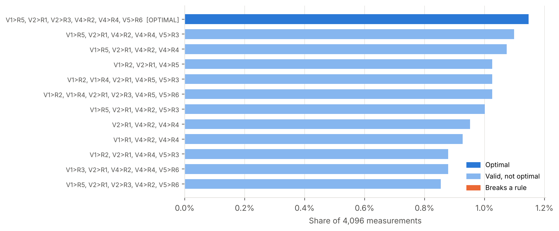
Figure 4. The twelve most frequent measured assignments, CVaR-QAOA at p = 4.
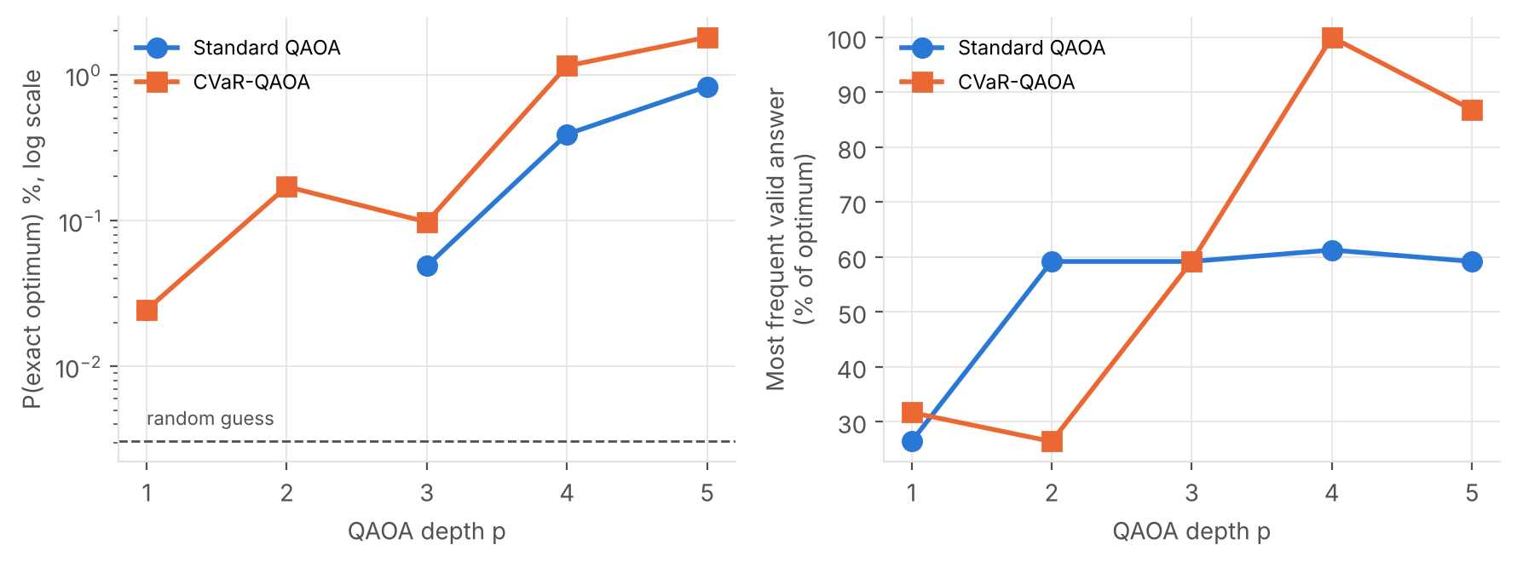
Figure 5. Effect of circuit depth. Left: chance of measuring the exact optimum (log scale; a gap means it was never measured). Right: quality of the most frequent valid answer.
Three things stand out. First, depth matters a lot. At depths 1 to 3 neither objective does much better than a heuristic guess, but from depth 4 the circuit concentrates on good assignments. CVaR at depth 4 measures the exact optimum 1.15% of the time, about 376 times more often than random guessing (0.0031%), and it is the single most frequent outcome. At depth 5, 12.2% of all shots are valid answers within 10% of the optimum.
Second, the two objectives trade against each other. Standard QAOA produces more valid answers (up to 89.6%) but its most frequent answer stays near 59.2% of optimal: it learns to make the average good, not the best answers likely. CVaR accepts more rule-breaking samples in exchange for a much better top end. Third, the margin is thin. In Figure 4 the optimum is only just ahead of several near-optimal assignments, and at depth 5 a near-optimal answer (86.8%) overtakes it, so we would not trust a single shot. In practice ReliefLink would take the best valid answer among the most frequent few, which it can check classically in microseconds.

Penalty weight and problem size
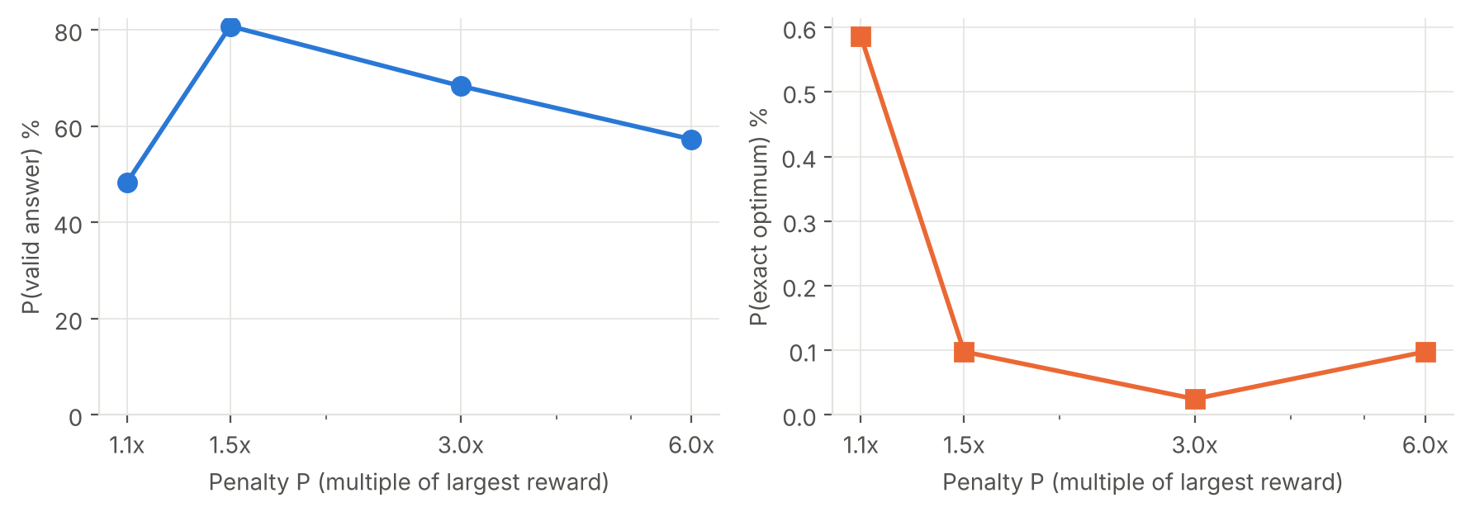
Figure 6. CVaR-QAOA (p = 3) for different penalty weights.
The penalty must be large enough to rule out rule-breaking answers, but a larger penalty also squashes the differences between the answers we care about. In our sweep, 1.5× gave the most valid answers (80.8%), 1.1× gave the best optimum rate (0.59%), and 6× was worse on both. The relationship is not monotone, so the penalty is a real tuning choice. We kept 1.5×.
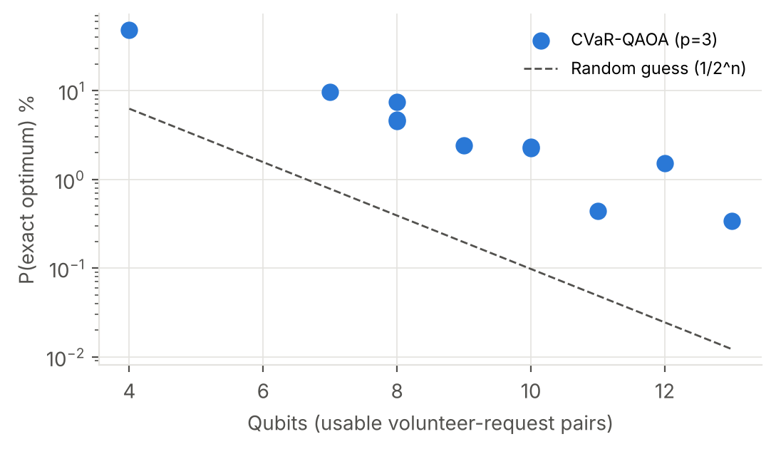
Figure 7. Random instances on the same town: chance of measuring the optimum with CVaR-QAOA (p = 3).
Across 11 random instances, QAOA always stayed above random guessing, but its absolute success rate falls quickly as problems grow: around 48.4% at 4 qubits, a few percent at 7 to 10 qubits, and 0.3% at 13 qubits. A fixed depth of 3 is clearly not enough for larger instances, and deeper circuits cost more to train.

Limitations
We want to be clear about what this project does not show.
- No speedup. Brute force checks all 32,768 assignments in well under a second, while training the depth-4 circuit took about a minute on a laptop. Simulating the circuit also needs memory that grows as 2ⁿ, so the simulation is not a way around brute force either.
- Qubit count. Qubits grow with volunteers × requests. Pruning helps (30 pairs became 15 qubits here), but a district-scale surge would still need hundreds of qubits and much deeper circuits than current hardware runs reliably.
- Low success rates. The exact optimum is measured only about 1–2% of the time even at the best depth, and the most frequent answer is not always the optimum.
- Hand tuning. The penalty weight, CVaR fraction (10%), depth, the top-three rule and the angle grid were all tuned on this instance.
- Ideal simulation. We used an exact, noiseless statevector simulator. For CVaR training we read exact probabilities from the statevector; on hardware they would have to be estimated from shots, which adds noise to training.
- Model simplifications. The town is a synthetic street grid, not real map data (real OpenStreetMap roads would plug into the same code). Flood zones are single polygons, equipment is treated as not needed because the spec does not say which requests need it, and the spec's own weights are unvalidated. Chains of three or more requests are only approximated by pair terms; the 2 km leg rule rules them out here.
- Batch timing. A real surge is continuous. Deciding when to close a batch and run the optimiser is an operational question we have not studied.

What is original
The problem does not come from a tutorial. It is a sub-problem of a disaster platform we designed for Pakistani floods, built from that design's own priority and scoring rules and validated against its own test oracles. Three modelling choices are ours. Flood closures and the spec's own dispatch rules (skills, top three candidates) prune qubits before the circuit is built, so hazard data directly shrinks the quantum problem. The chaining term turns a classically easy assignment problem into a genuinely quadratic one while staying grounded in the spec's workload and ETA terms. And the layer-by-layer training with a grid-searched start was what made fifteen qubits work at all. We are also open about where the classical Hungarian method is already enough, and use it as a baseline rather than hiding it.

Reproducing our results
Install the requirements, then run the tests, the full experiment and the demo:
pip install -r requirements.txt
python -m pytest -q
python run_all.py
streamlit run app.py
All runs are seeded, so the numbers in this report come out the same each time.

References
E. Farhi, J. Goldstone and S. Gutmann, A Quantum Approximate Optimization Algorithm, arXiv:1411.4028, 2014.
P. Kl. Barkoutsos, G. Nannicini, A. Robert, I. Tavernelli and S. Woerner, Improving Variational Quantum Optimization using CVaR, Quantum 4, 256, 2020.
L. Zhou, S.-T. Wang, S. Choi, H. Pichler and M. D. Lukin, Quantum Approximate Optimization Algorithm: Performance, Mechanism, and Implementation on Near-Term Devices, Physical Review X 10, 021067, 2020.
A. Lucas, Ising formulations of many NP problems, Frontiers in Physics 2, 5, 2014.
H. W. Kuhn, The Hungarian method for the assignment problem, Naval Research Logistics Quarterly 2, 83–97, 1955.
M. J. D. Powell, A direct search optimization method that models the objective and constraint functions by linear interpolation, in Advances in Optimization and Numerical Analysis, 1994 (COBYLA).
A. Javadi-Abhari et al., Quantum computing with Qiskit, arXiv:2405.08810, 2024.
ReliefLink team, ReliefLink: Technical Context v2, internal design document, 2026.
This project was developed with AI assistance (Claude).

