Artificial Intelligence Lab Report
Minimax and Alpha-Beta Pruning
Name: ____________________ Roll No: ____________
Semester: 4th Date: 7 November 2026

1. Objective
The aim of this lab is to understand how Minimax finds the best move in a two player game tree, and how Alpha-Beta pruning gives the same answer while looking at fewer leaf nodes. The lab has three tasks: (1) trace the tree by hand using Minimax, (2) add a leaf counter to both algorithms, and (3) change the order of the branches and see how pruning changes while the Minimax value stays the same.

2. The Tree
The tree has depth 3 and every node has 2 children, so there are 8 leaves. The root is a MAX node, the next level is MIN, then MAX again, and then the leaves. In the code it is stored as a nested Python list:
TREE = [[[3, 5], [6, 9]],
[[1, 2], [0, -1]]]

Node names used in my trace: A is the root (MAX), B and C are MIN nodes, and D, E, F, G are MAX nodes. D has leaves 3 and 5, E has 6 and 9, F has 1 and 2, G has 0 and -1.

3. Task 1: Hand Trace of Minimax
Minimax goes to the bottom first and then sends values upward. A MAX node takes the biggest child value and a MIN node takes the smallest.
Node | Type | Children values | Result
D | MAX | max(3, 5) | 5
E | MAX | max(6, 9) | 9
F | MAX | max(1, 2) | 2
G | MAX | max(0, -1) | 0
B | MIN | min(D, E) = min(5, 9) | 5
C | MIN | min(F, G) = min(2, 0) | 0
A (root) | MAX | max(B, C) = max(5, 0) | 5

So the Minimax value of the root is 5, and the best move for MAX is to go to B. Minimax had to look at all 8 leaves.

4. Task 2: Leaf Counters
I used a global counter for each algorithm. Whenever the function reaches a leaf (a number and not a list), it adds 1 to the counter. This is the only change needed in the terminal-node case.
def minimax(node, is_max):
global minimax_leaves
if not isinstance(node, list): # leaf
minimax_leaves += 1
return node
...

def alphabeta(node, is_max, alpha, beta):
global alphabeta_leaves
if not isinstance(node, list): # leaf
alphabeta_leaves += 1
return node
...
if alpha >= beta: # prune
break

Output
Minimax value = 5 leaves evaluated = 8
Alpha-beta value = 5 leaves evaluated = 5
Same value? True

Alpha-beta trace (original order)
Node | alpha, beta on entry | What happens
D (MAX) | -inf, +inf | leaf 3 then leaf 5, so D = 5
B (MIN) | -inf, +inf | gets 5 from D, beta becomes 5
E (MAX) | -inf, 5 | leaf 6 gives alpha = 6 which is >= beta = 5, so leaf 9 is PRUNED. E = 6
B (MIN) |  | min(5, 6) = 5, B = 5
A (MAX) | -inf, +inf | gets 5 from B, alpha becomes 5
F (MAX) | 5, +inf | leaf 1 then leaf 2, so F = 2
C (MIN) | 5, +inf | gets 2, beta becomes 2 which is <= alpha = 5, so G (leaves 0 and -1) is PRUNED. C = 2
A (MAX) |  | max(5, 2) = 5. Root value = 5

Leaves visited: 3, 5, 6, 1, 2 = 5 leaves. Leaves skipped: 9, 0, -1 = 3 leaves. The root value 5 matches Minimax.

5. Task 3: Reordering the Branches
Alpha-beta pruning depends on the order in which children are visited. I made three versions of the same tree by only changing the order (the values are not changed):
- Original order: the order given in the lab.
- Best order: at MAX nodes the best child is first, at MIN nodes the smallest child is first.
- Worst order: the opposite of the best order.

Ordering | Leaves from left to right | MM value | AB value | MM leaves | AB leaves
Original | 3, 5, 6, 9, 1, 2, 0, -1 | 5 | 5 | 8 | 5
Best | 5, 3, 9, 6, 0, -1, 2, 1 | 5 | 5 | 8 | 5
Worst | 1, 2, -1, 0, 6, 9, 3, 5 | 5 | 5 | 8 | 8

I also tried 200 random orderings of the branches. Alpha-beta evaluated between 5 and 8 leaves (average 6.13), and its value was equal to the Minimax value every time.
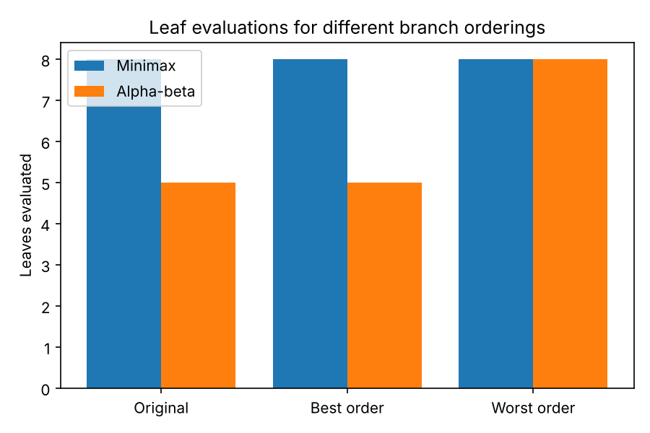
Figure 1: Leaves evaluated for each ordering
Observation: Minimax always evaluates all 8 leaves, no matter the order. Alpha-beta evaluates 5 in the original and best order, and all 8 in the worst order. The root value is 5 in every case, so ordering changes the amount of work but never the answer.

6. Edge Cases
I tested some special trees in edge_cases.py to check that both algorithms still agree.
Test | Minimax value | MM leaves | AB value | AB leaves
Single leaf | 7 | 1 | 7 | 1
All leaves equal (4) | 4 | 8 | 4 | 5
All negative leaves | -6 | 8 | -6 | 8
Skewed tree | 4 | 4 | 4 | 4
Ties at root | 5 | 8 | 5 | 5

In every case both values matched. The negative-leaf tree is a good failure-style example: alpha-beta could not prune anything there, so it did the same work as Minimax. This shows that pruning is not guaranteed, it depends on the values and the order.

7. Limitations
- Alpha-beta only helps if good moves are checked early. With bad ordering it is as slow as Minimax (8 leaves in the worst case above).
- My tree is very small (8 leaves), so the difference is small. In real games like chess the saving is much bigger.
- Both algorithms need a correct evaluation of the leaves. If the leaf values are wrong, the best move will also be wrong, even if the algorithm is correct.
- Minimax assumes the opponent always plays perfectly, which may not be true for a human player.

8. Connection to Lecture Learning Outcome
This lab shows the lecture idea that adversarial search can be made faster without changing the result. Alpha-beta keeps two bounds, alpha (best value MAX can already get) and beta (best value MIN can already get), and stops exploring a branch when it cannot change the final decision. The experiment confirmed this: the root value stayed 5 while the number of evaluated leaves changed from 8 to 5.

9. Reflection and Responsible Practice
What I learned: at first I thought pruning might change the answer, but the experiments proved that it only skips branches that do not matter. Tracing alpha and beta by hand helped me understand the cutoff condition alpha >= beta much better than just reading the code.
Responsible practice: I wrote and ran the code myself, checked the output against my hand trace, and tested edge cases instead of trusting one example. If AI tools or reference code are used for help, the student should understand every line and be able to explain it, and should mention the help honestly. Also, game-playing search should not be blindly trusted in real decision systems, because the result is only as good as the model of the game and the leaf values we give it.

10. Files Submitted
- minimax_lab.py - Minimax, Alpha-beta, counters, reordering experiments, plot
- edge_cases.py - edge case tests
- leaf_counts.png - plot used in Figure 1

