

**UNITED STATES INTERNATIONAL UNIVERSITY – AFRICA (USIU) FALL SEMESTER 2022 APT1050A Project INSTRUCTOR: DR. Malack Oteri**

**STUDENT’S NAME: Syntiche Musawu Cishimbi STUDENT’S ID: 664689**

**APT2020: PROJECT REPORT**

**Title: Project report on a microcontroller application which is an covid-19 social distancing system created using sensors and LCD to display the output.**

**Abstract**-

* The project is about a covid-19 social distancing system which has one sensor as inputs

, an LCD to display the output and a piezo buzzer to produce sound (alarm) as an output. A Ultrasonic distance sensor to detect whether the social distance has been kept or no. If the distance from the Ultrasonic distance sensor is set to greater or equal to 200 meters, the led will light up green and the LCD will display “Safe distance” else if the distance is less than 200 meters, the system will produce an alarm sound from the buzzer and light up the red led and display “Please keep social distance” to the LCD.

* In hardware, we will use an AND gate, it takes the distances as an input and if the requirement are not met, it will ask are not met, it will ask the user to keep the social distance.

**Introduction**

**Problem statement**- Design a **covid-19 social distancing system** using sensors and an LCD to display its output. A piezo buzzer is used so that it can alert people when the distance is not kept.

**Relevance of the study/justification**: Covid-19 Social distancing system is a new technology prevention methods that control intervention implemented to avoid or decrease contact between people who are infected with a disease causing pathogen and those who are not. It aims to stop or slow down the rate and extent of disease transmission in a community.

**Objectives**-**main**

* The system will be constructed so that the breadboard and Arduino are assembled. The Arduino will then be connected to the bread board using a 5V power source and ground.
  + In hardware form the sensor is connected to a digital input port. The positive terminal of the piezo buzzer was connected to the output port of the Arduino. When simulation begins, if distance of the ultrasonic distance sensor decreases, the buzzer will trigger the alarm and the led will light red, the LCD displays “Please keep social distance”. But when the distance of the ultrasonic distance sensor increases, the led lights green, the LCD displays “Safe distance”
  + For software implementation, ultrasonic distance sensor, LCD, buzzer and led were connected to the Arduino. We implemented a code and buzzer, LCD, and led observed.

**Literature Review:** Other similar projects of what people have done in this are:

* + A social distancing project by CASELLA using IoT (Internet of Thing) to maintain social distance in the workplace to stave off the spread of the COVID-19 virus. As a direct

response to the pandemic, social distancing (proximity) technology is a relatively recent idea. Its goal is to enable people's return to the workplace and alleviate their reasonable anxieties.

“A REVIEW OF SOCIAL DISTANCING TECHNOLOGY.” A REVIEW OF SOCIAL DISTANCING TECHNOLOGY.

* + A company that specializes in artificial intelligence (AI) has modified its object detection system and data pipelines for COVID-19 (UKRI,2021).

**Proposed Method**

* + Tinker cad was used to implement the following process in software. First, we prepared the required parts, including an Arduino, a breadboard, a photoresistor sensor, an ultrasonic distance sensor, a piezo buzzer, an LCD, and resistors.
  + The power source 5V and ground of the Arduino was then connected to the breadboard. Then IC was connected to the breadboard. The positive terminal of the IC chip was connected to the positive terminal of the breadboard while the negative terminal of the chip was grounded.
  + We connected red led to digital pin 8 and red led to digital pin 9 as outputs
  + We connected the buzzer to the digital pin 13 as an output
  + We connected the ultrasonic distance sensor to the digital pin 7 and 6, respectively as trig and echo as an input.
  + To initialize the library with the number of pins interface, the LCD is connected to port 12,11,5,4,3,2 of the Arduino

Note: Each input or output device from our system is connect from the Arduino to the breadboard using cables.

* + LINK TO SOFTWARE IMPLEMENTATION [https://www.tinkercad.com/things/dtJEQ22jZ6X-fantastic-](https://www.tinkercad.com/things/dtJEQ22jZ6X-fantastic-bruticus/editel?sharecode=NnhDzBbEt3Bga-W0vkKOBOG8M2s4HjoSMPdf1kbwW7M)

[bruticus/editel?sharecode=NnhDzBbEt3Bga-W0vkKOBOG8M2s4HjoSMPdf1kbwW7M](https://www.tinkercad.com/things/dtJEQ22jZ6X-fantastic-bruticus/editel?sharecode=NnhDzBbEt3Bga-W0vkKOBOG8M2s4HjoSMPdf1kbwW7M)

* + DIAGRAM OF HARDWARE IMPLEMENTATION

The picture below displays the message in the LCD when the ultrasonic sensor sets the distance to greater or equal to 200 meters, and the green led that is light up.

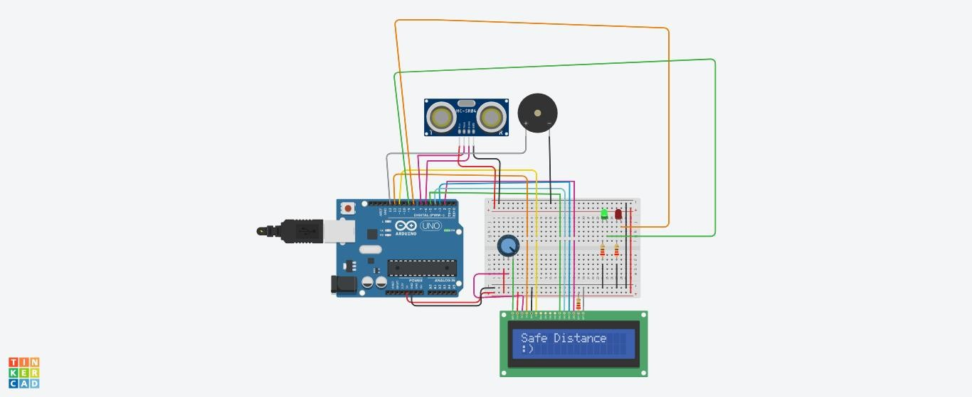

The second picture displays the message in the LCD when the ultrasonic sensor sets the distance to less than 200 meters, and the red led that is light up.

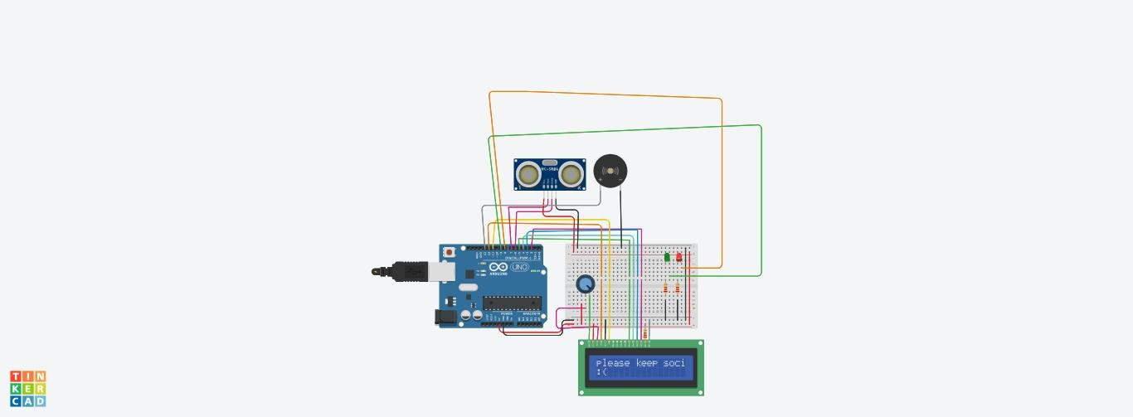

* + **Code:**

**// library code**

**#include <LiquidCrystal.h>**

**//initialize the library with the number of pins interface LiquidCrystal lcd(12, 11, 5, 4, 3, 2);**

**//initialize LED pin int rled=8;**

**int gled=9;**

**//initialize speaker pin int speaker=13;**

**//initialize ultrasonic pin int trig =7;**

**int echo=6;**

**long distance, duration; void setup()**

**{**

**//set LCD columns and rows lcd.begin(16,2);**

**//pinMode command**

**pinMode (rled,OUTPUT); pinMode (gled,OUTPUT); pinMode (speaker,OUTPUT); pinMode (trig,OUTPUT); pinMode (echo,INPUT); Serial.begin(9600);**

**//lcd.begin(16,2);**

**}**

**void loop()**

**{**

**digitalWrite(7,HIGH); delayMicroseconds(20); digitalWrite(7,LOW); delayMicroseconds(20); duration=pulseIn(echo,HIGH); distance=duration*0.034/2;**

**//if distance is more than 200cm/m**

**//print"social distance well kept"**

**//turn green led on**

**//turn speaker and red led off**

**if(distance>200){ lcd.setCursor(0,0); lcd.print("Safe Distance"); lcd.setCursor(0,1); lcd.print(":)");**

**delay(1000);**

**digitalWrite(gled,HIGH); digitalWrite(rled,LOW); digitalWrite(speaker,LOW);**

**}**

**//else if distance is less than 200cm/m**

**//print"please keep social distance"**

**//turn green led off**

**//turn speaker and red led on**

**else if (distance<200){ lcd.setCursor(0,0);**

**lcd.print("please keep social distance"); lcd.setCursor(0,1);**

**lcd.print(":("); delay(1000); digitalWrite(gled,LOW); digitalWrite(rled,HIGH);**

**digitalWrite(speaker,HIGH);**

**}**

**}**

**Timeframe-** Depending on your understanding of how to connect the circuits and dedication to the project, it can take 12 to 24 hours to implement the project using Tinkercad in hardware and software.

**Budget**: The project did not cost anything because we utilized the online software called tinker cad to create it in software. The expected cost of further developing and expanding the project by physically linking (hardware) it is as follows:

|  |  |  |  |
| --- | --- | --- | --- |
| **ITEM** | **QUANTITY** | **COST PER ITEM** | **TOTAL** |
| photoresistor | 1 | $0.02 | $0.02 |
| Ultrasonic distance sensor | 1 | $7 | $7 |
| wires | 25 | $4 | $100 |
| Piezo buzzer | 1 | $5 | $5 |
| Power supply | 1 | Can use a cpu |  |
| Breadboard | 1 | $6.50 | $6.50 |
| Arduino Uno R3 | 1 | $30 | $30 |
| Resistors | 3 | $0.01 | $0.01 |
| Quad OR gate IC |  | $0.49 | $0.49 |
|  | TOTAL | $59.52 | $149.02 |

**Conclusion**- In the project, a Covid-19 social distancing system with ultrasonic distance sensor with ultrasonic distance sensor having two pins as inputs, an LCD to show output, and a piezo buzzer to hear output is discussed. To determine whether there the distance is between people is correct, the ultrasonic distance system is employed. Piezo buzzer alarms and an LCD

message acknowledge the right social distance or warn the people to keep the social distance

**References**

“OOMaELecturer.”YouTube[,www.youtube](http://www.youtube.com/channel/UC4t96V6Vy1Z-G2cbmgoo0Ww).[com/channel/UC4t96V6Vy1Z-G2cbmgoo0Ww.](http://www.youtube.com/channel/UC4t96V6Vy1Z-G2cbmgoo0Ww) Accessed 27 Nov. 2022

, [www.casellasolutions.com/us/en/about/news/social-distancing-tech-review.html. Accessed 9](http://www.casellasolutions.com/us/en/about/news/social-distancing-tech-review.html.%20Accessed%209%20Dec.%202022) [Dec. 2022](http://www.casellasolutions.com/us/en/about/news/social-distancing-tech-review.html.%20Accessed%209%20Dec.%202022)

“Artificial Intelligence Tool for Social Distancing.” Artificial Intelligence Tool for Social Distancing – UKRI, 12 Apr. 2021, [www.ukri.org/news-and-events/tackling-the-impact-of-covid-](http://www.ukri.org/news-and-events/tackling-the-impact-of-covid-) 19/addressing-technological-challenges/artificial-intelligence-tool-for-social-distancing.