 | MUSCAB GYM  MANAGEMENT SYSTEM  Project Requirements Specification  Members, trainers, plans, workout programs, equipment and payment management

SOFTWARE REQUIREMENTS SPECIFICATION (SRS)
ASP.NET Core Web API • React + Vite • Tailwind CSS • SQL Server

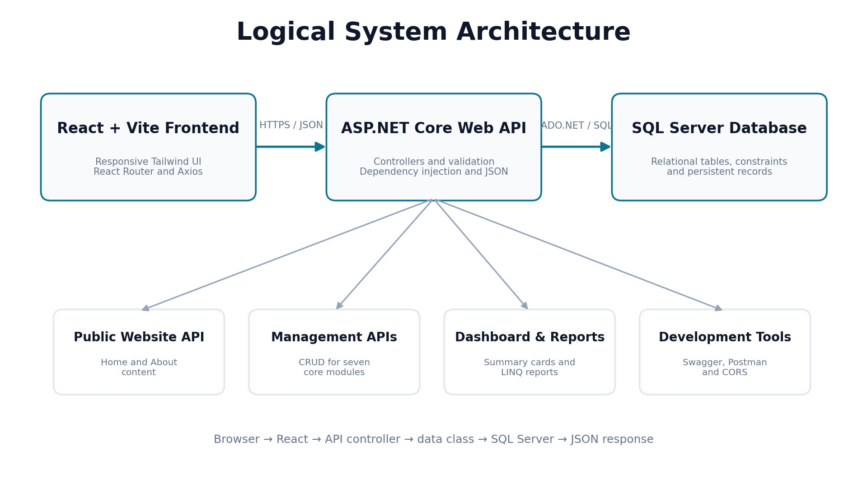
System architecture overview
Version 1.0 | Baseline Specification | 2 July 2026

Document Control
This document defines the functional, data, integration, user-interface and quality requirements for the Muscab Gym Management System. It was prepared from the supplied ASP.NET Core, SQL Server and React/Vite source code so the requirements remain traceable to the implemented baseline.

Revision History
Version | Date | Description | Status
0.1 | 1 July 2026 | Initial source-code review and requirements extraction | Draft
1.0 | 2 July 2026 | Completed functional, API, data, UI and acceptance requirements | Baseline

Approval Record
Role | Name | Signature | Date
Project Owner / Client
Developer / Analyst
Supervisor / Reviewer

Document Structure
- Introduction and scope
- Stakeholders and user classes
- System overview and architecture
- Functional requirements
- Business rules
- Data requirements
- API and integration requirements
- User interface requirements
- Non-functional requirements
- Testing and acceptance criteria
- Configuration and deployment
- Traceability, constraints and future improvements
Baseline note: The current implementation does not include user authentication or role-based authorization. This document distinguishes implemented baseline requirements from recommended production enhancements.

1. Introduction

1.1 Purpose
The purpose of this specification is to establish a clear and testable requirements baseline for a web-based Gym Management System. The system centralizes gym member records, trainer information, membership plans, payments, equipment inventory, workout programs and member-program assignments. It also provides a dashboard, public Home and About content, and operational reports.

1.2 Business Problem
Gyms that rely on paper files, spreadsheets or disconnected applications often experience duplicate records, missing payment history, unclear equipment status, inconsistent trainer assignments and slow reporting. The proposed system replaces those fragmented processes with a single SQL Server database accessed through an ASP.NET Core API and a responsive React user interface.

1.3 Objectives
- Provide one reliable source of operational gym data.
- Allow staff to create, search, update and delete records through a responsive web interface.
- Protect relational integrity between members, payments, trainers, programs and assignments.
- Present current operational totals and recent activity on a dashboard.
- Provide grouped management reports using LINQ.
- Support independent frontend and backend development through documented JSON APIs and CORS.
- Keep the code structure understandable for beginner and intermediate developers.

1.4 Scope
In Scope | Out of Scope / Not in Baseline
Member, trainer, plan, equipment, payment, workout program and assignment management | Biometric attendance and access-control hardware
Dashboard summary and recent activity | Online payment gateway processing
Home and About website content obtained from the API | Public member self-registration and member portal
Search, filtering and grouped reports | Payroll, accounting ledger and tax management
Swagger, Postman and React integration | Mobile native applications
SQL Server persistence and parameterized queries | Multi-branch tenancy and cloud synchronization
Responsive Tailwind web interface | JWT authentication and role enforcement in the current baseline

1.5 Definitions and Acronyms
Term | Meaning
API | Application Programming Interface used by React to communicate with ASP.NET Core.
CRUD | Create, Read, Update and Delete operations.
CORS | Cross-Origin Resource Sharing configuration for the Vite development host.
DTO / Detail Model | API response model containing joined display fields such as memberName or trainerName.
LINQ | Language Integrated Query used for search, filtering, grouping and reporting.
SRS | Software Requirements Specification.
Vite | Frontend development and build tool for the React application.
Baseline | The implemented capability represented by the supplied project package.

2. Stakeholders and User Classes

2.1 Stakeholders
- Gym owner or business manager
- Reception and administrative staff
- Trainers and fitness program coordinators
- Finance or cashier staff
- Gym members represented by stored records
- System developers and database administrators
- Project supervisor, testers and support personnel

2.2 User Classes
User Class | Primary Responsibilities | Baseline Access
Public Visitor | View Home and About information, featured plans and gym services. | Read-only website pages.
Gym Staff | Maintain members, trainers, plans, equipment, programs, assignments and payments. | Full frontend management screens in the current baseline.
Manager | Review dashboard totals, recent activity and grouped reports. | Dashboard and report pages; no enforced backend role restriction.
Developer / Administrator | Configure database connection, run API, test Swagger, maintain code and deployment. | Source code, SQL scripts and technical tools.

2.3 Access-Control Position
The current API registers authorization services but does not configure authentication, issue tokens or apply [Authorize] policies. Therefore, all mapped API endpoints are technically accessible to any client that can reach the API. Production deployment shall add authenticated user accounts and role policies before sensitive operational data is exposed.
Recommended production roles: Admin (full access), Manager (dashboard/reports and selected maintenance), Receptionist (members, payments and assignments), Trainer (program and assigned-member views), and Public Visitor (website-only access).

3. System Overview

3.1 Product Perspective
The solution is a three-tier web application. React and Tailwind CSS form the presentation layer. ASP.NET Core controller classes and Data classes form the application and data-access layers. SQL Server stores persistent records and enforces primary-key, foreign-key and uniqueness constraints.

Figure 1. Logical system architecture

3.2 Technology Baseline
Layer | Technology | Requirement
Frontend | React, Vite, React Router, Axios, Tailwind CSS, Lucide React | Responsive navigation, reusable CRUD pages and JSON API calls.
Backend | ASP.NET Core Web API on .NET 8 | Controller-based endpoints, dependency injection, validation and Swagger.
Data Access | Microsoft.Data.SqlClient / ADO.NET | Parameterized commands and explicit SQL joins.
Database | Microsoft SQL Server | Relational storage, identity keys and foreign-key integrity.
Development | Visual Studio, VS Code, npm, SSMS, Postman | Local build, debugging, API testing and database administration.

3.3 Operating Environment
- Windows 10 or Windows 11 workstation.
- Visual Studio 2022 with the ASP.NET and web development workload and .NET 8 SDK.
- Node.js and npm compatible with the installed Vite version.
- SQL Server and SQL Server Management Studio.
- Modern Chromium-based browser or Firefox.
- Backend development URLs: http://localhost:5092 and https://localhost:7092.
- Frontend development URL: http://localhost:5173.

3.4 System Context and Navigation
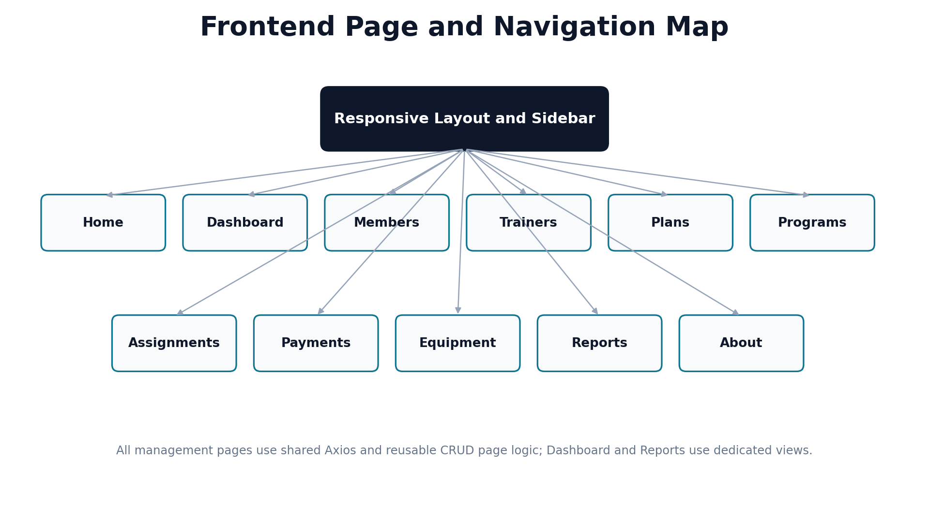
Figure 2. Frontend page and navigation map

3.5 Assumptions and Dependencies
- The GymManagementDB database exists and the configured Windows account can connect to SQL Server.
- Identity values are generated by SQL Server.
- The frontend API base URL matches the selected backend launch profile.
- CORS permits the active React origin.
- Network access between browser, API host and SQL Server is available.
- Required Node and NuGet packages can be restored when setting up a new workstation.

4. Functional Requirements
Requirement priorities: Must = required for baseline operation; Should = important quality or deployment requirement; Could = planned enhancement. Acceptance criteria are expressed in observable terms.

4.1 Public Website
ID | Requirement | Priority | Acceptance Criterion
FR-WEB-001 | The system shall expose API-driven Home page content including hero title, subtitle, statistics and featured records. | Must | GET /api/website/home returns a valid JSON response and the Home page renders without static database data.
FR-WEB-002 | The system shall expose About content including description, mission, vision, services and statistics. | Must | GET /api/website/about returns all defined content fields.

4.2 Navigation
ID | Requirement | Priority | Acceptance Criterion
FR-NAV-001 | The frontend shall provide responsive navigation to Home, Dashboard, Members, Trainers, Plans, Programs, Assignments, Payments, Equipment, Reports and About. | Must | Every configured route can be opened directly and through the navigation UI.

4.3 Dashboard
ID | Requirement | Priority | Acceptance Criterion
FR-DASH-001 | The dashboard shall display totals for members, trainers, plans, programs, equipment quantity, active assignments and payments. | Must | GET /api/dashboard returns current values derived from the database.
FR-DASH-002 | The dashboard shall show up to five recent members and five recent payments. | Must | Recent lists render member and payment display fields.

4.4 Members
ID | Requirement | Priority | Acceptance Criterion
FR-MEM-001 | Staff shall list all member records. | Must | GET /api/members returns memberID, fullName, gender, phone and address.
FR-MEM-002 | Staff shall search members by name, phone or address and filter by gender. | Must | Query parameters search and gender reduce the returned list correctly.
FR-MEM-003 | Staff shall create and update a member with validated field lengths. | Must | Valid POST/PUT requests persist and return success; invalid models return 400.
FR-MEM-004 | The API shall reject duplicate non-empty member phone numbers. | Must | Duplicate create/update returns HTTP 409 with a readable message.
FR-MEM-005 | The system shall prevent deletion of members linked to payments or workout assignments. | Must | Delete returns 400 when foreign-key relationships exist.

4.5 Trainers
ID | Requirement | Priority | Acceptance Criterion
FR-TRN-001 | Staff shall perform CRUD operations for trainers. | Must | The trainers API supports GET, GET by ID, POST, PUT and DELETE.
FR-TRN-002 | Staff shall search trainers by name, specialty or phone. | Must | The search parameter returns matching trainers case-insensitively.
FR-TRN-003 | The system shall prevent deletion of trainers referenced by workout programs. | Must | Linked delete returns 400 with an understandable message.

4.6 Membership Plans
ID | Requirement | Priority | Acceptance Criterion
FR-PLN-001 | Staff shall perform CRUD operations for membership plans. | Must | Plans can be created, listed, edited and deleted.
FR-PLN-002 | Plans shall include plan name, duration in months and price. | Must | Duration is 1-120 months and price is non-negative.
FR-PLN-003 | Staff shall search plans by name and optionally filter by maximum price. | Must | search and maxPrice query parameters are applied.

4.7 Equipment
ID | Requirement | Priority | Acceptance Criterion
FR-EQP-001 | Staff shall perform CRUD operations for equipment records. | Must | Equipment endpoints persist equipmentName, quantity and status.
FR-EQP-002 | Staff shall search equipment and filter by status. | Must | search and status parameters return expected records.
FR-EQP-003 | Equipment with quantity zero shall automatically use status Out of Stock when created or updated. | Must | API normalizes status when quantity equals zero.

4.8 Workout Programs
ID | Requirement | Priority | Acceptance Criterion
FR-PRG-001 | Staff shall perform CRUD operations for workout programs. | Must | Program endpoints support full CRUD.
FR-PRG-002 | Each workout program shall reference an existing trainer. | Must | Invalid trainerID returns HTTP 400.
FR-PRG-003 | Staff shall search programs by program or trainer name and filter by trainer. | Must | search and trainerId parameters are applied.
FR-PRG-004 | Programs linked to member assignments shall not be deleted. | Must | Delete returns 400 when member assignments exist.

4.9 Member Programs
ID | Requirement | Priority | Acceptance Criterion
FR-ASG-001 | Staff shall assign an existing member to an existing workout program with a start date. | Must | Valid assignment is persisted and returned with joined names.
FR-ASG-002 | The same member shall not be assigned to the same program more than once. | Must | Duplicate pair returns HTTP 409 and database unique constraint also protects the rule.
FR-ASG-003 | Staff shall search assignments by member, program or trainer and filter by member/program IDs. | Must | Relevant query parameters filter the result.
FR-ASG-004 | Staff shall update and delete assignment records. | Must | PUT and DELETE change the database and return clear status messages.

4.10 Payments
ID | Requirement | Priority | Acceptance Criterion
FR-PAY-001 | Staff shall perform CRUD operations for member payments. | Must | Payments API supports all CRUD operations.
FR-PAY-002 | Every payment shall reference an existing member and contain a positive amount and date. | Must | Invalid member returns 400; invalid model values return 400.
FR-PAY-003 | Staff shall search payment records by member name and filter by date range. | Must | search, fromDate and toDate parameters are applied.

4.11 Reports
ID | Requirement | Priority | Acceptance Criterion
FR-RPT-001 | The system shall group payment count and total amount by member. | Must | GET /api/reports/payments-by-member returns descending total-paid results.
FR-RPT-002 | The system shall group equipment type count and total quantity by status. | Must | GET /api/reports/equipment-by-status returns grouped status totals.
FR-RPT-003 | The system shall report distinct member enrollment counts by workout program. | Must | GET /api/reports/program-enrollment returns programs ordered by enrollment count.

4.12 Reusable CRUD UI
ID | Requirement | Priority | Acceptance Criterion
FR-UI-001 | Management pages shall share consistent create/update forms, tables, edit actions and delete confirmation. | Must | CrudPage operates correctly for configured resource modules.
FR-UI-002 | The frontend shall display loading, empty, validation and API error states. | Must | Users receive visible feedback for all request states.

4.13 Responsive UI
ID | Requirement | Priority | Acceptance Criterion
FR-UI-003 | Tables shall permit horizontal scrolling and navigation shall adapt on smaller screens. | Must | The interface remains usable at mobile, tablet and desktop widths.

5. Business Rules
Rule ID | Rule
BR-001 | SQL Server generates all primary-key values with IDENTITY(1,1).
BR-002 | A payment must reference an existing member.
BR-003 | A workout program must reference an existing trainer.
BR-004 | A member-program assignment must reference an existing member and existing workout program.
BR-005 | The pair MemberID + ProgramID must be unique in MemberPrograms.
BR-006 | A duplicate member phone number is rejected by application logic when the phone is not blank.
BR-007 | Equipment quantity cannot be negative; quantity zero forces status Out of Stock.
BR-008 | Membership duration must be between 1 and 120 months.
BR-009 | Payment amount must be greater than zero.
BR-010 | Deleting a referenced member, trainer or workout program must be blocked with a readable message.
BR-011 | Search operations are case-insensitive where implemented in controller LINQ.
BR-012 | API JSON property names are serialized in camelCase.
BR-013 | Public Home featured lists use the first three available plans, trainers and programs.
BR-014 | Dashboard recent lists return a maximum of five records from each configured source.
BR-015 | Dates shall be transmitted in ISO-compatible format and displayed without unintended time components where appropriate.

5.1 Status Values
The equipment user interface currently offers Available, Maintenance and Out of Stock. The database stores status as free text, therefore the API and frontend should use a controlled list consistently to prevent spelling variations.

5.2 Deletion and Referential Integrity
The database is configured without cascading deletes. This is appropriate for operational records because it prevents accidental deletion of parent data. Controllers catch SQL foreign-key exceptions for members, trainers and workout programs and translate them into understandable HTTP 400 responses.

6. Data Requirements

6.1 Entity Relationship Model
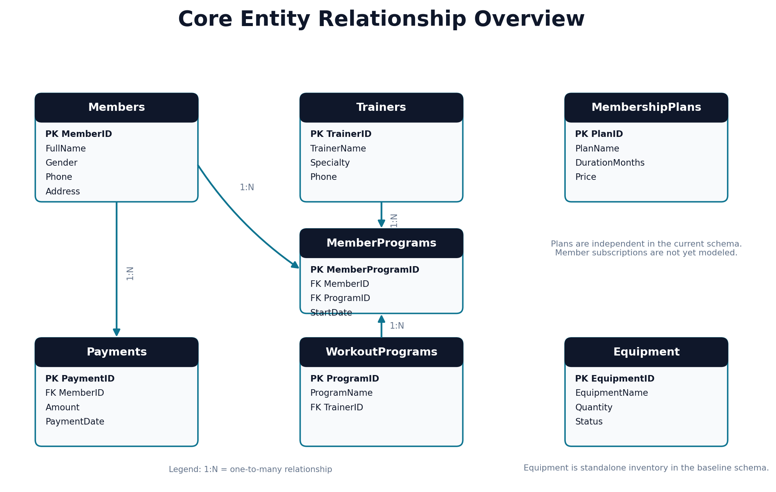
Figure 3. Core entity relationship overview

6.2 Entity Dictionary
Entity | Primary Key | Core Attributes | Relationship / Purpose
Members | MemberID | FullName, Gender, Phone, Address | Parent of Payments and MemberPrograms.
Trainers | TrainerID | TrainerName, Specialty, Phone | Parent of WorkoutPrograms.
MembershipPlans | PlanID | PlanName, DurationMonths, Price | Independent plan catalogue in current schema.
Payments | PaymentID | MemberID, Amount, PaymentDate | Many payments belong to one member.
Equipment | EquipmentID | EquipmentName, Quantity, Status | Independent inventory records.
WorkoutPrograms | ProgramID | ProgramName, TrainerID | Many programs may belong to one trainer.
MemberPrograms | MemberProgramID | MemberID, ProgramID, StartDate | Bridge entity between members and programs; unique pair.

6.3 Field Validation Requirements
Field | Validation
Member.FullName | Required; maximum 100 characters.
Member.Gender | Optional; maximum 10 characters.
Member.Phone | Optional; maximum 20 characters; duplicate non-empty values rejected by API.
Member.Address | Optional; maximum 100 characters.
Trainer.TrainerName | Required; maximum 100 characters.
Trainer.Specialty | Optional; maximum 50 characters.
Trainer.Phone | Optional; maximum 20 characters.
MembershipPlan.PlanName | Required; maximum 50 characters.
MembershipPlan.DurationMonths | 1 to 120.
MembershipPlan.Price | 0 to 1,000,000.
Payment.MemberID | Integer greater than zero and existing member.
Payment.Amount | 0.01 to 1,000,000.
Payment.PaymentDate | Required date.
Equipment.EquipmentName | Required; maximum 100 characters.
Equipment.Quantity | 0 to 100,000.
Equipment.Status | Required; maximum 20 characters.
WorkoutProgram.ProgramName | Required; maximum 100 characters.
WorkoutProgram.TrainerID | Integer greater than zero and existing trainer.
MemberProgram.MemberID / ProgramID | Integers greater than zero; both referenced records must exist.
MemberProgram.StartDate | Required date; defaults to current date in model.

6.4 Data Integrity and Security
- All externally supplied SQL values shall be passed as parameters, not concatenated into SQL text.
- Primary and foreign key constraints shall remain enabled.
- Connection strings shall remain in backend configuration and shall not be exposed to React.
- Backups shall be created according to the deployment organization’s recovery policy.
- Production logs shall not contain connection strings, passwords or sensitive personal data.
- The schema should add unique constraints where business uniqueness must be enforced independently of application code.

7. API and Integration Requirements

7.1 Endpoint Catalogue
Module | Method | Route | Purpose
Dashboard | GET | /api/dashboard | Operational summary and recent activity.
Website | GET | /api/website/home | Public Home page data.
Website | GET | /api/website/about | Public About page data.
Members | GET/POST | /api/members | List/search/filter and create.
Members | GET/PUT/DELETE | /api/members/{id} | Read, update or delete one member.
Trainers | GET/POST | /api/trainers | List/search and create.
Trainers | GET/PUT/DELETE | /api/trainers/{id} | Read, update or delete one trainer.
Membership Plans | GET/POST | /api/membershipplans | List/search/filter and create.
Membership Plans | GET/PUT/DELETE | /api/membershipplans/{id} | Single plan operations.
Payments | GET/POST | /api/payments | List/search/date filter and create.
Payments | GET/PUT/DELETE | /api/payments/{id} | Single payment operations.
Equipment | GET/POST | /api/equipment | List/search/status filter and create.
Equipment | GET/PUT/DELETE | /api/equipment/{id} | Single equipment operations.
Workout Programs | GET/POST | /api/workoutprograms | List/search/trainer filter and create.
Workout Programs | GET/PUT/DELETE | /api/workoutprograms/{id} | Single program operations.
Assignments | GET/POST | /api/memberprograms | List/search/filter and create.
Assignments | GET/PUT/DELETE | /api/memberprograms/{id} | Single assignment operations.
Reports | GET | /api/reports/payments-by-member | Grouped payment totals.
Reports | GET | /api/reports/equipment-by-status | Grouped equipment totals.
Reports | GET | /api/reports/program-enrollment | Program enrollment counts.

7.2 API Behavior
- Requests and responses shall use JSON with camelCase property names.
- Successful POST operations shall return HTTP 201 Created and identify the created resource.
- Successful reads and updates shall return HTTP 200 unless another standard result is more appropriate.
- Missing records shall return HTTP 404 with a readable message.
- Invalid foreign keys or business input shall return HTTP 400.
- Duplicate assignments and duplicate member phone values shall return HTTP 409 where implemented.
- Swagger shall be available in the Development environment.
- CORS shall permit only approved frontend origins.

7.3 Frontend Integration
The supplied React client creates a shared Axios instance and reusable CRUD API factory. The current base URL is hard-coded as https://localhost:7092/api, while the backend also exposes http://localhost:5092. To avoid environment-specific source changes, the release version should read VITE_API_URL from a frontend environment file and fall back to a documented local URL.
Configuration | Development Value | Requirement
Backend HTTP | http://localhost:5092 | Must match the http launch profile.
Backend HTTPS | https://localhost:7092 | Must use a trusted local development certificate.
React Vite | http://localhost:5173 | Must be permitted by CORS.
API base | VITE_API_URL or configured Axios baseURL | Must include /api and match the running backend profile.

Configuration risk: The backend README refers to HTTP port 5092, while the current React API file uses HTTPS port 7092. Both are valid launch URLs, but the selected profile and frontend configuration must match.

8. User Interface and Experience Requirements

8.1 Page Inventory
Page | Required Content / Behavior
Home | Public hero, API status message and featured membership plans.
Dashboard | Summary cards, recent members and recent payments.
Members | Reusable CRUD form, search and member table.
Trainers | Reusable CRUD form, search and trainer table.
Membership Plans | CRUD form and plan table.
Workout Programs | CRUD form, search and trainer display fields.
Assignments | Member-to-program assignment CRUD and joined display fields.
Payments | Payment CRUD and member display name.
Equipment | CRUD, search and controlled status selection.
Reports | Three API-driven tabular reports.
About | Mission, vision, services and API-provided content.

8.2 Reusable Components
- Layout shall provide a responsive sidebar, sticky header and route outlet.
- CrudPage shall be configurable for form fields, table columns, resource API, identifier and search support.
- The shared API module shall expose createCrudApi and consistent error extraction.
- Lucide icons shall be used consistently for navigation and actions.
- Forms shall convert numeric inputs to numbers before sending the payload.
- Date values shall be formatted as yyyy-MM-dd in edit forms and tables.
- Delete actions shall require confirmation.
- All tables shall support horizontal overflow on narrow screens.

8.3 Visual Design
Area | Requirement
Brand | Display Muscab Gym and Management System identity with a fitness-oriented icon.
Color | Use a dark slate foundation with cyan as the principal accent and high-contrast white surfaces.
Typography | Use readable sans-serif type with clear hierarchy and bold section titles.
Responsiveness | Support mobile, tablet and desktop layouts without clipped controls.
Feedback | Display loading, empty, saving and error states close to the relevant content.
Accessibility | Provide labels for inputs, keyboard-operable controls and adequate contrast.
Consistency | Use shared button, input, card, badge and table styles throughout the application.

8.4 Usability Acceptance
- A first-time staff user can add a member and payment without reading source code.
- The active navigation item is visually distinguishable.
- Validation and API errors explain the problem in user-friendly language.
- Users can cancel an edit and return to a clean create form.
- Search and refresh controls are clearly discoverable.
- Tables remain readable when records contain long names or addresses.

9. Non-Functional Requirements
ID | Category | Requirement | Priority
NFR-PERF-001 | Performance | Common list and dashboard requests should complete within 2 seconds for normal local/office data volumes. | Should
NFR-PERF-002 | Performance | Search and filtering should not freeze the browser while results are loaded. | Should
NFR-REL-001 | Reliability | Failed operations shall not leave partial relational records. | Must
NFR-REL-002 | Reliability | The API shall return predictable error responses instead of unhandled database exceptions. | Must
NFR-SEC-001 | Security | All SQL commands shall use parameters for user-supplied values. | Must
NFR-SEC-002 | Security | Production use shall implement authentication and backend authorization policies. | Should
NFR-SEC-003 | Security | HTTPS shall be used in deployed environments. | Must
NFR-SEC-004 | Security | CORS shall be restricted to approved frontend origins. | Must
NFR-MNT-001 | Maintainability | Controllers, data access, models and frontend concerns shall remain separated. | Must
NFR-MNT-002 | Maintainability | Reusable CRUD and API code shall minimize duplicated frontend logic. | Must
NFR-MNT-003 | Maintainability | Dependency versions shall be pinned rather than using latest before release. | Should
NFR-CMP-001 | Compatibility | The web interface shall work in current Edge, Chrome and Firefox releases. | Should
NFR-RSP-001 | Responsiveness | All pages shall be usable at widths from 320 px through desktop screens. | Must
NFR-A11Y-001 | Accessibility | Controls shall have visible labels, focus states and sufficient color contrast. | Should
NFR-OBS-001 | Observability | Production errors and important write operations should be logged without exposing sensitive values. | Should
NFR-BKP-001 | Recovery | The database shall be backed up and restore-tested according to operational policy. | Should

9.1 Security Gap Analysis
The baseline stores no user accounts and does not enforce login or roles. AddAuthentication, token/cookie issuance, password hashing and [Authorize] policies are required before deployment beyond a trusted local environment. Frontend route hiding alone is not sufficient security.

9.2 Maintainability Gap Analysis
The React package file uses latest for several core dependencies. This simplifies initial setup but makes builds non-reproducible. A release baseline should pin tested versions and commit the lock file. The frontend API URL should be externalized to an environment variable.

10. Testing and Acceptance Criteria

10.1 Test Levels
Level | Focus | Examples
Database | Schema, constraints and seed data | Foreign keys, unique member-program pair, identity keys.
API Unit / Component | Controller and Data class behavior | Validation, search, status normalization, error mapping.
Integration | API with SQL Server | CRUD persistence, joins, dashboard counts, report grouping.
Frontend | Components, forms and routes | Field conversion, loading/error states, navigation, responsive layout.
End-to-End | User workflow across all layers | Create member → record payment → dashboard/report update.

10.2 Acceptance Test Scenarios
Test ID | Scenario | Expected Result
AT-001 | Create a member with valid data. | Member appears in list and can be read by generated ID.
AT-002 | Attempt to create a second member with the same non-empty phone. | API returns 409 and no duplicate is inserted.
AT-003 | Create a workout program with a missing trainer ID. | API returns 400 and no record is inserted.
AT-004 | Assign a member to a valid program. | Joined assignment displays member, program and trainer names.
AT-005 | Repeat the same member-program pair. | API returns 409 and database remains unchanged.
AT-006 | Create equipment with quantity 0 and status Available. | Stored/returned status becomes Out of Stock.
AT-007 | Delete a trainer with linked programs. | API returns 400 with linked-record explanation.
AT-008 | Create a payment for an unknown member. | API returns 400.
AT-009 | Filter payments by date range. | Only payments within inclusive dates are returned.
AT-010 | Open dashboard after data changes. | Totals and recent lists reflect current database values.
AT-011 | Open each report. | Grouped rows and calculated totals match source records.
AT-012 | Use the site at mobile width. | Navigation opens, forms remain usable and tables scroll.
AT-013 | Stop the API while React is open. | A readable network/error message appears.
AT-014 | Run Swagger in Development. | All controller endpoints are discoverable and testable.
AT-015 | Run frontend against selected backend profile. | API URL, protocol, port and CORS configuration work together.

10.3 Definition of Done
- All Must requirements pass documented acceptance tests.
- The SQL script creates the database and sample records without manual correction.
- The API builds and Swagger loads using the documented launch profile.
- The React application installs, starts and reaches the API on a clean workstation.
- No critical console, API or SQL errors remain.
- Project configuration and setup instructions match actual ports and connection values.
- Known security limitations are either resolved or explicitly accepted for academic/local demonstration use.

11. Configuration and Deployment Requirements

11.1 Database Setup
- Install SQL Server and SQL Server Management Studio.
- Run GymManagement.Api/Database/01_CreateDatabaseAndSeed.sql.
- Confirm GymManagementDB and all seven tables exist.
- Update DefaultConnection in appsettings.json to the target SQL Server instance.
- Verify the Windows account running the API has required database permissions.

11.2 Backend Setup
- Open GymManagementSystem.sln in Visual Studio 2022.
- Set GymManagement.Api as the startup project.
- Restore NuGet packages and select the http or https launch profile.
- Run the API and confirm Swagger loads.
- Test one list endpoint and the dashboard endpoint before starting the frontend.

11.3 Frontend Setup
- Open gym-management-react in VS Code.
- Run npm install.
- Set the API base URL to match the active backend profile, preferably through VITE_API_URL.
- Run npm run dev.
- Open http://localhost:5173 and verify network requests succeed.

11.4 Configuration Items
Item | Location | Requirement
SQL connection string | GymManagement.Api/appsettings.json | Must point to GymManagementDB on the correct SQL Server instance.
Backend ports | Properties/launchSettings.json | HTTP 5092 and HTTPS 7092 in the supplied baseline.
CORS origins | Program.cs | Must include the active Vite origin.
Frontend API URL | src/api/api.js or VITE_API_URL | Must match protocol and port of the running API.
Frontend scripts | package.json | dev, build and preview scripts must remain available.
Tailwind scanning | tailwind.config.js | Must include React source files so classes are generated.

11.5 Deployment Modes
Mode | Description | Requirements
Separate hosts | React deployed as static site; API deployed separately. | Set public API URL, HTTPS and restricted CORS.
Single ASP.NET host | Build React and serve generated files from an ASP.NET static web root. | Add static-file middleware and SPA fallback; use relative /api URL.
Academic local demo | Run Vite and ASP.NET Core on localhost. | Start SQL Server, backend and frontend in the documented order.

12. Traceability, Constraints and Future Improvements

12.1 Requirement-to-Component Traceability
Requirement Area | Implementation Components
Members requirements | MembersController, MemberData, Member model, CrudPage members config, Members table
Trainer requirements | TrainersController, TrainerData, Trainer model, CrudPage trainers config, Trainers table
Plan requirements | MembershipPlansController, MembershipPlanData, MembershipPlan model, plans config, MembershipPlans table
Payment requirements | PaymentsController, PaymentData, Payment model, payments config, Payments table
Equipment requirements | EquipmentController, EquipmentData, Equipment model, equipment config, Equipment table
Program requirements | WorkoutProgramsController, WorkoutProgramData, WorkoutProgram models, programs config, WorkoutPrograms table
Assignment requirements | MemberProgramsController, MemberProgramData, Assignment page, MemberPrograms table
Dashboard requirements | DashboardController, DashboardData, DashboardModels, Dashboard.jsx
Website requirements | WebsiteController, WebsiteData, Home.jsx, About.jsx
Report requirements | ReportsController, LINQ queries, Reports.jsx

12.2 Current Constraints
- No login, password management or backend role authorization is implemented.
- Membership plans are not linked to members; plan subscriptions and expiry dates cannot be tracked.
- Payments are simple amounts and dates; they do not identify a plan, payment method or invoice.
- Equipment maintenance history and individual asset identifiers are not modeled.
- Attendance, trainer schedules and class booking are not included.
- Frontend dropdowns for relational IDs are currently numeric inputs in several forms.
- The frontend API URL is hard-coded and may not match the selected backend profile on another computer.
- Several frontend package versions use latest and should be pinned for stable releases.

12.3 Recommended Enhancements
Priority | Enhancement | Business Value
High | Add authenticated users, password hashing and role-based API policies. | Protect personal and financial records.
High | Create MemberSubscriptions linking Member, Plan, start/end dates and status. | Enable real membership lifecycle management.
High | Replace relational numeric ID inputs with API-populated dropdowns. | Reduce data-entry errors.
Medium | Add attendance, check-in and trainer schedule modules. | Support daily gym operations.
Medium | Add receipts, payment methods and invoice references. | Improve finance traceability.
Medium | Add equipment maintenance logs and service dates. | Improve safety and asset reliability.
Medium | Add pagination and server-side filtering for large data volumes. | Improve performance as data grows.
Low | Add export to PDF/CSV and visual charts. | Improve management reporting.
Low | Add automated tests and CI/CD pipeline. | Improve release quality and repeatability.

Appendix A. Codebase Inventory
Area | Key Files / Folders | Purpose
Solution | GymManagementSystem.sln | Visual Studio solution entry point.
Backend startup | GymManagement.Api/Program.cs | Service registration, Swagger, CORS and controller mapping.
Controllers | GymManagement.Api/Controllers | HTTP routes and business validation.
Data classes | GymManagement.Api/Data | ADO.NET SQL queries and joined data retrieval.
Models | GymManagement.Api/Models | Validation attributes and API data structures.
Database | GymManagement.Api/Database/01_CreateDatabaseAndSeed.sql | Schema, relationships and sample records.
API testing | GymManagement.Api/Postman and Swagger | Manual endpoint testing.
Frontend entry | gym-management-react/src/main.jsx and App.jsx | React startup and route definitions.
Frontend API | gym-management-react/src/api/api.js | Axios client and CRUD/report functions.
Frontend layout | src/components/Layout.jsx | Responsive sidebar/header and route outlet.
Frontend pages | src/pages | Home, Dashboard, CRUD, Assignment, Reports and About pages.
Styling | src/index.css, tailwind.config.js | Tailwind design system and responsive classes.

Appendix B. Requirements Sign-Off
Approval confirms that this document accurately represents the agreed baseline and that unresolved gaps are understood. Any change after approval should be recorded through a controlled change request.
Approval Role | Name | Decision | Signature | Date
Project Owner |  | Approved / Rejected
Technical Reviewer |  | Approved / Rejected
Academic Supervisor |  | Approved / Rejected

End of document: This specification is intended to guide implementation, testing, demonstration and future enhancement of the Gym Management System.

