Task 01
UML Diagram
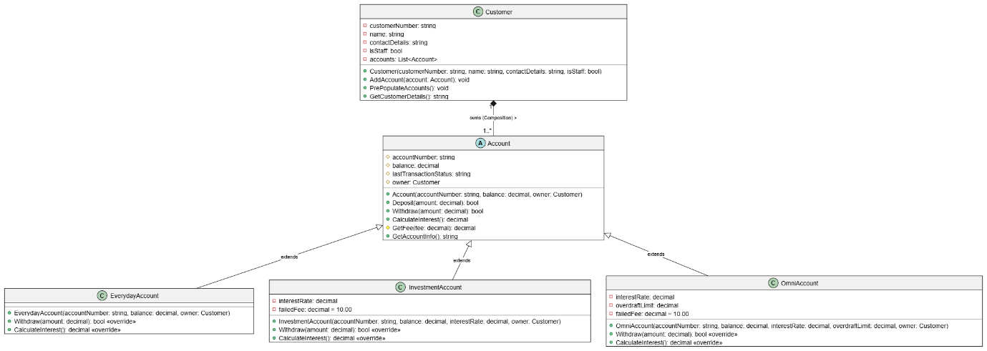

Technical Explanation
The proposed banking system uses important Object-Oriented Programming (OOP) principles, including inheritance, encapsulation, polymorphism, and composition. These principles help make the system easier to understand, maintain, and extend.
The main class in the design is the abstract Account class. It is abstract because a general account should not be created directly. Instead, it provides the common attributes and operations that are shared by all account types. These include accountNumber, balance, lastTransactionStatus, and owner. The class also provides methods such as Deposit, Withdraw, CalculateInterest, and GetFee. The account information is kept within the class so that banking operations and calculations are handled by the domain classes rather than the GUI.
The three account types inherit from Account: EverydayAccount, InvestmentAccount, and OmniAccount. Each account type has its own behaviour. EverydayAccount does not provide interest or overdraft facilities. InvestmentAccount uses a variable interest rate and has a fixed fee for failed transactions. OmniAccount provides interest on balances above $1,000 and allows a specified overdraft limit. The Withdraw and CalculateInterest methods are overridden where required so that each account can apply its own rules. This demonstrates polymorphism because the system can work with different account types through the common Account class.
Composition is used between Customer and Account. Each Customer owns a List<Account>, allowing the system to store the customer's accounts. The isStaff attribute also distinguishes regular customers from bank staff. When transaction fees apply, the GetFee method can apply the required 50% discount for bank staff. This keeps the business rules inside the domain model and maintains separation between the banking logic and the GUI.

User flow diagram
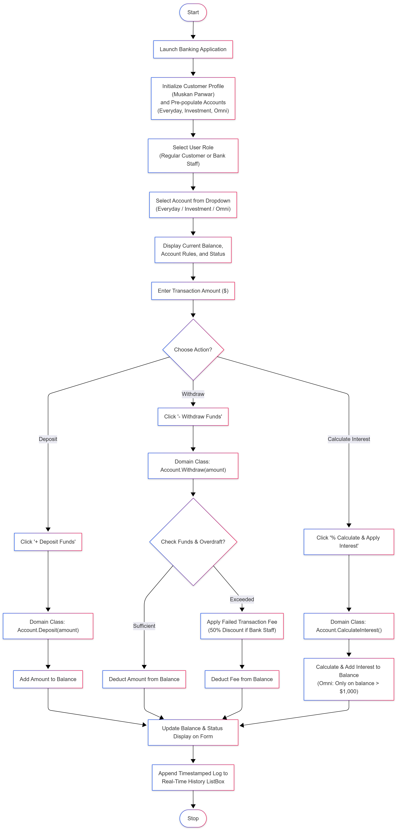

WireFrame
