**Download/Sort/Convert/Preprocess/QC Raw Data**

**Required Software**: Filezilla (or another FTP software), MRIcoGL, FSL6.0, MRTrix3, PyDesigner, [dicomSort](https://github.com/muscbridgelab/dicomSort)

1. **Download raw data from CBIHome**
   1. Access CBIHome through an FTP client (requires MUSC wifi or VPN)
      1. sftp://cbihome.musc.edu
      2. Log in with NETID and PW
   2. Navigate to MRdata folder

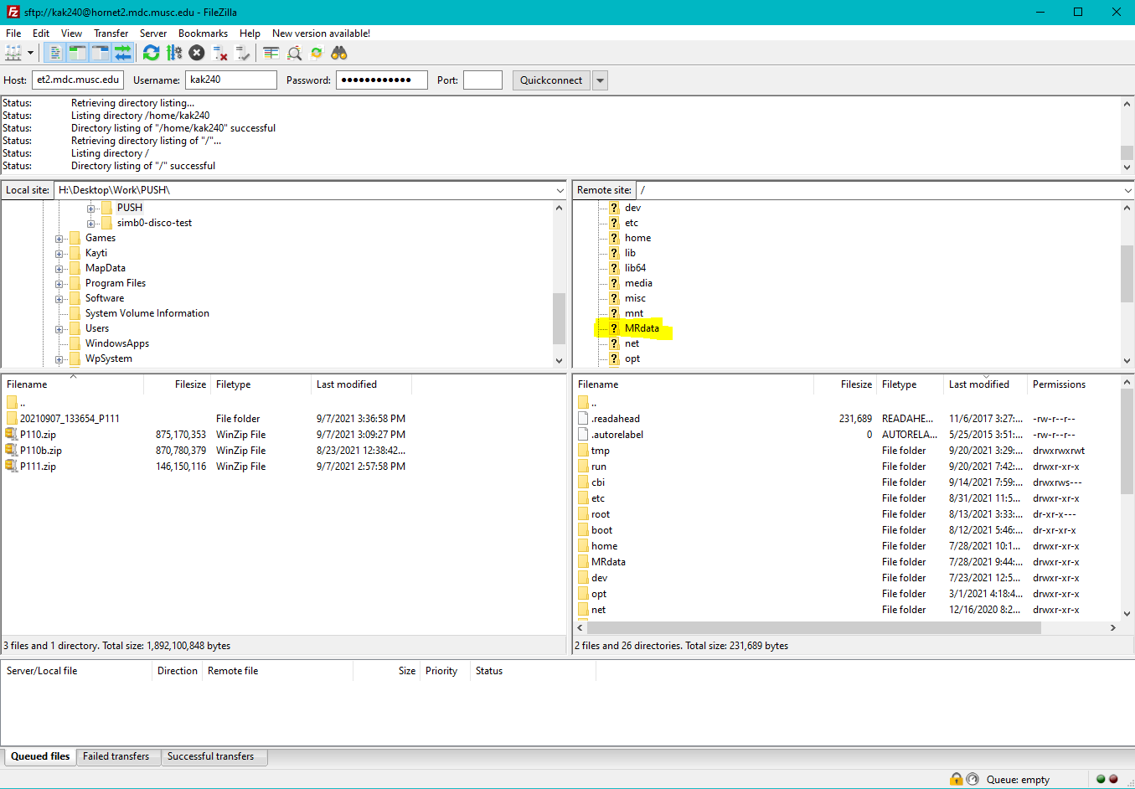

* 1. Navigate to the folder of the PI of the study, then to the study folder, then click on the ‘upload’ folder
  2. You will see a series of .zip folders, download whichever you need.
  3. Move them into the 00_zipped_archive folder

1. **Convert raw dicoms to nii**
   1. Run the script convert_dcm2nii.sh (open with the terminal app)
   2. Input the subject IDs that you want to convert
   3. The script will make a subject folder in the 02_dicom folder and the 03_nii folder