[label=parcel, autoclose, autoplay, text=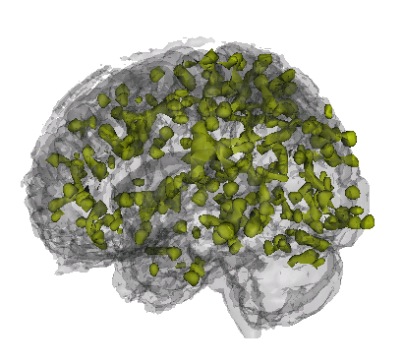 ]60pt60ptoutput.avi

1 Education
2008–2010ScMJohns Hopkins School of Public HealthBaltimore, MDArea of Study: fMRI brain image data analysis
Thesis Topic: An Iterative Approach to Hemodynamic Response Function Temporal Derivatives in Statistical Parametric Mapping for Functional Neuroimaging
Adviser: Professor Brian Caffo 2004–2008BSThe University of ScrantonScranton, PAGPA: 3.87Majors: Biomathematics and Neuroscience
Summa Cum Laude
Advisers: Professor Jakub Jasinski, Professor J. Timothy Cannon

2 Professional Experience
2009–PresentResearch AssociateJohns Hopkins Biostatistics Center (JHBC)Baltimore, MDCollaborated on statistical projects with senior consultants.
Report writing and analyzing data using statistical software: R, Stata.
Cleaning and checking quality of data 2010–PresentData AnalystLaboratory for Neurocognitive and Imaging Research at Kennedy Krieger InstituteBaltimore, MD Analysis of functional MRI (fMRI) imaging studies
Programming consultant: Matlab & R.
Participation in the ADHD 200 Competition 2008InternAnalysis & InferenceSwarthmore, PA Cooperated on statistical projects and conferenced with clients about possible analysis options.
Report writing of analyses: Stata
Data cleaning 2007Research InternDupont Stine-Haskell LaboratoryWilmington, DEDeveloped lab skills and techniques: cell culturing, making and sterilizing broth media, optical density readings, inoculations, quality control, cell counts, screening for fungicidal properties of compounds.
References
[1] H.E. Hinson, E. Melnychuk, Muschelli, J., D.F. Hanley, I.A. Awad, and W.C. Ziai. Drainage efficiency with dual versus single catheters in severe intraventricular hemorrhage. Neurocritical Care, pages 1–7, 2011.
[2] J. Jaffe, E. Melnychuk, Muschelli, J., W. Ziai, T. Morgan, D.F. Hanley, and I.A. Awad. Ventricular catheter location and the clearance of intraventricular hemorrhage. Neurosurgery, 2011.
[3] D.W. Newell, M.M. Shah, R. Wilcox, D.R. Hansmann, E. Melnychuk, Muschelli, J., and D.F. Hanley. Minimally invasive evacuation of spontaneous intracerebral hemorrhage using sonothrombolysis. Journal of neurosurgery, pages 1–10, 2011.
[4] M.F. Niedner, W.C. Huskins, E. Colantuoni, Muschelli, J., JM Ii, T.B. Rice, R.J. Brilli, and M.R. Miller. Epidemiology of central line-associated bloodstream infections in the pediatric intensive care unit. Infection control and hospital epidemiology: the official journal of the Society of Hospital Epidemiologists of America, 32(12):1200, 2011.

3 Computer skills
ScriptingProficient: R, Stata, Matlab, Novice: SASMarkup TEX, http://www.latex-project.org/LATEX, BibTEX, TeXShop, WinEdt Programminghttp://www.cplusplus.com/C++, http://msdn.microsoft.com/en-us/vbasic/defaultVisual Basic

4 Honors and Awards
2007–2008Presidential Scholar (Full Tuition Scholarship) 2004–2008Dean’s List 2004Alpha Lambda Delta 2008Alpha Sigma Nu

5 Academic Service
2010–PresentMentor, Head of Householdhttp://incentivementoringprogram.org/Incentive Mentoring Program Mentor and tutor a student from Dunbar High School, teaching coursework, life skills, support as needed.

