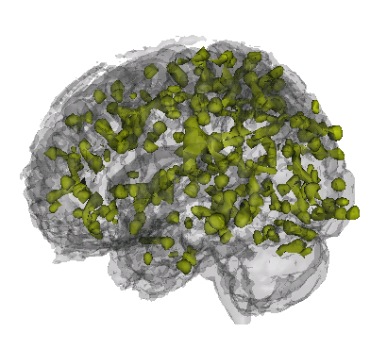

John Muschelli

Education
2008–2010 ScM, Johns Hopkins School of Public Health, Baltimore, MD.
Area of Study: fMRI brain image data analysis
Thesis Topic: An Iterative Approach to Hemodynamic Response Function Temporal Deriva- tives in Statistical Parametric Mapping for Functional Neuroimaging
Adviser: Professor Brian Caffo
2004–2008 BS, The University of Scranton, Scranton, PA, GPA: 3.87.
Majors: Biomathematics and Neuroscience
Summa Cum Laude
Advisers: Professor Jakub Jasinski, Professor J. Timothy Cannon

Professional Experience
2009–Present Research Associate, Johns Hopkins Biostatistics Center (JHBC), Baltimore, MD.
Collaborated on statistical projects with senior consultants.
Report writing and analyzing data using statistical software: R, Stata. Cleaning and checking quality of data
2010–Present Data Analyst, Laboratory for Neurocognitive and Imaging Research at Kennedy
Krieger Institute, Baltimore, MD.
Analysis of functional MRI (fMRI) imaging studies Programming consultant: Matlab & R. Participation in the ADHD 200 Competition
2008 Intern, Analysis & Inference, Swarthmore, PA.
Cooperated on statistical projects and conferenced with clients about possible analysis options. Report writing of analyses: Stata
Data cleaning
2007 Research Intern, Dupont Stine-Haskell Laboratory, Wilmington, DE.
Developed lab skills and techniques: cell culturing, making and sterilizing broth media, optical density readings, inoculations, quality control, cell counts, screening for fungicidal properties of compounds.

Publications
[1] H.E. Hinson, E. Melnychuk, Muschelli, J., D.F. Hanley, I.A. Awad, and W.C. Ziai. Drainage efficiency with dual versus single catheters in severe intraventricular hemorrhage. Neurocritical Care, pages 1–7, 2011.

[2] J. Jaffe, E. Melnychuk, Muschelli, J., W. Ziai, T. Morgan, D.F. Hanley, and I.A. Awad.
Ventricular catheter location and the clearance of intraventricular hemorrhage. Neurosurgery,
2011.

[3] D.W. Newell, M.M. Shah, R. Wilcox, D.R. Hansmann, E. Melnychuk, Muschelli, J., and D.F. Hanley. Minimally invasive evacuation of spontaneous intracerebral hemorrhage using sonothrombolysis. Journal of neurosurgery, pages 1–10, 2011.

2221 E Lombard Street, Baltimore MD – 21231
H 610-291-7685 • B muschellij2@gmail.com 1/2
[4] M.F. Niedner, W.C. Huskins, E. Colantuoni, Muschelli, J., JM Ii, T.B. Rice, R.J. Brilli, and M.R. Miller. Epidemiology of central line-associated bloodstream infections in the pediatric intensive care unit. Infection control and hospital epidemiology: the official journal of the Society of Hospital Epidemiologists of America, 32(12):1200, 2011.

Computer skills

Scripting Proficient: R, Stata, Matlab, Novice: SAS
Programming C++, Visual Basic

Markup TEX, LATEX, BibTEX, TeXShop, WinEdt

Honors and Awards
2007–2008 Presidential Scholar (Full Tuition Scholarship).
2004–2008 Dean’s List.
2004 Alpha Lambda Delta.
2008 Alpha Sigma Nu.

Academic Service
2010–Present Mentor, Head of Household, Incentive Mentoring Program.
Mentor and tutor a student from Dunbar High School, teaching coursework, life skills, support as needed.

2221 E Lombard Street, Baltimore MD – 21231
H 610-291-7685 • B muschellij2@gmail.com 2/2

