MS WORD Example

library(knitcitations)  
cleanbib()  
cite_options(citation_format= "pandoc")  
  
library(pander)  
pander(summary(cars))

|  |  |
| --- | --- |
| speed | dist |
| Min. : 4.0 | Min. : 2 |
| 1st Qu.:12.0 | 1st Qu.: 26 |
| Median :15.0 | Median : 36 |
| Mean :15.4 | Mean : 43 |
| 3rd Qu.:19.0 | 3rd Qu.: 56 |
| Max. :25.0 | Max. :120 |

ctl <- c(4.17,5.58,5.18,6.11,4.50,4.61,5.17,4.53,5.33,5.14)  
trt <- c(4.81,4.17,4.41,3.59,5.87,3.83,6.03,4.89,4.32,4.69)  
group <- gl(2, 10, 20, labels = c("Ctl","Trt"))  
weight <- c(ctl, trt)  
lm.D9 <- lm(weight ~ group)  
pander(lm.D9)

|  |  |  |  |  |
| --- | --- | --- | --- | --- |
|  | Estimate | Std. Error | t value | Pr(>|t|) |
| **groupTrt** | -0.371 | 0.3114 | -1.191 | 0.249 |
| **(Intercept)** | 5.032 | 0.2202 | 22.85 | 9.547e-15 |

Fitting linear model: weight ~ group

And you can embed things coefficients like we always could using the r syntax. Like the coefficient for treatment was -0.371 and the CI was ....

You can also embed plots, for example:

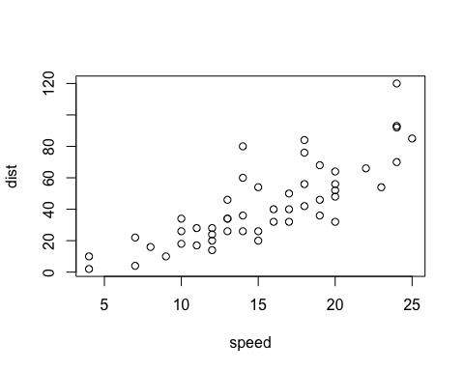

Note that the echo = FALSE parameter was added to the code chunk to prevent printing of the R code that generated the plot.

$$α+β=x$$

$$\begin{matrix}\dot{x}+\overline{x} & = & 2 \\ \hat{y} & = & 400\end{matrix}$$

I think the knitr package 1–3 is really awesome!  
I cannot believe this shit. I can't believe Reference 4 really did it.

write.bibtex(file = "test.bib")  
# bibliography()

1. Xie Y. knitr: A general-purpose package for dynamic report generation in r [Internet]. 2014. Available from: <http://yihui.name/knitr/>

2. Xie Y. Dynamic documents with R and knitr [Internet]. Boca Raton, Florida: Chapman; Hall/CRC; 2013. Available from: <http://yihui.name/knitr/>

3. Xie Y. knitr: A comprehensive tool for reproducible research in R [Internet]. In: Stodden V, Leisch F, Peng RD, editors. Implementing reproducible computational research. Chapman; Hall/CRC; 2014. Available from: <http://www.crcpress.com/product/isbn/9781466561595>

4. Boettiger C. knitcitations: Citations for knitr markdown files [Internet]. 2014. Available from: <http://CRAN.R-project.org/package=knitcitations>