January 29, 2019

Dear Editor,

Thank you for the comments about the confusing notation for my original submission TAS-19-016. I have discussed the notation with colleagues and have updated it to hopefully be more standard and understandable. If additional revisions are necessary to allow this paper to be reviewed, I will be happy to accommodate.

Thank you for your consideration.

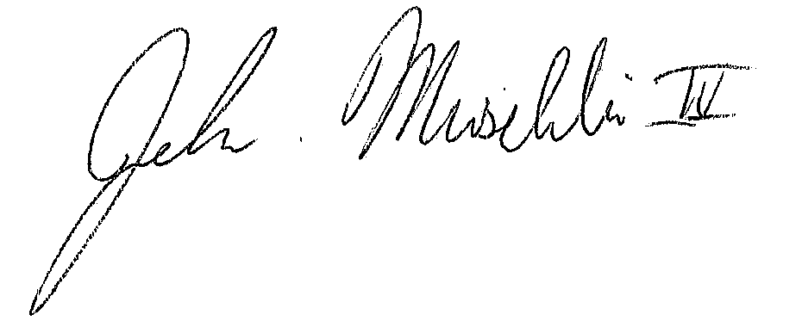

John Muschelli, PhD

Assistant Scientist

Department of Biostatistics

Johns Hopkins Bloomberg School of Public Health