design and analysis of a Tunable stiffness joint

|  |  |
| --- | --- |
| Walter Bircher*  Yale University  New Haven, CT, USA | Ali Yawar*  Yale University  New Haven, CT, USA |

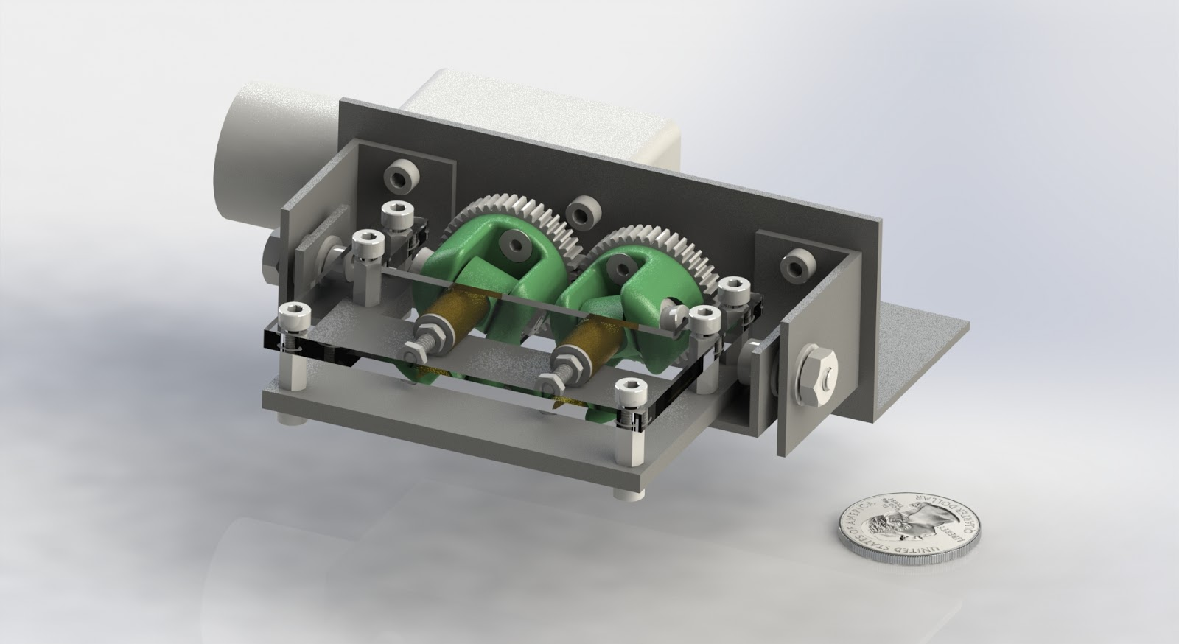

Figure 1: A one DOF revolute joint, capable of modulating perceived joint stiffness using a single DC motor. *Future version of this figure will include updated CAD model with encoder and spring, at multiple Joint Angles to illustrate splaying of prongs. Could include similar view of metatarsals splaying under load for comparison if we want to go that route.*

Abstract

We present the design and analysis of a revolute joint with tunable stiffness mechanically controllable by a single actuator. Kinematic constraints convert angular displacement at the joint hinge to extension () of a linear spring, such that where is the tuning parameter. We model the mechanism as a constrained kinematic chain to develop design guidelines. We also present experimentally characterized moment-angle properties of the joint, where we observe a 7-fold increase in stiffness as is spanned in .

INTRODUCTION

Traditionally, robots have been built to have rigid actuators and joints, making them excellent at tasks such as moving objects to precise locations in space, and handling large external loads. While this is useful in industrial settings, robots are more frequently being used in unstructured environments -where compliant joints can increase energy efficiency and robustness to unexpected disturbances. For this reason, a great deal of research has focused on incorporating compliance into the design of robots. In particular, controlled compliance can increase energy efficiency in walking robots [22],[23]. While compliance can be generated from operating a motor in torque control mode, in many situations tuning structural compliance is often simpler, more effective, and more dependable than relying on precise control and feedback. Tunable stiffness actuators and joints are frequently used in locomotion [2],[4],[7],[15] as compliant knee/ankle joints, for safe operation in Human-Computer Interaction scenarios [14], tunable vibration reduction [8], compliant manipulators [3],[5], or for general purpose actuation of robot joints [17], [19], [21].

These joints can be classified according to the phenomenon underlying their operation. Purely mechanical joints mostly rely on antagonistic springs [1],[14], changing effective spring length and location of the equilibrium point [1], [2], [7], [8], [13], [14], [15], [17], [19], variable structural compliance [4], [18], [20], and jamming [3],[5]. Magnetism has been used extensively in active stiffness joints in [9], [10], [11], in the form of magneto-rheological elastomers (MREs) whose stiffness and damping properties are a function of the applied magnetic field, as well as in [12] which uses alignment of magnetic disks to modify the coupling between input and output torque within a range of motion of 20°. Additional circuitry and control schemes are required for control of the magnetic field in these devices, and there are limitations of the types of environments they can operate in.

***\*Both authors contributed equally***

This paper presents a novel tunable stiffness joint, originally inspired by human metatarsals--bones in the human foot. The presented joint is inspired from the human foot’s stiffening as a result of misalignment between the metatarsal bones which cause extension of distal transverse metatarsal ligaments [25] under bending. By tuning this misalignment (disk angle in our mechanism), the overall structural stiffness can be modified. Our mechanism could effectively be incorporated into the foot of a walking/hopping robot. Our design provides a continuous stiffness increase from zero to infinity (where the structural rigidity of components becomes dominant). Rather than depending on MRE liquids and magnetic field generating coils, our design relies purely on mechanical components. Unlike MREs, or granular jamming based mechanisms, material selection is only a function of suitability for the range of loads under which the mechanism is expected to operate.

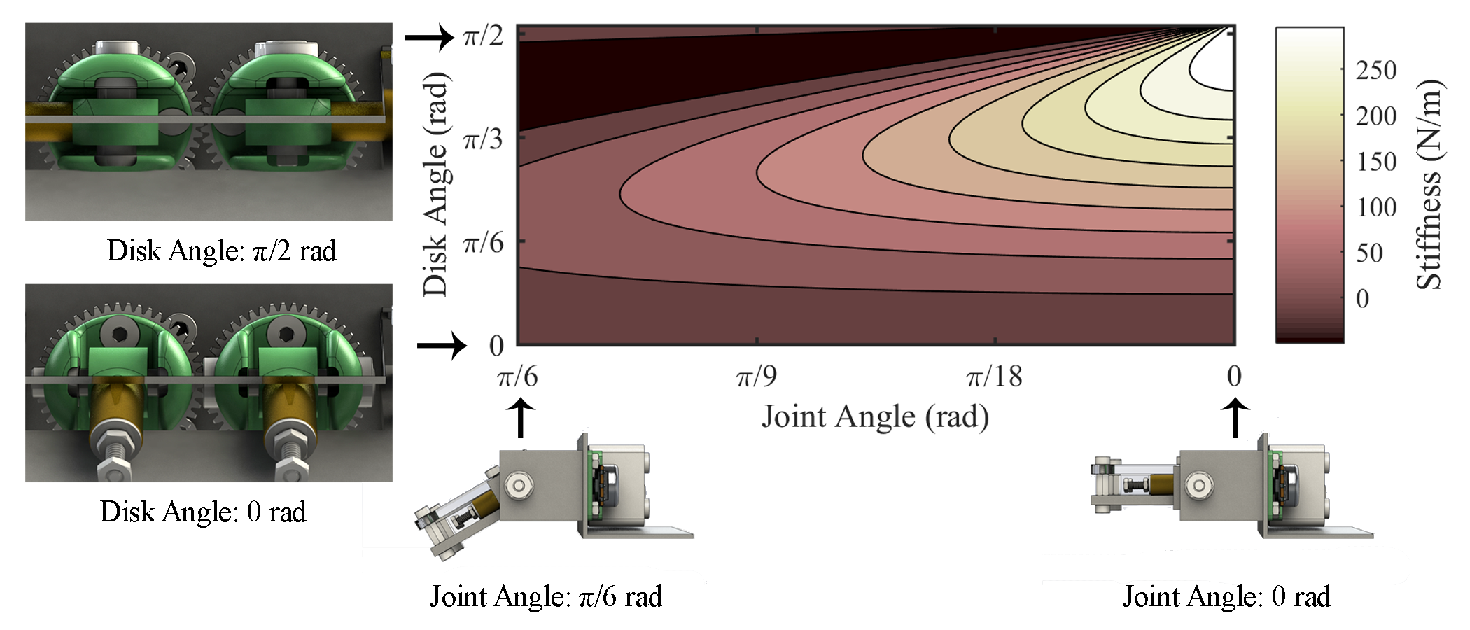

Figure 2: Theoretical perceived joint stiffness over a range of joint angles and disk angles. For a given disk angle, stiffness is linear as the joint angle increases, starting from neutral (Joint Angle: 0 rad). As the disk angle approaches π/2, much higher stiffness is achievable, but varies nonlinearly as the joint angle is forced further away from neutral. *Future version of this figure will include updated CAD model with encoder, as well as clearer renderings of Disk Angles.*

Nomenclature

= spring stiffness  
 = prong length  
 = disk angle     
= joint angle  
= hinge angle   
= spring length

= restoring torque

Methods and materials

The principle of operation, mathematical formulation, design, and prototype evaluation of the tunable stiffness device are presented in detail herein.

Principle of Operation & Formulation

A diagram of the tunable stiffness mechanism is shown in fig 3. The joint consists of two parallel plates or boards (separation = 10 mm) hinged at one end. Sandwiched between these plates are a pair of equal length prongs (length ), hinged on the proximal end and spring loaded on the distal. Prongs are in contact with the hinged plates all along their length, and hence are kinematically coupled to the plates. A single parameter () controls the kinematic coupling, by modifying the angle of the prong hinges with respect to the board hinge according to equation 1 (fig 5).

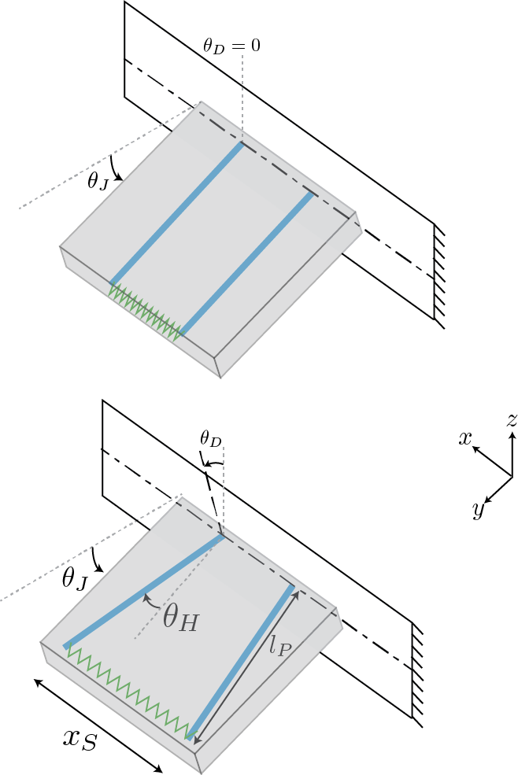

Figure 3 Sketch showing important parameters of the model. It is worth noting that restoring torque acts in +x direction, is measured in the xz plane.



Figure 4: Physical prototype of tunable stiffness joint, made from machined aluminum and 3D-printed (Stratasys ABS*plus*) parts. *Will be replaced with DSLR photograph in lightbox of updated prototype with encoder. Will also include photographs of final experimental setup.*

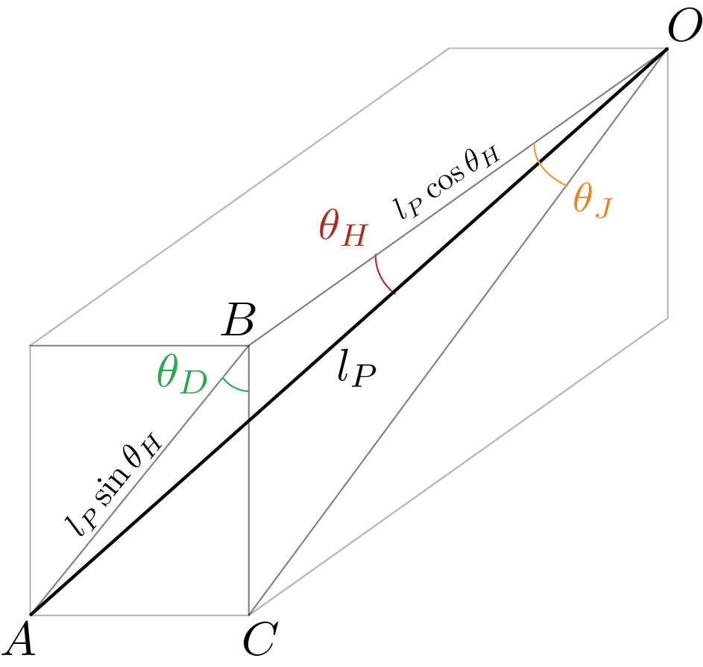

Figure 5 Relationship between the joint, disk and hinge angles, expressed as the trigonometric relationship in equation 1. AC is a prong, hinged at O.

Comparing side **BC** in and , we get,

Rearranging,

When , and are always equal Specifically, aligns the prong hinges with the board hinge, and deflection of the board causes no spring extension which results in the zero stiffness regime. causes theoretically infinite extension of the spring for an infinitesimal board deflection, resulting in the infinite stiffness regime.

**AC** is stretched spring length. Therefore,

At , for all values of , i.e. the spring doesn’t stretch at all.

Let be vector along a prong, with its origin at the base of the prong. Let be the direction of movement of the prong at a given hinge angle. At any given position of the joint, spring force is given by

Restoring torque due to one prong is produced by the component of this force along

Adding torques due to forces on both prongs, the resultant torque is only in the +x direction, as torque contributions in other directions are equal and opposite from both the prongs.

From the expression for net torque, we can see that the effective torsional stiffness scales with , which provides a design guideline i.e. a smaller form factor is achievable with a stiffer spring, without compromising overall torsional stiffness. In virtually all published designs, stiffness is nonlinear beyond a certain strain range. In our design, by manipulating , an appropriate strain range can be prescribed depending on the expected loads on the mechanism.

Need to discuss negative stiffness region. Need to discuss Figure 2 a bit. Can you explain negative stiffness? Hard to explain-ish.

Also need to briefly highlight scale invariance, with corresponding maths.

Prototype Design & Evaluation

To validate the theoretical results found in analysis, a tunable stiffness joint was constructed and its stiffness characterized over a range of disk angles and input torques. The prototype was constructed from aluminum stock, 3D-printed parts (Stratasys ABS*plus*), and COTS (commercial off the shelf) hardware. An inexpensive DC motor with non-back-drivable worm gearhead was used to actuate the disk angle, and a linear 10K potentiometer used to measure the disk angle. A Renco RCML15 optical encoder was used to measure the board angle deflection. Data from both the disk angle potentiometer and the board angle encoder was read by an Arduino Mega 2560. The disk angle potentiometer reading was used in a PID control loop to incrementally move the disk angle to linearly spaced set points within . A tendon was attached to the free portion of the board, and was driven by a DC motor was used to vary the torque applied to the board.

The system was rigidly mounted to an optical breadboard, shown in fig. 4, and all desired combinations of disk angle and loading torque were cycled through automatically, while the Arduino read the encoder to obtain the corresponding board angle for each data point. This data was recorded in an array on a host machine, which read available serial data transmitted via USB by the Arduino. Then, the resultant force vector applied to the board was computed, which was possible due to the known geometry of the system, as well as the power supplied to the loading DC motor. The result of this characterization is shown in fig. 5.





Figure 6: Experimental characterization of resistive joint torques, over a range of Board Angles, and corresponding joint stiffness at each disk angle tested, assuming linear stiffness profiles over the range of tested joint angles. *Will be replaced with densely sampled results of final experimental setup (properly formatted plots), the corresponding data of which will be collected automatically and much more precise than the results shown here. Will also include figure comparing experimental results to theoretical stiffness.*

Experimental results agree qualitatively with theoretical predictions viz. stiffness increases with increasing disk angle, with the slope of stiffness rise also increasing (fig 5b). Moreover, for small angular deflections, the joint behaves virtually linearly (fig 5a). *What remains is to conduct a finer resolution experiment and overlay experimental data points over theoretical plot.*

Conclusion

This paper presents the design and analysis of a continuously tunable stiffness joint, along with physical experimental validation, which characterizes the stiffness of the device in good agreement with the theoretical model. We showed that the resultant stiffness of the joint can be easily adjusted from zero to infinity (in which case the perceived stiffness is due to the material stiffness of the load bearing members of the device), and that the perceived stiffness is constant for small deflections of the board in any configuration. Thus, this device would find great use in any application requiring a large range of tunable stiffness at a joint, for which the expected joint deflection does not exceed 0.2-0.3 rad -- for example the ankle of a walking robot. We show that the tunable stiffness behavior of the device is scale invariant, and foresee future applications in miniature devices.

Acknowledgments

The authors would like to thank M. Venkadesan, S. Mandre and M.M. Bandi for the original idea and motivation behind studying bending stretching coupling resulting from misaligned metatarsals in human foot.

References

[1] B. Vanderborght, A. Albu-Schaeffer, A. Bicchi, E. Burdet, D.G. Caldwell, R. Carloni, M. Catalano, O. Eiberger, W. Friedl, G. Ganesh, M. Garabini, M. Grebenstein, G. Grioli, S. Haddadin, H. Hoppner, A. Jafari, M. Laffranchi, D. Lefeber, F. Petit, S. Stramigioli, N. Tsagarakis, M. Van Damme, R. Van Ham, L.C. Visser, S. Wolf, Variable impedance actuators: A review, Robotics and Autonomous Systems, Volume 61, Issue 12, December 2013, Pages 1601-1614.

[2] Enoch A, Vijayakumar S. Rapid Manufacture of Novel Variable Impedance Robots. ASME. J. Mechanisms Robotics. 2015;8(1):011003-011003-11. doi:10.1115/1.4030388.

[3] Y. J. Kim, S. Cheng, S. Kim and K. Iagnemma, "A Novel Layer Jamming Mechanism With Tunable Stiffness Capability for Minimally Invasive Surgery," in IEEE Transactions on Robotics, vol. 29, no. 4, pp. 1031-1042, Aug. 2013. doi: 10.1109/TRO.2013.2256313

[4] Kevin C. Galloway, Jonathan E. Clark and Daniel E. Koditschek, “Design of a Tunable Stiffness Composite Leg for Dynamic Locomotion” in ASME 2009 International Design Engineering Technical Conferences and Computers and Information in Engineering Conference

[5] N. G. Cheng et al., "Design and Analysis of a Robust, Low-cost, Highly Articulated manipulator enabled by jamming of granular media," Robotics and Automation (ICRA), 2012 IEEE International Conference on, Saint Paul, MN, 2012, pp. 4328-4333. doi: 10.1109/ICRA.2012.6225373

[6] Polymeric micromechanical components with tunable stiffness, Manias, E. and Chen, J. and Fang, N. and Zhang, X., Applied Physics Letters, 79, 1700-1702 (2001)

[7] T. Takuma, S. Hayashi and K. Hosoda, "3D bipedal robot with tunable leg compliance mechanism for multi-modal locomotion," 2008 IEEE/RSJ International Conference on Intelligent Robots and Systems, Nice, 2008, pp. 1097-1102

[8] Johan M. Cronjé, P. Stephan Heyns, Nico J. Theron, and Philip W. Loveday Development of a Variable Stiffness and Damping Tunable Vibration Isolator Journal of Vibration and Control March 2005 11: 381-396

[9] Dynamic compression testing of a tunable spring element consisting of a magnetorheological elastomer M Kallio, T Lindroos, S Aalto, E Järvinen, T Kärnä and T Meinander Published 2 March 2007 • IOP Publishing Ltd Smart Materials and Structures, Volume 16, Number 2

[10] John M. Ginder ; William F. Schlotter ; Mark E. Nichols; Magnetorheological elastomers in tunable vibration absorbers. Proc. SPIE 4331, Smart Structures and Materials 2001: Damping and Isolation, 103 (July 2, 2001)

[11] G. J. Liao, X-L Gong, S. H. Xuan, C. J. Kang, and L. H. Zong, Development of a real-time tunable stiffness and damping vibration isolator based on magnetorheological elastomer Journal of Intelligent Material Systems and Structures January 2012 23: 25-33, first published on December 8, 2011

[12] Choi, Junho, et al. "Design of a robot joint with variable stiffness." Robotics and Automation, 2008. ICRA 2008. IEEE International Conference on. IEEE, 2008.

[13] Choi, Junho, et al. "A robot joint with variable stiffness using leaf springs." IEEE Transactions on Robotics 27.2 (2011): 229-238.

[14] T. H. Huang, J. Y. Kuan and H. P. Huang, "Design of a new variable stiffness actuator and application for assistive exercise control," 2011 IEEE/RSJ International Conference on Intelligent Robots and Systems, San Francisco, CA, 2011, pp. 372-377

[15] Ronald Van Ham, Bram Vanderborght, Michaël Van Damme, Björn Verrelst, Dirk Lefeber, MACCEPA, the mechanically adjustable compliance and controllable equilibrium position actuator: Design and implementation in a biped robot, Robotics and Autonomous Systems, Volume 55, Issue 10, 31 October 2007, Pages 761-768, ISSN 0921-8890

[16] David J. Braun, Matthew Howard and Sethu Vijayakumar, Exploiting Variable Stiffness in Explosive Movement Tasks In Proc. R:SS 2011

[17] B. S. Kim and J. B. Song, "Design and Control of a Variable Stiffness Actuator Based on Adjustable Moment Arm," in IEEE Transactions on Robotics, vol. 28, no. 5, pp. 1145-1151, Oct. 2012

[18] O. Tabata et al., "Microfabricated tunable bending stiffness device," Proceedings IEEE Thirteenth Annual International Conference on Micro Electro Mechanical Systems (Cat. No.00CH36308), Miyazaki, 2000, pp. 23-27

[19] Sugano, Shigeki, S. Tsuto, and Ichiro Kato. "Force control of the robot finger joint equipped with mechanical compliance adjuster." Intelligent Robots and Systems, 1992., Proceedings of the 1992 lEEE/RSJ International Conference on. Vol. 3. IEEE, 1992

[20] J. Schuy, P. Beckerle, J. Wojtusch, S. Rinderknecht and O. von Stryk, "Conception and evaluation of a novel variable torsion stiffness for biomechanical applications," 2012 4th IEEE RAS & EMBS International Conference on Biomedical Robotics and Biomechatronics (BioRob), Rome, 2012, pp. 713-718

[21] M. G. Catalano et al., "VSA-CubeBot: A modular variable stiffness platform for multiple degrees of freedom robots," 2011 IEEE International Conference on Robotics and Automation, Shanghai, 2011, pp. 5090-5095

[22] Sawicki GS, Lewis CL, Ferris DP. It pays to have a spring in your step. Exercise and sport sciences reviews. 2009;37(3):130

[23] Juergen Rummel, Fumiya Iida, Andre Seyfarth, One-Legged Locomotion with a Compliant Passive Joint IOS Press, 2006

[24] H. Q. Vu and L. G. Marcantini, "Knee stiffness adjustment for energy efficient locomotion of a legged robot on surfaces with different stiffness," 2013 IEEE International Conference on Robotics and Biomimetics (ROBIO), Shenzhen, 2013, pp. 1825-1831

[25] Dias, M.A. Singh, D.K., Bandi, M.M., Venkadesan, M. and Mandre S. Role of the tranverse arch in stiffness of the human foot, APS Meeting Abstracts, 2015