Table of contents

1. Introduction
2. Purpose of the document
3. Client specification
   * 1. Company Background
     2. Company Requirement
4. E-R Diagram
5. Project Overview
   * 1. Project architecture

1. Introduction

Students are introduced to databases and given a basic understanding of database systems in the foundations of database system course. This course, which is a part of our curriculum, covers data models, entity and attribute definitions, database design, database building and manipulation, and the database management software that underpins all of these concepts.

Based on the task, we selected a local construction company that can be taken as a perfect candidate to implement what we learned from the course. This documentation is prepared to underline the requirements and the purpose of our project. The purpose of the document and what is included in the document is briefly explained on the next section. As a course assignment, we were required to build a database system for a certain company that will facilitate and manage business activities.

The section on customer specifications offers information about the company's history and requirements. The company's history and an explanation of the industries it mostly works in will be provided in the company's background. This requirement analysis document explains how various project-related tasks, such as managing employees, capital, expenses, and so on, may be handled while still meeting the client's requirements. These inquiries form the core of the project and must be addressed in a way that ensures the client provides unambiguous answers.

The corporate database is built based on the requirement analysis of the entire project. The project's domain is where the majority of record-keeping and business administration issues are resolved. Setting the project's scope and functionality is made simpler by the information provided in the requirement. The project users section clearly states who is able to modify, update, and maintain the system. These users are client workers who are authorized to consume data and create queries for making business decisions. The project type and platform section offer insights on the project's application areas and operating conditions.

1. Purpose of the document

This document is prepared is prepared to give a general road-map of how DBDLS(database development life cycle) can be implemented while building the database system. From the table of content section each part is on their own will be briefly explained.

Building a system without a requirement analysis and underlying system mission and objective would be a much difficult. This document offers those things independently. Client requirement are specified in a clear way, this helps identifying and conceptually building system data model.

Entity relational diagram is included from the requirements set by the client. Company background is there for knowing for what type of enterprise is our system will be built.

In the project overview section project scope and users are obtained from background of company and their requirements. The system we are building includes a range of users in the company. This section is included to get what are the daily users of this system and at what extent the project covers.

1. Client specification

We have acquired a lot of data that can be used into our product. We are able to pinpoint the key issues and issues that this database system will be able to tackle based on customer input and their requirements. It is preferable to understand for what sort of organization the project is before moving directly to the firm requirements.

3.1 Company background

**Huang He Construction and Trade**, a private successful business founded in 2018, specializes in building structures and delivering building supplies to construction sites. On a daily basis, a significant volume of data is produced on each and every business action. Building an information system—in this example, an enterprise database system—helps to effectively and efficiently track the progress, activity, and transaction. The database system makes an excellent choice for this need. Ingestion of data, updating, and querying of data that might result in business-driven decisions should all be supported by the system.

The business supports a large number of people in a variety of professions; these workers are a tremendous benefit to the business' development and performance. Projects accepted provide a diverse skill set. One of the rules in the bureaucracy is founded on the idea that treating employees professionally might lead to improved working conditions.

Every project and business activity is made possible by the company's capital, which includes its cars, machinery, trucks, and equipment. It is essential to manage and track capital effectively. This business is raising the number of capitals from the ground up. Projects include new machinery and vehicles, while older equipment is being replaced by newer ones when it wears out. This entire action ought to be planned.

Customers of the business comprise both clients who are wanting to hire the organization for a project and prospective clients. Huang He They feel that a number of the tendencies he has highlighted will lead to an enormous rise in the demand for their service. They incorporate project tracking using a centralized information system that includes workers and resources as part of the process. A successful management system may result from this strategy. The benefits of using an effective management system include increased productivity, efficient workforce management, and on-time project completion.

Another strategy is to keep track of daily project activities' accomplishments. Customers that are dependent on the firm for material supply find that this strategy works best for them. When a client requests a certain type of material, such as when a truck, time, or material is needed, these details are documented as part of the project.

Expense management is the final task. Paying employees, buying supplies, and fulfilling orders are a few of them. The list of expenses is not exhaustive. With a system that can track every spending, the financial sector may benefit. Reports on data that lead to an informed decision can be created as an aggregate query to determine when there is a higher expenditure.

Currently there is a record system that keeps track of all those activities. It provides a general information about Huang He, its projects, almost all the activates listed above. The system is record based, that can promote redundancy and inconsistency of data.

Problems with the current system include:

* The information available on the record-based system is too limited and it is much harder to access it because of improper organization of data, access time is very large.
* The existence of a record-based system means information is often recorded repetitively and there is no guarantee for recording again.
* Updating information is inconsistent, changes made to certain part is not reflected to the whole system.
* Generating a report is a huge task, time consuming because of the above problems.

3.2 company requirement

In this section of the document project requirement is briefly addressed. Requirements are collected using questionary method, Huang He record office was responsible for giving insights on the company background. Activities, transaction business guidelines listed on company background sub section. Requirement is the continuation and related to the above.

Responsibility of the database system:

1. Provide employee management that keep recording of every individual personnel working for the company, this sub-system must specify the role, salary, project participation, full profile of an employee.
2. A capital management for organizing and listing all capitals owned by the company, allows providing information which capital is currently in use, specifies which employee is currently administrating the capital.
3. Project held by should be available in a system, includes employee participation and capital management as association for generating information effectively.
4. Expense should be recorded in consistent manner, that can easily be modified when needed, recording expense is required to be a robust and inclusiveness of every type of expense the company can have.
5. They system must allow users to generate a specific information from sub-system.
6. Updating and modifying data should be facilitated in the system.

On the completion of project above requirements must be addressed fully. The next E-R Diagram section uses them for conceptualizing the potential system structure.

1. E-R Diagram

This sub-section of the document elaborates the requirements set above. An Entity relational diagram can be used to conceptualize the system in an easy and explanative way. Non-technical users of the system can take this diagram to check whether it meets the ways of solving old system problems.

The diagram has sub-components technically called entities as building block of its visual representation. Each block is carefully designed to meet the goals of system, there is a separate illustration that explains working atomic units, interconnection as well.

From listed system requirements these entities and attributes are able to be driven:

* A lot of employees share a common trait that can be mentioned as profession, the date they are part of the company (employed date), name, sex, address, employee identification, contact number. All these atomic units are part of a single, whole inclusiveness entity named **Employee**.

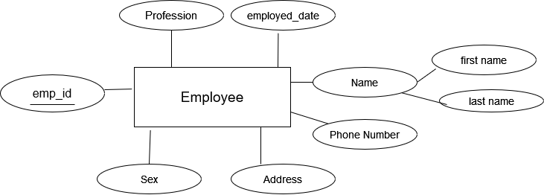

* Every capital in the company has these characteristics capital name, owned date, capital identification, how the capital is used or purpose. Capital identification is some sort of semantic numbering that is given to every capital. This could be used to identify capitals one from other.

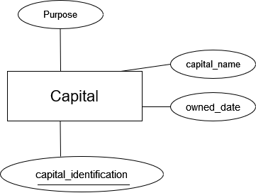

* Project name, start date, deadline date, project address, client potential owner of project. The dates project taken and put in action, the date agreed to finish represent start and deadline date respectively. Project address is for the place where the project is taking place.

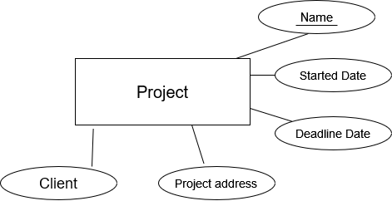

* The last sub-part is expense entity that has its own attributes like expense name, amount of expense, how much unit, expense name, date and description. The way will be used to identify each expense is joining expense date with its name. the main reason for this is if we have more than one expense of same name an attribute units is there for how many times that expense has occurred. So, units are simply couniting number of expenses on same date. This helps to identify each attribute uniquely.

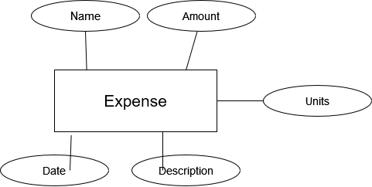

While on the stage of identifying each object entity for the system relationship was found among them. These relationships are set of practices, a way of conducting activities in the enterprise and illustrate how each particular business-related work is done.

Their relationship as follows:

* Employees serve as administrators for any capital the firm has. In this instance, a large number of capitals are managed by several staff. There are several connections present, and according to the company's rules, all capitals must be administered by a third party. An employee is fully permitted to refuse to be paid. Start date is the day an employee began working for a company or assumed control of a capital.

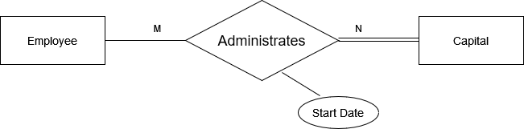

* As required by corporate regulations, there is a strong relationship between an employee and a project. Both the employee and the project cannot survive without the other; this is true of all participants. Start date is the day on which a worker first began to work on a certain project. Working hour is a property used to monitor how many hours an employee worked.

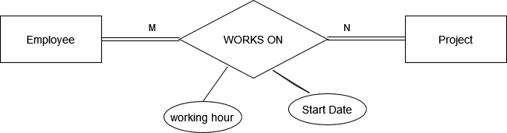

* The capital-expense connection is a type created to monitor capital-related costs. These might include car fuel fill-ups, rent on real estate, and a host of other expenses. While it makes sense for a capital to have expenses, it makes no sense for expenses to have capital. Expenses only play a small part in this connection.

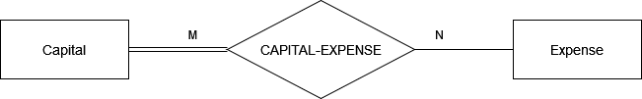

* Employee-expense relationship is same as capital-relationship in terms of participation, which is must to be included. One thing different is salary attributes is included.

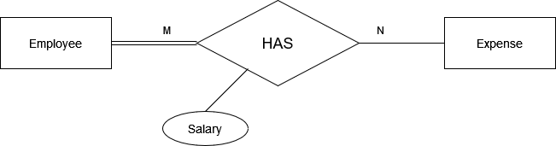

* 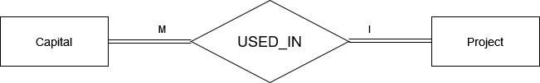The unique connection between capital and a project is the last. This connection illustrates how capital is used and managed in projects. A significant amount of capital is invested in one particular activity. Both entities must participate fully. We are unable to identify characteristics connecting them, in contrast to the correlations mentioned above

On their own, entities and connections don't provide a sophisticated picture of the system. The E-R diagram below shows every entity and their relationships.

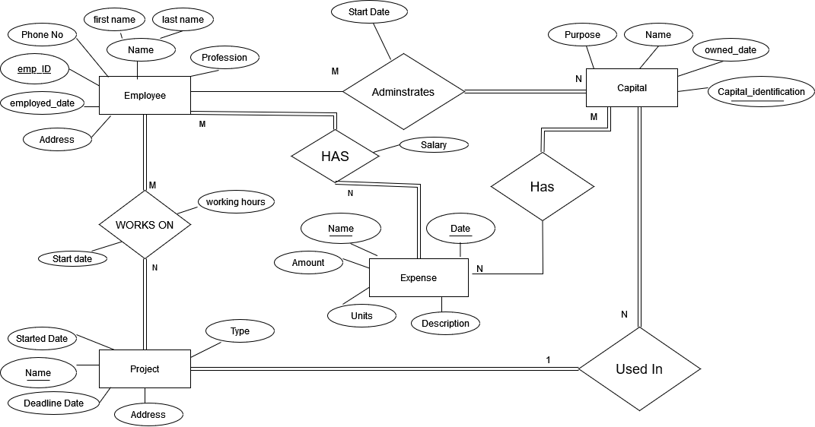

1. Project overview

5.1 project architecture

The database system will be installed on a personal computer locally. It is made to work with a single user who will be in charge of updating and manipulating in a single layer architecture. The system needs a Postgres database management program, which is installed on the user's computer.