Total is 18 marks, minus 2 mark for each question that cannot be answer.

PowerPoint or google slide required for presentation

PART 1:

3 students per group.

Each student responsible for a part of the coding and presentation. No one student should do all of the coding.

A PowerPoint Slide for the presentation:1 mark

Part 2:

web application:

<http://ec2-54-212-208-228.us-west-2.compute.amazonaws.com:8080/group-presentation/>

Web Services:

<http://ec2-3-134-92-53.us-east-2.compute.amazonaws.com:8080/products-ut-wo-db/rest/products>

Tomcat 9:

<http://ec2-3-134-92-53.us-east-2.compute.amazonaws.com:8080/>

PART 2:

url: http://localhost:8080/products-ut-wo-db/rest/availableProducts

Home Page:

Has top menu of the following:

Home

Add Product

Search Product

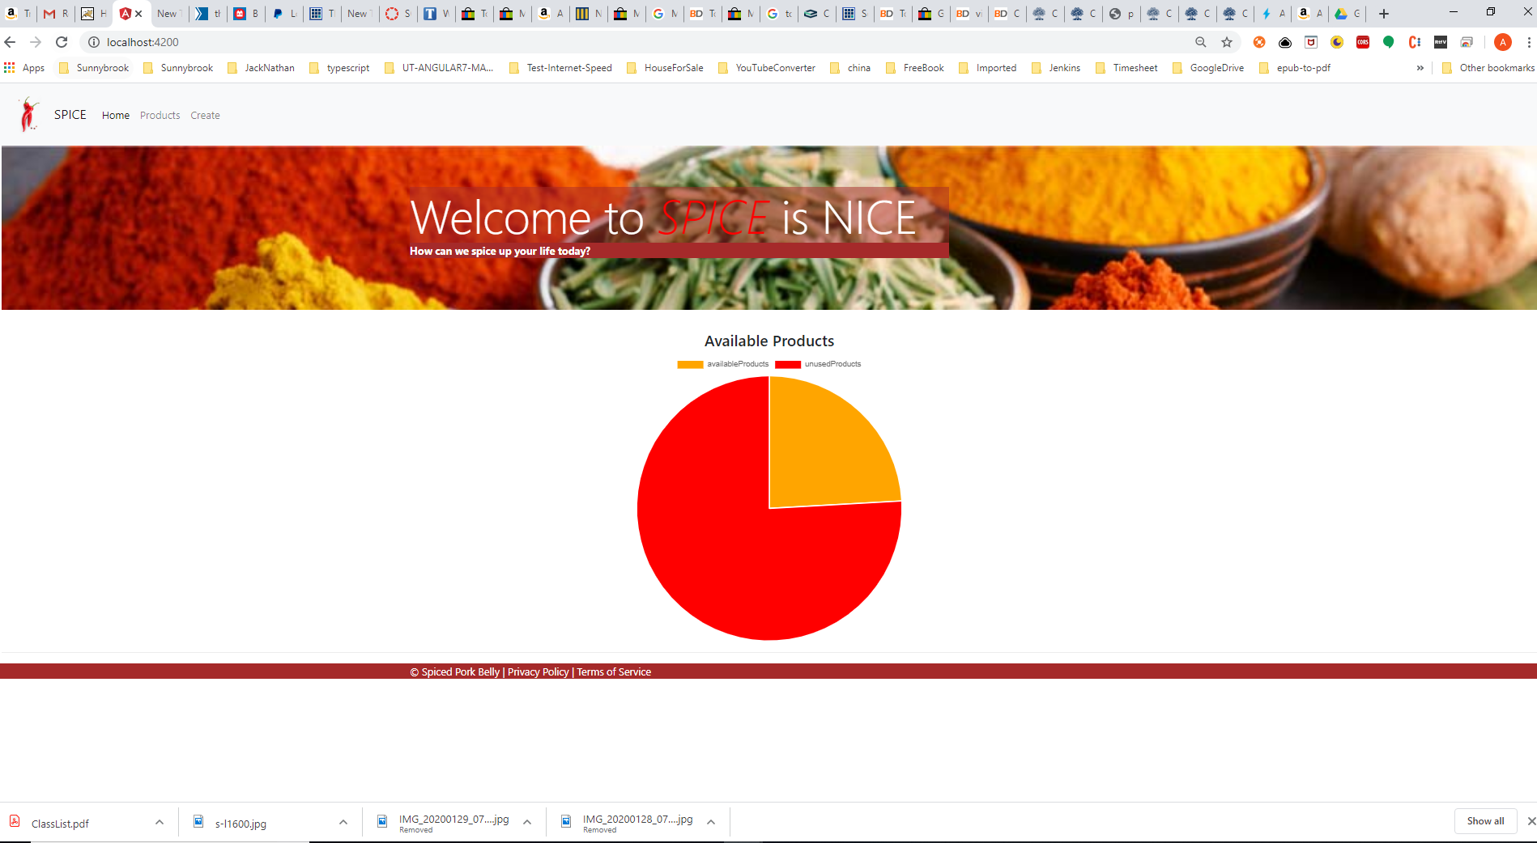

Contains a Pie Chart of “Available and Used Products”.

Marks – 2 marks for creating Pie Chart(Must use HighChart to create the pie chart)

PART 3:

url: http://localhost:8080/products-ut-wo-db/rest/emp/create

Note: Need to display message if add product successfully or not(1)

Add Product:

Has top menu of the following:

Home

Add Product

Search Product

The following fields:

1.)

Product Descriptin English

Type:input field

Validation:Mandatory field

2.)

Product Description French

Type:input field

Validation:Mandatory field

3.)

Brand Name English

Type:input field

Validation:Mandatory field

4.)

Brand Name French

Type:input field

Validation:Mandatory field

5.)

Product Type

Type: drop-down field

Validation:Mandatory field

6.)

Additional Product Identification

Type:input field

Validation:Mandatory field

7.)

Target Market

Type: drop-down field

Validation:Mandatory field

8.)

Product Image url:

Type:input field

Validation:Mandatory field

10.)

Status:

Type: drop-down field

Validation:Mandatory field

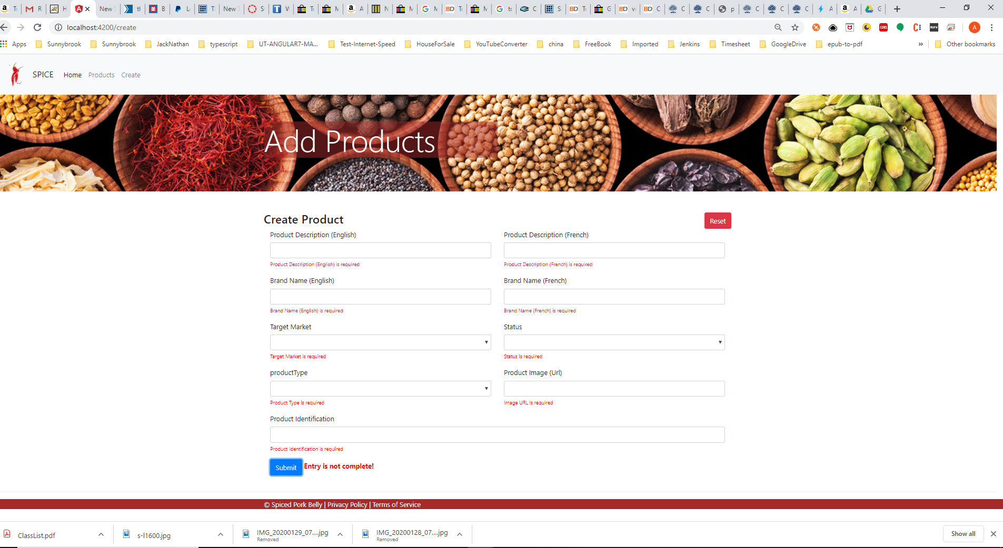

Cancel and Save buttons at the bottom of page.

Marks – 10 marks for validation for mandatory fields.

Mark 1-After submit the form, should get a message saying “submission successful” and if not successful, a message should display not successful.

PART 4:

Search Page:

Search Criteria:

Product Id field

Product Description fields.

Product Id or Production description are optionally fields.

Result fields:

Product Id,

Product Description

Brand Name

Product Type

Additional Product Identification

Target Market

Product Image Url

Status

Basic scenario:

url: http://localhost:8080/products-ut-wo-db/rest/products

If user doesn’t any values for any of the input fields the method get for restful web services will be called with no restricted criteria.

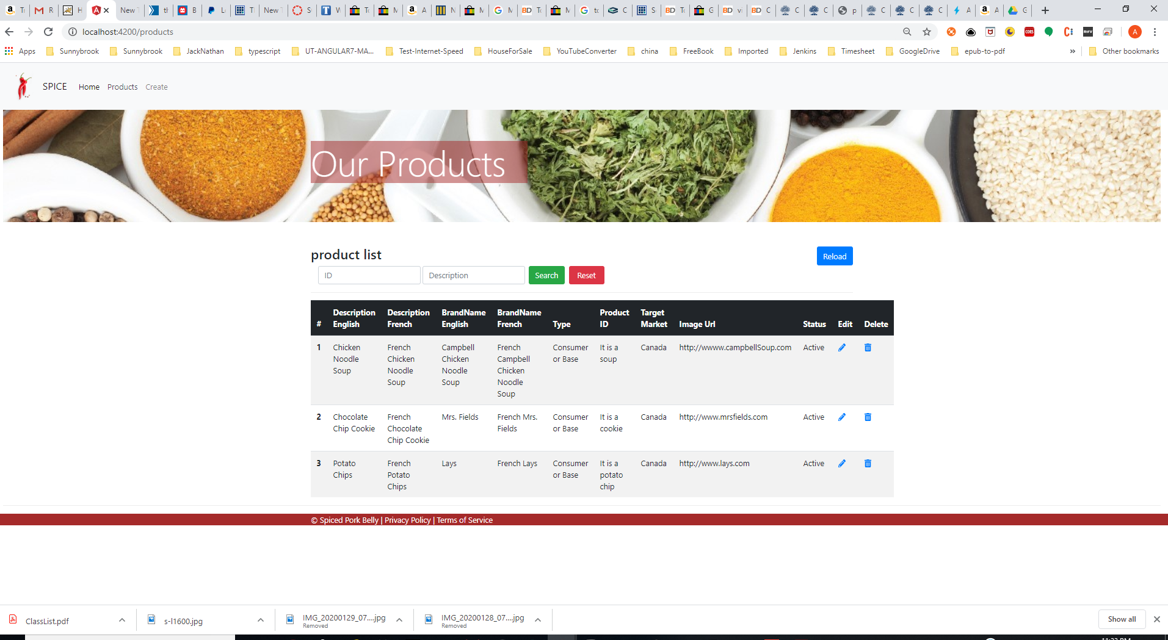

Marks – 1

Alternative path 1:

url: http://localhost:8080/products-ut-wo-db/rest/product/1

User entered only product Id field.

Marks – 1 mark

Alternative path 2:

url: http://localhost:8080/products-ut-wo-db/rest/product/1/productIdAndProductDescriptionEnglish/CHICKEN%20NOODLE%20SOUP

User entered only product Id and product description fields.

Marks – 1 mark

Alternative path 3:

Enter only product description:

url: <http://localhost:8080/products-ut-wo-db/rest/product/productDescriptionEnglish/CHICKEN%20NOODLE%20SOUP>

Mark -1 mark.

PART 5:

2 marks deduction for any questions that cannot be answered in your group.

PART 6:

The submit button must be disable when click submit and the web service having return yet.

When the web service return the submit button is enabled.

1 mark

PART 7:

An hour glass will be displayed when the web service is called.

It disappeared when the web service return.