Programming Sequence Improvement Program(PSIP)

Musfikur Rahaman
Department of Engineering and Computing Science
Arkansas Tech University
Russellville, USA
mrahaman@atu.edu
Dr. Robin Ghosh
Department of Engineering and Computing Sciences
Arkansas Tech University
Russellville, USA
rghosh@atu.edu

Dr. Indira Dutta
Department of Engineering and Computing Sciences
Arkansas Tech University
Russellville, USA
idutta@atu.edu

Dr. Tolga Ensari
Department of Engineering and
Computing Sciences
Arkansas Tech University
Russellville, USA
tensari@atu.edu

MRS Becky Cunningham
Department of Engineering and
Computing Sciences
Arkansas Tech University
Russellville, USA
rcunningham@atu.edu

Abstract— Every semester, students from various STEM (Science, Technology, Engineering, and Mathematics) majors at Arkansas Tech University take the programming sequence (PS) courses (over 650 students in the 2020–21 academic year). The Engineering and Computing Sciences Department has struggled to retain students in the PS courses. Minor efforts have been made to increase retention, but they have had little success. The Programming Sequence Improvement Program (PSIP) aims to increase retention and student success in three PS courses: Foundations of Computer Programming I (COMS 2104), Foundations of Computer Programming II (COMS 2203), and Data Structures (COMS 2213), reducing the rate of D, F, Withdraw, and Incomplete grades by 10% annually from the current average baseline of 32%, 35%, and 27%, respectively (2015-2019). The main goal of this PSIP project is to change the face of the PS program within the first two years of study by enhancing programming techniques for students. The project's interventions are likely to influence ATU (Arkansas Tech University) students' academic performance and retention, leading to higher degree completion rates. This program used four different methods to reach its objective: creating a tutoring lab for students enrolled in a programming course, implementing communication and collaboration tools such as Discord and Webex for students, researching current pedagogies for teaching programming, and better aligning the curriculum with platforms like GitHub, Hacker rank & Leet Code.
Keywords—

Introduction
The Department of Computer and Information Science currently employs 11 full-time faculty members in three different major areas (Computer science (CS), Information technology (IT), and Cyber Security (CS). The department has undertaken several ongoing projects to modernize its curriculum and faculty to ensure students enrolled in the program are exposed to the many facets of computer science, but limited resources have hampered these efforts. Currently, at Arkansas Tech University (ATU), Programming sequence instruction COMS 2104 (Foundations of Computer Programming I), COMS 2203 (Foundations of Computer Programming II), and COMS 2213 (Data Structures) are available for the different majors within the computer and information science department. Computer science degree and STEM completion rates are significantly impacted by improving these courses' sequential process, learning infrastructure, and retention.
The typical CS, Cyber Security, and IT students at ATU must master Programming Sequence (PS) courses. Out of 661 students enrolled in different STEM majors in Fall 2021, CS students are the highest number (160) of undertaking those courses. For many incoming first-generation college students, there is a cognitive conflict and gap that they experience. Many of the programming skills they learned in their K-12 training contradict the programming expected at the university level. For instance, the typical incoming first-year student enrolls in a 2104 course, who are in the initial stages of the computational thinking process and have higher withdrawal rates, but later courses (2203 & 2213), which build in the previous knowledge, have lower withdrawal rates in terms of 2020-2021 academic year. Also, we noticed that, on average from 2015-2019, there is a slight increase of DFWI (D, F, Withdraw and Incomplete) rates from COMS 2104 to COMS 2203; this is because of the complexity of the higher level of logical understanding. This project focuses on enhancing the PS curriculum.

Literature Review
Although there is a significant need for CS experts and career opportunities are many, dropout rates are still high, and little is known about what motivates people to finish their CS education and pursue a CS career. The U.S. has fallen from 1st to 16th in the world in the number of students completing college degrees (Joyce, 2010). [01] According to studies on student attrition in computer science, most dropouts occur in the first two years of study (Huang and Brainard 2001). [02] According to the literature, 40% of students who enroll in CS degree programs eventually drop out without receiving a degree (Ohland et al. 2008). [03] Student retention is influenced favorably by a degree's elevated level of utility. Additionally, the usefulness of a degree is positively impacted by a supportive atmosphere and cognitive improvements, but negatively impacted by non-cognitive gains. (Ilias et al. 2016) [04] Many STEM courses have been taught using a traditional, lecture-based approach, particularly in large, introductory courses (Budd et al., 2013). [05] When compared to lecture-based methods, incorporating active-learning techniques into science, technology, engineering, and math (STEM) classes has been demonstrated to improve student learning and performance, boost knowledge retention, and close achievement disparities between diverse student populations (Jennifer et al., 2018). [06] Computer instructors should incorporate creative, learner-centered teaching methods into their instructional process as they increase student engagement. The use of innovative pedagogy enhanced undergraduate students’ academic achievement and retention in computer programming (Christian et al., 2021). [07]

Methodology

Objective
Our objective for Programming Sequence Improvement Program (PSIP) is to increase the first year and second-year student retention in Programming Sequence courses COMS 2104, COMS 2203, and COMS 2213 by decreasing DFWI ((D, F, Withdraw and Incomplete grades) rates 10% each year, from the current average baseline of 32%, 35% and 27% respectively (2015-2019).

Action Plans
The high-level goal of this PSIP project is to change the face of the Programming Sequence (PS) program within the first two years of studies by enhancing programming techniques for students. The project's interventions are expected to significantly impact student achievement and retention in several STEM disciplines at ATU, resulting in increased degree completion rates. Each project objective lends guidance to the overall successful outcome of the proposal. For exams, each goal is intended to promote activities to students taking part in Programming Sequence courses with the specific outcome to prepare students in their STEM field of study leveraging programming concepts and Data structures.
Action Plan 1: Create comprehensive programming tutoring laboratories connected to the computer science (CS) curriculum within the Department of Computer and Information Science (CIS) to support dynamic collaborative learning and project-based coding activities.
- Semester 1 (Spring 2022): Equipment acquisition and start deployment and utilize by at least 10~25 using them daily
- Semester 2 (Fall 2022): Fully operational lab and utilized by all students enrolled in PS courses at ATU
- Semester 3 (Spring 2023): Retention/completion in COMS 2104, COMS 2203, and COMS 2213 increased by 10%.
- Semester 4 (Fall 2023): Retention/completion in COMS 2104, COMS 2203, and COMS 2213 increased by 10% from semester 1 & 2.

Action Plan 2: Develop a Social Media PS reaction system (SMPSRM): To measure students' understanding of programming/Data structure topics using social analytics tools in the classroom.
- Semester 2 (Fall 2022): 20~25 participants enrolled in COMS 2104, COMS 2203, and COMS 2213.
- Semester 3(Spring 2023):10% increase in participation from semester 2 in social media sites.
- Semester 4 (Fall 2023): 10% increase in participation from semester 3 in social media sites.

Action Plan 3: Programming Sequence Curriculum Alignment
- Identify curriculum content for which an increased emphasis on critical thinking and analytical skills is appropriate within several different sections in the PS.
- Examine the creation of team-taught PS courses within CIS faculty members using lab technologies.
- Increase dialogue among faculty within the departments to increase awareness of relevance, usage, benefits of the changes within other disciplines, and the value of these approaches to STEM students' career paths.

Action Plan 4: Programming Sequence Curriculum Alignment Faculty Development in New programming Sequence Pedagogies
- Develop a training program for CIS faculty in PS pedagogies models for PS curriculum as listed in object 2
- Develop a departmental wiki training series for faculty to train them to leverage digital tools such as Leet Code & Hacker Rank.
- Encourage faculty to participate in national conferences to receive training in the new curriculum efforts and student learning approaches.

Results
In 2019 – 2021 the DFWI rate of students taking that course for the first time was over 30%, which is around the same rate over the last six years. Based on the pandemic-related uncertainties, when many of us had to handle the overall student enrollment and retention, we had excluded the 2019-2020 and 2020 – 2021 data points. Also, we believe that teachers and administrations were more lenient and forgiving during the pandemic years, and those years' data do not represent the regular DFWI rates for those courses. Hence, we decided to take the average DFWI rates of 2015- 2019, which are 32%,35%, and 27% in PS courses COMS 2104, COMS 2203, and COMS 2213, respectively.

Figure 1, 2, 3 List first and second-year students’ DFWI(D, F, Withdraw and Incomplete rates of COMS 2104, COMS 2203 and COMS2213.

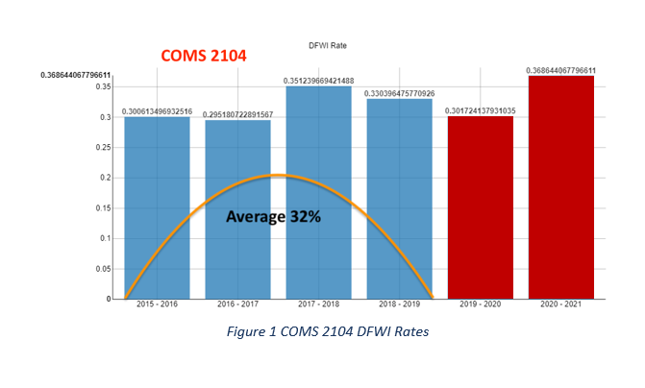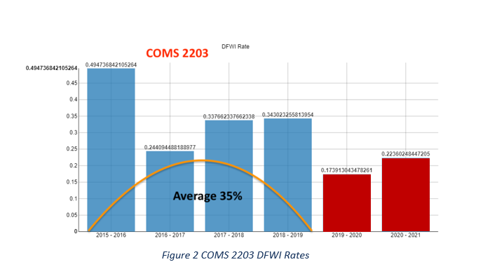
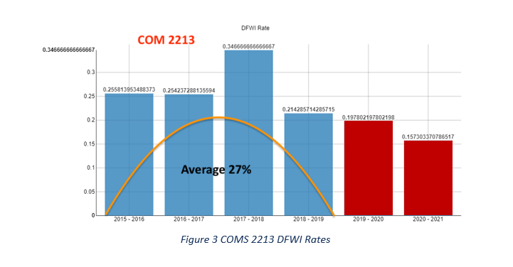

Project Evalution Plan
For the project evaluation plan, we Developed Assessment tools to evaluate new educational strategies implemented within the community.
These are:
- Develop Assessment tools for action plans 1, 2 and 3
- Assess the impact of curriculum changes using tools developed in (a)
- Assess the ease of curriculum adoption using tools developed in (a)
- Administer a modified Motivated Strategies for Learning (MSL) questionnaire to measure the nature of students' motivations and usage of learning strategies related to the project.
- Administer Classroom Community Scale Questionnaire to students to measure their sense of community within their learning environments.
- Submit findings and data to conferences and journals that indicate project assessment results

The project evaluation is done after each semester in four phases. We completed our activities for each phase; then, we evaluated the project's success. Since the project's duration is two years, we have three semesters to see the effects of the proposed activities. We are evaluating three classes (COMS 2104, COMS 2203, and COMS 2213) with the evaluation as mentioned above plan.

Student Engagement Survey Result
From 2015-2019 average DFWI rate for those PS courses was 32%, 35% and 27% and our project target was to reduce 10% DFWI rate by Fall 2022.
We have taken many initiatives to accomplish our goal: we have created a tutoring lab for students and implemented communication and collaboration tools like Discord and Webex. We have aligned our curriculum and made the students familiar with platforms like GitHub and Hacker Rank. Developing training programs for faculties, also encourage faculties to participate in national conferences to receive training in new curricular. The DFWI rates for COMS 2104 (Programming I), COMS 2203 (Programming II), and COMS 2213 (Data Structure) have been successfully reduced from 32% to 23%, 35% to 15%, and 27% to 0% for the fall 2022 semester.

Figure 4, 5, 6 List Change in DFWI(D, F, Withdraw and Incomplete rates of COMS 2104, COMS 2203 and COMS2213 through Spring 2022, Fall 2022.

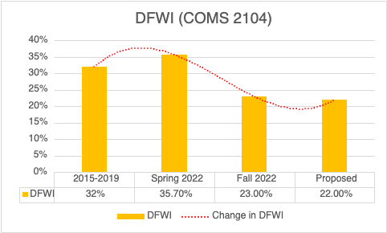
Figure 4 Change in DFWI COMS 2104

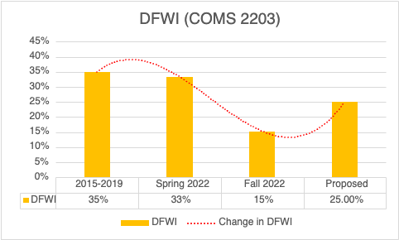

Figure 5 Change in DFWI COMS 2104

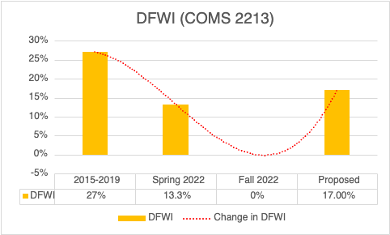

Figure 6 Change in DFWI COMS 2104

The results of the student survey on how they use platforms like GitHub, Discord, Leet Code, Hacker Rank we have introduced for those PS courses, including our tutoring laboratories. Our tutoring labs offer both in-person and Webex assistance to the students. Additionally, they receive guidance outside of the classroom. They also received aid from the other students. Participants in the poll included 40 students for Programming I, 22 students for Programming II, and 18 students for Data Structures.

Figure 7, 8, 9 List Student Survey Results of COMS 2104, COMS 2203 and COMS2213 for Fall 2022.
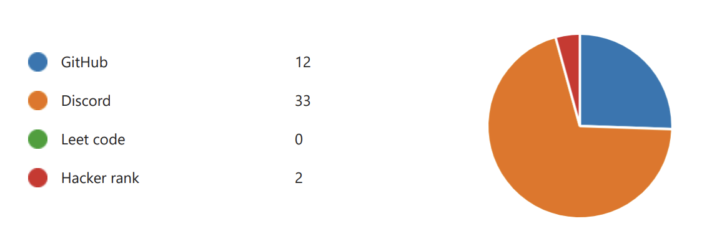
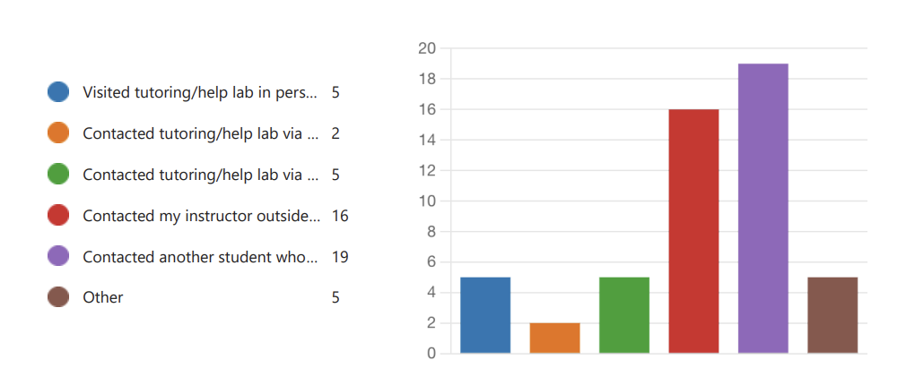
Figure 7 Students Survey Results COMS 2104

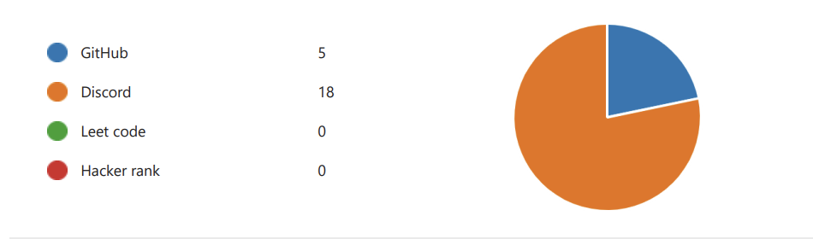
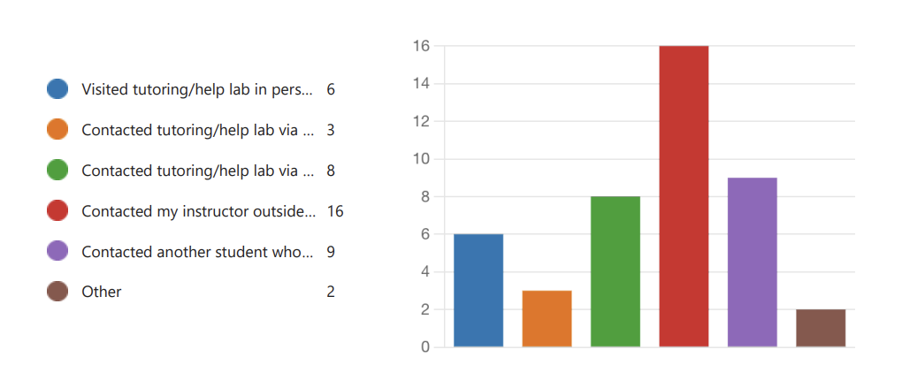

Figure 8 Students Survey Results COMS 2203

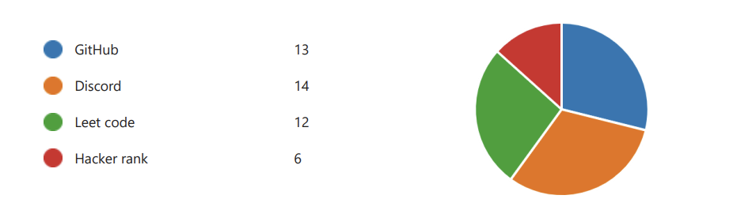
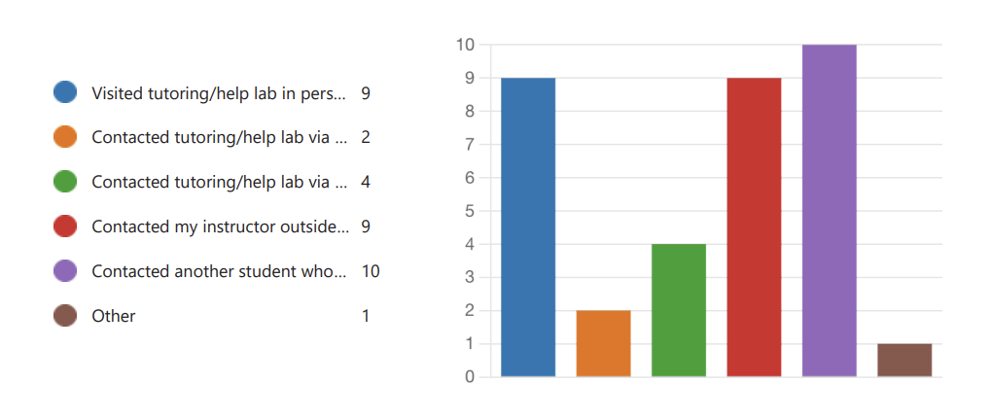
Figure 7 Students Survey Results COMS 2213

Discussion
We expect to significantly impact and improve the PS courses' completion rate. The department currently handles all the PS courses, serving all students at the university. The courses combine the foundational concepts of programming using structured programming concepts of C++ as an implementation tool.

Conclusion
This project is solely student centric. By studying some previous data, we realized three courses of programming sequence require special attention. As mentioned before, many students will be affected positively by this project. First, with the curriculum alignment implemented in these courses, the students are getting similar standards regardless of the section or the faculty teaching that section. The student feedback on the preset assignments is a unique way of assessing their problems in these courses. The labs are also helping us identify the problem areas in these courses. The student workers who have already passed these courses have been able to help. Once all the sections are aligned and monitored (By getting feedback from the students), we will improve these three programming sequence courses. That will eventually help us lower the DFWI rates and student retention in several STEM disciplines.

Acknowledgment
Arkansas Tech Innovation Grant, ​
Department of Engineering and Computing Sciences, ​
Arkansas Tech University, Russellville, Arkansas​

References

- Joyce, J. (2010). Nations’s governors tackle college-completion rates. Diverse: Issues in Higher Education, 27(12), 1-8.
- Penelope M. Huang, S. Brainard (2001). Indetifying Departments of Academic Selfconfidence Among Science, Math, Engineering, and Technology Studuents. Journal of Women and Minorities in Science and Engineering, V7.I4.40.
- Ohland, M., Sheppard, S., Lichtenstein, G., Eris, O., Chachra, D., & Layton, R. (2008). Persistence, engagement, and migration in engineering programs. Journal of Engineering Education, 97(3), 259–278.
- Michail N. Giannakos, Ilias O. Pappas, Letizia Jaccheri, Demetrios G. Sampson(2017). Understanding student retention in computer science education: The role of environment, gains, barriers and usefulness, Education and Information Technologies, Volume 22, Issue 5.
- Budd, D. A., van der Hoeven Kraft, K. J., McConnell, D. A., & Vislova, T. (2013). Characterizing reaching in introductory geology courses: Measuring classroom rractices. Journal of Geoscience Education, 61, 461–475.
- Jennifer A. Roberts, Alison N. Olcott, Noah M. McLean, Gregory S. Baker, & , Andreas Moller “Demonstrating the impact of classroom transformation on the inequality in DFW rates (“D” or “F” grade or withdraw) for first-time freshmen, females, and underrepresented minorities through a decadal study of introductory geology courses,” JOURNAL OF GEOSCIENCE EDUCATION, 2018, VOL. 66, NO 4, 304-318.
- Christian Basil Omeh, & Chijioke Jonathan Olelewe “Assessing the Effectiveness of Innovative Pedagogy and Lecture Method on Students Academic Achievement and Retention in Computer Programming” Hindawi, Education Research International, VOL 2021, Article ID 5611033.

