KHULNA UNIVERSITY

# Course Title: Software Development Project

Course No : CSE 3106

Project Proposal

|  |  |  |  |
| --- | --- | --- | --- |
| **Submitted by:** |  | **Submitted to:** |  |
| S M Musfikur Rahman (SID : 190224) | | Prof. Dr. Kazi Masudul Alam | |
| Utsa Debnath (SID : 200242) | | Professor |  |
| 3rd Year, 1st Term  Computer Science and Engineering | | Computer Science and Engineering Discipline, Khulna University | |
| Discipline, Khulna University | |
|  | Submission Date – 15/02/2023 | |  |
|  |  |

FLAPPY BIRD GAME STORY

Flappy Bird was a mobile game that became an overnight sensation in early 2014. The game was developed by Dong Nguyen, a Vietnamese game developer who had previously created several other mobile games. Flappy Bird, however, was different from his previous games in that it was incredibly simple but frustratingly difficult. The game involved tapping the screen to make a bird flap its wings and fly through a series of pipes. The goal was to get the highest score possible without hitting any of the pipes or crashing into the ground. The gameplay was extremely addictive, and players soon became obsessed with trying to beat their high scores. Within a few weeks of its release, Flappy Bird had become the most downloaded game on both the App Store and Google Play. Nguyen was making an estimated $50,000 per day from advertising revenue generated by the game. However, the sudden success of the game also brought a lot of attention and criticism. Many people accused Nguyen of copying other games and some criticized the game for its difficulty and addictive nature, claiming that it was harmful to players' mental health. In a surprise move, Nguyen announced on Twitter that he was removing Flappy Bird from the app stores, citing the overwhelming attention and stress that the game had brought into his life. Many fans were disappointed by this decision and some even speculated that it was a marketing ploy to generate even more interest in the game. After the removal of Flappy Bird, Nguyen continued to develop and release new games, but none of them achieved the same level of success as Flappy Bird. The legacy of the game, however, lived on through countless clones and imitations that flooded the app stores in the months following its removal.

**Gameplay:**

**Starting Page:** This is our starting page. By clicking the play button, we start our game.

**Environment:** In this environment there are green pipes among these pipes the bird will fly across the pipe. If the bird goes through the pipes successfully then a score will be added. If the bird doesn’t successfully cross the pipe, then the game will over.

**Game over Page :**

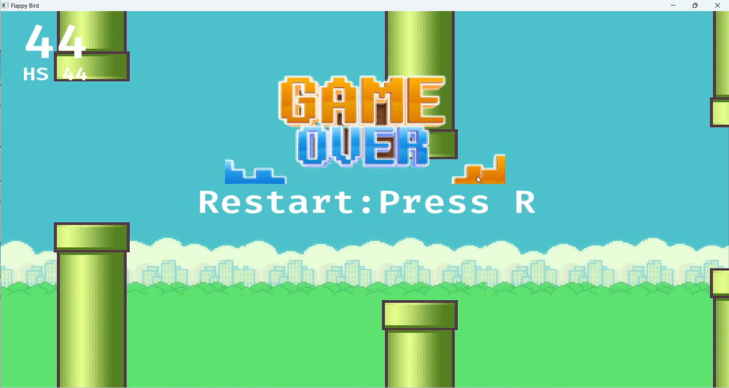

**Game rules for the flappy bird game:**

* The player must tap the screen to make the bird flap its wings and gain altitude. Each tap causes the bird to flap once.
* The bird automatically descends over time, so the player must keep tapping to keep it in the air.
* The player must navigate the bird through a series of pipes that appear on the screen, with gaps in between them.
* If the bird collides with any part of a pipe or the ground, the game is over.
* The player earns one point for each pipe successfully passed.
* The game continues until the bird collides with a pipe or the ground, at which point the player's score is displayed and the game can be restarted.
* The pipes gradually become closer together and more difficult to navigate as the player earns more points.
* There are no levels or stages in the game - the difficulty level increases continuously as the player earns more points.