Gemini

Here is the software architecture to make this system work, explicitly leveraging the ESP32-S3's dual-core capabilities and relying on a central Sensor Fusion approach.

1. The Local Firmware (ESP32-S3 via C++/FreeRTOS)
The S3 will act as a dedicated, high-speed hardware manager. Using FreeRTOS task pinning, you will divide the labor completely to prevent the Wi-Fi stack from interfering with your motor control.
- Core 1 (Motor & PCNT Manager): This core handles all the physical hardware. It uses the S3’s hardware Pulse Count Controller (PCNT) to track the N20 encoder ticks in the background, guaranteeing zero dropped pulses. It runs a strict, high-frequency (e.g., 100Hz) PID control loop to dynamically adjust the DRV8833 PWM signals. This ensures the wheels actually spin at the targeted speeds, regardless of battery voltage drop or chassis inertia.
- Core 0 (Networking Node): This core is dedicated purely to the Wi-Fi stack. It listens for incoming UDP packets containing the target wheel velocities from the central PC. Simultaneously, it blasts the local odometry data (the raw encoder tick counts) back to the PC at a high frequency (e.g., 50Hz).

2. The Vision Pipeline (Central PC via Python & OpenCV)
This script acts as the "ground truth" observer for the entire swarm.
- Camera Initialization: The script interfaces with the Logitech C922, explicitly locking cv2.CAP_PROP_AUTOFOCUS and cv2.CAP_PROP_AUTO_EXPOSURE.
- AprilTag Detection: It processes the incoming frames to detect the tag36h11 markers, applying camera matrix intrinsic parameters to yield the absolute physical coordinates $(x, y, \theta)$ of every robot in the arena.

3. State Estimation & Sensor Fusion (Central PC)
Because the camera has a rolling shutter and lower frame rate, and the local encoders suffer from physical wheel slip, neither data source is perfect on its own.
- The Extended Kalman Filter (EKF): A central Python script will heavily utilize NumPy matrix operations to fuse the two data streams. It uses the high-frequency odometry UDP packets to track rapid, short-term movements, and snaps that trajectory back to reality whenever a new, clean camera coordinate arrives.
- Live Visualization: Matplotlib can be hooked into this pipeline to provide a live scatter plot of the swarm's estimated positions versus their raw camera positions, allowing you to tune the EKF covariance matrices on the fly.

4. The Trajectory Tracking Controller (Central PC)
Instead of calculating separation, alignment, and cohesion, this script is dedicated purely to keeping the robots on their pre-destined paths.
- CSV Lookup: At every time step (e.g., $t=0.02$), the Python script reads the CSV file to find the exact target coordinate $(x_{ref}, y_{ref})$ where Robot 1 should be at that exact moment.
- Error Calculation: It takes the current, real-world $(x, y, \theta)$ position of Robot 1 (provided by the EKF sensor fusion) and calculates the physical distance and heading error between where the robot is and where the CSV says it should be.
- Kinematic Correction Law: The script applies a non-holonomic tracking control algorithm (such as a standard unicycle kinematic controller) to calculate the linear and angular velocities ($v$ and $\omega$) required to pull the robot back onto the CSV path.
- Command Dispatch: It converts the required $v$ and $\omega$ into specific left and right wheel RPMs and sends them as a UDP packet to the ESP32-S3.

ClaudeSoftware Architecture Overview

Three Layers
Layer 1 — Simulation (MATLAB, already done)
- Outputs reference trajectories as CSV: [timestep, agent_id, x, y, theta, v, omega]
- Timestep is 0.02s from prior work — you may want to resample to 0.016s (60fps) to match C922 framerate

Layer 2 — Central PC (Python)
Four modules running in a coordinated loop at 60Hz:
- Vision module — OpenCV captures C922 feed at 1080p/60fps, detects AprilTags, outputs (x, y, theta) per bot in camera coordinates
- Calibration transform — one-time homography matrix converts camera pixel coordinates to simulation world coordinates. Done once at setup, applied every frame
- Controller module — for each bot, computes error between reference pose (CSV at current timestep) and actual pose (camera), outputs corrected (v, omega) using a pure pursuit or PID tracker
- Comms module — sends corrected (v, omega) to each bot over UDP WiFi via 2.4GHz router. One packet per bot per frame
Loop timing:
Camera frame (16.6ms) → AprilTag detection → transform →
control computation → UDP send → next frame
All of this needs to be completed within 16.6ms per cycle to keep up with 60fps.

Layer 3 — Each Bot (ESP32-S3)
Two tasks running on separate cores:
- Core 0 — WiFi/Comms: Listens for UDP packets containing (v, omega), parses and passes to Core 1
- Core 1 — Motor PID: Converts (v, omega) to left/right wheel target RPM via differential drive kinematics, runs PID loop using encoder feedback to hit target RPM, outputs PWM to DRV8833
Encoder interrupts feed into Core 1's PID loop at hardware interrupt level — highest priority.

Data Flow
MATLAB CSV
↓
PC reads reference pose at current timestep
↓
C922 (60fps, 5m USB) → AprilTag detection → actual pose
↓
Homography transform → sim coordinate space
↓
Controller → error → corrected (v, ω)
↓
UDP → 2.4GHz router → ESP32-S3 (Core 0)
↓
Differential drive kinematics → left/right RPM targets
↓
Encoder PID (Core 1) → PWM → DRV8833 → N20 motors

Key Parameters to Tune During Setup
- Homography calibration — place calibration markers at known positions in arena, map to sim coordinates once
- PWM operating range — empirically find minimum reliable PWM per bot (deadband varies unit to unit), target 25-30% as planned
- PID gains — tune wheel-level PID on bench before full swarm test
- UDP packet rate — if 60Hz causes network congestion with 6 bots simultaneously, drop to 30Hz (still fine for slow bots)

Possible solution:
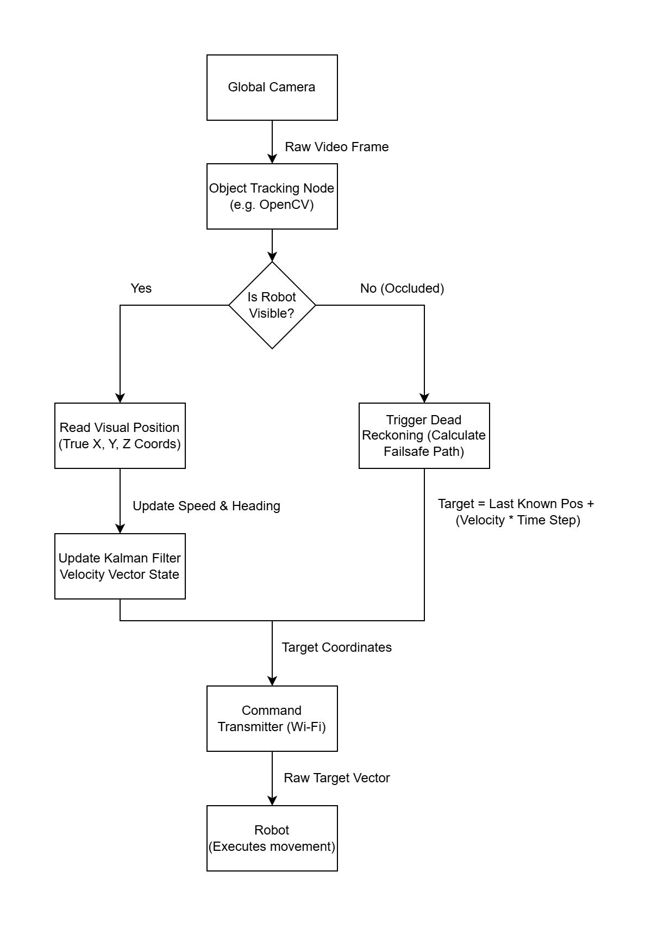
Finalized Version:

Layer 1: The Simulation Blueprint (MATLAB CSV)
This layer acts as the absolute, ground-truth script for your multi-agent maneuvers.
- The Data: A pre-calculated CSV containing the ideal coordinates and velocities: [timestep, agent_id, x, y, \theta, v, \omega].
- The Timing: The file is strictly structured at a fixed 0.02s timestep (50Hz). You will not resample this data, ensuring the mathematical integrity of your previously established models remains intact.

Layer 2: The Central PC (Command & Vision Hub)
Written in Python and utilizing OpenCV, this layer is decoupled into two asynchronous threads so that variable camera frame rates never delay a motor command.
Thread 1: Vision & State Estimator (Runs at ~60Hz)
- Capture: Reads the Logitech C922 frame with auto-exposure and auto-focus manually locked off.
- Detection & Transformation: OpenCV identifies the 6 AprilTags and applies a homography matrix to convert pixel coordinates into physical meters and radians.
- Occlusion Failsafe: If an AprilTag is visible, it extracts the position $(x, y, \theta)$ and passes it through a vision-only Kalman Filter to calculate a smooth velocity vector. If a robot is temporarily occluded (e.g., hidden by glare), it triggers a Dead Reckoning failsafe, estimating the current position based on the last known pose and that smoothed velocity vector.
- State Update: Instantly updates a globally shared dictionary with the latest estimated poses of all 6 agents.
Thread 2: Kinematic Controller (Strictly locked to 50Hz)
- Target Calculation: Reads the exact timestep from the CSV and pulls the actual real-world coordinates from the shared dictionary.
- Error Correction: Computes the tracking error and generates the required corrective velocity vector $(v, \omega)$.
- Differential Matrix Math: Translates the abstract vector into precise target_left_RPM and target_right_RPM values for all 6 bots simultaneously using NumPy arrays.
- One-Way Dispatch: Broadcasts a lightweight UDP packet over the dedicated 2.4GHz router directly to the microcontrollers.

Layer 3: The Robot Firmware (ESP32-S3 via C++/FreeRTOS)
The swarm hardware is completely stripped of complex spatial mathematics. It operates purely as a dual-core hardware manager designed to enforce the PC's RPM commands against physical friction and battery voltage drops.
Core 0: The Network Listener
- UDP Receiver: Sits in a continuous loop listening for the incoming UDP packets.
- Variable Hand-off: Safely unpacks the target_left_RPM and target_right_RPM and updates the shared memory variables using a FreeRTOS mutex. To cut network congestion in half, it transmits absolutely nothing back to the PC.
Core 1: The Hardware PID Manager (Strictly locked to 100Hz)
- Hardware PCNT: Utilizes the S3's Pulse Count Controller peripheral to independently track the N20 encoder pulses in the background with zero CPU overhead.
- Local Closed-Loop Control: Calculates the physical wheel speeds from the encoders, compares them to the target RPM set by Core 0, and dynamically adjusts the PWM to the DRV8833 drivers. This guarantees the heavy 18650 battery payload moves exactly as intended, instantly correcting for minor floor slips long before the overhead camera registers an error.

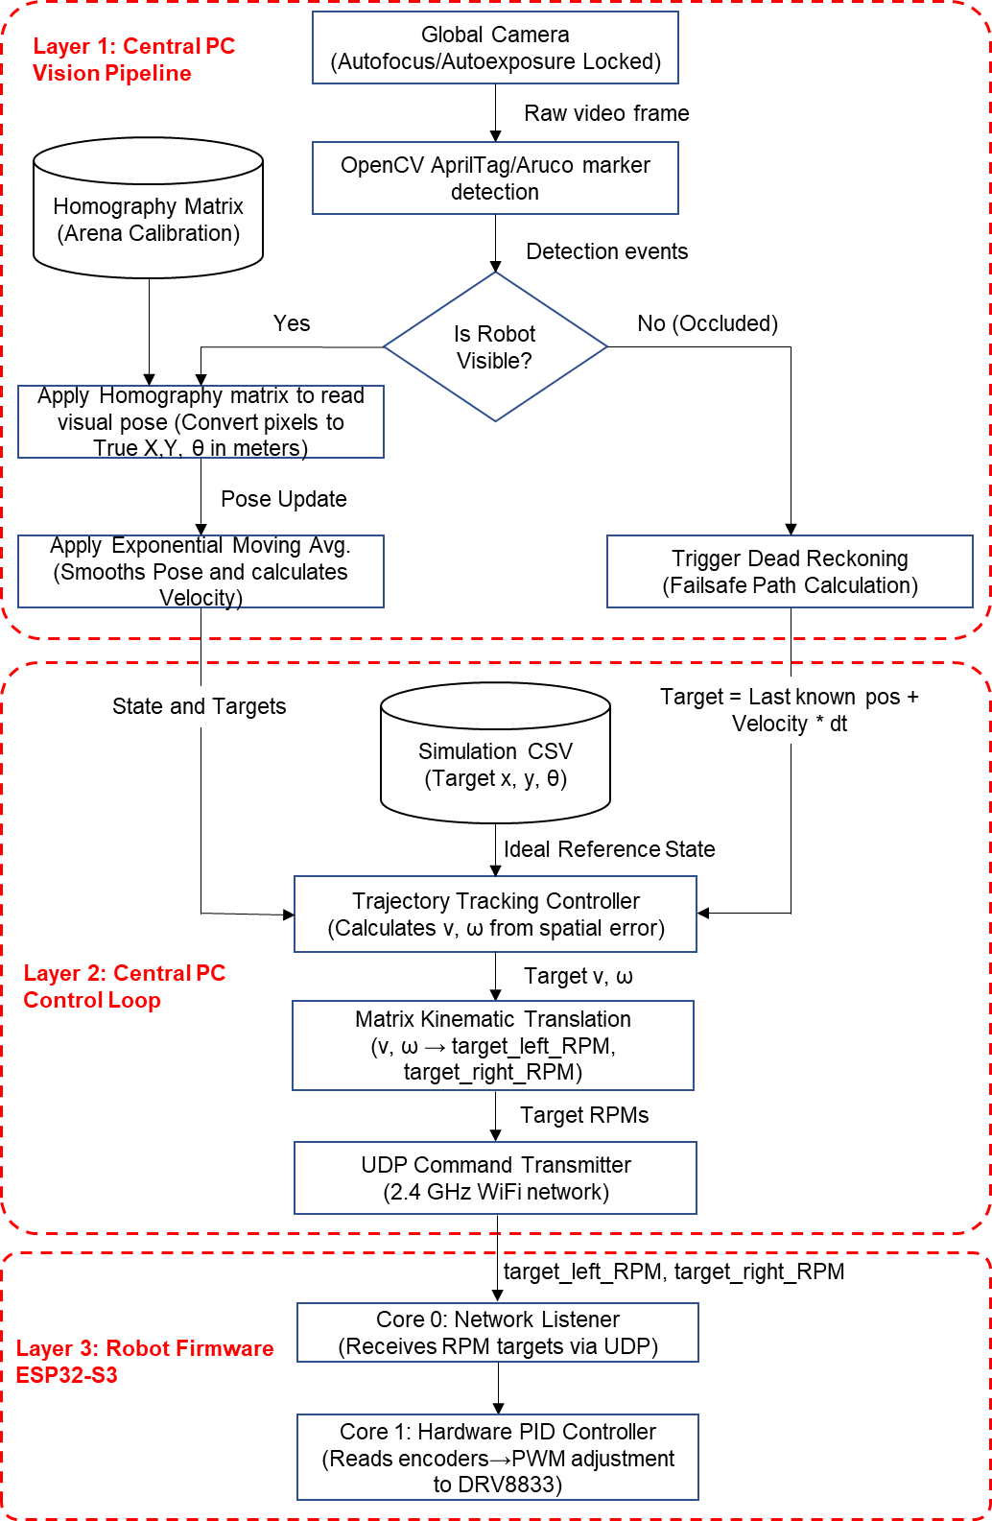Setup 1 (N20 Motors) :

1. Power Regulation & Protection
This steps the 7.4V–8.4V battery pack down to a pristine 5V rail.
- Battery Pack Positive (+) ➔ SPDT Switch (Middle Pin)
- SPDT Switch (Outer Pin) ➔ DD38LOSA VIN+ (Input)
- Battery Pack Negative (-) ➔ DD38LOSA VIN- or GND
- 100 uF Capacitor ➔ Placed directly across VOUT+ and VOUT- of the DD38LOSA (Ensure the striped negative leg connects to VOUT-).

2. The 5V Power Distribution
Instead of using external batteries for the motors, we now share the regulated 5V rail between the microcontroller and the motor driver.
- DD38LOSA VOUT+ (5V) ➔ ESP32-S3 5V (or VBUS) Pin
- DD38LOSA VOUT- (GND) ➔ ESP32-S3 GND Pin
- DD38LOSA VOUT+ (5V) ➔ DRV8833 VM Pin (Motor Power)
- DD38LOSA VOUT- (GND) ➔ DRV8833 GND Pin

3. ESP32-S3 Logic to DRV8833 (Control)
These pins handle the PWM signals and wake the driver up from sleep mode.
- ESP32-S3 3V3 ➔ DRV8833 STBY (Pulls the chip out of sleep mode)
- ESP32-S3 GPIO 4 ➔ DRV8833 AIN1 (Left Forward)
- ESP32-S3 GPIO 5 ➔ DRV8833 AIN2 (Left Reverse)
- ESP32-S3 GPIO 6 ➔ DRV8833 BIN1 (Right Forward)
- ESP32-S3 GPIO 7 ➔ DRV8833 BIN2 (Right Reverse)

4. DRV8833 to N20 Motors (Output)
- DRV8833 AO1 ➔ Left N20 Motor Pin M2
- DRV8833 AO2 ➔ Left N20 Motor Pin M1
- DRV8833 BO1 ➔ Right N20 Motor Pin M1
- DRV8833 BO2 ➔ Right N20 Motor Pin M2

5. N20 Encoders to ESP32-S3 (PID Feedback)
The magnetic encoders are powered by the ESP32's internal 3.3V regulator to keep the logic signals safe for the GPIO pins.
- Left Encoder VCC ➔ ESP32-S3 3V3
- Left Encoder GND ➔ ESP32-S3 GND
- Left Encoder C1 (Phase A) ➔ ESP32-S3 GPIO 1
- Left Encoder C2 (Phase B) ➔ ESP32-S3 GPIO 2
- Right Encoder VCC ➔ ESP32-S3 3V3
- Right Encoder GND ➔ ESP32-S3 GND
- Right Encoder C1 (Phase A) ➔ ESP32-S3 GPIO 9
- Right Encoder C2 (Phase B) ➔ ESP32-S3 GPIO 10
Pins to avoid: 0, 3, 43, 44, 46

Setup 2 (Stepper Motor) :

1. Power Regulation & Protection (The Foundation)
Because you are using two 18650 batteries in series (creating roughly 7.4V to 8.4V), you must step this down to a safe 5V for the motors and the microcontroller.
- Battery Pack Positive (+) ➔ SPDT Switch (Middle Pin)
- SPDT Switch (Outer Pin) ➔ DD38LOSA VIN+ (Input Positive)
- Battery Pack Negative (-) ➔ DD38LOSA VIN- or GND (Input Negative)
- 100 uF Capacitor ➔ Place this directly across the VOUT+ and VOUT- pins of the DD38LOSA.
  - Crucial Note: Capacitors are polarized. Ensure the leg on the side with the stripe (negative) goes to VOUT-, and the longer leg goes to VOUT+. This will absorb voltage spikes from the steppers and prevent the ESP32-S3 from rebooting mid-run.

2. Distributing the 5V Rail
Now that you have a clean, stable 5V output from the DD38LOSA, you will share it among your active components.
- DD38LOSA VOUT+ (5V) ➔ ESP32-S3 5V (or VBUS) pin
- DD38LOSA VOUT- (GND) ➔ ESP32-S3 GND pin
- DD38LOSA VOUT+ (5V) ➔ Left ULN2003 Driver + pin
- DD38LOSA VOUT- (GND) ➔ Left ULN2003 Driver - pin
- DD38LOSA VOUT+ (5V) ➔ Right ULN2003 Driver + pin
- DD38LOSA VOUT- (GND) ➔ Right ULN2003 Driver - pin

3. ESP32-S3 Logic to ULN2003 Drivers
Each stepper motor requires four GPIO pins to sequence the electromagnets. I have assigned a clean sequence of safe GPIO pins available on the SuperMini.
Left Motor Driver:
- ESP32-S3 GPIO 1 ➔ ULN2003 IN1
- ESP32-S3 GPIO 2 ➔ ULN2003 IN2
- ESP32-S3 GPIO 3 ➔ ULN2003 IN3
- ESP32-S3 GPIO 4 ➔ ULN2003 IN4
Right Motor Driver:
- ESP32-S3 GPIO 9 ➔ ULN2003 IN1
- ESP32-S3 GPIO 10 ➔ ULN2003 IN2
- ESP32-S3 GPIO 11 ➔ ULN2003 IN3
- ESP32-S3 GPIO 12 ➔ ULN2003 IN4 (Skipping GPIO 8 as it is tied to your built-in LED)

4. Final Motor Connections
- Simply plug the white 5-pin plastic connector from the Left 28BYJ-48 motor into the white socket on the Left ULN2003 board.
- Plug the white connector from the Right 28BYJ-48 motor into the white socket on the Right ULN2003 board.
.\venv\Scripts\activate

Robot Tasks:
- Initialization: Load the parametric S-curve CSV and extract the very first waypoint as the absolute starting origin.
- Homing Phase: Utilize the camera tracking and kinematic control loop to navigate the robot from its arbitrary drop point in the physical arena directly to this starting origin.
- Waypoint Acquisition: Once the homing tolerance is met, sequentially read the next target spatial coordinate and heading (x, y, θ) from the trajectory file.
- State Estimation (Vision Feedback): Obtain the current physical position (x, y) and normalized heading θ from the overhead ArUco camera tracking, utilizing the EMA filter to reject visual noise.
- Error Calculation: Compute the Euclidean distance to the active waypoint and calculate the shortest-path rotational heading error to face the target.
- Kinematic Translation: Apply the unicycle control law to determine the necessary linear and angular velocities, splitting those into independent left and right wheel velocity commands.
- Friction Compensation (Anti-Stall): Apply proportional deadband scaling to ensure the commanded wheel velocities are strong enough to overcome the floor's static friction (>0.15 m/s) while preserving the mathematical turning ratio.
- Velocity Clamping: Cap the finalized wheel speeds at the absolute safety limit (0.30 m/s) to prevent skidding.
- Actuation (Hardware Execution): Transmit the finalized left and right speed commands over UDP to the ESP32 and drive the physical motors via the internal 50ms PID loop.
- Tolerance Check & Iteration: Continuously execute steps 4-9 until the spatial error drops below the 0.10m arrival tolerance, then proceed to the next waypoint (Step 3) until all 250 waypoints of the S-curve are successfully traversed.

