

**United International University (UIU)**

**Dept. of Computer Science & Engineering (CSE)**

Course Code: CSE 2218 Section: J

Course Title: Data Structure and Algorithms Lab

Kruskal’s Algorithm

**Pseudocode and some sample I/O for Kruskal’s Algorithm are given below:**

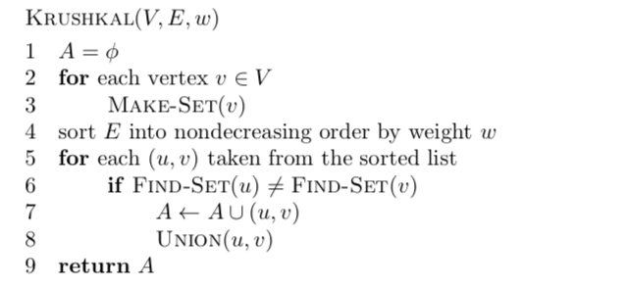

|  |  |
| --- | --- |
| **Sample Input** | **Sample Output** |
| Vertex = 5  Edge = 8  0 1 9  0 2 5  0 3 2  1 3 6  1 4 5  2 3 4  2 4 5  3 4 4 | Minimum Spanning Tree:  0 3  1 4  2 3  3 4 |
| Vertex = 4  Edge = 5  0 1 10  0 2 6  0 3 5  1 3 15  2 3 4 | Minimum Spanning Tree:  2 3  0 3  0 1 |