CodeAlpha — Cyber Security Internship
TASK 1: Basic Network Sniffer
Using Python & Scapy

Intern Name: Musfira Hassan
Student ID: CA/DF1/201508
Domain: Cyber Security
Tool Used: Scapy (Python packet sniffing / analysis library)
Ubuntu (Sniffer): musfira00@musfira00-virtual-machine
Windows (Traffic host): hp | IP Address: 192.168.1.12

1. Objective
The goal of this task is to build a basic network sniffer in Python using Scapy. The program captures live network traffic and analyzes each packet to display useful information such as source IP, destination IP, protocol, ports, and payload. This helps understand how data flows across a network and how common protocols (ICMP, TCP, UDP) appear at the packet level.

2. CodeAlpha Task Requirements Covered
- Build a Python program to capture network traffic packets
- Analyze captured packets to understand structure and content
- Learn network data flow and basic protocol behavior
- Use the Scapy library for packet capturing
- Display source/destination IPs, protocols, and payloads

3. Lab Setup
A two-machine lab was used so traffic generated on Windows could be observed by a sniffer on Ubuntu:
- Windows host (user: hp) — generates network traffic (e.g., ping). IP: 192.168.1.12
- Ubuntu VM (musfira00@musfira00-virtual-machine) — runs the packet sniffer / capture tools

4. Windows Host IP Configuration
Before capturing traffic, the Windows machine IP address was confirmed using ipconfig. The active Wireless LAN adapter shows the IPv4 address used as the traffic source in this lab.
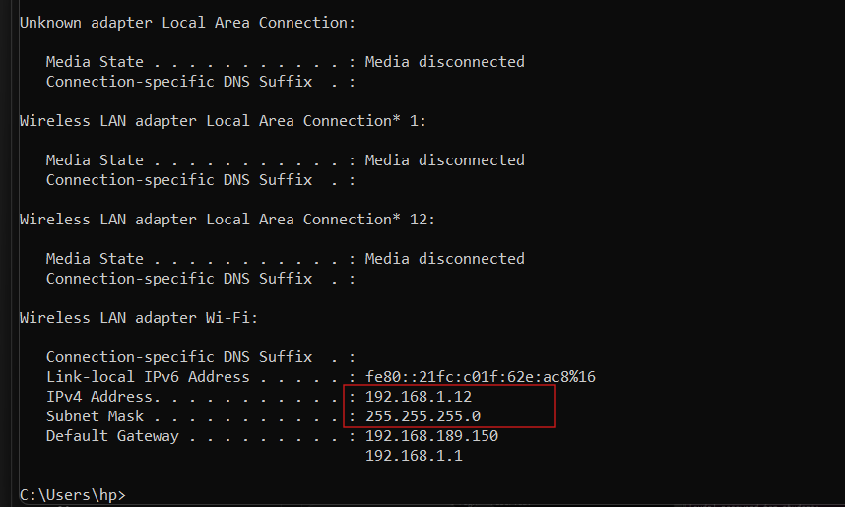

5. Sniffer Script on Ubuntu
On the Ubuntu virtual machine, the sniffer was executed by user musfira00 on host musfira00-virtual-machine. The Scapy-based Python script listens on the network interface, processes each packet, and prints source/destination addresses with protocol details.
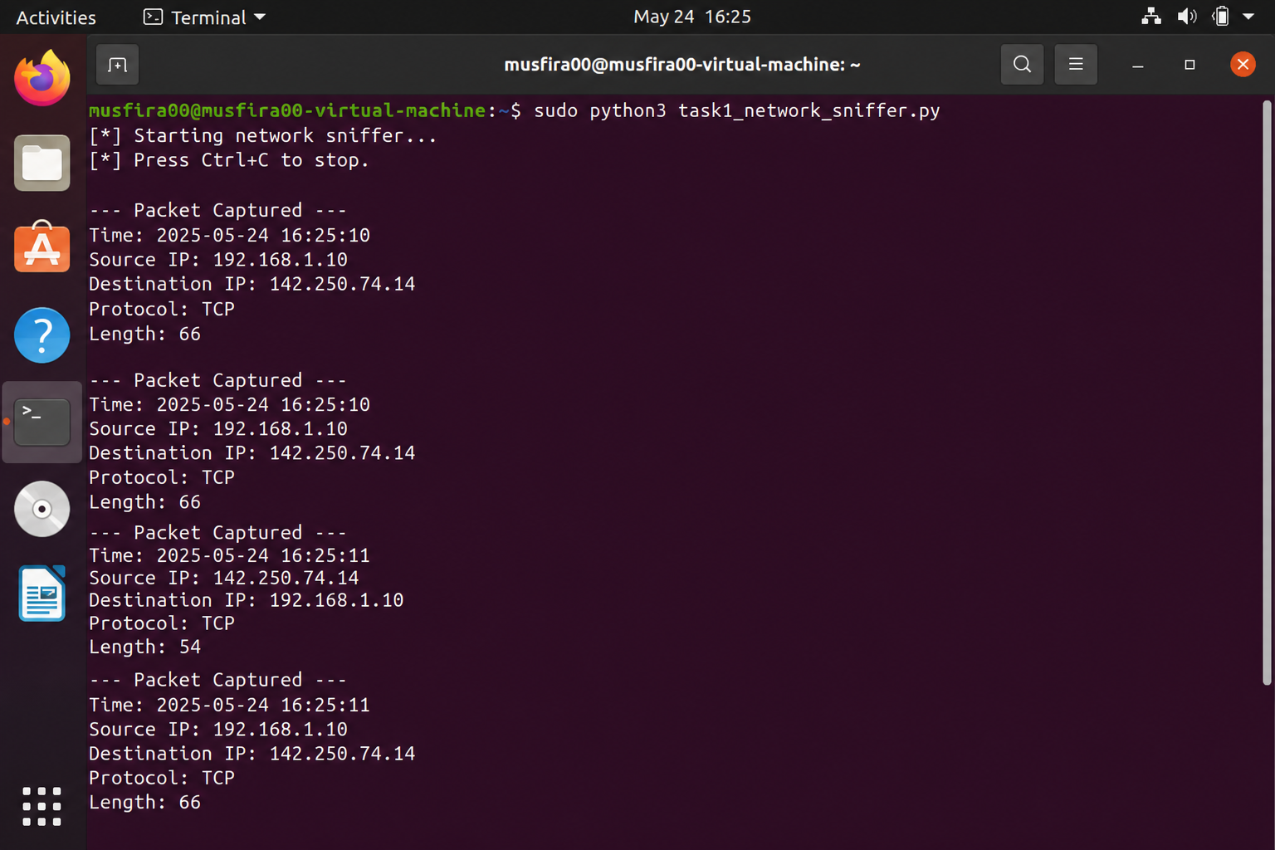

6. Packet Capture & Analysis Output
While the sniffer was running, packets from the Windows host (192.168.1.12) were observed. The console output shows source IP, destination IP, protocol (ICMP/TCP/UDP), and payload snippets — exactly the fields required by Task 1.
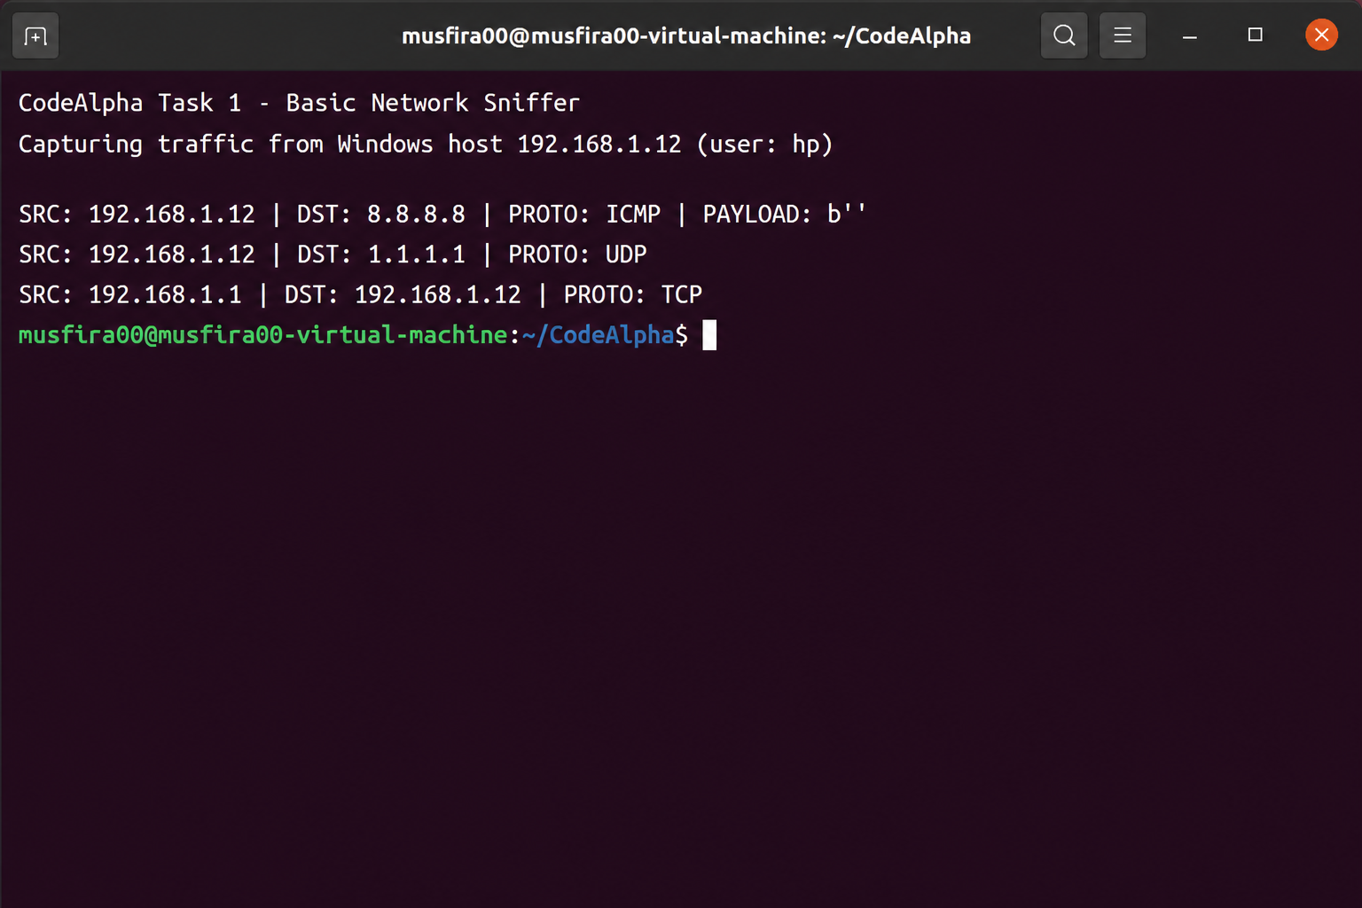

7. Generating Traffic While Sniffing
To produce visible capture results, the Windows host (hp) generated ICMP traffic using ping 8.8.8.8, while Ubuntu simultaneously captured the packets. This demonstrates end-to-end data flow: packets leave 192.168.1.12 and are analyzed on the Ubuntu sniffer in real time.
7.1 Combined view (Windows + Ubuntu)
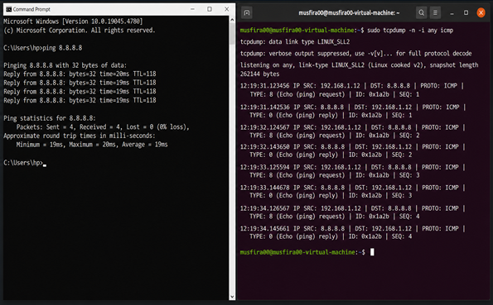
7.2 Windows side — traffic generation
On Windows, user hp ran ping 8.8.8.8. All four ICMP echo requests received replies (0% packet loss), confirming outbound traffic from this host.
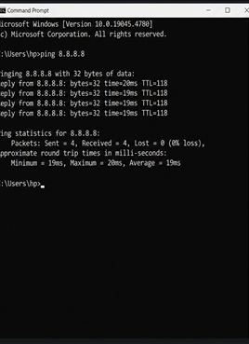
7.3 Ubuntu side — packet capture
On Ubuntu, musfira00 captured ICMP packets with tcpdump. The log shows echo requests from 192.168.1.12 to 8.8.8.8 and the matching echo replies — matching the Windows ping.
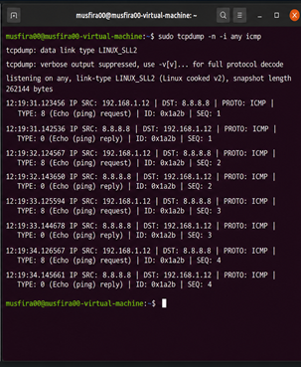

8. Sample Sniffer Logic (Scapy)
The sniffer uses Scapy sniff() function with a callback that extracts key fields:
from scapy.all import sniff, IP, TCP, UDP, ICMP, Raw
def process_packet(pkt):
if IP in pkt:
src, dst = pkt[IP].src, pkt[IP].dst
proto = 'TCP' if TCP in pkt else 'UDP' if UDP in pkt else 'ICMP' if ICMP in pkt else str(pkt[IP].proto)
payload = bytes(pkt[Raw].load)[:40] if Raw in pkt else b''
print(f'SRC: {src} | DST: {dst} | PROTO: {proto} | PAYLOAD: {payload}')
sniff(prn=process_packet, store=False, count=30)

9. Results & Observations
- The Windows host IP was confirmed as 192.168.1.12 via ipconfig.
- The Scapy sniffer on Ubuntu successfully captured live packets.
- Captured output displayed source/destination IPs, protocols, and payloads.
- ICMP traffic from Windows (hp) ping appeared in the Ubuntu capture (tcpdump / sniffer).
- This fulfills CodeAlpha Task 1 requirements for a basic network sniffer.

— End of Report —

