CodeAlpha — DevOps Internship
TASK 4: Web Server using Docker

Intern Name: Musfira Hassan
Tool: Docker Desktop + Nginx Alpine

1. Objective
Deploy and manage a web server inside a Docker container, understand container lifecycle, and verify the site is reachable.

2. Commands used
docker build -t codealpha-webserver .
docker run -d --name codealpha-web -p 8080:80 codealpha-webserver
docker ps

3. Screenshots
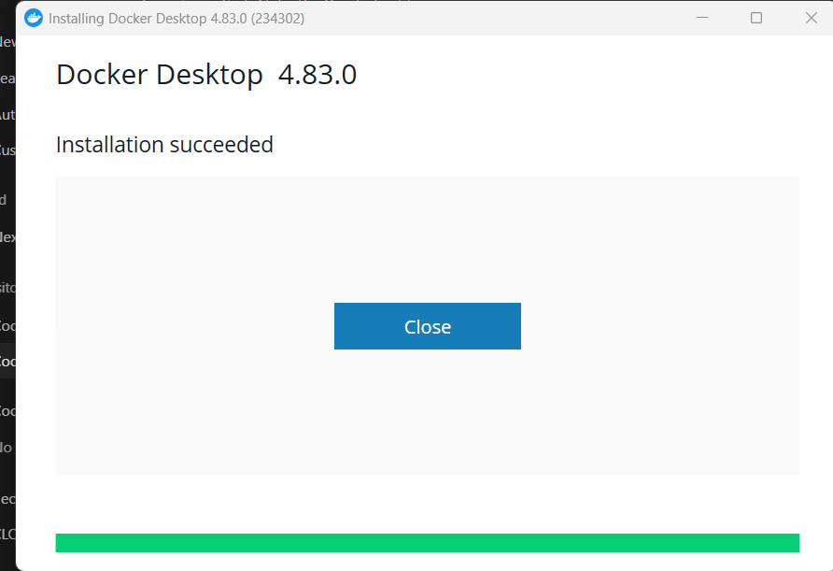
Figure 1: Docker Desktop installation succeeded.
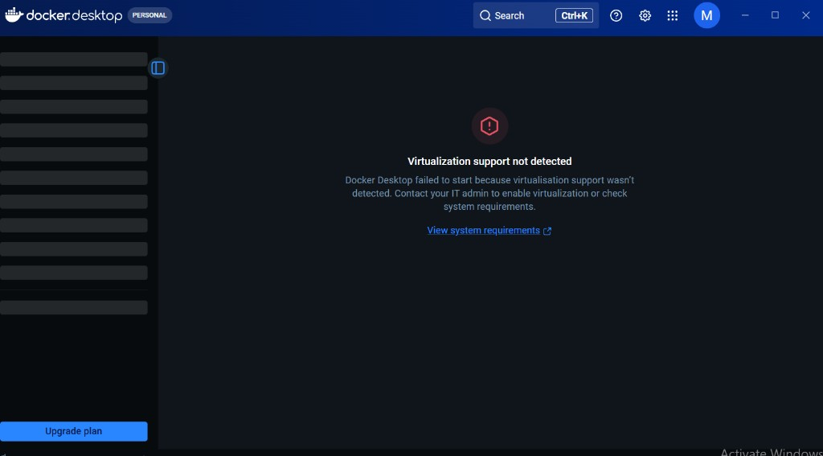
Figure 2: Initial virtualization/WSL issue (resolved by installing WSL2).
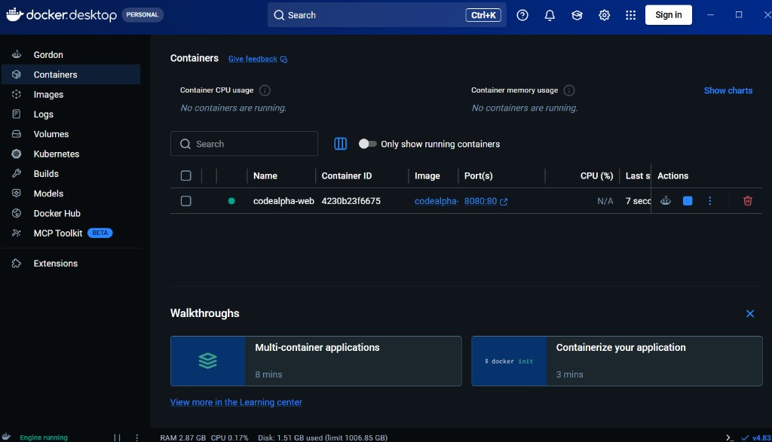
Figure 3: Container codealpha-web running in Docker Desktop (8080:80).
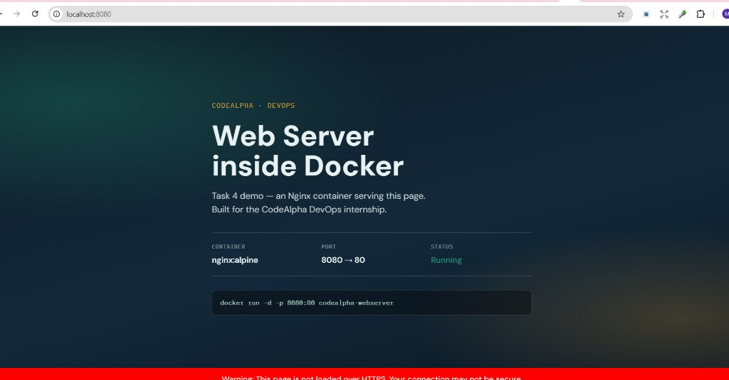
Figure 4: Browser — http://localhost:8080 showing CodeAlpha Docker web page.

4. Results
- Docker image codealpha-webserver built successfully
- Container codealpha-web running with port mapping 8080->80
- Website reachable at http://localhost:8080 (HTTP 200)
- /health endpoint returns healthy

