CodeAlpha — DevOps Internship
TASK 1: CI/CD Pipeline using Azure
Progress Report

Intern Name: Musfira Hassan
Domain: DevOps
Subscription: Azure for Students

1. Objective
Build an automated CI/CD pipeline with Azure Pipelines, store container images in Azure Container Registry (ACR), and deploy a web app to Azure App Service.

2. Azure resources created
- Resource Group (ACR): codealpha-devops-rg — Central India
- Azure Container Registry: codealphacr15128 (codealphacr15128.azurecr.io), Admin enabled
- Resource Group (Web App): codealpha-devops-rg2 — new RG used due to App Service capacity limits
- App Service Plan: ASP-codealphadevopsrg2-9b83 — Linux, Free F1, Central India
- Web App: created via Azure Portal (Publish = Container)

3. Capacity issue and workaround
Creating an App Service Plan with Basic B1 in resource group codealpha-devops-rg failed with no available instances. Azure suggested deploying to a new resource group. Creating codealpha-devops-rg2 with Free F1 succeeded.

4. Screenshot — Web App deployment complete
The Azure Portal confirmed a successful Web App deployment in resource group codealpha-devops-rg2.
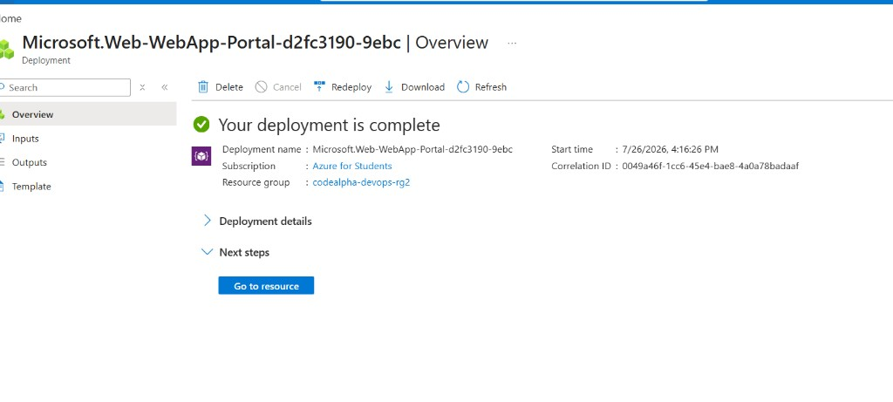
Figure 1: Deployment complete — Azure for Students · Resource group codealpha-devops-rg2 · 7/26/2026, 4:16:26 PM.

5. Next steps
- Confirm Web App name and URL
- Set up Azure DevOps project and connect GitHub repo CodeAlpha_DevOps
- Create service connections (ACR + Azure Resource Manager)
- Run pipeline to build Task 4 Docker image, push to ACR, deploy to App Service

6. Values for pipeline YAML
acrLoginServer: 'codealphacr15128.azurecr.io'
imageName: 'codealpha-webserver'
appName: '<web-app-name>'

