**Faculty of Computing**

**SE-314: Software Construction**

**Class: BESE 13AB**

# Lab 12: Recursion-II

**CLO-03:** Design and develop solutions based on Software Construction principles.  
**CLO-04:** Use modern tools such as Eclipse, NetBeans etc. for software construction.

**MUHAMMAD MUSFIR BAIG**

**4****09968**

**Instructor: Dr. Mehvish Rashid  
Lab Engineer: Mr. Aftab Farooq**

**Introduction:**

# Lab 12: Recursion-II

Students will have hands-on experience on designing, testing, and implementing recursive problems. Given a scenario, you will write the specifications and implement it by dividing into base case and recursive step. You may design helper methods to simplify your implementations. Write unit tests that check for compliance with the specifications.

## Lab Tasks

## GITHUB: <https://github.com/musfirbaig/sc_labs/tree/main/Lab12>

**Task 1: Recursive Binary Search on a Sorted Array**

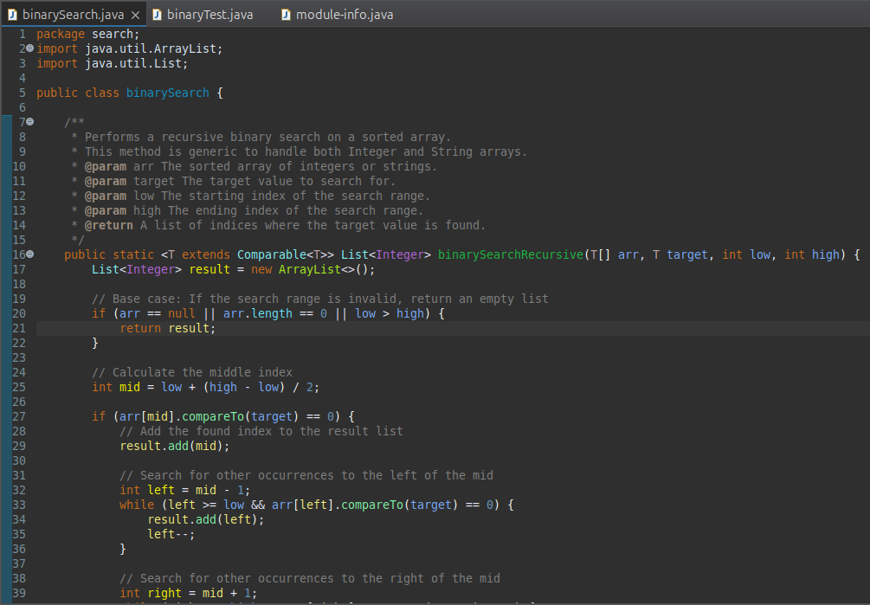

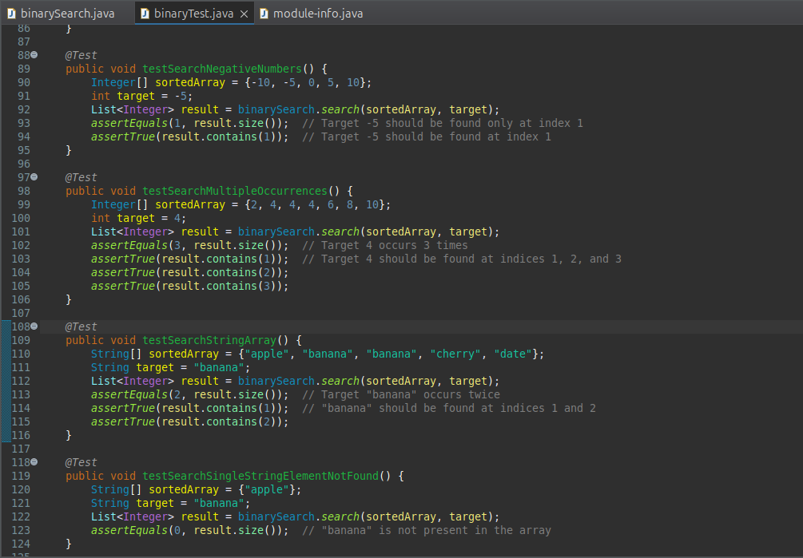

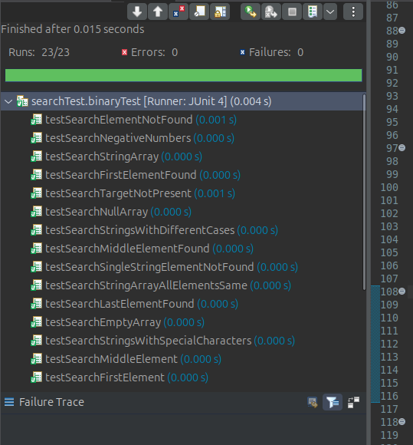

**Task 2: Recursive Parser for Mathematical Expressions**

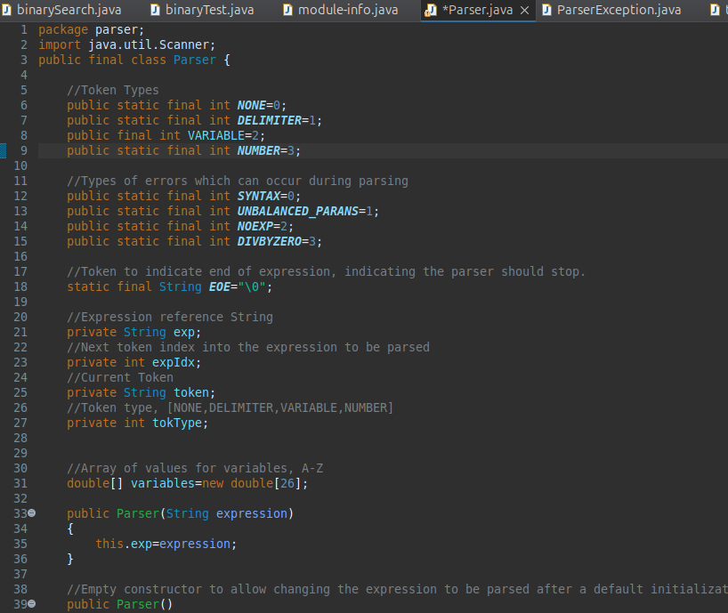

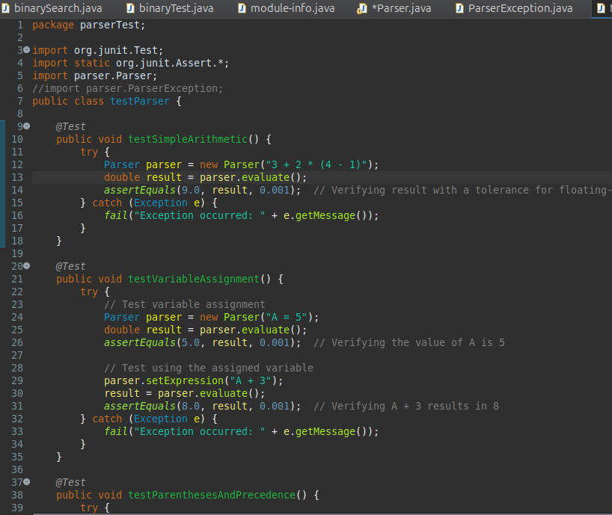

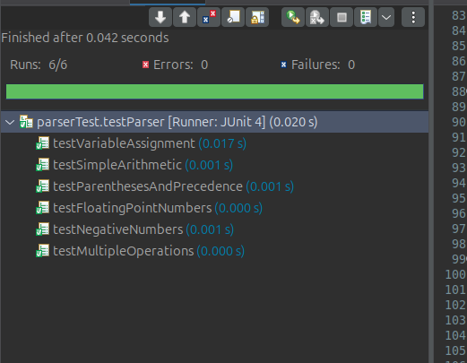

**Task 3: Recursive Sum of Digits**

