Normalization & Relational Modeling
ASSIGNMENT - 2
SUBMITTED BY: MUSHAHID RAZA

Part 1: Relational Modelling – Sakila
A new lookup table `payment type` was added to the Sakila schema with a one-to-many relationship to the `payment` table. The purpose is to categorize different payment methods used by customers.
Attributes of payment type:
- payment_type_id SMALLINT (6) (Primary Key)-
- method VARCHAR (10)
- description VARCHAR (45)

Field (Attributes) | Primary Key (Y/N) | Foreign Key (Y/N) | Related Table(s) and Cardinality between tables
payment_id | YES | NO | N/A
customer_id | NO | YES | Customer (1) to Payment (Many)
staff_id | NO | YES | Staff (1) to Payment (Many)
rental_id | NO | YES | Rental (1) to Payment (1)
amount | NO | NO | N/A
payment_date | NO | NO | N/A
payment_type_id | NO | YES | payment_type (1) to Payment (Many)

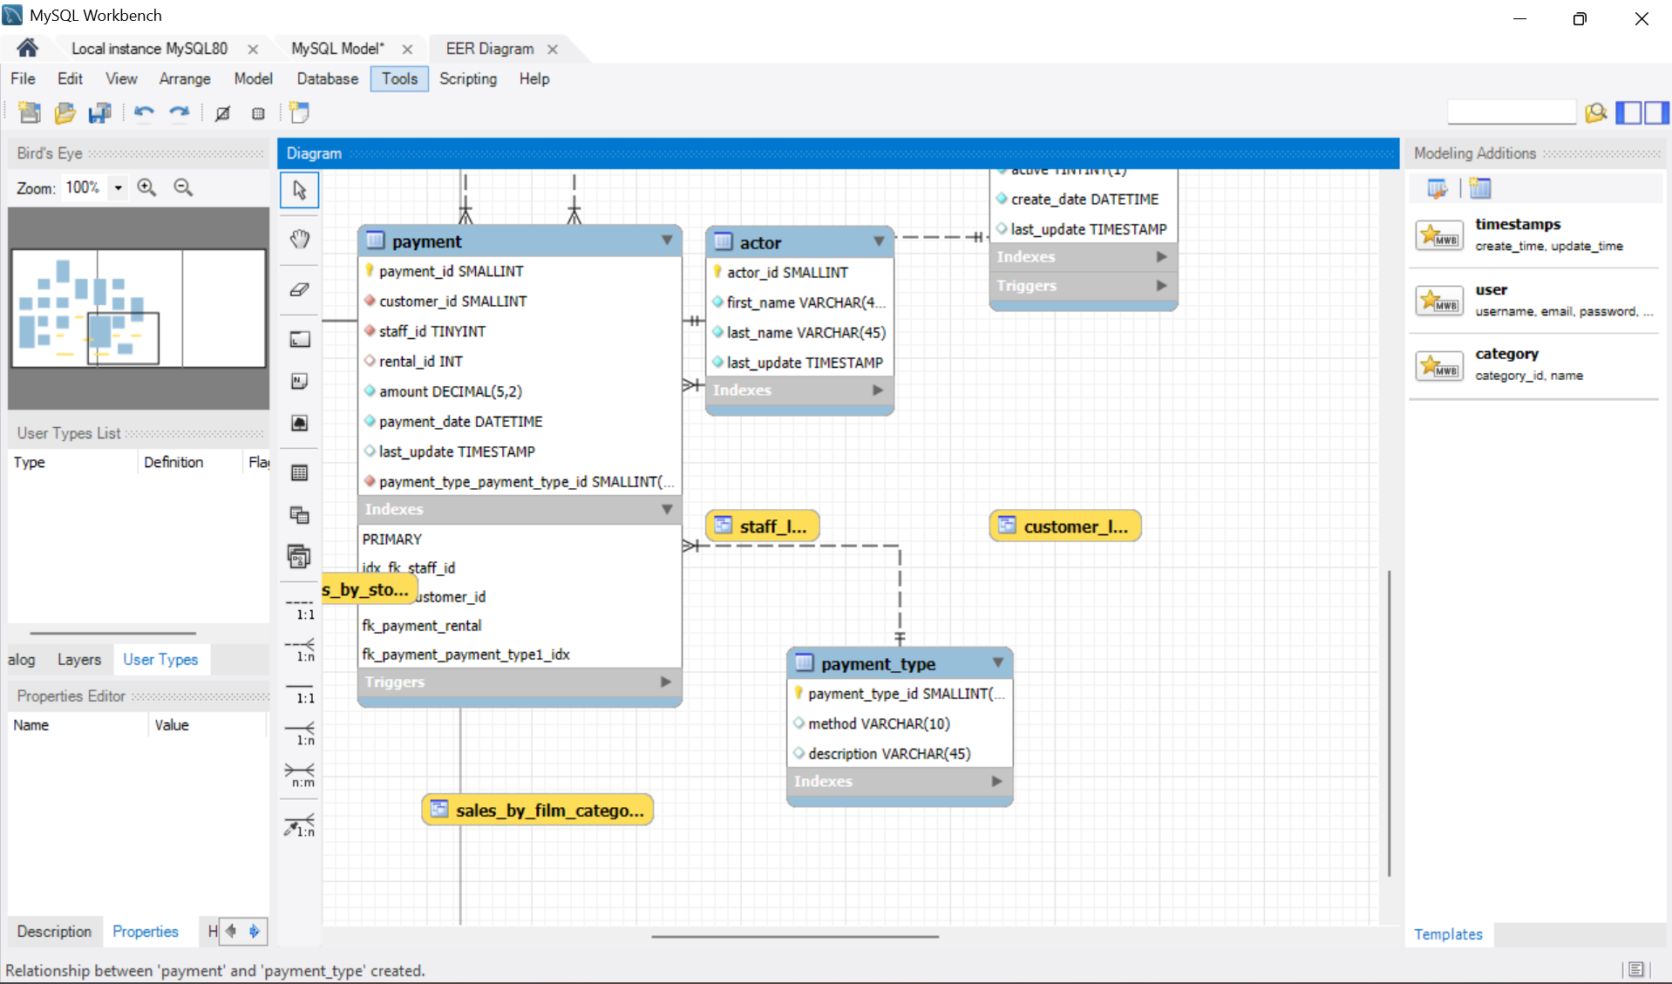
Part 3: Data Modeling – Movie Production Studio:

The data model was designed to track movies, producers, actors, theatres, and exhibitions.
Normalization to 3NF was ensured to prevent redundancy and maintain referential integrity.
Key Entities and Attributes:
- Movie: movie_id (PK), title, production_year, rating_code (FK), producer_id (FK)
- Producer: producer_id (PK), first_name, last_name
- Actor: actor_id (PK), first_name, last_name
- RoleType: role_type_id (PK), role_name
- MovieCast: movie_id (FK), actor_id (FK), role_type_id (FK), pay_amount PK (movie_id,actor_id)
- Rating: rating_code (PK), description
- Theatre: theatre_id (PK), theatre_name, address_line1, address_line2, city, state, postal_code, ticket_price
- Exhibition: movie_id (FK), theatre_id (FK), tickets_sold — PK(movie_id, theatre_id)
Relationship Notes:
- Movie ↔ Producer: Many-to-One (each movie has one producer)
- Movie ↔ Actor: Many-to-Many via Movie Cast
- Movie ↔ Theatre: Many-to-Many via Exhibition
- Theatre.ticket_price applies uniformly to all tickets per theatre

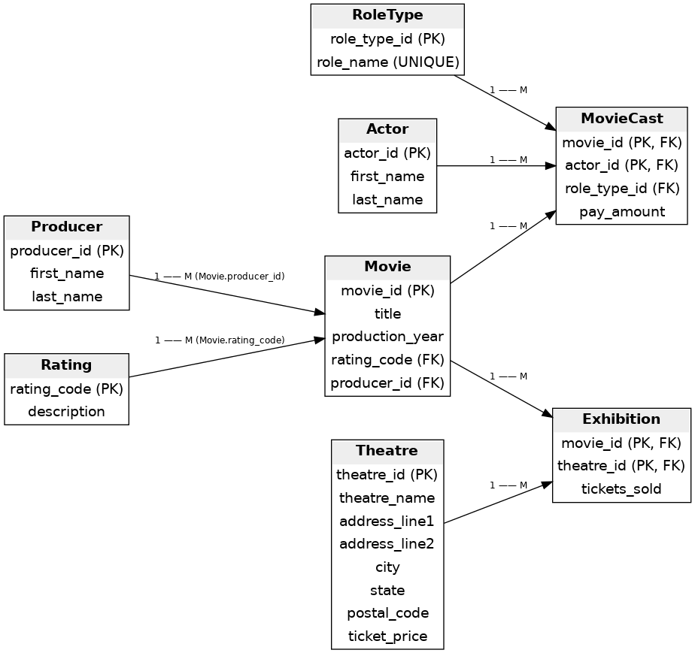
PART 4: Design Document:

Database Type:
- Type: Relational Database Management System (RDBMS) (e.g., MySQL, PostgreSQL).
- Reasoning: An RDBMS is best suited for this model because the data requires high data integrity (e.g., ensuring every actor record points to a real movie) and complex, defined relationships (1:M, M:M), which RDBMS excels at maintaining.
Type/Number of Users:
- Who will be using this database:
- Production Staff
- Finance/Accounting
- Marketing/Sales
- Number (Roughly): 10–50 concurrent users (low to medium volume). This is a typical volume for internal studio staff.
Need for Distributed Databases:
- Not initially required; a single instance with backups is sufficient.
Data Security Considerations:
- Control Access: Implement Role-Based Access Control (RBAC). Users should only be granted the minimum access (read, write, delete) required for their job function.
- Access Levels:
  - Financial Data
  - PII
  - Sales Data
Data Privacy Considerations:
- Sensitive Personal Information: Yes, the names and addresses of Actors and Producers are considered Personally Identifiable Information (PII).
- Restriction/Processing: Access to these fields should be heavily logged and restricted to protect individual privacy.
Data Integrity Considerations:
- Enforce foreign keys, unique constraints, and check constraints (non-negative values, unique per-day appointment rule). Use transactions for atomic updates.

