**Assignment #1**

**Web Technology**

**Submitted By:**

**Mushal Manzoor**

**Registration #:**

**FA19-BSE-082-B**

**Submitted To:**

**Ma,am Sayeda Fatima**

**Date:**

**6 October 2021**



**Admission Form:**

**Screenshots:**

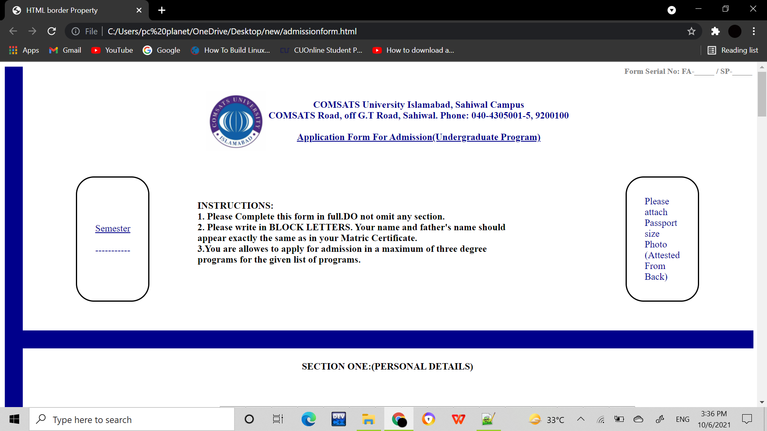

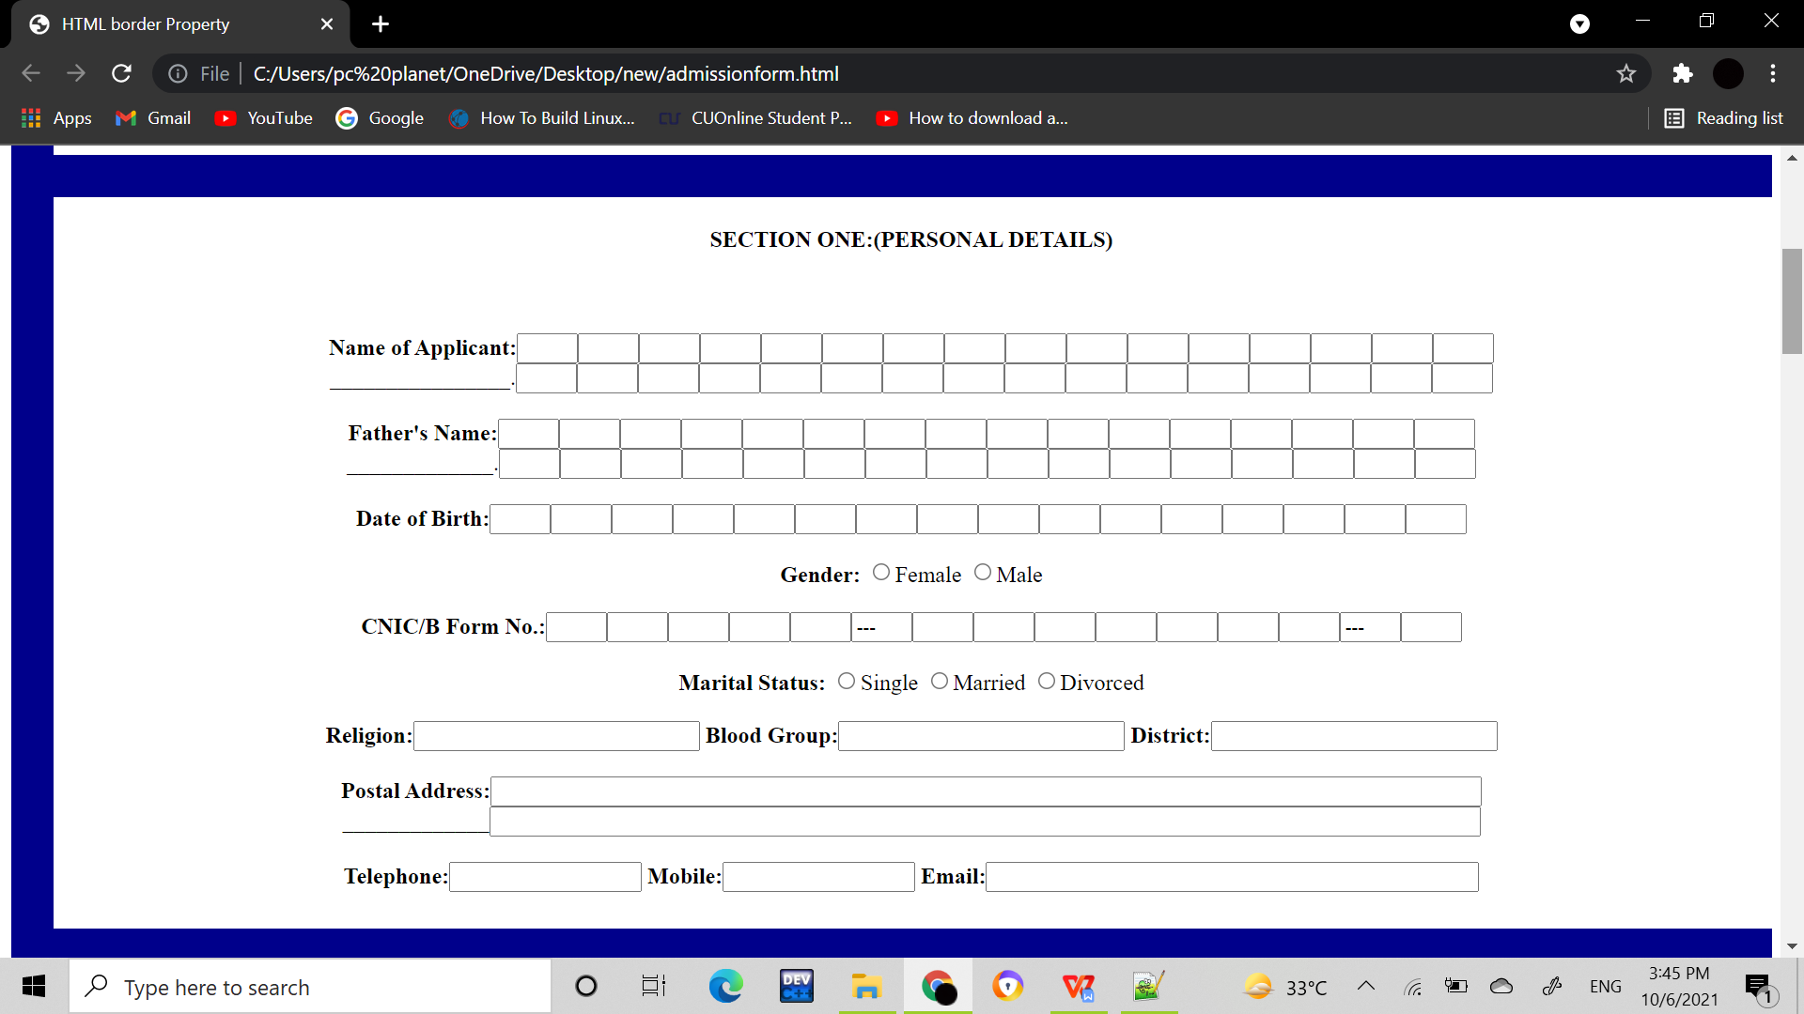

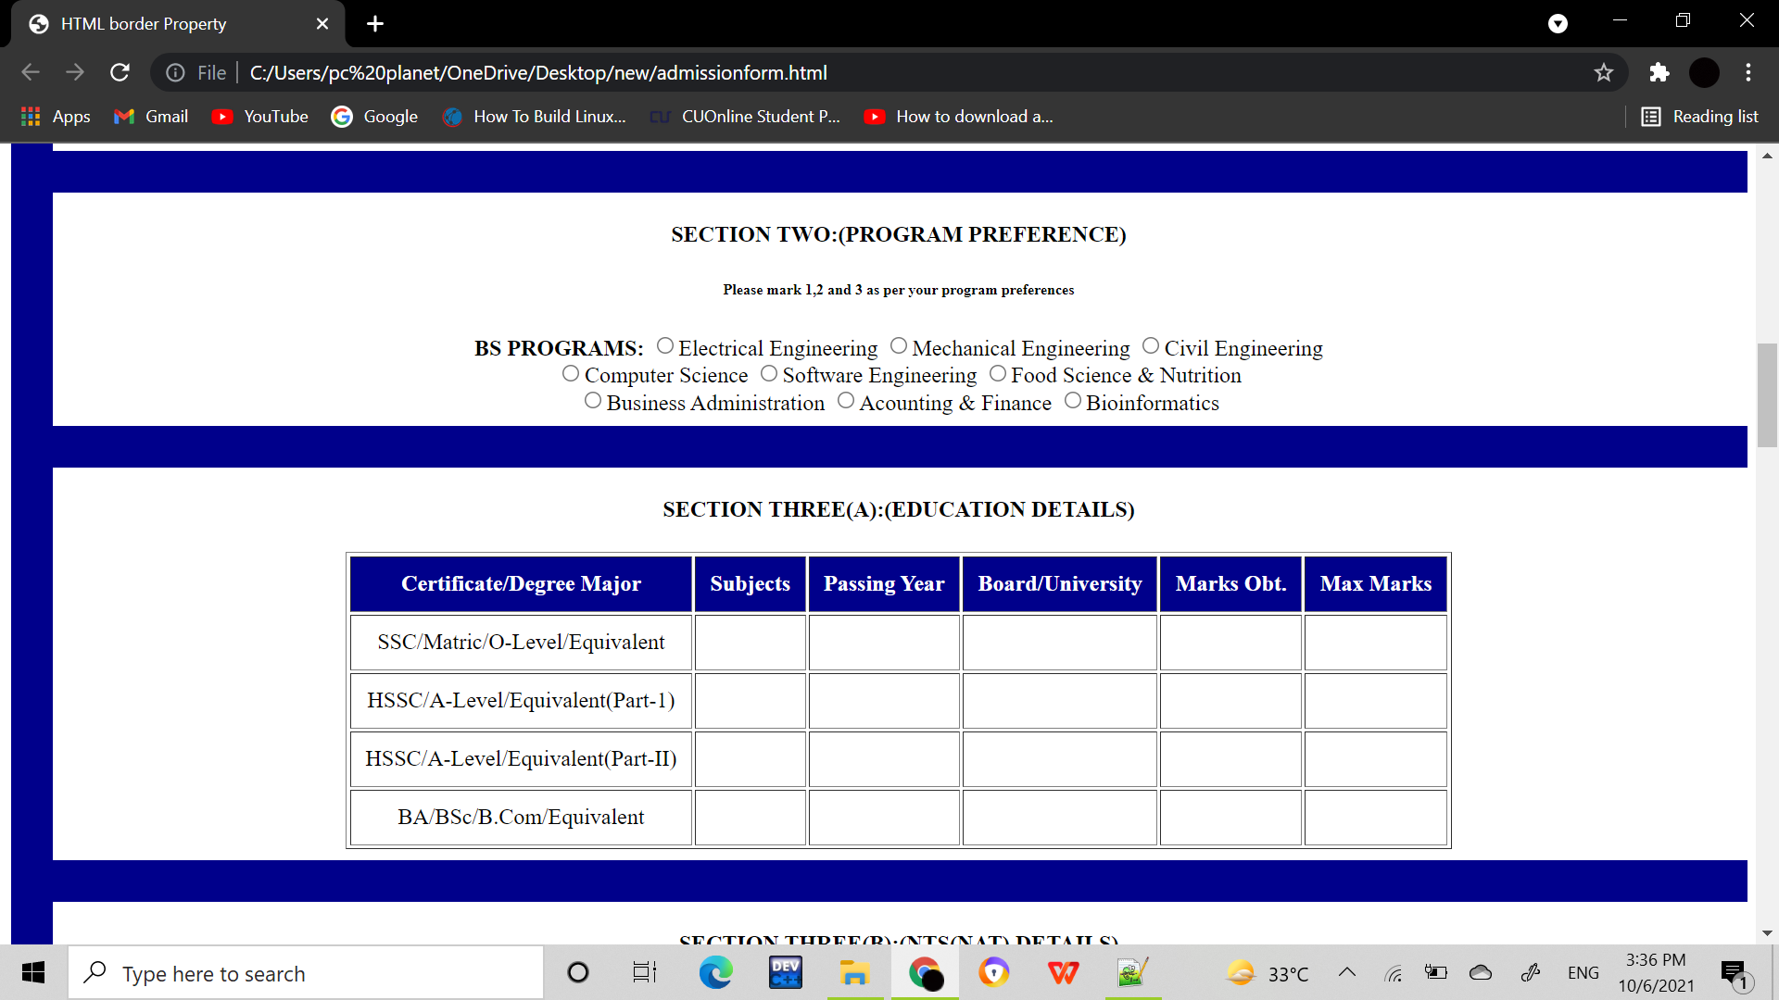

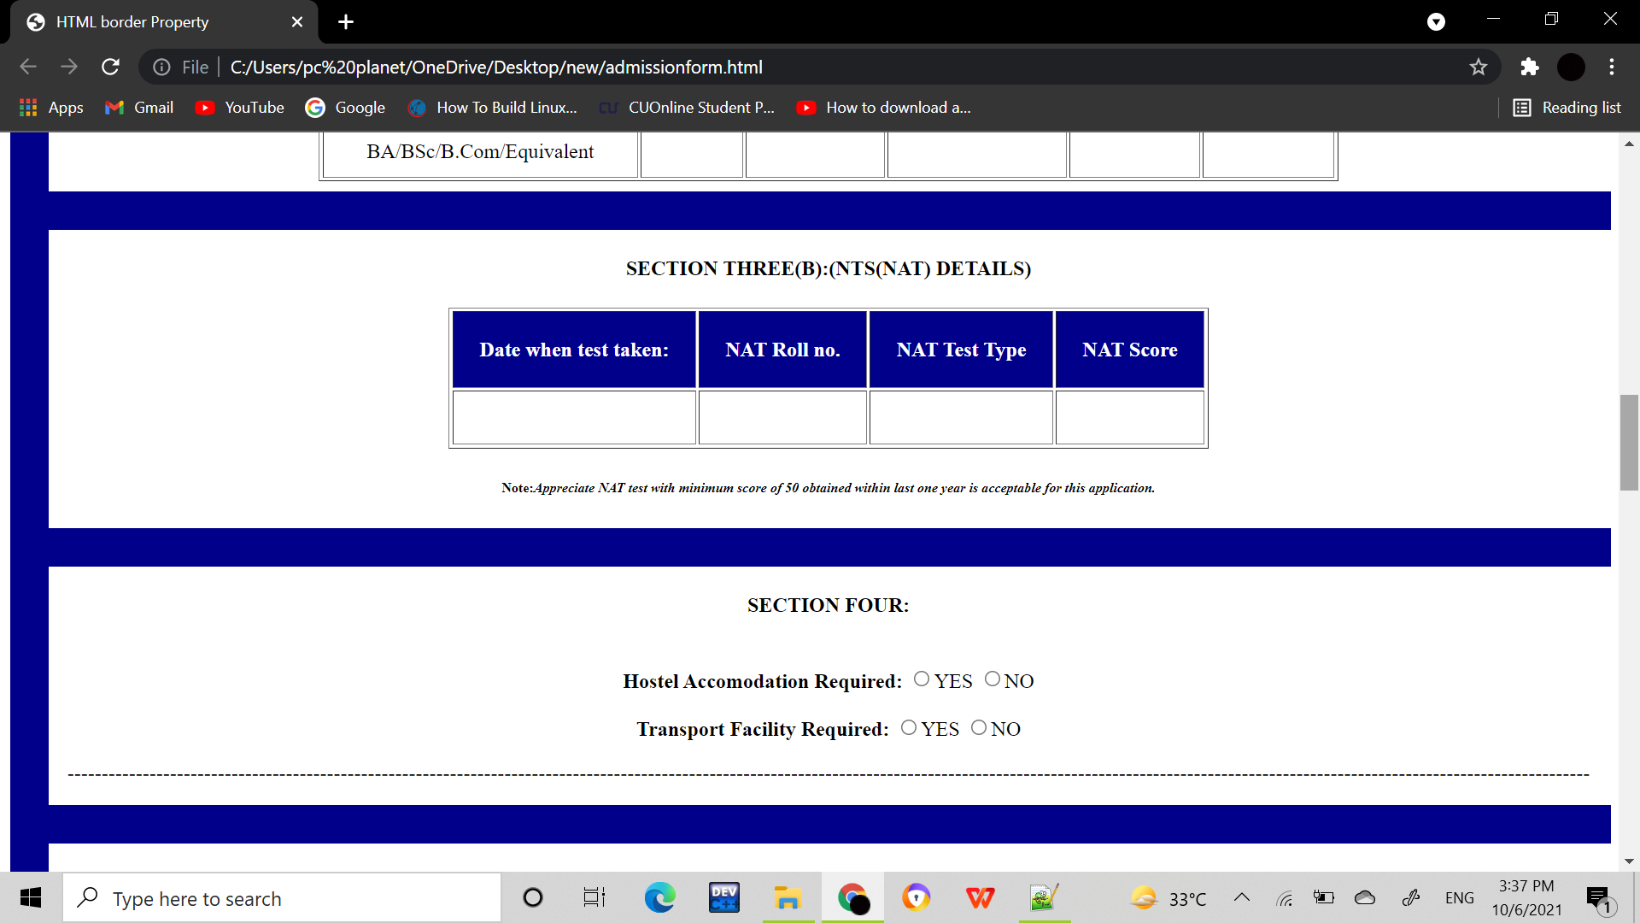

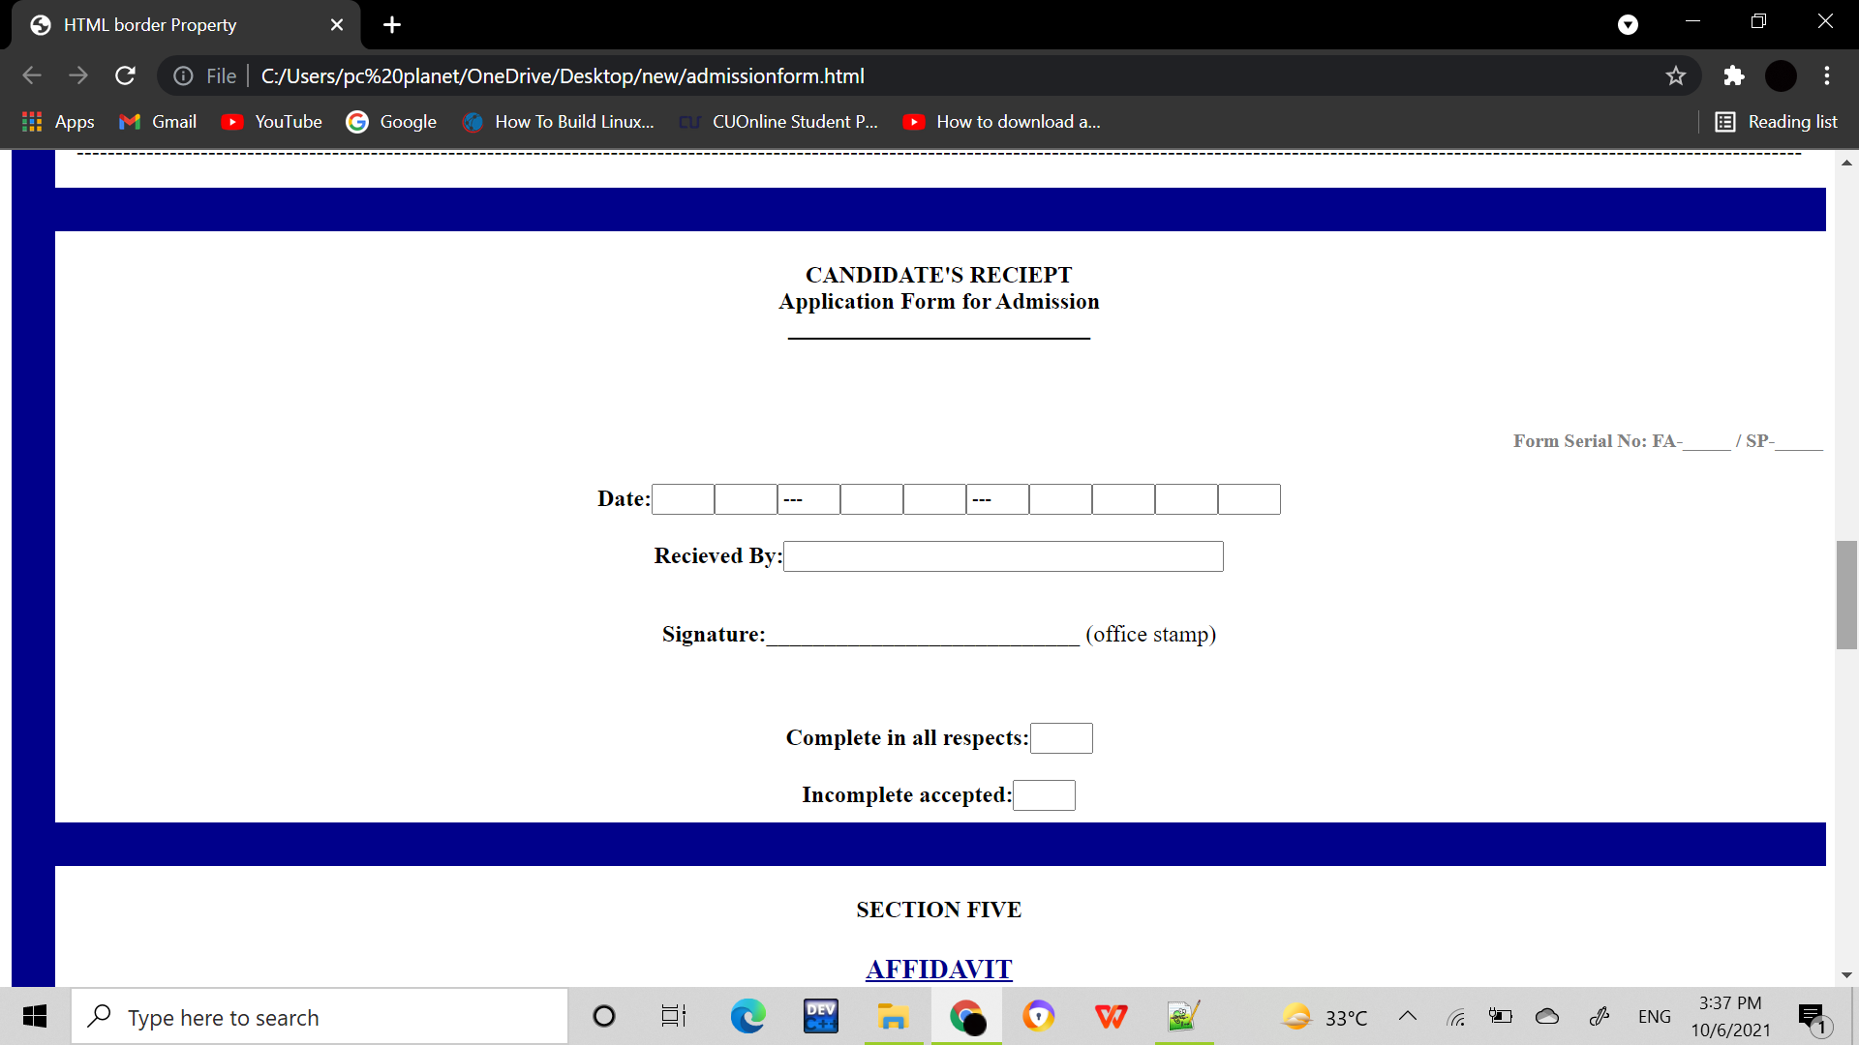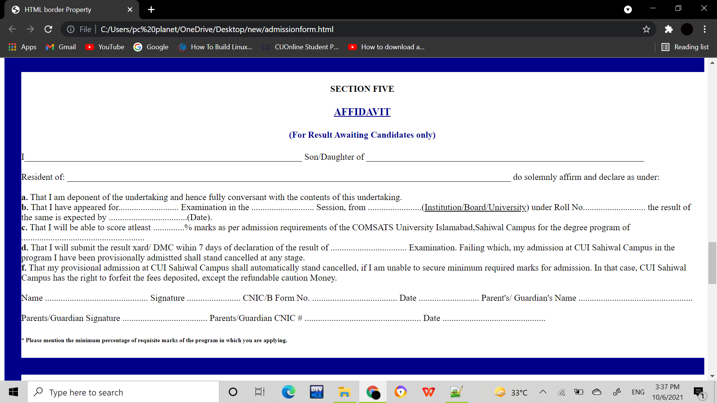

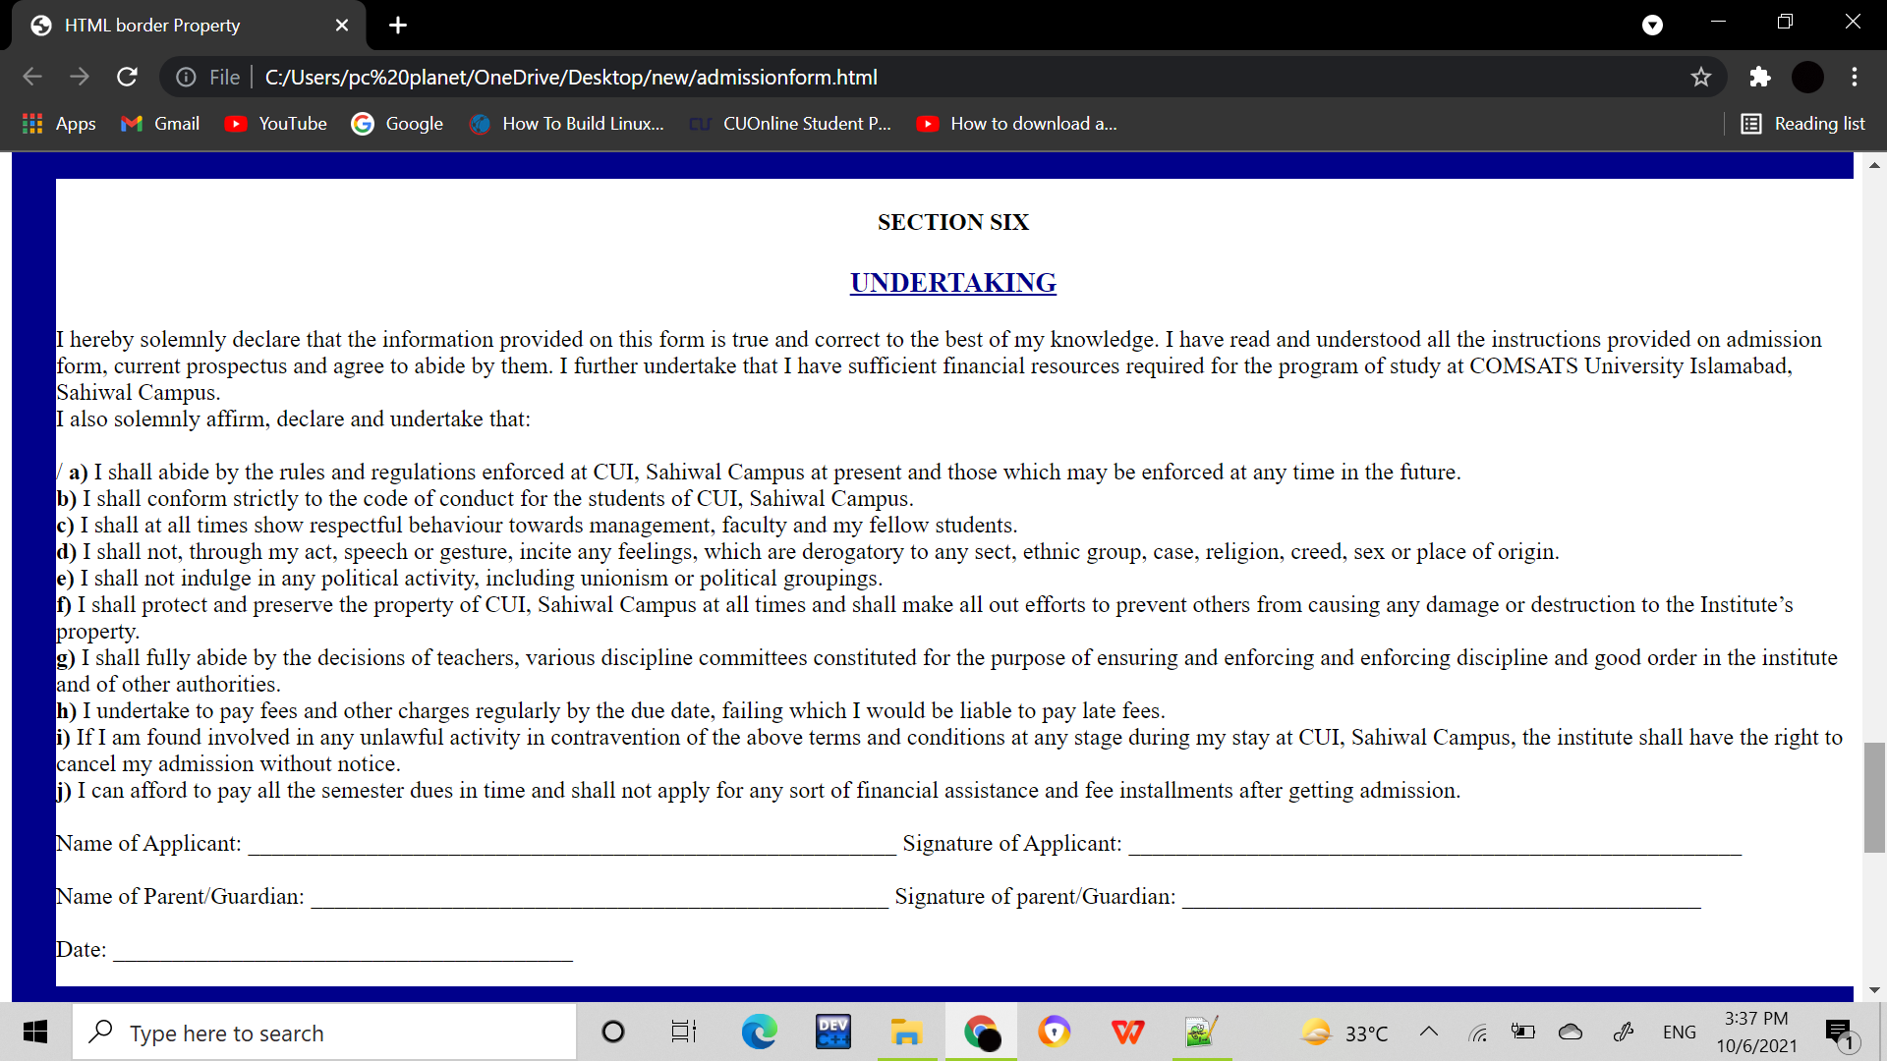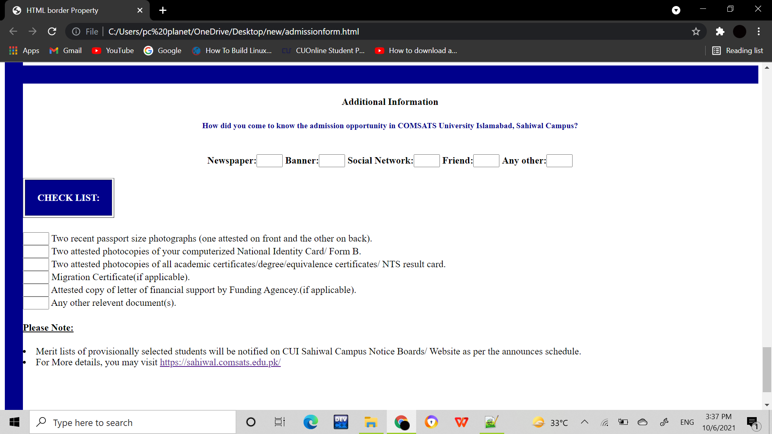

**Code:**

<html>

<head>

<title>

HTML border Property

</title>

<!-- border-left property is used to

create vertical line -->

<style>

.vertical {

border-left: 30px solid darkblue;

height: 4200px;

}

#rcorners2 {

border-radius: 30px;

border: 2px solid black;

padding: 30px;

width: 40px;

height: 10px;

}

</style>

</head>

<body <div class= "vertical"></div>

<form >

<h5 style="color:gray; text-align:right"> <b> Form Serial No: FA-_____ / SP-_____ </b></h5>

<table align="center">

<tr height="5" align="center" vertical-align="top">

<td><img src="comsat.jpg" height="100px" width="100px"></td>

<td style="color:darkblue;"><b>COMSATS University Islamabad, Sahiwal Campus<br>COMSATS Road, off G.T Road, Sahiwal. Phone: 040-4305001-5, 9200100 <br><br> <u>Application Form For Admission(Undergraduate Program)</u></b></td>

</tr>

</table>

<table cellpadding="40" cellspacing="40" align="center">

<tr >

<td id="rcorners2" style="color:darkblue;"> <u>Semester</u><br><br>-----------</td>

<td > <b><h4>INSTRUCTIONS:</b><br> <b>1.</b> Please Complete this form in full.DO not omit any section.<br><b>2.</b> Please write in BLOCK LETTERS. Your name and father's name should<br>appear exactly the same as in your Matric Certificate.<br><b>3.</b>You are allowes to apply for admission in a maximum of three degree<br>programs for the given list of programs.<h4><td>

<td id="rcorners2" style="color:darkblue;"> Please attach Passport size Photo<br>(Attested From Back) </td>

</tr>

</table>

<hr style="width:100%", size="30", color=darkblue>

<h4 align="center"><b>SECTION ONE:(PERSONAL DETAILS)</b></h4><br><br>

<center>

<b> Name of Applicant:</b><input type="text" size="1" value=""><input type="text" size="1" value=""><input type="text" size="1" value=""><input type="text" size="1" value=""><input type="text" size="1" value=""><input type="text" size="1" value=""><input type="text" size="1" value=""><input type="text" size="1" value=""><input type="text" size="1" value=""><input type="text" size="1" value=""><input type="text" size="1" value=""><input type="text" size="1" value=""><input type="text" size="1" value=""><input type="text" size="1" value=""><input type="text" size="1" value=""><input type="text" size="1" value=""> <br>

________________.<input type="text" size="1" value=""><input type="text" size="1" value=""><input type="text" size="1" value=""><input type="text" size="1" value=""><input type="text" size="1" value=""><input type="text" size="1" value=""><input type="text" size="1" value=""><input type="text" size="1" value=""><input type="text" size="1" value=""><input type="text" size="1" value=""><input type="text" size="1" value=""><input type="text" size="1" value=""><input type="text" size="1" value=""><input type="text" size="1" value=""><input type="text" size="1" value=""><input type="text" size="1" value=""><br><br>

<b> Father's Name:</b><input type="text" size="1" value=""><input type="text" size="1" value=""><input type="text" size="1" value=""><input type="text" size="1" value=""><input type="text" size="1" value=""><input type="text" size="1" value=""><input type="text" size="1" value=""><input type="text" size="1" value=""><input type="text" size="1" value=""><input type="text" size="1" value=""><input type="text" size="1" value=""><input type="text" size="1" value=""><input type="text" size="1" value=""><input type="text" size="1" value=""><input type="text" size="1" value=""><input type="text" size="1" value=""> <br>

_____________.<input type="text" size="1" value=""><input type="text" size="1" value=""><input type="text" size="1" value=""><input type="text" size="1" value=""><input type="text" size="1" value=""><input type="text" size="1" value=""><input type="text" size="1" value=""><input type="text" size="1" value=""><input type="text" size="1" value=""><input type="text" size="1" value=""><input type="text" size="1" value=""><input type="text" size="1" value=""><input type="text" size="1" value=""><input type="text" size="1" value=""><input type="text" size="1" value=""><input type="text" size="1" value=""><br><br>

<b> Date of Birth:</b><input type="text" size="1" value=""><input type="text" size="1" value=""><input type="text" size="1" value=""><input type="text" size="1" value=""><input type="text" size="1" value=""><input type="text" size="1" value=""><input type="text" size="1" value=""><input type="text" size="1" value=""><input type="text" size="1" value=""><input type="text" size="1" value=""><input type="text" size="1" value=""><input type="text" size="1" value=""><input type="text" size="1" value=""><input type="text" size="1" value=""><input type="text" size="1" value=""><input type="text" size="1" value=""> <br><br>

<b> Gender:</b> <input type="radio" name="radio" value="checked">Female

<input type="radio" name="radio" value="checked">Male<br><br>

<b> CNIC/B Form No.:</b><input type="text" size="1" value=""><input type="text" size="1" value=""><input type="text" size="1" value=""><input type="text" size="1" value=""><input type="text" size="1" value=""><input type="text" align="center" size="1" value="---"><input type="text" size="1" value=""><input type="text" size="1" value=""><input type="text" size="1" value=""><input type="text" size="1" value=""><input type="text" size="1" value=""><input type="text" size="1" value=""><input type="text" size="1" value=""><input type="text" size="1" value="---"><input type="text" size="1" value=""> <br><br>

<b> Marital Status:</b> <input type="radio" name="radio" value="checked">Single

<input type="radio" name="radio" value="checked">Married

<input type="radio" name="radio" value="checked">Divorced<br><br>

<b> Religion:</b><input type="text" size="25" value=""> <b> Blood Group:</b><input type="text" size="25" value=""><b> District:</b><input type="text" size="25" value=""><br><br>

<b> Postal Address:</b><input type="text" size="100" value=""><br>_____________<input type="text" size="100" value=""><br><br>

<b> Telephone:</b><input type="text" size="15" value=""> <b> Mobile:</b><input type="text" size="15" value=""><b> Email:</b><input type="text" size="47" value=""><br><br>

<hr style="width:100%", size="30", color=darkblue>

<h4 align="center"><b>SECTION TWO:(PROGRAM PREFERENCE)</b><br><h6> Please mark 1,2 and 3 as per your program preferences</h6></h4>

<center>

<b> BS PROGRAMS:</b> <input type="radio" name="radio" value="checked">Electrical Engineering

<input type="radio" name="radio" value="checked">Mechanical Engineering

<input type="radio" name="radio" value="checked">Civil Engineering<br>

<input type="radio" name="radio" value="checked">Computer Science

<input type="radio" name="radio" value="checked">Software Engineering

<input type="radio" name="radio" value="checked">Food Science & Nutrition<br>

<input type="radio" name="radio" value="checked">Business Administration

<input type="radio" name="radio" value="checked">Acounting & Finance

<input type="radio" name="radio" value="checked">Bioinformatics<br>

</center>

<hr style="width:100%", size="30", color=darkblue>

<h4 align="center"><b>SECTION THREE(A):(EDUCATION DETAILS)</b></h4>

<table border="1"align="center" cellpadding="10">

<tr style="color:white;" height="5" align="center" vertical-align="top">

<th style="background-color:darkblue;"> Certificate/Degree Major</th>

<th style="background-color:darkblue;"> Subjects</th>

<th style="background-color:darkblue;"> Passing Year</th>

<th style="background-color:darkblue;"> Board/University</th>

<th style="background-color:darkblue;"> Marks Obt.</th>

<th style="background-color:darkblue;"> Max Marks</th>

</tr>

<tr height="5" align="center" vertical-align="top">

<td> SSC/Matric/O-Level/Equivalent</td>

<td> </td>

<td></td>

<td></td>

<td></td>

<td></td>

</tr>

<tr height="5" align="center" vertical-align="top">

<td> HSSC/A-Level/Equivalent(Part-1)</td>

<td> </td>

<td></td>

<td></td>

<td></td>

<td></td>

</tr>

<tr height="5" align="center" vertical-align="top">

<td> HSSC/A-Level/Equivalent(Part-II)</td>

<td> </td>

<td></td>

<td></td>

<td></td>

<td></td>

</tr>

<tr height="5" align="center" vertical-align="top">

<td> BA/BSc/B.Com/Equivalent</td>

<td> </td>

<td></td>

<td></td>

<td></td>

<td></td>

</tr>

</table>

<hr style="width:100%", size="30", color=darkblue>

<h4 align="center"><b>SECTION THREE(B):(NTS(NAT) DETAILS)</b></h4>

<table border="1"align="center" cellpadding="20">

<tr style="color:white;" height="5" align="center" vertical-align="top">

<th style="background-color:darkblue;">Date when test taken:</th>

<th style="background-color:darkblue;"> NAT Roll no.</th>

<th style="background-color:darkblue;"> NAT Test Type</th>

<th style="background-color:darkblue;"> NAT Score</th>

</tr>

<tr>

<td></td>

<td></td>

<td></td>

<td></td>

</tr>

</table>

<h6 align= "center"><b>Note:</b><i>Appreciate NAT test with minimum score of 50 obtained within last one year is acceptable for this application.</i></h6>

<hr style="width:100%", size="30", color=darkblue>

<h4 align="center"><b>SECTION FOUR:</b></h4><br>

<b> Hostel Accomodation Required:</b> <input type="radio" name="radio" value="checked">YES

<input type="radio" name="radio" value="checked">NO<br><br>

<b> Transport Facility Required:</b> <input type="radio" name="radio" value="checked">YES

<input type="radio" name="radio" value="checked">NO

<p>-------------------------------------------------------------------------------------------------------------------------------------------------------------------------------------------------------------------------------</p>

<hr style="width:100%", size="30", color=darkblue>

<h4 align="center"><b>CANDIDATE'S RECIEPT<br>Application Form for Admission<br>__________________________</b></h4><br>

<h5 style="color:gray; text-align:right"> <b> Form Serial No: FA-_____ / SP-_____ </b></h5>

<b> Date:</b><input type="text" size="1" value=""><input type="text" size="1" value=""><input type="text" size="1" value="---"><input type="text" size="1" value=""><input type="text" size="1" value=""><input type="text" size="1" value="---"><input type="text" size="1" value=""><input type="text" size="1" value=""><input type="text" size="1" value=""><input type="text" size="1" value=""><br><br>

<b> Recieved By:</b><input type="text" size="40" value=""><br><br><p> <b> Signature:</b>___________________________ (office stamp)</p><br><br>

<b> Complete in all respects:</b><input type="text" size="1" value=""><br><br>

<b> Incomplete accepted:</b><input type="text" size="1" value="">

<hr style="width:100%", size="30", color=darkblue>

<h4 align="center"><b>SECTION FIVE</b></h4>

<h3 style="color:darkblue; align="center"><b><u>AFFIDAVIT</u></b></h3>

<h4 style="color:darkblue; align="center">(For Result Awaiting Candidates only)</h4>

<p align="left"> I______________________________________________________________ Son/Daughter of ______________________________________________________________<br> <br>Resident of: ___________________________________________________________________________________________________ do solemnly affirm and declare as under:<br><br>

<b>a.</b> That I am deponent of the undertaking and hence fully conversant with the contents of this undertaking.<br>

<b>b.</b> That I have appeared for........................... Examination in the ............................ Session, from ........................(<u>Institution/Board/University</u>) under Roll No............................ the result of the same is expected by ...................................(Date).<br>

<b>c.</b> That I will be able to score atleast ..............% marks as per admission requirements of the COMSATS University Islamabad,Sahiwal Campus for the degree program of ....................................................... <br>

<b>d.</b> That I will submit the result xard/ DMC wihin 7 days of declaration of the result of .................................. Examination. Failing which, my admission at CUI Sahiwal Campus in the program I have been provisionally admistted shall stand cancelled at any stage.<br>

<b>f.</b> That my provisional admission at CUI Sahiwal Campus shall automatically stand cancelled, if I am unable to secure minimum required marks for admission. In that case, CUI Sahiwal Campus has the right to forfeit the fees deposited, except the refundable caution Money.<br><br>

Name .............................................. Signature ........................ CNIC/B Form No. ...................................... Date ........................... Parent's/ Guardian's Name ...................................................<br> <br>Parents/Guardian Signature ...................................... Parents/Guardian CNIC # .................................................... Date .............................................. <br>

<h6 align="left">* Please mention the minimum percentage of requisite marks of the program in which you are applying.</h6>

</p>

<hr style="width:100%", size="30", color=darkblue>

<h4 align="center"><b>SECTION SIX</b></h4>

<h3 style="color:darkblue; align="center"><b><u>UNDERTAKING</u></b></h3>

<p align="left">I hereby solemnly declare that the information provided on this form is true and correct to the best of my knowledge. I have read and understood all the instructions provided on admission form, current prospectus and agree to abide by them. I further undertake that I have sufficient financial

resources required for the program of study at COMSATS University Islamabad, Sahiwal

Campus.<br>

I also solemnly affirm, declare and undertake that:<br><br>/

<b>a) </b>I shall abide by the rules and regulations enforced at CUI, Sahiwal Campus at present

and those which may be enforced at any time in the future.<br>

<b>b)</b> I shall conform strictly to the code of conduct for the students of CUI, Sahiwal Campus.<br>

<b>c)</b> I shall at all times show respectful behaviour towards management, faculty and my fellow

students.<br>

<b>d)</b> I shall not, through my act, speech or gesture, incite any feelings, which are derogatory to

any sect, ethnic group, case, religion, creed, sex or place of origin.<br>

<b>e)</b> I shall not indulge in any political activity, including unionism or political groupings.<br>

<b>f)</b> I shall protect and preserve the property of CUI, Sahiwal Campus at all times and shall

make all out efforts to prevent others from causing any damage or destruction to the

Institute’s property.<br>

<b>g)</b> I shall fully abide by the decisions of teachers, various discipline committees constituted

for the purpose of ensuring and enforcing and enforcing discipline and good order in the

institute and of other authorities.<br>

<b>h)</b> I undertake to pay fees and other charges regularly by the due date, failing which I would

be liable to pay late fees.<br>

<b>i)</b> If I am found involved in any unlawful activity in contravention of the above terms and

conditions at any stage during my stay at CUI, Sahiwal Campus, the institute shall have

the right to cancel my admission without notice.<br>

<b>j)</b> I can afford to pay all the semester dues in time and shall not apply for any sort of

financial assistance and fee installments after getting admission.<br><br>

Name of Applicant: _______________________________________________________

Signature of Applicant: ____________________________________________________<br><br>

Name of Parent/Guardian: _________________________________________________

Signature of parent/Guardian: ____________________________________________<br><br>

Date: _______________________________________

</p>

<hr style="width:100%", size="30", color=darkblue>

<h4 align="center"><b>Additional Information</b></h4>

<h5 style="color:darkblue; align="center"><b>How did you come to know the admission opportunity in COMSATS University Islamabad, Sahiwal Campus?</b></h5><br>

<b> Newspaper:</b><input type="text" size="1" value=""> <b> Banner:</b><input type="text" size="1" value=""> <b> Social Network:</b><input type="text" size="1" value=""> <b> Friend:</b><input type="text" size="1" value=""> <b> Any other:</b><input type="text" size="1" value="">

<br><br>

<table border="1"align="left" cellpadding="20">

<tr style="color:white;" height="5" align="center" vertical-align="top">

<th style="background-color:darkblue;">CHECK LIST:</th>

</tr>

</table>

<br><br><br><br><br>

</center>

<input type="text" size="1" value=""> Two recent passport size photographs (one attested on front and the other on back).<br>

<input type="text" size="1" value=""> Two attested photocopies of your computerized National Identity Card/ Form B. <br>

<input type="text" size="1" value=""> Two attested photocopies of all academic certificates/degree/equivalence certificates/ NTS result card.<br>

<input type="text" size="1" value=""> Migration Certificate(if applicable).<br>

<input type="text" size="1" value=""> Attested copy of letter of financial support by Funding Agencey.(if applicable).<br>

<input type="text" size="1" value=""> Any other relevent document(s).

<h4><u>Please Note:</u></h4

<ul>

<li>Merit lists of provisionally selected students will be notified on CUI Sahiwal Campus Notice Boards/ Website as per the announces schedule.<li>

</ul>For More details, you may visit <a href="https://sahiwal.comsats.edu.pk/" >https://sahiwal.comsats.edu.pk/</a>

</form>

</body>

</html>