1. Create mariadb db on ec2.

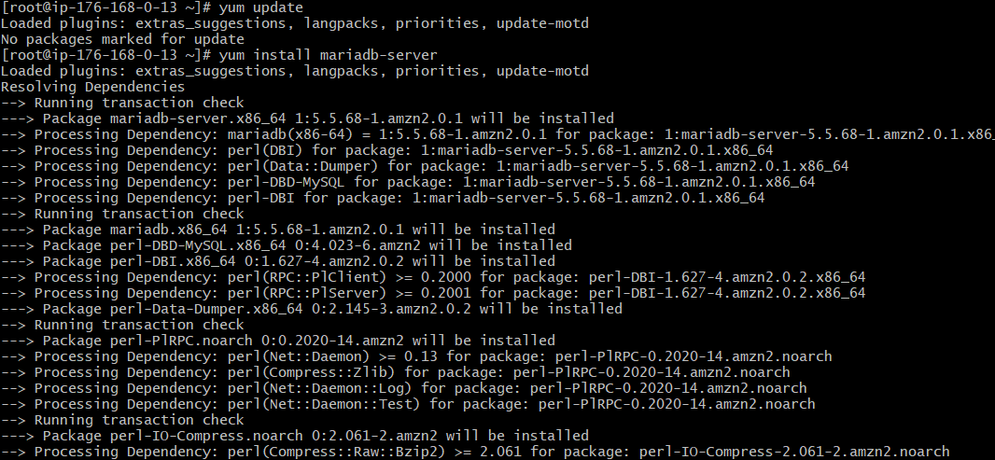

1. Insert some dummy data

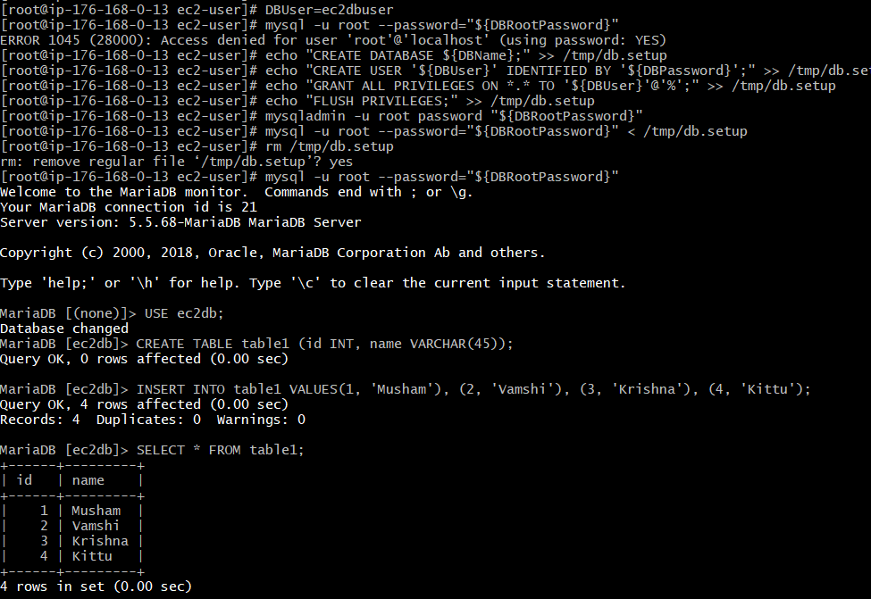

3) Take the backup of dummy data on ec2

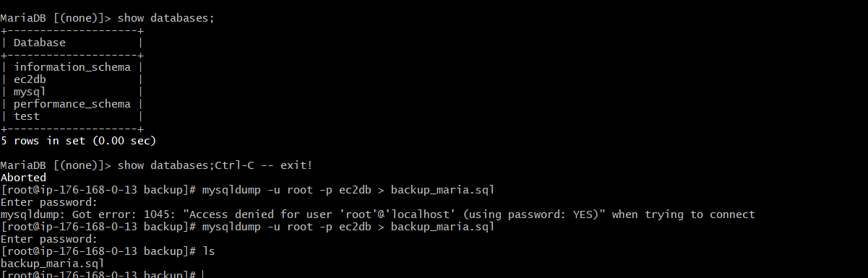

4) launch Mariadb RDS instance.

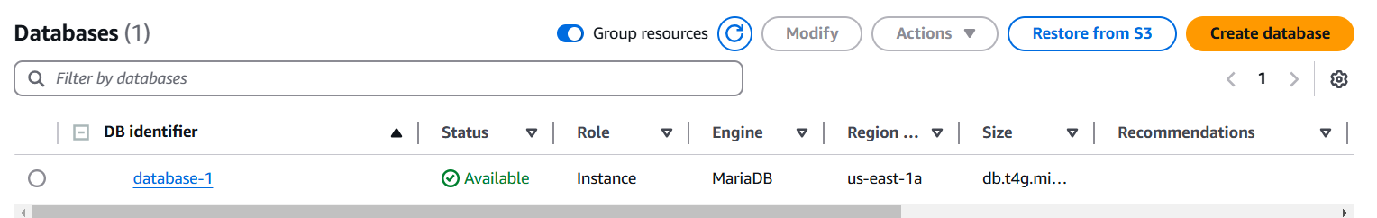

5) Migrate database from ec2 to RDS.

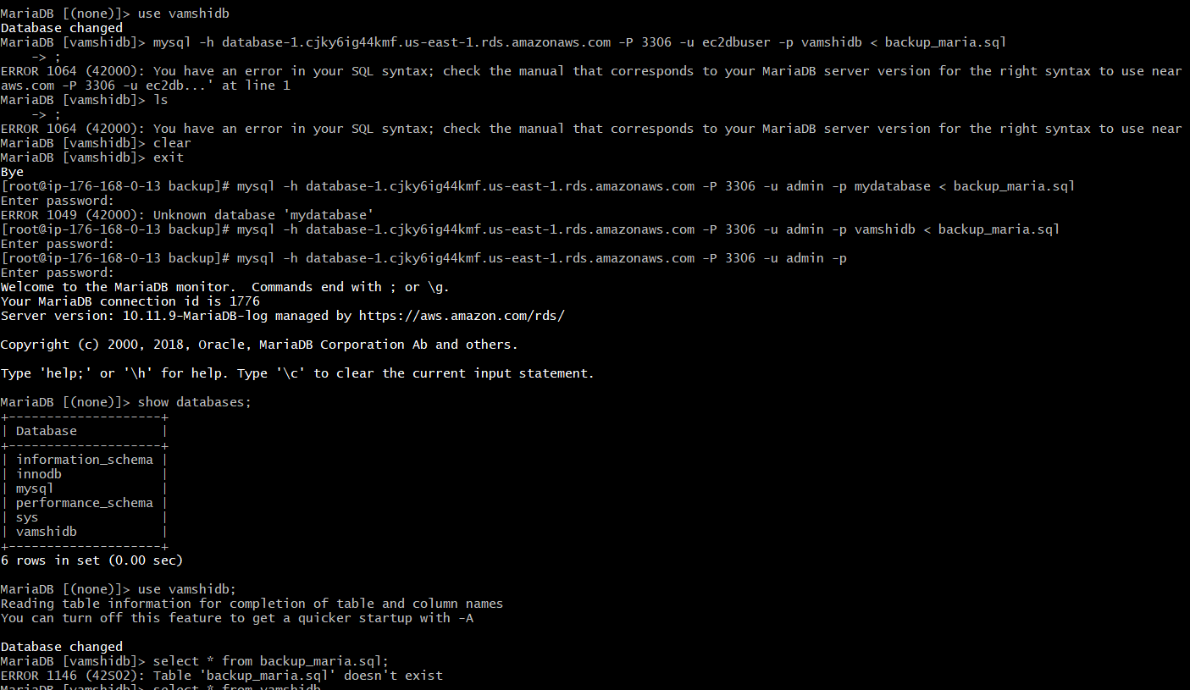

6) Install mysql db on ec2

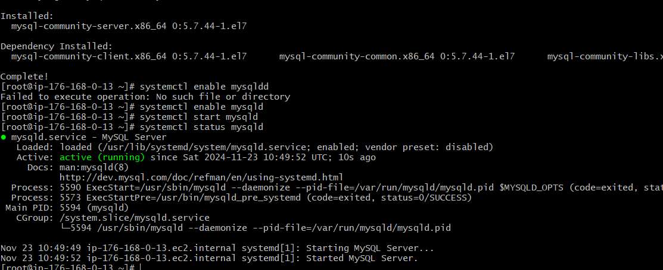

7) Launch mysql RDS image

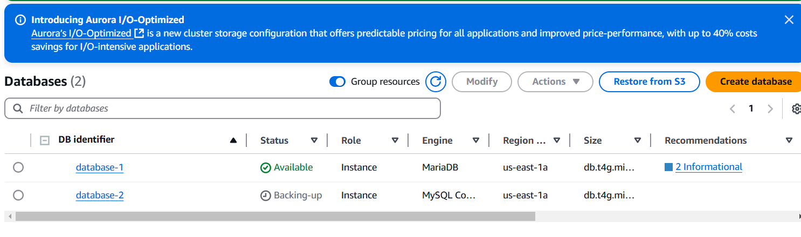

8) COnfigure multi AZ

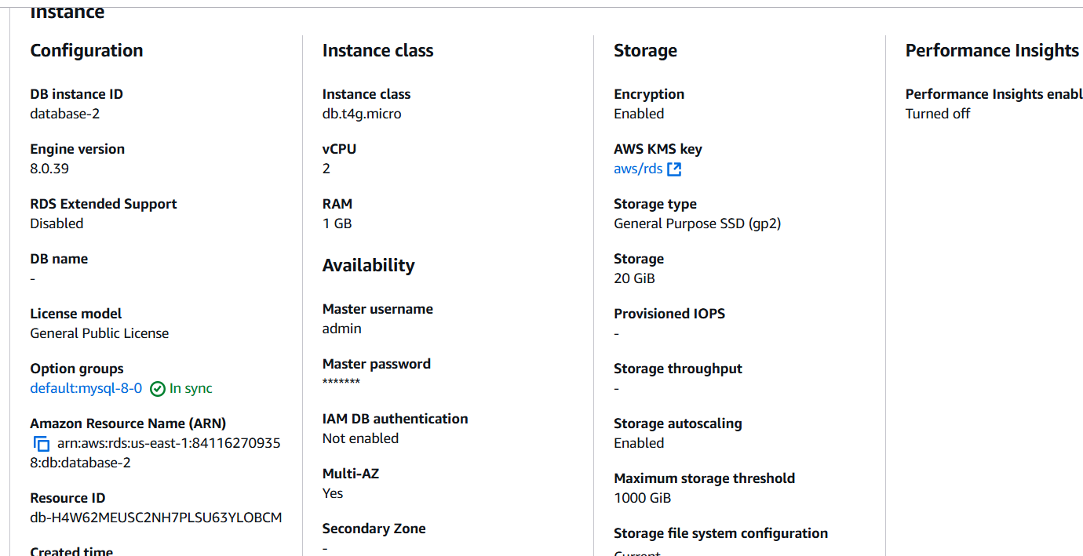

9) Take Backup of db and restore the DB

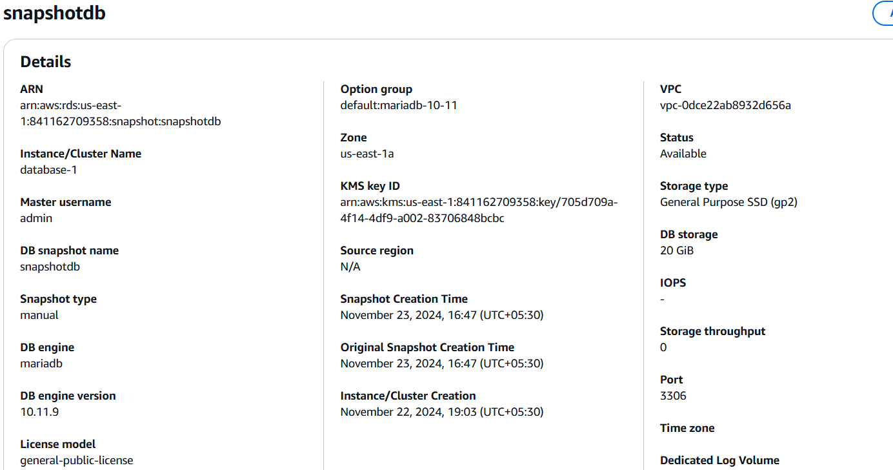

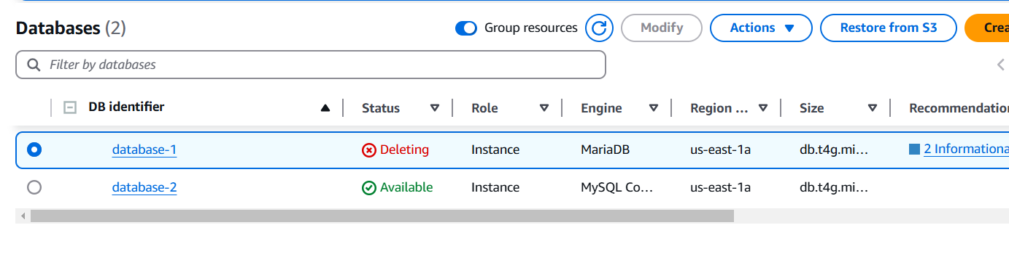

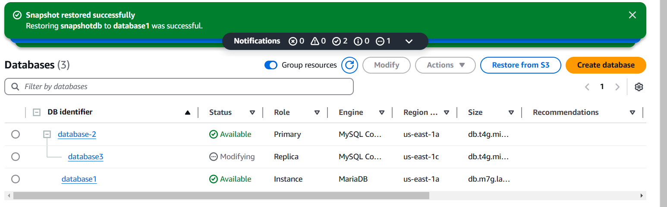

10) Create ReadReplca

