1) Create one IAM user and assign ec2,s3 full access role.

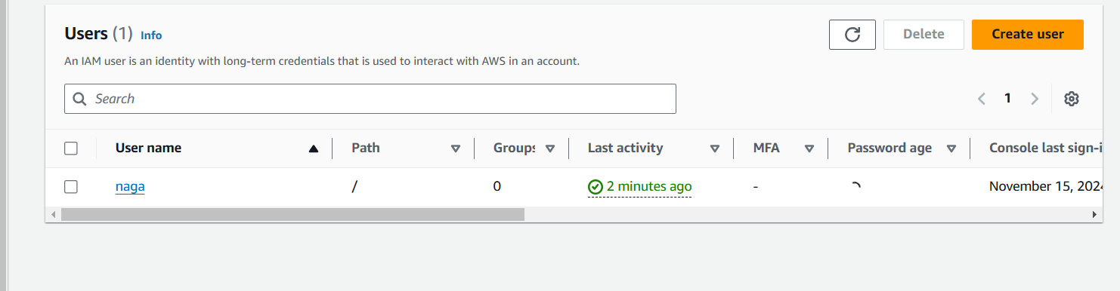

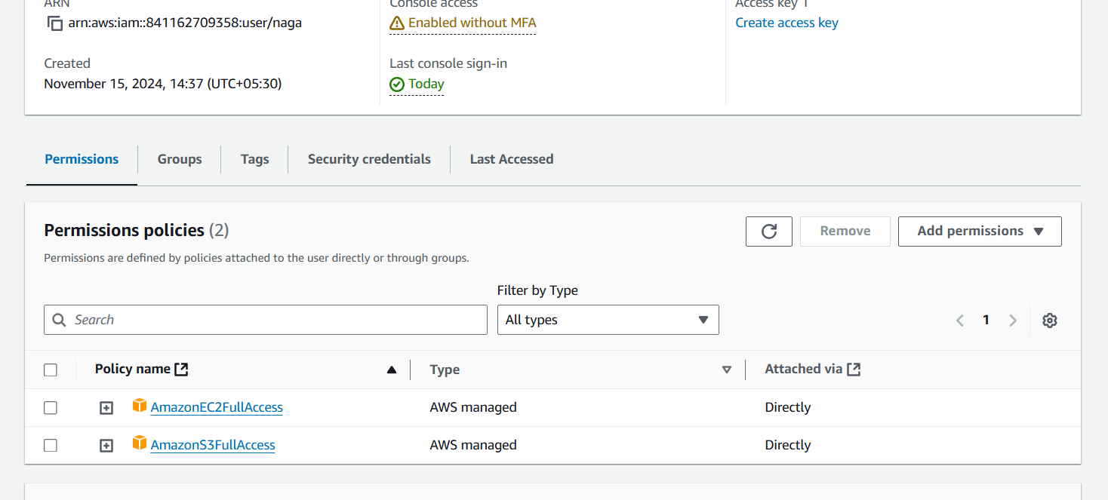

2) Create one Group in IAM and Assign Read access for ec2.

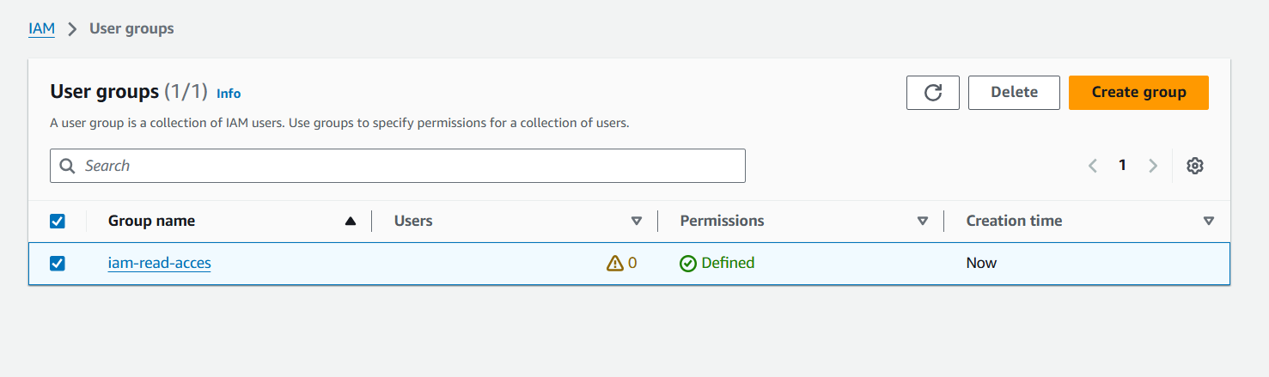

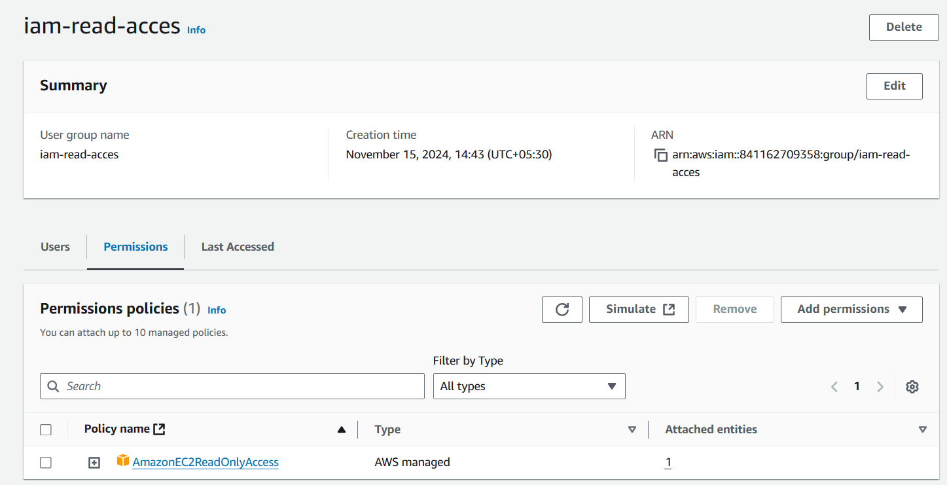

3) Create a new user with name Devops and add to the group created in task2.

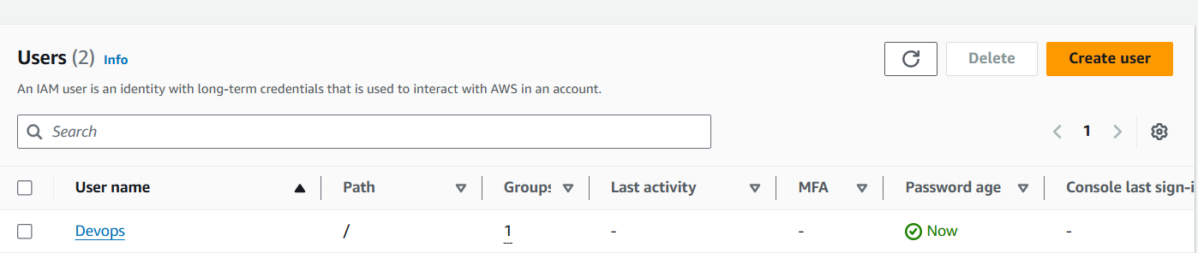

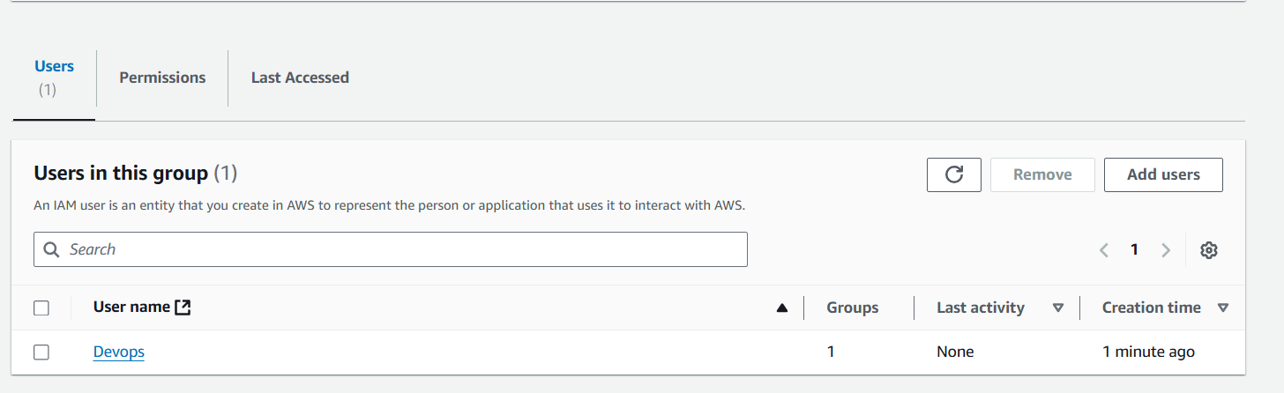

4) Write a bash script to create a IAM user with VPC full access.

#!/bin/bash

#owner vamshi

#purpose to create iam user and attach vpc full access policy

USER_NAME="vpc-iam"

POLICY_ARN="arn:aws:iam::aws:policy/AmazonVPCFullAccess"

echo "Creating IAM user $USER_NAME..."

aws iam create-user --user-name "$USER_NAME"

if [ $? -eq 0 ]; then

echo "User $USER_NAME created successfully."

else

echo "Failed to create user $USER_NAME." >&2

exit 1

fi

echo "Attaching the AmazonVPCFullAccess policy to $USER_NAME..."

aws iam attach-user-policy --user-name "$USER_NAME" --policy-arn "$POLICY_ARN"

if [ $? -eq 0 ]; then

echo "Policy $POLICY_ARN attached to user $USER_NAME."

else

echo "Failed to attach policy $POLICY_ARN to $USER_NAME." >&2

exit 1

fi

echo "IAM user setup completed successfully."

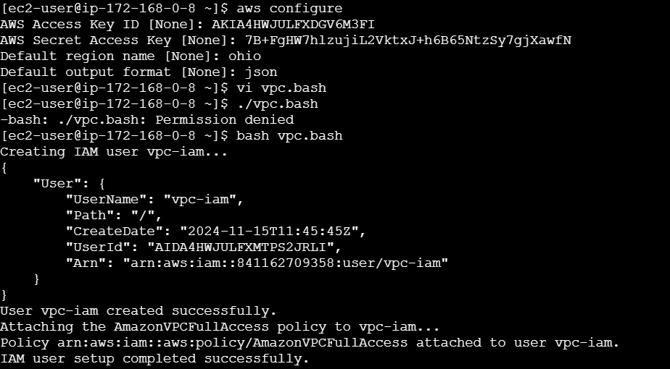

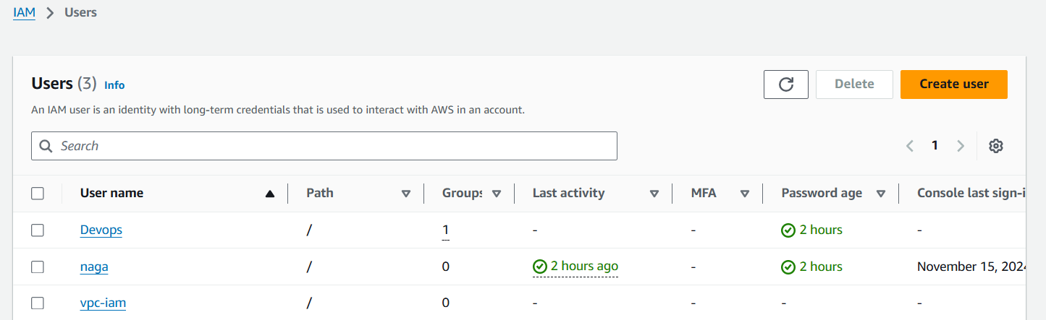

5) Create a IAM policy to access ec2 for a specific user in specific regions only.

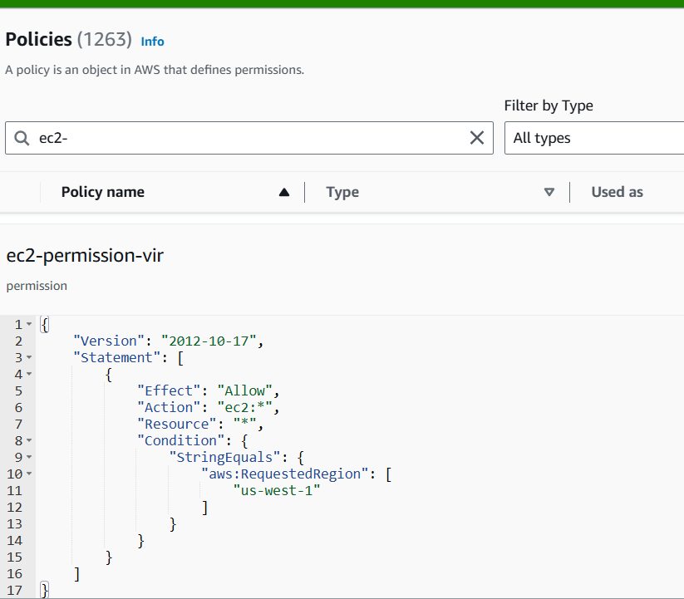

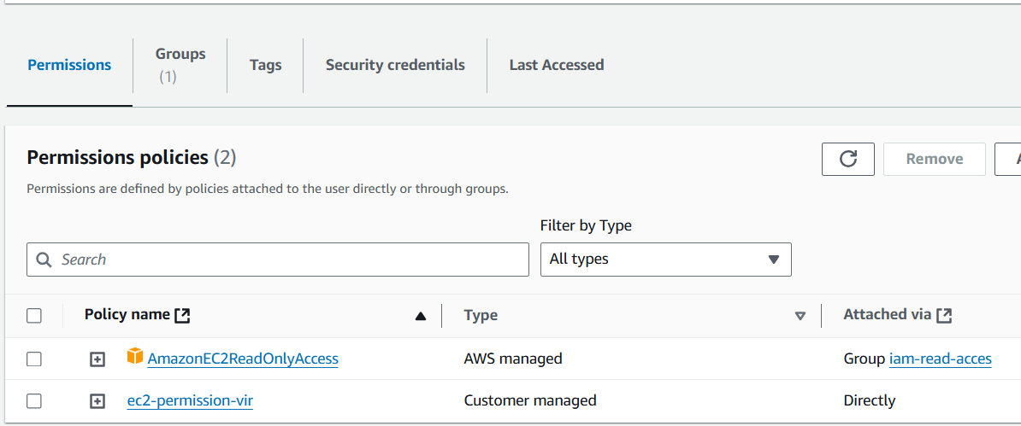

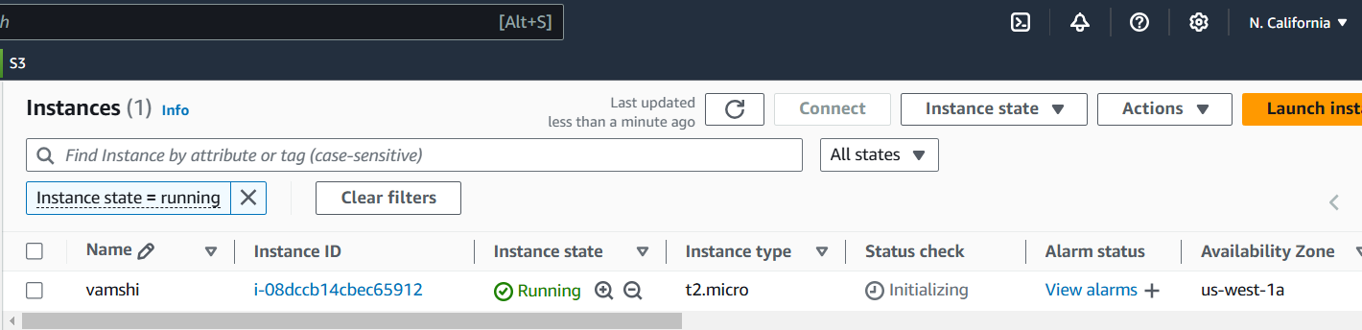

6) We have two accounts Account A and Account B, Account A user should access s3 bucket in Account B. (Collaborate with team member and execute this.Mostly asked in every interview)