**Bash script to print odd numbers from the list: (12,5,7,10,8,19,20,23,25)** 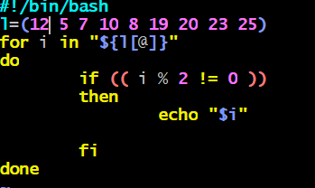

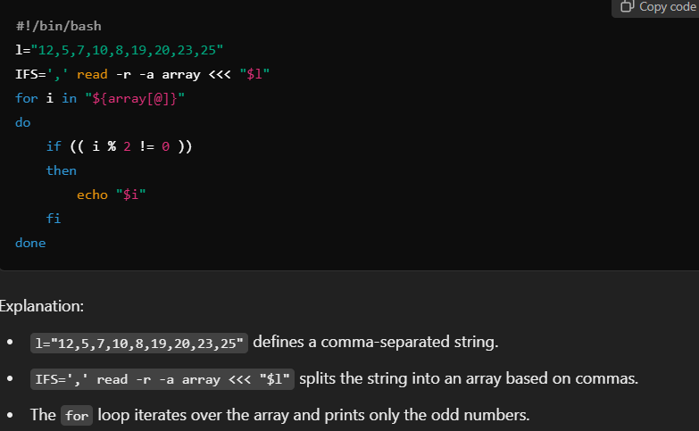

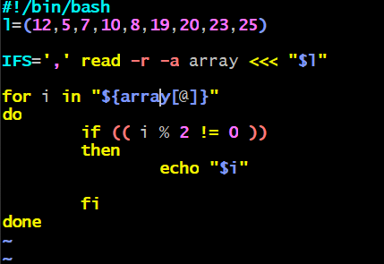

**Bash script to take an input from the user and check if it’s greater than or less than 10**

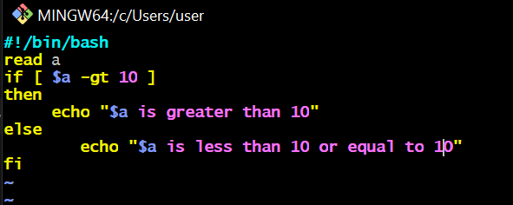

**Bash script to log in to multiple servers and check if httpd service is running**

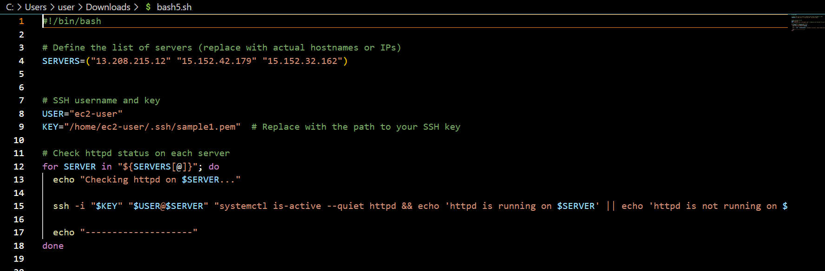

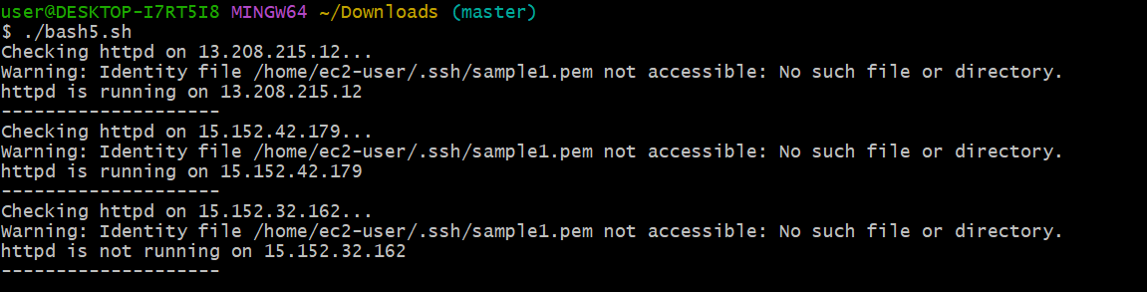

**Bash script to check log files from a specified path and delete files older than 20 days** 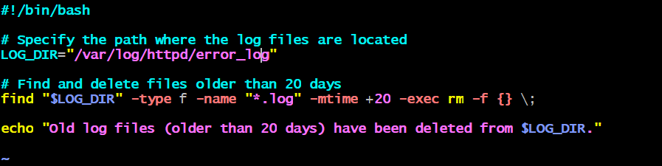

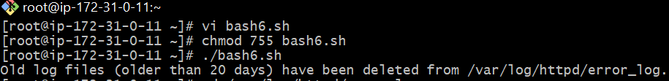

**Bash script to print the 3rd and 5th words from user input** 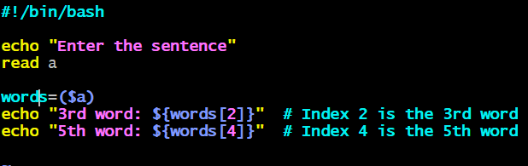 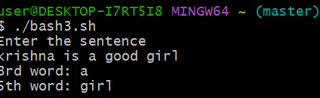

• **Input**: The script prompts the user to enter a sentence using echo and read.

• **Splitting**: The line words=($input) automatically splits the input into an array of words based on spaces.

• **Printing**: It accesses and prints the 3rd word (${words[2]}) and the 5th word (${words[4]}).

**Bash script to print numbers from 1 to 100 and then separate them into odd and even numbers**

