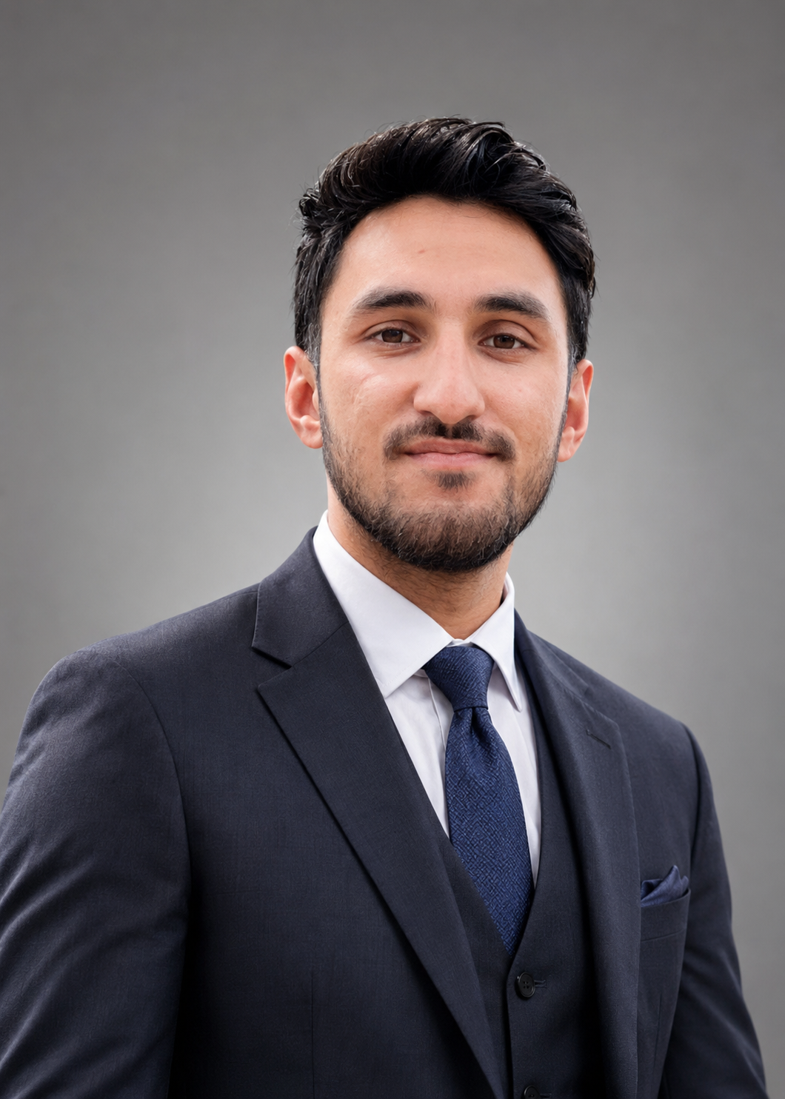
MUSHARRAF ALI

Software Engineer | Smart Contract Developer | Full-Stack AI Developer
Gilgit-Baltistan, Pakistan | +92 341 8848066 | musharafalioffical@gmail.com
LinkedIn | GitHub |

PROFESSIONAL SUMMARY
Software Engineering student and Blockchain Developer with hands-on experience in Ethereum smart contract development, decentralized applications (DApps), full-stack web development, and database management. Skilled in Solidity, JavaScript, Python, C++, MongoDB, MySQL, and Web3 technologies. Experienced in building secure blockchain solutions, responsive web applications, and SEO-driven digital platforms.

EDUCATION
BS Software Engineering, Karakoram International University (KIU), Gilgit-Baltistan, Pakistan (Expected Graduation: 2027)

TECHNICAL SKILLS
Programming: Solidity, JavaScript, Python, C++
Web: HTML5, CSS3, React.js, Node.js, Express.js
Blockchain: Ethereum, Smart Contracts, Web3.js, Ethers.js, MetaMask, DApps
Databases: MongoDB, MySQL
Tools: Git, GitHub, VS Code, Figma, Adobe XD
SEO: Technical SEO, On-Page SEO, Keyword Research

PROJECTS
Blockchain-Based Peer-to-Peer Lending Platform
• Designed and deployed Ethereum smart contracts using Solidity.
• Integrated Web3.js and MetaMask authentication.
Decentralized Voting System
• Developed tamper-resistant blockchain voting smart contracts.
• Built secure vote verification and transparency mechanisms.
Blockchain Thrift Store System
• Developed a decentralized marketplace using Ethereum smart contracts.
• Implemented secure ownership transfer and transaction workflows.
Hospital Management System
• Developed a patient management application using C++.

EXPERIENCE
Founder & Lead Developer, Printf Tech Valley (2024–Present)
• Delivered web development, blockchain, and SEO solutions.
• Managed software projects from planning to deployment.
Intern, Discover Pakistan
• Assisted in digital content production and media operations.
Freelance Blockchain & Web Developer
• Built websites, smart contracts, and client-focused digital solutions.

CERTIFICATIONS
• Decentralized Applications (DApps) – Coursera
• SEO Fundamentals – Coursera
• Adobe Premiere Pro – Coursera
• UI/UX Design – Great Learning Academy
• Computer Networking & Digital Security – Alison

LANGUAGES
Urdu (Native), Shina (Native), Balti (Native), English (Professional), Persian (Professional)

