**ABSTRACT**

With new changes seen in engineering field day by day, it become quite important for society to search out specific new ways in which of interaction with computer systems and technology as its need is increasing in society everyday. Today, all device is creating the application of touch screen technology on its computer systems, that is not affordable to be employed in every applications. A particular system sort of a virtual mouse that generates **object pursuit**(tracking) and **Gestures** which will ease us to interact, it can be an alternate technique for the typical touch screen and also the solid physical mouse. the target is to make associate Object pursuit(tracking) application that interacts with the computer system.This system proposed is a **Computer Vision-based control system**, that uses hand gestures that are being captured from a digital camera through associate with hand detection technique implemented using **OpenCV** libraries.

Our project which applies **gesture recognition** as a topic which comes under two computer science fields like augmented reality and human-computer interaction and we have created a virtual gesture system with the goal of elucidating human gestures through the mathematical algorithms. Users can use simple finger or hand gestures to control or interact with the system without physically touching them and also we included a **voice assistance** to start and end the gesture controlling system. Gesture recognition can be viewed as a way for computers to begin to recognize human body language and signs, thus stuffing the void between computing systems and humans than earliest text user interfaces or even graphical user interfaces, which still limit the majority of input to keyboard and mouse are may not be very efficient at all times.

The algorithm is focused on deep learning for detecting the gestures. Hence, the proposed system will avoid pandemic situation of **COVID-19** spread by reducing the **human interaction** with the devices to control the system.

**CHAPTER - 1**

**INTRODUCTION**

* 1. **OVERVIEW:**

The years 2019-2021 has shown mankind some mind-boggling series of events amongst which the **COVID-19** pandemic is the most life-changing event which has startled the world since the year began. Affecting the health and lives of masses, COVID-19 has called for strict measures to be followed in order to prevent the spread of disease. In this project, we have tried to reduce the gap between the real world and the augmented environment to produce a mixed reality system. For that purpose, we created a virtually controllable keyboard, mouse and some other gesture controlling system and voice assistance.

To provide an easy immersive augmented experience which is also gesture enabled, we employ a web camera which is integrated with OpenCV libraries through a compiler. Using our system, users can control a virtual keyboard using their finger movements and finger tips. Further, users can communicate with people who are viewing the screen, the user selects an alphabet with their fingertip and can move the keyboard with the help of **hand gesture**. This paper describes the way of implementing a virtual keyboard, mouse and some other gesture controlling system without any additional hardware but by using the webcam available in the system. The webcam simply captures the consecutive frames and compares them to recognize it as a click if there is a difference in the contour.

* 1. **OBJECTIVE OF THE PROJECT:**

The general objective of the project is to develop a Virtual Interface system to support contact-less interaction with the computers in public places. The specific objectives of the project is to replace the traditional physical I/O devices with virtual AI framework using hand gestures and voice assistance.

* 1. **PROBLEM STATEMENT:**

**1.** The task here is to access and analyze the webcam images and let the computer act accordingly to it.

**2.** We want to build a system that allows the user to interact with the computer with hand gestures and voice assistance.

* 1. **SCOPE OF THE PROJECT:**

There are no efficient contact-less interactive applications to allow the user to have a safe experience. This increases the demand for an efficient interface system in public places like ATM, Airports,Railway Stations etc. This project uses Human-Computer Interaction using OpenCV and Voice assistance to perform input operactions without direct interactions.

# CHAPTER - 2

# LITERATURE SURVEY

### Title: A Static Hand Gesture Recognition based on local contour sequence

**Author:** Sandeep Bhargava

**Publisher: IEEE**

**Year: 2016**

### Context:

### This project uses Local Contour Sequence (LCS) technology.

### It works on a very basic principle like that of a shadow. So it demands very less prerequisites and even less analyzing and processing functionalities.

### It is the least efficient gesture tracking method. Even under slight different conditions it cannot different between the fingers.

### Title: Virtual Gesture with RGB tapes

### Author: Kanchana Venkatasubbaiah

**Publisher: IEEE**

### Year:2019

### Context:

### This project uses RGB image capturing, Cored tapes technology.

### It analyzes the gestures in a 2D plane with 3 critical points thereby opening up more opportunities than the contour sequence system.

### It cannot analyze the depth of the fingers therefore severely limits the possibilities of gesture recognition.

### Title: Gesture Recognition Apparatus And Method

**Author:** Youichi miyake

**Publisher:** Panasonic Corporation, Osaka

**Year:** 2018

### Context:

### A gesture recognition apparatus which controls a display device based on a gesture operation performed by a user in a vicinity of a screen includes: a picture obtainment unit which obtains a picture of the vicinity of the screen; a direction determination unit which determines, based on position information indicating a direction of a movement to be recognized as the gesture operation; a gesture recognition unit which recognizes, as the gesture operation. A movement to recognized as the gesture operation; the movement of the whole part of the body of the user in the operational direction determined by the direction determination unit.

### Title: Hand Gesture Recognition for Home Automation

**Author:** V. Savitha, J. Nandhini, S. Kokilavani

**Publisher:** ISSN (Online)

**Year:** 2019

### Context:

### Here we present an Expectation Maximization based system to control Various Appliances by just using hand gestures recognition like showing first finger will switch the first device. It uses real time image processing for hand gestures Recognition using a simple webcamera and microcontroller based embedded system. This project paper proposes a possible solution to control the gadgets for people in industries, who cannot touch electric panels too often during their work, just by showing hand gestures, devices get controlled. There will be a computer application designed in MATLAB to have a real time image processing. A web camera giving images to the computer application.

### Title: Learning Fast and Robust Gesture Recognition

**Author:** Christos Papaioannidis

**Publisher:** EUSIPCO

**Year:** 2021

### Context:

### Autonomous Unmanned Aerial Vehicles (UAVs, or drones) are being increasingly employed to assist in many tasks, typically in collaboration with humans. Since most drones are equipped with RGB cameras, a typical way of visual interaction is through human hand gestures. Thus, this paper examines a common, two-stage algorithmic framework for gesture recognition, suitable for execution on any camera-equipped UAV with embedded AI capabilities. First, a fast 2D human body pose estimation Deep Neural Network (DNN) extracts 2D skeleton information from the input video frames. Then, these per-frame skeletons that have been computed over a temporal window are fed to a separate classifier, which outputs the final gesture prediction. However, no exhaustive quantitative comparisons have been conducted up to now in order to specify the best-performing algorithmic ingredients in the context of this framework. Therefore, we investigated and experimentally evaluated various possibilities for 2D skeleton information utilization, as well as for gesture classification itself, in order to identify the ideal combination for optimal efficiency. Using the empirically best approach, we achieved increased gesture recognition performance on two challenging datasets, when compared to competing relevant methods, at a runtime advantage on embedded AI compute hardware.

### Title: Customized Voice Assistant

**Author:** Senthur R, Prashant P, Ragul P

**Publisher: IEEE**

**Year:2021**

### **Context:**

### There are some famous mobile-app voice assistants like ‘SIRI’, ‘Google Voice Search’ which help the end-users to communicate with the device for maximum utilization of automation. Windows’s voice assistant ‘Cortona’ is customized for business and productive malignant to automate their work in an efficient way. But still, many companies, industries demand extreme automation to optimize their work in an effective manner. But our proposed voice assistant named ‘**FRIDAY**’ with voice recognition intelligence, which takes the input from the end-user, process it and returns it in various form like what the end-user is intended. Basic Operations which are done by several voice assistants such as Alexa, Siri, Google are integrated into our voice assistant. In addition, a unique automation feature is added ‘Automatic Login Authentication’ where the user’s respective ‘Gmail’, ‘Instagram’, etc., accounts can be logged in automatically using our unique feature using the AES cryptographic key. This may be the significant outcome of our voice assistant to process the information quickly with the help of Google API and Packages. The system is designed in such a way that all the services that are provided by the systems are accessible by the end-user on the user’s voice dictation commands.

### 7. Title: Humanizing voice assistant: The impact of voice assistant personality on consumers’ attitudes and behaviors

**Author:** Atieh Poushneh

**Publisher:** Journal of Retailing and Consumer Services 58’

**Year:** 2019

**context:**

### A voice assistant (VA), a type of voice-enabled artificial intelligence, is no longer just a character in science fiction movies. Currently, voice is embedded in a variety of products such as smartphones (mobile applications) and smart speakers in consumers’ homes. Furthermore, voice assistants are becoming integral to our daily lives. While human personalities shape the way we interact with the world, voice assistant personalities can also impact everyday interactions with our environment. This study identifies seven voice assistant personality traits (VAP) of three commonly used mobile applications: **Microsoft’s Cortana, Google’s Assistant**, and **Amazon’s Alexa.** To examine the effect of VAP on consumer experience, this study applies and extends flow theory to uncover why VAP has the effects it has and what facets of VAP drive the voice interaction flow experience that can influence consumers’ attitudes and behavioral intentions. Our study shows that voice interaction with a VA that incorporates functional intelligence, sincerity, and creativity empowers consumers to take control of their voice interactions with the VA, focus on their voice interaction, and engage in exploratory behavior. Consumers’ exploratory behavior leads to consumer satisfaction and consumers’ willingness to continue using voice assistant.

### 8. Title: Real-Time Hand Gesture Recognition

**Author:** Pranjali Manmode, Rupali Saha, Manisha N

**Publisher:** ISSN (Online)

**Year:** 2021

### **Context:**

The paper researches a set of overall flows for hand gesture recognition. Using AdaBoost classifier based on Haar feature, hand gesture segmentation realizes the acquisition of hand gesture area in a complicated environment. Using camshaft algorithm for hand gesture tracking according to the movement of hand gestures and features of deformation ensures to acquire the hand gesture area in real time, finally, the hand gesture area is classified by a convolution neural network.

### Title: Gesture recognition technology

**Author:** Sameer Mohammed

**Publisher:** ISSN

**Year:** 2017

### **Context:**

The importance of gesture recognition lies in building efficient human machine interaction . Its applications range from sign language recognition through medical rehabilitation to virtual reality .Gesture recognition 35 soft computing tools pose another promising applications to static hand gesture identification . Thus , gesture recognition promises wide-ranging applications in fields from photojournalism through medical technology to biometrics.

### Title: GIntelligent Voice Assistant by Using OpenCV Approach

**Author:** Saibaba CH M H, Dr. Vijaychandra jathaila

**Publisher:** ISSN

**Year:** 2021

### **Context:**

The basic plan of our work is to integrate as several tasks as double and create it execute by our voice command. AN Intelligent Virtual Assistant (IVA) or 12 Intelligent Personal Assistant (IPA) could be a software system agent which will perform tasks or services for a private supported commands or queries. It is convenient, there are square measure some sectors wherever voice is that the solely approach of double communication, and a lot of typically, it permits to free-up each hands and vision doubtless for doing another activity in parallel or helps conjointly disabled individuals.

Generally, to try and do such quite tasks we would like a voice assistant to prefer and to get gadgets like Alexa. However identical practicality will be done by several the powerful packages like pywhatkit, Wikipedia, pyttsx3, pygame, speech recognition, OpenCV etc. One of the relevant trends in artificial intelligence is that the technology of recognizing the natural language of a personalities. New insights during this topic will cause new means of natural human-machine interaction, during which the machine would find out how to know human’s language, adjusting and interacting in it. One is every of such tools is voice assistant, which can be integrated into several alternative intelligent systems. Voice may be a ton of economical than writing on a keyboard. Here we tend to square measure desegregation varied options and place along as one practicable file. Hence, we will create several things among less quantity of your time with the simplest performance. The basic set up of our work is to integrate as many tasks as achievable and build it execute by our voice command.

**Figure 3.1: Existing system with colored tapes**

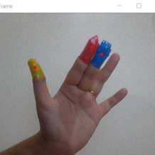

**Disadvantage Of Existing System:**

* Insists on Physical Contact
* Costly
* Depends on mechanical parts which may fail
* Wired and Messy
* Not always handy
* The components change with respect to region, so not universal
* If fails, no backup plan

## CHAPTER - 3

## SYSTEM ANALYSIS

## EXISTING SYSTEM:

The existing system consists of a mouse that can be either wireless or wired to control the cursor, we know that can use hand gestures to monitor the system. The existing virtual mouse control system consists of the simple mouse operation using the coloured tips for detection which are captured by web-cam, hence coloured fingers acts as an object which the web-cam senses colours like red, green, blue colour to monitor the system and therefore could perform basic mouse operation like minimize, drag, scroll up , scroll down , left-click right-click using hand gestures without any coloured finger because skin colour recognition system is more flexible than the existing system.

**Figure 3.2: Proposed system with critical points**

**Figure 1:System Architecture**

**Figure 1:System Architecture**

**Figure 1:System Architecture**

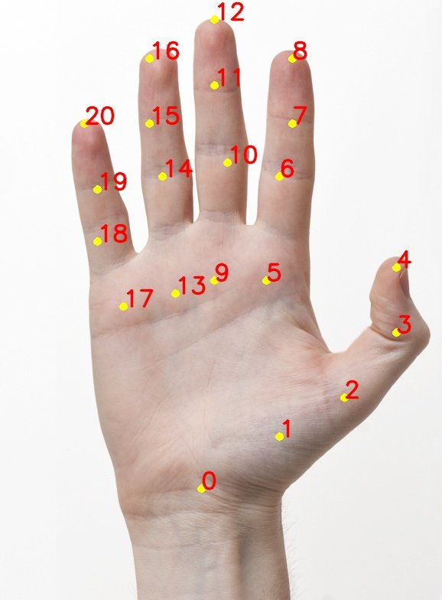

**Advantage Of Proposed System**

* No chance of failure
* Easily modifiable, so universal
* No need for physical contact
* 100% mobile and handy
* No wires and physical or mechanical components
* No compatibility issues
* Fun to use

## PROPOSED SYSTEM:

The system works by identifying the colour of the hand and decides the position of the cursor accordingly. The proposed system can work for the skin tone of any colour and as well as can work accurately in any lighting condition. For the purpose of clicking the user needs to create an angle between his/her finger. This is done using a hand gesture recognition which receives inputs from a web-cam.

The proposed system can easily replace the traditional I/O hardware as well as the algorithm that requires coloured tapes for controlling the mouse. This research paper can be a pioneer in its field and can be a source of further research in the corresponding field. The project can be developed with “Zero Cost” and can easily integrate with the existing system. This work can easily replace the traditional mouse and keyboard system that has been in existence for decades. With the use of this algorithm the user can control the mouse without the fuss of any other hardware device.

**Working Of Proposed System:**

The main objective of the proposed system is to perform computer input and output functions and some gesture control function using a web camera or a built-in camera in the computer instead of using a traditional input and output device. Hand gesture and hand tip detection by using computer vision is used as a **HCI** with the computer. With the use of the AI virtual mouse system, we can track the fingertip of the hand gesture by using a built-in camera or web camera and perform the mouse cursor operations and scrolling function and also move the cursor with it.

While using a wireless or a Bluetooth mouse, some devices such as the mouse, the dongle to connect to the PC, and also, a battery to power the mouse to operate are used, but in this paper, the user uses his/her built-in camera or a webcam and uses his/her hand gestures to control the computer operations. In the proposed system, the web camera captures and then processes the frames that have been captured and then recognizes the various hand gestures and hand tip gestures and then performs the particular mouse function.

In the proposed Gesture control system, this limitation can be overcome by employing webcam or a built-in camera for capturing of hand gestures and hand tip detection using computer vision. The algorithm used in the system makes use of the machine learning algorithm. Based on the hand gestures, the computer can be controlled virtually and can perform left click, right click, scrolling functions, and computer cursor function without the use of the physical mouse.

**Applications of Proposed System:**

The AI virtual mouse system is useful for many applications; it can be used to reduce the space for using the physical mouse, and it can be used in situations where we cannot use the physical mouse. The system eliminates the usage of devices, and it improves the human-computer interaction.

**Major applications:**

**(i)** The proposed model has a greater accuracy of 99% which is far greater than the that of other proposed models for virtual mouse, and it has many applications

**(ii)** Amidst the COVID-19 situation, it is not safe to use the devices by touching them because it may result in a possible situation of spread of the virus by touching the devices, so the proposed AI virtual mouse can be used to control the PC mouse functions without using the physical mouse

**(iii)** The system can be used to control robots and automation systems without the usage of devices

**(iv)** 2D and 3D images can be drawn using the AI virtual system using the hand gestures

**(v)** AI virtual mouse can be used to play virtual reality- and augmented reality-based games without the wireless or wired mouse devices

**(vi)** Persons with problems in their hands can use this system to control the mouse functions in the computer

**(vii)** In the field of robotics, the proposed system like HCI can be used for controlling robots

**(viii)** In designing and architecture, the proposed system can be used for designing virtually for prototyping.

## Chapter - 4

## REQUIREMENT SPECIFICATION

## SOFTWARE SPECIFICATION:

The software requirements document is the specification of the system. It should include both a definition and a specification of requirements. The software requirements provide a basis for creating the software requirements specification.

Software Requirements:

* Python 3.9
* Libraries – OpenCV, NumPy, pyautoGUI
* Pycharm IDE

## HARDWARE SPECIFICATION:

The hardware requirements may serve as the basis for a contract for the implementation of the system and should therefore be a complete and consistent specification of the whole system. They are used by software engineers as the starting point for the system design.

Hardware Requirements:

* Processor - i7
* Memory - 512 GB
* RAM - 2GB(Minimum)
* Web Camera

## INTRODUCTION TO PYTHON:

Python is a widely used high-level programming language for general- purpose programming, created by Guido Van Rossum and first released in 1991. An interpreted language, Python has a design philosophy that emphasizes code readability (notably using white space indentation to delimit code blocks rather than curly brackets or keywords),might be used in languages such as C++ or Java. The language provides constructs intended to enable writing clear programs on both a small and large scale.

Python features a dynamic type system and automatic memory management and supports multiple programming paradigms, including object- oriented, imperative, functional programming, and procedural styles. It has a large and comprehensive standard library. Python interpreters are available for many operating systems, allowing Python code to run on a wide variety of systems.

### FEATURES:

* Easy to code.
* Simple than other languages.
* Explicit programming language.

## CHAPTER - 5

## SYSTEM DESIGN

## SYSTEM ARCHITECTURE:

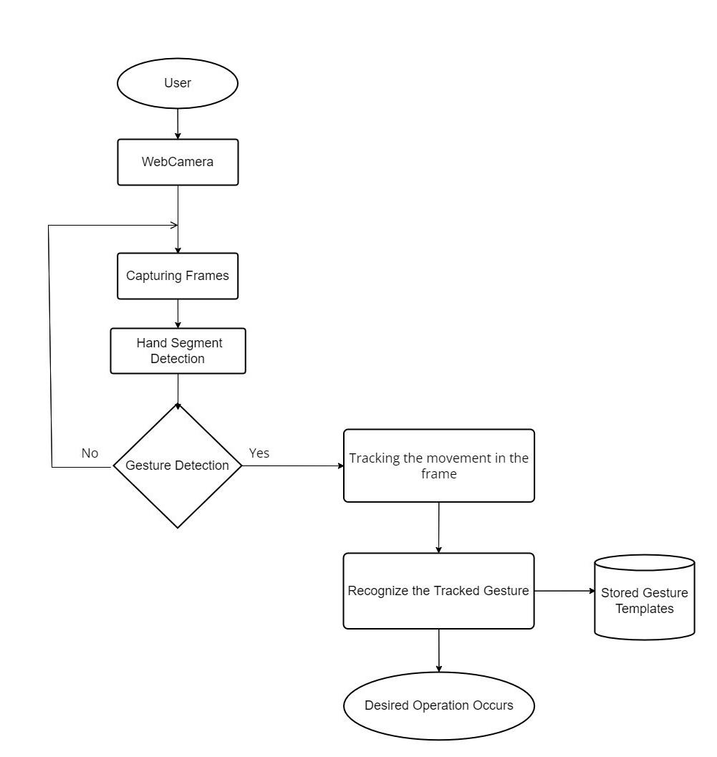

**Figure 5.1:System Architecture**

**CHAPTER - 6**

**MODULE DESCRIPTION**

We have devised a smart framework for creating a virtual interface in this paper. As the cases of covid-19 are decreasing maximum public places are opening with half or full capacity. ATMs are always open. If we install this system in the public places like ticket counters, ATMs and computerized docking facilities, the spread of germs, bacteria, and viruses can be greatly reduced.

The block diagram of the developed framework is depicted in **Fig. 5.1**.

1. **Hand Detection**

In this module, the main focus is access the webcam and allow the program to access the hand images.

1. **Gesture Detection and Recognition**

In this module, the accessed images are analysed and the movements and the significant gestures are noted and stored.

1. **Accessing The Database To Check Verify Gesture**

In this module, the recorded gestures and movements are cross-checked with the pre-programmed gestures and movements to facilitate the program functioning

1. **Desired Actions Occur**

In this module, the cross-checked gestures are triggered to perform the preprogramed actions like moving cursor, scrolling, clicking, double clicking, etc..

1. **Help From Voice Assistance**

In this module, we create a voice assistant to facilitate and help us use the virtual interface more efficiently and safely. It can also perform many other basic functions

**CHAPTER 7**

**RESULT AND DISCUSSION**

By using various modules, we were able to build a virtual interface system. The system’s efficiency level is enough to fully function in a public environment. Even though there is still ground for development in the voice control module, as of right it fulfills it’s responsibilities perfectly.

In it’s current level, this project is fully capable of functioning in a controlled singular environment.

The program captures the images, processes them, analyses them, extracts necessary information from them, and completes the pre programmed tasks satisfactorly.

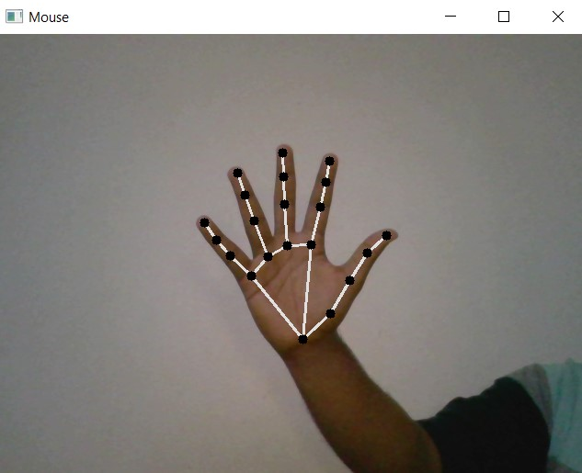

**Figure 7.1:Hand Recognition By the System**

* The proposed AI virtual mouse system is based on the frames that have been captured by the webcam in a laptop or PC. By using the Python computer vision library OpenCV, the video capture object is created and the web camera will start capturing video, as shown in **Figure 7.1**. The web camera captures and passes the frames to the AI virtual system.
* The AI virtual mouse system uses the webcam where each frame is captured till the termination of the program. The video frames are processed from BGR to RGB color space to find the hands in the video frame by frame as shown in the following code:

**def findHands(self, img, draw = True):**

**imgRGB = cv2.cvtColor(img, cv2.COLOR_BGR2RGB)**

**self.results = self.hands.process(imgRGB)**

* The AI virtual mouse system makes use of the transformational algorithm, and it converts the co-ordinates of fingertip from the webcam screen to the computer window full screen for controlling the mouse. When the hands are detected and when we find which finger is up for performing the specific mouse function, a rectangular box is drawn with respect to the computer window in the webcam region where we move throughout the window using the mouse cursor, as for now we hidden that box to get clear view of screen.
* we are detecting which finger is up using the tip Id of the respective finger that we found using the **MediaPipe** and the respective co-ordinates of the fingers that are up, and according to that, the particular mouse function is will be performed using the **pyautoGU**I python package.
* For performing Gesture control, we will find and set the tip ID for respective operations.
* For example: If the index finger is up with tip Id = 1 or both the index finger with tip Id = 1 and the thumb finger with tip Id = 2 are up, the volume of our system can be controlled using the **Pycaw** package of Python, as shown in **Figure 7.2**.
* Here we just implemented only volume control gesture, like this we can perform more gesture control operation such as slider control, scroll wheel control, tab control etc., using **openCV** libraries.

**Figure 7.2: Gesture Recognition By the System**

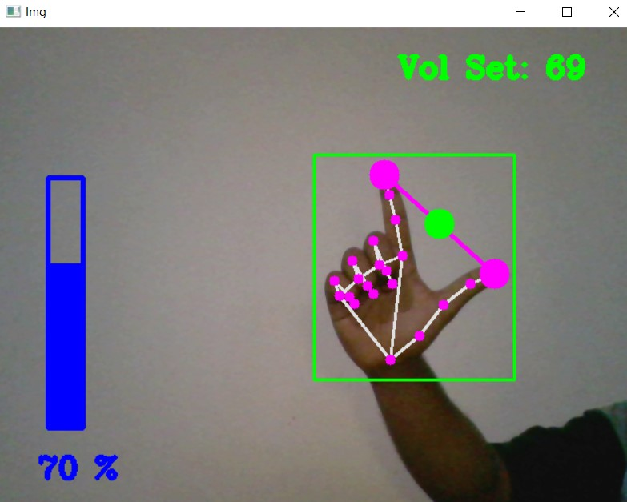

* The system combines aspects of the traditional system keyboard with more modern, gesture-based approaches to typing. To enter text, users perform a assigned gesture in which their index finger traces over the letters of their intended word.
* For example: If the index finger with tip Id = 1 and the thumb finger with tip Id = 0 are up and the distance between the two fingers is lesser than 30px, the computer is made to perform the button click over the letter, which inputs the letter in system using the **pynput** Python package, as shown in **Figure 7.3**.
* A gesture-based interface in which a user can input data in a hands-free way presents a solution to this requirement.

**Figure 7.3: Onscreen Keyboard to Facilitate Virtual Typing**

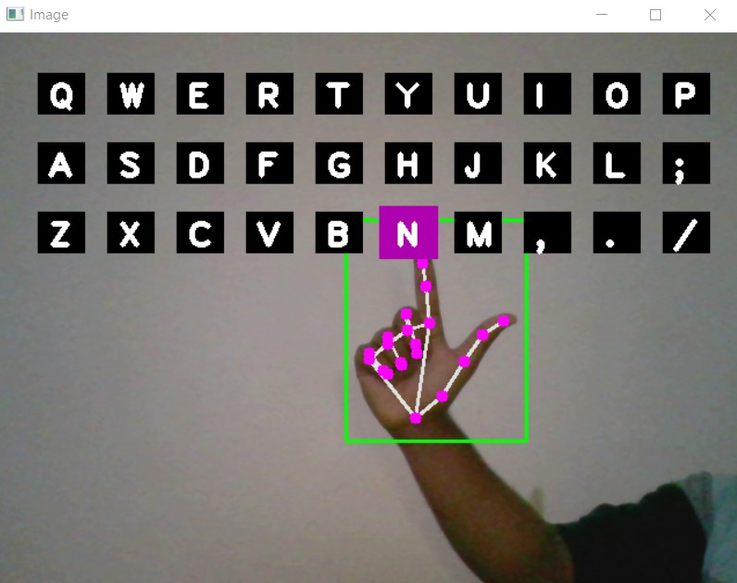

* Our aim is to operate the system without direct interactions. The gesture-control system we implemented will do lot of operations without direct interactions even though, we might need to interact the system to start the gesture control process.
* So we included voice assistance, which can help us to start and terminate the process of gesture-control system as shown in **Figure 7.4**.
* It works with the **pyttsx3** and **speech-recognition** in python modules which will fetch the word from our voice and convert it to text and recognize it with our command which we assigned with some operations(opening virtual mouse, closing virtual mouse, etc.,).

**Figure 7.4:Voice Command Recognition And Assistance**

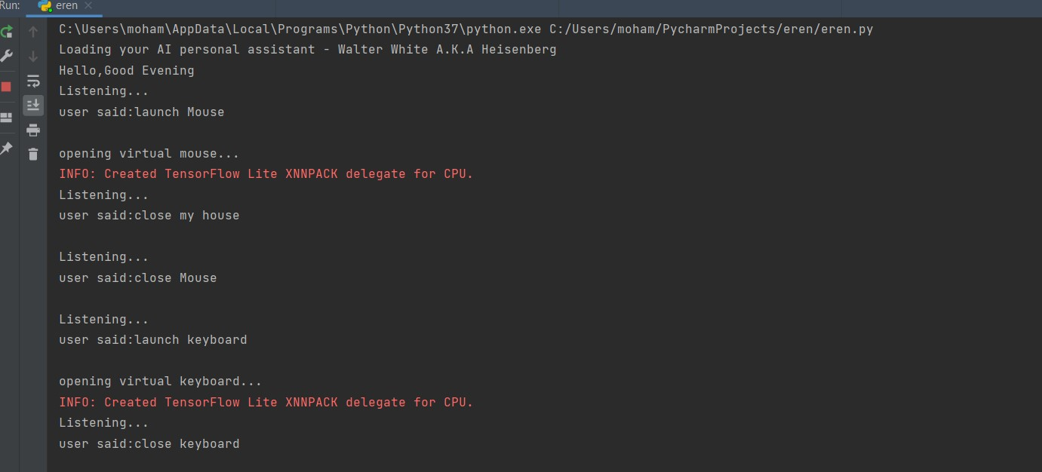

**CHAPTER 8**

**CONCLUSION**

As the technology is booming with emerging trends therefore the virtual I/O interface which can possibly contribute to public healthcare. We used OpenCV and TensorFlow to detect movements and gestures. The models were tested with images and real-time video. The accuracy of the model is achieved and, the optimization of the model is a continuous process and we are building an accurate solution by tuning the hyper parameters. This specific model could be used as a use case for Virtual **Human-Computer Interaction**. By the developing this system, we can allow the user to have a contact-less interactive experience, which would be of great help to the society.

From the results of the model, we can come to a conclusion that the proposed Gesture control system has performed very well and has a greater accuracy compared to the existing models and also the model overcomes most of the limitations of the existing systems. Since the proposed model has greater accuracy, the Gesture control system can be used for real-world applications, and also, it can be used to reduce the spread of **COVID-19**, since the proposed system can be used virtually using hand gestures without using the traditional physical devices.

The model has some limitations such as small decrease in accuracy in right click mouse function and some difficulties in clicking and dragging to select the text. Hence, we will work next to overcome these limitations by improving the finger tip detection algorithm to produce more accurate results.

**CHAPTER - 9**

**REFERENCES**

* Chu-Feng Lien, “Portable Vision-Based HCI – A Realtime Hand Mouse System on Handheld Devices”, Jun 2019, National Taiwan University, Computer Science Department.
* Ahmed Siddique, Abishek Kommera, DivyaVarma, “Simulation of Mouse using Image Processing Via Convex Hull Method”, Vol.4, Issue 3, March 2019.
* Hojoon Park, “A Method for Controlling the Mouse Movement using a Real Time Camera”, Brown University, Providence, RI, USA, Department of Computer Science, 2017.
* Matthew B. Hoy (2018) “Alexa, Siri, Cortana, and More: An Introduction to Voice Assistants”, Medical Reference Services Quarterly, 12 Jan 2018.
* Divya Varma , Abishek Kommera “Simulation of Mouse using Image Processing Via Convex Hull Method”, Vol.4, Issue 3, March 2018.
* Sahu, G., Mittal, S.: Controlling mouse pointer using web cam (2016)
* Saraswati, V.I., Sigit, R., Harsono, Eye gaze system to operate virtual keyboard. In: 2016 International Electronics Symposium (IES). pp. 175–179. IEEE (2016).
* Shetty, S., Yadav, S., Upadhyay, R., Bodade, V.: Virtual mouse using colour detection (2016).
* Shibly, K.H., Dey, S.K., Islam, M.A., Showrav, Design and development of hand gesture based virtual mouse. In: 2019 1st International Conference on Advances in Science, Engineering and Robotics Technology (ICASERT). pp. 1–5. IEEE (2019).
* Shindhe, P.C., Goud, Mouse free cursor control. Bonfring International Journal of Research in Communication Engineering 6(Special Issue Special Issue on Recent Advancements in Electronics and Communication Engineering— Editors: Dr. GA Bidkar, Dr. C. Vijaya and Dr. SB Kulkarni), 92–98 (2016).
* Abedin, M.Z., Nath, A.C., Dhar, P., Deb, K., Hossain, M.S.: License plate recognition system based on contour properties and deep learning model. In: 2017 IEEE Region 10 Humanitarian Technology Conference (R10-HTC). pp. 590–593. IEEE (2017)
* Adajania, Y., Gosalia, J., Kanade, A., Mehta, H., Shekokar, N.: Virtual keyboard using shadow analysis. In: 2010 3rd International Conference on Emerging Trends in Engineering and Technology. pp. 163–165. IEEE (2010)
* Ahmed, T.U., Hossain, S., Hossain, M.S., ul Islam, R., Andersson, K.: Facial expression recognition using convolutional neural network with data augmentation. In: 2019 Joint 8th International Conference on Informatics, Electronics & Vision (ICIEV) and 2019 3rd International Conference on Imaging, Vision & Pattern Recognition (icIVPR). pp. 336–341. IEEE (2019)
* Asad, M.U., Mustafa, R., Hossain, M.S.: An efficient strategy for face clustering use in video surveillance system. In: 2019 Joint 8th International Conference on Informatics, Electronics & Vision (ICIEV) and 2019 3rd International Conference on Imaging, Vision & Pattern Recognition (icIVPR). pp. 12–17. IEEE (2019)
* Bhuvana, S., Ashwin, E., Boopathi, R., Victor, A.D.: Virtual keyboard interaction with system based on webcam (2017)
* Tingyao Wu, D. Van Compernolle, H. Van hamme, “Feature Selection in Speech and Speaker Recognition” June 2009. U.D.C. 681.3_I27. Phd Thesis.
* Chris Biemann, Dirk Schnelle-Walka, “Unsupervised acquisition of acoustic models for speech-to-text alignment”, Master-Thesis von Benjamin Milde 10. April 2014.