Name: Jaret Arnold
Background:
1. Orchidaceae is one of the most diverse families of flowering plants with approximately 28,000 species recognized. Human hybridization of orchids has been occurring since the mid-19th century with the creation of the first artificial hybrid of Calanthe by Dominy.
2. The Royal Horticultural Society (RHS) serves as the de facto authority on new Orchid hybrid registration. As this authority it publishes lists of new crosses, their parentage, and their registerer and has for centuries.
3. As open information efforts has propagated, community scientists have compiled this data into a central resource known as orchidroots.com. This site serves as a centralized repository for hybrid information like parentage, photos, registration information, lineage, and progeny. Though downloading en masse from this website isn’t a supported feature, python packages like BeautifulSoup make this a feasible approach to collecting hybridization efforts in orchids quickly.
Hypothesis: As hybridization has progressed, hybrids have been created with human traits in mind (flower size, color, longevity, etc.). These preferences can be analyzed through the use of data stored in the registration of hybrids by the Royal Horticultural Society and be used to infer how hybridization efforts in orchids have changed over time and created the hybrids we have today.
Methods:
1. I will scrape data using a python script from orchidroots.com to serve as a repository for hybridization data of a single genus of interest (Cattleya).
2. I will use R to plot the data and analyze for trends listed below.
3. Additional metrics will be extrapolated as needed using R and R-packages (parent A and parent B from parentage for instance using tidyverse)
4. I will use the image data obtained from orchidroots and Stylegan2 architecture to create a generative adversarial network capable of generating images in the style of the collected images (~8000 images).
5. I expect an increase in hybridization over time since species discovery, but not necessarily linear trends (shift in consumer demand, changing laws, trends in horticulture, etc.). I also expect generated images to be reflective of the high diversity of flower colors and patterns in this genus.
- Datasets:
  - Orchidroots.com
  - Open tree of life -
- Variables of hybrids:
  - Grex Name, Link/URL, Parentage, Registrant, Originator. Year, Ancestors (#) Descendents (#), Images (#), and saved images
- Variables of species:
  - Binomial, Link/URL, Author, Year, Subgeneric Rank, Descendents (#), Photos (#), and saved images
- Planned analyses:
  - Comparison of descendent number of species versus phylogenetic tree data from available publication/open tree of life
  - Creation of a model to predict which hybrids are more likely in comparison to those which are less likely and which variables correlate
  - Use of images to create a generative adversarial model from the flower images and Style2Gan architecture.
- Potential Figures:
  - Number of hybrids vs Year (line plot)
  - Ancestry number distribution vs year (box and whisker plot)
  - Trend of primary hybrid (species x species) vs complex (species x hybrid) creation vs time (line plot with two lines)
  - Ancestry Number vs descendent number (scatterplot)
  - Potentially more
- Screenshots:
  - 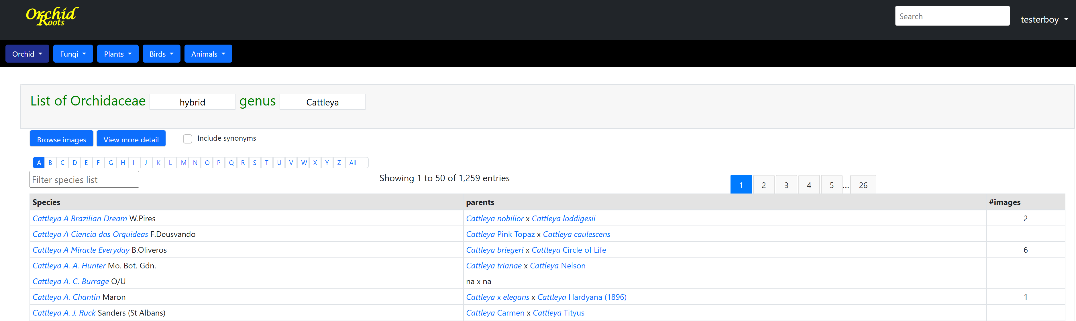
(data in R)
  - 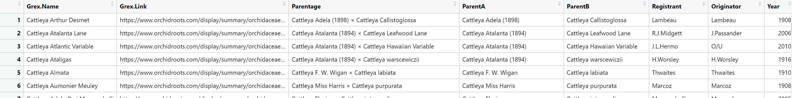
(info in open tree of life which could be improved)
  - 